Step-by-Step: Completing your Disclosure Profile in myResearch*
STEP 1: Go to myResearch* at https://research.stonybrook.edu/myResearch.php/
STEP 2: Log in to the Conflict of Interest module using your NetID and password

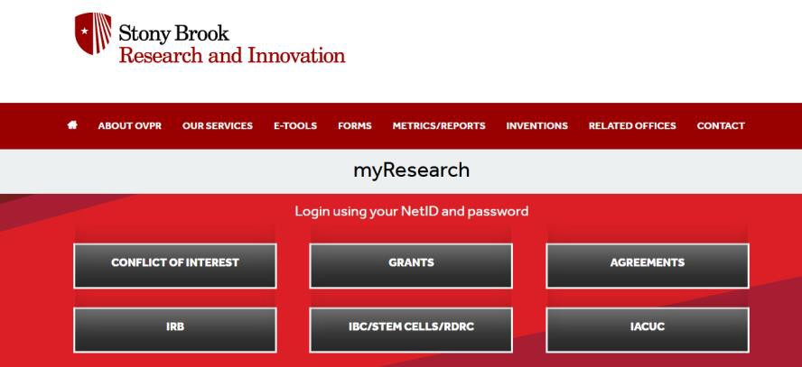

If you get an error message when logging in to the Conflict of Interest module,
please reach out to the OVPR Admin at ovpr_coi_admin@stonybrook.edu to request disclosure rights in the portal.
You will need to provide your Solar ID (nine-digit Stony Brook University ID).

STEP 3: Go to your InBox and select your Disclosure Profile
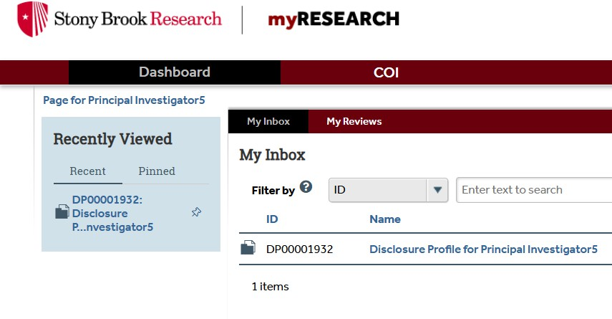

STEP 4: Edit your Disclosure Profile
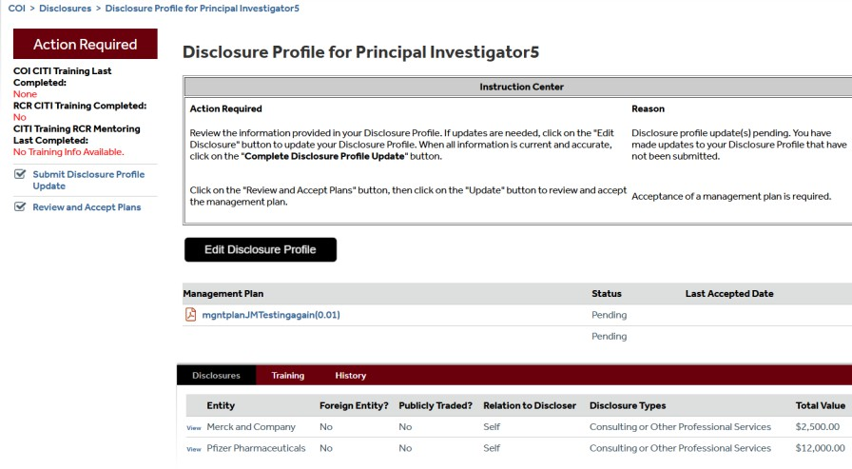

STEP 5: Review the Instructions and Policies for disclosure and then click on the Continue button
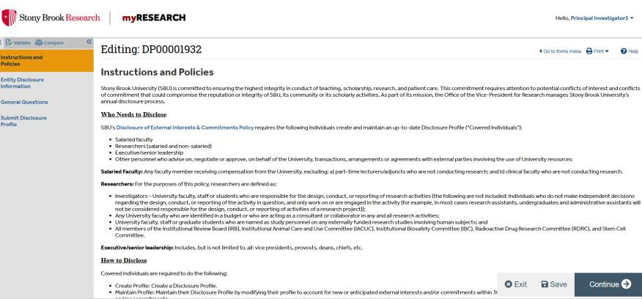

STEP 6: You now see the Entity Disclosure Information page where you can Add a disclosure
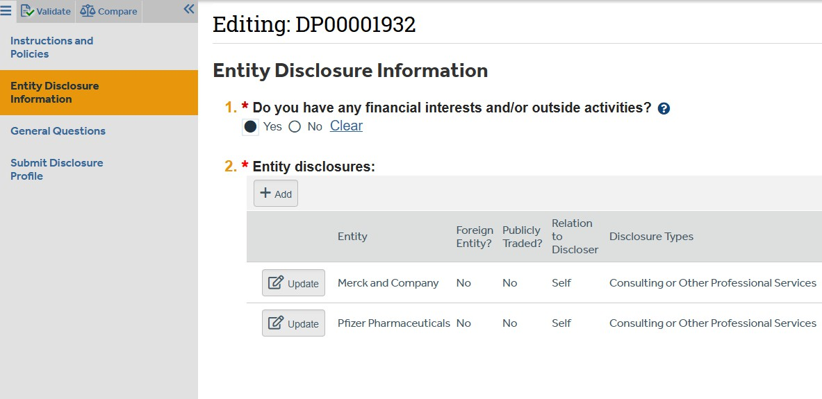

STEP 7: Add a disclosure entity and indicate the Relation to [the] discloser and the Disclosure type
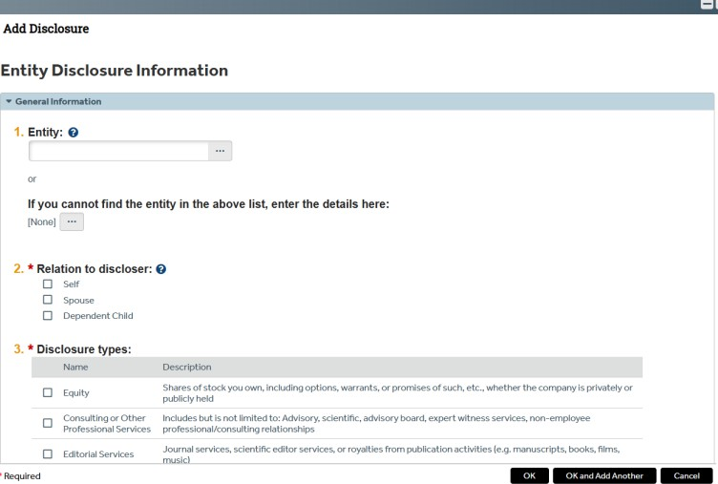

STEP 8: Answer all General Questions
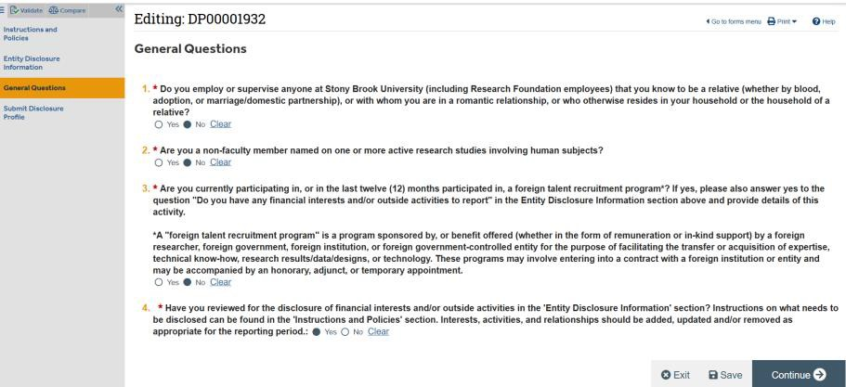

STEP 9: Click on "Submit Disclosure Profile Update" and follow the screens to finalize the submission
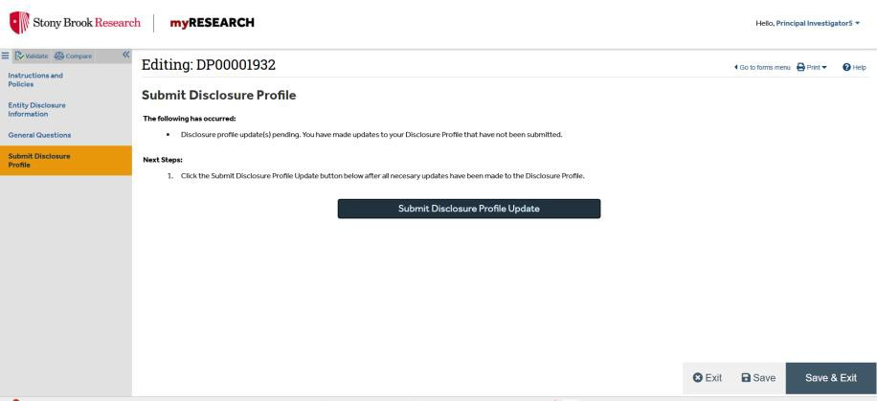

STEP 10: You should receive an email from myResearch* indicating that your Disclosure Profile has been submitted.

Success -- you have completed your Annual Disclosure Profile!

If you have any questions or need assistance regarding your Disclosure Profile, please schedule an appointment with Marina Galanakis, COI Coordinator,
for further consultation or email our office at ovpr_COI_admin@stonybrook.edu.

