myRESEARCH IACUC TRAINING GUIDE

October 2020

Table of Contents
What is myRESEARCH? 2
Getting a myRESEARCH Account 2
Overview 2
Roles in myRESEARCH 3
Submission Process 3
Logging into the myRESEARCH Portal 3
Overview of the Application SmartForm 7
Where are my Research Studies from IRBNet? 10
Creating a Research Team 10
myRESEARCH Protocol – Organization 11
Creating Substances and Procedures 11
Ancillary Reviews 16
Creating an Annual or Triennial Review 20
Responding to Reviewer Notes or Modifications 28

Questions and Issues
For policy related questions and issues including how to fill out the application, please contact the Stony Brook University Institutional Animal Care and Use Committee (631) 632-9036.

What is myRESEARCH?
MYRESEARCH is the new electronic system that will replace IRBNet. It will automate the development, review, and approval processes of your study while managing all major administrative aspects of the research and compliance lifecycle – from application submission, through amendments, continuing reviews, and any type of compliance reporting (i.e. protocol deviations, etc.).

Getting a myRESEARCH Account
You must be SBU-affiliated faculty/staff in order to access myRESEARCH. All users will log into the system using their SBU NetID and password. If your login attempt is unsuccessful, please contact (631) 632-9036.

Overview
This training pertains to the following:

Research Study | Details related to the specific information related to a study
Research Study Site | Details related to a specific institution’s site
Modification | Details related to changes made to a study
Annual Review | A yearly update on animal usage, reporting of adverse events and possible refinements to the original study.
Triennial Review | A complete review conducted once every three years.

myRESEARCH integrates the following aspects of research management into a single system:

- Conflict of Interest (COI) applications
- IRB applications

- IACUC applications
- Safety applications
- Grant applications
- Research Agreements

Roles in myRESEARCH

Registered Users | Individuals authorized to input information in myRESEARCH (must  have an SBU NetID Single Sign On).
Principal Investigator | Individual in charge of the research. Only this person can submit the initial study, continuing review application, or a modification. This is also the only person that can submit a response.
Study Team Members | Individuals involved in developing the study application and listed on the application as a study team member. A co-investigator or a laboratory assistant could be a study team member.

Submission Process
- Pre-submission state: Principal Investigator (PI) or study team members are working on an application.
- Pre-Review: IACUC Coordinator reviews the application for completeness.
- IACUC Review: IACUC members review the application and make a determination about the study.
- Post Review: IACUC Coordinator sends the determination information back to the PI and study team members.

Logging into the myRESEARCH Portal
Navigate to myResearch.stonybrook.edu Click the Login using the NetID button (under IACUC)
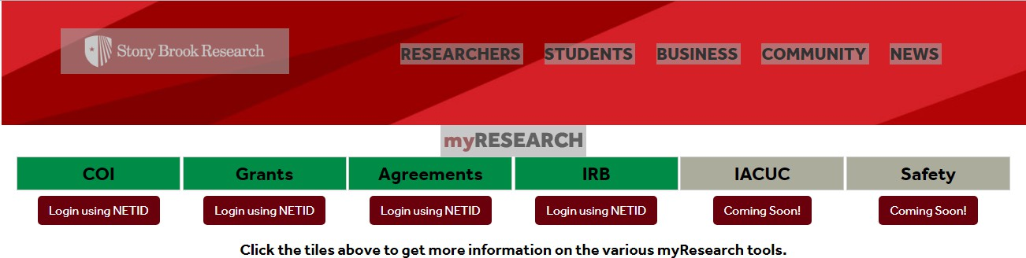

My Inbox IACUC Tab
When you first log into the system, you will see your inbox (My Inbox). From this page, click IACUC from the top menu bar. The tabs available to you on the menu bar are based on the user roles that you have for your account.
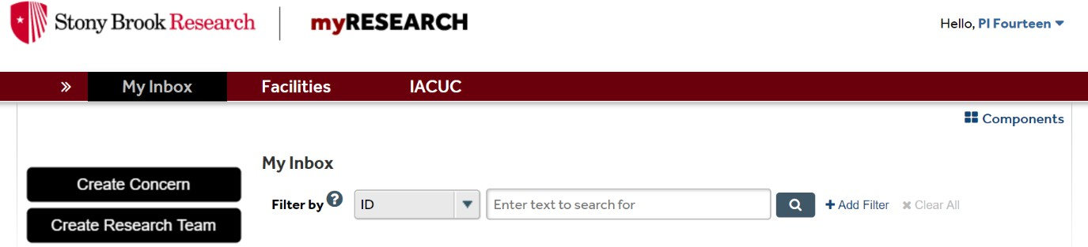

IACUC Main Screen Navigation
On the IACUC page, you can do a variety of functions. You can also search for specific study applications (through the use of the filter). To view details of a particular study application, click on either the ID or the name. Then enter the information in the search box.
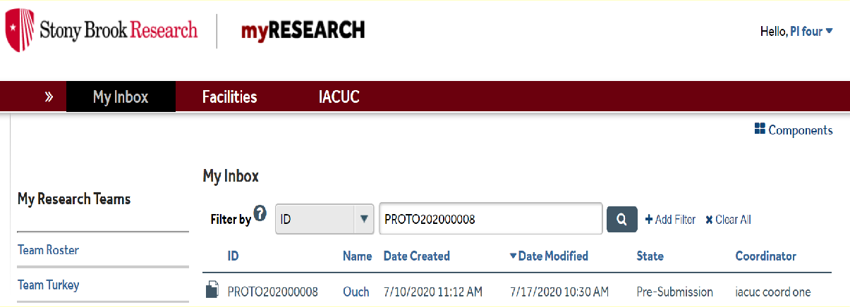

Main Workspace
The Main Workspace page can be subdivided into the left navigation area and the main content area on the right. Within the main workspace, you can view the current state of the application on the left navigation area and the main content area. The left navigation area contains all the buttons and activities that are available to you based on the state of the application.

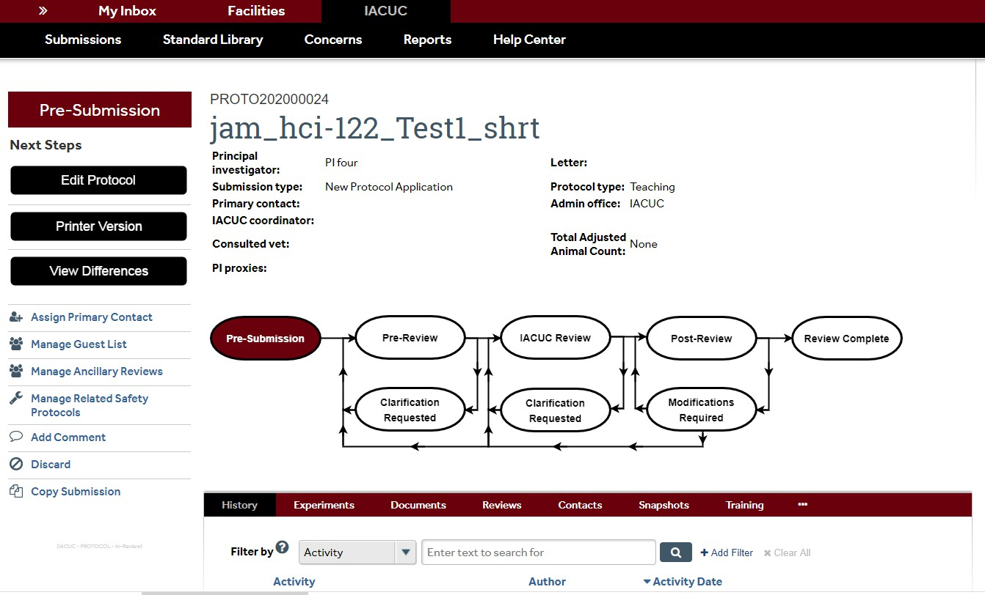

Left Navigation Main Content
Left Navigation
If the application is still in a state where you can edit the application, you can edit the application by clicking on the Edit Protocol button in the left navigation area.
Printer Version will allow you to scroll through the entire application on one page.
View Differences will show you the changes that were made in an amendment versus the information in your original document.

Assign Primary Contact allows you to add an individual to the study that will receive all communications regarding the study in addition to the PI.

PI Proxy can edit the IACUC submission when it is in an editable state and create amendments, annual reviews and triennial reviews. The "PI Proxy" can submit responses back to the IACUC when clarifications are requested. NOTE: If the PI changes the "PI Proxy" on the original

protocol, and there is already an amendment, annual review or triennial review in process, the "PI Proxy" will NOT get changed on the existing amendment, annual review or triennial review.
Manage Guest List allows the study team members to manage who has guest access to the protocol. Individuals identified on the guest list will be able to read all items about the protocol, but will not be able to edit the protocol, submissions, or execute activities.
Manage Ancillary Reviews gives options for the Principal Investigator to submit the application to a specific department of committee.
Manage Related Safety Protocols associates Safety protocols with a specific IACUC submission.

Add Comment allows the user to record a comment in the history log. When you use this option, everyone on the study team and on the IACUC can view the comment.
Discard permanently removes a submission from the review process and sends it to the end state “Discarded”. A discarded submission can no longer be edited or resubmitted to the review process. If the submission is a protocol, it can be copied to start a new protocol submission.
Copy Submission allows you to make an exact copy of the existing application.
Main Content
The right side contains the Main Content. The application title appears towards the left of the Main Content area and the application ID is contained above the application title. A summary box is displayed below the application title. Depending on the application, there is different information that is displayed in the summary box.
The History and Documents tabs always appear for all applications. The History tab contains a chronological log of all of the activities that have happened in the application. It includes the person responsible and the date/time the activity occurred. The Documents tab contains all documents that were uploaded into the application.
The Experiments tab lets you see at a glance which experiments are included in the study. The Reviews tab lets you view all reviews that have occurred for the study.
The Contacts tab lets you view each team members name and email, procedures the team member is allowed to do, occupational health status, and whether the team member can care for the animals. The Contacts tab displays external team member contact and affiliation information, as well as their role on the protocol. The Contacts tab also displays guests who can view the protocol and their contact information.
The Snapshots tab lets you take a picture of the application at any specific moment in time.

The Training tab gives up to date information about the team member’s training and experience data.

Overview of the Application SmartForm
- Each question on the SmartForm is numbered, and the questions that have a red asterisk (*) must be answered.
- A question mark appears beside many of the SmartForm questions. If you click on the question mark, information will appear that will assist you in answering the question.
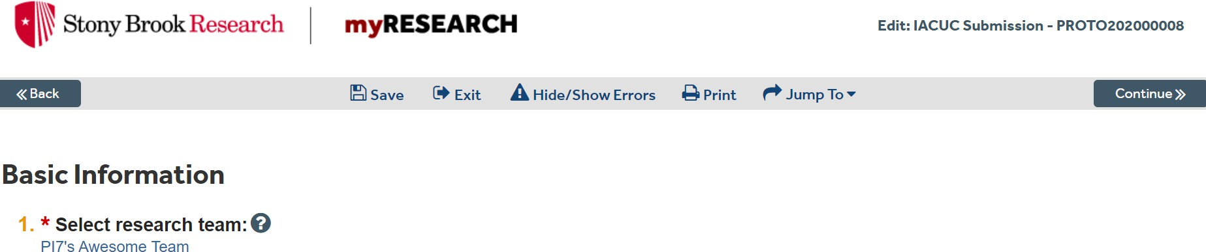

- You can view all of your submissions no matter the state.
  - In-Review: All submissions undergoing IACUC review
  - Active: All approved submissions
  - Archived: All discarded and closed submissions
  - All Submissions: All submissions, in any state
- You can search the system using key words
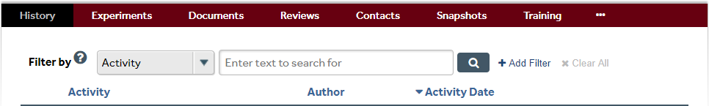
  - From My Inbox, click Submissions.
  - In the Search field, type the search criteria.
    - If you include “And”, the search will find all of the specified words.
    - If you include “Or”, the search will find at least one of the specified words.
    - If you include “No”, the search will exclude the specified word.
    - If you input an “Asterisk” (*) or “Wildcard” character, the search will find part of a word.
    - If you add “Quotation” marks, the search will find the exact phrase.

  - Press “Enter” or click the magnifying glass to perform the search.
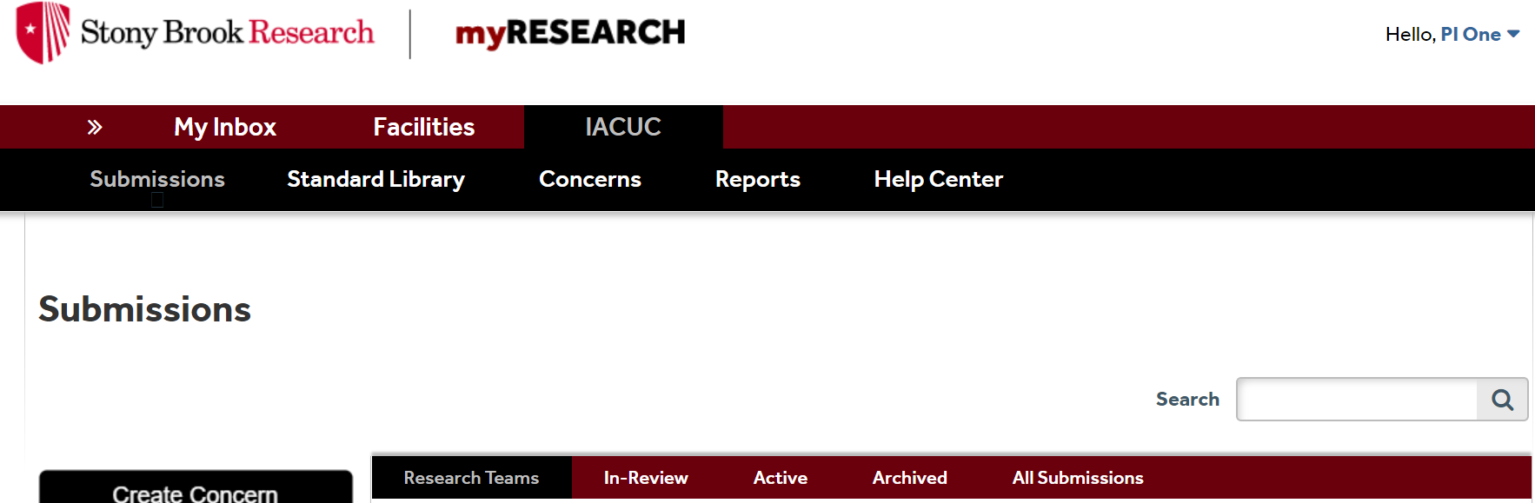
- You can filter to show specific data.
  - Select the column to filter by.
  - Type the beginning characters for the items you want to find.
  - Or type a % symbol as a wildcard before the characters.
  - For operators you can type in the text box, click the Help icon.
  - Click “Go” to apply the filter.
  - To combine multiple filter criteria, click “Add Filter”.
While completing your application, several areas will ask you to attach a related file. Examples are listed below:

Funding Sources: (Funding Sources page)
- Industry Sponsor
- Grant
- Foundation
- Departmental or Internal Funding Source
Animal Justification (Animal Justification page)
- Supporting documents that give justification for use of animals in the research
Supporting Documents (Supporting Documents page)
- Safety data sheets
- Permits
- Genetically Modified Rodent registration forms

A “Jump To” menu item will appear after you save the initial page of the application that will enable you to jump to specific sections of the application.

NOTE: You must complete the application questions in order because the application shows questions/sections based on answers to earlier questions.

When the “Hide/Show Errors” is clicked or when you attempt to submit your study, all of the questions that are unanswered will appear in an “Error/Warning Messages” section. The “Hide/Show Errors” menu item enables you to see if you have any unanswered required questions. For each error message, there is a “Jump To” link that will take you directly to the question which applies to the error message. The application can only be submitted when all issues are fixed.

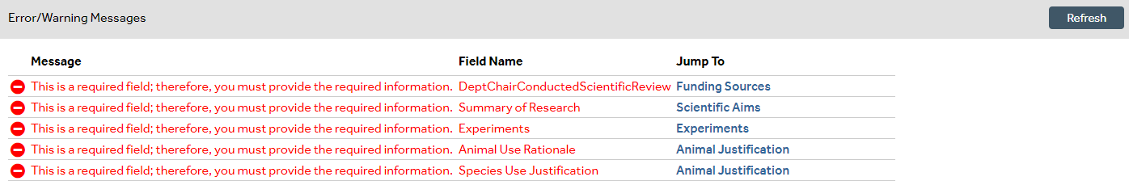
If you need to leave the application for any reason, you can save the document and return to the application at a later time. However, it is important to save each page as you are working, as the system does not “autosave”. If you attempt to exit the SmartForm without saving your responses, you will receive the following prompt:

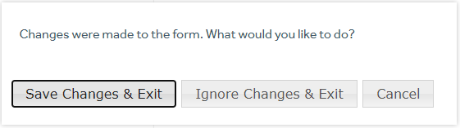

Where are my Research Studies from IRBNet?

The following study information for all active studies will be transferred to myResearch IACUC: IRBNet ID number, study title, and study PI name, study team members, the last day of the annual review period and the last day of the triennial approval period. Study documents from IRBNet will be uploaded into your “shell” prior to your study coming up for review. The number of your “shell” study is the IRBNet ID number

Creating a Research Team
Prior to creating a protocol, you will need to create a “Research Team”. Research Teams make it easy to assign a group of people to a protocol. You can create more than one Research Team. Only one person needs to create the Research Team, but everyone on the team can edit it, as needed. Research Team members can be added or removed as your lab staffing changes.
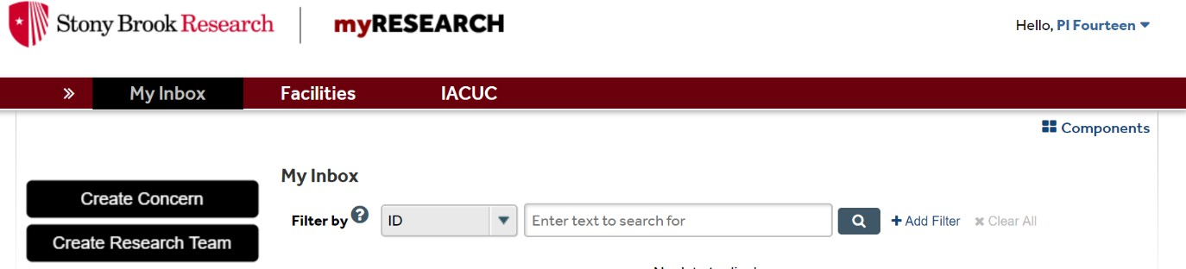
When you first login, you may or may not have a Research Team already created for you. This depends on whether you had a protocol imported from the old system (IRBNet). If you had a protocol imported from IRBNet, you will have to create a new Research Team in myRESEARCH.

- To get started, click on the black “Create Research Team” button on the left-hand side.
- Give your Research Team a name (ex: Rachel’s Team, Brownlee Lab, etc). NOTE: If your study has been imported from IRBNet, you have the ability to change the Research Team name.
- Use the ellipsis to select the appropriate Principal Investigator for that team.
- Click on the “Add” button to add team members.

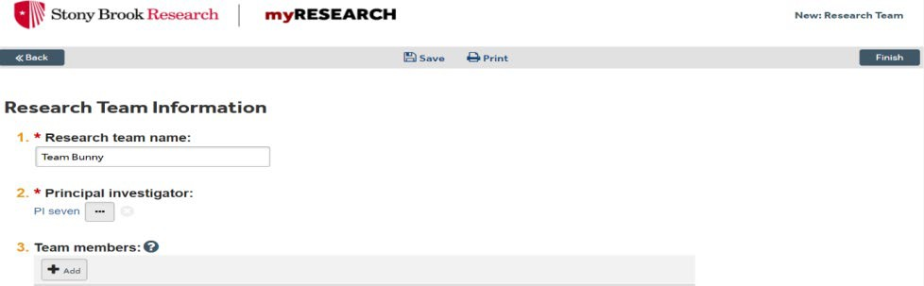
  - Use the ellipsis to select the protocol team member you want to add.
  - Answer the questions about that team member. If you need help with a question, click on the Help Tip icon.
  - To complete adding the team member, click OK in the bottom right corner.
- Select a Team default species (that can be changed anytime).
- Click the Finish button in the bottom right corner when you are done creating your Research Team.
- Next time you log in to myRESEARCH, you will see your Research Teams under “My Research Teams” in the top left corner of the page.
NOTE: To edit the Research Team, click on the “Edit Research Team” button.
NOTE: If you do not create a Research Team correctly, it will not show up on your main “My Inbox” page under “My Research Teams”.

myRESEARCH Protocol – Organization
Substances and Procedures are the “building blocks” of Experiments, which are the building blocks of a Protocol. Therefore, you must create Substances and Procedures before creating Experiments and Protocols. The table below illustrates this idea:

Substance 1 | Substance 2 | Substance 3 | Substance 4
Procedure 1 | Procedure 2 | Procedure 3
Experiment A |  | Experiment B
Protocol

Creating Substances and Procedures
Creating Substances:
Creating Substances is the first step toward creating a protocol. Substances will be used in
Procedures, which are the “building blocks” of Experiments within a Protocol.
- Click on the red “My Inbox” button on the top left-hand side, then your “Research Team” name in blue.
- Click on the black “Create Substance” tab on the left hand side of the main page.

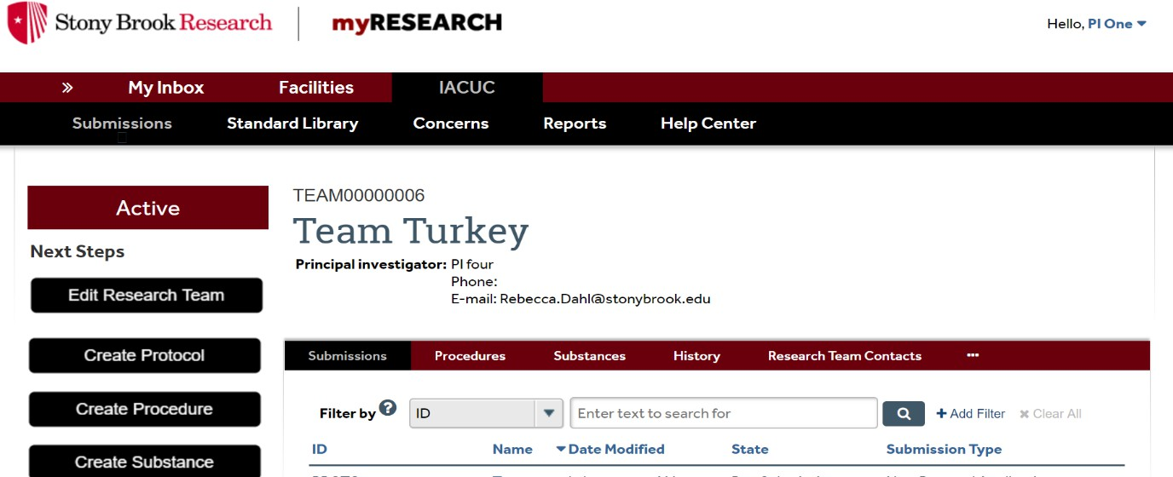
- To view substances that are already in the system, click on “Standard Library” in the main bar of the History page, and then click Substances. Or, you can click on the Substances button on the red bar in the middle of the History page.

a) Substances labeled as “Standard” (far right column) are those that have already been built into the system and can be used as is, or changed as needed.
- Search for the Substance you will be using by name to see if the Substance exists within the standard library.
- If you cannot locate the Substance, you will need to create a Substance. Return to “My Inbox” by clicking the top left button, then click on your “Research Team” name.
  - Click on the black “Create Substance” button on the left hand side.
    - Name your substance.
    - Select what type of substance it is by selecting all that apply.
    - Answer any remaining applicable questions.
  - Select the blue “Finish” button in the bottom right corner.
  - Your new substance will be located under the Substances tab on the Research Team’s page.
  - This Substance is specific to your team and only your team can view/edit/utilize it.
    - You can edit the substance by clicking on the substance name.
    - Click on the black “Edit Substances” button on the left hand side.
Creating Procedures:
Procedures must be created before you can put them together as experiments within a protocol. This will make it easier for you to add procedures that are common to multiple experiments and/or protocols.
- Click on the red “My Inbox” button on the top left-hand side, then your Research Team’s name in blue.

- Click on the red procedures tab in the middle of the page. Note that there are already several procedures within the system known as “Standard” procedures. To find a procedure, simply search for it by name. If you are unable to find a procedure within the “Standard” procedures, you will need to create it yourself.
- To create a procedure, click on the black “Create Procedure” tab on the left hand side of the page.
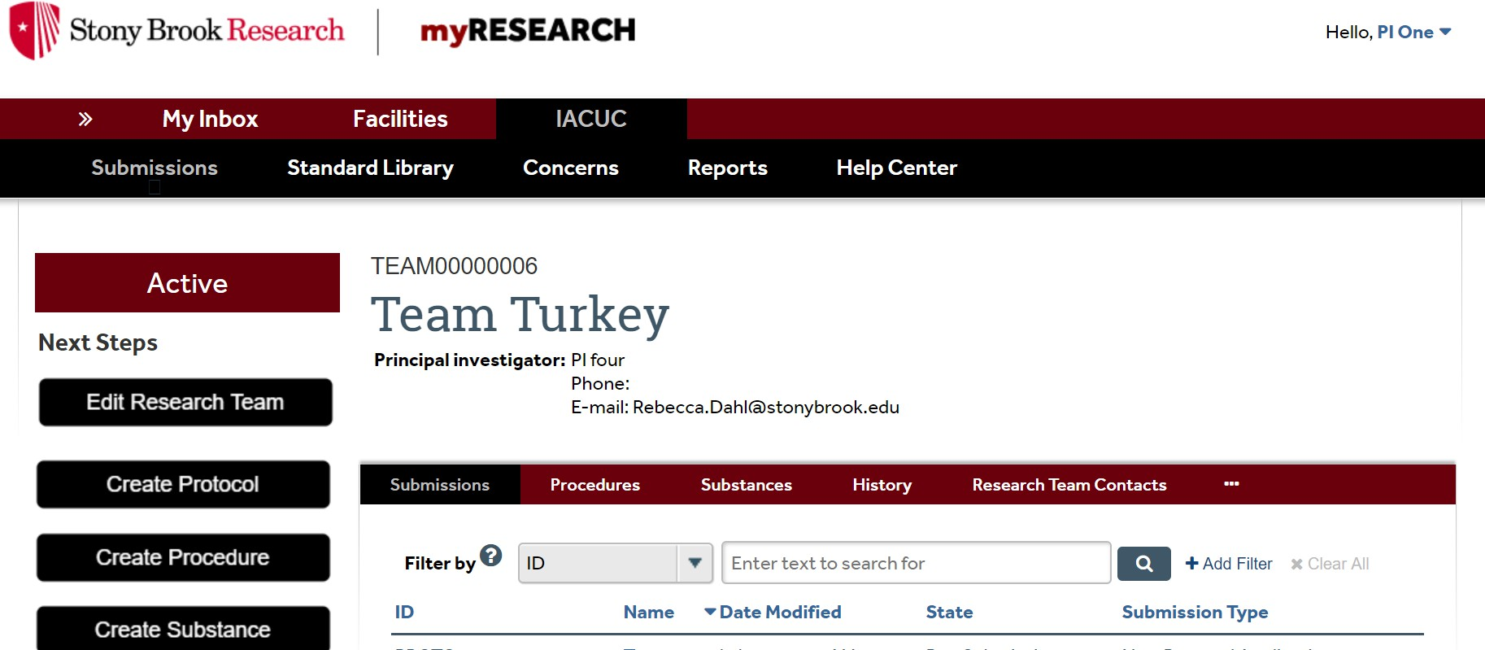

  - Name the procedure you would like to create.
  - Select the procedure type. This is a crucial step, as your selection will determine what questions are asked in the following pages.
  - Select the species to this procedure will apply. You may only select 1 species.
  - Complete any remaining applicable questions, and then click the “Continue” button in the bottom right corner.
  - Complete the questions about your procedure. If at any point you need help with a question, simply click on the help tip (the “?” symbol). Then click the “Continue” button.
  - You will have the opportunity to upload any supporting documents you feel are necessary for this procedure.
  - When you are done, simply click the “Finish” button in the bottom right corner to complete your procedure.
  - Your new procedure will now be listed under the “Procedures” tab in your research team’s page. NOTE: Only your team will have access to this procedure.
- To edit a procedure, simply click on it, and then click on the black “Edit Procedure” button on the left-hand side. This also gives you access to copy a procedure, or archive a procedure (which is equivalent to deleting a procedure).
- To save time, many of the “Standard” procedures may be customized for your needs.
  - Simply search for the procedure by name.
  - Click on the procedure most closely related to what you need.

  - Then select the blue “Copy Procedure” option on the left-hand side. For more information about “Copy Procedure” option, please watch the training video - 2.49
at https://www.youtube.com/watch?v=xjMlSHJyavQ
  - Name the copied procedures.
  - Select your research team.
  - Click OK in the bottom right corner.
  - You will now find the copied procedures under the History tab of the “Standard”
procedure.
    - To customize your copied procedure, click on the black “Edit Procedure” button on the left-hand side. Verify all other information before clicking “Continue”.
    - To customize the substances administered, click the “Update” button on the left-hand side. Make changes as needed.
    - Answer all other applicable questions, and click OK.
    - Verify that all the other information in the procedure is customized to your needs.
    - When you have completed all the necessary questions, click the “Continue” button.
    - Add any supporting documents you may need.
    - Click the “Finish” button. You will find your customized copied procedure under the “Procedures” tab of your research team’s page. NOTE: Only your research team will have access to this copied customized procedure.

Creating a Protocol
All Research Teams, Substances, and Procedures must be made PRIOR to creating your Protocol. From the main page, click on the black “Create Protocol” button on the left hand side. Remember to click “Save” as you are completing each page.

- Start by clicking on the black “Create Protocol” button on the left hand side.
- Complete the basic information in the subsequent pages, as needed, utilizing the blue “Continue” button in the bottom right.

- Select the intention of your animal use protocol. This selection will determine the questions you will be asked in subsequent pages.
  - When you are done with the basic information, click the “Continue” button. There are several pages of questions which must be answered before you can continue.
- When you get to the experiments page, click the “Add” button to create your experiments.
  - Each experiment will automatically fill in with your team’s default species.
  - Check to make sure the correct species is inserted, and then complete the remaining information.
  - Select the procedures you will be using in this experiment using the ellipsis (you will only be able to select procedures that use the species chosen in this experiment).
  - Click the “OK” button.
  - Complete any remaining information about this experiment.
  - Determine the total number of animals that will be used in the experiment.
    - Indicate the pain category that corresponds to the animals in this experiment. (These pain categories differ from the categories in IRBNet.)
  - If you plan to breed animals on the protocol, you must add a breeding experiment to your protocol to describe your breeding methods.
NOTE: Selecting a breeding experiment will give you access to a breeding chart.
    - Fill out the breeding information for each strain or line you plan to breed.
    - Click on the “OK” button.
NOTE: The total number of animals across strains and lines will automatically be calculated for you.
    - Transcribe this number into the total number of animals you will be using for this experiment.
    - Breeding animals will automatically fall under pain category “B”.
    - Complete any remaining information for this experiment and click “Ok”.
  - Once you have added all of the experiments to your protocol, click the “Continue” button. You will have several more pages to complete. When you get to the animal justification page, you will be asked to adjust the number of animals used in your protocol.
  - Animal numbers are automatically imported from the experiments page. This means that animals that are used in both breeding, as well as animals used in other experiments, may be counted twice.
    - To adjust your animal numbers, click on the pen icon on the right hand side.
    - Explain why you adjusted the number of animals used.
  - Complete the remaining pages of your protocol. Upload any supporting documents under the “Supporting Documents” area (e.g. safety data sheets, permits, genetically modified rodent registration forms, etc).
  - When you are complete, click on the “Finish” button. NOTE: clicking the “Finish” button does not submit your protocol. To submit the protocol, you must click on the “Submit” button.
  - Make sure to assign your Department Chair as Ancillary Reviewer before submission.
    - Do this by clicking on “Manage Ancillary Reviews” on the left hand side of the screen on the History page.
    - Select your Department Chair by clicking on the “Add” button.

    - Be sure to select that a response is required. Then click “OK”.
  - The protocol is now ready to be submitted.
  - Once the “Submit” button is pressed, the system automatically analyzes your application for any errors. You must navigate to those pages and correct those errors before the system will actually allow you to submit.
- To submit your protocol, return to “My Inbox” and click on the protocol name in the center of the page.
  - On the left side is a blue “Submit” button. Click this and an error check will be run to determine if your protocol is complete.
  - If complete, click the blue “OK” in the bottom right to submit.

Ancillary Reviews
Once you have completed the application, you will reach the “Attestation” page. Read the information on the “Attestation” page carefully to ensure that the ancillary review is requested. NOTE: New studies, renewals, and amendments require that you share the study with the Department Chair PRIOR to submission.
- The PI’s Department Chair or designee can be selected as an ancillary reviewer by using the “Manage Ancillary Reviews” option on the left hand side.
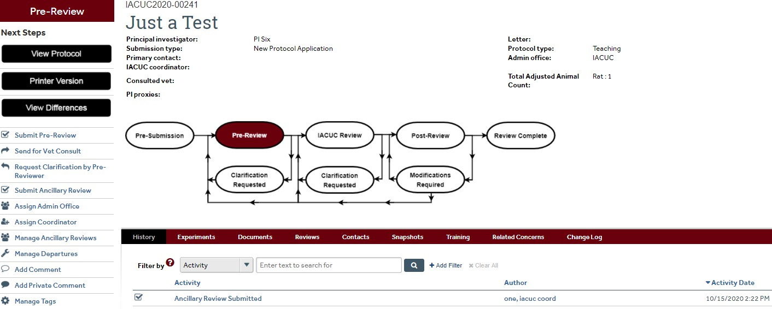
- Once you click “Submit”, the Department Chair will receive an email notification with a link stating that they must submit ancillary review. When they click on the link, they will be taken to the main workspace of the submission, and can click “Submit Ancillary Review” on the left hand side.

Creating an Amendment
Please see the following information on what to do when submitting different types of amendments for a study that was migrated from IRBNet to myResearch:

For changes that can be reviewed/approved administratively (i.e. personnel additions, grant additions, etc):

- Email the Amendment Form from IRBNet to Jamie Fuellbier, IACUC Coordinator at Jamie.fuellbier@stonybrook.edu.
- IACUC Coordinator will review it.
- IACUC Coordinator will upload the Amendment Form to the study shell in myResearch, and add a comment stating that it is approved.

For MINOR amendments that require Designated Member Review:
- Email the Amendment Form from IRBNet to Jamie Fuellbier, IACUC Coordinator at Jamie.fuellbier@stonybrook.edu.
- IACUC Coordinator uploads the Amendment Form to the study's "shell" and has the Designated Member Reviewers review the amendment.
- IACUC Coordinator adds a comment with the reviewers' determination (i.e. approval, modifications required, etc).

For MAJOR amendments that require Full Committee Review:
You must first find the “shell” for that study. Follow steps 1 through 4 to find the shell.
  - When you login to myResearch, click on “IACUC”.
  - Click on “All Submissions”.
  - Make sure the filter is set on ID and type in the IRBNet study number (i.e. 1122334, 157632, etc).
  - You should see your study number listed. Click on the study. If you do not see your study listed, email Jamie Fuellbier (IACUC Coordinator).
  - Click "Create Amendment".
  - Complete each page.
  - When you reach the last page, click "Finish".
  - Then click "Submit".
  - The Full Committee reviews the amendment at the meeting.
  - The amendment receives a determination at the meeting.
  - You will be notified regarding the Committee’s determination.
To create an amendment for a study that was submitted/approved in myResearch, follow these steps. If an amendment is already in review, wait until the first amendment is processed.
- Go to “My Inbox” and click the Research Team on the left hand side.
- Select the name of the approved protocol.
- Click the “Create Amendment” button on the left hand side.

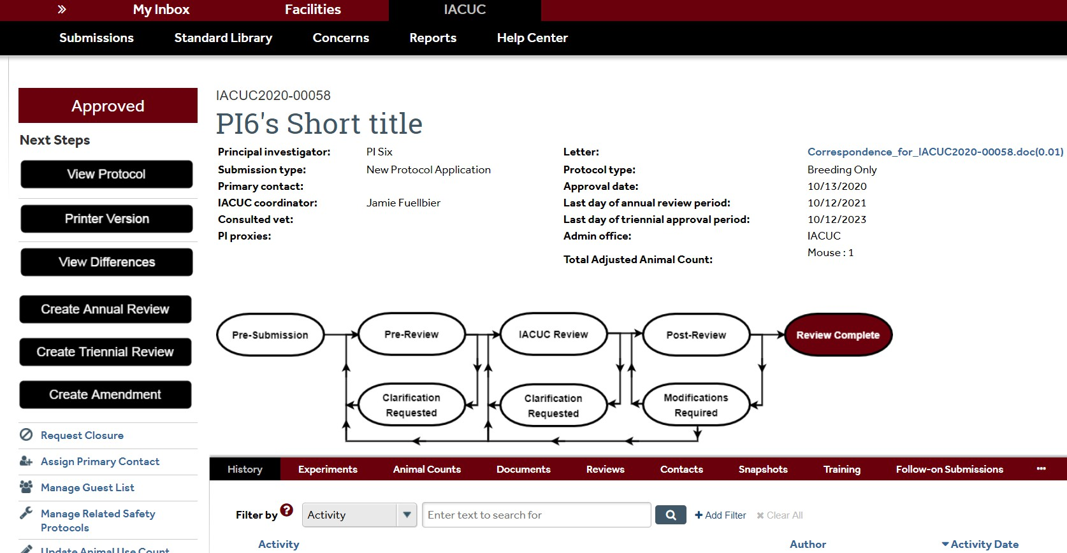

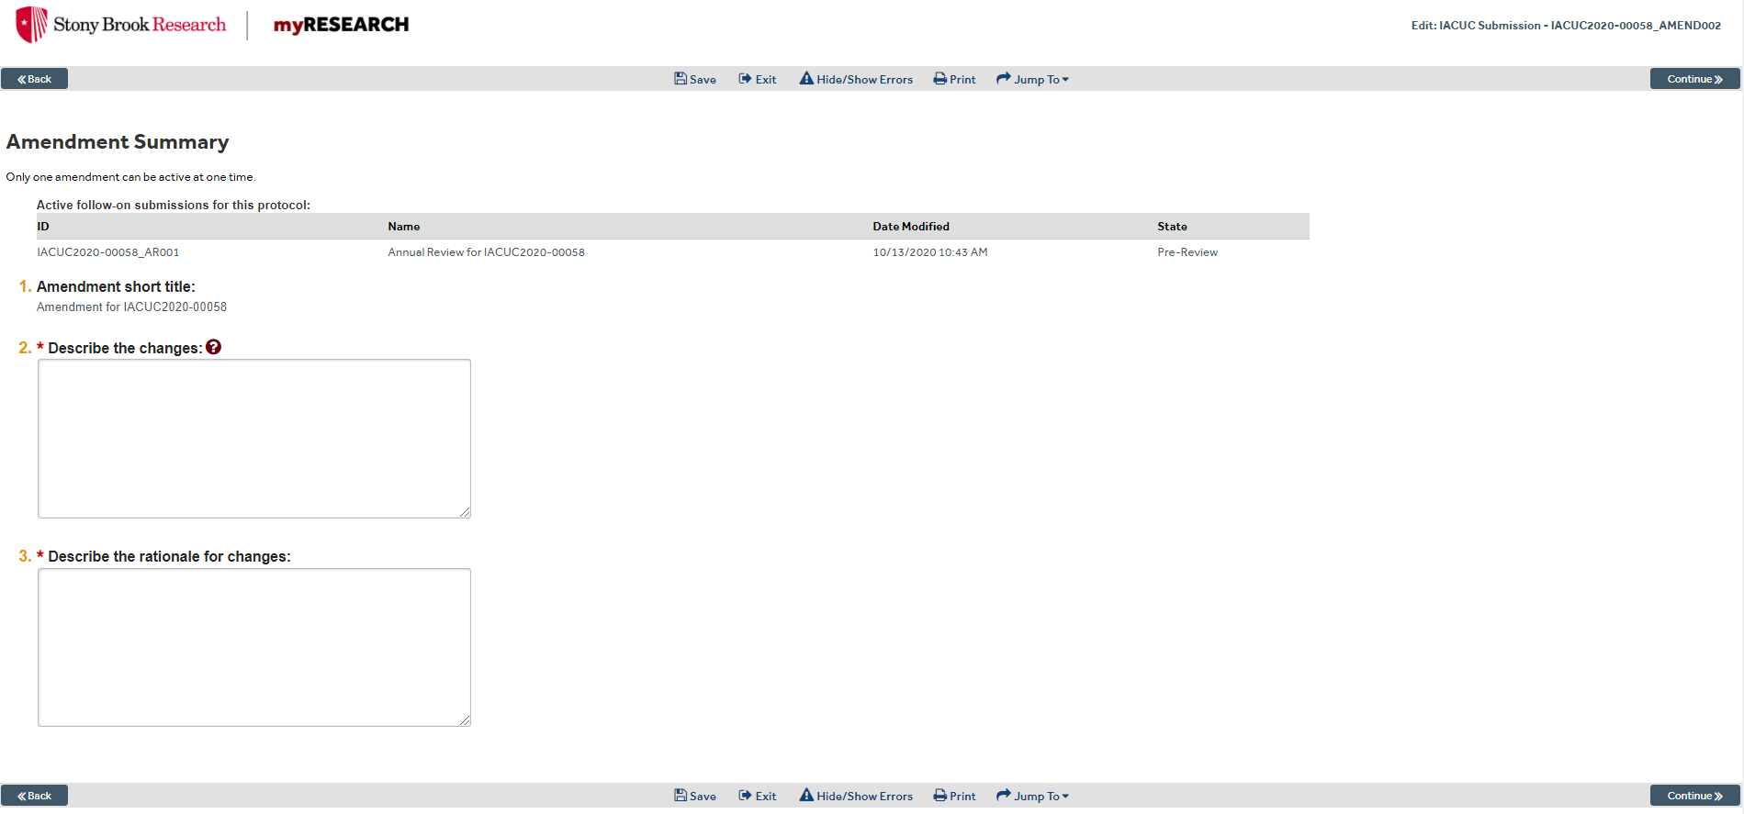
- Complete the first page, which is the Amendment Summary page. Then click “Continue”.

- This brings you to the Basic Information page. From here, you can keep clicking “Continue” to go through each page and edit as applicable to your amendment. You can also use the “Jump To” option above to jump to the specific page.

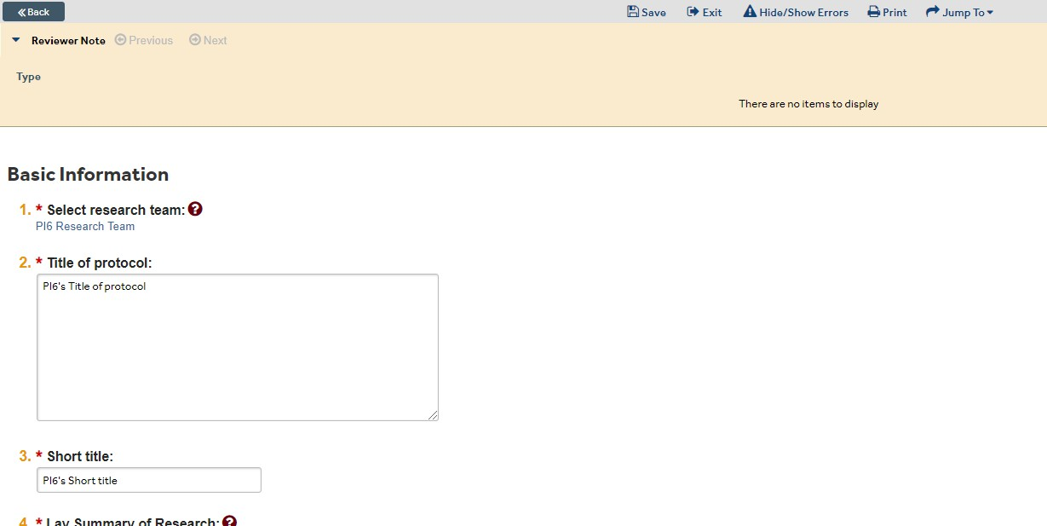
- When done, click “Finish” on the last page. This will bring you to the main workspace.
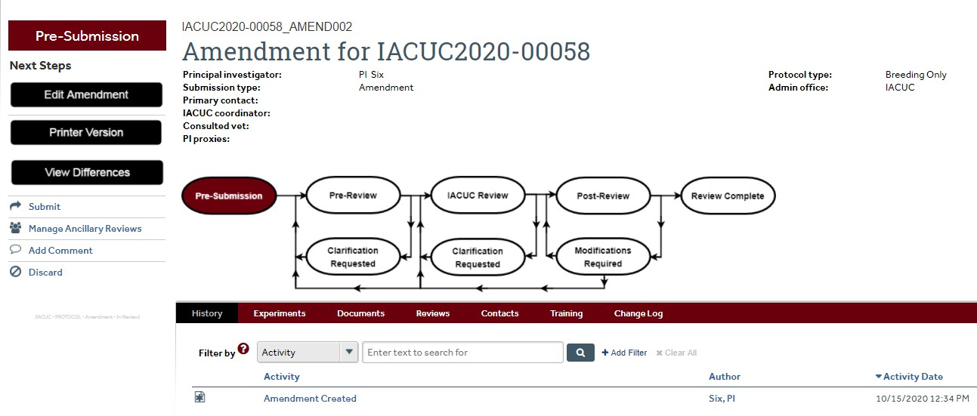
- Click “Submit” on the left hand side. NOTE: Once you click “Submit”, you can no longer edit the amendment.

- Click “OK” to agree to the statement and submit it for review.
- Your Amendment has successfully been submitted, and is now in the “Pre-Review” state.

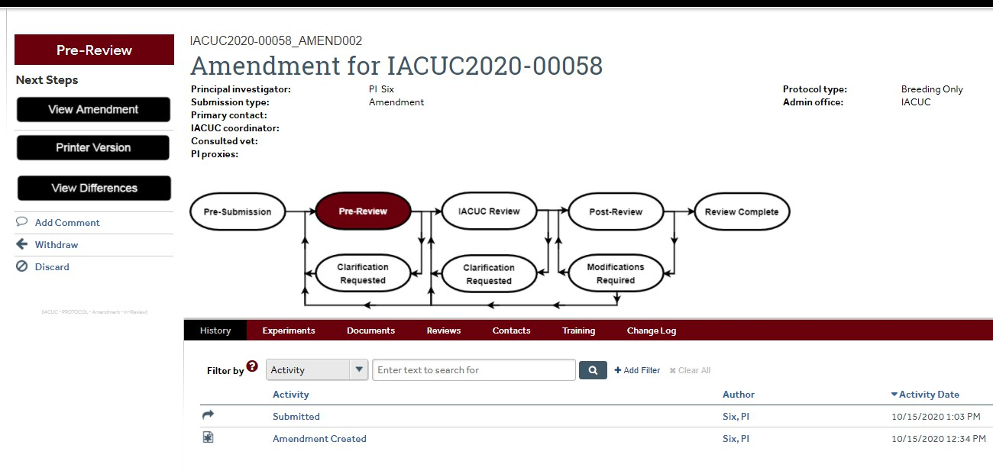

Creating an Annual or Triennial Review
NOTE: If this is the first time you are renewing a study that was migrated from IRBNet to myRESEARCH, you must first find the “shell” for that study. To find the “shell”:
- When you login to myRESEARCH, click on “IACUC”.
- Click on “All Submissions”.
- Make sure the filter is set on ID and type in the IRBNet study number (i.e. 1122334, 157632, etc).
- You should see your study number listed. Click on the study number, and you will see the option to create an annual or triennial review. If you do not see your study listed, email Jamie Fuellbier (IACUC Coordinator) at Jamie.fuellbier@stonybrook.edu.
NOTE: If you are renewing a study that has already been approved in myRESEARCH, you can find the study by going to your “My Inbox”, or by searching for the study following the same steps as above.
Creating an Annual Review:
Once you have clicked on either your “shell” or your already approved study, follow these steps:
- Click “Create Annual Review” on the left hand side.

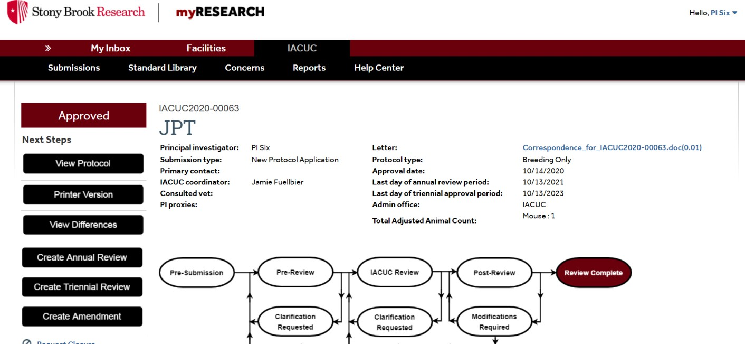
- You will see an introduction page with some helpful information. When you are ready to move on, click “Continue” in the bottom right corner.
- If no activity has occurred on your study, click “No”. You can add any supporting documents if needed. Then click “Finish” in the bottom right corner. If there has been activity, click “Yes”. You will then be prompted to answer additional questions, as well as the ability to add any supporting documents.
- Click “Finish”, which will bring you back to the main workspace.
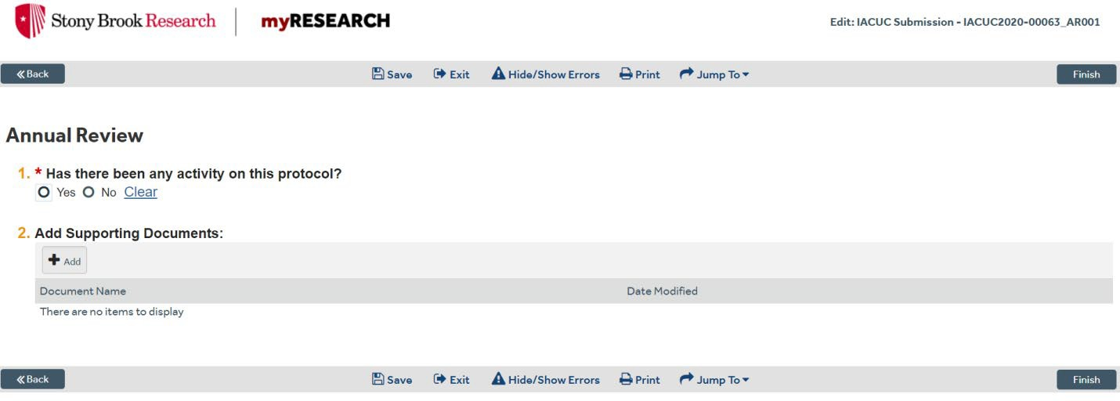

5. Click “Manage Ancillary Reviews“ on the left hand side.

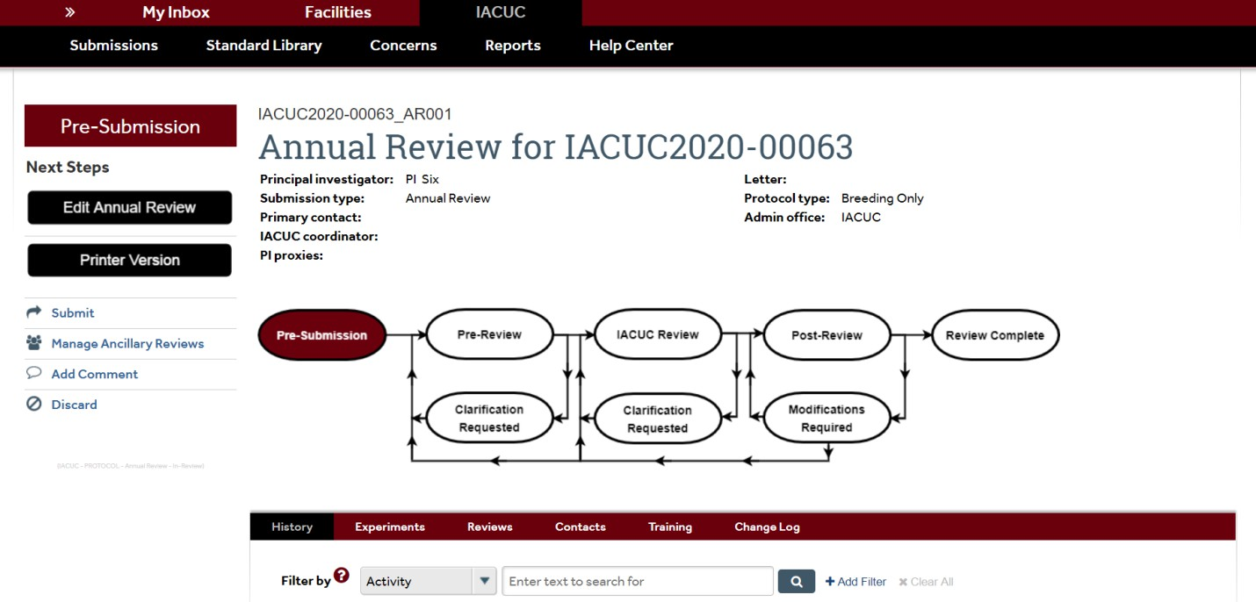
- Click “Add”.
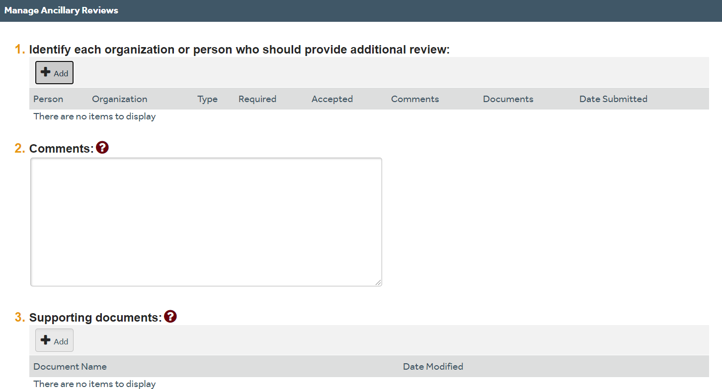
- Select a person (not an organization) by clicking on the ellipsis. You will then be able to search for your Department Chair by name.
- Select “Review Type” by using the drop down arrow. You will notice that “Department Chair” is the only option.
- When asked if a response is required, always select “Yes”.
- Click “OK”, and then click “OK” again.

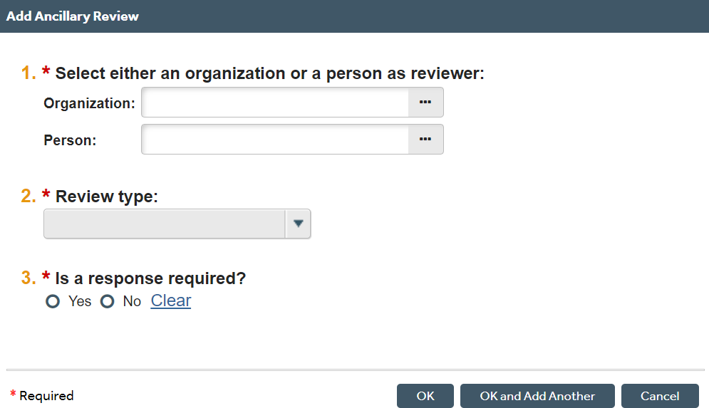

- Click “Submit” on the left hand side, and then click “OK”.
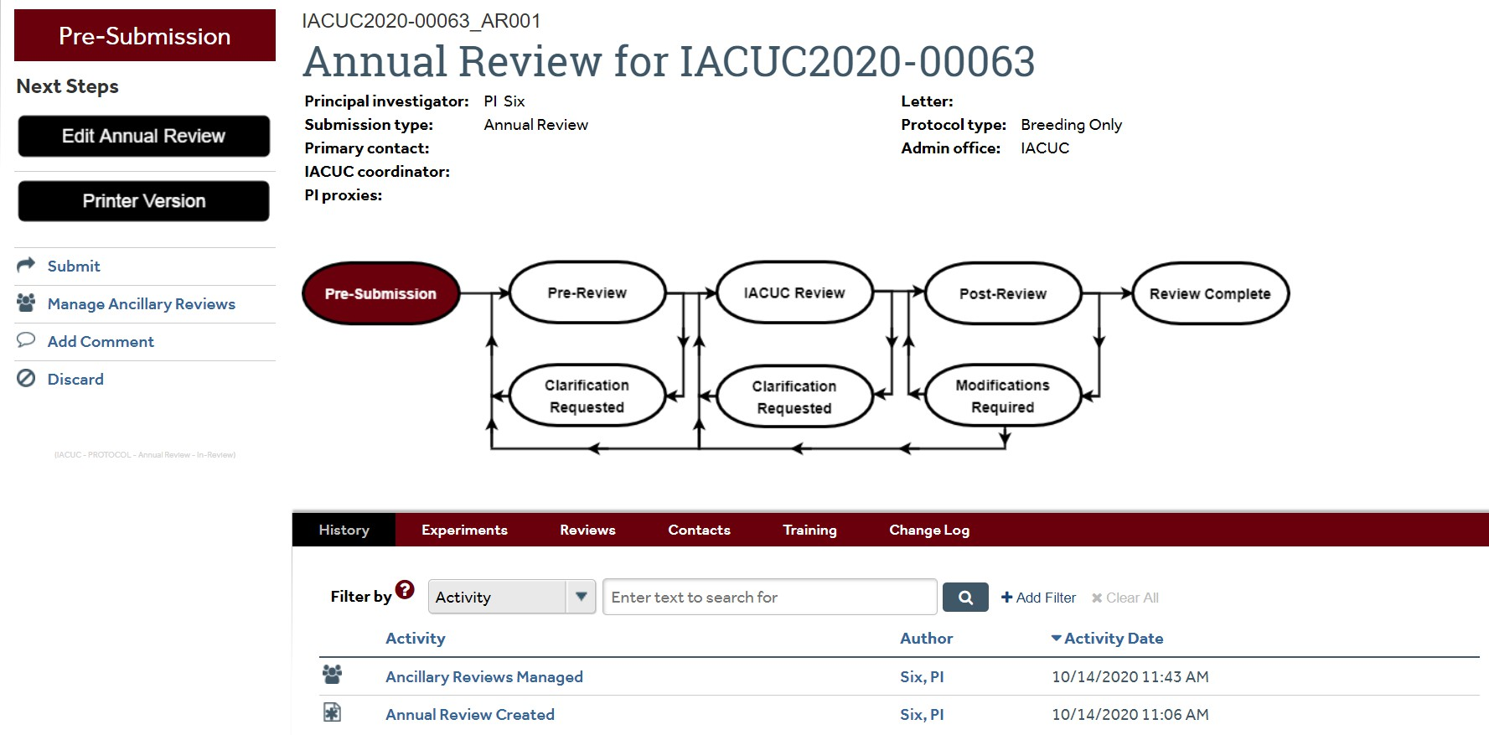

- Your Annual Review has successfully been submitted, and is now in the “Pre-Review” state.

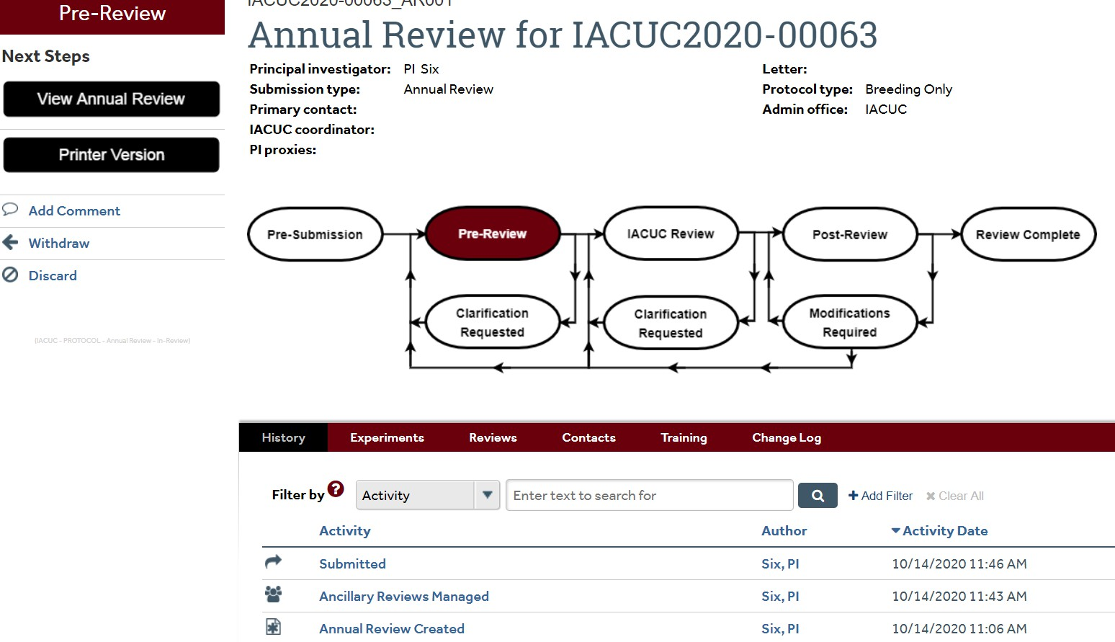

Creating a Triennial Review:
Once you have clicked on either your “shell” or your already approved study, follow these steps:
- Click “Create Triennial Review” on the left hand side.
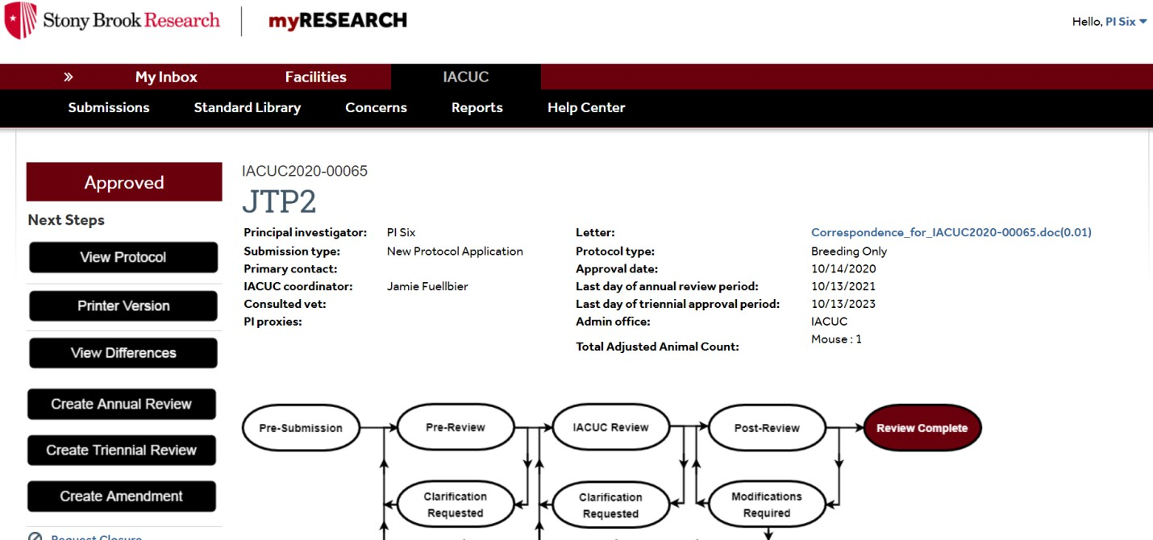
- You will see an introduction page with some helpful information. When you are ready to move on, click “Continue” in the bottom right corner.

- If no activity has occurred on your study, click “No”. You can add any supporting documents if needed. Then click “Continue” in the bottom right corner. If there has been activity, click “Yes”. You will then be prompted to answer additional questions, as well as the ability to add any supporting documents. Then click “Continue”.
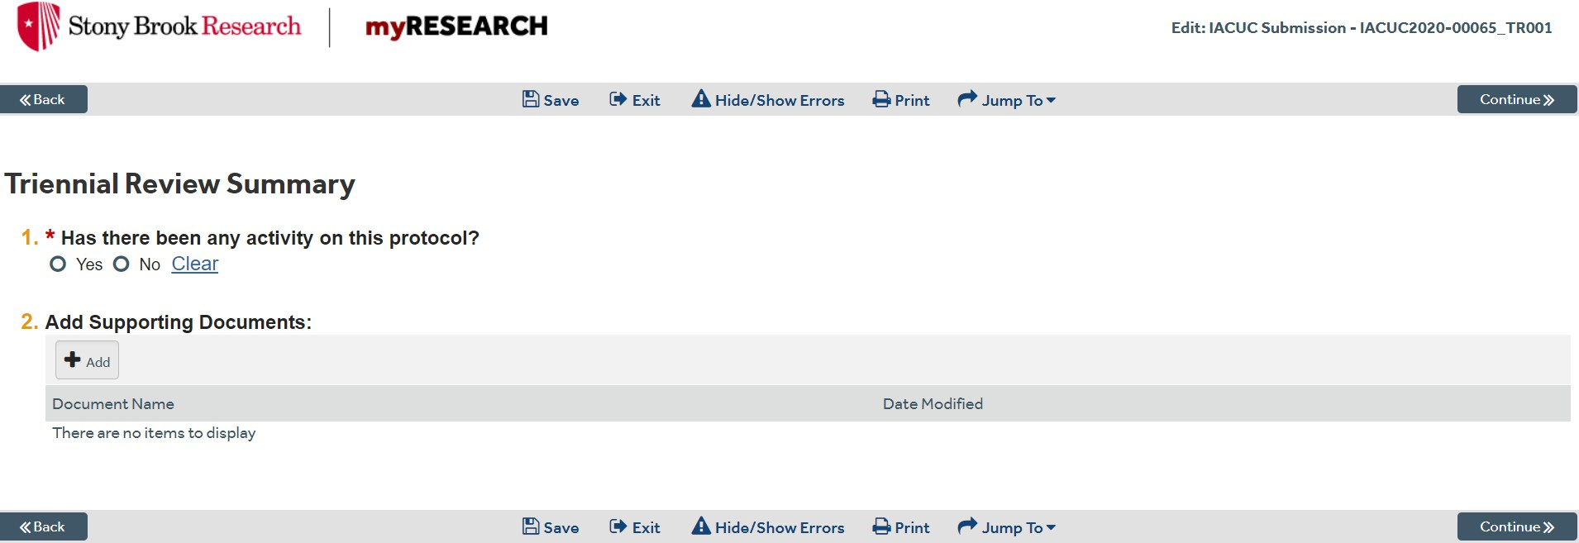

- You will then be taken to the “Basic Information” page.
NOTE: If this is the first time you are renewing a study that was migrated from IRBNet to myRESEARCH, you will need to answer the questions throughout the application. For studies that have already been approved in myRESEARCH, you will notice that questions throughout the application will already contain the information from the last approval.
- Click “Continue” as you complete each page.
- When you have made it to the last page of the application, click “Finish”. This will bring you back to the main workspace.
- Click “Manage Ancillary Reviews” on the left-hand side.
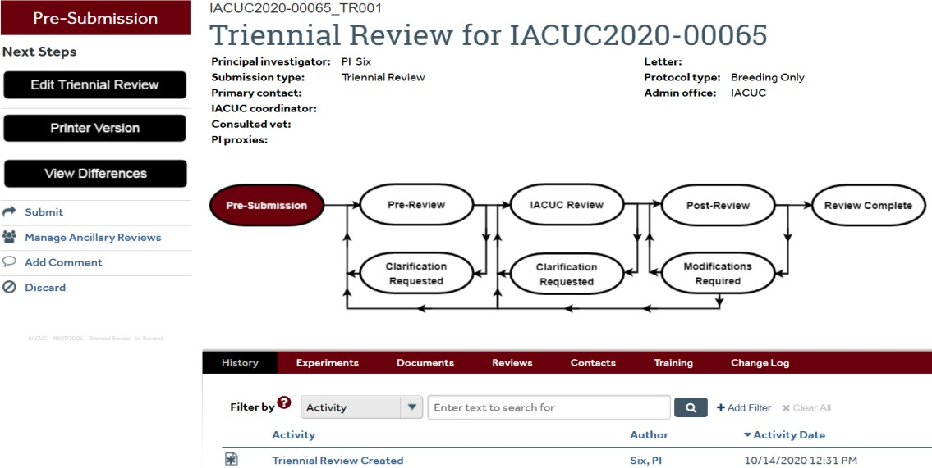
- Click “Add”.

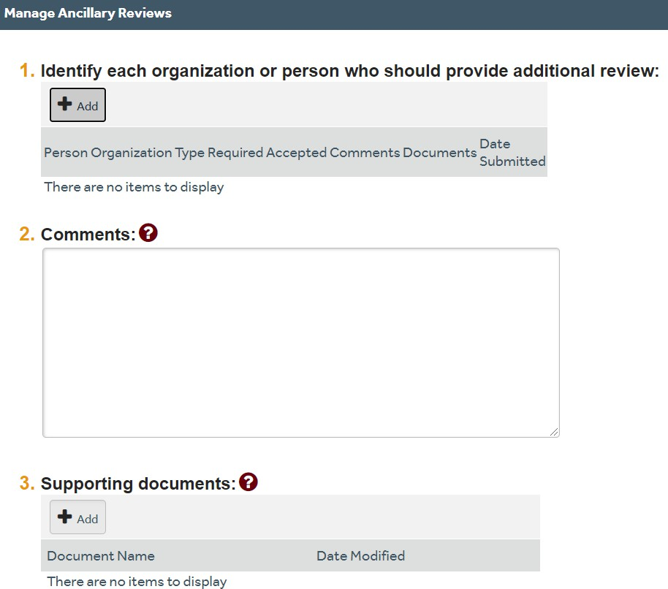

- Select a person (not an organization) by clicking the ellipsis. You will then be able to search for your Department Chair by name.
- Select “Review Type” by using the drop down arrow. You will notice that “Department Chair” is the only option.
- When asked if a response is required, always select “Yes”.
- Click “OK”, and then click “OK” again.

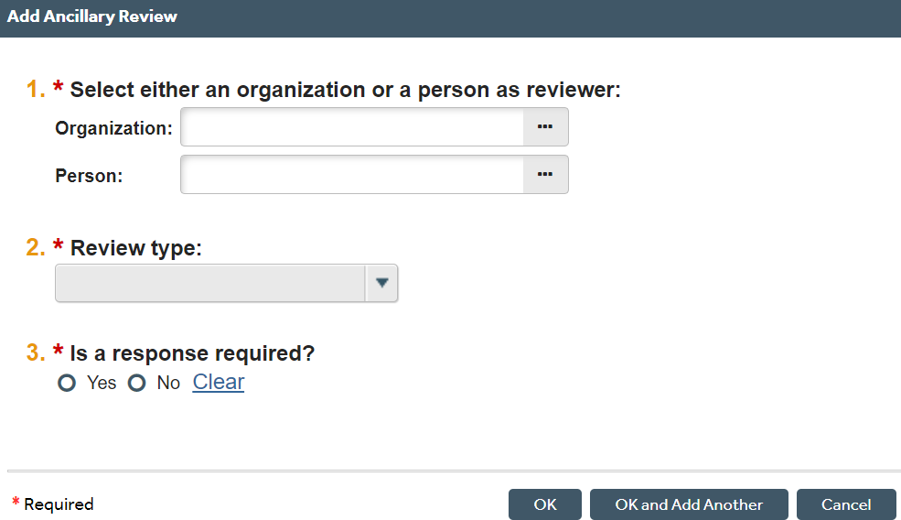

- Click “Submit” on the left hand side, and then click “OK”.

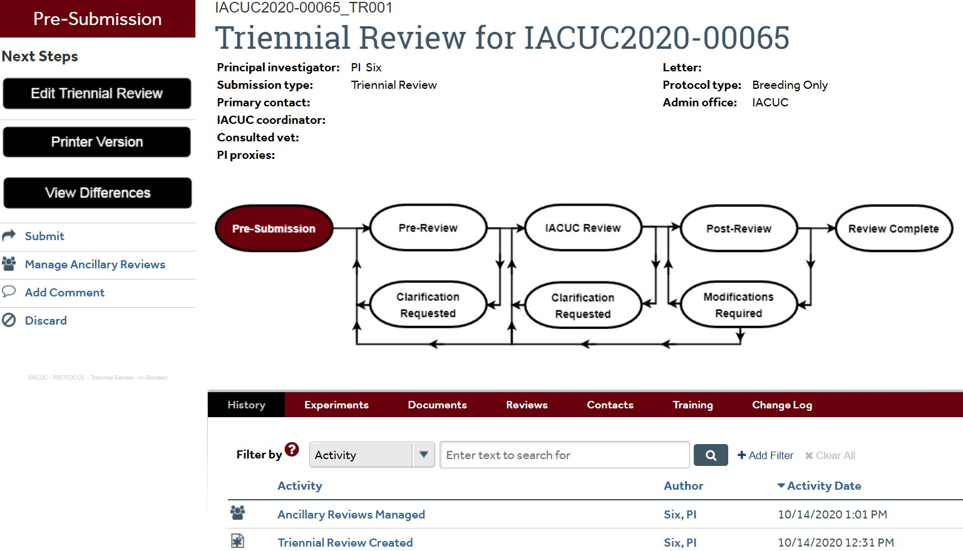

- Your Triennial Review has successfully been submitted, and is now in the “Pre-Review” state.

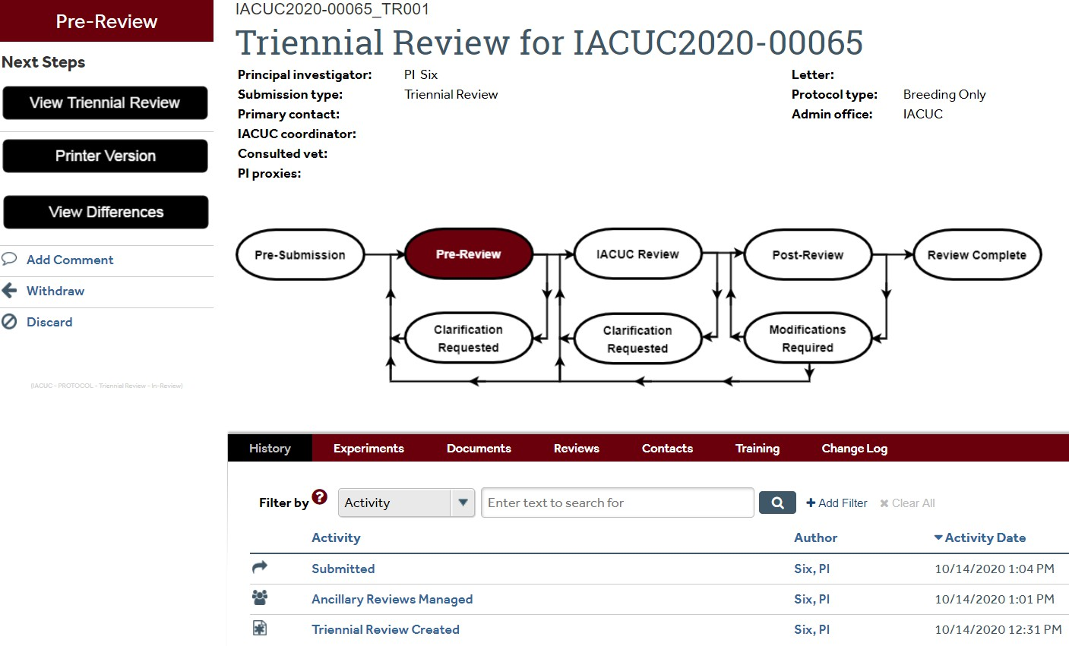

Responding to Reviewer Notes or Modifications
You will receive an email notification if a response to Reviewer Notes or Modifications are required to secure approval of your submission.
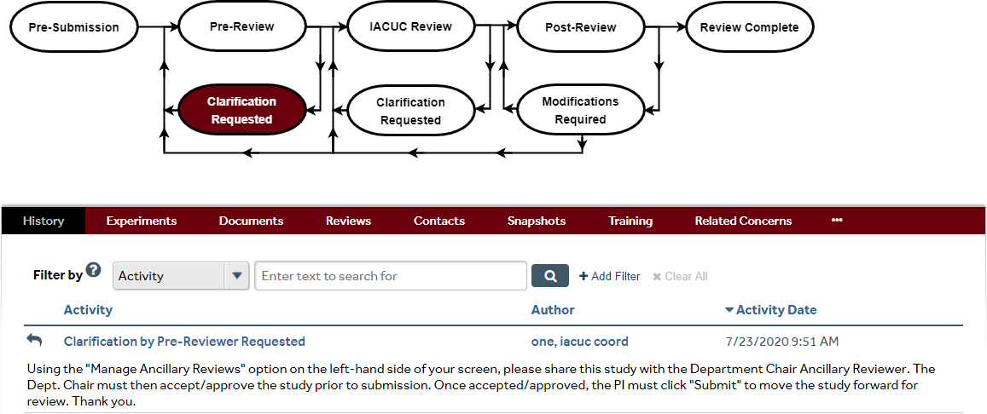

  - Click the email link to open the submission. If you no longer have the email, open the study in “My Inbox”.
    - Click on the protocol in “My Inbox” to get started. You will see that modifications are required.

    - Navigate to the “Reviewer Notes” tab on the protocol page. Here you will see all of the reviewer notes on your protocol. If you need to make adjustments to the protocol itself, use the convenient link to go directly to that page of the protocol.
    - If a response to the reviewer note is required, you need to click on “Click here to respond…” and explain your response in the box.
    - If you are on a protocol page, exit the protocol when done.
    - You can now log off the system (top right button).
  - If there are no “Reviewer Notes”, go to “Submit Response”.
    - On the protocol workspace, click “Submit Response”.
    - In the “Comments” box, explain your response to the reviewer.
    - Click “OK”.
    - You can now log off the system.

