




Pivot Snippet
How to Create a Funding Opportunity Search

What is PIVOT?
The Office of the Vice President for Research subscribes to Pivot, which is a web-based discovery and workflow tool that combines a comprehensive source of global funding opportunities with the largest collection of scholar profiles into one intuitive solution.

With Pivot, faculty, research administrators, postdocs, and graduate students can easily explore new avenues for funding, view funding opportunities uniquely matched to their scholar profile, collaborate with colleagues, and build a funding strategy that supports both immediate and long-term funding needs.

For more information or assistance with building your profile or searches, please contact OPD at OPD_OVPR@stonybrook.edu.

Benefits of Creating a Funding Opportunities Search
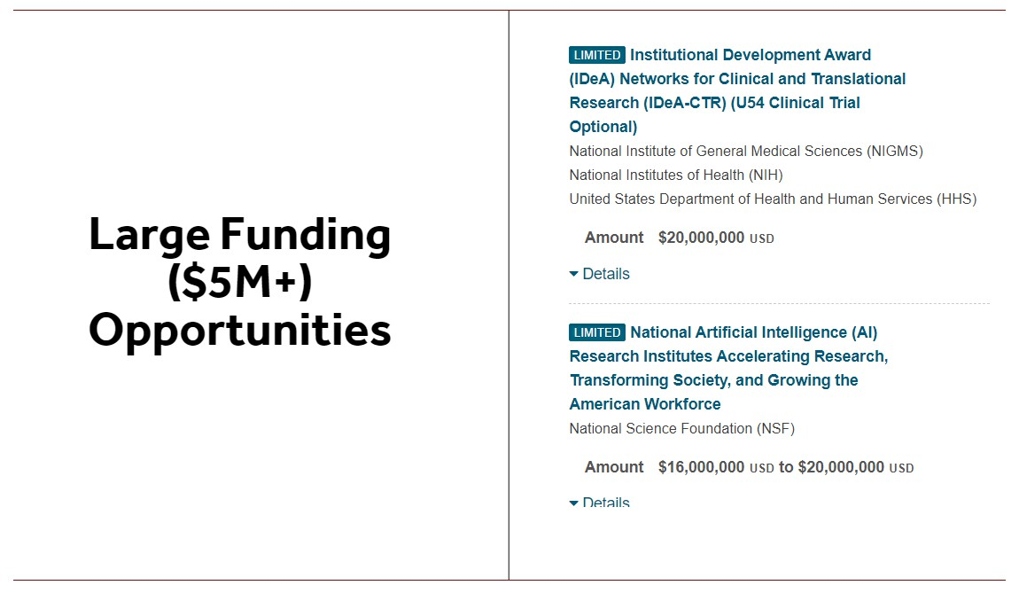
- Automatic Results - Receive weekly email notifications after setting up a saved search
- OPD uses saved searches for:
  - Limited Competitions
  - Helping faculty find funding
  - Priority research areas - embedded searches on OPD website

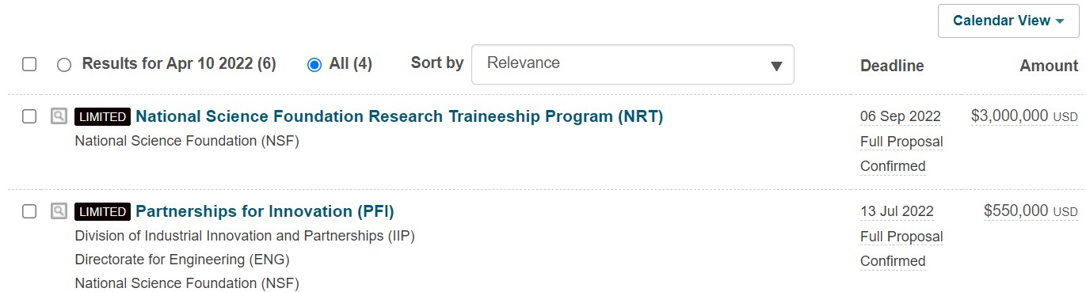

Home Page
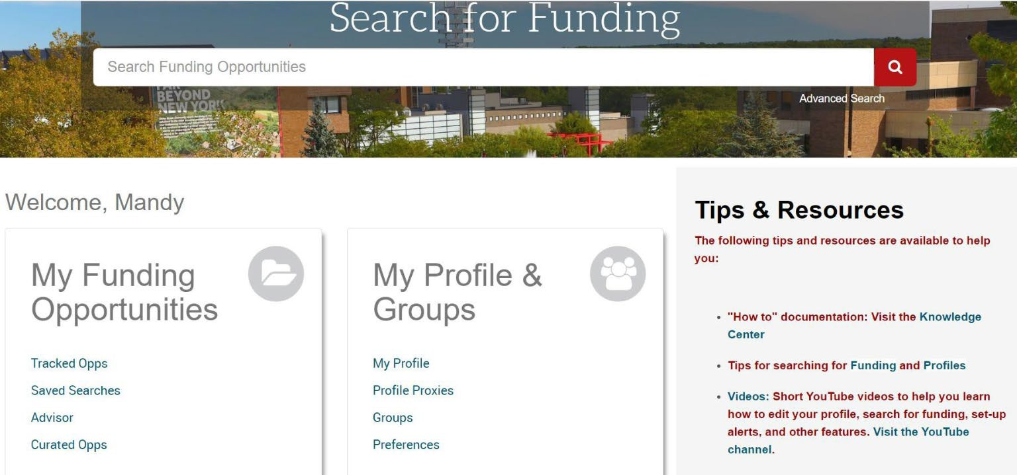

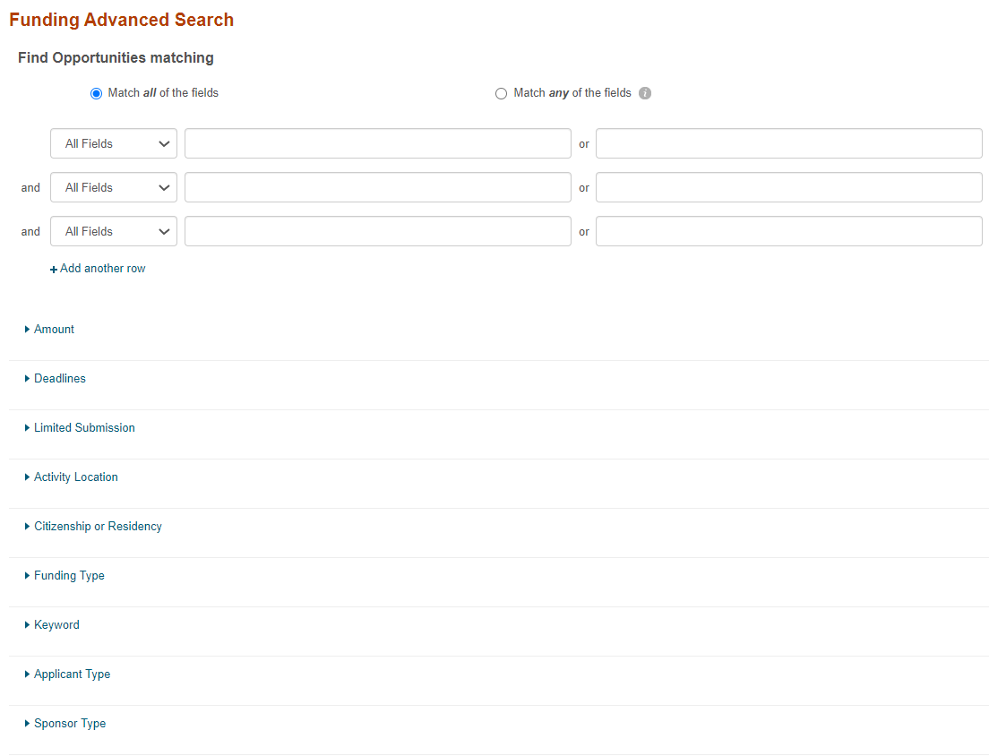
Advanced Funding Opportunities Search

Any web searchable word

Specify any/all for the narrowest search parameters

*Find OR Exclude funding opportunities based on your specific parameters

Advanced Search Contd.

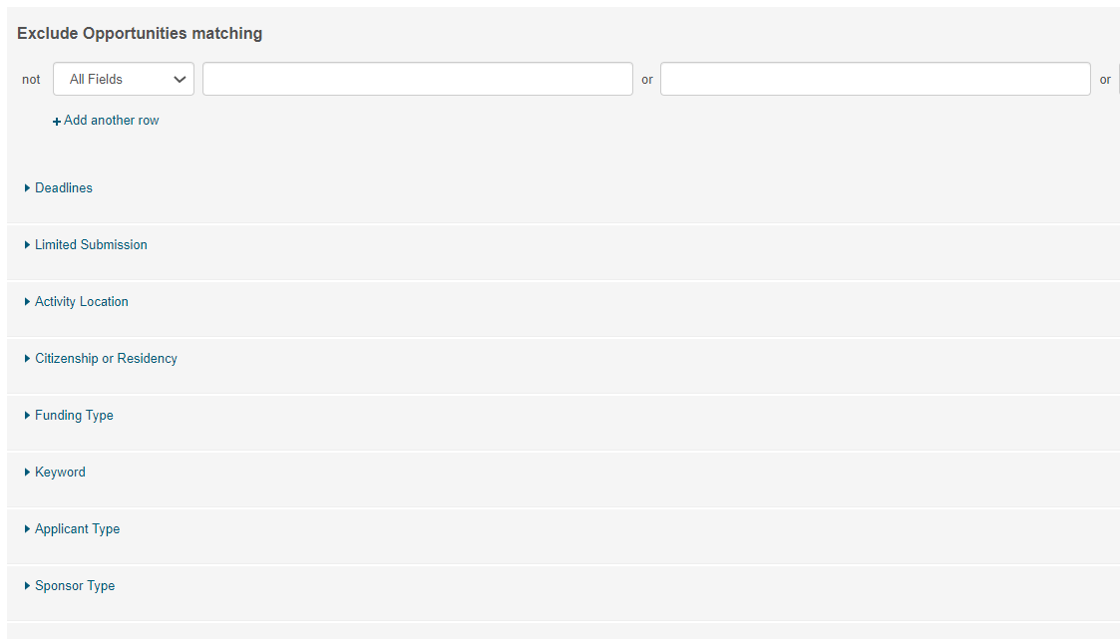
Similar to above but choose funding opportunity parameters that you do NOT want to see/receive.

Search Funding Results Page

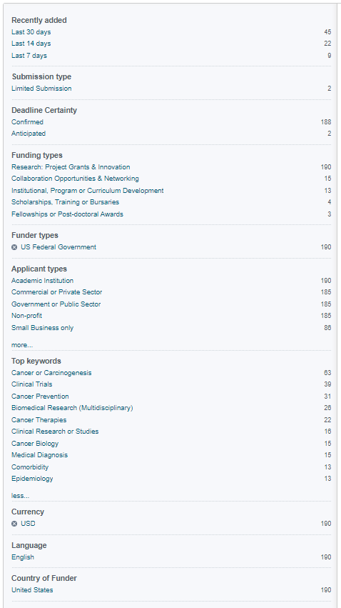
You can narrow results further by using the criteria on the left sidebar

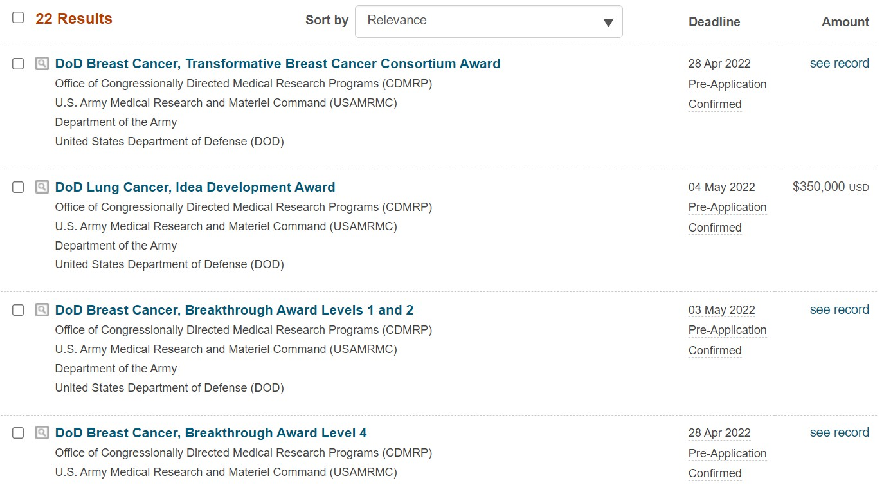

The results provide the program name, sponsor, deadline, and award amount.

Funding Opportunity Page

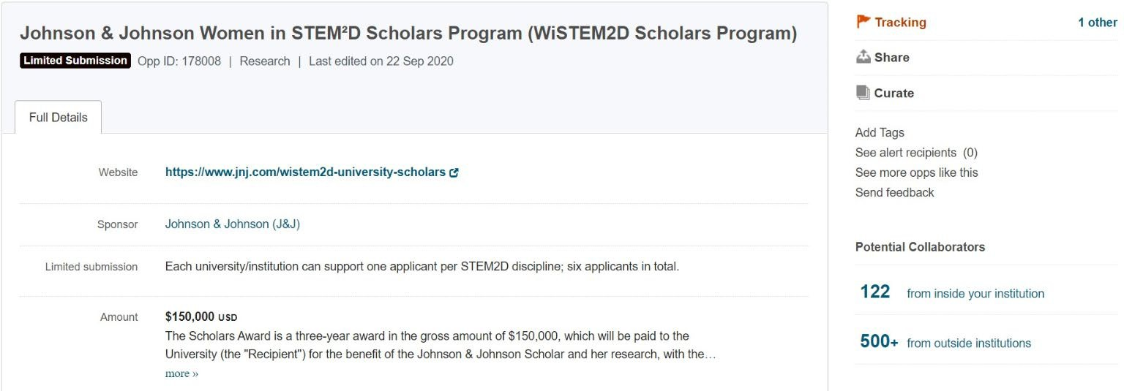

Funding Opportunity Page Contd.

Eligibility restrictions

Funding Opportunity Page Contd.
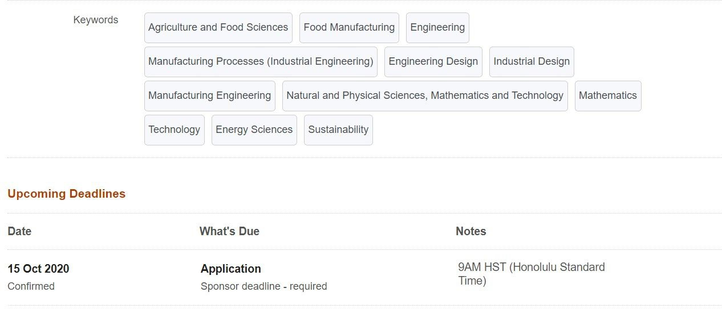

Save Your Search
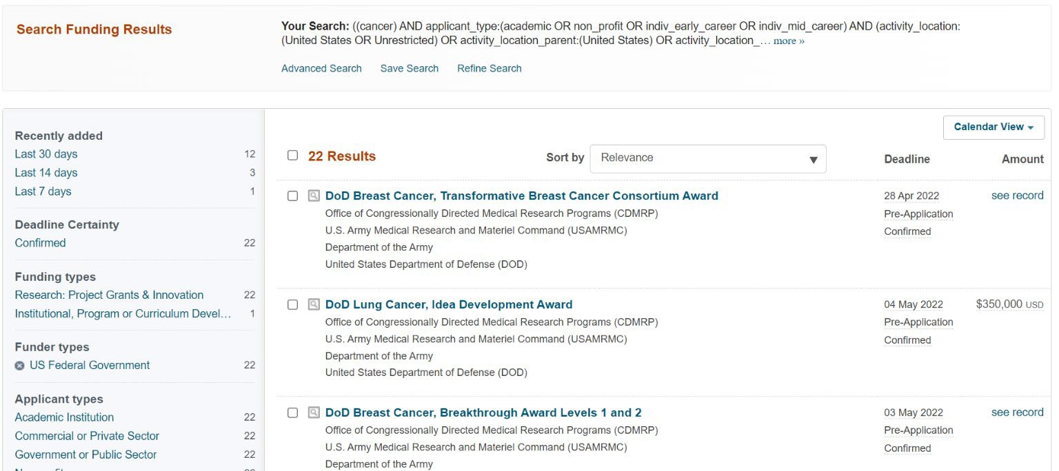

Once you have the desired search parameters, you can save your search or refine it to adjust the parameters

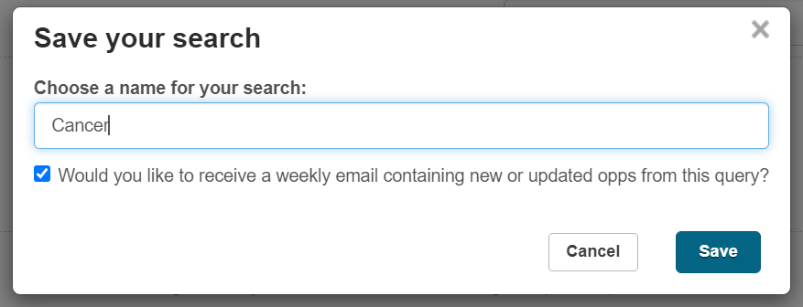
Make sure this box is checked to receive weekly emails on this particular search. You may choose multiple searches and will receive an email that is tailored to each.

Saved Opportunities

Funding opportunities you have tracked can be found here to easily return to

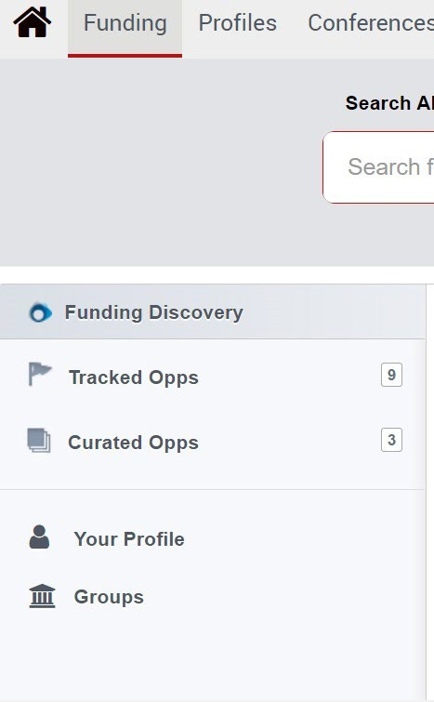
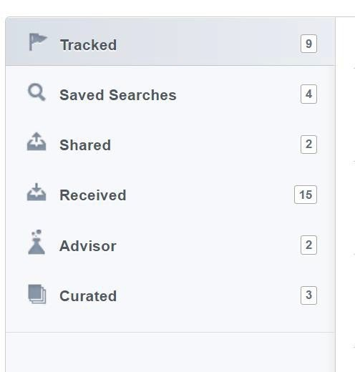


Your saved searches - Clicking any of these will take you to an updated list of active opportunities that meet all of the search criteria

Refine your Search
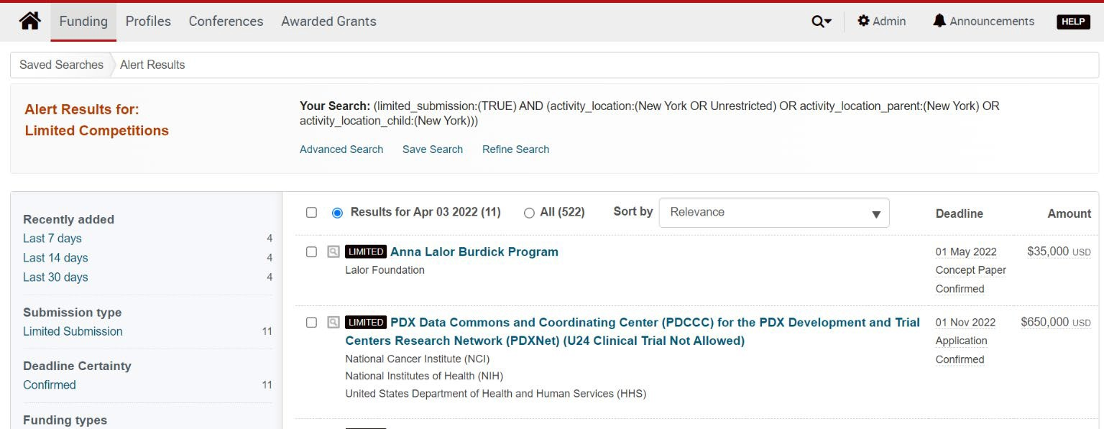
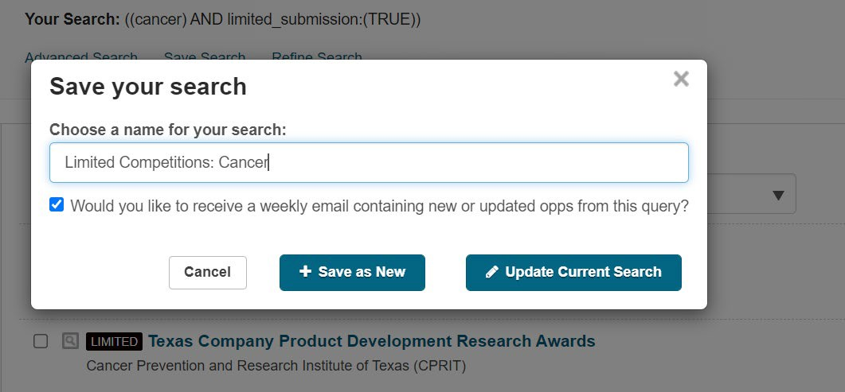

Click ‘Refine Search’ at top of page to edit a saved search. You can either save a new search or update current search

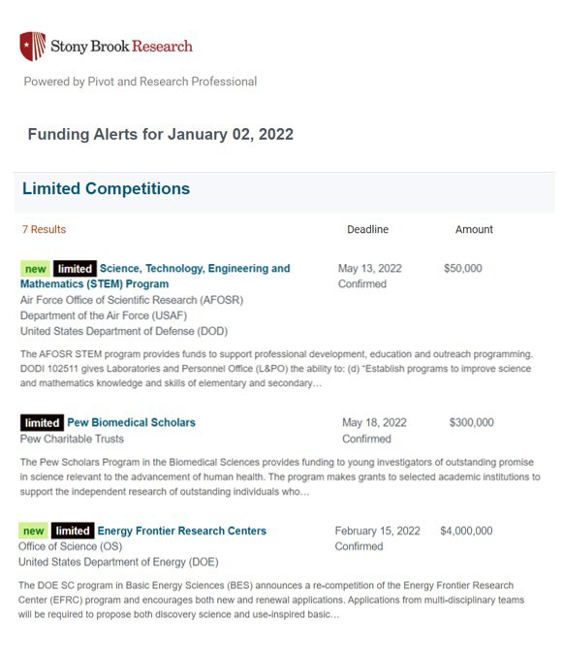
Weekly Email Notification

Weekly email provides all new opportunities that came out in the past week related to your saved searches.

Brief abstract and basic information on opportunity is included. Click on opportunity to learn more in Pivot.

Questions?

Contact OPD_OVPR@stonybrook.edu

