




Pivot by Proquest

Finding funding opportunities and faculty profiles through Pivot

1

What is PIVOT?
The Office of the Vice President for Research subscribes to Pivot, which is a web-based discovery and workflow tool that combines a comprehensive source of global funding opportunities with the largest collection of scholar profiles into one intuitive solution.

With Pivot, faculty, research administrators, postdocs, and graduate students can easily explore new avenues for funding, view funding opportunities uniquely matched to their scholar profile, collaborate with colleagues, and build a funding strategy that supports both immediate and long-term funding needs.

For more information or assistance with building your profile or searches, please contact OPD at OPD_OVPR@stonybrook.edu.

2

How can I make Pivot work most effectively for me?

3

Step 1: Create your account at https://pivot.proquest.com/
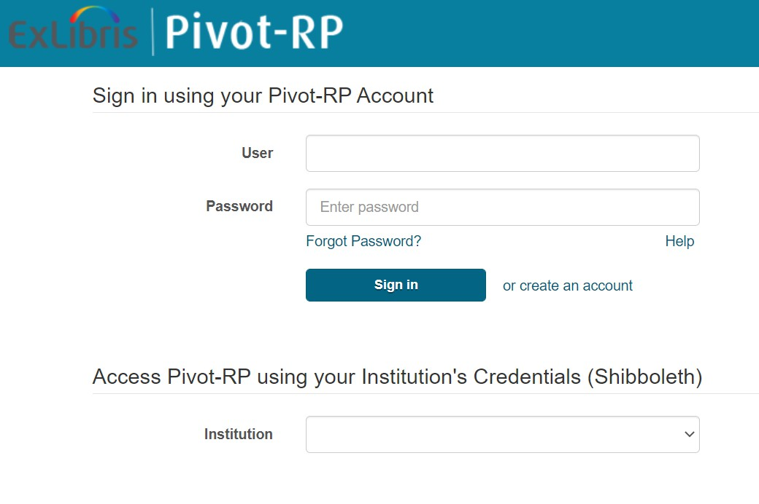

4
You must use a stonybrook.edu or
stonybrookmedicine.edu email address

Step 2: Log into PIVOT
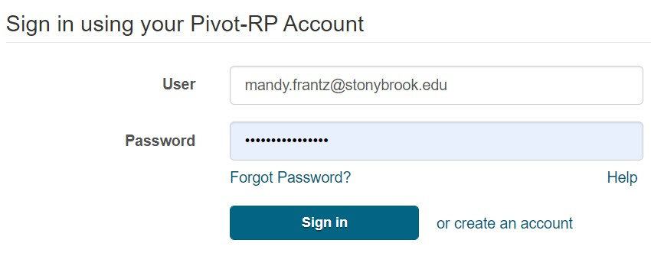
For most faculty members, you will see a profile already set up when you first log in. You may see more than one profile. If there is more than one profile for you, select the ‘THIS IS ME’ option of the profile that is most current and email us at OPD_OVPR@stonybrook.edu and we will ask that the second profile be removed. If you do not see a profile for you, you can create your own by following their prompts or email us and we will add your information.
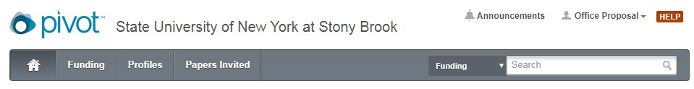

Step 3: Claim Your Profile
Under your Profile drop down menu in the top right corner, select Claim Profile.
You must ‘Claim’ your profile to begin receiving funding opportunities or editing your profile.

5

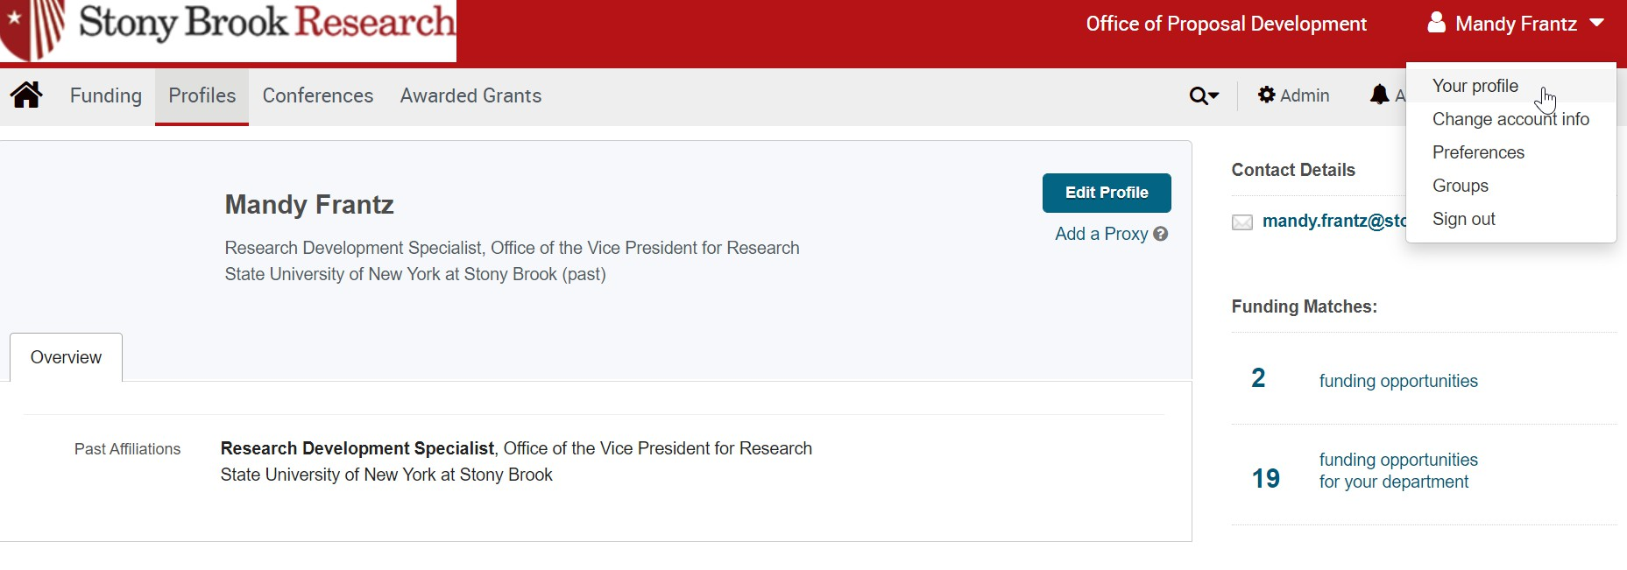

Editing Your Profile

You can edit your profile at any time by going under your profile tab in the upper right hand corner.

6

Editing Your Profile
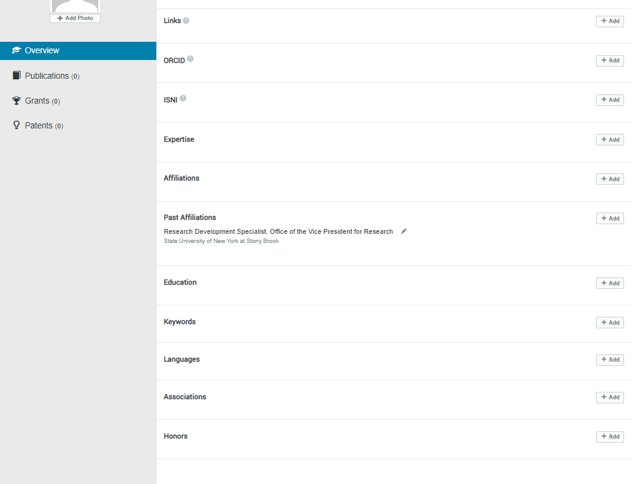
7

Now that I have a profile on Pivot, what can I do?

8

Home Page
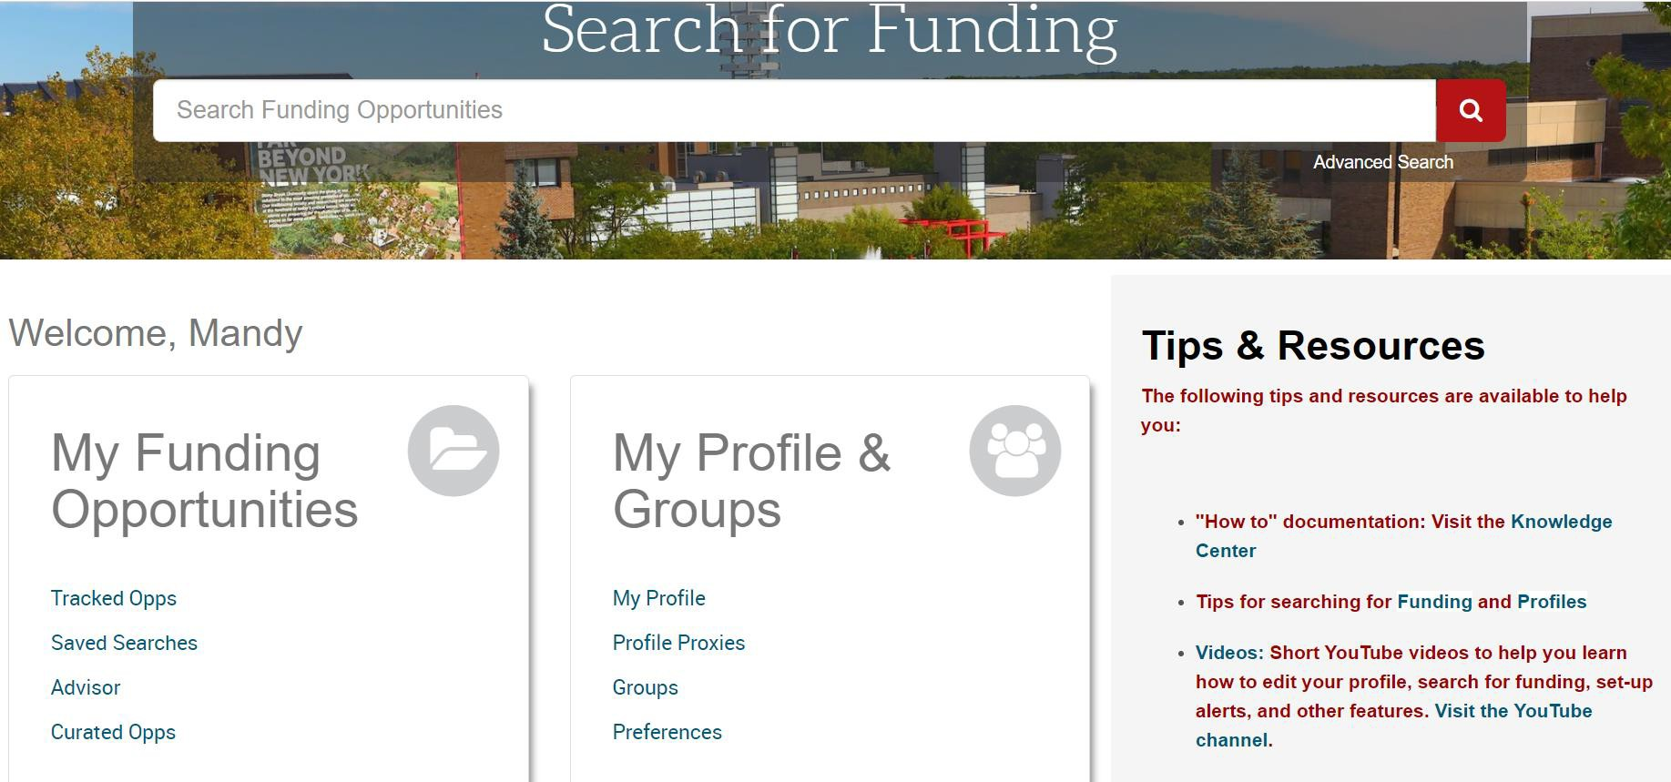

9

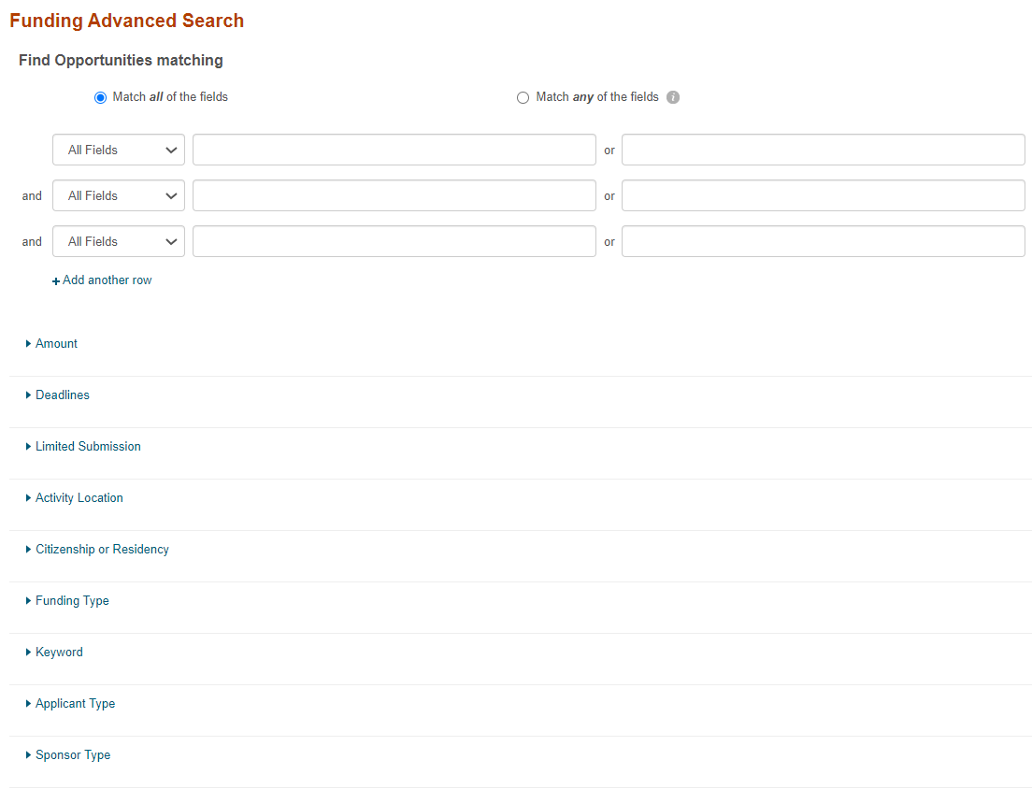
Advanced Funding Opportunities Search

Any web searchable word

Specify any/all for the narrowest search parameters

*Find OR Exclude funding opportunities based on your specific parameters
10

Advanced Search Contd.
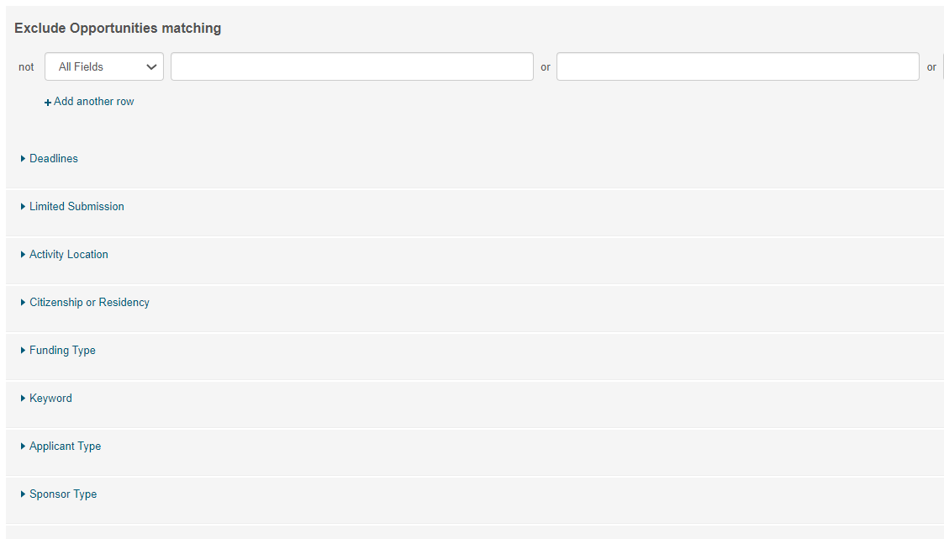
Similar to above but choose funding opportunity parameters that you do NOT want to see/receive.

11

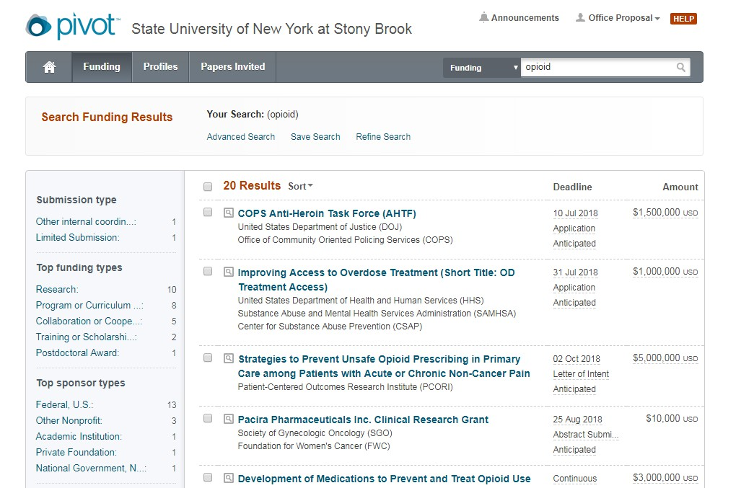
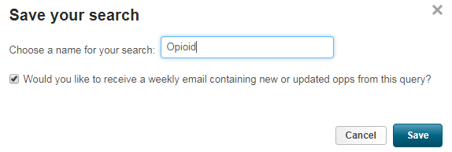
Save Your Search

Once you have the desired search parameters, you can save your search or refine it to adjust the parameters

Make sure this box is checked to receive weekly emails on this particular search. You may choose multiple searches and will receive an email that is tailored to each.

12

Funding Opportunity Page

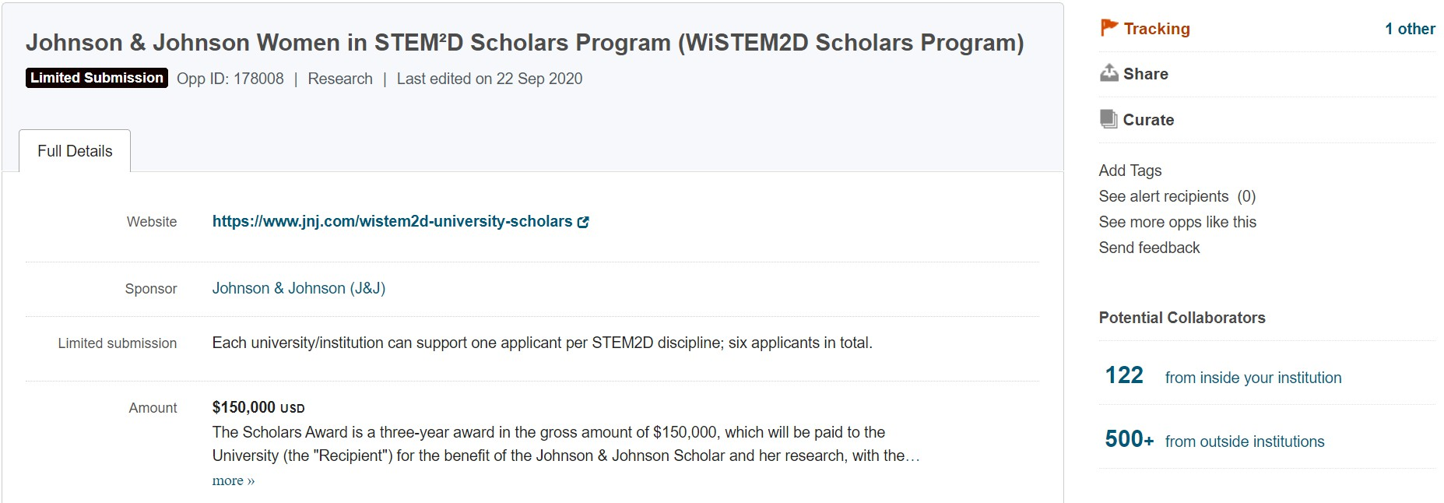

Funding Opportunity Page Contd.


Eligibility restrictions

14

Funding Opportunity Page Contd.

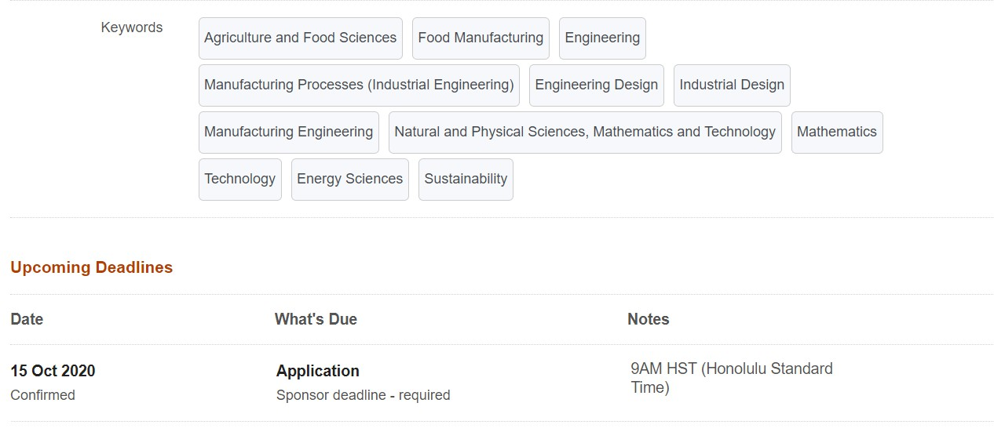

15

Saved Opportunities

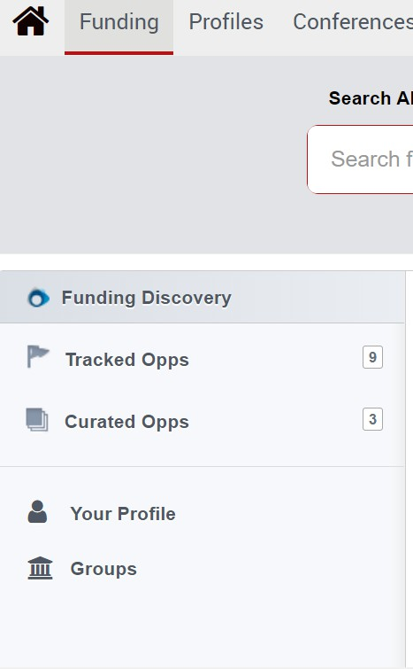
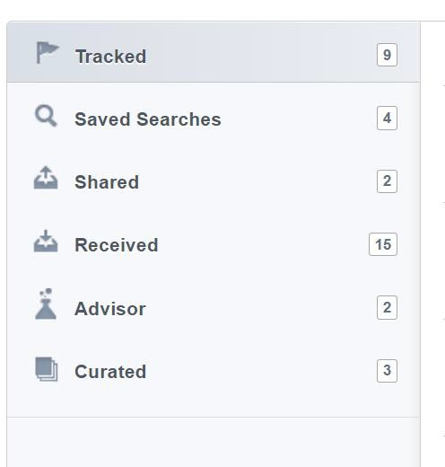
Your saved searches - Clicking any of these will take you to an updated list of active opportunities that meet all of the search criteria

Funding opportunities you shared with others in the last 60 days

Funding opportunities shared with you

Funding opportunities recommended by Pivot based on your profile

16

How can I use Pivot to look at faculty interests?

17

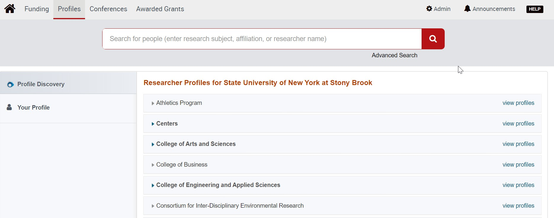
Faculty Profiles Search

18

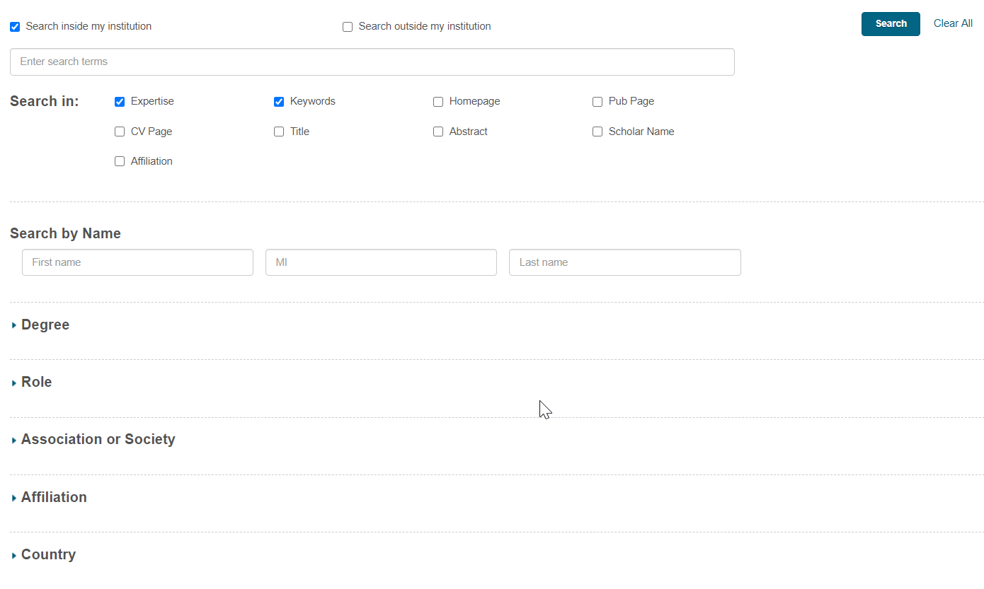
Faculty Profiles Advanced Search

19

Faculty Profiles Advanced Search – Filtering Results

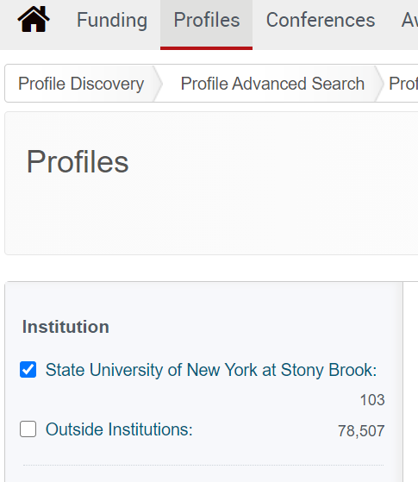
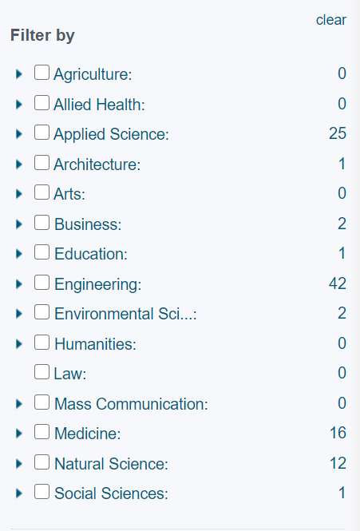
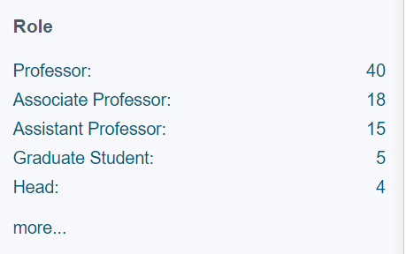

20

Faculty Profile Page

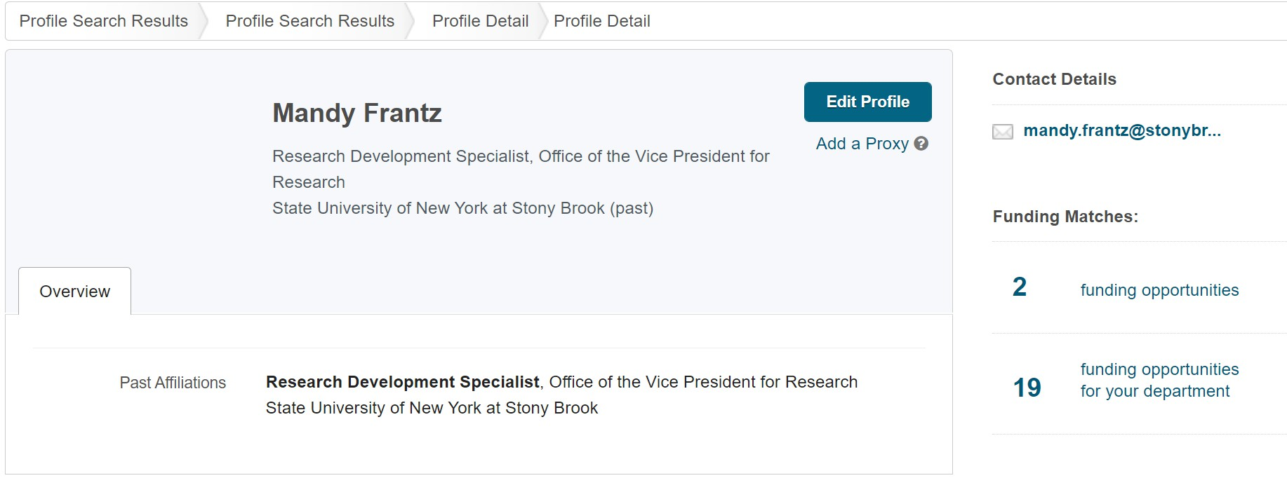

21

How can I use Pivot to bring the funding opportunities and faculty profiles together?

22

Groups

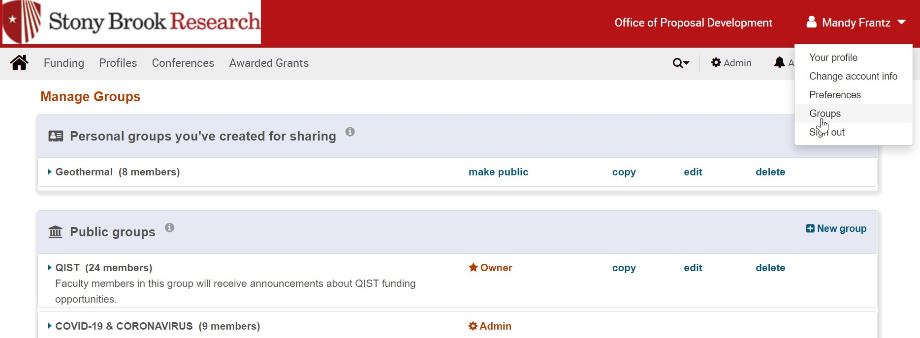

Groups
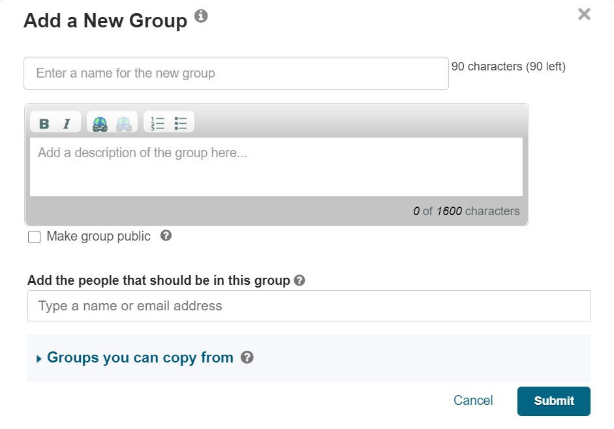
24

How does Pivot fit into OPD’s mission of assisting faculty to expand their research?

25

OPD Funding Opportunities

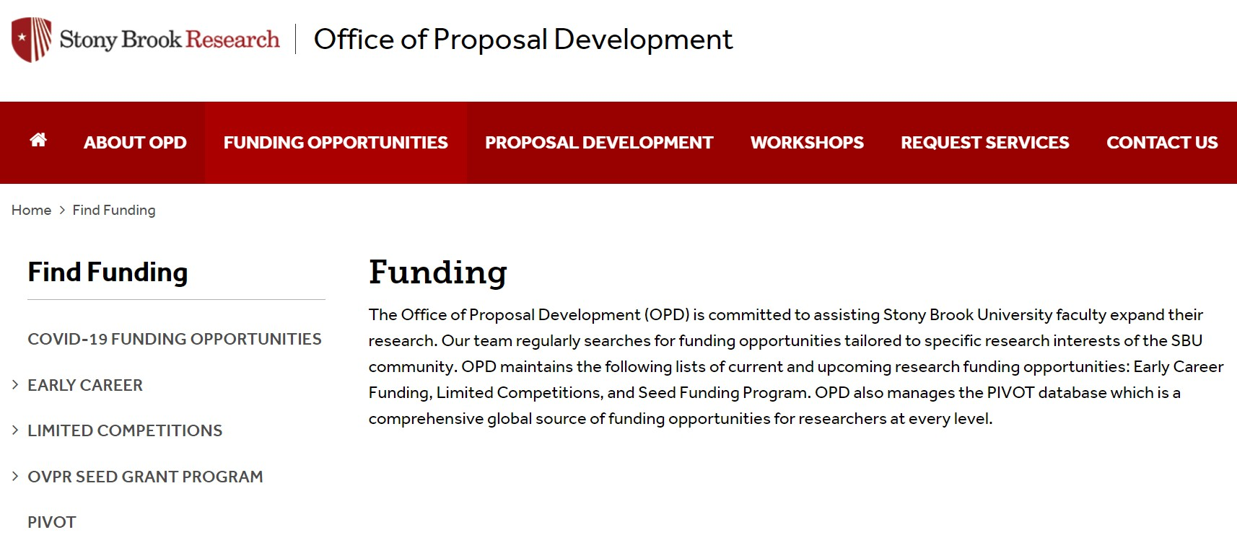

Questions?

Contact OPD_OVPR@stonybrook.edu

27

