Closing the Assessment Loop
Congratulations, you have reached the last stage of the assessment cycle, commonly referred to as “closing the loop”. You are to be commended for reaching this point, and your efforts reflect a commitment to assessment and improvement over the long term.

What does it mean to “close the loop”?
Closing the loop implies taking your assessment activities a step further, by examining whether or not the changes implemented as a result of a prior assessment actually worked. Closing the loop is the “reassess” stage represented in the illustration below.
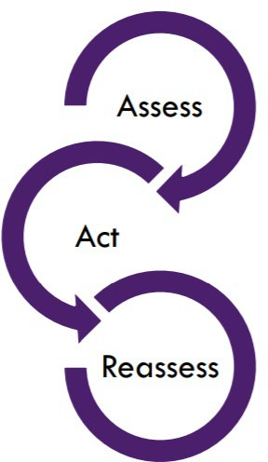
“To close the loop, programs should not only use assessment information to inform action but, should come back and examine (and document) whether the action led to improvement of student learning. “

Source: University of Southern Mississippi, Assessment Office

What are the steps required to “close the loop”?

Step 1: Review Assessment Data
Take time to reflect on assessment results. You now have a new set of data generated as a result of a prior change in the program. This new set of data requires analysis. Once you have organized all of your data, you’ll want to effectively review the data. To do this, consider using the Assessment Data Review Worksheet. The Assessment Data Review Worksheet, is useful for:

- Interpret assessment evidence
- Compare results with classroom experiences
- Look for themes

Step 2: Discuss your findings
Disseminate assessment data to faculty and other program stakeholders, in the method that works best for the parties involved. Some options include: Dropbox, email, website and online dashboards.

Which groups should see results?
- Faculty teaching in the program
- Program administrators
- Boards or other program advisory groups
- Deans
- Alumni

Schedule time to discuss the data. It is recommended that you, plan early for these discussions and consider using options already on the calendar when stakeholders typically come together such as faculty meetings, advisory board meetings and annual faculty retreats.
Recruit a note-taker for the discussion to record what was discussed. Inviting a department assistant, or student assistant to take notes is also a good idea as they can help to summarize key points from the discussion.

Step 3: Examine whether the implemented changes have been successful or unsuccessful
As you compare the results from the initial assessment with those after changes were implemented, you may or may not have realized any improvements in student learning. This is just fine This is a good opportunity to pose new questions for next time. By closing the loop, a program can make “evidence-informed” decisions.

Step 4: Document “closing the loop”
You’ve put a lot of work into improving your program and in some cases, completely reimagining the program. It is imperative that at this point you document your efforts. Documenting “closing the loop” can assist the program in the future in that it chronicles the changes made to the program and why those changes took place. Documentation of your “Closing the Loop” efforts is also desired by specialized and regional accrediting bodies as it serves as evidence of a commitment to assessment and continuous improvement. For a simple approach to documenting “closing the loop” consider the example on the following page.

Example Table Documenting “Closing the Loop”
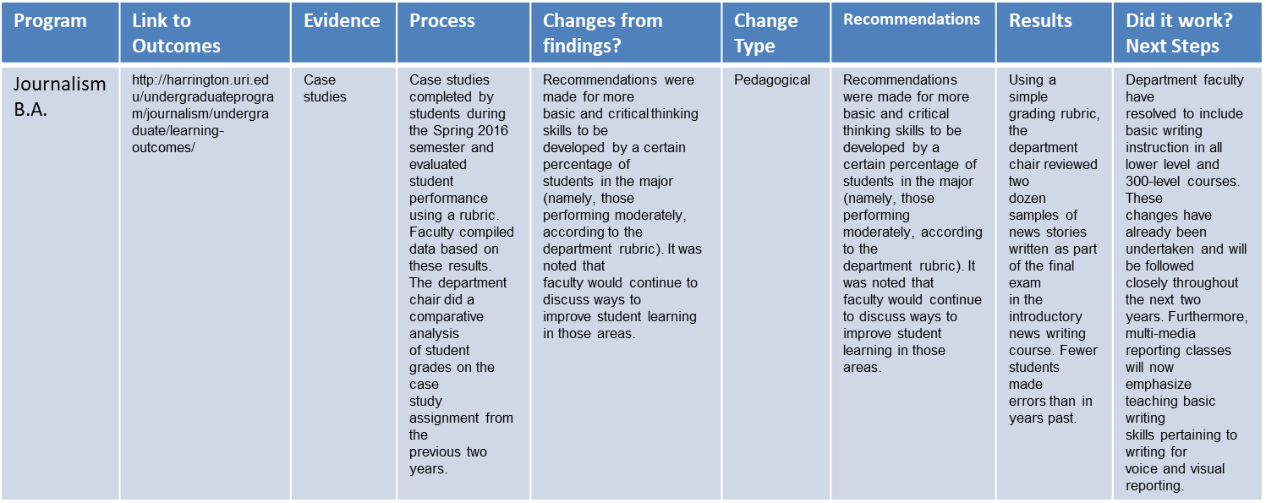
Source: University of Rhode Island

Step 5: Keep assessing
This is a good opportunity to pose new questions for next time. Remember, assessment is an ongoing process of continuous improvement. There is no winning or losing. Improvement is a “moving target”. The purpose is to constantly ask, “Can we deliver this program better?”. The list below contains some examples of aspects of a program that can always be improved

Curriculum  - Revise course content or assignments  - Widely share anchors/models with students  - Modify frequency or schedule of course offerings  - Add or delete course(s)  Resources  - Hire or re-assign faculty and/or staff  - Increase classroom space | Academic process  - Revise advising standards or processes  - Revise admission criteria Program promotion  - Communicate quality of student work and student voices to stakeholders in Brochures, Websites, Recruiting materials & Requests for funding  Assessment process  - Select alternative assessment measures  - Reconsider performance targets
Source: University of Hawai‘i at Mānoa Assessment Office

