
Spring 2023

Stony Brook University General Education Assessment Report

Executive Summary
This report summarizes the findings of an assessment of Stony Brook University’s general education curriculum, the Stony Brook Curriculum (SBC). The assessment adopted a mixed methods approach that enabled faculty to summarize direct measurements of student learning with their qualitative feedback. Major findings include:

- All 60 SBC learning outcomes were assessed across 210 SBC course sections
- In all assessed outcomes, 70% of students performed at an acceptable level or better
- 80% of students performed acceptable or better in 16 of the 20 areas assessed
- Highest performing category was SPK while the lowest performing category was WRT
- Approximately 40% of the faculty respondents noted that they planned to make a change for improvement to their SBC course as a result of their participation in the general education assessment initiative.

Purpose and Background
Stony Brook University's General Education Assessment Initiative was jointly conducted by the Office of Educational Effectiveness (OEE) in consultation with the Assessment Council in Spring 2023. The initiative aimed to assess students' progress in achieving the general education (GenEd) student learning outcomes. It included a comprehensive assessment of the curriculum, teaching strategies, and learning outcomes across Stony Brook Curriculum disciplines, with data collected from faculty discussions between April 6 and May 23, 2023. This assessment builds upon an analysis conducted five years earlier (Fall 2017-2019). Previous feedback from faculty indicated the need for a less burdensome approach. Recommendations from the previous assessment report prompted the creation of the General Education Advisory Committee and the Stony Brook University Assessment Council¹, led by faculty members with administrative support. The Assessment Council is charged with overseeing the structure and function of assessment, while the General Education Advisory Committee² focuses attention on the purpose of General Education outcomes for student learning, degree progress, and
post-graduation outcomes.

Methodology: A New Approach
Leveraging SUNY's update to its general education requirements and student learning outcomes alignment, OEE devised an approach to collect student performance data, designed to minimize faculty burden. This involved collaborative discussions, incorporating insights from key stakeholders such as the Provost's Office, the General Education Advisory Committee, and the Assessment Council. The process included a virtual forum, and email communication with assessment coordinators, which led to individual "guided conversations" with faculty teaching

¹ https:// .stonybrook.edu/commcms/oee/about/Assessment%20Council%20.php
²https://www.stonybrook.edu/commcms/oee/about/Gen%20Ed%20Advisory%20Committee.php
general education courses. These conversations were designed to engage faculty and foster understanding of this assessment initiative. Guiding principles of the process are as follows:

  - Consider ways to constantly improve our students' educational experience through assessment
  - Ensure the assessment approach is in alignment with SUNY and Middle States expectations
  - Limit unnecessary or distracting requirements and burdens on units and faculty/staff within those units charged with assessment or teaching general education (GenEd) courses

First, OEE provided all of the assessment coordinators responsible for undergraduate programs with a list of faculty teaching general education courses within their department. Coordinators were asked to select five faculty members to participate in the guided conversations.
Considering faculty availability, OEE scheduled sessions virtually and in-person with the selected faculty and an assessment consultant.

Within the scope of these 45-minute sessions, the assessment consultant collaborated closely with faculty members to explore course assessment methods, establish alignments between assessment methods and course and/or general education learning outcomes, review syllabi, and distribute student performance across three distinct categories: "Developing," "Acceptable," and "Exemplary." Faculty were asked to consider the following:

Think about a typical college-educated person who is not a major in this subject or general area.
- How many of your students would you say are Developing?
- How many of your students would you say are Acceptable?
- How many of your students would you say are Exemplary?

Participating faculty provided counts relating to student performance in each of the distinct categories. Faculty were asked to discuss assessment methods that best aligned with student learning outcomes. Chart 1 is a visualization of the full distribution of the methods mentioned during the guided conversations. The top three assessment methods were homework assignments, quizzes, and papers.
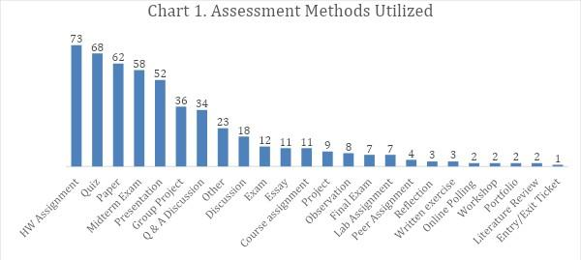

Additionally, faculty were asked to describe actions implemented to improve student performance in areas where faculty saw room for growth. Although several actions were offered, faculty actions generally encompassed the following:
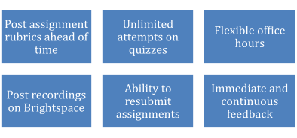
Assessment consultants entered data provided by faculty into a customized content management system developed by OEE. After the conversation, faculty received a personalized summary report outlining outcome assessed, methods used, actions taken to assist students, and results of student performance.

Findings/Analysis
Data from the assessment initiative covered 20 Stony Brook Curriculum (SBC) categories, including 60 learning outcomes³, 210-course sections, 39,612 duplicated students assessed, and insights from 107 faculty members. OEE examined the samples within each SBC category and estimated an average 4.4% margin of error based on 95% confidence level and maximum comparison variance (see Appendix A for a detailed analysis). Each SBC category, excluding WRT, had more than one department represented in the data. The SBC with the most

³ https://www.stonybrook.edu/commcms/gened/SLOs.php
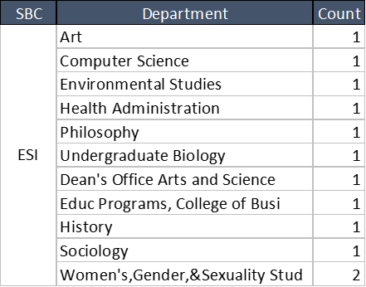
departments was ESI: Evaluate Synthesizing Information (see Table 1). For a full breakdown, view Appendix B.

Chart 2 groups students collectively, distributing performance into three performance categories where in total 84% (n=33,140) of duplicated students demonstrated "Acceptable" or "Exemplary" performance.
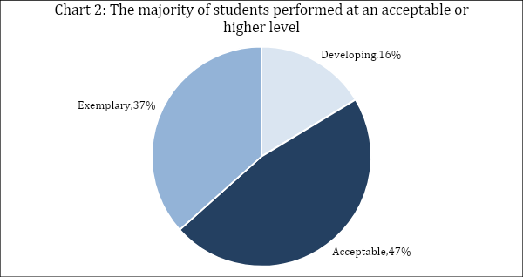
Table 2 represents student performance within the twenty SBC categories that fall within GenEd. Looking at all 20 categories at least 68% of students performed at acceptable or higher level. Notably, in 16 of the 20 categories, 80% or more of the students assessed performed at an acceptable or higher level. A comparative ranking of the SBC categories revealed that the top five categories were SPK, WRTD, HFA+, EXP+ and CER. Although the SPK category had 97.7% of student performance as acceptable or higher, the smaller sample size denotes a potential higher margin of error due to insufficient representation (see Appendix A for detailed information).

The lowest two categories, WRT and STEM+, indicate that 70% or fewer of the assessed students are performing at an acceptable or exemplary level. Faculty members participating in the STEM+ SBC category have noted that the rigor of coursework affects students who are assessed as acceptable or exemplary. Additionally, faculty often report that students taking entry-level or lower-level writing courses within the WRT category encounter some difficulty in synthesizing sourced information to draw comprehensive conclusions in their written arguments. Faculty indicated they have implemented various actions to help students improve their performance, including working one-on-one with students, scaffolding projects, using low-stakes assessment methods, providing prompt and continuous feedback, implementing peer-review assignments, and offering extra credit to students who work with tutors in either the Writing Center or various science and math centers. Appendix C contains a table with detailed performance data for student learning outcomes.

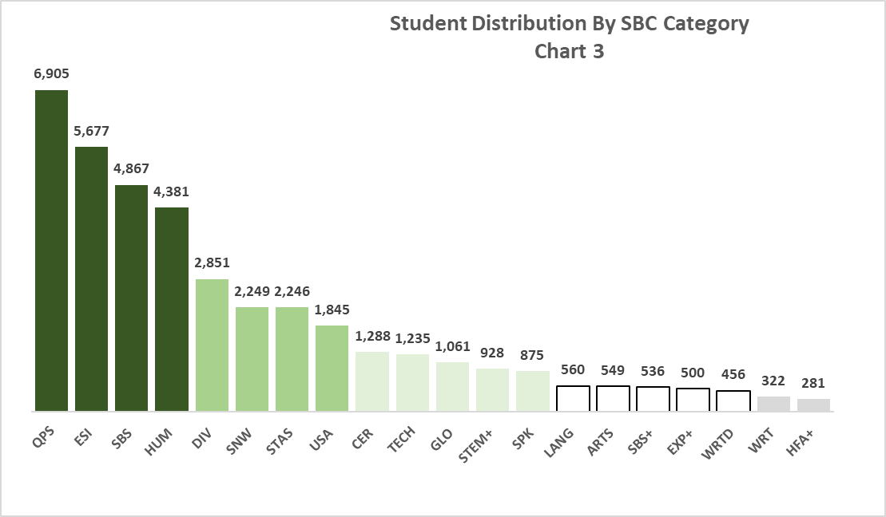
Chart 3 demonstrates the distribution of measurements by SBC area. The largest SBC category, QPS: Quantitative Problem Solving, assessed almost seven thousand students.

Throughout the guided conversations, faculty practices revealed in-depth insights into how to enhance student learning. These encompassed transparency in grading criteria, continuous feedback, reviewing content during class, varying assessment methods, and fostering peer-led feedback and collaborative learning. These practices highlight our faculty’s commitment to enriching the learning experience of our students.

Assessing the Assessment
In order to assess the effectiveness of the Spring 2023 General Education Assessment Initiative, the OEE distributed an anonymous feedback survey to all faculty who participated in the guided assessment conversations in May 2023. The survey was distributed for two reasons:
1) to give participants the opportunity to reflect on their perceptions of the assessment initiative and 2) to compare those reflections to those of the prior assessment report.

Feedback from the survey (response rate of 26%) revealed evolving perceptions of the assessment initiative's value. Results reported herein reflect the responses received as of this date, although the survey will remain open and accessible to participants through September 2023 to collect as much feedback as possible. Faculty members expressed improved positivity after engaging in guided assessment conversations. A majority rated the initiative as valuable and indicated their intent to implement changes based on their experiences. Valuable insights were generated, such as reservations about the purpose of general education and suggestions for improvement in preliminary instructions.

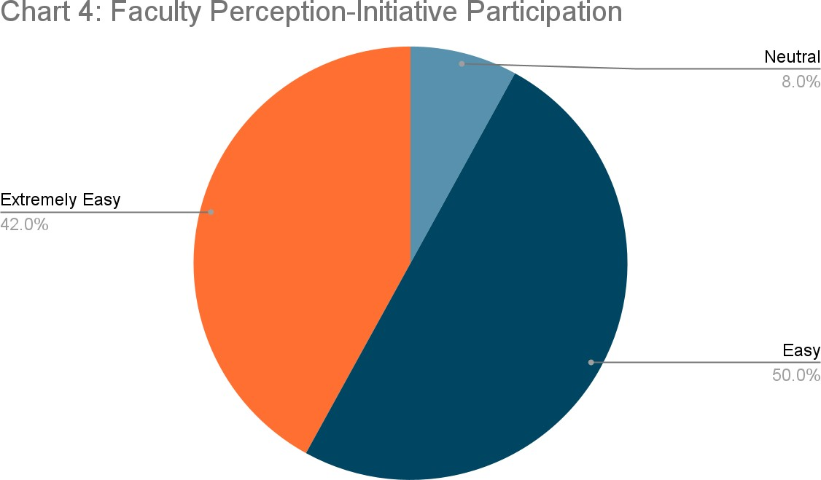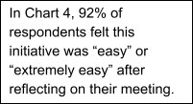
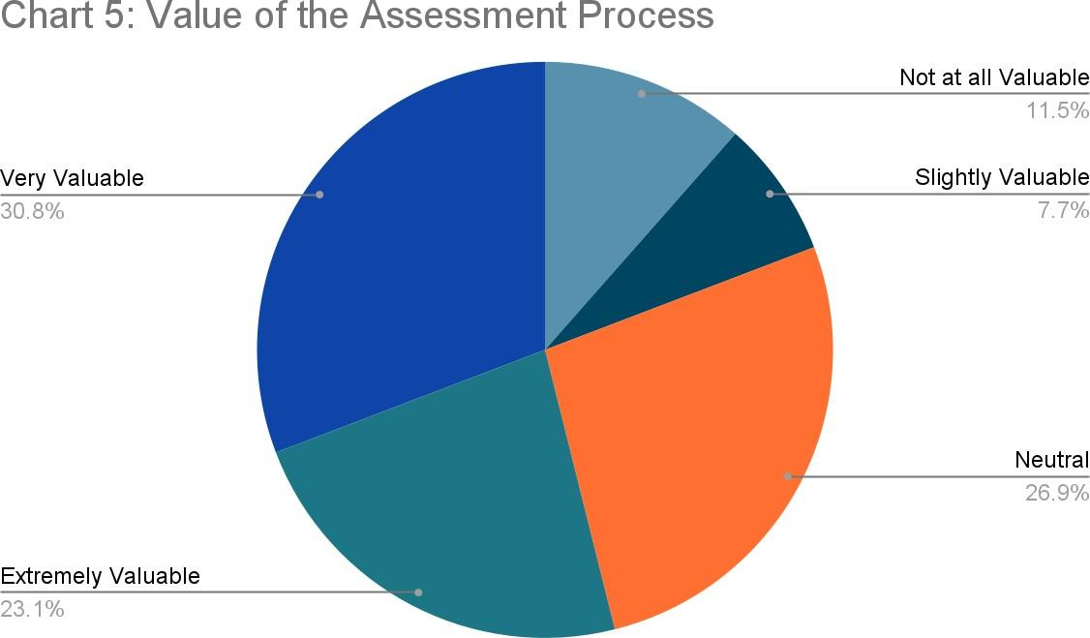
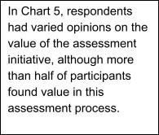

Approximately 40% of the faculty respondents noted that they planned to make a change or improvement to their SBC course as a result of their participation in the general education assessment initiative. For example, some noted that they intended to clarify the alignment of general education student learning outcomes (SLOs) to their specific assignments by revising the way they are worded. Others noted that they would incorporate more variety in assessment methods to provide students with the opportunity to demonstrate their proficiency in a given
SLO in a different way. Others found it a helpful exercise to refresh their course SLOs within the broader context of the general education SLOs.

Limitations
During the implementation of this initiative, some limitations were identified which influenced the process and data components.

First, one limitation that emerged was that not all courses were required to assess every learning outcome assigned to their respective SBC category. In such instances, only a subset of the designated learning outcomes was assessed, potentially leading to incomplete representations of the overall educational outcome categories. Furthermore, certain learning outcomes were changed over time, either due to modifications in the course curriculum or variations in faculty instruction.

Second, a critical limitation highlighted during the assessment pertained to departmental variation in the use of PeopleSoft to manage teaching and course assignment. As a result, discrepancies occasionally arose in the information listed within the database. For example, PeopleSoft listed a specific instructor, but in conversation with the faculty member, the assessment consultant discovered the faculty member was responsible for teaching a different course section. In such cases, manual corrections were required to rectify discrepancies in the data. While these inconsistencies were minimal, they must be considered while interpreting the findings derived from the research study.

Finally, several faculty members expressed concerns that the timing of the initiative coincided too closely with the end of the semester when they were preoccupied with final exams and graduation-related commitments. For some, this affected availability and may have impacted faculty participation.

Impact and Future Steps
The use of guided conversations with faculty as a mixed-methods approach to assessment has enriched the assessment process. The General Education Assessment Initiative yielded valuable insights into the strengths and areas for improvement within the general education curriculum. Additionally, connecting through these conversations, we identified faculty who offered best practices to improve student performance and engage in continuous assessment. We look forward to inviting these faculty members to collaborate in future workshops and share their strategies with the wider faculty community.

Subsequent assessment initiatives may benefit from the following:

- Encourage courses assigned to specific SBC categories to assess all designated learning outcomes.
- Create a workshop in conjunction with CELT, Academic Affairs, and GEAC to educate faculty on the purpose of GenEd, how to align assignments with student learning outcomes, how to assess learning outcomes, and understand the steps involved to certify and/or change a GenEd course.
- Host an open assessment period allowing instructors to input assessment data as early as the beginning of the semester and as late as the end of semester.
- Consider creating an institutional benchmark to measure growth over time and accurately determine success.

The recommendations outlined in this summary will guide the University's efforts to continuously improve its general education program, ensuring it remains responsive to the evolving needs of our students and their impact on the global society.

Appendix A
Title: SBC General Assessment Initiative Margin of Error

Spring 2023 SBC Courses |  |  |  | Spring 2023 SBC Assessment
SBC | N  Enrollment | N  Courses | % of Enrolled | N  Course Sample | N  Enrollment | N  Enrollment Sample* | % of Available SBC  Courses | % of Available SBC Course Enrollment | % of Sample | %  Difference of Sample | +/- error Based on # of Students Sampled | Selection Weight
ARTS | 2,679 | 68 | 3.3% | 6 | 189 | 147 | 8.8% | 5.5% | 1.1% | -2.2% | 7.86% | 2.91
CER | 4,338 | 92 | 5.4% | 9 | 564 | 480 | 9.8% | 11.1% | 3.7% | -1.6% | 4.22% | 1.44
DIV | 5,127 | 79 | 6.3% | 11 | 897 | 723 | 13.9% | 14.1% | 5.6% | -0.7% | 3.38% | 1.13
ESI | 3,894 | 93 | 4.8% | 12 | 1,632 | 1,438 | 12.9% | 36.9% | 11.2% | 6.3% | 2.05% | 0.43
EXP+ | 3,365 | 686 | 4.2% | 6 | 135 | 127 | 0.9% | 3.8% | 1.0% | -3.2% | 8.53% | 4.22
GLO | 3,341 | 72 | 4.1% | 10 | 653 | 532 | 13.9% | 15.9% | 4.1% | 0.0% | 3.90% | 1.00
HFA+ | 2,973 | 115 | 3.7% | 11 | 389 | 281 | 9.6% | 9.5% | 2.2% | -1.5% | 5.56% | 1.69
HUM | 3,823 | 81 | 4.7% | 7 | 997 | 813 | 8.6% | 21.3% | 6.3% | 1.6% | 3.05% | 0.75
LANG | 2,012 | 90 | 2.5% | 9 | 219 | 188 | 10.0% | 9.3% | 1.5% | -1.0% | 6.81% | 1.71
QPS | 4,060 | 38 | 5.0% | 10 | 1,592 | 1,435 | 26.3% | 35.3% | 11.1% | 6.1% | 2.08% | 0.45
SBS | 7,483 | 53 | 9.3% | 16 | 1,957 | 1,330 | 30.2% | 17.8% | 10.3% | 1.1% | 2.44% | 0.90
SBS+ | 6,656 | 102 | 8.2% | 12 | 651 | 536 | 11.8% | 8.1% | 4.2% | -4.1% | 4.06% | 1.98
SNW | 6,493 | 53 | 8.0% | 16 | 853 | 664 | 30.2% | 10.2% | 5.2% | -2.9% | 3.60% | 1.56
SPK | 2,854 | 138 | 3.5% | 13 | 306 | 294 | 9.4% | 10.3% | 2.3% | -1.3% | 5.41% | 1.55
STAS | 3,882 | 61 | 4.8% | 9 | 1,239 | 1,133 | 14.8% | 29.2% | 8.8% | 4.0% | 2.45% | 0.55
STEM+ | 6,480 | 67 | 8.0% | 9 | 1,077 | 928 | 13.4% | 14.3% | 7.2% | -0.8% | 2.98% | 1.11
TECH | 3,320 | 63 | 4.1% | 14 | 698 | 631 | 22.2% | 19.0% | 4.9% | 0.8% | 3.51% | 0.84
USA | 3,005 | 31 | 3.7% | 7 | 723 | 630 | 22.6% | 21.0% | 4.9% | 1.2% | 3.47% | 0.76
WRT | 2,178 | 87 | 2.7% | 7 | 163 | 112 | 8.0% | 5.1% | 0.9% | -1.8% | 9.02% | 3.10
WRTD | 2,807 | 131 | 3.5% | 16 | 492 | 456 | 12.2% | 16.2% | 3.5% | 0.1% | 4.20% | 0.98
Grand Total | 80,770 | 2,200 | 100% | 210 | 15,426 | 12,878 | - | - | 100% | 0.0% | - | -
*Unique students
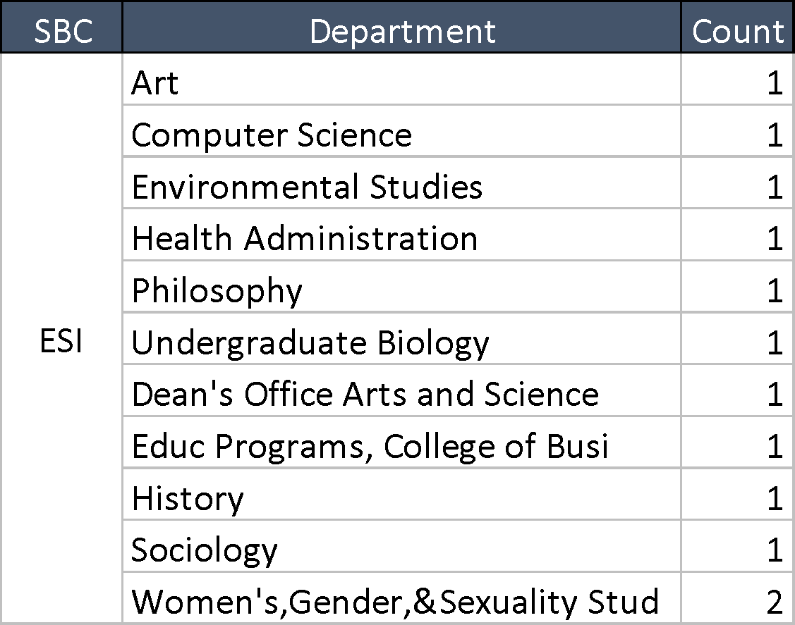
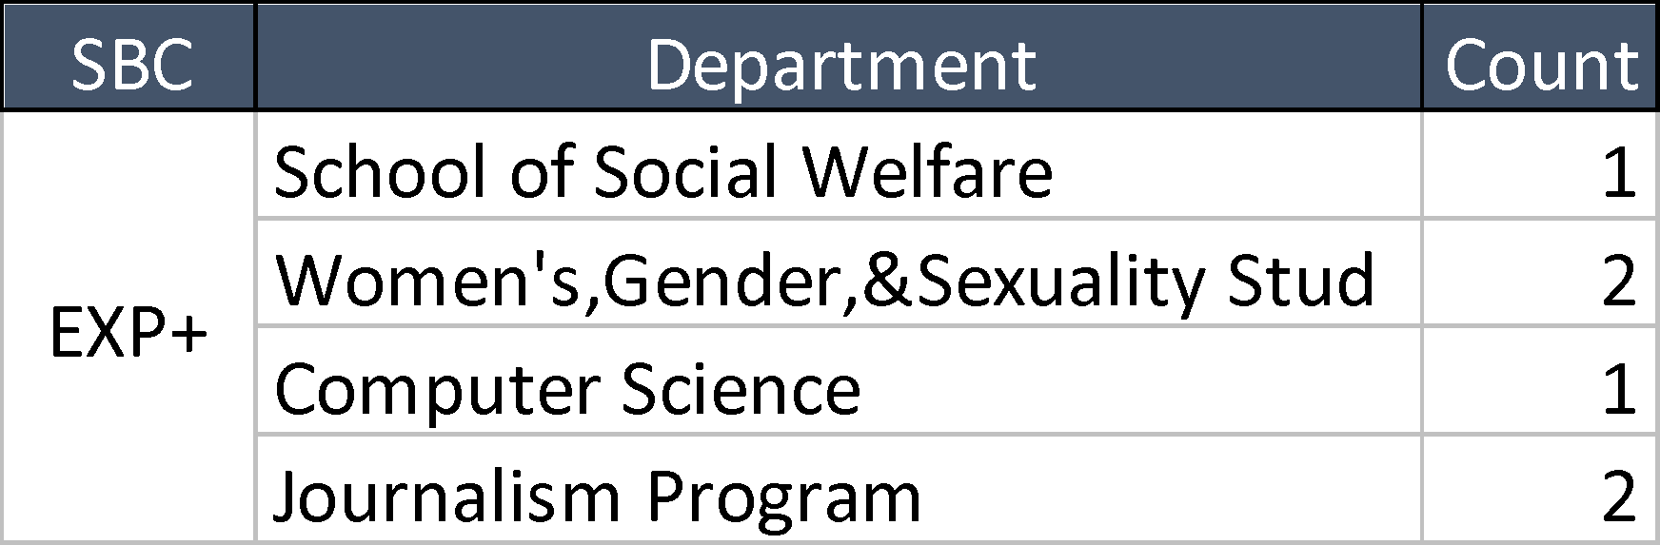
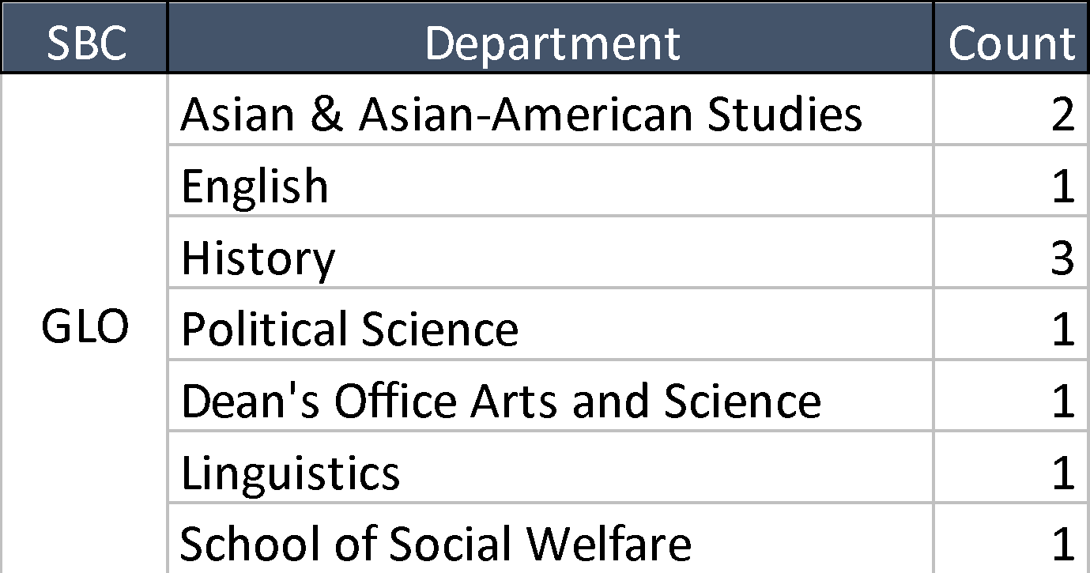
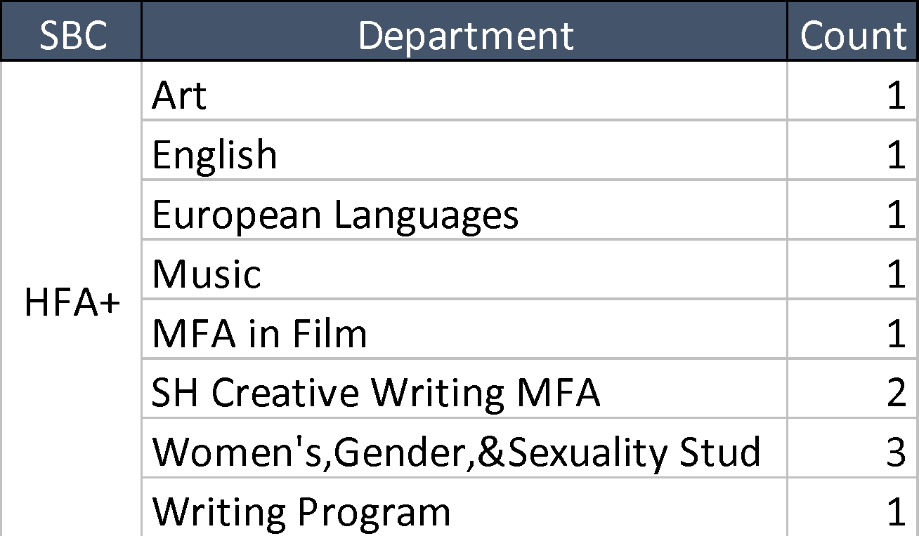
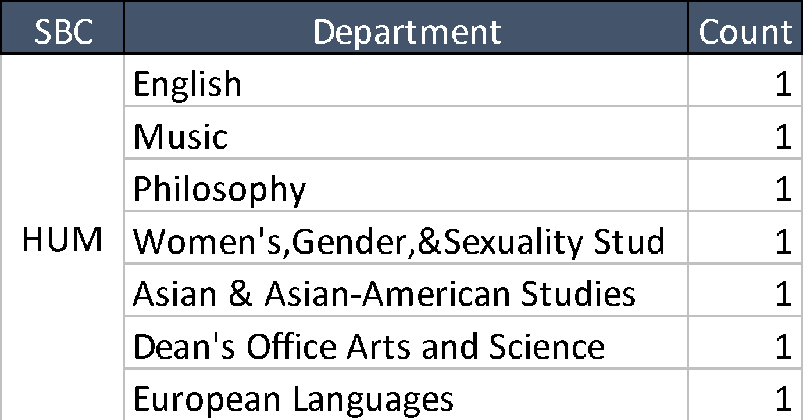
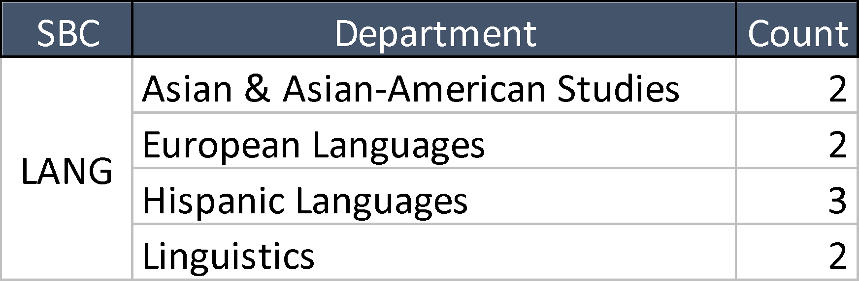
Appendix B
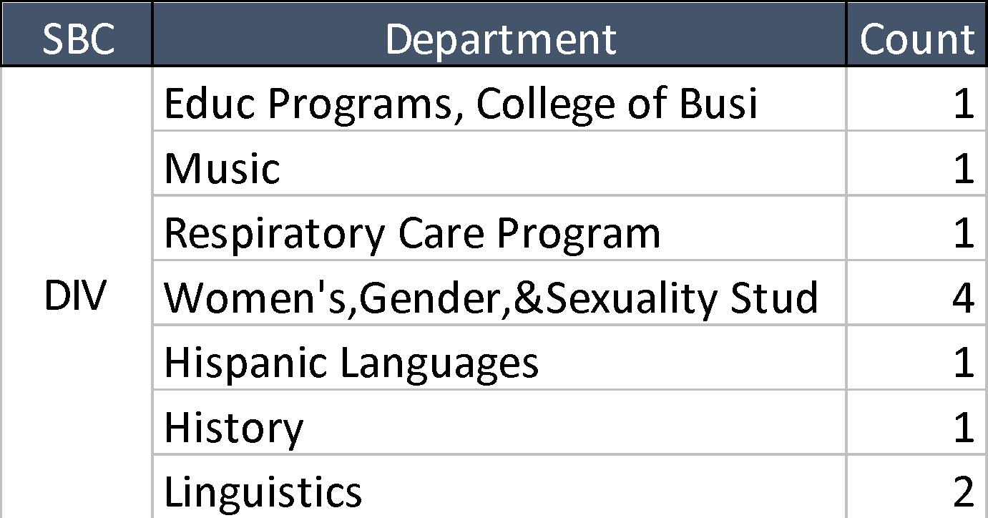
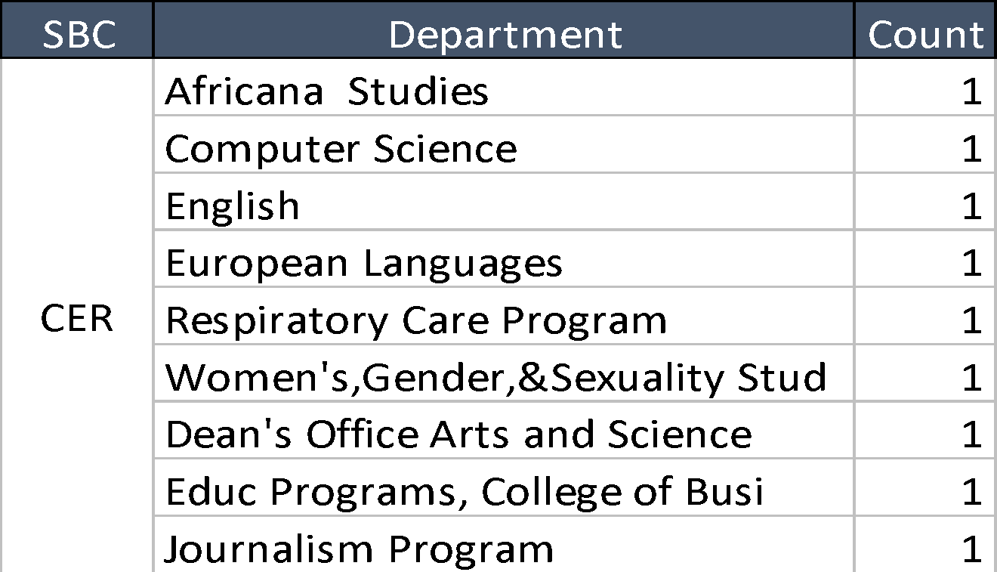
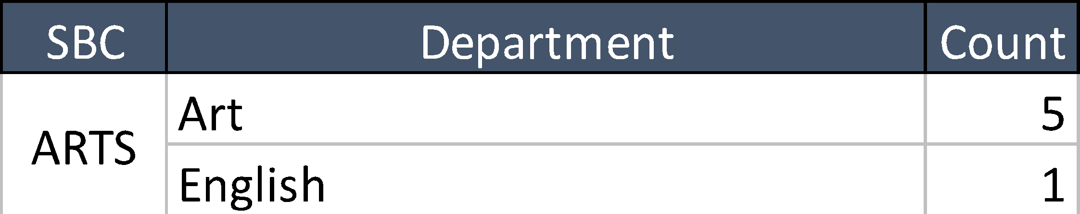
Title: The number of departments represented per SBC category
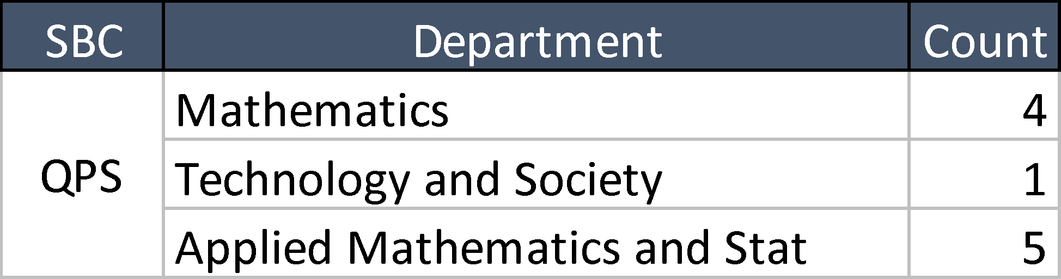

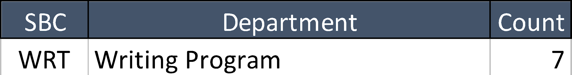
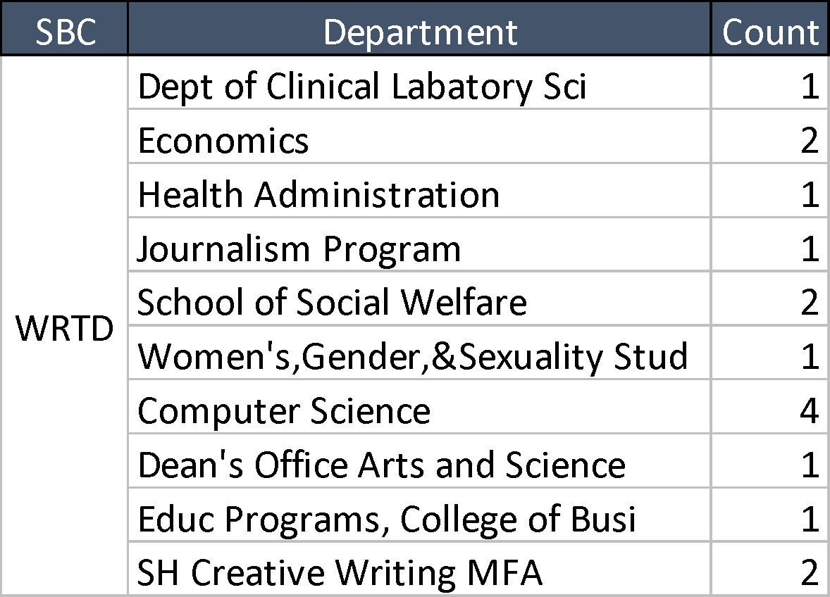
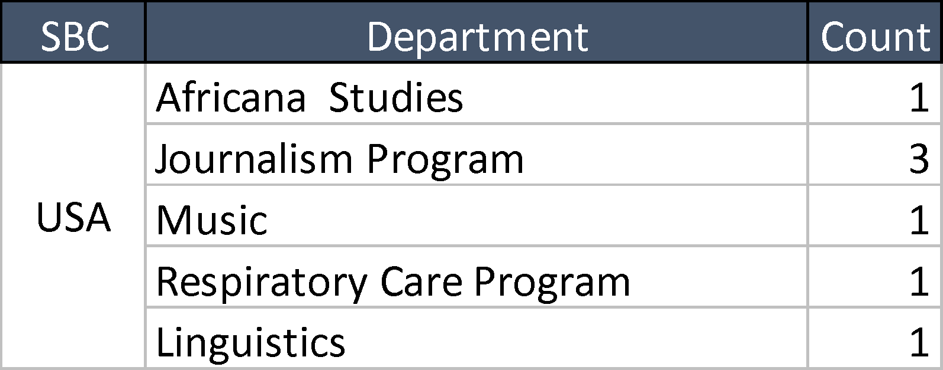

Appendix C
Title: Overview of the SBC categories and corresponding learning outcomes assessed.

SBC | N  Course s | N  Enrollme nt | N  Sample |  |  | Learning Outcomes | Dev elop ing | Acce ptab le | Exempl ary
ARTS  Fine & Performance | 6 | 189 |  | 146 | ARTS - 1. Develop an understanding of works of art and their practitioners through an examination of the works in the historical and cultural context in which the art was or is created. |  | 21.2% | 23.3% | 55.5%
ARTS  Fine & Performance | 6 | 189 |  | 147 | ARTS - 2. Understand the materials, forms, and/or styles of art through study of arts  theories and the works themselves. |  | 5.4% | 32.7% | 61.9%
ARTS  Fine & Performance | 6 | 189 |  | 109 | ARTS - 3. Understand ideas, materials, technical skills, and forms of art in order to express oneself creatively through an artistic medium. |  | 19.3% | 27.5% | 53.2%
ARTS  Fine & Performance | 6 | 189 |  | 147 | ARTS - 4. Develop tools of aesthetic discourse through contact with works of art – as well as through writings on art – related to its critical understanding, cultural placement, and  appreciation. |  | 8.2% | 22.4% | 69.4%
ARTS  Fine & Performance | Total |  |  | 549
CER  Critical & Ethical Reasoning | 9 | 564 |  | 331 | CER - 1. Demonstrate an ability to distinguish among the ethical principles guiding human behavior. |  | 11.2% | 34.7% | 54.1%
CER  Critical & Ethical Reasoning | 9 | 564 |  | 477 | CER - 2. Apply ethical reasoning to a variety of  situations and human experience. |  | 13.0% | 35.0% | 52.0%
CER  Critical & Ethical Reasoning | 9 | 564 |  | 480 | CER - 3. Understand and differentiate ethical,  legal, social justice, and political issues. |  | 13.1% | 40.0% | 46.9%
CER  Critical & Ethical Reasoning | Total |  |  | 1,288
DIV  Diversity | 11 | 897 |  | 713 | DIV - 1. Describe and analyze the impact of power and privilege on self and society in the context of diversity and inclusion. |  | 13.5% | 56.8% | 29.7%
DIV  Diversity | 11 | 897 |  | 723 | DIV - 2. Identify systematic barriers to equality and inclusiveness and discuss how those barriers and biases affect the perceptions of  others. |  | 12.2% | 59.5% | 28.4%
DIV  Diversity | 11 | 897 |  | 714 | DIV - 3. Examine how human and cultural similarities and differences shape personal identities and influence structural and institutional inequities. |  | 14.4% | 54.9% | 30.7%
DIV  Diversity | 11 | 897 |  | 701 | DIV - 4. Critically reflect upon how one’s own personal and cultural presuppositions affect  one’s values and relationships. |  | 12.3% | 55.3% | 32.4%

 | Total |  |  | 2,851
ESI  Evaluate & Synthesize Research Information | 12 | 1,632 |  | 1,438 | ESI - 1. Locate and organize information from a variety of appropriate sources. | 16.6% | 51.3% | 32.2%
ESI  Evaluate & Synthesize Research Information | 12 | 1,632 |  | 1,400 | ESI - 2. Analyze the accuracy of information and  the credibility of sources. | 21.9% | 42.1% | 35.9%
ESI  Evaluate & Synthesize Research Information | 12 | 1,632 |  | 1,434 | ESI - 3. Determine the relevance of  information. | 16.5% | 46.9% | 36.5%
ESI  Evaluate & Synthesize Research Information | 12 | 1,632 |  | 1,405 | ESI - 4. Use information ethically and  responsibly. | 11.1% | 53.7% | 35.2%
ESI  Evaluate & Synthesize Research Information | Total |  |  | 5,677
EXP+  Experiential Learning | 6 | 135 |  | 127 | EXP+ - 1. Demonstrate interpersonal competency (e.g. teamwork, communication, collaboration, etc.), including relationships with faculty advisor(s), on-site supervisor(s)/ mentor(s), team members and/or the broader  community that is impacted by the project | 6.3% | 19.7% | 74.0%
EXP+  Experiential Learning | 6 | 135 |  | 122 | EXP+ - 2. Apply knowledge and skills gained  through coursework to a real-world situation. | 18.0% | 27.9% | 54.1%
EXP+  Experiential Learning | 6 | 135 |  | 127 | EXP+ - 3. Appraise the personal, academic, and/or professional effects before, during, and after the applied learning experience through deep and sustained reflection. | 3.1% | 79.5% | 17.3%
EXP+  Experiential Learning | 6 | 135 |  | 124 | EXP+ - 4. Apply feedback on performance  promptly and productively. | 18.5% | 40.3% | 41.1%
EXP+  Experiential Learning | Total |  |  | 500
GLO  Engage Global Issues | 10 | 653 |  | 529 | GLO - 1. Demonstrate knowledge and understanding of the interconnectedness of the world, past and present. | 19.7% | 36.5% | 43.9%
GLO  Engage Global Issues | 10 | 653 |  | 532 | GLO - 2. Demonstrate knowledge and understanding of a society or culture outside of  the United States. | 11.1% | 36.7% | 52.3%
GLO  Engage Global Issues | Total |  |  | 1,061
HFA+  Humanities & Fine  Arts | 11 | 389 |  | 281 | HFA+ - 1. Students must use the skills expected from their Versatility courses to study and practice them in greater depth, with further study applied to the area in which they are  certified. | 11.0% | 48.0% | 40.9%
HFA+  Humanities & Fine  Arts | Total |  |  | 281
HUM  Humanities | 7 | 997 |  | 684 | HUM - 1. Understand the major principles and concepts that form the basis of knowledge in the humanities. | 11.4% | 61.3% | 27.3%
HUM  Humanities | 7 | 997 |  | 638 | HUM - 2. Understand the theoretical concepts  that undergird one or more of the humanities. | 15.5% | 66.1% | 18.3%
HUM  Humanities | 7 | 997 |  | 680 | HUM - 3. Develop an awareness of some of the key historical themes of one or more of the humanities. | 10.3% | 63.4% | 26.3%

 |  |  |  | 783 | HUM - 4. Develop an awareness of the multi- or interdisciplinary nature of issues within the  humanities. | 11.7% | 66.2% | 22.1%
 |  |  |  | 783 | HUM - 5. Develop an awareness of the contexts (historical, social, geographical, moral) in which these issues emerged. | 12.0% | 65.9% | 22.1%
 |  |  |  | 813 | HUM - 6. Develop the verbal and written skills  to articulate valid arguments on these issues. | 15.3% | 61.9% | 22.9%
 | Total |  |  | 4,381
LANG  Foreign Language | 9 | 219 |  | 187 | LANG - 1. Write, read, listen and speak with basic proficiency in at least one non-English language. | 15.5% | 55.6% | 28.9%
LANG  Foreign Language | 9 | 219 |  | 188 | LANG - 2. Demonstrate an understanding of the people and culture associated with that  language. | 8.5% | 53.2% | 38.3%
LANG  Foreign Language | 9 | 219 |  | 185 | LANG - 3. Present coherent information and ideas in that language to listeners or readers about the people and culture of that language. | 16.2% | 40.0% | 43.8%
LANG  Foreign Language | Total |  |  | 560
QPS  Quantitative Problem Solving | 10 | 1,592 |  | 1,435 | QPS - 1. Interpret and draw inferences from mathematical models such as formulas, graphs, tables, or schematics. | 18.7% | 38.4% | 42.9%
QPS  Quantitative Problem Solving | 10 | 1,592 |  | 1,343 | QPS - 2. Represent mathematical information  symbolically, visually, numerically, and verbally. | 20.5% | 22.9% | 56.7%
QPS  Quantitative Problem Solving | 10 | 1,592 |  | 1,396 | QPS - 3. Employ quantitative methods such as algebra, geometry, calculus, or statistics to  solve problems. | 18.4% | 31.3% | 50.3%
QPS  Quantitative Problem Solving | 10 | 1,592 |  | 1,399 | QPS - 4. Estimate and check mathematical results for reasonableness. | 27.2% | 40.4% | 32.4%
QPS  Quantitative Problem Solving | 10 | 1,592 |  | 1,332 | QPS - 5. Recognize the limits of mathematical  and statistical methods. | 18.4% | 47.3% | 34.3%
QPS  Quantitative Problem Solving | Total |  |  | 6,905
SBS  Social Sciences | 16 | 1,957 |  | 1,330 | SBS - 1. Understand the major concepts and phenomena that form the basis of knowledge in the social sciences. | 18.3% | 42.0% | 39.8%
SBS  Social Sciences | 16 | 1,957 |  | 1,302 | SBS - 2. Understand methods of inquiry into the social world and the methods social and behavioral scientists use to explore social phenomena including observation, hypothesis development, measurement and data collection, experimentation, and the evaluation  of evidence. | 17.4% | 49.4% | 33.2%
SBS  Social Sciences | 16 | 1,957 |  | 985 | SBS - 3. Understand various types of theory (e.g., behavioral, political, economic, linguistic) that organize predictions and evidence in the  social sciences. | 20.6% | 46.8% | 32.6%
SBS  Social Sciences | 16 | 1,957 |  | 1,250 | SBS - 4. Skillfully interpret and form educated opinions on social science issues. | 9.5% | 56.4% | 34.1%

 | Total |  |  | 4,867
SBS+  Social &  Behavioral Sciences | 12 | 651 |  | 536 | SBS+ - 1. Students must use the skills expected from their Versatility courses to study and practice them in greater depth, with further study applied to the area in which they are certified. | 17.4% | 42.7% | 39.9%
SBS+  Social &  Behavioral Sciences | Total |  |  | 536
SNW  Study Of the Natural World | 16 | 853 |  | 527 | SNW - 1. Understand the methods scientists use to explore natural phenomena including observation, hypothesis development, measurement and data collection,  experimentation, and evaluation of evidence. | 16.1% | 59.6% | 24.3%
SNW  Study Of the Natural World | 16 | 853 |  | 664 | SNW - 2. Understand the natural world and the major principles and concepts that form the  basis of knowledge in the natural sciences. | 24.4% | 45.2% | 30.4%
SNW  Study Of the Natural World | 16 | 853 |  | 610 | SNW - 3. Assess scientific information and understand the application of scientific data, concepts, and models in the natural sciences. | 11.1% | 46.4% | 42.5%
SNW  Study Of the Natural World | 16 | 853 |  | 448 | SNW - 4. Make informed decisions on  contemporary issues involving scientific information. | 17.4% | 47.5% | 35.0%
SNW  Study Of the Natural World | Total |  |  | 2,249
SPK  Speak Effectively Before  An Audience | 13 | 306 |  | 294 | SPK - 1. Research a topic, develop an oral argument and organize supporting details. | 2.0% | 41.8% | 56.1%
SPK  Speak Effectively Before  An Audience | 13 | 306 |  | 293 | SPK - 2. Deliver a proficient and substantial oral presentation for the intended audience using  appropriate media. | 2.0% | 36.2% | 61.8%
SPK  Speak Effectively Before  An Audience | 13 | 306 |  | 288 | SPK - 3. Evaluate oral presentations of others according to specific criteria. | 2.8% | 45.8% | 51.4%
SPK  Speak Effectively Before  An Audience | Total |  |  | 875
STAS  Relationships Between Science or Technology And the  Arts, Humanities, Or  Social Sciences | 9 | 1,239 |  | 1,133 | STAS - 1. Apply concepts and tools drawn from any field of study in order to understand the links between science or technology and the arts, humanities or social sciences. | 21.5% | 39.6% | 38.8%
 | 9 | 1,239 |  | 1,113 | STAS - 2. Synthesize quantitative and/or  technical information and qualitative information to make informed judgments about the reciprocal relationship between science or technology and the arts, humanities or social sciences. | 23.4% | 32.7% | 43.9%
 | Total |  |  | 2,246
STEM+  Science, Technology, Engineering, &  Math | 9 | 1,077 |  | 928 | STEM+ - 1. Students must use the skills expected from their Versatility courses to study and practice them in greater depth, with further study applied to the area in which they are certified. | 29.3% | 54.2% | 16.5%
STEM+  Science, Technology, Engineering, &  Math | Total |  |  | 928

TECH  Technology | 14 | 698 |  | 604 | TECH - 1. Demonstrate an ability to apply technical tools and knowledge to practical  systems and problem solving. | 12.9% | 44.9% | 42.2%
TECH  Technology | 14 | 698 |  | 631 | TECH - 2. Design, understand, build, or analyze selected aspects of the human-made world.  The “human-made world” is defined for this purpose as “artifacts of our surroundings that are conceived, designed, and/or constructed using technological tools and m | 15.6% | 33.4% | 51.7%
TECH  Technology | Total |  |  | 1,235
USA US  History | 7 | 723 |  | 604 | USA - 1. Demonstrate knowledge and understanding of the rights and responsibilities of citizenship, and the workings of federal, state, and municipal governments in the  United States. | 14.1% | 59.3% | 26.7%
USA US  History | 7 | 723 |  | 611 | USA - 2. Demonstrate knowledge and understanding of U.S. history and society. | 12.8% | 62.0% | 25.2%
USA US  History | 7 | 723 |  | 630 | USA - 3. Demonstrate knowledge of a subculture or relationships among subcultures  within U.S. society. | 12.7% | 57.5% | 29.8%
USA US  History | Total |  |  | 1,845
WRT  Writing | 7 | 163 |  | 106 | WRT - 1. Research a topic, develop an  argument and organize supporting details. | 35.8% | 33.0% | 31.1%
WRT  Writing | 7 | 163 |  | 104 | WRT - 2. Produce coherent texts within common college-level written forms. | 35.6% | 31.7% | 32.7%
WRT  Writing | 7 | 163 |  | 112 | WRT - 3. Demonstrate the ability to revise and  improve such texts. | 24.1% | 38.4% | 37.5%
WRT  Writing | Total |  |  | 322
WRTD  Writing Intensive | 16 | 492 |  | 456 | WRTD - 1. Collect the most pertinent evidence, draw appropriate disciplinary inferences, organize effectively for one's intended audience, and write in a confident voice using correct grammar and punctuation. | 5.7% | 55.9% | 38.4%
WRTD  Writing Intensive | Total |  |  | 456
Total | 210 | 15,426 |  | 39,61  2

