Stony Brook University
Academic Program Assessment Procedure
May 16, 2023

Introduction
Academic degree and certificate programs at Stony Brook University engage in cyclical assessment processes to ensure that our students’ education is of the highest quality. The SBU Assessment Procedure document provides guidance to carry out the requirements of the SBU Assessment Policy.

Connection to Policy

- The Academic Program Assessment Policy was developed and approved by the SBU Assessment Council on 2/8/23.
- To date the policy has been distributed to the following members of the campus community: Provost & Executive Vice President for Academic Affairs, Vice President of Educational & Institutional Effectiveness, Deans, the Executive Vice President of Health Sciences, and the CEO of Stony Brook University Medicine.

Scope of Academic Program Assessment
Stony Brook University will engage in cyclical assessment of: (1) general education, (2) programs without specialized accreditation, and (3) programs with specialized accreditation (with streamlined requirements).

Assessment of General Education
Assessment of student learning in general education will be conducted by faculty in the department(s) delivering Stony Brook Curriculum (SBC) courses using a staggered assessment schedule. Development of specific general education assessment procedures is underway effective March 2023 and will be incorporated into this document, pending completion of the Spring 2023 general education assessment initiative with input from the Assessment Council and campus community.

Assessment of Programs without Specialized Accreditation
Programs without specialized accreditation will complete an annual report using a standardized template provided by the Office of Educational Effectiveness. Programs will develop a comprehensive assessment plan and assess a minimum of one program learning objective per year, completing a full assessment cycle within five years.

Assessment of Programs with Specialized Accreditation
Programs with specialized accreditation will use annual assessment findings, programmatic updates, and/or other existing sources of evidence pertaining to student learning in accordance with the assessment policy.

Submission Deadlines
Program assessment reports will be collected on February 23, 2024 for the 2023-2024 academic year. In all future academic years, program assessment reports will be collected on September 30 annually, beginning September 30, 2025 for the 2024-2025 academic year.

Best Practices for Academic Program Assessment Plans

  - Enhance the student experience by evaluating and improving the learning experience;
  - Document improvements in pedagogy and curriculum;
  - Review academic programs and support services;
  - Plan professional development activities;
  - Budget provisions (faculty lines, equipment, technology etc.);
  - Market programmatic highlights (internally and externally);
  - Improve key indicators such as retention, graduation, transfer and placement rates.

Roles and Responsibilities

  - Faculty
    - As experts in their field and/or discipline, program faculty hold the primary responsibility for determining how best to assess student learning and educational effectiveness, and should develop assessment plans consistent with the standards in their field of study.

  - Assessment Coordinators
    - Each degree program has a designated assessment coordinator(s), a representative from the discipline(s) who is/are responsible for communicating and coordinating with OEE and the Assessment Council. For an updated list of all program assessment coordinators, click here. This list includes a representative for all bachelor’s, master’s, doctoral, and advanced graduate certificate programs. Assessment coordinators will facilitate submission of annual program assessment reports.

  - Program Directors
    - Program Directors support Assessment Coordinators and faculty to facilitate annual program assessment activities and reporting. In some programs, the Program Director also serves as the Assessment Coordinator.

  - Chairs
    - Chairs serve as a liaison between the department and administration. Chairs support Program Directors, Assessment Coordinators, and faculty to facilitate annual program assessment activities, reporting, and development of action plans. This may include implementing changes to the curriculum, modifying program policies, or revising assessment methods.

  - Deans
    - Deans provide leadership, resources, and oversight to ensure that the assessment process is effective, efficient, and aligned with institutional and college or school-level goals. Deans support Chairs, Program Directors, Assessment Coordinators, and faculty to facilitate annual program assessment activities and reporting.

  - Provost
    - The Provost may make changes to processes and procedures on an institutional level based on assessment results and feedback from the campus community. The Provost works with Deans to implement improvements using program assessment data.

  - Assessment Council

    - The Assessment Council includes broad representation of faculty from all Schools and Colleges, supported by administrative staff from the Office of the Provost. Collectively, they are responsible for providing feedback to Assessment Coordinators, Program Directors, Chairs and Deans on annual assessment reports in collaboration with the Office of Educational Effectiveness. The Council is charged with the following responsibilities:

      - Develop and implement an institutional policy for student learning assessment, with clear timelines and expectations;
      - Lead institution-wide student learning assessment initiatives, including assessment of student learning outcomes in general education;
      - Review institutional assessment progress and makes recommendations for improvement;
      - Review assessment reports prepared by programs; provide feedback as appropriate; and make recommendations for adjustments to policy and process;
      - Communicate to the Provost, University Senate, and faculty at-large about assessment activities and their effectiveness;
      - Identify professional development needs in the area of assessment and recommend appropriate strategies for addressing these needs;
      - Develop and sponsor a university-wide recognition program for assessment of student learning;
      - Assess assessment policies and procedures.

Administrative Support
The Office of Educational Effectiveness (OEE) provides support to programs, faculty and staff to apply best practices in assessment, develop comprehensive assessment plans, measure student learning effectively, and interpret results, as appropriate. A variety of training and support resources are available through the Office of Educational Effectiveness, including one-on-one consultations, personalized presentations and workshops, facilitated training and discussions at standing departmental meetings, and other services upon request. See below for a sample of available resources:

  - Request a consultation
  - Educational resources on the OEE website
  - View OEE’s Assessment Process Workshop Series:
    - Step 1 - Articulating Goals & Objectives: PowerPoint presentation and video recording.
    - Step 2 - Mapping & Metrics: PowerPoint presentation and video recording
    - Step 3 - Benchmarks & Timelines: PowerPoint presentation and video recording
    - Step 4 - Data Collection, Analysis & Reporting: PowerPoint presentation and video recording
    - Step 5 - Closing the Loop: PowerPoint presentation and video recording

Overview of the Program Assessment Process in Five Steps
All degree and certificate programs are required to develop and implement plans to assess educational effectiveness regularly. Plans will be developed by the program’s faculty and must include:

- Articulation of the knowledge, skills and abilities that students should achieve by completing the program.
- Strategies to measure all programmatic learning objectives.
- Creation of student performance assessment criteria.

- A statement of findings and results.
- A framework for using assessment results to make necessary changes or improvements when benchmarks are not met.

Step 1: Articulation of the knowledge, skills and abilities that students should achieve by completing the program (Articulating Goals & Objectives)
Defining program goals and objectives involves clearly articulating what the program intends to achieve and the specific skills it expects graduates to possess. Programs are required to develop three to six goal statements which describe the educational experience that is provided to students. These are generally broad, mission-derived, aspirational statements which do not need to be measurable or mapped to the curriculum.

Programs are required to develop three to six learning objectives (PLOs) which describe the knowledge, skills, abilities and competencies that students should possess by the conclusion of the program. These should be measurable statements which are mapped to the curriculum. Consider using specific, measurable, attainable, relevant, and time-based goals and objectives (S.M.A.R.T. Method).

Learning objectives are often concise extensions of the phrase, “By completing the [degree/certificate/ program], students will be able to ."

Step 2: Strategies to measure all programmatic learning objectives (Mapping & Metrics)
A curriculum map is a visual representation of where each learning objective will be assessed in your program’s curriculum. After determining where a learning objective will be assessed in the curriculum, programs must determine how the learning objective will be assessed. This can include both direct and indirect assessment methods, which can be formative or summative in nature. See the brief example of a curriculum map below:
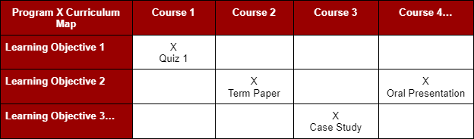

It is recommended that programs map each program learning objective to one course, and align it with one specific assessment method within that course. Programs are welcome to map learning objectives to multiple courses and assessment methods, but should keep in mind that results/findings and actions/improvements will need to be provided for each identified course or assessment method.

Step 3: Creation of student performance assessment criteria (Benchmarks & Timelines) Programs are required to develop performance benchmarks for each program learning objective. Benchmarks are established at the local level and describe the level of performance that is considered acceptable to the program and professional field. Creating a benchmark serves as a point of comparison for your assessment results, and allows instructors to determine at what level students are performing.

Benchmarks facilitate a better understanding of whether students are meeting internal standards of the University and external standards of the field.

Programs are required to develop a predictable timeline for assessment which repeats cyclically.

- Annual Requirements
  - At a minimum, programs must assess at least one program learning objective per year. This offers programs the opportunity to make annual, incremental progress and identify potential areas of improvement.
  - Using the template provided by OEE, programs will submit an annual report to the Office of Educational Effectiveness detailing their annual assessment activities.
- Required Every Five Years
  - Programs must assess all program learning objectives at least once within a five-year cycle.
    - For this reason, OEE recommends developing 3-5 program learning objectives in order to keep annual assessment requirements manageable.
    - Assessment is a cyclical process which repeats upon completion.
  - See the sample timeline below to complete a full assessment cycle within 5 years.

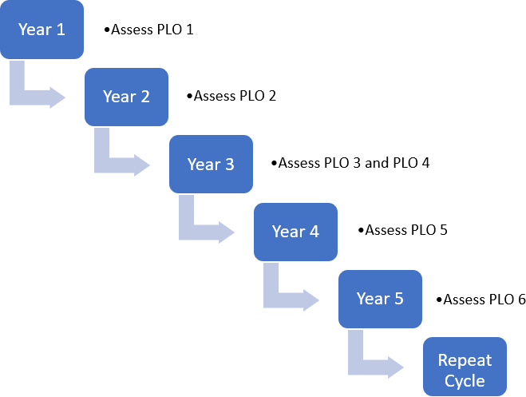

Step 4: A statement of findings and results (Data Collection, Analysis and Reporting)
After conducting your assessment, programs can begin the critical process of collecting evidence, analyzing data, and reporting the findings or results to stakeholders in order to prompt thoughtful discussions on next steps. First, establish a data collection plan by considering the ‘five Ws’:

- Who will collect the data?
- What are you assessing?
- Where will you store the data?
- When is the best time to collect data?
- Why are you assessing a particular course or assignment?

Take stock of the assessment artifacts and evidence at your disposal, and consider data sources that may already exist within the University or within your school, department or program. Programs should collect enough data from direct sources (tests, quizzes, rubric scores, capstone performances, internship evaluations) and indirect sources (surveys, feedback from focus groups, graduation or employment rates) to feel confident about their data and subsequent results.

Next, analyze your data to determine if the benchmark was met, and why or why not.

- Gather all relevant data needed to assess the objective.
- Check the data for errors, missing values or outliers that could impact the accuracy of your results.
- Analyze data to identify trends, patterns, relationships, strengths, weaknesses and areas of improvement.
- Draw conclusions about your data in relation to your PLOs.

Then, prepare a summary of your results and findings to share with relevant stakeholders. Programs will use the standardized report template provided by OEE to document their aggregated data, results and findings for each PLO.

Step 5: A framework for using assessment results to make necessary changes or improvements when benchmarks are not met. (Closing the Loop)
The final and most critical step in the assessment process is "closing the loop," meaning the intentional use of assessment results to inform future actions. The results from the assessment of student learning may not be used for the evaluation of individual faculty or administrators in appointment, promotion or tenure processes. Results will be used to inform continuous improvement or sustainment of excellence of the educational experience. Data from the assessment process may be used to inform changes to the program and/or educational experience, such as resource allocation and management.

Upon reviewing your assessment results, consider the following key questions:

- Was the objective met?
  - If so, what went well?
  - If not, what could be improved next time?
- What meaningful action can the program take to replicate results or improve outcomes in a subsequent assessment?
  - Consider curricular changes, such as revisions to course sequencing, teaching methods, exam questions, etc.
  - Consider administrative changes, such revisions to admissions criteria, advisement processes, student services, program-level policies, etc.
  - Consider resource allocation changes, such as additional teaching assistants, faculty, staff, physical space, software, etc.
  - Consider assessment process changes, such as revisions to PLO statements, curriculum mapping, adjusted benchmarks, etc.

Next, develop an action plan to address the areas that need improvement. The plan should include specific actions, timelines, and responsible parties. Document results in the “Actions/Improvements” section of the report template. Lastly, be sure to revisit the changes implemented to evaluate whether they had the desired impact.

*Note: Procedures are subject to change according to the decisions of the SBU Assessment Council.

