





LMS-Assisted Early Course Outcome Warning System
AIR Forum
May 29, 2024

Nora Galambos, PhD
Senior Data Scientist Stony Brook Univeristy

1

Introduction
- Our institution has for several years used data mining models to predict at-risk students.
- Knowing in the opening weeks of the term what students appear to be struggling has allowed for early interventions.
- The initial focus of the modeling was first-time full-time
freshmen, with the goal of improving freshmen outcomes.
- As success was demonstrated, the modeling expanded to transfer and continuing students.

The initial models focused on the prediction of the first semester GPA of first-time full-time freshmen on day 1 of the semester, and at week 3, and week 6, with the goal of identifying struggling
students before they earn their first low GPA.
The red bars below represent the lowest freshmen GPA decile. Those students have much lower 1- and 2-yr. retention rates

100%
80%
60%
40%
20%
0%
One-Year Retention

Fall 2012 Fall 2013 Fall 2014 Fall 2015
Lowest Decile Decile 2 Decile 3 All Others

100%
80%
60%
40%
20%
0%
Two-Year Retention

Fall 2012 Fall 2013 Fall 2014
Lowest Decile Decile 2 Decile 3 All Others

Motivation
- With the low retention rate of first-time freshmen in the lowest GPA decile, the modeling focused on identifying those students and intervening to avoid the low first-term GPAs.
- Decision tree models were used for predictive modeling.
  - Unlike regression models, decision trees allow variables to be divided into significant splits with different variables associated with different parts of those splits.
  - Decision tree models can also allow all of the missing data to be retained, avoiding the listwise deletion of regression models.

Additional Background
- Educational Data Mining (EDM) continues to expand as Learning Management Systems (LMS) include a greater volume and variety of data in formats that are becoming easier to download and
utilize.
  - Our institution has incorporated logins to the LMS for some time. More recently we have begun working with individual course assignment grades.
- Overall, we have found that harnessing the predictive power of these data can be of great benefit, particularly to students at risk.

Small Section of Decision Tree Model to Predict the First Semester GPA of FT FT Freshmen at
Mid-Semester¹

*Mid-term report from faculty to advisors has mid-term info on students in their class. Many faculty do not participate or only furnish info when a student is at risk, however the modeling method places the missing data in the model where significantly associated.

HS GPA
<94.5
**Data from students who are in classes not using Blackboard can stay in the model. The decision tree method places those values where predicatively appropriate.

Mid Term Report-No Concerns or Missing*

Mid Term Report --Faculty Indicated Concerns

BB Logs As Of Wk.
6 <32.5

BB Logs As Of Wk.
6 >=32.5 or
Missing**

BB Logs per NonSTEM Crs. < 4.4

BB Logs per NonSTEM Crs.
>=4.4 or
Missing**
Predicted Mid-Semester GPA

GPA = 2.29

GPA = 3.00

GPA = 1.17

GPA = 2.39

1Complete tree has over 30 leaves

Model Results
  - Models have demonstrated significant accuracy (actual average GPA for most at-risk groups was within 0.2 grade points of the predicted average GPA) and may be used to develop interventions for at-risk students before they receive final grades.
  - Lower first term average GPAs were associated with
    - Weaker high school records and test scores
    - Lower activity in the Blackboard learning management system (LMS)
    - Enrollment in courses with higher historical rates of students earning course grades of D, F, and W
    - Students receiving mid-term reports of weak performance from their instructor

Learning Management Systems: Blackboard and Brightspace
- Until recently our institution used the Blackboard LMS system.
  - Our modeling has been based on college and pre-college characteristics, as well as Blackboard logins. Our campus IT department provided clean BB
login data.
- Now that our campus is using Brightspace, we are beginning to explore the new types of data which include:
  - Attendance, assignment grades, logins by class, logins by class from a mobile app, learner outcomes for required competencies, data on
Instructor usage of LMS in their courses, competency activity results (data on activities associated with learning objectives that have been created for our org. units), and discussion topic scoring.

Brightspace Class Grade Data
- Contains class grades for all gradable items. Included for each assignment are the numerator points earned, and the total assignment points for the denominator. Assignment category types are also included.
- Brightspace data are provided as CSV files which can be downloaded from the campus Brightspace site.
- Currently, I am cleaning and assembling the data myself, but the hope is that the data cleaning can be transferred to the IT department.
- Although the Brightspace login data was straightforward to handle, the grade data proved to be problematic to download due to the long grader comment text fields which often cause the data to wrap to one, or
sometimes many following lines, making downloading and cleaning the data a challenge.

Summarizing the Course Grade Data for Analysis
- Included in the Brightspace grade data are the points earned for each assignment, the total number of points that can be earned for each assignment, and the date the score was posted.
- In order to calculate the cumulative score:
- Use date arithmetic functions to calculate the number days between the beginning of the term and the date the assignment is graded.
- Use the dates to assign score results to the corresponding week of the term, and then add the score points and the total assignment points by week.
- Add the desired number of weeks together to obtain cumulative numerator and dominator totals, and then divide to obtain the
cumulative percentage score for a given number of weeks to obtain the cumulative score.

PHY 132 – Classical Physics II
Cum. Assignment Averages, Wk. 3*

PHY 132 |  | Course Grade
Wk. 3  Cum. Avg. | Count | A | B | C | D | F | Other
95 - 100 | 614 | 87.3%  76.2%  33.3%  14.3%  33.3%  5.6% | 9.4% | 2.8% | 0.3%  4.8%  6.7%  6.7%  11.1% | 0.2%  7.1%  6.7%  5.6% | 21.4%  20.0%  11.1%
90 - 94 | 21 | 87.3%  76.2%  33.3%  14.3%  33.3%  5.6% | 14.3% | 4.8% | 0.3%  4.8%  6.7%  6.7%  11.1% | 0.2%  7.1%  6.7%  5.6% | 21.4%  20.0%  11.1%
85 - 89 | 15 | 87.3%  76.2%  33.3%  14.3%  33.3%  5.6% | 46.7% | 13.3% | 0.3%  4.8%  6.7%  6.7%  11.1% | 0.2%  7.1%  6.7%  5.6% | 21.4%  20.0%  11.1%
80 - 84 | 14 | 87.3%  76.2%  33.3%  14.3%  33.3%  5.6% | 35.7% | 21.4% | 0.3%  4.8%  6.7%  6.7%  11.1% | 0.2%  7.1%  6.7%  5.6% | 21.4%  20.0%  11.1%
75 - 79 | 15 | 87.3%  76.2%  33.3%  14.3%  33.3%  5.6% | 6.7% | 26.7% | 0.3%  4.8%  6.7%  6.7%  11.1% | 0.2%  7.1%  6.7%  5.6% | 21.4%  20.0%  11.1%
70 -74 | 7 | 87.3%  76.2%  33.3%  14.3%  33.3%  5.6% | 42.9% | 57.1% | 0.3%  4.8%  6.7%  6.7%  11.1% | 0.2%  7.1%  6.7%  5.6% | 21.4%  20.0%  11.1%
60 - 69 | 3 | 87.3%  76.2%  33.3%  14.3%  33.3%  5.6% | 33.3% | 66.7% | 0.3%  4.8%  6.7%  6.7%  11.1% | 0.2%  7.1%  6.7%  5.6% | 21.4%  20.0%  11.1%
Below 60 | 18 | 87.3%  76.2%  33.3%  14.3%  33.3%  5.6% | 27.8% | 38.9% | 0.3%  4.8%  6.7%  6.7%  11.1% | 0.2%  7.1%  6.7%  5.6% | 21.4%  20.0%  11.1%
No Grade Entries | 116 | 23.3% | 22.4% | 23.3% | 9.5% | 11.2% | 10.3%

PHY 132 – Classical Physics II
Cum. Assignment Averages, Wk. 9*

PHY 132 |  | Course Grade
Wk. 9  Cum. Avg. | Count | A | B | C | D | F | Other
95 - 100 | 599  30  21  20  17  10  19  106 | 90.2% 8.0% 1.8%  56.7% 30.0% 10.0% 3.3%  76.2% 19.0% 4.8%  45.0% 50.0% 5.0%  23.5% 47.1% 29.4%  20.0% 70.0% 10.0%  10.5% 52.6% 36.8%  0.9% 12.3% 36.8% 16.0% 15.1% 18.9%
90 - 94 | 599  30  21  20  17  10  19  106
85 - 89 | 599  30  21  20  17  10  19  106
80 - 84 | 599  30  21  20  17  10  19  106
75 - 79 | 599  30  21  20  17  10  19  106
70 -74 | 599  30  21  20  17  10  19  106
60 - 69 | 599  30  21  20  17  10  19  106
Below 60 | 599  30  21  20  17  10  19  106
No Grade Entries | 1 | 100.0%

SOC 105 – Introduction to Sociology Cum. Assignment Averages, Wk. 3

SOC 105 |  | Course Grade
Wk. 3  Cum. Avg. | Count | A | B | C | D | F | Other
95 - 100 | 125  16  23 | 90.4% | 6.4% | 0.8% | 0.8% | 1.6%
90 - 94 | 125  16  23 | 81.3% | 18.8%
85 - 89 | 125  16  23 | 82.6% | 17.4%
80 - 84 | 42 | 45.2% | 23.8% | 11.9% | 7.1% |  | 11.9%
75 - 79 | 14 | 64.3% | 14.3% | 14.3% |  | 7.1%
70 -74 | 6 | 50.0% | 33.3% | 16.7%
60 - 69 | 69 | 20.3% | 24.6% | 27.5% | 18.8% | 2.9% | 5.8%
Below 60 | 96 | 7.3% | 15.6% | 25.0% | 22.9% | 10.4% | 18.8%
No Grade  Entries | 95 | 61.1% | 17.9% | 4.2% | 7.4% | 6.3% | 3.2%

SOC 105 – Introduction to Sociology Cum. Assignment Averages, Wk. 9

SOC 105 |  | Course Grade
Wk. 9  Cum. Avg. | Count | A | B | C | D | F | Other
95 - 100 | 84 | 98.8% | 1.2%
90 - 94 | 80 | 93.8% | 5.0% | 1.3%
85 - 89 | 43 | 83.7% | 14.0% |  | 2.3%
80 - 84 | 41 | 68.3% | 19.5% | 4.9% | 4.9% | 2.4%
75 - 79 | 51 | 31.4% | 43.1% | 17.6% |  |  | 7.8%
70 -74 | 35 | 31.4% | 40.0% | 22.9% |  | 2.9% | 2.9%
60 - 69 | 70 | 4.3% | 27.1% | 35.7% | 17.1% | 1.4% | 14.3%
Below 60 | 82 | 3.7% | 4.9% | 13.4% | 37.8% | 22.0% | 18.3%
No Grade  Entries | 0

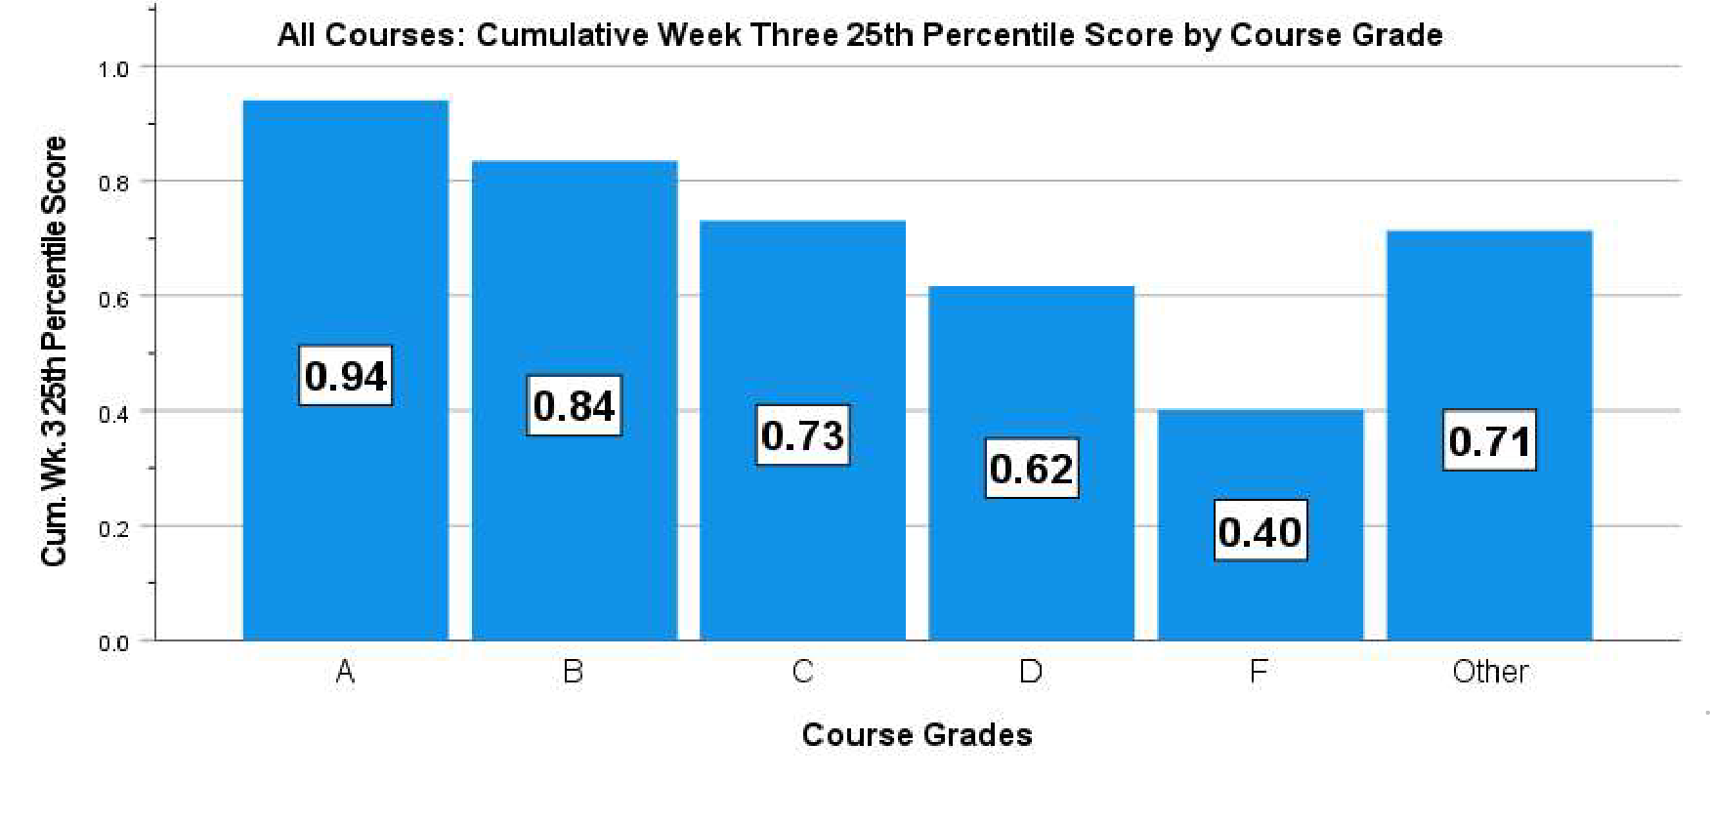
1
All Courses – Cum. 25th Percentile Score at Wk. 3
25% of scores are less than the value shown in the bars.

Median Brightspace Cumulative Course Logins at Weeks 3, 6, and 9

Course  Grade | Median Cum. Course Logins
Course  Grade | Wk. 3 | Wk. 6 | Wk. 9
A | 11 | 22 | 29
B | 11 | 21 | 28
C | 10 | 20 | 27
D | 10 | 19 | 25
F | 8 | 16 | 19
Other | 7 | 14 | 18

Developing Interventions
- The information can be used for targeted interventions designed by various stakeholders, customized for groups of courses, departments, or colleges.
- The amount of faculty involvement will be built into the intervention plans, with the goal of conserving faculty
time, particularly for large courses.
- The course results can be provided in real time and used with other modeling results.

Upcoming Steps
- The Center for Excellence in Learning and Teaching will present results to deans and department chairs to obtain buy-in.
  - Provide additional content materials and resources for students who are struggling in courses early on.
  - Better support for TAs for improved teaching strategies
  - Withdrawing from problematic courses may be suggested to some students where appropriate.
  - Focus on courses with high rates of D’s, F’s, and W’s
  - Continue the use of progress reports, possibly sending them earlier in the semester.




19

Please contact me with your comments or questions.
Nora Galambos, PhD nora.galambos@stonybrook.edu

20

