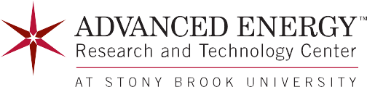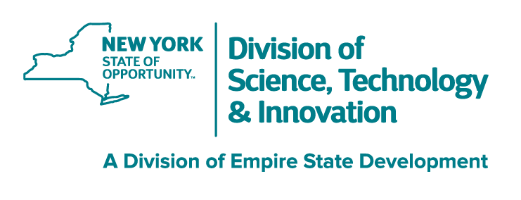
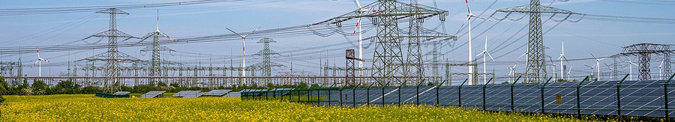

INNOVATIVE RESEARCH, DEVELOPMENT, AND DEMONSTRATION TO MEET ENERGY INDUSTRY NEEDS

Overview
The Advanced Energy Research and Technology Center (AERTC) is located in the Research & Development Park at Stony Brook University and is a true partnership of academic institutions, research facilities, energy providers and industrial corporations. The Center’s mission is innovative energy research, education and technology deployment with a focus on energy storage, transmission, distribution, behind the meter, sustainable fuels, community engagement and workforce development.

AERTC Goals
- To advance a targeted range of sustainable energy technologies by leveraging the competencies of the AERTC faculty, business leaders and students along with the physical capabilities that exist within the facility to help foster collaborative relationships between industry and academia.
- To engineer full scale demonstration and testing facilities to accurately simulate the power generation grid and which will optimize the distribution network, provide alternatives in case of local failures, and provide early warning of sabotage, leaks, or terrorist infringements.
- To design a program of public outreach to the community in order to explain emerging technologies and foster workforce development. This includes:
  - Organize workshops to inform the public of energy policies
  - Outreach to schools through special programs designed for K-12 teachers and their students
  - Develop workforce by supporting the process of awareness, engagement, education, training, upskilling, and retention
  - Sponsor of national and international conferences for leaders in energy research
- Build a state-of-the-art laboratory to model power generation that can test new technologies such as biomass, hydrogen fuels, fuel cells, carbon sequestration, and power cogeneration. This facility will be able to quantitatively evaluate the economic factors of zero emissions power generation and will enable the Center to be a national leader in establishing universal standards for safety and environmental impact for the energy industry.

VISIT OUR WEBSITE FOR MORE INFORMATION


aertc.org

Stony Brook University Research and Development Park • 1000 Innovation Road, Stony Brook, NY 11794 Phone: (631) 216-7400

AERTC Innovation and Exploration


Offshore Wind
AERTC collaborates across several areas of importance to the Offshore Wind market. These include technologies that aid in the design of wind turbines, configuration of the offshore wind farm, high voltage equipment for power conversion, grid modeling
for power distribution, energy storage, and utilization. AERTC also provides offshore wind training, and supports workforce development at the K-12 level.

Electric Grid Modernization
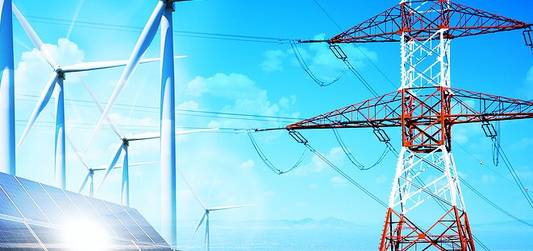
The industry roadmaps for decarbonization rely heavily on electrification of applications from automotive to home heating. New sources of carbon free electricity such as wind, solar and hydro will continue to come online soon. The electric grid requires
modernization to adapt to the changing supply and demand profiles, and is referred to as a smart grid. AERTC, in collaboration with leading researchers at Stony Brook University along with the utility partners, are advancing several technologies to aid this effort.

Hydrogen and Sustainable Fuels
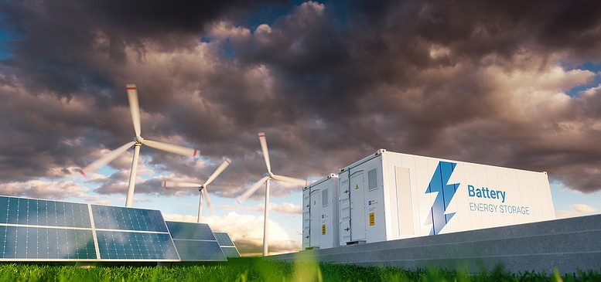
There are certain applications where direct electrification is extremely challenging, if not impossible. Examples include historical buildings, aviation, and shipping. Alternative solutions are required to meet decarbonization goals. Green hydrogen and hydrogen-derived e-fuels can be produced by clean energy sources such as offshore wind, especially in times where supply exceeds demand
in what has become collectively known as the Power-to-X (P2X) process. These fuels are clean energy carriers with many uses.

Energy Storage

AERTC works with a wide range of researchers, start-ups, utilities and industrial companies to development and demonstration a wide range of energy storage devices. Examples include Vanadium Flow Batteries (VFB) and Flywheel Energy Storage (FES) systems.
In partnership with Brookhaven National Laboratory, new material development, characterization, and demonstration at AERTC continue to expand the fundamental understanding of complex battery systems.

Emerging Decarbonization Technologies
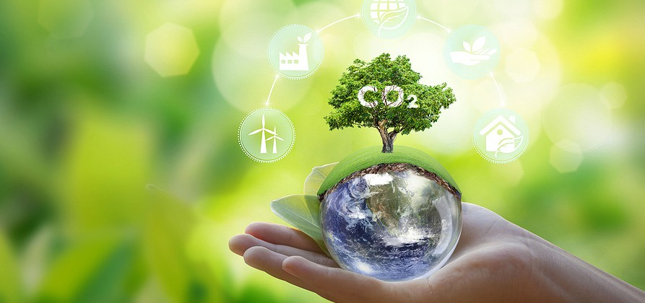
Constantly challenging the status quo, AERTC’s researchers and innovators explore unique solutions to everyday problems.
These applications range from energy efficient remediation of soil
contamination to superconducting material for fusion reactors. Collaborations draw on a deep pool of talent including Stony Brook University faculty, graduate students, industrial innovators, and nationally recognized technology leaders from Brookhaven National Laboratory and elsewhere.

Stony Brook University is an equal opportunity educator and employer. This publication can be made available in an alternative format upon request.

