Graduate Program in Genetics


Stony Brook University College of Arts & Sciences
Doctoral Dissertation Defense

Metformin impairs myelin quantity and quality during development

Maryam Azmi
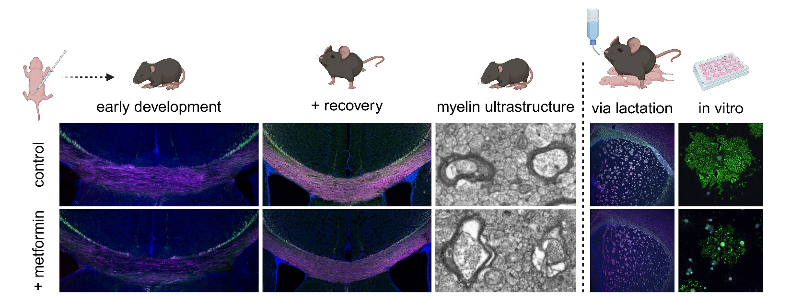
Advisor: Dr. Holly Colognato

July 21, 2026 12:00 p.m.
Basic Sciences Tower 8th Floor, Seminar Room 180 (BST 8-180)
To Join Virtually Click Here
Meeting ID: 946 0184 9783
Passcode: 134416

Stony Brook University Cold Spring Harbor Laboratory Brookhaven National Laboratory

