Graduate Program in Genetics


Stony Brook University College of Arts & Sciences
Doctoral Dissertation Defense

Understanding the effects of modifiable life events on mammary immunity and the risk of mammary tumorigenesis

Dhivyaa Anandan
Advisor: Dr. Camila dos Santos

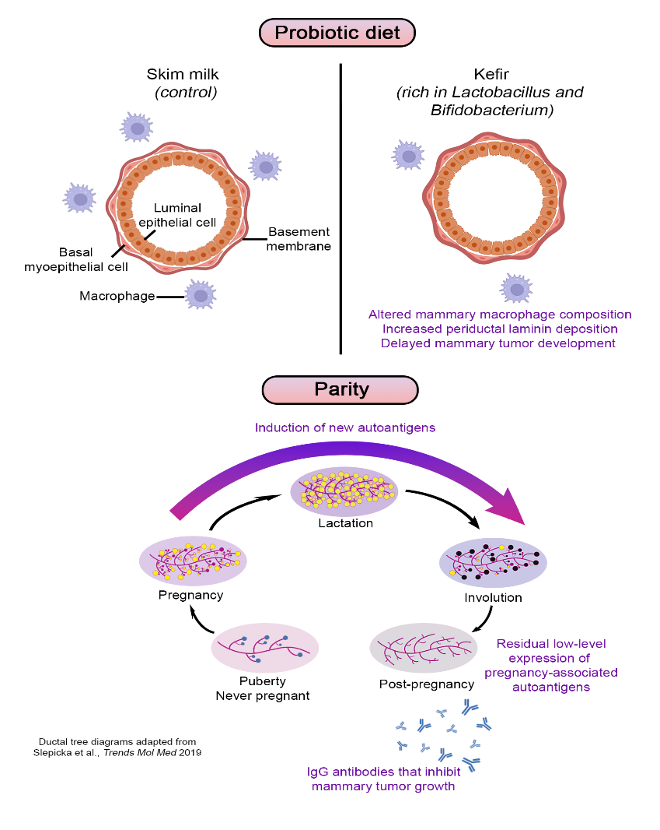

October 14, 2026 11:00 a.m.
Bush Auditorium, Cold Spring Harbor Laboratory

To join virtually: https://zoom.us/j/92038634295?pwd=Mx4IfKCnaGP6187BjCN78c2RmGnXYb.1
Meeting ID: 920 3863 4295; Passcode: 671000
Stony Brook University Cold Spring Harbor Laboratory

