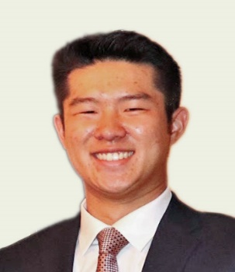 | Gabriel Chan: Gabriel graduated with a BA in Biochemistry from Columbia University in 2023 and then completed a master's at ENS Paris-Saclay as a Fulbright Scholar. In 2024, he joined the MSTP at Stony Brook and is now working in Lucas Cheadle’s lab at CSHL investigating how neuro-immune interactions in glioblastoma drive or inhibit tumor progression.  Likes: Volleyball, football (Go Bills), cooking, and spending time with his cat Raphael
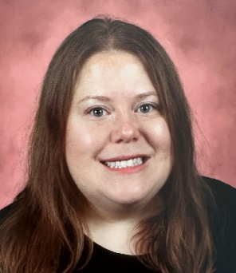 | Kimberly Elicker: Kimberly graduated from Williams College with a double major in Biology and Mathematics. She then spent several years teaching high school math and science in New York City public schools through Math for America. The COVID-19 pandemic drew her back to science, and she joined Dr. Lamia Wahba's lab at Rockefeller University as a research assistant, studying how small RNA pathways safeguard genome integrity in the C. elegans germline. She is interested in RNA-mediated genome defense.  Likes: Reading, board games, and exploring the historical sites of Long Island
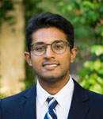 | Arun Krishnaraj: Arun earned his bachelor's degrees in mathematics and computational biology from the University of Texas in 2021. He went on to complete a Master’s in Bioinformatics at Georgetown University, where he worked with Dr. Sreejith Nair to investigate transcriptional regulation and the off-target effects of platinum chemotherapeutics in cancer. In 2024, Arun joined the MSTP at Stony Brook University, and he is excited to conduct his dissertation research in the lab of Dr. Gilbert Rahme.  Likes: Backpacking, tabletop gaming, and a good cup of coffee
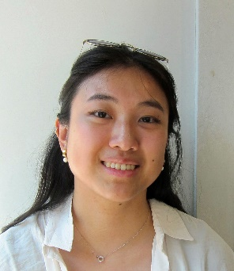 | Jessie Zhang: Jessie graduated with a B.S. in Biology and a minor in Mathematics from NYU Shanghai in 2021. After graduation, she worked as a junior laboratory associate in Dr. Andreas Hochwagen’s lab at NYU studying the regulation of meiotic chromosome inheritance. She joined the MSTP at Stony Brook in 2024 and is completing her dissertation research in the lab of Dr. Jonathan Nelson.  Likes: Crocheting, baking, rock climbing, trying out new restaurants

