Contents
What is SBU Research Connect? 2
Logging in to SBU Research Connect 3
Viewing your SBU Research Connect Profile 4
Updating your SBU Research Connect Profile 5
Update Personal Profile data 5
Add Research Content to Profile 7
Add a “Trusted User” to make changes on your behalf 10
Toggle Award Amount Visibility on the Portal 11
Toggle Award Visibility on the Portal 12
Request Help 13
Content which can’t be updated in SBU Research Connect 14

What is SBU Research Connect?
SBU Research Connect is a comprehensive and accessible portal that empowers discovery, collaboration, and innovation among researchers within SBU and beyond.
The Research information management system is built on Elsevier’s Pure software. It includes a public-facing portal https://stonybrook.elsevierpure.com, which is a custom-branded instance of the SUNY Research Connect platform built specifically for Stony Brook University. Faculty profiles will appear in both the SUNY Research Connect Community Portal and the SBU Research Connect portal.
The Pure software also includes a back-end administrative system enabling reporting and features for researchers with profiles to login and edit their own data. SBU researchers and their trusted designees can update their profiles by adding additional biographical information, research interests, links, or publication information not automatically indexed in Elsevier’s Scopus database.

Logging in to SBU Research Connect
- Click link: https://stonybrook.elsevierpure.com/admin/
- Sign in through SBU Secure Sign On using your SBU campus credentials.
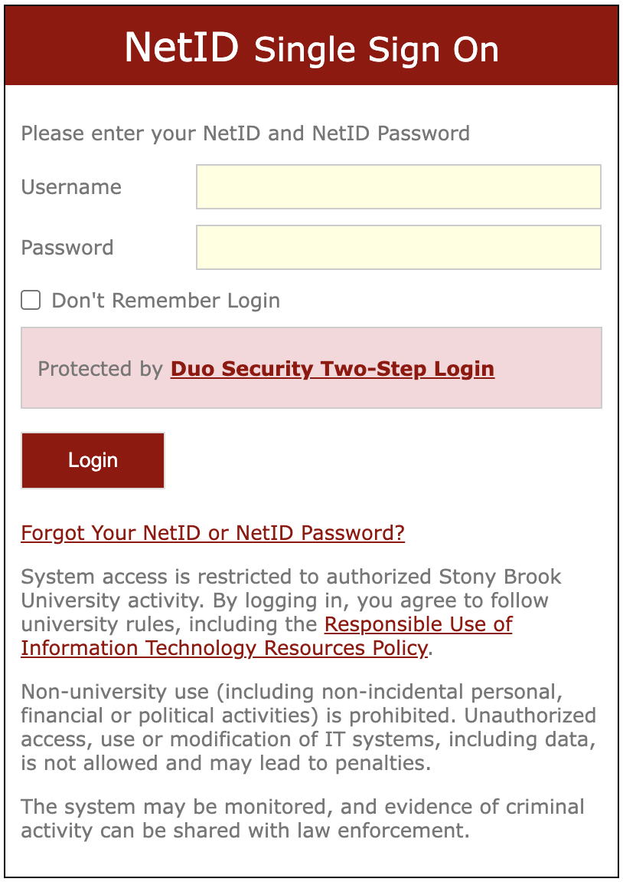

Viewing your SBU Research Connect Profile
- Upon logging in, you will see your profile picture, research outputs, PlumX metrics, Projects (i.e., Sponsored Awards), and research network
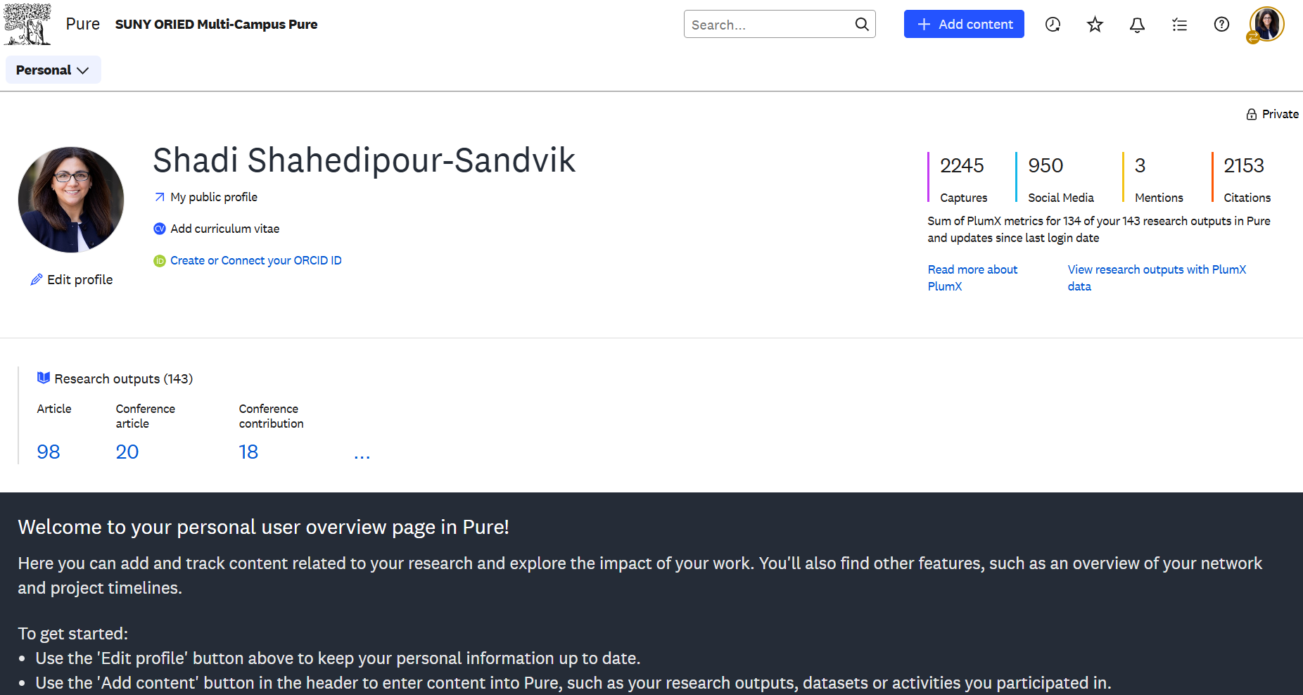
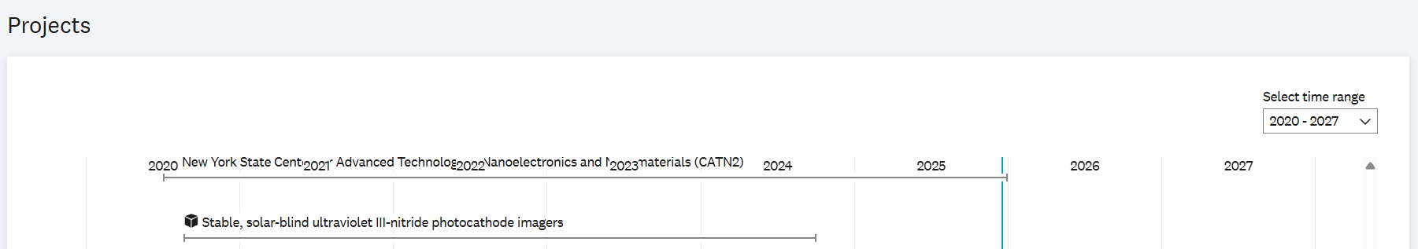
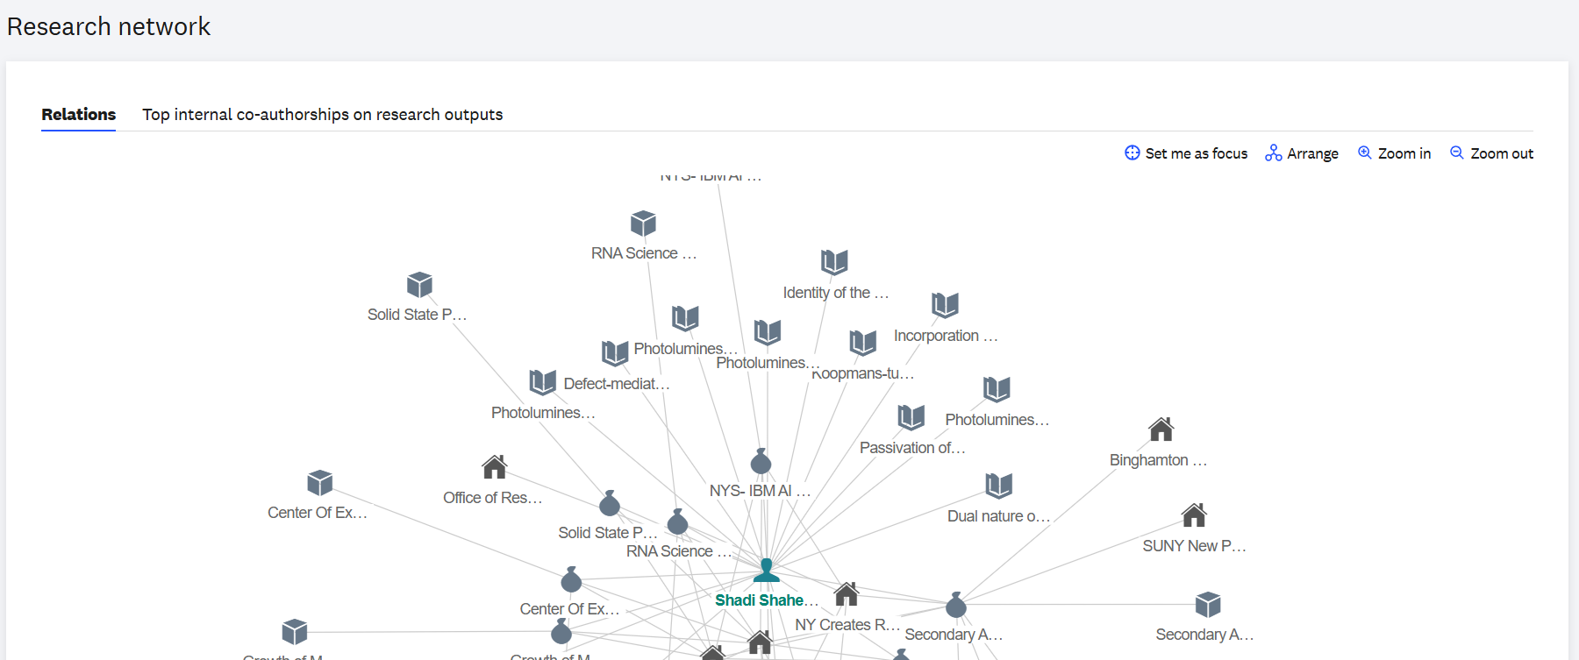

Updating your SBU Research Connect Profile

Update Personal Profile data
Link to Elsevier Pure Help Center - Take Advantage of the Person Profile, Name Variants in Pure
- To update personal data (pictures, links, research interests, etc.), click “Edit profile”
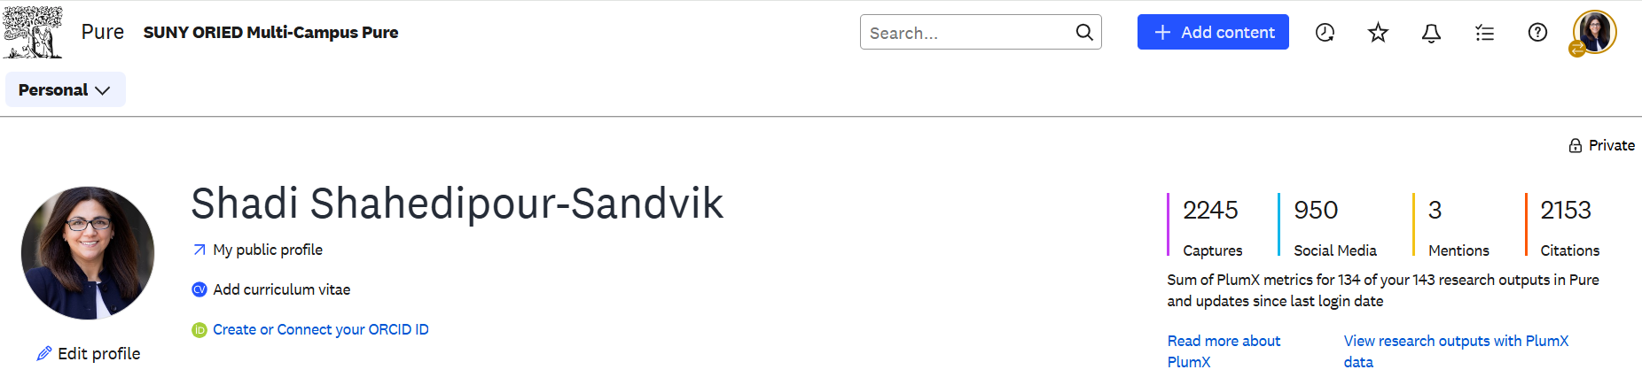
- Edits can be made wherever you see an “Add…” button or an “Edit” button except:
  - Scopus Author IDs which are required to maintain up-to-date publications
    - Removing this will sever the link to your publication feed
  - Where you see a circle with two arrows () which indicates that the data is synchronized via our internal data update process
    - If you change this, it will get overwritten during the next data sync
- Click “Save” button at bottom of the screen
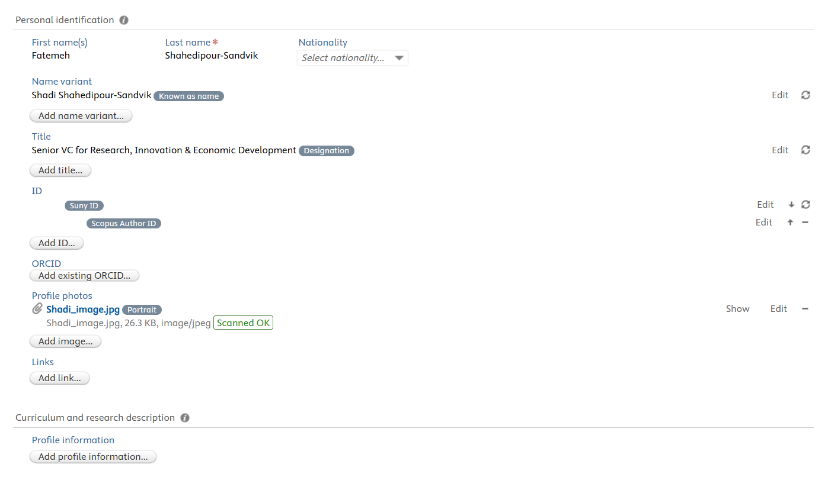
- It may take up to 36 hours for updates to show in the SUNY Research Connect Community portal.
- To remove fingerprints from your profile
  - Click the “Fingerprints” button on the left-hand panel
  - To remove individual fingerprints, click the red “X”
  - To remove all fingerprints within a specific discipline, toggle the “On” button to “Off” to the right of the discipline.
  - Click “Save” button at bottom of screen
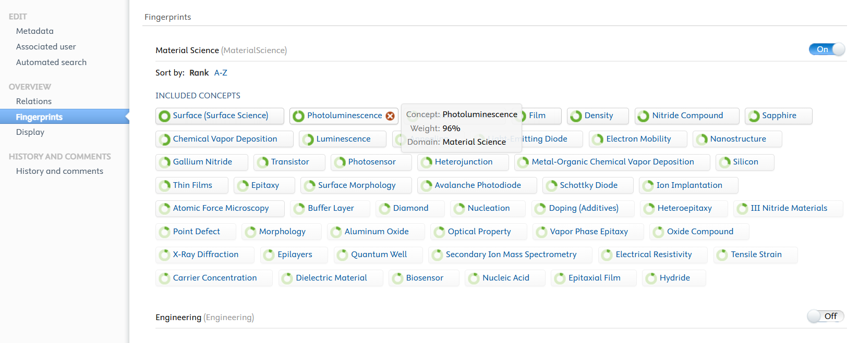
- Changing Profile Visibility
  - Scroll all the way to the bottom of the edit profile screen
  - Change the ‘Visibility’ setting
    - Public – The profile will be shown on the public portal
    - Campus – This is NOT currently configured
    - Backend – This will hide the profile on the public portal but still show to authenticated users with proper access
  - Save the record
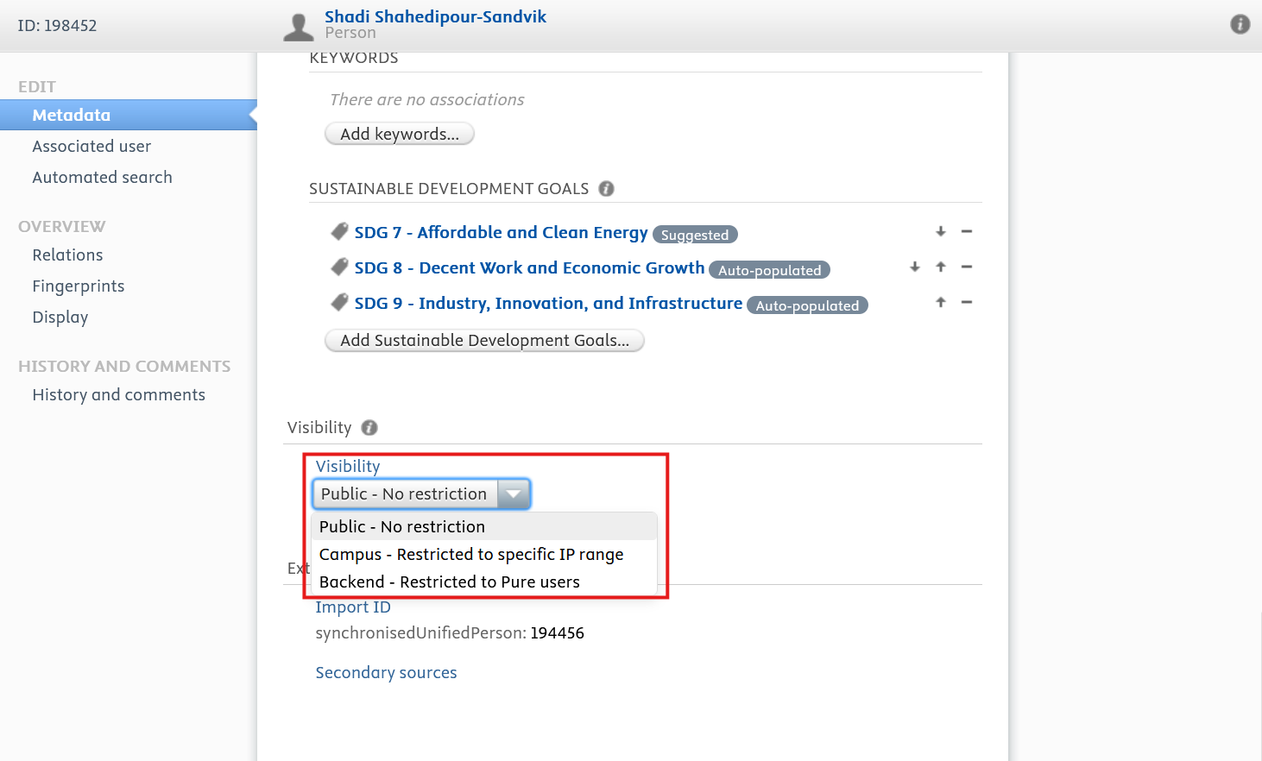

Add Research Content to Profile
- Select the content type you’d like to edit by clicking the down arrow next to the “Personal” drop down or click hyperlinked data within the profile. You are adding information about or links to each content type, instead of uploading the scholarly work to each section.
  - Note, you can only add content for types which have the “+ Add new” button
    - Research output: you have the option of adding publications or scholarly works that are NOT automatically associated with your profile in Scopus
    - Activities: Examples include but are not limited to organizing conferences, publication peer-review, memberships (board, committee, council, etc.), invited talks, and consultancy(ies)
    - Prizes: Recommend adding professional prizes only to this section
    - Datasets: share links to your published datasets
    - My curricula vitae: generates a CV in one of several formats
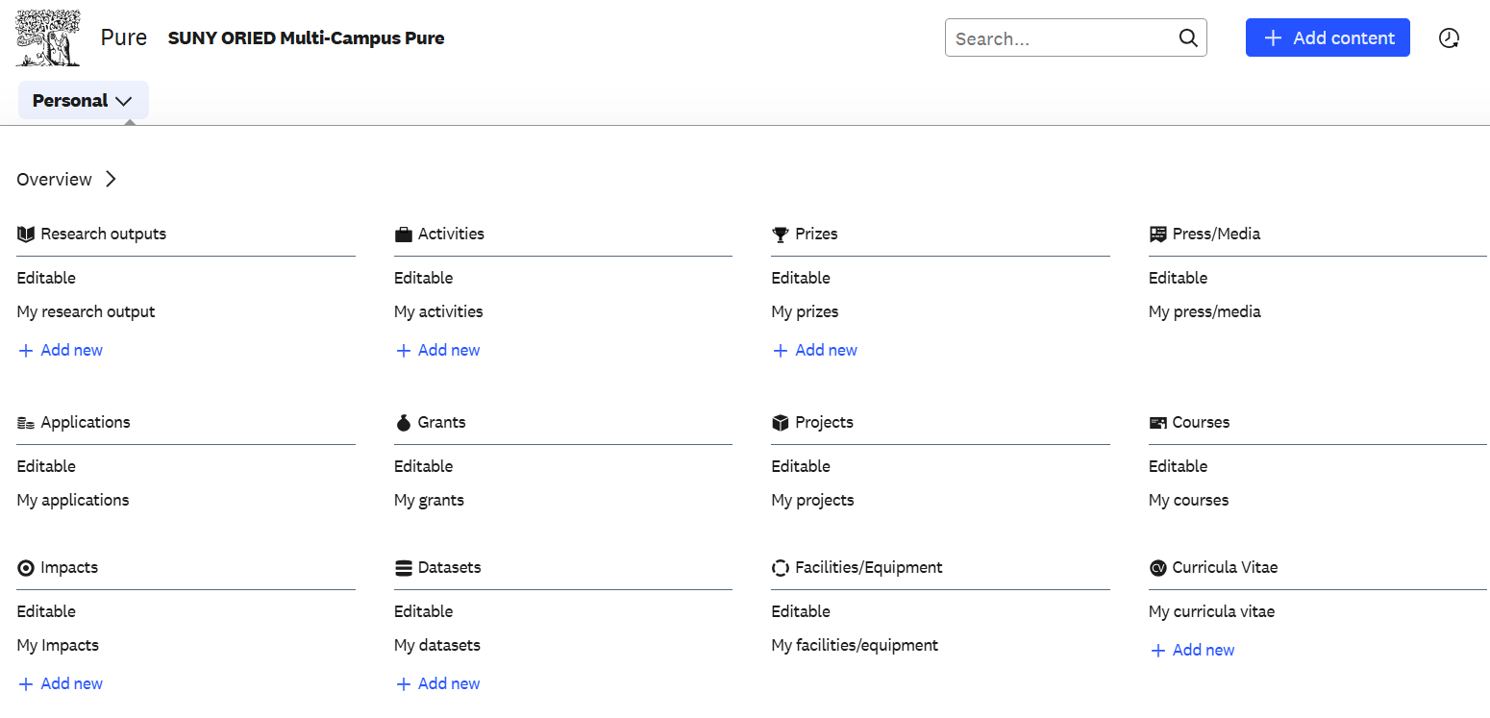
- To manually add data, fill in all available data and click “Save” button at the bottom
  - All data with a red asterisk next to it must be completed to save the record
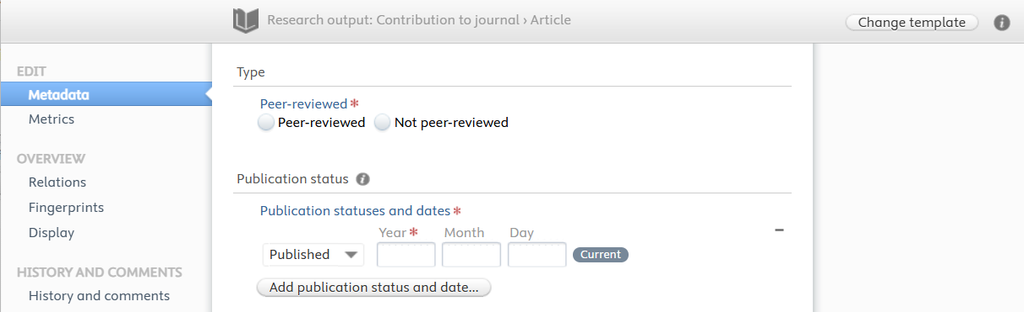
- For Research outputs specifically, you have the options of setting up integrations with specific external data sources and/or importing documents from specific file types
  - Integrations: Integrations have been enabled with PubMed and ORCID. To add additional publications via available integration (i.e., PubMed, ORCID), click “Research outputs” and “Import from online sources”. You will have the option to search for individual publications (via “Query”) or to “Set up automatic search”.
    - Link to Elsevier Pure Help Center - Setting up the ORCID ID on a Person
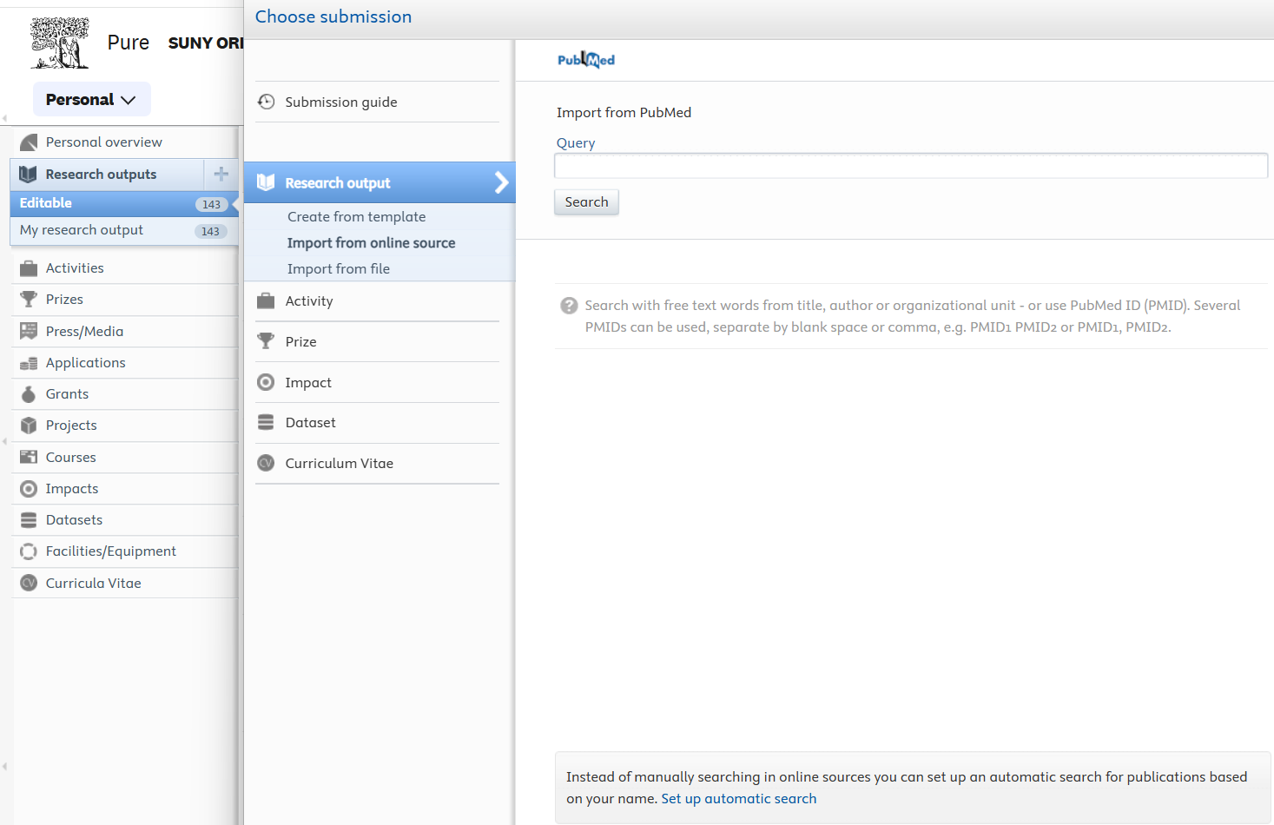
    - Surfaced publications will appear in the Task List. Then the Researcher or a “Trusted User” / “Editor” needs to “Import” to add the publication to the researcher’s profile. If it is incorrectly associated with the researcher, click “Remove” to remove it from the Task List.
      - This is a platform requirement, not a SBU one.
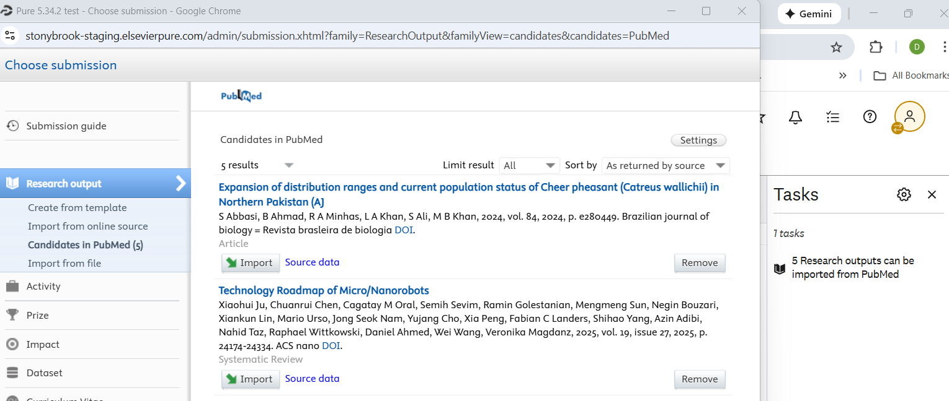
  - Importing: To add additional publications via file import (i.e., OpenAIRE, BibTex, RIS), click “Research outputs” and “Import from file”. Once you select the file type, you will have the option to “Paste text” or “Upload file” then click “Import”.
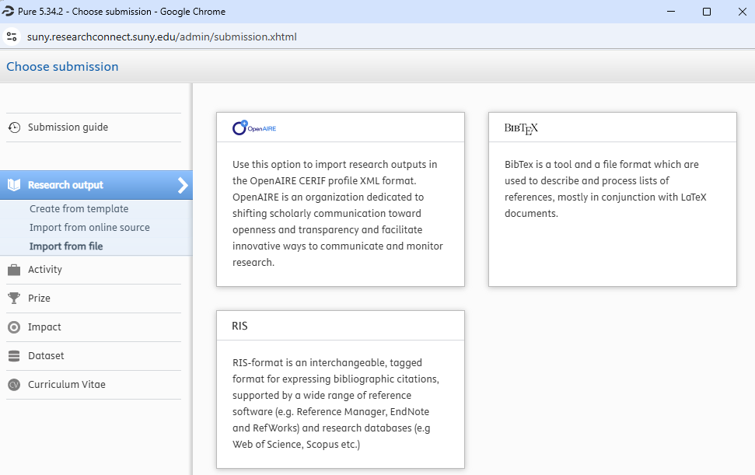

Add a “Trusted User” to make changes on your behalf
Link to Elsevier Pure Help Center - Add a Trusted User, Users as Only Trusted Users
- Click the Profile Menu (profile picture or ) icon at the top right corner of the screen then select “User settings”
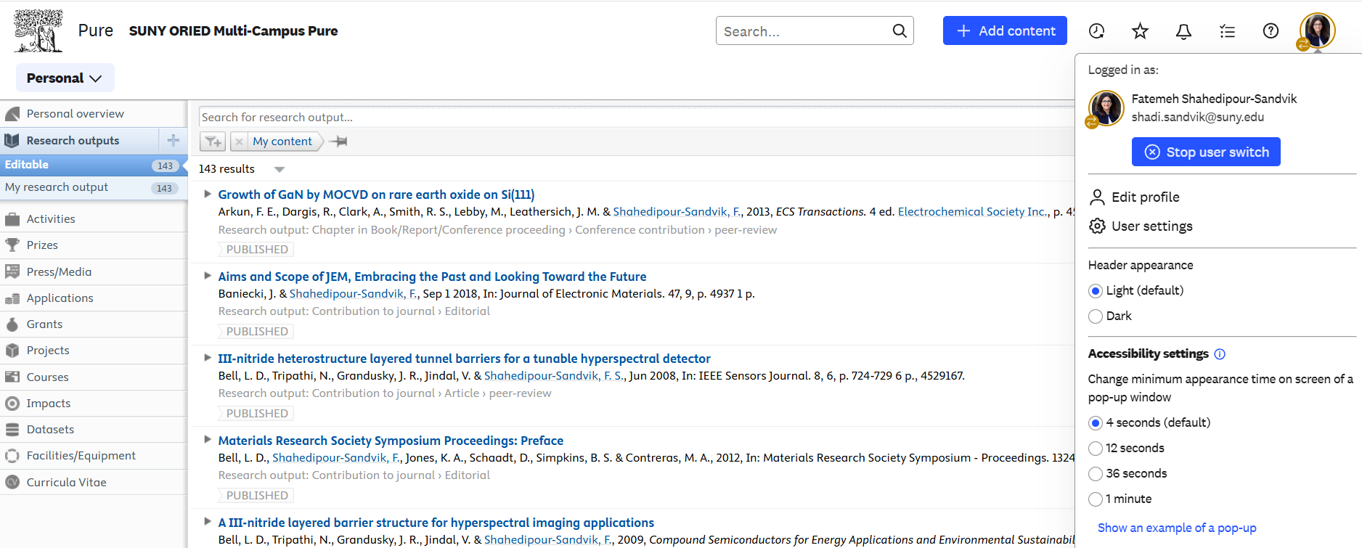
- Scroll down, click “Trusted User”, search for the user’s name, then click save at the bottom of the screen
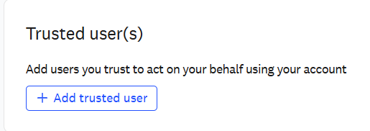

Toggle Award Amount Visibility on the Portal
Awards in SBU Research Connect are listed as both an Award and Project. Awards contain the awarded amounts, and the Project is what is shown on the Portal. To remove the award amount but leave the award itself on the portal, follow these steps:
- In the top left of the screen, click ‘Personal’
- Select ‘Grants’
- Search for the award you are looking for and click on it
- In the top left corner of the screen, switch from the eye to the pencil
- Scroll all the way to the bottom and select Visibility à Backend or Confidential
  - Public – Visible on Public Portal
  - Campus – NOT configured for use
  - Backend - Visible on the backend to any authenticated SBU Research Connect user
  - Confidential – Visible on the backend to only administrators or users associated with the award
- Save the record at the bottom
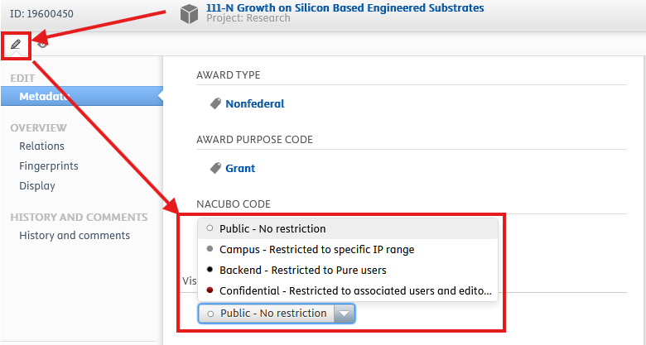

Toggle Award Visibility on the Portal
Awards in SBU Research Connect are listed as both an Award and Project. Awards contain awarded amounts, and the Project is what is shown on the Portal. To remove the Award from the portal entirely, follow these steps:
- In the top left of the screen, click ‘Personal’
- Select ‘Projects’
- Search for the award you are looking for and click on it
- In the top left corner of the screen, switch from the eye to the pencil
- Scroll all the way to the bottom and select Visibility à Backend or Confidential
  - Public – Visible on Public Portal
  - Campus – NOT configured for use
  - Backend - Visible on the backend to any authenticated SBU Research Connect user
  - Confidential – Visible on the backend to only administrators or users associated with the award
- Save the record at the bottom

Request Help
- Click “History and comments” then click “Write a comment about the content” button
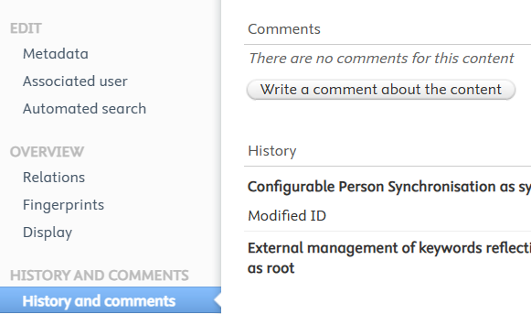
- Write your comment / question and select which campus administrators to which the comments / questions will be routed
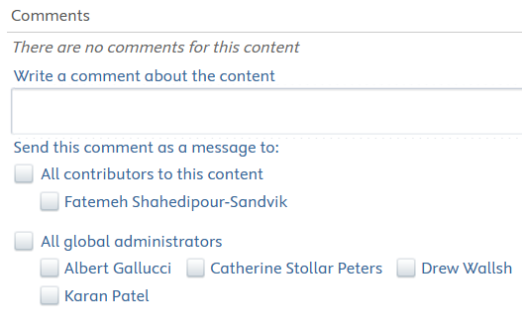

Content which can’t be updated in SBU Research Connect
- Persons (personal profile information):
  - Name (You may add a name variant)
  - Title
  - SUNY ID
  - Scopus Author ID
  - RF Employee ID (if pre-populated)
  - Campus ID (if pre-populated)
  - Organizational Affiliation (you can add additional organizational affiliations, edit your affiliation start date and/or update your e-mail address)
- Grants / Projects (click the pencil icon at the top left corner of the screen)³:
  - Classifications
    - Grant type
    - Project type
  - Identification
    - Title
    - Project ID (i.e., Report Center “Award Number”)
  - Grant holders / Participants
    - PI
    - Co-PI
    - Co-I
  - Grant / Project managed by
    - Managing organizational unit
  - Collaborative partners
    - Collaborative grant
    - Collaborative project
  - Funding (Grant only)
    - Financial
      - Note, you can hide this by clicking “Edit” and changing “Visibility” at the bottom of the screen
  - Life cycle
    - Actual start date
    - Actual end date
    - Award date
  - Related Project / Related applications and grants
  - AWARD PURPOSE CODE
  - AWARD TYPE
  - NACUBO CODE

Persons data is sourced from Stony Brook University HR and RF HR. Grants and Projects data is sourced from RF Sponsored Program data. To change the above data, make changes in the respective source systems and the data will flow through to SBU Research Connect.

