
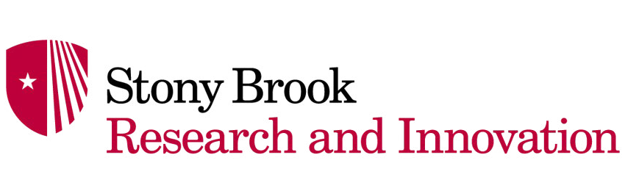

The WOLF DEN

Where Investors Meet Innovators

Sponsorship Brochure

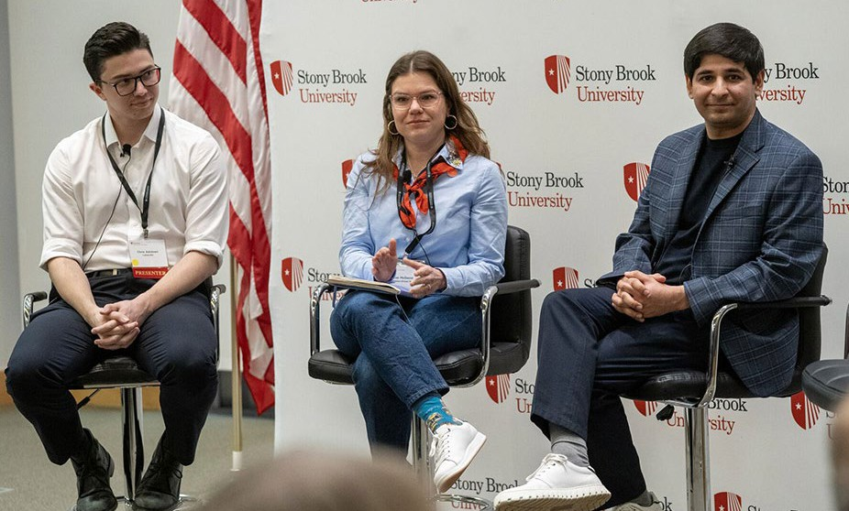
What is The Wolf Den
The Wolf Den is a premier event hosted by Stony Brook University’s Office for Research and Innovation, serving as a vital hub
“Where Investors Meet Innovators”. Designed to bridge the gap between scientific discovery and commercial success, the event brings together investors, researchers, startup founders, and industry leaders to spark collaboration and accelerate technology development
and commercialization across Long Island.
Each installment spotlights relevant themes to founders such as AI implementation and fundraising strategies through dynamic panel discussions and founder-led conversations. These firsthand
“founders’ journeys” highlight the challenges and momentum behind
building successful ventures, while structured and informal networking
connects attendees with emerging startups and critical resources.
The Wolf Den helps innovators move “further, faster - together”.
Sponsoring the Wolf Den offers a unique opportunity to align your organization with a high-impact innovation ecosystem.
Your support directly contributes to regional economic growth and technology advancement while positioning your organization at the forefront of innovation and entrepreneurship.

Compelling Reasons to Support at Any Level

Regardless of the tier chosen, supporting The Wolf Den provides your organization with the following advantages:
- Access to Top Talent and Innovation: Connect directly with investors, researchers, startup founders, and industry leaders.
- Visibility in a Growing Ecosystem: Be recognized as a key supporter of collaboration and innovation-driven success across the region.
- Insight into Emerging Tech: Gain firsthand knowledge of the latest breakthroughs and meet the researchers and entrepreneurs behind these innovations.
- High-Impact Networking Opportunities: Build impactful relationships through both structured and informal networking with regional innovation leaders.

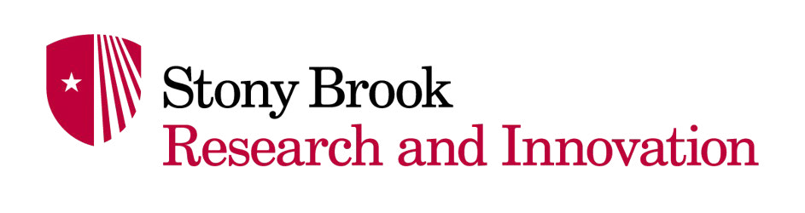
Platinum Sponsorship* - $7,500

Benefits

Promotion
- Sole logo and name on invitations, emails, website and social media
- Logo on signage at the event (not including reusable entrance banner)
- Logo alongside SBU logo on badges
- Sponsor participation in Wolf Den podcast or vlog episode

Program Development
- Opportunities for sponsor participation in the development of event theme, content, and presentations
- Acknowledgement during welcome remarks and three to five minutes (welcome) opportunity

Branding

Sponsorship Visibility:
» Logo/bio on all event print/web collateral
» Logo and 200 word company bio on Wolf Den and Innovation websites
» Logo on CEWIT lobby video wall
» Table for promotional material and swag in event room

Press Opportunities:
» Exclusive press opportunities during event with attending media
» Include in post-event story with quote

*On-site at CEWIT only

Gold Sponsorship - $4,500

Benefits

Promotion
- Logo and name on invitations, emails, website and social media (possibly shared)
- Logo alongside SBU logo on badges (maximum three logos)

Program Development
- Opportunities for sponsor participation in the development of event theme and content
- Acknowledgement during welcome remarks and one to three minutes (welcome) opportunities

Branding

Sponsorship Visibility:
» Logo/bio on all event print/web collateral
» Logo and 120 word company bio on Wolf Den and Innovation websites
» Logo on CEWIT lobby video wall
» Table for promotional material and swag in event room

Press Opportunities:
» Include in post-event story with quote

Silver Sponsorship - $2,500

Benefits

Promotion
- Logo and name on invitations, emails, website and social media

Program Development
- Acknowledgement during welcome remarks

Branding

Sponsorship Visibility:
» Logo/bio on all event print/web collateral
» Logo and 75 word company bio on Wolf Den and Innovation websites
» Logo on CEWIT lobby video wall
» Table for promotional material and swag in the CEWIT lobby near registration

Press Opportunities:
» Sponsorship mentioned in post event story

Supporter Sponsorship - $1,000

Benefits

Promotion
- Logo and name on invitations, emails, website and social media

Program Development
- Acknowledgement during welcome remarks

Branding

Sponsorship Visibility:
» Logo/bio on all event print/web collateral
» Logo and 50 word company bio on Wolf Den and Innovation websites



FOR MORE INFORMATION
Scan the QR Code to learn more or visit The Wolf Den website
Contact
Sponsorship Coordinator: Kathleen Ferrell
631-216-7114
kathleen.ferrell@stonybrook.edu

The Wolf Den

Stony Brook University/SUNY is an equal opportunity educator and employer. This document is available in alternative format upon request. Contact 631.216.7114.

