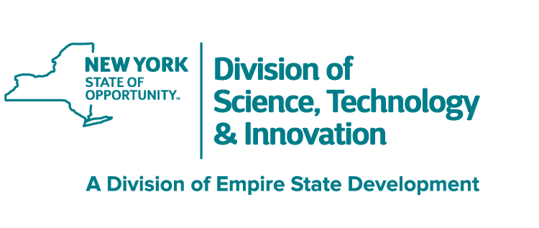



EMPOWERING LONG ISLAND MANUFACTURERS: FUELING GROWTH, INSPIRING INNOVATION

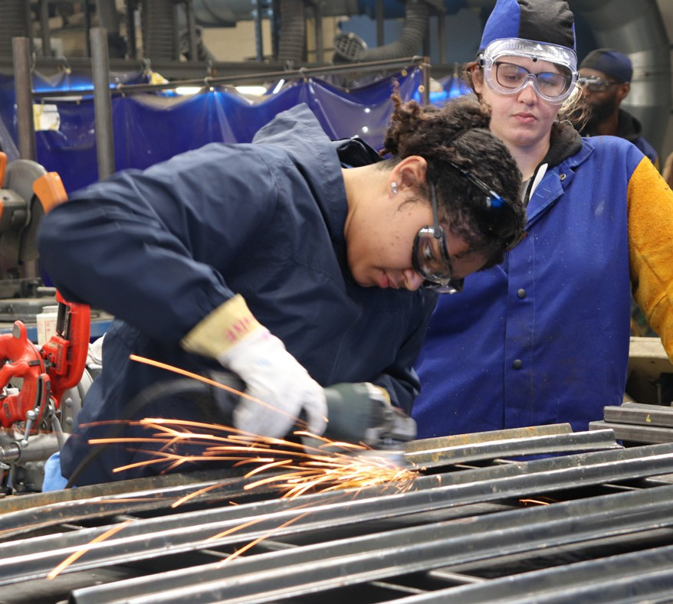
Overview
The Long Island Manufacturing Extension Partnership (LIMEP) at Stony Brook University is Empire State Development’s Regional Manufacturing Extension Partnership (MEP) center for the Long Island region.
We are one of the ten centers within the NIST NY-MEP program, with FuzeHub being the state-wide MEP center.
LIMEP is designed to assist small to medium-sized manufacturing companies develop business growth and increase competitiveness through training, workforce development, revitalization or renewal of their product lines.

Our Mission
LIMEP provides growth and innovation resources to small - and medium-sized Long Island manufacturers of all kinds, assisting them with creating and retaining jobs, increasing profits, and saving time and money through consultant experts and workforce training. To engage with larger companies to assist the small- and medium-sized companies in their supply chain.
And to support biotechnology, our region’s priority industry cluster.

Our Vision
LIMEP is the go-to resource for all small- and medium-sized Long Island manufacturers. LIMEP will work collaboratively with our internal experts, regional partners, and New York State MEP centers to connect needed resources to manufacturers.

What LIMEP Can Do For You
LIMEP encourages the strength and competitiveness of LI regional manufacturers by providing onsite technical assistance through manufacturing engineering assessments, coaching, training, and consulting, collaboration-focused industry programs, and leveraging government, university and economic development partnerships.

CHECK OUR WEBSITE FOR MORE INFORMATION
www.limep.org

Stony Brook University is an equal opportunity educator and employer. This publication can be made available in an alternative format upon request.

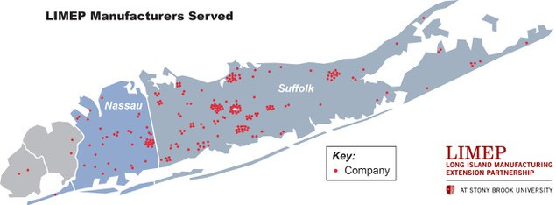
Services We Provide
- Innovation strategies
- Process improvements
- Quality control
- Manufacturing scale-up
- Sustainable manufacturing
- Supply chain assistance
- Technology acceleration
- New market strategies
- Product development and prototyping
- Entrepreneurial and startup assistance including financing and grant information
- Other services tailored to key NYS industry clusters

Our Projects
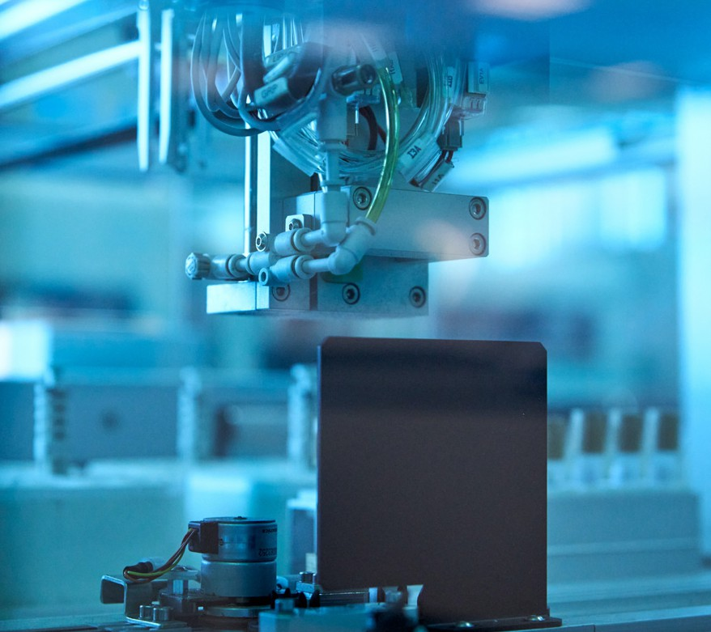
Here are the types of manufacturing projects that LIMEP currently supports:
- Lean
- Quality
- Growth
- Sustainability
- Strategic Planning
- Technology
- Financial Analysis
- Sales/Marketing
- Engineering
- Cybersecurity
- Workforce information
- Other services tailored to key NYS industry clusters

Contact Us

Amy Erickson
Executive Director
(631) 216-7516 • (631) 848-7557
amy.erickson@stonybrook.edu

Maheen Khan
Events, Grants Advocacy & Partnership Specialist maheen.khan.1@stonybrook.edu
Stony Brook University • CEWIT, Research and Development Park 1500 Stony Brook Road, Stony Brook, NY 11794-6040
Phone: (631) 216-7100 • Email: info_limep@stonybrook.edu

