- Jonathan Sanders, PhD  jonathan.sanders@stonybrook.edu  212-452-9623  Zoom office hours by request  Read Daily  The NYTimes  International  Section  AP/Rahmat Gul  WEEK 1  26 August  W””Our mission is to speak truth to power. We send home the first rough draft of history. We can and do make a difference….”  --Marie Colvin  https://mariecolvin.org/archive  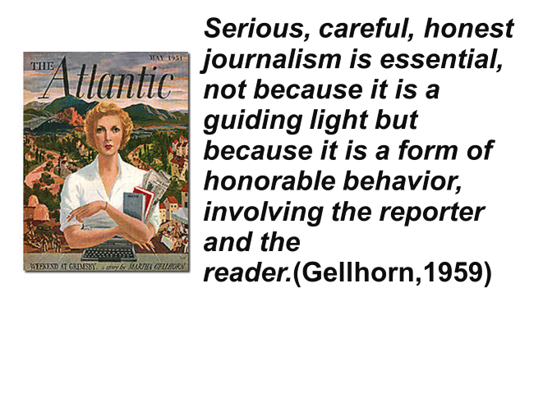  Week 2 2 Sept  "(The foreign correspondent) .. must ever be at the post of danger, for that is also the point of observation...For the sake of the public at home they must take every precaution to preserve that human camera from hurt, yet in order to fix their lens on the objects to be seen they must continually expose it to imminent peril of destruction." The London Review of Reviews on Creelman  1 October 1898  WEEK 3 9 Sept  “I think all education, all scholarship is ultimately an aspect of citizenship…Education is always about how to live in the world…to prepare one for life in society, for public life in the widest sense…”  James W. Carey  Week 4 16 Sept  “I want my pictures to cut through political abstractions…and make a connection on a human level. ..I don’t believe there’s such a thing as objective reality. It’s only reality as we experience it.”  – James Nachtwey  “The press is a watchdog. Not an attack dog. Not a lapdog. A watchdog. Now, a watchdog can't be right all the time. He doesn't bark only when he sees or smells something that's dangerous. A good watchdog barks at things that are suspicious.”  Dan Rather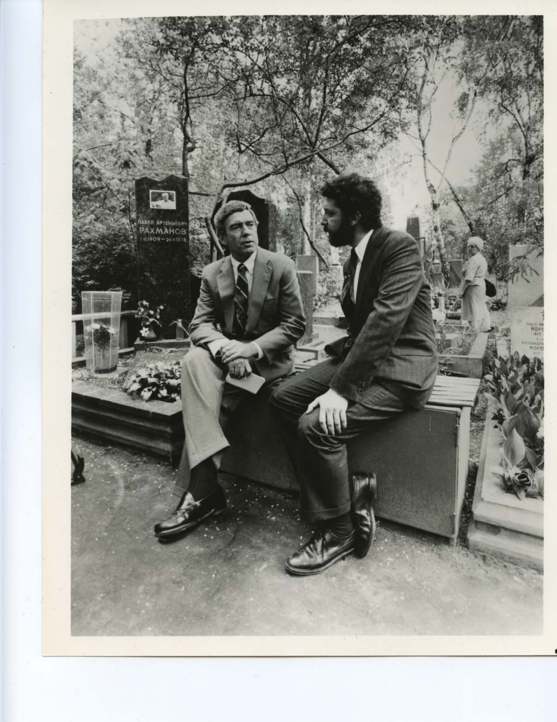  WEEK 5 23 Sept  “This program is not a place where personal opinion should be mixed up with ascertainable facts...It is not, I think, humanly possible for any reporter to be completely objective, for we are all to some degree prisoners of our education, travel, reading—the sum total of our experience.”  Edward R. Murrow  “If your pictures aren't good enough, you aren't close enough.”  Robert Capa  WEEK 6 30 Sept  “When people talk, listen completely. Most people never listen.”  Ernest Hemingway  “Journalism is printing what some else does not want printed: everything else is public relations.”  G. Orwell  “  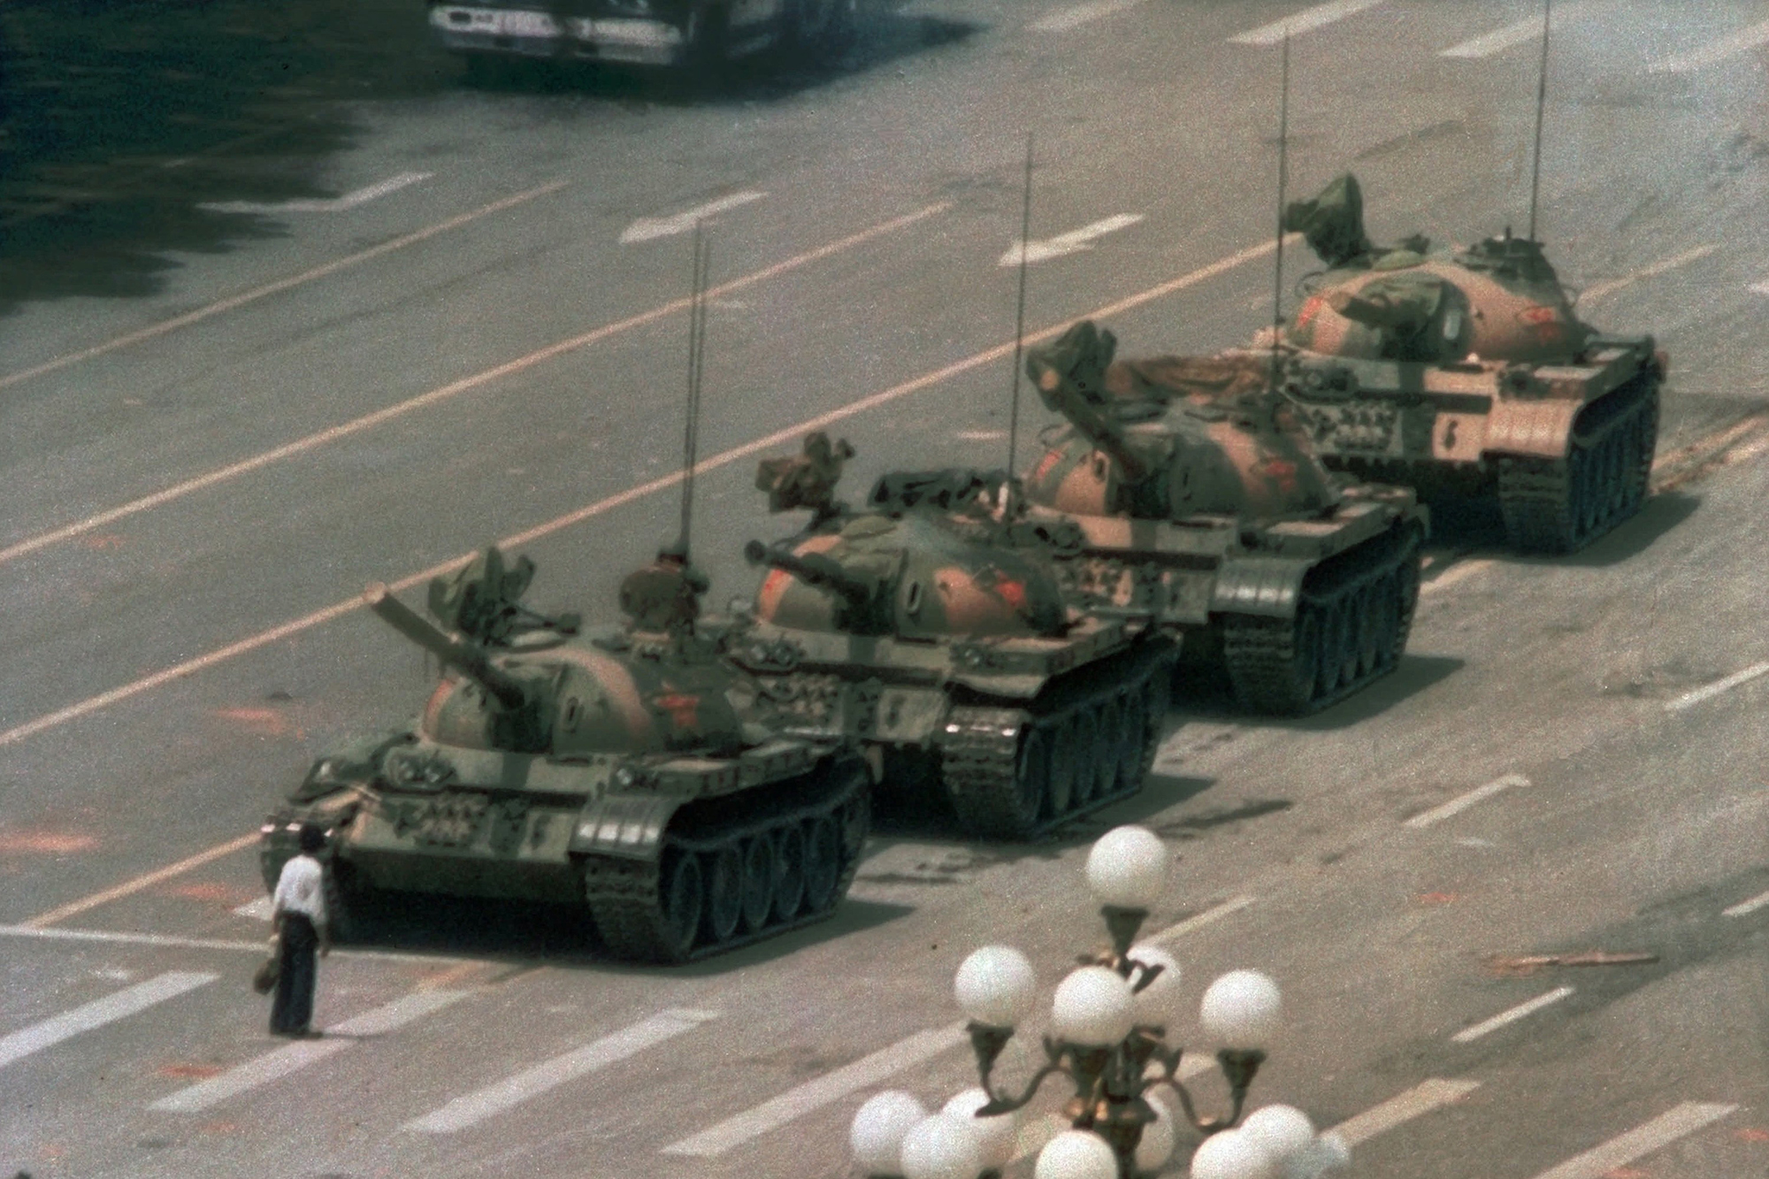  WEEK 7 7 October  "Do not suppose, first of all, that Mao Tse-tung could be the "saviour" of China. Nonsense. There will never be one "saviour" of China. Yet undeniably you feel a certain force of destiny in him." ~ Edgar Snow  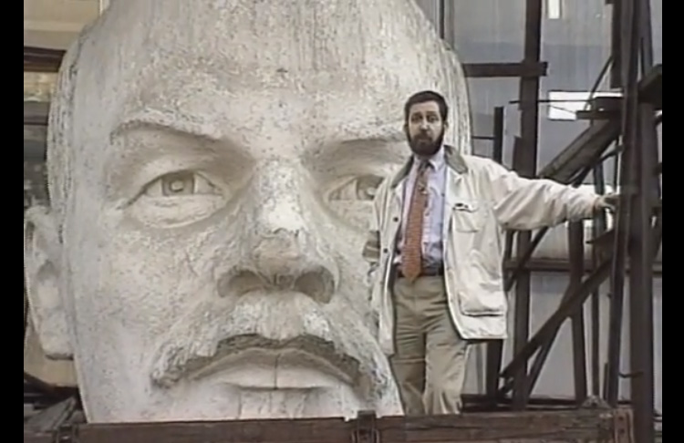  WEEK 8 14 October  “War means an ugly mob-madness, crucifying the truth tellers, choking the artists, sidetracking reforms, revolutions, and the working of social forces.”  John Reed  WEEK 9 21 Oct  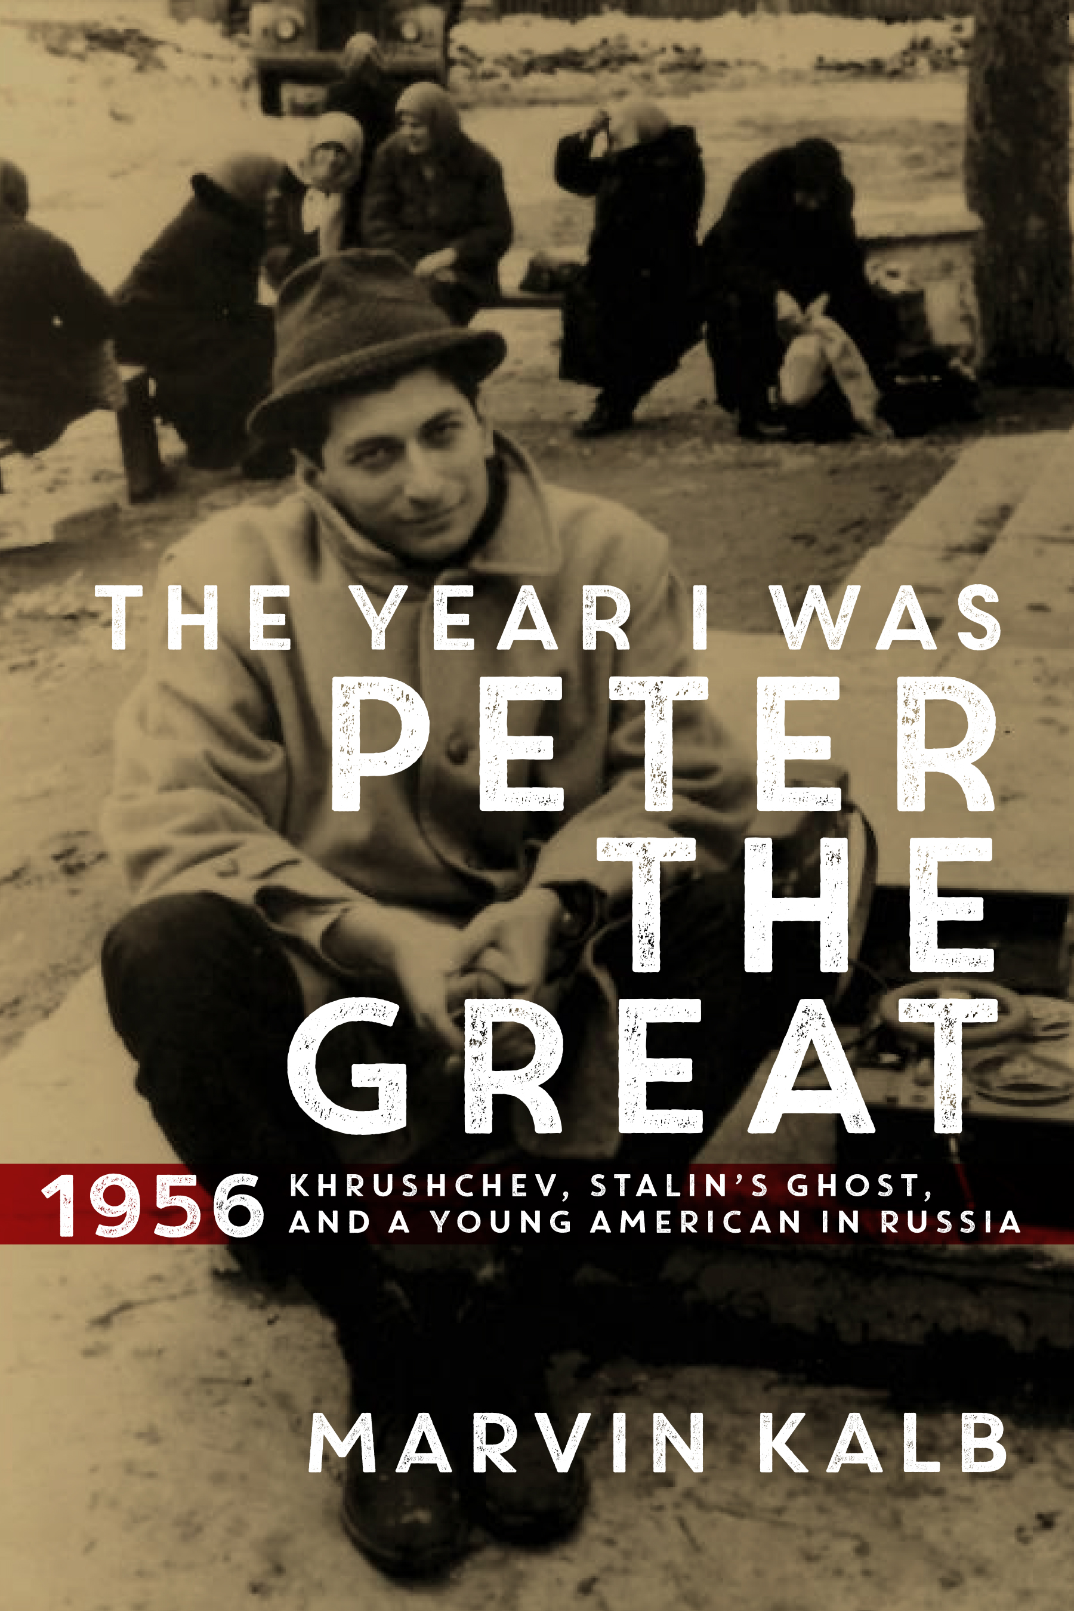  WEEK 10 28 Oct  “Assignment in Moscow was the Ph.D. for a foreign correspondent.”  Larry Lesueur  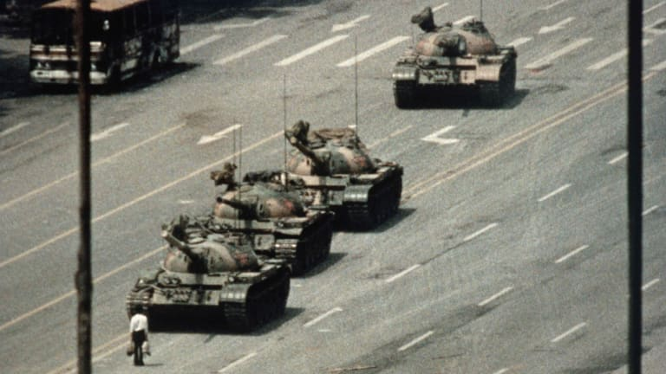  Week 12 Cold Wars 4 Nov  “Can a nation be free if it oppresses other nations? It cannot.”  V. Lenin  WEEK 13 Heat in the Middle East 11 Nov  “Travel is fatal to prejudice, bigotry and narrow-mindedness, and many of our people need it sorely on these accounts.”  Mark Twain  “The cold war is over. The world has become much more complicated.”  V.V. Putin  WEEK 14 Forward!  “The road is our source, our vault of treasures, our wealth. Only on the road does the report feel like himself, at home.’  Ryszard Kapuscinskii. | JRN 339  Foreign Reporting  Fall 2021 Thursdays 4-6.50pm  An introduction to interpreting complicated events outside North America for domestic audiences at home through studying foreign correspondents, their practices, practicalities, tradecraft, ethics, scoops, successes, and failures. Learning by doing…the class produce a podcast on news of the world each week. A course for U3 and U4 students.  It  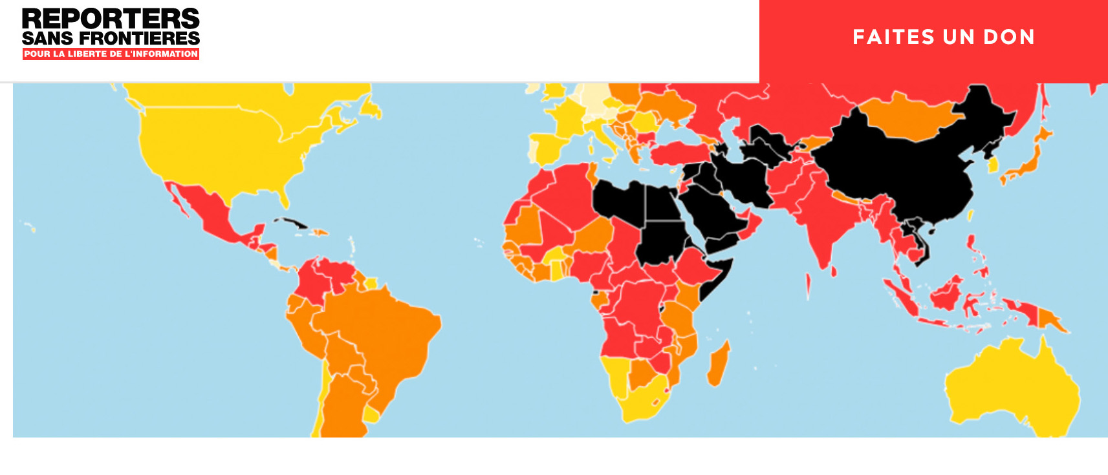  It is situated in the context of understanding the geopolitics of information, cross-cultural studies, ethics, and identifying the impact of propaganda, and disinformation. This seminar format course focuses on key reporting techniques including identifying reliable sources, quickly analyzing complex situations, and writing and speaking, about them under time pressure.  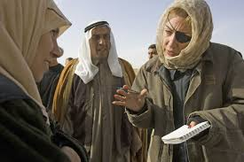  The aim is to train the next generation of foreign correspondents and for those who consume the reports of such compassionate foreign correspondents. This seminar format course inculcates key reporting techniques, including finding reliable sources and quickly analyzing complex situation, writing and speaking about them under time pressures It animates intellectually engagement of today, tomorrow, and the past.  The course includes up-to-the-minute advice on working in conditions of war and other physical danger, police harassment and cyber surveillance.  Russian developments will be used to illustrate broader concepts and lessons of reporting from distant places.  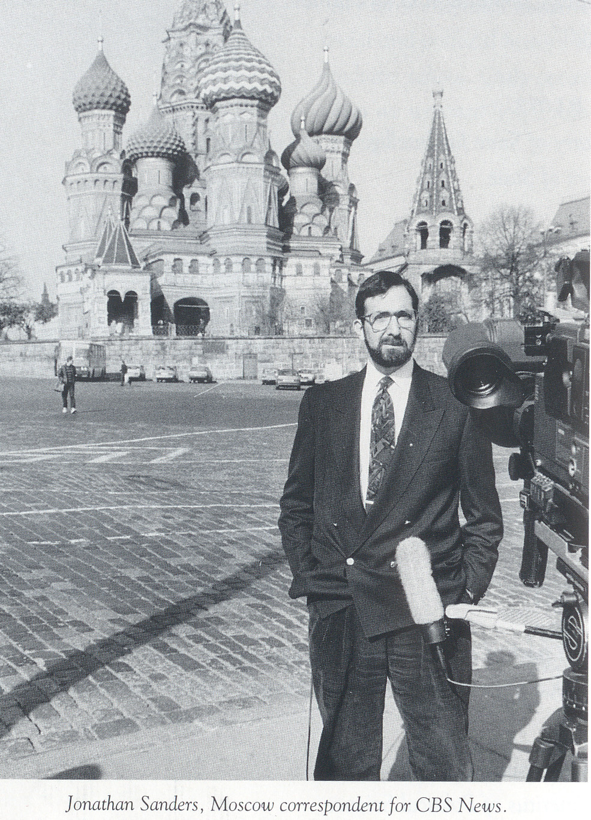 Photo by Michael Rosenbaum  For the most part, the course focuses on the Northern Hemisphere. On the southern hemisphere see courses offered by Professor Pablo Calvi.  Specific topics may change as the focus of the world news spotlight shifts.  The animating spirit of this course on ‘roving knights or the pencil and pixel powered mobile phone’ is reflected in quotations one by Walter Dean, “Journalism is an act of conscience. Its practitioners can be arrogant and greedy but also a threat to those with no conscience or little faith in humanity. All in all, as a profession, it probably now gives more than it receives;” the other from Bernard Weisberg, “While the city beat might have its exciting side, the peak in reporting circles was [and is] reached when a writer could don a felt hat, riding boots, and a knapsack and swagger off to cover a war or a revolution.”  COURSE REQUIREMENTS  Participation: This is a seminar style class operated by the Socratic method. Every student must be prepared to contribute o every class. Students will be assigned in pairs to report each week on a specific country or International organization  (World Food Program, Human Rights Watch Reporters Without Borders). Each student will report on one memoir, biography, autobiography or monograph about a Foreign reporter.  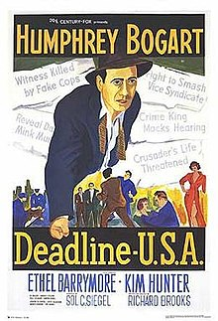  Late Assignments: Deadlines matter in journalism. No late work will be accepted. Exceptions, if any, will be determined  on case-by-case basis. Such will require compelling, well-documented reasons. If you experience dire circumstances  (hospitalization, arrest, family death, car crash, ICE raid etc.) you must provide documentation  Students will take turns reading and presenting the essence of some weekly  Readings to the collective seminar. [so don’t ‘freak out’ because it appears there is much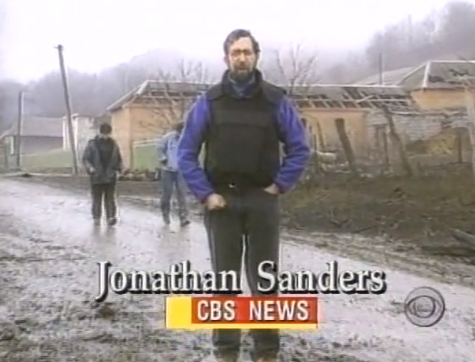 more reading than usual in a j course]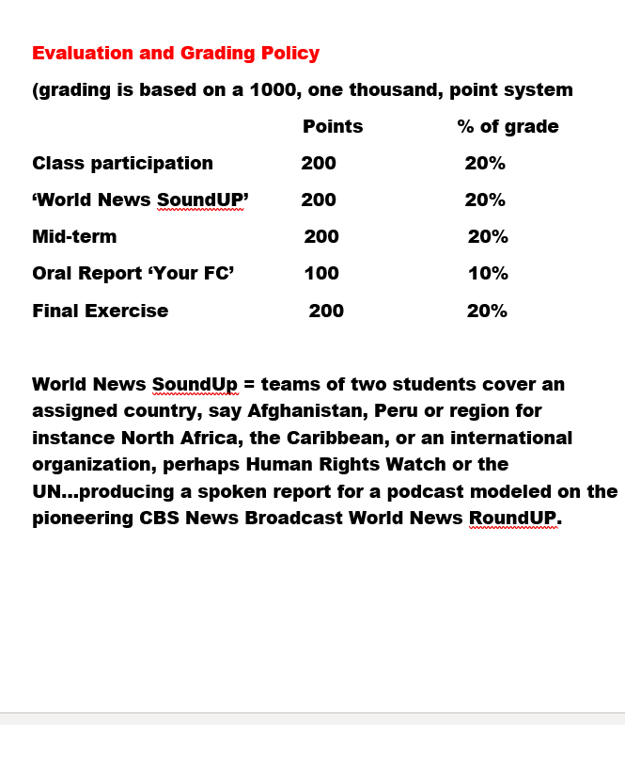  Student Information Form Due  Readings/viewings  Our textbook, John Maxwell Hamilton, Journalism’s Roving Eye: A History of Foreign Reporting (Baton Rouge, Louisiana State Press, 2009) [hereafter Hamilton] pp.11-18)  Clarissa Ward, “My Life As…the Marie Colvin Lecture 2013”  https://www.youtube.com/watch?v=Gdz5C_VnbV4&t=452s  Walter Lippman, ‘Pictures in Our Heads” Public Opinion ’http://www.gutenberg.org/etext/6456.  Ying Chan, “Journalism and Digital Times: Between Wider Reach and Sloppy Reporting,” in Open Soicety Foundation, Digital Journalism: Making News, Breaking News (NY 2014) pp. 107-128. BB  or  K.W Trammel and D. Perlmutter, “Bloggers as the New ‘Foreign’ Foreign Correspondents, in David D. Permutter and John Maxwell Hamilton  (eds) From Pigeons to News Portals: Foreign Reporting and the Challenge of New Technology (Baton Rouge: Louisiana State University Press, 2007) pp.70-88 e-book can be read on-line https://search.library.stonybrook.edu/discovery/fulldisplay?context=L&vid=01SUNY_STB:01SUNY_STB&docid=alma9917675099504856  Jonathan Sanders, “Two Minutes to Mid Night” Icastnews  http://icastnews.com/doomsday-2018.html “Armand Daquesh” icastnews http://icastnews.com/hl-10.html “Special Olympic Edition” icastnews https://www.youtube.com/watch?v=DzbcdnsWop0&t=46s  Marie Colvin at the IWMF 2000 Awards Ceremony:  https://www.youtube.com/watch?v=f4i7tOWpABg  Scott Pelley https://www.youtube.com/watch?v=P5Rq45gcmtU  Christiane Amanpour on Marie Colvin : https://www.youtube.com/watch?v=Oa1QeEcbiWo  PBS Newshour on Marie Colvin https://www.youtube.com/watch?v=dk_Um6NeANo.  And Lindsey Hilsom at SBU on Marie https://www.youtube.com/watch?v=b3p96aWcLtE  Highly recommended: Ryszard Kapucscinski, The Other (Verso, 2006)  Ripped from the headlines:  Louisa Lim and Ilaria Maria Sala, “The arrest of Hong Kong activists is an assault on civil society.” The Guardian 6 Jan 2021  The arrest of Hong Kong activists is an assault on civil society | Hong Kong | The Guardian  Shibani Mahtani and Theodora Yu. “’Total submission’: With mass arrests, China neutralizes Hong Kong democracy movement” The Washington Post 6 Jan 2021 Hong Kong mass arrests crush opposition as China tightens control - The Washington Post  Martha Gelhorn, “Time Bomb in Hong Kong: Britain expects the worst, and is ready” Collier’s Weekly June 7 1941 p.13 ff Time Bomb in Hong Kong, by Martha Gellhorn, COLLIER'S WEEKLY - The Unz Review  Kevin T. Dugan, “Inside Operation Gideon A Coup Gone Very Wrong.”Rolling Stone January 2021 pp.40-43, 79.  “If it hadn’t been for the Prompt work of the medics” FSB Officer inadvertenly Confesses Murder Plot to Navaly’ Bellingcat 21 Dec 2020 https://www.bellingcat.com/news/uk-and-europe/2020/12/21/if-it-hadnt-been-for-the-prompt-work-of-the-medics-fsb-officer-inadvertently-confesses-murder-plot-to-navalny/  Isabel Kershner, “The Making of the World’s Vaccination Leader.” The New York Times 2 January 2021  https://www.nytimes.com/2021/01/01/world/middleeast/israel-coronavirus-vaccines.html?searchResultPosition=1  Roger Cohen, “An Embattled Public Servant in a Fractured France.” The New York Times 2 January 2021  https://www.nytimes.com/2021/01/01/world/europe/an-embattled-public-servant-in-a-fractured-france.html?searchResultPosition=3  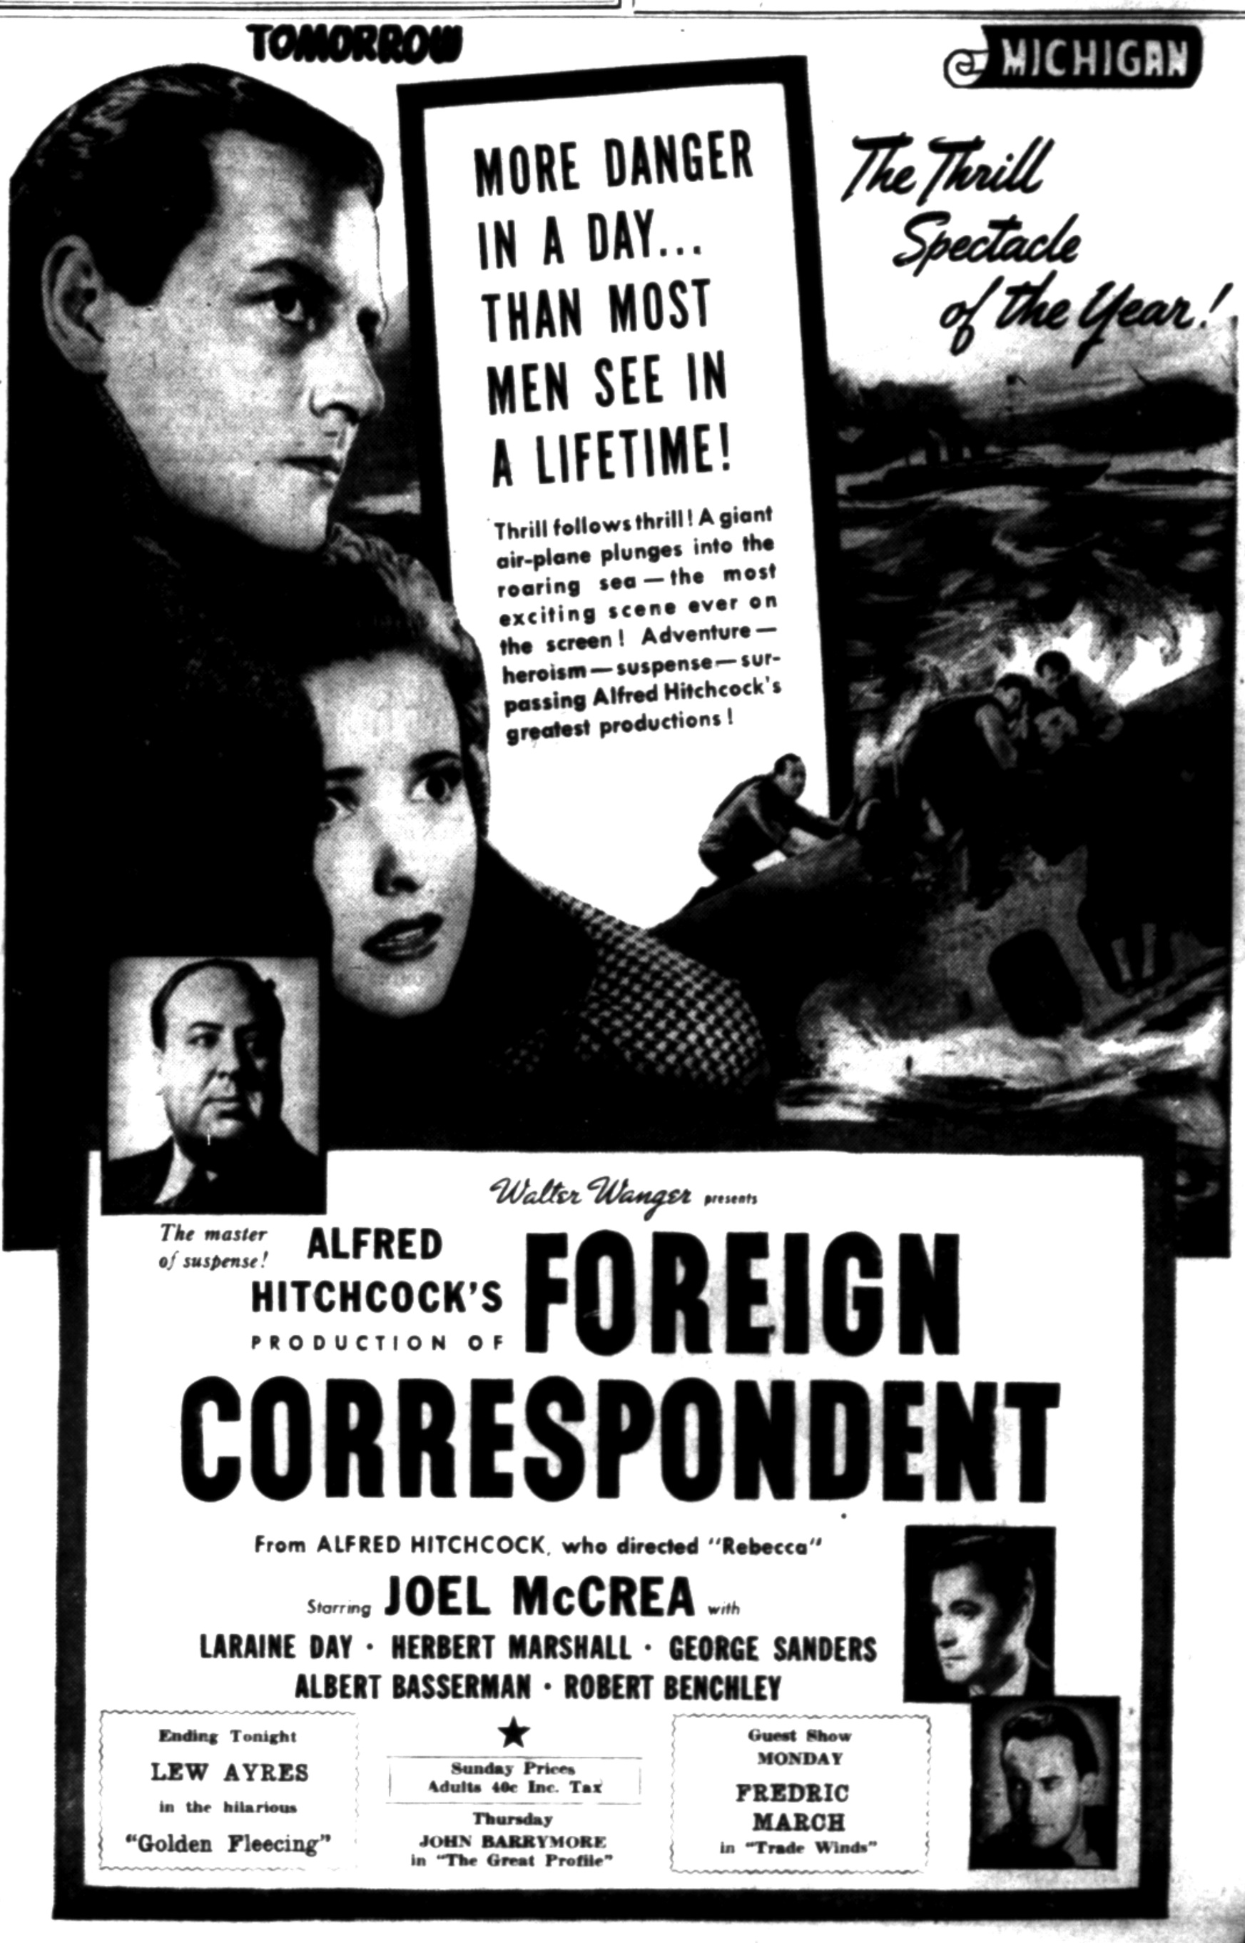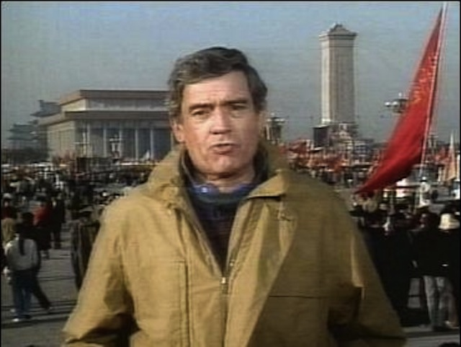  The Rise of the Objectivity God; the rise of American Imperial Wars (of, habits of mind and minding.  Hamilton pp. 89-109  M. Schudson, “The objectivity norm in American journalism.”  Journalism: Theory, Practice & Criticism, 2 (2), 2001 149–170. BB  R. B. Cockett, 'In Wartime Every Objective Reporter Should Be Shot.' The Experience of British Press Correspondents in Moscow, 1941-5” Journal of Contemporary History , Oct., 1988, Vol. 23, No. 4 (Oct., 1988), pp. 515-530 BB  W. Donbsbach, “Lapdogs, Watchdogs and Junkyard Dogs” Media Studies Journal vol.9 n.4 fall 1995 pp.17-30 BB  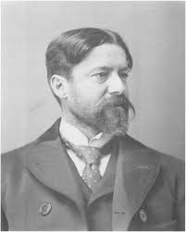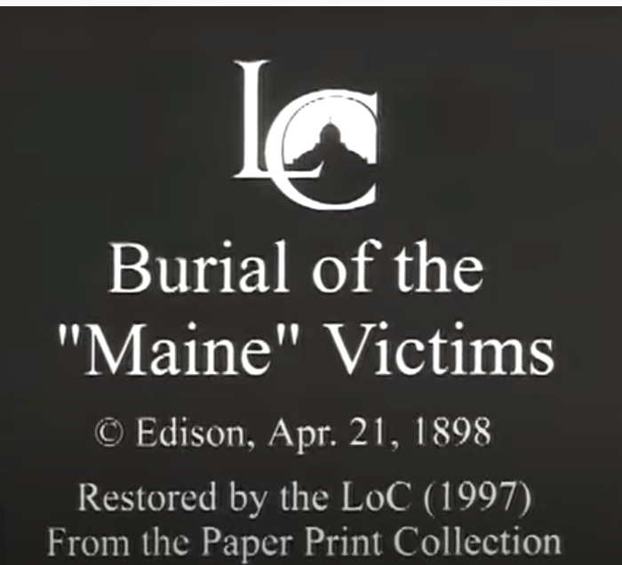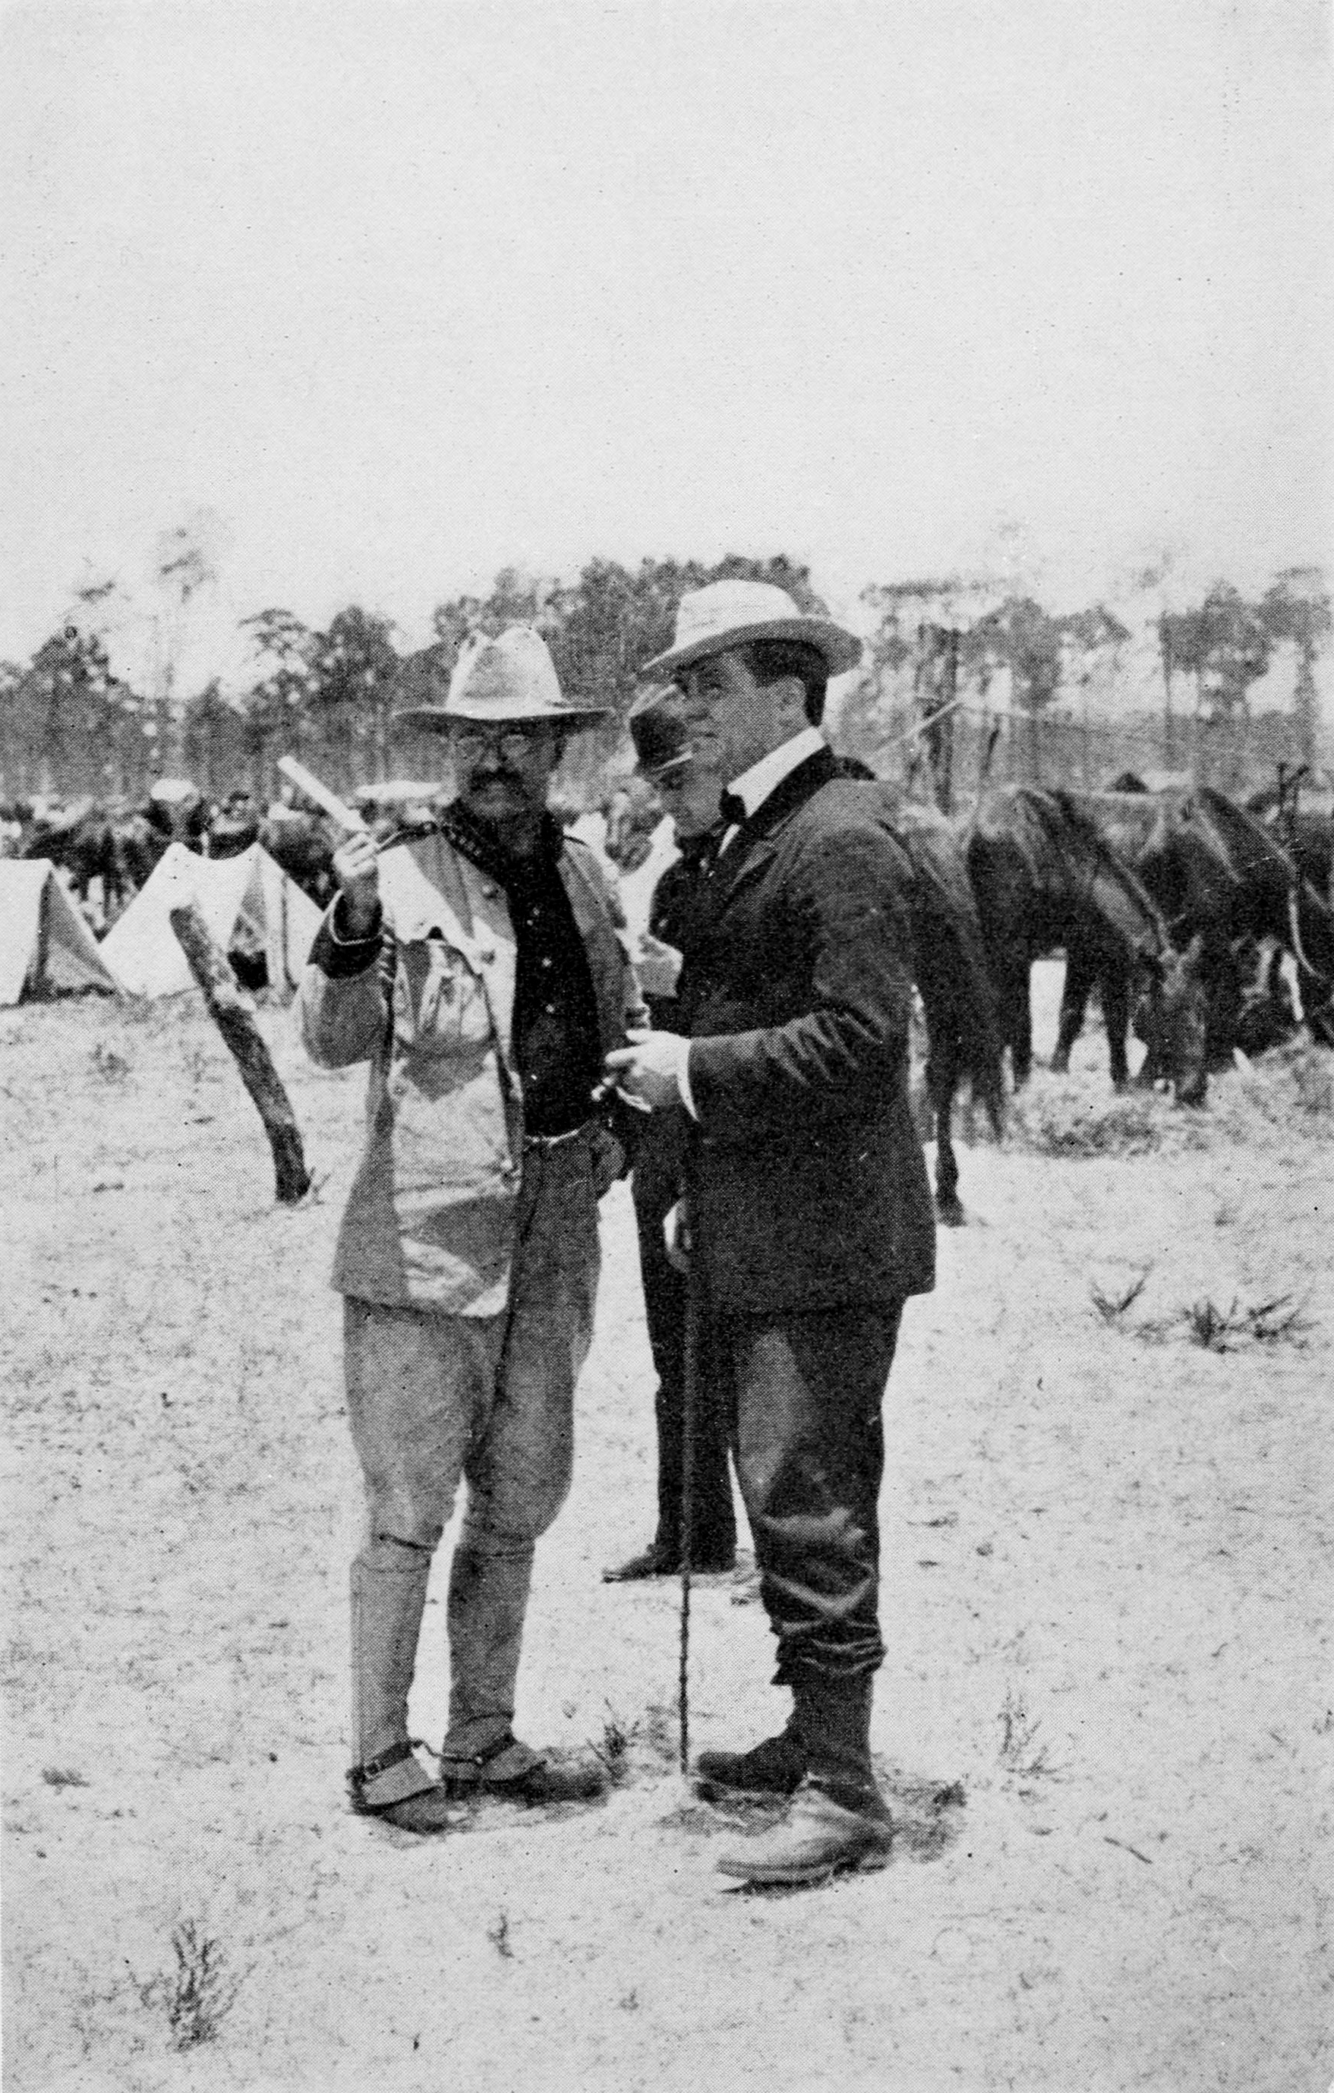 TR & James Creelman Richard Harding Davis  Edison, “The Spanish-American War 1898” (19) The Spanish-American War-1898- Edison's famous movies - Films from the battlefield - YouTube  Who sunk the Maine ? Allen, Thomas B. “Remember the Maine?” National Geographic 193, no. 2 (Feb 1998): 92–111.BB  https://theamericanchronicle.blogspot.com/201  0/02/who-sunk-uss-maine.html  Josephine Herbst, “The Soviet in Cuba.” The New Masses 19 March 1935 pp.9-11 https://www.unz.com/print/NewMasses-1935mar19-00009/  preparing for our first Seawolves World News SoundUP in week 3  segments from CBS News, “Farewell to Studio 9” 16 Aug 1964 https://www.oldtimeradiodownloads.com/historical/farewell-to-studio-9/farewell-to-studio-9-19xx-xx-xx  Listen to Sylvia Poggioli, “Reginald Foster, World’s Renowned Latinist Dies at 81” NPR from Rome 28 Dec 2020 https://www.npr.org/people/2101034/sylvia-poggioli  Lucian Kim, “Russia Steps in to End War Between 2 Former Soviet Republics” 10 Nov 2020 https://www.npr.org/people/505600000/lucian-kim  Frederic A. Moritz, “James Creelman: “Father” of Human Rights Reporting” James Creelman_ "Father" of human rights reporting (worldlymind.org) BB  T Kent Journalism’s Era of Change, but Objectivity Still Plays a Critical Role,") Ethical Journalism Network, Jan. 15, 2013 BB and  T. Kent , "An ethical checklist for robot journalism,") Medium, March 2019.  The World News Lighthouse Search Light  How we live in the world  Hamilton: study “The Confederacy of Correspondents” pp.465-481  James W Carey, “A Short History of Journalism for Journalists: A Proposal and Essay,” Harvard International Journal of Press/Politics 12.1 (2007) pp.3-16 BB [for a perspective on Carey watch: Frank Moretti “A Conversation with James Carey, March 15, 2002”  https://www.youtube.com/watch?v=-Mozx7z6ues ]  Steven Livingston, “The Nokia Effect: The Reemergence of Amateur Journalism and What It Means for International Affairs” in David D. Permutter and John Maxwell Hamilton  (eds) From Pigeons to News Portals: Foreign Reporting and the Challenge of New Technology (Baton Rouge: Louisiana State University Press, 2007) pp. 47- 69. e-book can be read on-line https://search.library.stonybrook.edu/discovery/fulldisplay?context=L&vid=01SUNY_STB:01SUNY_STB&docid=alma9917675099504856  Steven Livingston, W. Lance Bennett, “The disinformation order: Disruptive communication and the decline of democratic institutions” European Journal of Communications 2 April 2018 pp.122-139. BB  J. Hartley, “Journalism and Popular Culture” K. Wahl-Jorgesen, The Handbook of Journalism Studies (London: Routledge, 2009) pp.310-324 BB.  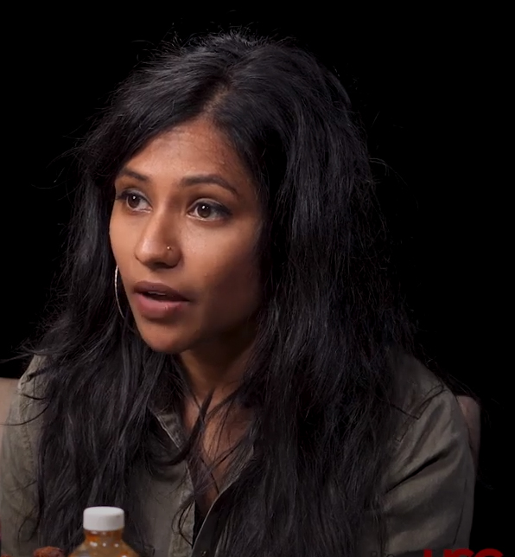  Vice News Interview with Tania Rashid https://www.youtube.com/watch?v=xVVMWOYsbzA  Eric Jenner, John Maxwell Hamilton, “Foreign Correspondence: Evolution, Not Extinction.” Nieman Reports Fall 2004  Zvi Rech et al, “Mapping Journalism Cultures Across Nation A comparative study of 18 countries.” Journalism Studies vol 12 no.3 2011 pp.273-293 BB  Laurel Leff, “When the Facts Didn’t Speak for the Themselves: The Holocaust in the New York Times.” The Harvard International Journal of Press/Politics vol. 5 n.2 (Spring 2000) pp.52-72 BB  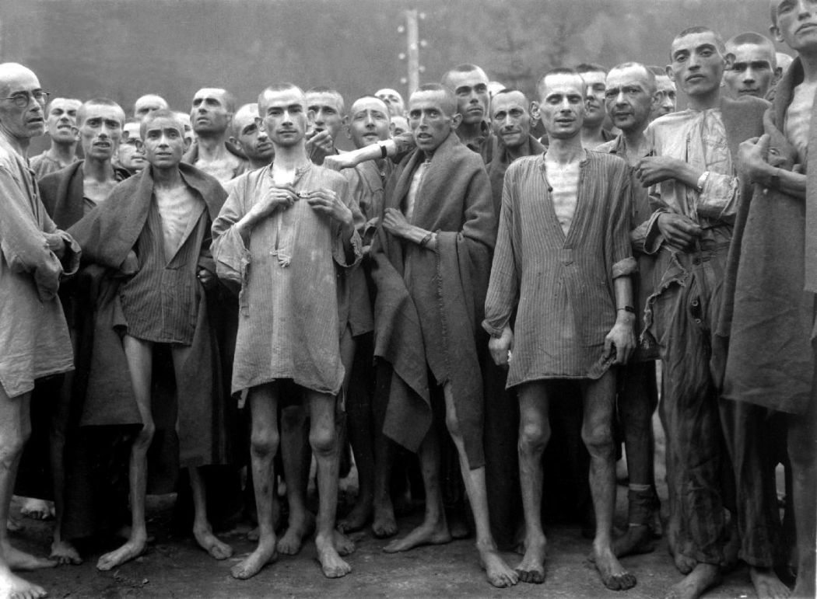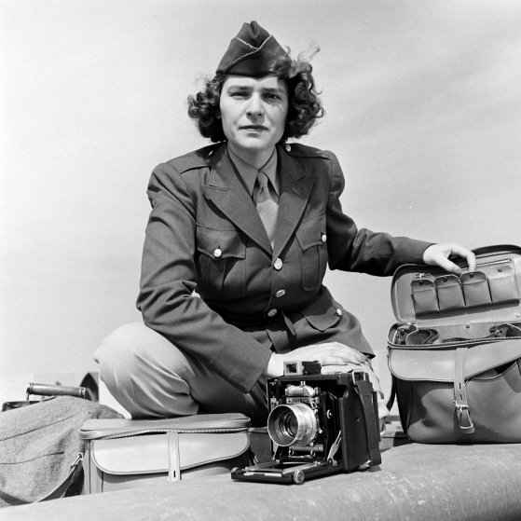  Watch a 60 Minutes Story by Lara Logan. We [SBU library] has access to many of these on line. library.stonybrook.edu, select Journals above the big search box and search 60 minutes. This takes you to the page linking to the online article  Then watch Ms. Logan’s keynote address at the 2012 BGA Chicago Awards  https://www.youtube.com/watch?v=DYovcU6vYAI&t=268s  and on LL now  https://www.youtube.com/watch?v=YqNLgH3niuE  John Hartley, “Journalism as a Human Right: The Cultural Approach to Journalism.” In Global Journalism Research Theories, Methods Future  (New York: Peter Lang Publishers, 2007) pp.6-24 BB  Technology Determines or Detonates; Generations generate  Hamilton pp.418-4570  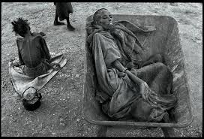James Nachtwey’s Photographs & the Somalia Famine, Time https://www.youtube.com/watch?v=WSjQWsh7nXg&has_verified=1  1992 - CNN's Amanpour covers the initial beach landing in Mogadishu. Frustrated troops are met with a gang of Press with lights, cameras and microphones CNN https://www.youtube.com/watch?v=Xj9Fn3qG-Cw  Jim Laurie, ABC “Children Baodoa Most Affected by the Famine” https://www.youtube.com/watch?v=I9v74ZVfTjs  George Kennan, “Somalia: Through A Glass Darkly,” The New York Times 30 September 1993 p.A23  Dan Rather, “Don’t Blame TV for Getting Us Into Somalia” The New York Times 14 October 1993 p.A22 [on Dan see, Judy Tygard Producer Dan Rather: A Reporter Remembers,” CBS 2005-03-09 https://www.youtube.com/watch?v=NxsJJwpKC-4]  Warren P. Strobel, “The CNN Effect,” American Journalism Review vol.18 issue 4 BB  Steven Livingston, “Clarifying the CNN: An Examination of Media Effects According to Type of Military Intervention,” Shorenstein Center Research Paper R-18 June 1997  https://shorensteincenter.org/wp-content/uploads/2012/03/r18_livingston.pdf  - Pier Robinson, “The CNN Effect Revisited” Critical Studies in Media Communication vol 22 issue 4 2005 pp.344-349 . https://doi-org.proxy.library.stonybrook.edu/10.1080/07393180500288519  Those not aware of the denouement of the US Somalia incursion should watch: Ridley Scott, producer, Black Hawk Down a 2001 feature film based on journalist Mark Bowden’s reporting  Ashley Dawson, “New World Disorder: Black Hawk Down and the Eclipse of U.S. Military Humanitarianism in Africa,” African Studies Review vol 54 n 2 (Sept 2011) pp.177-94 BB  - 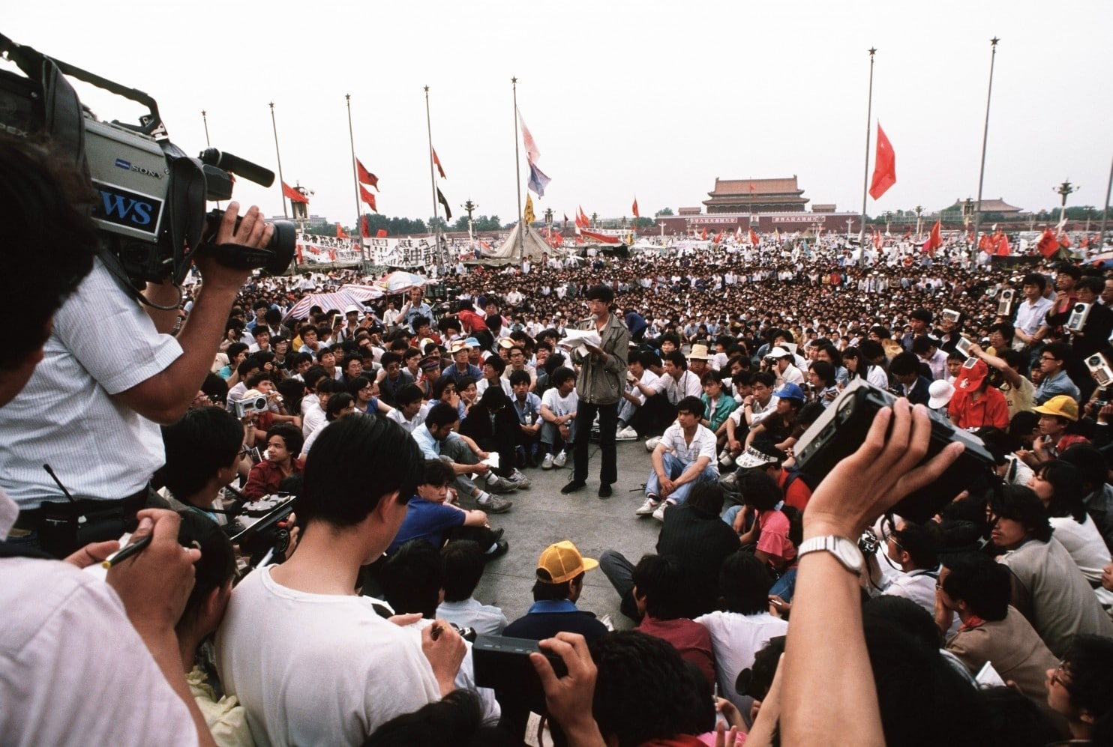  Michael Steissguth, “How CBS scooped the world on the Tiananmen Square story,” The Washington Post Magazine 30 May 2014  https://www.washingtonpost.com/lifestyle/magazine/how-cbs-scooped-the-world-on-the-tiananmen-square-story/2014/05/29/a20a9e84-bfef-11e3-b195-dd0c1174052c_story.html?hpid=z1#  Learning from the 1930s..heading to the 2030s  Hamilton pp. 218-307  M. Emery, “Radio and the Munich Crisis, The Front Lines Following America’s Foreign Correspondents Across the Twentieth Century ( Washington: The American University Press, 1995) pp.59-88  First Broadcast of CBS's World News Roundup: March 13, 1938 https://www.youtube.com/watch?v=WoGYXiyNWRM  Listen to [pick stories from 3 different Murrow boys]  https://history-journalism.ku.edu/1940/multimedia/audio/Murrow_broadcasts/wwii_radio.shtml  Schramm W, Huffer R. “ What Radio News Means to Middleville.”  Journalism Quarterly. 1946;23(2):173-181.  H.V Kaltenborn “Germans Seize ‘City of Flint’ CBS Kaltenborn Edits the News https://www.youtube.com/watch?v=F1jlFOEJCeY  And “FDR Repeats Determination to Stay Out of The War,”CBS Kaltenborn Edits the News https://www.youtube.com/watch?v=Fdjt_a7OR0U  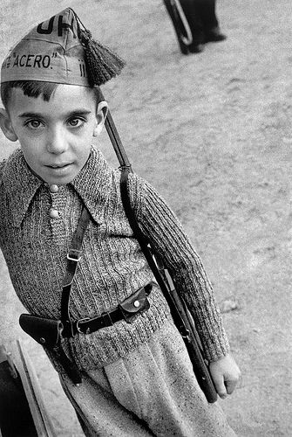  Robert Capa 1947 Radio interview [with overlain photographs] https://www.youtube.com/watch?v=MYe4ynXnqug&t=214s  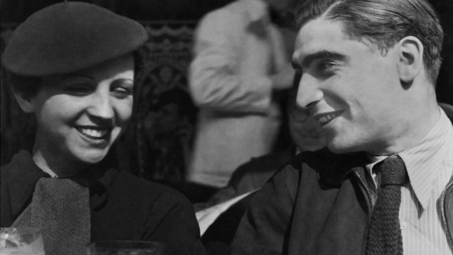  Use google images : roberta capa Spanish civil war’ gerda taro spanish civil war  Nora Ruth Roberts, “Herbst and Hemingway in Spain.” [on the feminist eye for reporting vs the macho] North Dakota Quarterly vol 60 n. 2 (Spring 1992) pp.204-216 BB.  M. R. Gladstein, “Mr. Novelist Goes to War: Hemingway and Steinbeck as Front-Line Correspondents.” War, Literature and the Arts vol 15 (1/2) 2003 Jan 1 pp.258-266 BB  K. S. Trammel and D. Perlmutter, “Bloggers as the new Foreign Correspondents: Personal Publishing as Public Affairs” in From Pigeons to News Portals Foreign Reporting and the Challenge of New Technology [e book above cited] pp.70-88.  Lindsay Palmer, “Outsourcing Authority in the Digital Age: Television News Networks and Freelance War Correspondents.” Critical Studies in Media Communications vol. 32 no.4 October 2015 225-239 BB  Lindsay Palmer, “IReporting” an Uprising: CNN and Citizen Journalism in Network Culture Television & New Media 2013 vol 14 (5) pp.367-385  Three 30’s Classics  Watch: Hemingway, Ivens The Spanish Earth 1937 documentary  https://www.youtube.com/results?search_query=hemingway+the+spanish+earth  Arthur Coleman "Hemingway's" The Spanish Earth"." Hemingway Review 2, no. 1 (1982): 64.  Dorothy Thompson, “I Saw Hitler!” Cosmopolitan March 1932 pp.32-47 BB and her “Good-by to Germany,” Harpers Monthly December 1934 pp.51-59 BB.  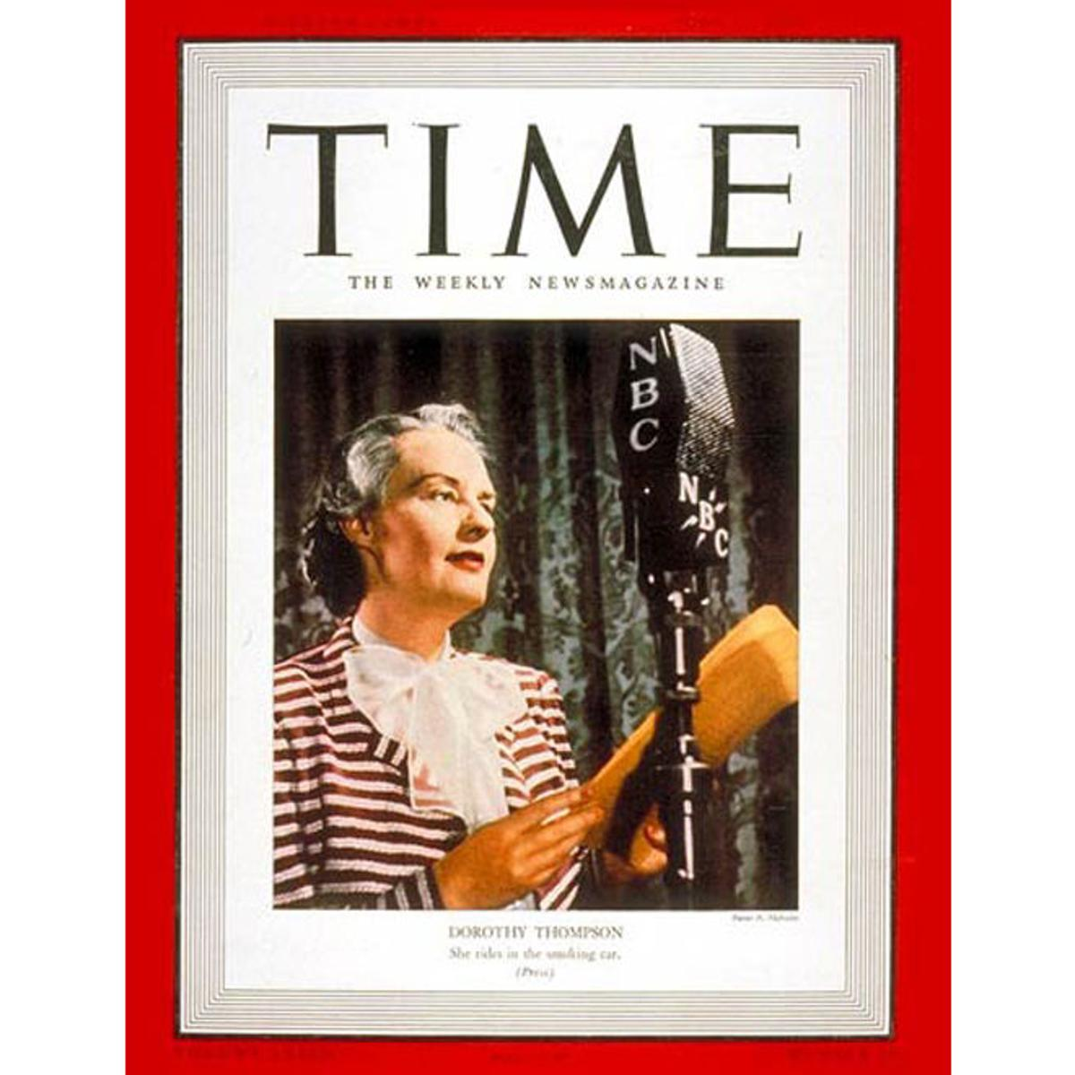  Nancy Cott, “A Good Journalist Understands That Fascism Can Happen Anywhere, Anytime.” Literary Hub 30 April 2020  https://lithub.com/a-good-journalist-understands-that-fascism-can-happen-anywhere-anytime/  George Orwell, Homage to Catalonia  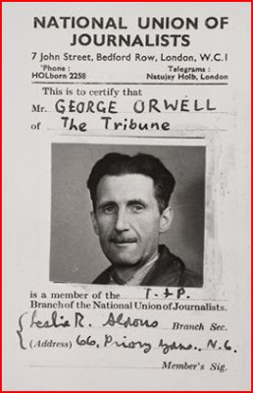  China The Big Far East  Hamilton pp.350-381  Edgar Snow, Red Star Over China pp.13-169  Martha Gellhorn, The Face of War [ any edition] part 3 China, The Canton Front  S. Topping, On the Front Lines of the Cold War pp.7-121  James L. Baughman, “The American Century.” In Henry R. Luce and the Rise of the American News Media (Baltimore: John Hopkins University Press, 2001) pp.129-157 BB  D. Haygood , Henry Luce's Anti-Communist Legacy An Analysis of U.S. News Magazines’ Coverage of China's Cultural Revolution Journalism History pp.98-105 June 2009  CBS News Tiananmen Square Protest Coverage 19 May 1989 https://www.youtube.com/watch?v=Af14Ksv79uk  CBS News Tiananmen Square 4 June 2013 https://www.youtube.com/watch?v=YjOCYbV6uuc  CBS News Tianamen Square protesters recount massacre 30 years later  https://www.youtube.com/watch?v=6TMYVOTzE1k  Michael Steissguth, “How CBS scooped the world on the Tiananmen Square story,” The Washington Post Magazine 30 May 2014  https://www.washingtonpost.com/lifestyle/magazine/how-cbs-scooped-the-world-on-the-tiananmen-square-story/2014/05/29/a20a9e84-bfef-11e3-b195-dd0c1174052c_story.html?hpid=z1#  Watch, Scott Pelley “Where your ‘recycled e-waste really goes,” 60 Minutes 12 Jun 2011  Russia: The Big (Red) East  G. Kennan [the elder] “Camping Out in Siberia” Putnam’s 2 (Sept 1868) 18-27 ; “Siberia—The Exile’s Abode.” Journal of the American Geographical Society of New York 14 (1882) 13-68 BB  “Eyes of Jews All Over the World Turned by Kishineff Atrocities,” The Brooklyn Eagle 31 May 1903 BB  Watch Warren Beatty, Reds (1981)  Jonathan Sanders, ‘The Unpublished Revolution” in Russia 1917 (New York: Abbeyville Press, 1989 pp. 12-58 BB  Russia— Revolutionary Classic  John Reed, Ten Days That Shook the World  [some could read Louise Bryant, Six Red Months in Moscow ]  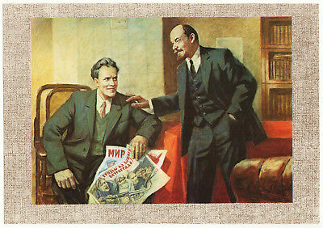  Revanche…The Magic Dateline  David Remnick, “Echo in the Dark: A Radio Stations Strives to Keep the Airwaves Free.” The New Yorker 22 September 2008 BB  R. Gamache, “Breaking Eggs Walter Duranty, the Walter Duranty, the New York Times and the Denigration of Gareth Jones,” Journalism History v. 39 issue 4 (2014) pp.208-218  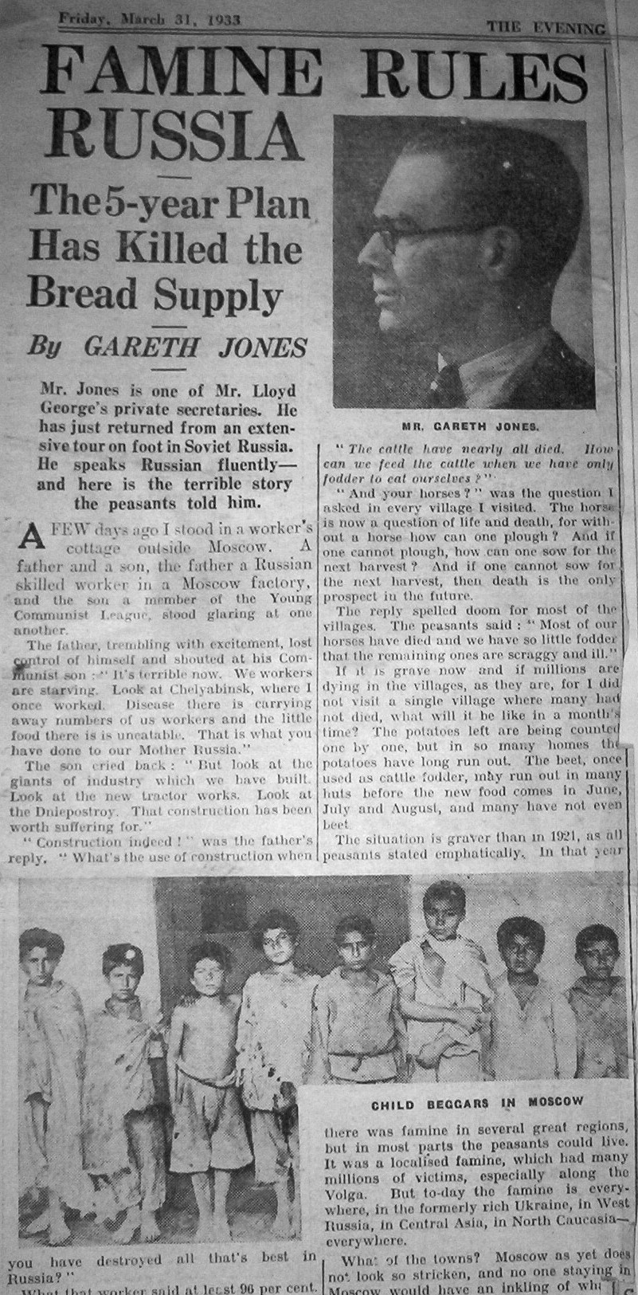  Editors, Our Soviet Ally. The New Masses 23 June 1942 pp.5-20 https://www.unz.com/print/NewMasses-1942jun23/  Marvin Kalb, “Soviet Youth: ‘ Bewildered Generation’.” The New York Times 28 July 1957 p.151/ 9 BB  Marvin Kalb, “How I Got a job Interview with Edward R. Murrow.” Brookings https://www.youtube.com/watch?v=oY0oAAYJk24  [forthcoming] Marvin Kalb Assignment Russia: Becoming a Foreign Correspondent in the Crucible of the Cold War. Brookings Institution Press.  Jonathan Sanders video sampler Russia in the 1990s  Ann Cooper, “ How Russian Media Reported the Coronavirus Pandemic.” Nieman Reports 11 August 2020 https://niemanreports.org/articles/how-russian-media-reported-the-coronavirus-pandemic/  Vietnam, Korea and Beyond  Hamilton pp.382-382-417  Knightly, pp.336-356 373-400  Watch: Watch Michael Walzer “On Just War Theory”  https://www.youtube.com/results?search_query=Michael+Walzer  Friendly-Murrow, “See It Now, Christmas in Korea, CBS Television, https://www.youtube.com/watch?v=eZv7ZW994qo  Richard Threlkeld on patrol https://www.youtube.com/watch?v=eZv7ZW994qo  1963 Malcolm Brown and Thich Quang Duc  https://www.youtube.com/watch?v=30TShAJQe8Q  Tet; 1968 & Eddie Adams https://www.youtube.com/watch?v=Eld5aJHYx4M  Nick Ut & Kim Phuc https://www.youtube.com/watch?v=Pa9auMart0E  Democracy Now, “My Lai Revisited: 47 Years Later, Seymour Hersh Travels to Vietnam Site of the US Massacre He Exposed https://www.youtube.com/watch?v=91Zr7Kp6ooY  Jack Lawrence on why Mai Lai wasn’t reported in Vietnam https://www.youtube.com/watch?v=ii5WTzh-HIo  David Halberstam Talks About Vietnam  https://www.youtube.com/watch?v=af6UycmPHhE  Walter Cronkite—Morely Safer’s Vietnam War https://www.youtube.com/watch?v=X-SmnHDsJyI&t=53s196  Frontline Club, “Vietnam—A Turning Point for War Reporting”—pay attention to Jack Lawrence https://www.youtube.com/watch?v=tZ-mZRXhZy8  Mike Wallace, “Back to Mai Lai” https://www.youtube.com/watch?v=3N7AZs1sNjI  Sanders --Vietnam selection tape  BB  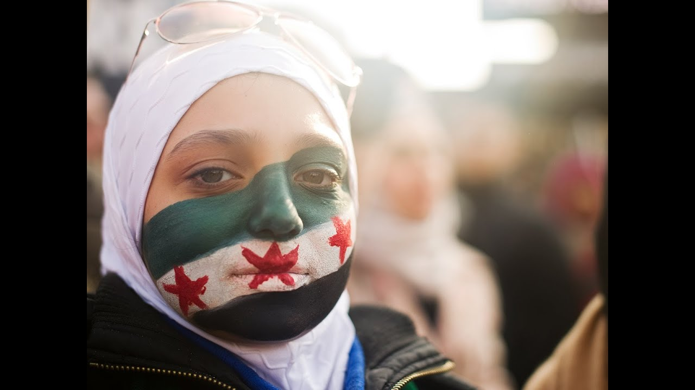  John R. Macarthur, “Operation Desert Muzzle,” in Second Front: Censorship and Propaganda in the Gulf War (Berkeley: U Cal Press) pp.146-198BB  Listen and compare: Bernard Shaw “The Skies Over Bagdad are illuminated,” https://www.youtube.com/watch?v=vIXvCfnM2-E vs  VXU Network “D-Day + 50 Years” Tape 5 John Maginn eyewitness account landing in France Howard Marshall on Beach Landings’ [to be digitized and put on BB]  SBU SOJ, Ilana Ozernoy, “My Life As… “ 19 November 2012 https://www.youtube.com/watch?v=1wryN5BJopM  Watch: “Charlie Wilson’s War” Melville Library Streaming videos  Dan Rather, “60 Minutes 5 May 2004 II Minutes Abuse at Abu Gharai” BB  Jonathan Sanders, “Syria: Fear and Battle” icastnews.com http://icastnews.com/Arab-hme-j-9-18.html  On the Front Line: The Collected Journalism of Marie Colvin (London: Harper Press, 2012) pp.10-91  F. Gregory Gause, “Why Middle East Studies Missed the Arab Spring: The Myth of Authoritarian Stability,” Foreign Affairs (81) 2011.  Dan Rather, “Advice to President Obama on Afganistan.” Asia Society Sept 2012https://www.youtube.com/watch?v=FOcCeOhY90c  Chrstiane Amanpour, “The Srebrenica genocide: A Defining Moment.” CNN 17 July 2015 https://www.cnn.com/2015/07/09/europe/amanpour-srebrenica/index.html  Deborah Copaken Kogan, Shutterbabe (New York: Random House, 2002)  Scott Pelly, Nicole Young, “A Crime Against Humanity.” CBS News 60 Minutes 19 April 2015 https://www.cbsnews.com/news/syria-sarin-gas-attack-in-2013-60-minutes/  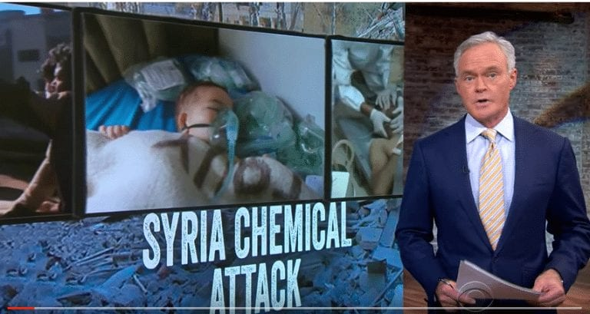  Jonathan Sanders, “Two Minutes to Mid Night” Icastnews  http://icastnews.com/doomsday-2018.html  Lea Hellmueller et al, “The Networks of Global Journalism: Global news construction through collaboration of global news startups with freelances.” Journalism Studies 19 Aug 2016 pp.45-64 BB  Brian McNair, “After Objectivity?” Journalism Studies 1 aug 2017 BB  Anne Cooper, Taylor Owen, “The New Global Journalim: Foreign Correspondence in Transition.” The Tow Center for Digital Journalism 3 Dec 2014 https://www.cjr.org/tow_center_reports/the_new_global_journalism.php  Ryszard Kapuscinskii, “We Stand in Darkness Surround by Light.”Travels with Herodotus (NY Vintage 2008) pp.265-275

