Data + Computing = Discovery REU Faculty
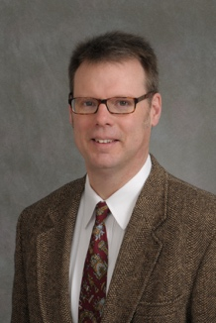 | Alan Calder  Physics & Astronomy Department  http://www.astro.sunysb.edu/acalder/
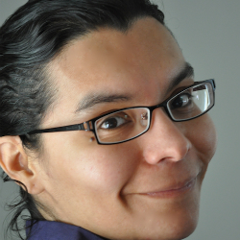 | Liliana Davalos-Alvarez  Ecology & Evolution  http://lmdavalos.net/lab/The_Lab.html
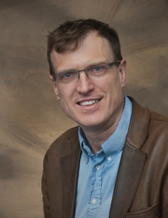 | Robert Harrison  Institute for Advanced Computational Science  http://www.iacs.stonybrook.edu/people/faculty/robert-j-harrison
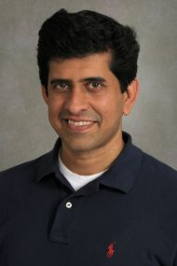 | Dilip Gersappe  Materials Science & Chemical Engineering  http://www.stonybrook.edu/commcms/matscieng/people/facultypages/DilipGersappe.html
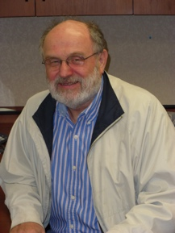 | Predrag Krstic  Institute for Advanced Computational Science  http://www.iacs.stonybrook.edu/pages/predrag-s-krstic
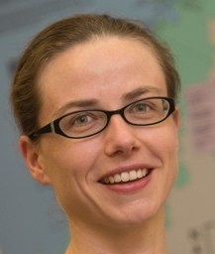 | Heather Lynch  Ecology & Evolution  https://lynchlab.com/
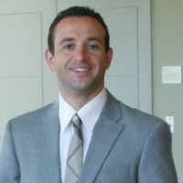 | Sotirios Mamalis  Mechanical Engineering  http://you.stonybrook.edu/combustion/
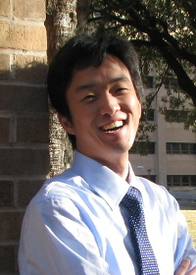 | Memming Park  Neurobiology & Behavior  https://memming.wordpress.com/
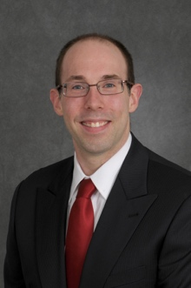 | Matthew Reuter  Applied Mathematics & Statistics  http://you.stonybrook.edu/reutergroup/
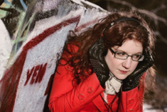 | Margaret Schedel  Music Department  http://www.stonybrook.edu/commcms/music/aboutus/faculty/schedel_margaret.html
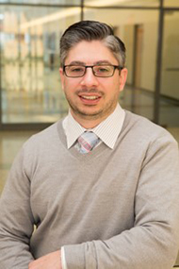 | Jason Trelewicz  Materials Science & Chemical Engineering  http://www.stonybrook.edu/commcms/emnl/people2/
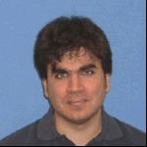 | Michael Zingale  Physics & Astronomy  http://www.astro.sunysb.edu/mzingale/

