Frequently Asked Questions
- How do I enter data into Digital Measures?
Directly import your publications stored in another software system such as Crossref or PubMed. Other reference managers or databases such as EndNote, Google Scholar, Mendeley, RefWorks, Scopus, Web of Science and Zotero enable you to select publications and export them into a BibTeX file.
https://www.digitalmeasures.com/activity-insight/docs/directdataimports/
Manually enter your own data directly using the "Manage Your Activities" screen by typing directly or copying and pasting into the screen fields.

- I can’t find my activity (journal, book, presentation, etc.) on my report, why?
There are a few possible reasons why the activity is missing:
- The activity has a status or date that is outside the specified date range of the report.
- The activity is missing required information needed in order for it to appear.
- The status you selected for your activity is one that does not appear in the report you are generating.
- There is an error with the DM data reporting output criteria.

- How do I change information on my web profile?

Your web profile is created and updated from the information entered in Digital Measures. If you want to add a new publication, please do so on the Intellectual Contributions screen. As new information is added, your web profile will update instantly. Not all screens have been made available to web profiles, please contact Amy Milligan or Marie McCallion for questions on this.

- Why is certain information missing from my web profile and Digital Measures?

Faculty control the information displayed on their web profile by checking the “publish on web profile” box on individual records.

Decisions regarding data and the display of it are driven by AACSB reporting requirements. Some information may not be available in Digital Measures because we are not reporting on it and want our reports to be accurate. For example, faculty teaching BUS 301 – Business Communications will see limited information because we do not report on this class. The same is true for courses taught by more than one faculty member, in Digital Measures the course will only be assigned to one faculty member so it does not count several times in the reporting.

If you have questions regarding the data in Digital Measures, please contact Amy Milligan.

If you have questions regarding your web profile, please contact Amy Milligan or Marie McCallion.

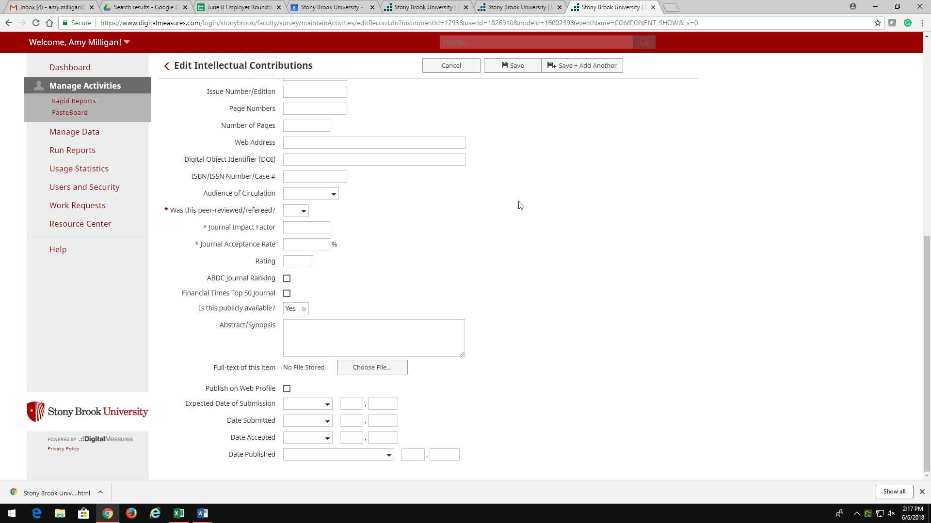

- How do I update my photo on my web profile?
Send a new photo in Jpeg format to Marie McCallion.

