Making Accessible VoiceThread Content For Students
By: Lindsay Bryde
Table of Contents
How VoiceThread Improves the Learning Experience 1
Best Practices for VT 1
Why Transcripts and Closed Captions Matters 1
Editing Transcripts and Captions 2
Best Practices for Editing Transcripts/Captions 4
Listen carefully 4
Keep captions short 4
Avoid filler words 4
Use proper punctuation 4
Spell check in context of the dialogue 4
Add tone and visual cues 4
Additional Resource 5
Learn More About Document Accessibility 5

How VoiceThread Improves the Learning Experience
VoiceThread (VT) fosters interactive, multimedia-rich communication with participants. Its asynchronous format offers everyone the flexibility to participate at their own pace.

Best Practices for VT
- Do not share content that contains blinking or flashing (e.g., animations or fast transitions). It can cause seizures in individuals with photo-sensitivity.
- Check that all slides have accurate closed captions or transcripts. This benefits anyone who prefers to read content or needs it for translation purposes.
- Ensure all content being uploaded (e.g., slide decks or PDFS) is accessible beforehand.
- Include verbal or written descriptions of what is being shown in any videos/narration. This helps users understand the context of what's being displayed.

Why Transcripts and Closed Captions Matters
Transcripts and closed captions ensure content is accessible for individuals who are deaf or hard of hearing, allowing them to fully engage with what's being shown. They can also aid in comprehension for non-native speakers and those with learning disabilities.
Transcripts are a written document with the audio content of a video and descriptions of any visuals displayed on screen. They do not break down the timing of when certain actions take place or when certain words are spoken.
Closed captions are when the content of a transcript is chunked out based on the video's timing. They can enhance the viewing experience in noisy environments where audio might be difficult to hear (e.g., a big lecture hall).
Overall, transcripts and closed captioning promotes inclusivity and ensures that video content is accessible to a broader audience. To be accessible, they need to be edited for at least 98% accuracy.

Editing Transcripts and Captions
If you're recording comments, all recordings have computer generated captions generated automatically. Captions will appear after the recording is complete and it takes minutes to hours to appear for review. Generally, the longer the video, the longer it will take before the captions appear.
Once your auto-generated captions appear, they must be checked for accuracy in VoiceThread:
- Open the Closed Captions option of the VT player.
- Select Edit Captions from the drop-down menu, a dialog box will open.
- Edit the Closed Captions in the text fields for accuracy.
- Select the Save button; the Transcript will automatically updated. You can view it by selecting the Transcript header at the top of the dialog box.
- Select the Close button (it looks like an X) to return to the VT player to see all the slides.
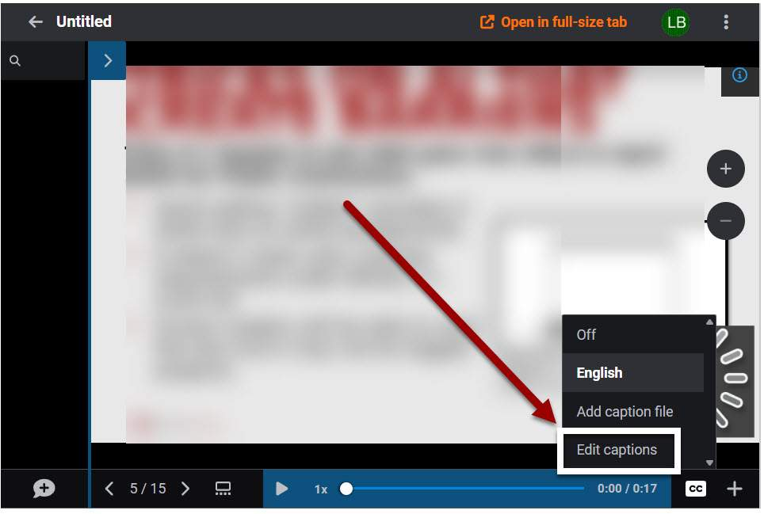
Figure 1. A VT with an arrow pointing toward the Edit Captions option of the player's Closed Captions section
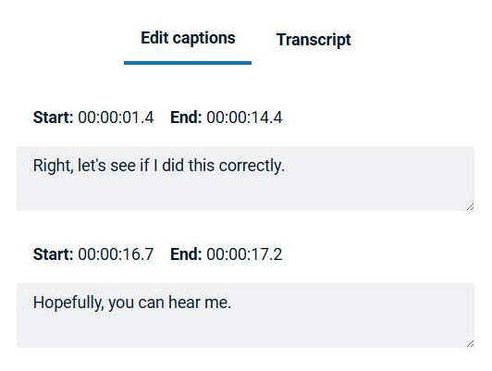
Figure 2. A copy of closed captions in in the editor.
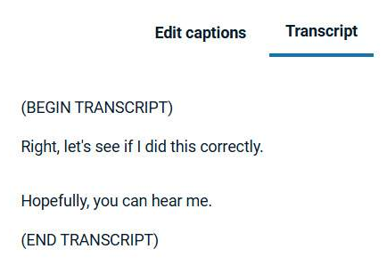
Figure 3. A copy of a Transcript in VT.
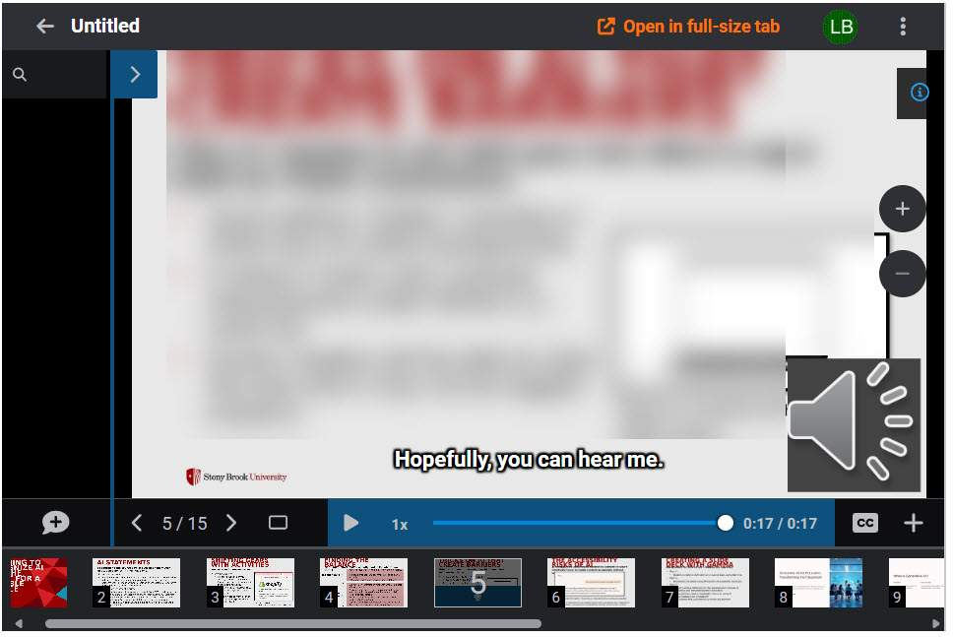
Figure 4. How closed captions appear in the player, at the bottom of the screen and overlaying the slide.

Best Practices for Editing Transcripts/Captions
Auto-generated transcripts and closed captions need to be manually checked and edited for accuracy.

Listen carefully
Play the video while editing to ensure you capture the exact words spoken.

Keep captions short
Limit captions to 20–30 characters per second.

Avoid filler words
Eliminate unnecessary fillers like "um," "uh," and "you know" unless they add value to the content (i.e., you need to show how lost or awkward the conversation is).

Use proper punctuation
Ensure correct punctuation for better flow and comprehension.

Spell check in context of the dialogue
Check the context of words to ensure the accurate word is displaying (e.g., SUNY versus sunny).

Add tone and visual cues
Notes about tone and visual cues in video transcripts provide a comprehensive understanding of the content.
Tone indicators, such as noting when someone is speaking sarcastically or emotionally, help convey the speaker's intent and nuances that might be lost in text alone. Visual cues, like describing significant gestures, facial expressions, or on-screen actions, ensure that viewers can fully grasp the context and subtleties of the video.
In the transcript, non-verbal cues should be placed in brackets.
Examples:
- [angrily] How dare you.
- [bird chirping] What was that?
- [music starts] Want to dance?

Additional Resource
VT provides their own support page with additional guidance and instructions.

Learn More About Document Accessibility
For more information about document accessibility, please reach out to CELT by emailing celt@stonybrook.edu (opens in a new tab).
To view additional tutorials and resources, visit CELT's Student Accessibility page (opens in a new tab).
Please fill out the Feedback Survey Form (opens in a new tab) to record your completion of this course and to provide feedback for improvements.

Figure 5. Stony Brook University's logo

