Google Tutorial for Students: Accessibility Features
By: Lindsay Bryde
Table of Contents
Google Tutorial for Students: Accessibility Features 1
Available Features 1
Accessing the Accessibility Features 1
Additional Resources 2
Google Docs with a Screen Reader 2
Google Slides with a Screen Reader 2
Google Sheets with a Screen Reader 2
Learn More About Document Accessibility 2

Available Features
Screen readers, screen magnifiers, and braille are invaluable accessibility tools to support low and no-vision users. Google Workspace does provide these features, but they need to be turned on. As a best practice, you want to turn on these features when collaborating on a Google Doc, Slide, or Sheet to ensure all users have access.

Accessing the Accessibility Features
- Go to Tools>Accessibility, the Accessibility settings dialog box will open.
- Check the types of support needed for:
  - Screen reader
  - Braille
  - Collaborator announcements
  - Screen magnifier
- Click the Ok button to save your selections.
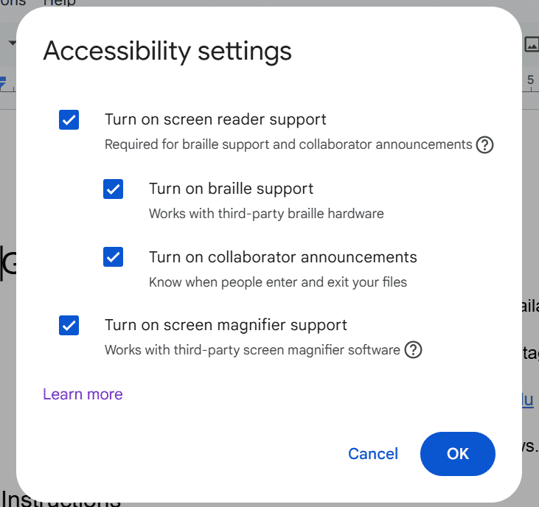
Figure 1 The Accessibility settings dialog box is open and all options are selected.

Additional Resources

Google Docs with a Screen Reader
Learn more about how to use Google Docs with a screen reader.

Google Slides with a Screen Reader
Learn more about how to use Google Slides with a screen reader.

Google Sheets with a Screen Reader
Learn more about how to use Google Sheets with a screen reader.

Learn More About Document Accessibility
For more information about document accessibility, please reach out to CELT by emailing celt@stonybrook.edu (opens in a new tab).
To view additional tutorials and resources, visit CELT's Student Accessibility page (opens in a new tab).
Please fill out the Feedback Survey Form (opens in a new tab) to record your completion of this course and to provide feedback for improvements.

Figure 2 Stony Brook University's logo

