Closed Captioning and Transcription with Echo 360 for Students
By: Lindsay Bryde
Table of Contents
How Videos Improve the Learning Experience 1
Tips for Creating Accessible Videos 2
Best Practices When Sharing/Embedding Videos 2
Why Transcripts and Closed Captions Matters 2
Echo 360 3
Editing Captions 4
Echo 360 Lecture Capture 5
Best Practices for Editing Transcripts/Captions 5
Track speakers 5
“Pause when typing” slider 5
Listen carefully 6
Keep captions short 6
Avoid filler words 6
Use proper punctuation 6
Spell check in context of the dialogue 6
Add tone and visual cues 6
Apply Closed Captions 7
Learn More About Document Accessibility 8

How Videos Improve the Learning Experience
Using videos in a course can significantly enhance engagement and comprehension. Videos provide a dynamic and visual way to present information, making complex concepts easier to understand through animations, demonstrations, and real-life examples.
Embedded videos can be paused and replayed, allowing learners to review material at their own pace. This flexibility helps reinforce learning and retention, making videos a powerful tool in educational settings.

Tips for Creating Accessible Videos
- When doing a video presentation with slides and voiceover narration, describe any images and/or visuals on the screen with clarity and specificity in addition to any main points on the slide. For instance, if an image that appears on screen has people speeding while driving, you'd want to include that information in the dialogue or voiceover.
- Use sans-serif fonts (a typeface that does not have small decorative lines at the ends of its letters) and ensure high contrast between the text and background colors. Some popular sans-serif fonts are Arial, Helvetica, Lato, Open Sans, and Roboto. Another example, this training is in Lato font.
- Body text should be at least 14 point or 20 pixels to ensure it's still visible on smaller screens (e.g. mobile devices). Headings should be at least 32 point or 42 pixels.
- Avoid placing text in places where closed captions will be placed (e.g., at the bottom of the screen).

Best Practices When Sharing/Embedding Videos
- Do not use content that contains blinking or flashing. It can cause seizures in individuals with photo-sensitivity.
- Do not set videos to automatically play when a page loads. Users need to be able to control the player.
- Check that all videos from the internet (e.g., YouTube, TedTalks) have closed captions and transcripts. This benefits anyone who prefers to read content or needs it for translation purposes. To be accessible, closed captions and transcripts need to be edited for at least 98% accuracy.

Why Transcripts and Closed Captions Matters
Transcripts and closed captions ensure content is accessible for individuals who are deaf or hard of hearing, allowing them to fully engage with what's being shown. They can also aid in comprehension for non-native speakers and those with learning disabilities.
Transcripts are a written document with the audio content of a video and descriptions of any visuals displayed on screen. They do not break down the timing of when certain actions take place or when certain words are spoken.
Closed captions are when the content of a transcript is chunked out based on the video's timing. They can enhance the viewing experience in noisy environments where audio might be difficult to hear (e.g., a big lecture hall).
Overall, transcripts and closed captioning promotes inclusivity and ensures that video content is accessible to a broader audience. To be accessible, they need to be edited for at least 98% accuracy.
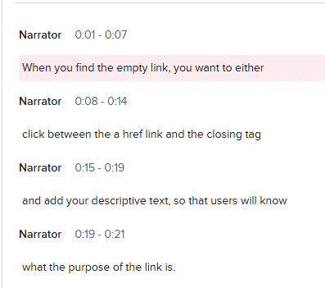
Figure 1 Figure 1 An example of a transcript in Echo 360 with clearly identified speakers for each line of text being spoken in the video.
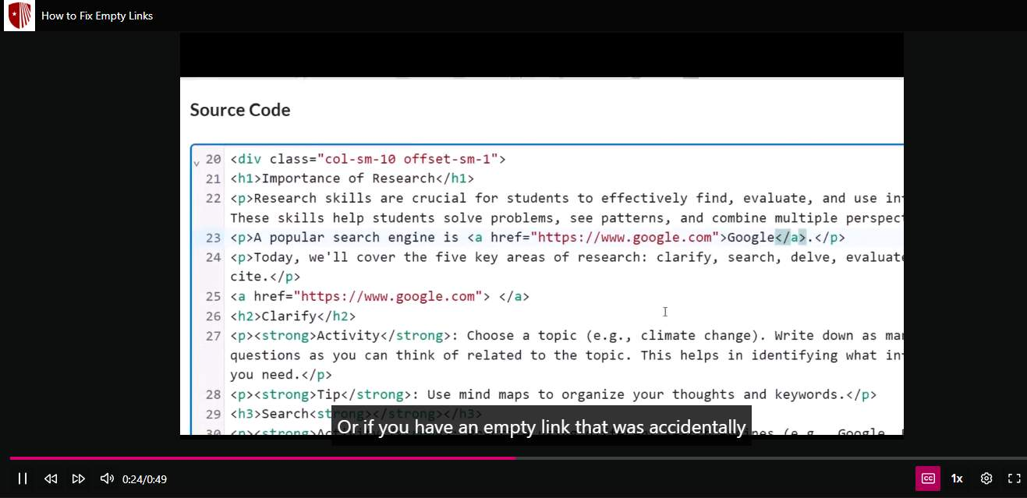
Figure 2 An example of closed captioning in Echo 360's media player. The Closed Captioning button is a purple color to signal it's been turned on. White text in a black box appears at the bottom of the video.

Echo 360
If you're using Echo 360 to record lectures or share video content you've created, all recordings less than 4 hours have machine-generated transcriptions (ASR) added to them.
Click the Edit Transcript button below the video's player to review and edit your transcripts for accuracy.
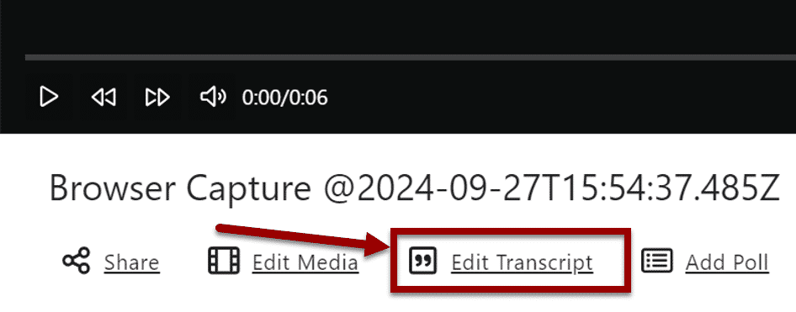
Figure 3 The overview of an individual Echo 360 recording.
The Edit Transcript option has an arrow pointing to it.

Editing Captions
- Select the Options menu for the video (icon contains three dots).
- Choose the Edit Transcript option from the drop-down menu, you’ll initially see a read-only version of the editor.
- Select the Edit Transcript button in the editor.
- Optional: Use the Search and Replace function to correct words that are frequently misspelled.
  - All instances of the word will be highlighted in the transcript to see where they are located and allows for quick verification that they all need to be corrected.
  - 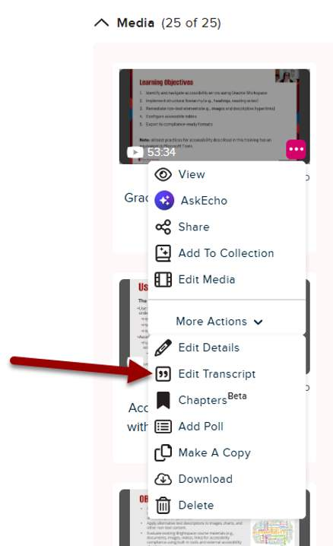
Figure 4 Find the Edit Transcript option to get started.

Echo 360 Lecture Capture
To learn more about Echo 360 and all its uses, see the Division of Information Technology's Echo 360
page.

Best Practices for Editing Transcripts/Captions

Track speakers
When you have more than one speaker, you want to identify each of them in the transcript.
You can do this by:
- Adding their names (if known), or
- Identifying them with numbers of letters (e.g., Speaker A or Speaker 1).
In the Echo360 transcript, add new speakers by clicking the Speaker drop-down and select Edit Speakers.
Note: add them all here, save their names, and toggle throughout the rest of the transcript to select which speaker goes where.
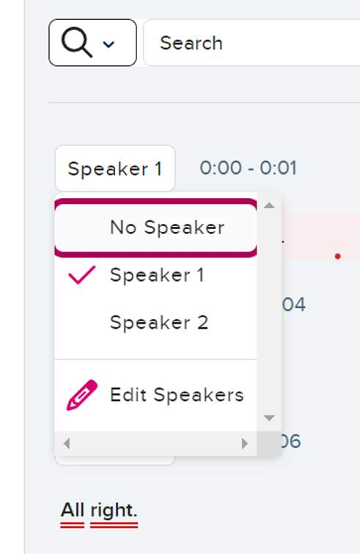
Figure 5 The Edit transcript page of Echo360. The Speaker drop-down is open, displaying the names of multiple speakers.

“Pause when typing” slider
Turn on the "Pause when typing" slider to better keep up with the video content.

Listen carefully
Play the video while editing to ensure you capture the exact words spoken.
In Echo 360, turn on the "Pause when typing" slider to better keep up with the video content.
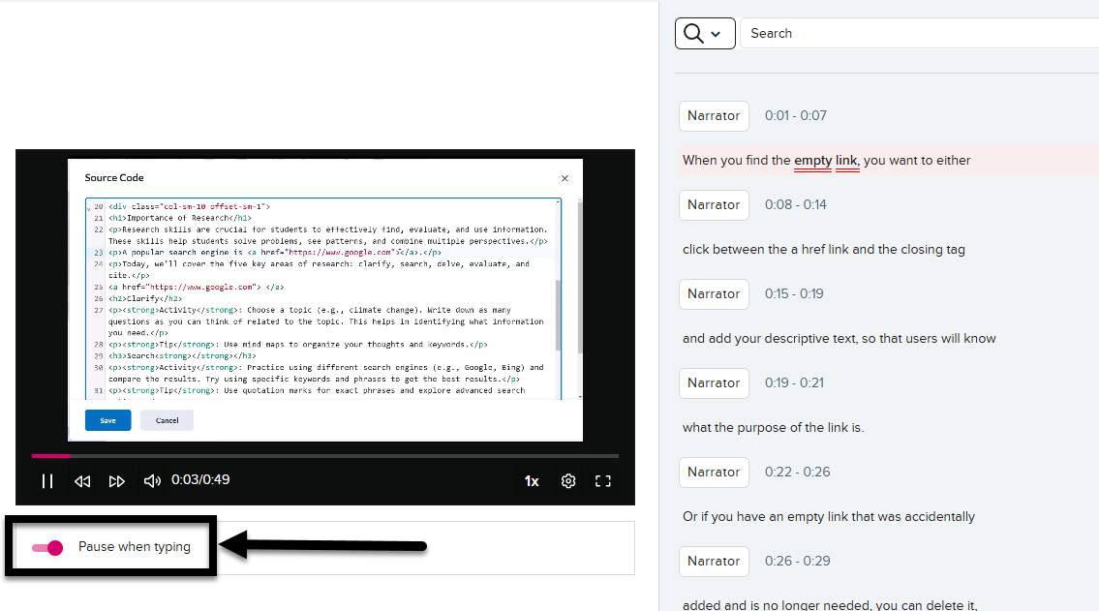
Figure 6 The Edit Transcript page. The "Pause when typing" slider is turned on and noted with an arrow.

Keep captions short
Limit captions to 20–30 characters per second.

Avoid filler words
Eliminate unnecessary fillers like "um," "uh," and "you know" unless they add value to the content (i.e., you need to show how lost or awkward the conversation is).

Use proper punctuation
Ensure correct punctuation for better flow and comprehension.

Spell check in context of the dialogue
Check the context of words to ensure the accurate word is displaying (e.g., SUNY versus sunny).

Add tone and visual cues
Notes about tone and visual cues in video transcripts provide a comprehensive understanding of the content.
Tone indicators, such as noting when someone is speaking sarcastically or emotionally, help convey the speaker's intent and nuances that might be lost in text alone. Visual cues, like describing significant gestures, facial expressions, or on-screen actions, ensure that viewers can fully grasp the context and subtleties of the video.
In the transcript, non-verbal cues should be placed in brackets.
Examples:
- [angrily] How dare you.
- [bird chirping] What was that?
- [music starts] Want to dance?
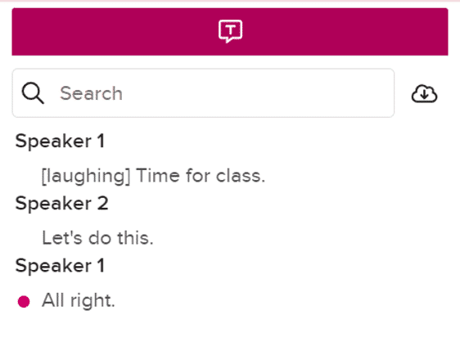
Figure 7 A transcript of a conversation between two students following Transcript best practices: Speaker 1: [laughing] Time for class. Speaker 2: Let's do this.

Apply Closed Captions
When your transcript is fully edited, it's time to add it your video as closed captions.
Note: any previous captions that had been applied will be deleted and replaced with the current version of the transcript.
From the Edit Transcript page of your video, click Apply to CC, a confirmation pop-up will appear.
Click the Apply button to confirm your selection.
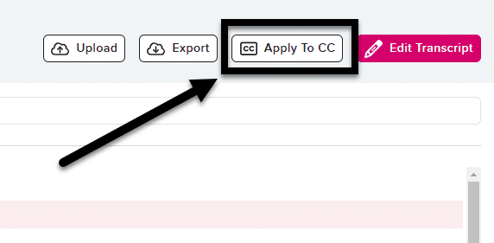
Figure 8 The upper-right corner of the Edit Transcript page, and the Apply to CC button is noted with an arrow.

Learn More About Document Accessibility
For more information about document accessibility, please reach out to CELT by emailing celt@stonybrook.edu (opens in a new tab).
To view additional tutorials and resources, visit CELT's Student Accessibility page (opens in a new tab).
Please fill out the Feedback Survey Form (opens in a new tab) to record your completion of this course and to provide feedback for improvements.

Figure 9 Stony Brook University's logo

