Basic Brightspace Accessibility for Students
By: Lindsay Bryde
Table of Contents
Welcome 2
Learning Objectives 2
Ally and Brightspace Accessibility Checker 3
What is Ally? 3
What do the symbols mean? 4
Ally for Students 4
Reviewing Results 4
Brightspace Accessibility Checker 5
Knowledge Check 1: Ally and Brightspace Accessibility Checker 6
Document Templates and Formatting 7
Setting Default Fonts and Sizes 7
How to Set Default Font and Size in Brightspace 7
Document Templates 9
How to Set Up a Document Template 9
Best Practices for Headers and Formatting 14
Knowledge Check 2: Document Templates and Formatting 16
Hyperlinks 16
Quicklinks 16
What are Empty Links 17
Force Focus Bookmarklet 19
Fixing Empty Links 20
Knowledge Check 3: Hyperlinks 22
Lists 23
Why Lists Need to be Created and Formatted in Brightspace 23
Creating a List with Advanced Editor 23
How to Check If a List is Inaccessible 24
Knowledge Check 4: Lists 25
Tables 25
Best Practices 25
Table Headers 25
Table captions 29
Knowledge Check 5: Tables 31
Equation Editor 31
Why use the Brightspace Equation Editor? 31
Creating an Equation 31
Knowledge Check 6: Equation Editor 34
Conclusion 34
Knowledge Check Answer Key 35
Knowledge Check 1 Answers: Ally and Brightspace Accessibility Checker 35
Knowledge Check 2 Answers: Document Templates and Formatting 35
Knowledge Check 3 Answers: Hyperlinks 35
Knowledge Check 4 Answers: Lists 35
Knowledge Check 5 Answers: Tables 35
Knowledge Check 3 Answers: Equation Editor 35


Figure 1 Stony Brook University Logo

Welcome
In this course, we provide guidance and introductory instructions on creating accessible content in Brightspace. There are many elements that go into making content accessible; this guide is not exhaustive.
It is highly recommended that you review the Digital Accessibility Resource Guide for Students before beginning this course.
The estimated time to complete this course is 15-20 minutes.

Learning Objectives
- By the end of this guide, you will be able to
- Locate and complete an accessibility check with Ally
- Describe the limitations of Ally.
- Identify and fix empty links.
- Explain the importance of using Quicklinks.
- Create lists, tables, and equations using built-in tools.
- Apply document templates, including accessible font sizing and spacing.
- Execute a check for sufficient color contrast.
For more information about document accessibility, please reach out to CELT by emailing celt@stonybrook.edu.
If you come across an accessibility barrier in this guide, please let us know by emailing celt@stonybrook.edu.
Note on links:
All links open to a new tab.

Ally and Brightspace Accessibility Checker

What is Ally?
Ally is a tool built into Brightspace that allows to download course materials in ePub, Electronic Braille (BRF), Audio (MP3), and BeeLine Reader.
Click the Ally button next to any page and a dialog box will open displaying the available document types that can be downloaded.
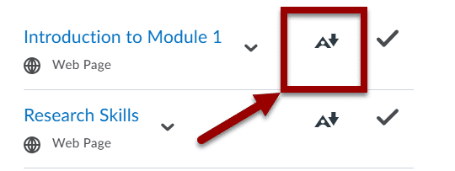
Figure 2. A Brightspace content section with two pages displayed. An arrow is pointing to an Ally symbol next to a page's title.
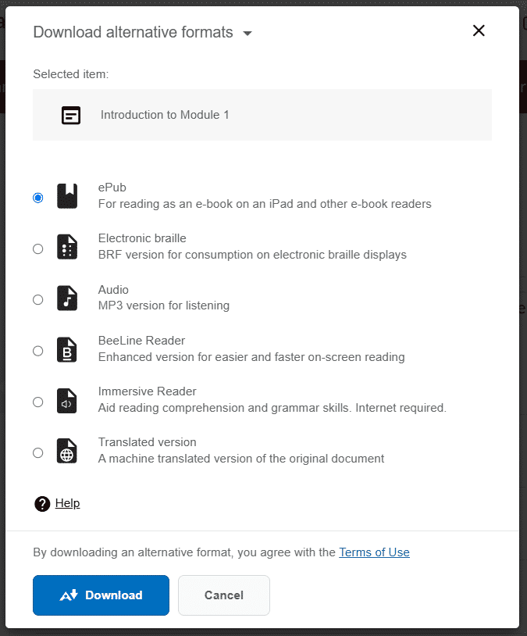
Figure 3. The download page of Ally, displaying all available document types that a user can select.
To learn more about Ally for Students, see this 3-minute video by Anthology Ally.


Brightspace Accessibility Checker
For content Ally cannot check (e.g. module overviews, assignments, discussions, and quizzes), users can run their own review using the Brightspace Accessibility Checker. In the Brightspace Editor, click the Accessibility Checker icon (an eye over a checkmark).
A pop-up window displays showing you any identified issues and recommendations on how to remediate the content.
Similar to Ally, the Brightspace Accessibility Checker has it's own limitations. It cannot check the quality or accuracy of headers, alt text, or captions.
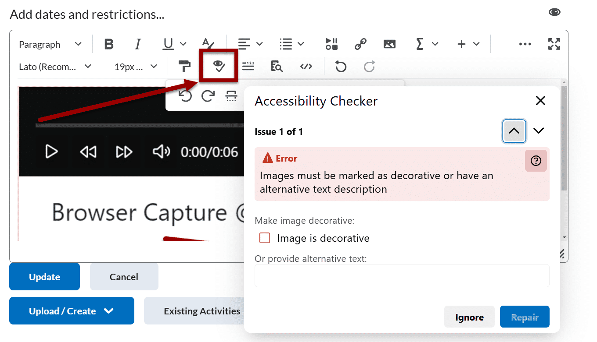
Figure 4. A Brightspace module open for editing with the Accessibility Checker report on display in a pop-up. The Accessibility Checker icon is noted with an arrow.
Note: the Brightspace Accessibility Checker is also available for anyone adding a new thread or writing a reply in a discussion forum.

Knowledge Check 1: Ally and Brightspace Accessibility Checker
Answer the following question to self-check your knowledge (answers are at the end of the document).
What is one of the primary functions of Ally in Brightspace?
- To check the quality of alt text in images
- To create new discussion threads
- To provide alternative formats for course materials
- To grade assignments automatically

Document Formatting
Set Heading Levels in Brightspace Discussion Forums
If you are posting about multiple topics in discussion forums, you need to organize your information with headers. Be careful that you're taking the time to properly set the heading levels:
- Select the text that is part of your header.
- Click the Paragraph drop-down menu and select the appropriate heading level for that text.
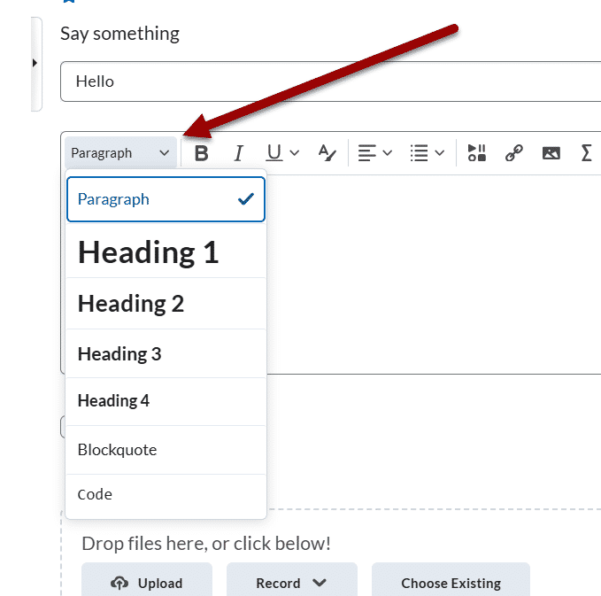
Figure 5. A Brightspace discussion forum, an arrow is pointing to the Paragraph drop-down, which is open and displaying all the heading level options.

Best Practices for Headers and Formatting

Use unique and descriptive names
Make sure each module, activity (e.g., assignment, discussion, quiz), page, and file has a unique and descriptive name. These are read as headers by screen readers.
It can be confusing if you have two assignments with the same name, and you don't know why the phrase is repeating itself.

Set heading level 1 as text
There should only be one Header 1 <h1> level per page. Header 1 cannot be an image, it must include text.

Don't skip heading levels
It's best to avoid skipping heading levels. For example, don’t go from an <h1> to an <h3> without using an <h2> in between.

Use built-in formatting tools to create white space
Instead of adding multiple blank spaces or lines, use the built-in paragraph styles and formatting tools to create white space on the page.
For example:
- add a Divider if you want to visually add a space between sections (pictured below).
- Use the Paragraph Left to Right or Right to Left tools to create indents.
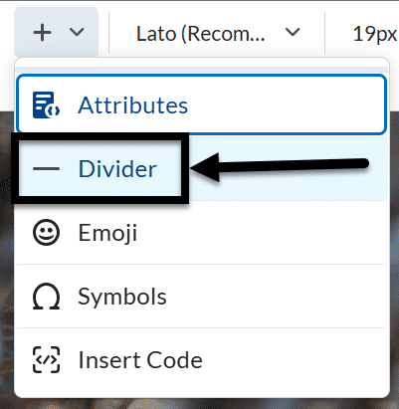
Figure 6 The More options drop down is open with the Divider tool indicated by an arrow.

Check the color contrast checker when making updates
Using the Brightspace color contrast checker is essential for ensuring that your course content is accessible to all students, including those with visual impairments. Located under the Select a Color tool, it helps you verify that the text and background colors in your content meet the Web Content Accessibility Guidelines (WCAG) standards for contrast.
Adequate color contrast improves readability and ensures that all users can perceive the information clearly, regardless of their visual abilities.
Be careful that your color select is passing both the Small and Large Contrast checks.
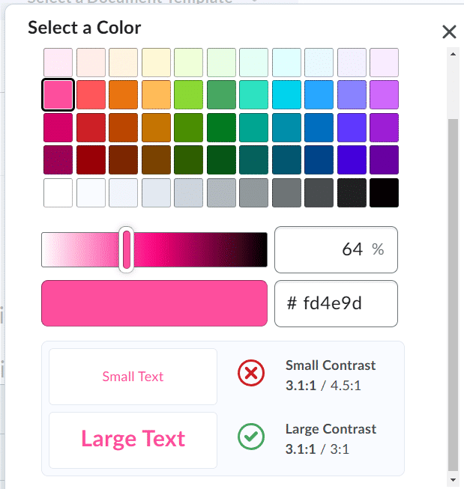
Figure 7 The color contrast checker displays underneath the color options in the Select Color pop-up.

Knowledge Check 2: Document Templates and Formatting
Answer the following question to self-check your knowledge (answers are at the end of the document).
- What is a best practice for using headers in Brightspace?
  - Use multiple Header 1 levels per page
  - Skip heading levels for simplicity
  - Use unique and descriptive names for each module and activity
  - Use images as Header 1

Lists

Why Lists Need to be Created and Formatted in Brightspace
Lists can very easily be made inaccessible when content creators:
- type them out phonetically or
- copy and paste them from another source (e.g., a Word document or a PPT)
While these lists may look okay visually, the code underneath it (that's only visible to you) is unable to read the list accurately to screen reader users.

Creating a List with Advanced Editor

Create a New List
- Place the cursor where you want to create the list in the page.
- Click the List icon in the Advanced Editor.
- Select Bulleted List (for unordered lists) or Numbered List (for ordered lists).
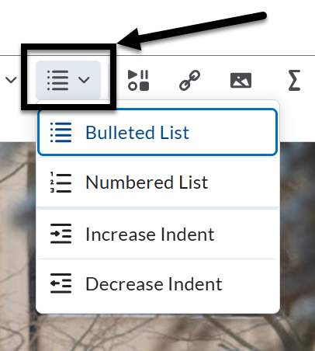
Figure 20 The List drop-down is open in the Brightspace editor displaying the numbered and bulleted list options.

Format an Existing List
Note: it's best practice to remove any manually added or copied bullets or numbers from the list before you start this process.
- Highlight the content you want to format as a list.
- Click the List icon in the Advanced Editor.
- Select Bulleted List (for unordered lists) or Numbered List (for ordered lists).

How to Check If a List is Inaccessible
If you have older content and you're not sure if the lists were set up properly, you can open the page's Source Code and scroll down to where the list is noted.

What you'll see if it's not accessible
- The <div> </div> tags.
  - The tags mean that each line is its own section/list – it's not all in one list.
- You can see the bullet/symbol or number in the code, after the tag.
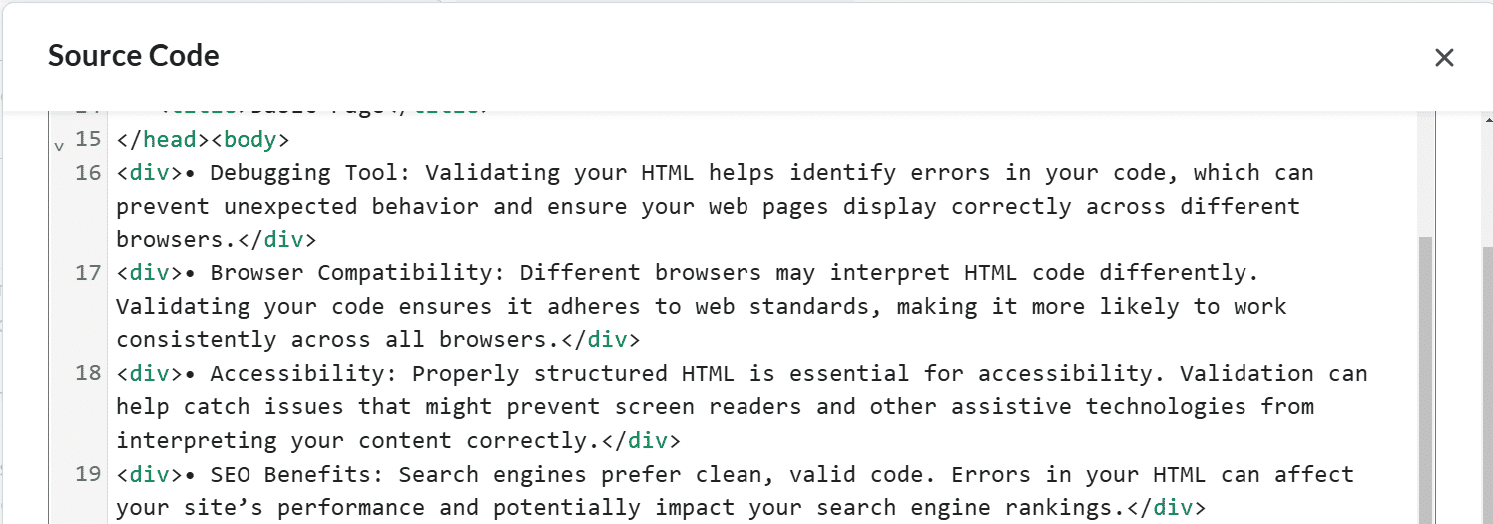
Figure 21 An example of inaccessible code for a list with the <div> tag.

What you'll see if it's accessible
- The <ul> and </ul> for unordered lists.
- The <ol> and </ol> tags ordered lists.
- The <li> and </li> tags for each item in the list.
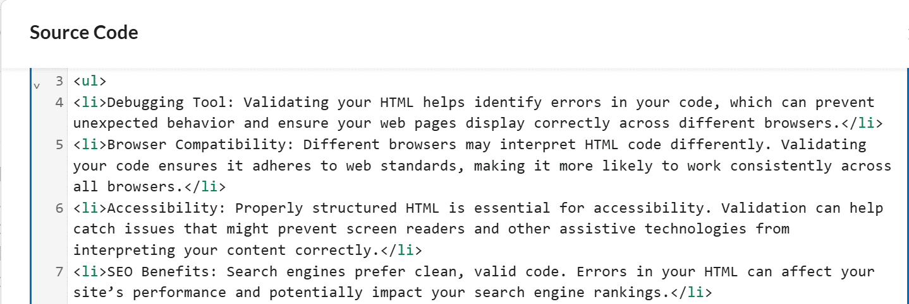
Figure 22 An example of accessible code for an unordered list with the <li> and <ul> tags.

Knowledge Check 3: Lists
Answer the following question to self-check your knowledge (answers are at the end of the document).
- Why can lists become inaccessible when content creators type them out phonetically or copy and paste them from another source?
  - They look visually unappealing
  - The underlying code is unable to read the list accurately to screen reader users
  - They take up too much space on the page
  - They are difficult to edit

Tables

Best Practices
- Create tables in Brightspace pages directly and use the Brightspace Editor to format them.
- Keep the data simple and avoid splitting or merging cells
- Avoid copying and pasting content from another source. Any accessibility settings in the old table will not copy over.
- Set which cells in the table are column or row headers.
- Include a summary of the data before or after the table to provide context to the information.
- If you change topics, start a new table.

Table Headers
A table's rows or columns indicate the significance of the grid's data.
When a user can see the table, they can quickly form visual associations between the data and the row/column headers. When a user cannot see the table, they must use a screen reader to navigate through the cells one at a time, which means the table's column/row headers need to be properly marked to read the information accurately.
Below is a tutorial on how to set the table's headers and scope accurately.
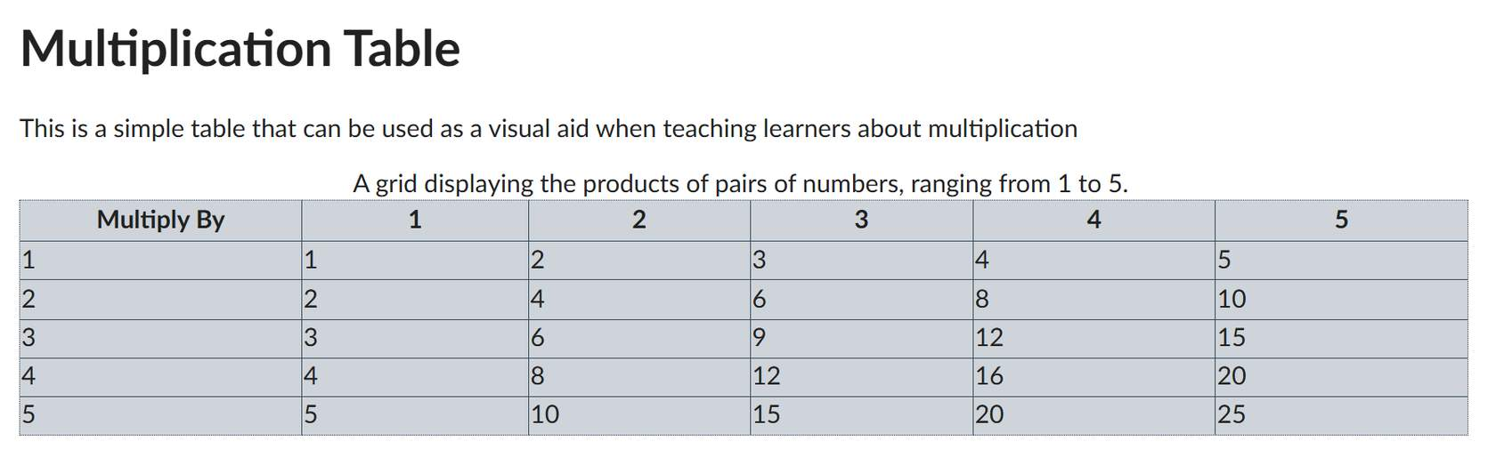
Figure 23 A simple table created in Brightspace about multiplication.

Step 1: Highlight the cell(s) of the header(s)
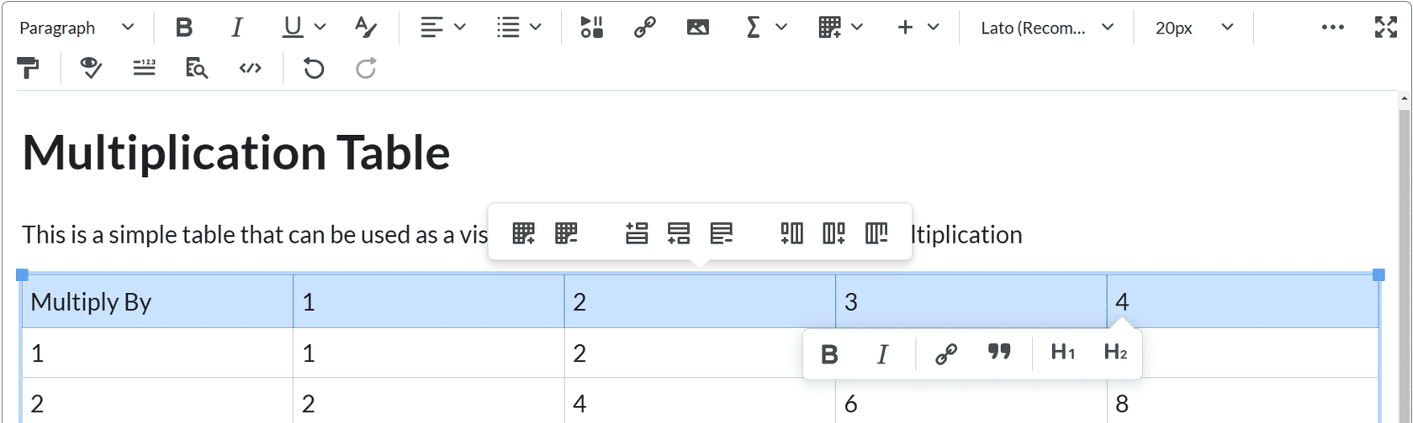
Figure 24 A Brightspace table with the cells of the entire top row highlighted.
Put the cursor in the cell or highlight the cells you want to mark as a table header.

Step 2: Table icon
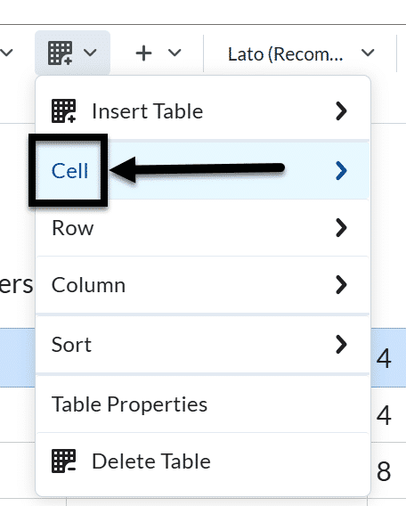
Figure 25 The Table icon has been selected and the Cell option is indicated with an arrow.
Click on the drop-down menu next to the Table icon in the Brightspace Editor, and select the Cell option from the drop-down.

Step 3: Cell properties
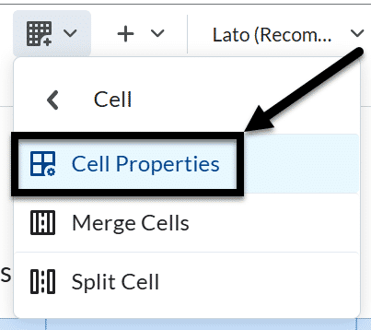
Figure 26 The Cell drop-down is open and the Cell properties option is indicated with an arrow.
Select Cell Properties, the Cell properties window will pop-up.

Step 4: Cell Type
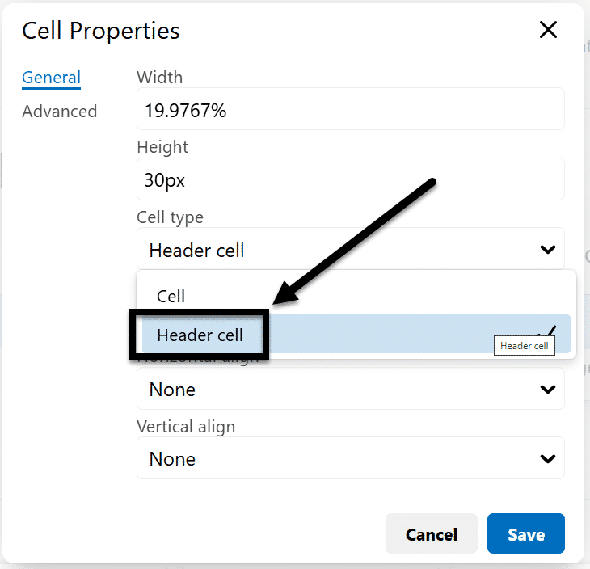
Figure 27 The Cell Properties pop is open and the Cell type drop-down is showing the header cell option.
In the Cell type field, click on the drop-down list and select Header cell.

Step 5: Set the scope
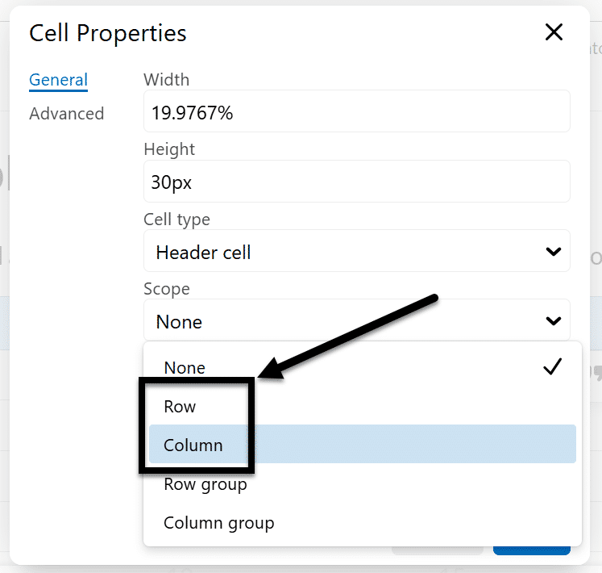
Figure 28 The Scope drop-down is open and showing the row and column options.
In the Scope field, click on the drop-down list, and select whether the header is for a Column or Row.

Step 6: Save and repeat as needed
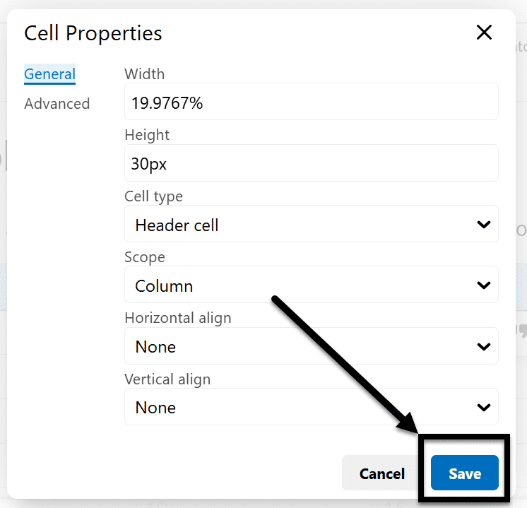
Figure 29 The Cell properties pop-up is open with the Save button being indicated by an arrow.
Click the Save button and repeat for each cell that is a column or row header.

Table captions
Table captions can be a good way of capturing the overall purpose of your table for all users.
Follow the tutorial below to add captions to your table using the Brightspace Editor.

Step 1: Select the table
Click on the table you want to add captions to.

Step 2: Table icon
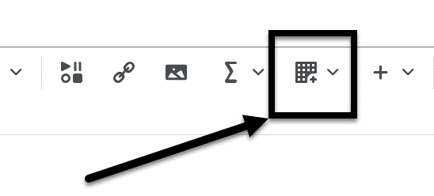
Figure 30 The Table icon is indicated in the Brightspace Editor with an arrow.
Click the Table icon in the Brightspace Editor.

Step 3: Table Properties
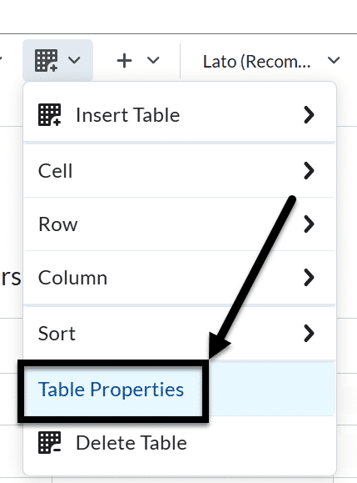
Figure 31 The Table drop-down is visible and the Table properties option is indicated with an arrow.
Select the Table Properties option, the Table properties window will pop-up.

Step 4: Show caption
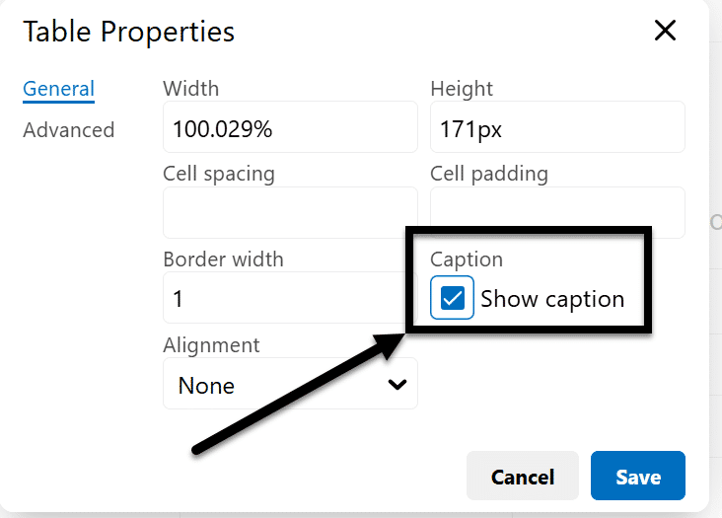
Figure 32 The Table Properties pop-up is open and the Show Caption checkbox is checked and indicated with an arrow.
Check the Show caption box and click the Save button

Step 5: Add caption
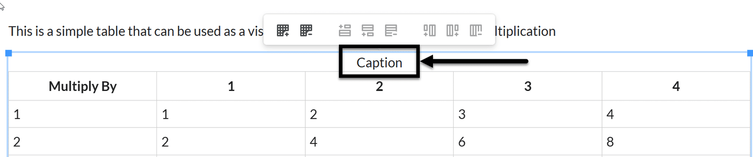
Figure 33 The Caption placeholder is indicated in a table with an arrow.
Enter your caption into the table; there’s now a placeholder in the last row for it.

Knowledge Check 4: Tables
Answer the following question to self-check your knowledge (answers are at the end of the document).
- What is the purpose of including a caption with a table?
  - To make the table look more professional
  - To provide context to the information for all users
  - To increase the size of the document
  - To add more content to the page

Equation Editor

Why use the Brightspace Equation Editor?
Using an Equation Editor ensures that mathematical expressions are clear and accurately formatted, which is critical for understanding complex equations.
The Brightspace Equation Editor presents information in MathML or LaTeX, which supports assistive technologies in ways that manually typing out an equation is not equipped to do.

Creating an Equation
The Equation Editor's seamless integration into various parts of Brightspace (e.g., quizzes, assignments, and content pages) ensures consistent and accurate display of equations.

Step 1: Which page or activity needs an equation?
Open the module overview, page, assignment, discussion, or quiz on Brightspace where you want to create an equation.

Step 2: Where does the equation need to go on the page?
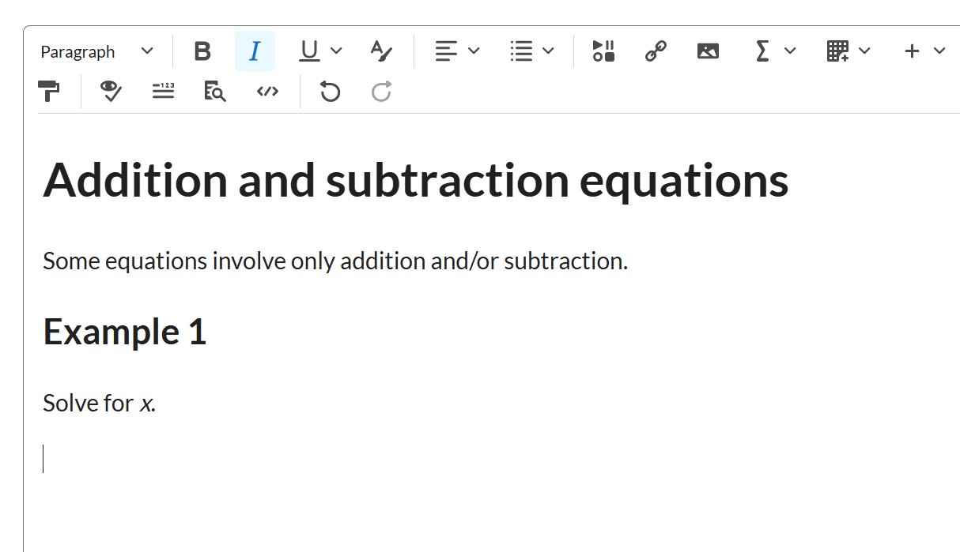
Figure 34 The cursor is in the middle of a Brightspace page.
Put the cursor where you want to add the equation.

Step 3: Which type of equation is needed?
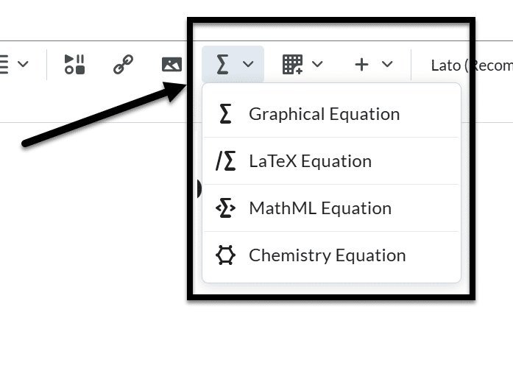
Figure 35 The Equation editor icon is indicated with an arrow and the drop-down is open, displaying the Graphical Equation, LaTeX Equation, MathML Equation, and Chemistry Equation options.
From the Graphical equation drop-down list, do one of the following:
- To insert a graphical equation, click Graphical equation.
- To insert a chemistry equation, click Chemistry equation.
- To insert a MathML equation, click MathML equation.
- To insert a LaTeX equation, click LaTeX equation.

Step 4: How do you want to format your equation?
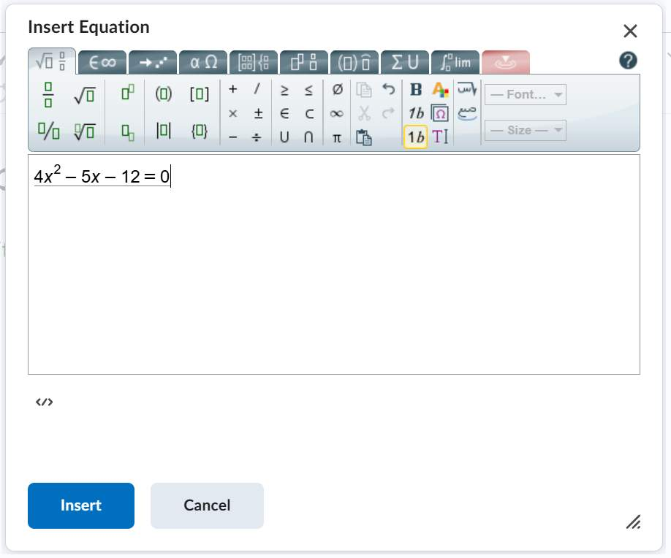
Figure 36 The Graphical Equation editor is open with an equation displaying.
In the Insert Equation window, enter your equation using keyboard characters and your cursor to select symbols from the tabs.
Note: Click the Source code button </> to preview what the code looks like.
Step 5: What happens when I'm done formatting the equation?
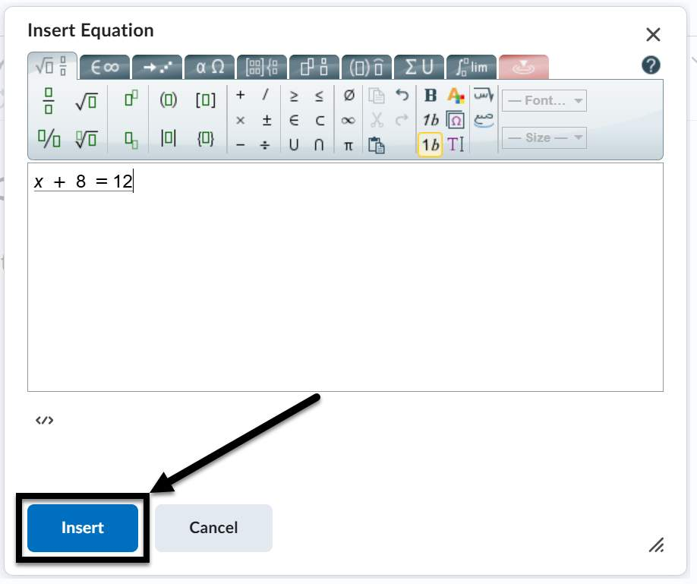
Figure 37 The Graphical Equation editor is open and an arrow is pointing toward the "Insert" button at the bottom of the screen.
Click Insert to add the content to the Brightspace editor and add any additional, non-equation content needed.
Click the Save and close button when you’re done editing the overall page.

Knowledge Check 5: Equation Editor
Answer the following question to self-check your knowledge (answers are at the end of the document).
- Why is it important to use the Brightspace Equation Editor for mathematical expressions?
  - It makes the equations look colorful
  - It allows for the use of emojis in equations
  - It automatically solves the equations
  - It ensures that mathematical expressions are clear and accurately formatted

Conclusion
You have completed the Brightspace Accessibility course!
Please fill out the following feedback form to record your completion of this course and to provide feedback for improvements.

Knowledge Check Answer Key

Knowledge Check 1 Answers: Ally and Brightspace Accessibility Checker
- C

Knowledge Check 2 Answers: Document Formatting
- C

Knowledge Check 3 Answers: Lists
- B

Knowledge Check 4 Answers: Tables
- B

Knowledge Check 5 Answers: Equation Editor
- D

