Advanced PDF Accessibility for Students: Tables
By: Lindsay Bryde
Table of Contents
Tables 1
Set Headers and Scope to Tables 1
Add the Table Summary 4
Step 1: Prepare for accessibility 4
Step 2: Fix Reading Order 5
Step 3: Select the table and Edit Table Summary 5
Step 4: Enter the summary 6
Confirm and save 6
Learn More About Document Accessibility 6
Note on Course Attribution 6

Tables
Those who use a screen reader to access your document will find it easier to navigate and comprehend if you ensure that the tables in your PDF are appropriately tagged.
Even if a PDF has been tagged in general, tables may need additional markup to be fully accessible.

Set Headers and Scope to Tables
It's best to specify row and column headers for tables, as well as their “scope” using the Reading Order (formally known as the Fix reading order option). This would potentially aid assistive computer technology applications in speaking the relevant row or column information to an individual navigating the data table.

Step 1: Determine if the document is tagged or untagged
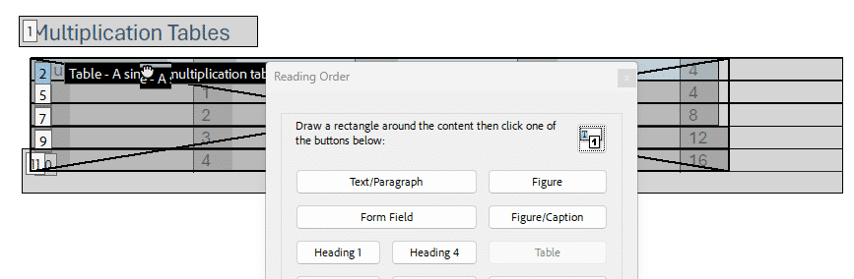
Figure 1 The Reading Order dialog box is open. In the background is a PDF with a table. The first row of the table is highlighted a light blue, showing the cell has been selected as the header.
If the table is untagged, in Reading Order, draw a rectangle around the content then click on Table.
If the table is tagged, in Reading Order, designate a header cell by selecting it. To select a cell, click it, and the cell should turn blue.

Step 2: Open the Reading Order panel
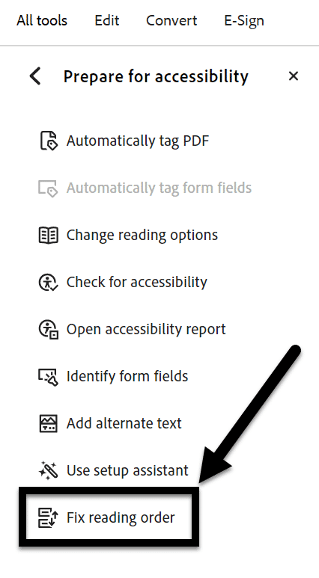
Figure 2 The All Tools panel is opened with the "Fix reading order" option noted at the bottom of the list with an arrow.
To add row and column header information, enable the Fix reading order option (All Tools > Prepare for accessibility > Fix reading order).

Step 3: Find the Table Editor
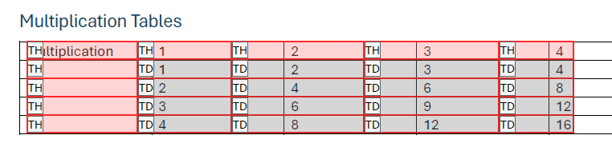
Figure 3 The Table Editor is active and displaying the tags for each cell in the table. TH for headers and TD for data. The headers are highlighted a light red, and the data is a light grey.
In the Fix reading order option, choose the Table Editor button.

Step 4: Show cell type
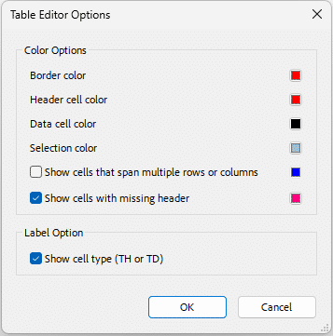
Figure 4 The Table Editor Options dialog box is open and the Label Option "Show cell type (TH or TD)" is checked.
If on the table, you do not see TD or TH, right click on a cell > select Table Editor Options > check mark under Label Option > Show cell type (TH or TD).

Step 5: Set the table cell properties
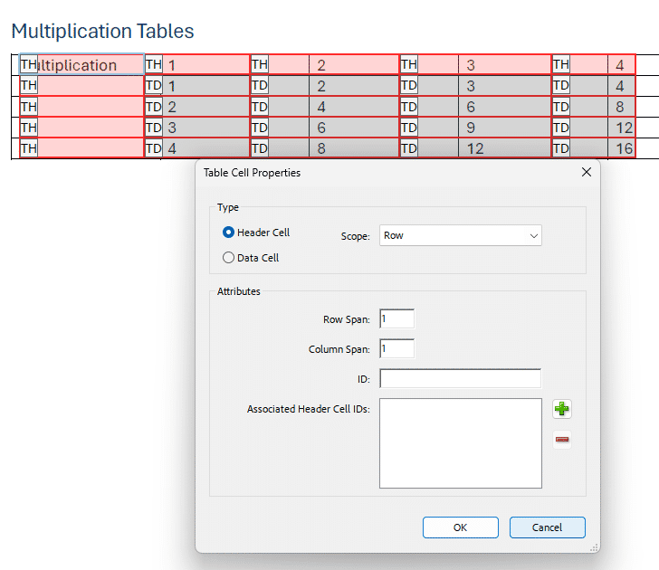
Figure 5 The Table Cell Properties dialog box is open and displays what type of cell has been selected and the scope of the cell. The table in the background shows the cell that has been selected has a light blue box around it.
For each row header, right-click in the actual table cell and choose Table Cell Properties.
Set the Type as "Header Cell" and the Scope property as "Row" or "Column."

Check your work
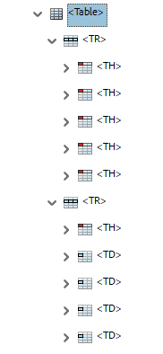
Figure 6 A table in the Accessibility Tags panel. The entire first row of the table has been marked as a header. The first cell in the second row has been marked as a header for the row, and all other cells contain data.
When you're done, verify table headers and cell types are in the correct reading order using the Accessibility tags panel.

Add the Table Summary
A table summary is a brief description that provides an overview of the content and structure of a table. It helps users who rely on screen readers to understand the context and purpose of the table without having to navigate through all the data.

Step 1: Prepare for accessibility
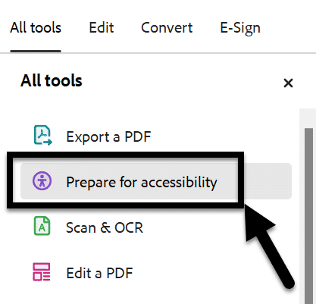
Figure 7 The All Tools panel is open and the Prepare for Accessibility option is noted with an arrow.
Go to All Tools>Prepare for accessibility.

Step 2: Fix Reading Order
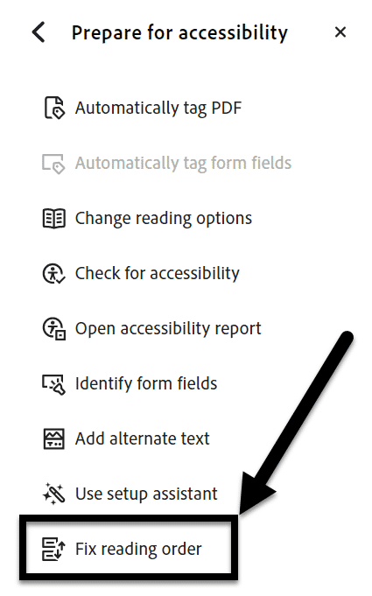
Figure 8 The Prepare for Accessibility panel is open and the "Fix reading order" option is noted with an arrow.
Click on Fix reading order, a dialog box will open.

Step 3: Select the table and Edit Table Summary
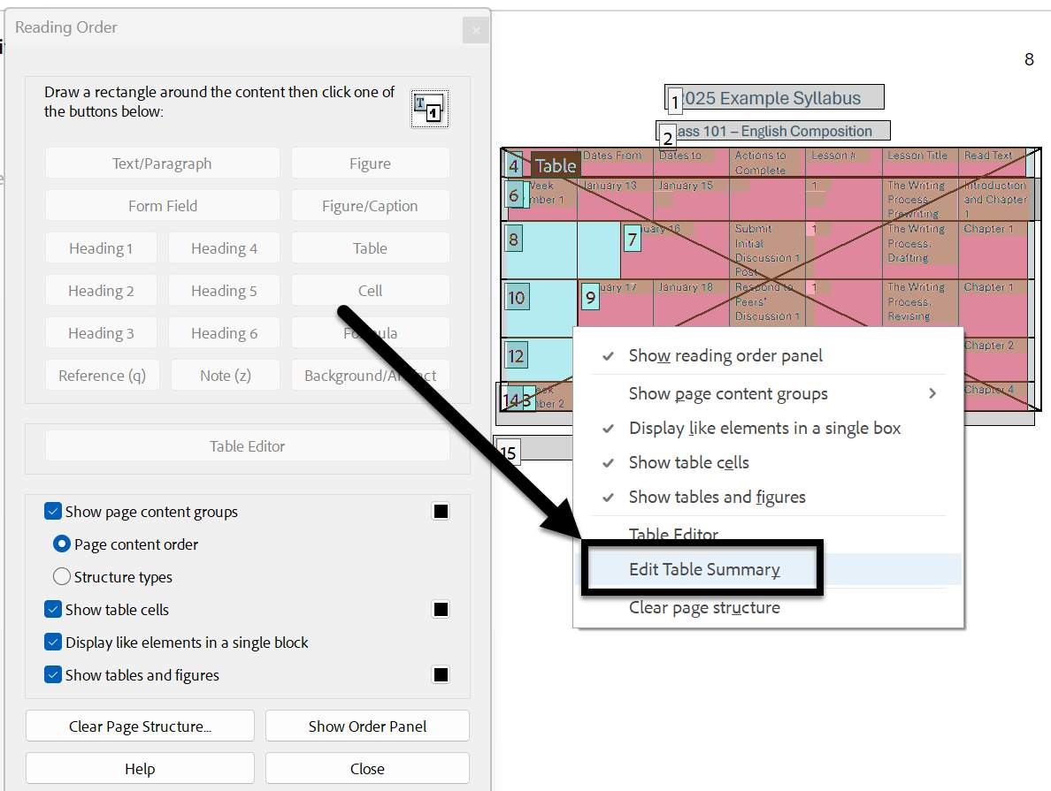
Figure 9 A table has been right-clicked and the "Edit table summary" option is noted in the drop-down menu.
Right-click on the table you want to add a summary to.
From the drop-down menu, select Edit Table Summary, a dialog box will appear.

Step 4: Enter the summary
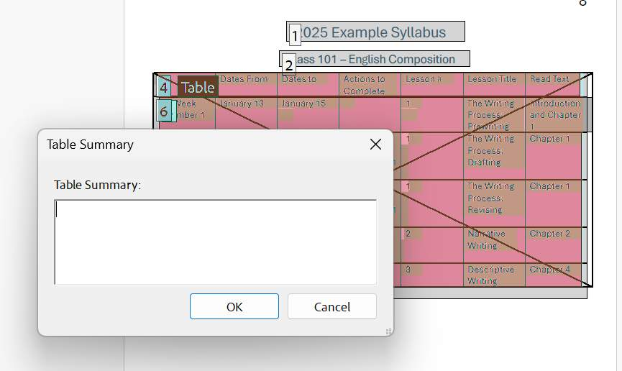
Figure 10 The Edit Table Summary box is open.
Enter a descriptive summary of the table. Be careful to include key details about the table's purpose and organization.

Confirm and save
Click the Ok button to save the summary.
Make sure to save your overall document.

Learn More About Document Accessibility
For more information about document accessibility, please reach out to CELT by emailing celt@stonybrook.edu (opens in a new tab).
To view additional tutorials and resources, visit CELT's Student Accessibility page (opens in a new tab).
Please fill out the Feedback Survey Form (opens in a new tab) to record your completion of this course and to provide feedback for improvements.

Figure 11 Stony Brook University's logo

Note on Course Attribution
This course has been adopted from San Diego Mesa College's PDF Accessibility (Self-Paced) course(opens in a new tab), licensed under a Creative Commons Attribution 4.0 International License(opens in a new tab). San Diego Mesa College adopted their training from PDF Accessibility by CCC Accessibility Center(opens in a new tab), licensed under a Creative Commons Attribution 4.0 International License(opens in a new tab). Development of this course was funded by a grant from the California Community Colleges' Chancellor's Office. *Our version focuses on the section on tables in the module "Tag Panel" and contains additions to reflect Adobe Acrobat's current navigation and features.

