Introduction to Universal Design for Learning
By: Lindsay Bryde
Table of Contents
Welcome 2
Learning Objectives: 2
Introduction 2
Universal Design for Learning (UDL) 2
Removing Barriers 3
The Impact of UDL 4
Engagement: The Why of Learning 4
Choice 5
Relevance 5
Collaboration 6
Knowledge Check: Engagement 7
Representation: The What of Learning 7
Supporting Tools & Experiences 8
Customizable Content 8
Flexible Formats 9
Knowledge Check: Representation 10
Action and Expression: The How of Learning 10
Strategy Development 10
Assessment Methods 11
Reflection and Feedback 11
Knowledge Check: Action and Expression 13
Technology: Tools at Stony Brook University 13
Brightspace 13
Ally 13
Echo 360 13
VoiceThread 14
Solstice 14
Virtual Reality/Augmented Reality Studio 14
Conclusion 14
Knowledge Check Answer Keys 14


Figure 1 Stony Brook University's logo

Welcome
In this course, we provide guidance and an introduction on Universal Design for Learning. This guide is not exhaustive.
The estimated time to complete this course is 15 minutes.

Learning Objectives:
By the end of this guide, you will be able to:
- Describe the principles and goals of Universal Design for Learning.
- Recognize and explain the three main principles of UDL: Multiple Means of Engagement, Representation, and Action & Expression.
- Identify potential barriers to learning and how UDL can help mitigate these barriers.
- Utilize technology to support diverse learning needs and preferences.
For more information about document accessibility, please reach out to CELT by emailing celt@stonybrook.edu.
If you come across an accessibility barrier in this guide, please let us know by emailing celt@stonybrook.edu.
Note on links:
All links in this course open to a new tab.

Introduction

Universal Design for Learning (UDL)
Universal Design for Learning (UDL) is an educational framework that aims to improve and optimize teaching and learning for all people. It is grounded in the belief that variability in learners is the norm, not the exception, and that educational environments should be designed to accommodate this diversity from the outset. By proactively planning for a wide range of abilities, disabilities, interests, and backgrounds, UDL seeks to create more inclusive and effective learning experiences.
The Center for Applied Special Technology (CAST) established three core principles to build the framework: Multiple Means of Engagement, Multiple Means of Representation, and Multiple Means of Action and Expression.
- Engagement: The ways students are motivated and interested in learning.
- Representation: Presenting information in a variety of ways to ensure all students can access and understand it.
- Action and Expression: Providing different ways for students to demonstrate what they know.

Removing Barriers
One of the key aspects of UDL is its emphasis on proactively removing barriers.
In architecture, Universal Design prioritizes creating buildings that are accessible to everyone from the start. This approach ensures that structures are designed to accommodate people of all abilities, eliminating the need for costly and time-consuming retrofits. By considering accessibility during the initial design phase, architects can create inclusive environments that promote independence and ease of use.
Similarly, some educational approaches can create obstacles for students with diverse needs, whether due to physical, sensory, cognitive, or emotional differences. UDL encourages educators to anticipate these barriers and design learning environments that minimize them.

Figure 2 A building that is only accessible via a staircase

Figure 3 The Guggenheim museum, which features a large circular ramp that gradually keeps going up to the next level.

The Impact of UDL
In the 2-minute video below, hear about the impact that UDL can have on classrooms and students.


Engagement: The Why of Learning
Engagement is about motivating learners and sustaining their interest throughout the course. By providing multiple means of engagement, educators can cater to the diverse preferences and needs of their students. Ultimately, the goal is to create an inclusive learning environment where every student feels valued and invested in their learning journey.
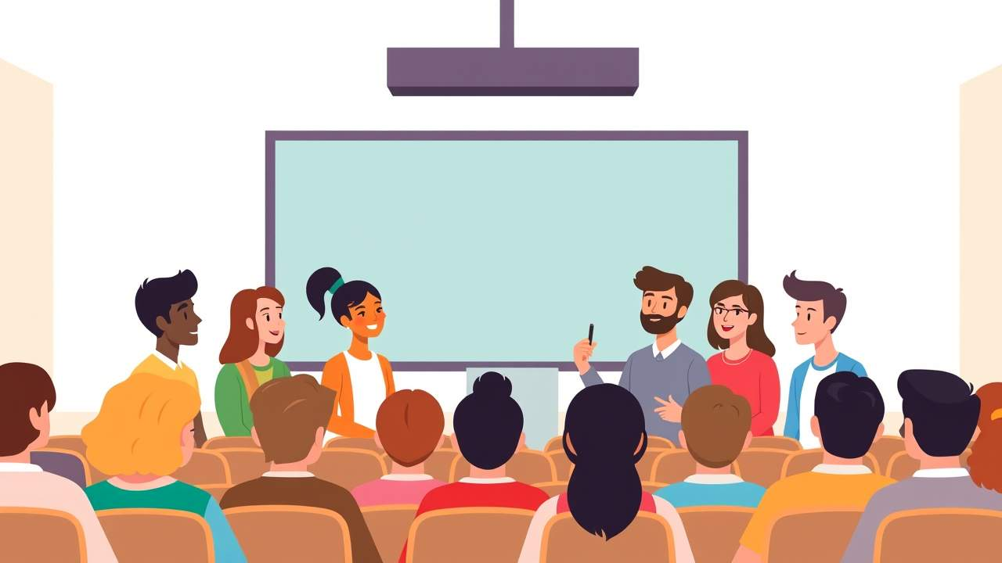
There are many ways of fostering engagement in learners:

Choice
Providing students with choices in their learning process can significantly enhance engagement. When learners have the autonomy to select topics or methods that interest them, they are more likely to invest effort and stay motivated.
Ways we can provide choice in the classroom:
- Assignment Options: Allow students to choose from a variety of assignment types, such as essays, presentations, videos, or creative projects, to demonstrate their understanding.
- Reading Materials: Offer a selection of books or articles on a topic, enabling students to pick the ones that interest them most.
- Learning Paths: Create different learning modules or pathways that students can follow based on their interests and learning preferences.
- Assessment Methods: Provide options for how students can be assessed, such as through traditional tests, portfolios, or peer reviews.
- Pacing: Allow students to work at their own pace, giving them the flexibility to spend more time on challenging topics and move quickly through areas they find easier.

Relevance
Connecting learning material to students' lives and interests is a powerful way to boost engagement. When content is relevant, learners see the value in what they are studying and are more likely to participate actively.
Ways we can provide relevance to the classroom:
- Real-World Applications: Connect lessons to real-life scenarios, current events, and career options to show how the material is applicable outside the classroom.
- Guest Speakers: Invite professionals from the field to discuss how they use the subject matter in their careers.
- Project-Based Learning: Design projects that solve real-world problems or address community issues, making learning more meaningful.
- Technology Integration: Use modern technology and digital tools that students are familiar with to teach and explore topics.
- Interdisciplinary Connections: Show how the subject connects with other disciplines, highlighting its broader significance.

Collaboration
Encouraging collaboration among students can lead to higher levels of engagement. Working together on projects or discussions allows learners to share ideas, challenge each other, and build a sense of community.
Ways to promote collaboration can include:
- Group Projects: Assign projects that require students to work together, leveraging each other's strengths to achieve a common goal.
- Peer Review: Implement peer review sessions where students provide feedback on each other's work, fostering a collaborative learning environment.
- Collaborative Technology: Use digital tools like shared documents, online forums, and collaborative platforms to facilitate teamwork and communication.
- Role-Playing Activities: Organize role-playing exercises where students must work together to solve problems or simulate real-world scenarios.
- Classroom Debates: Host debates on relevant topics, allowing students to collaborate in teams to research and present their arguments.
In the 2-minute video below, the Southern Illinois Professional Development Center provides a tutorial on Engagement with examples to show how it can be applied practically.
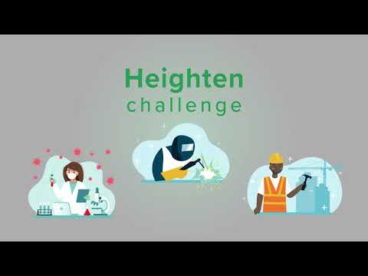

Knowledge Check: Engagement
Answer the following question to self-check your knowledge (answers are at the end of the document).
- Which of the following strategies can enhance student engagement according to Universal Design for Learning (UDL)?
  - Providing students with choices in their learning process
  - Strictly following a single teaching method
  - Connecting learning material to students' lives and interests
  - Discouraging group work to focus on individual tasks

Representation: The What of Learning
Representation in Universal Design for Learning (UDL) refers to the various ways in which information and content are presented to learners. It emphasizes the need to provide multiple means of representation to cater to the diverse needs of students. This approach ensures that all learners can access and understand the material, regardless of their individual learning preferences or abilities.
By offering content in different formats such as text, audio, video, and interactive media, educators can create a more inclusive learning environment. This flexibility allows students to engage with the material in a way that best suits their preferences and needs, ultimately enhancing their learning experience and outcomes.

There are many ways to introduce representation into a class:

Supporting Tools & Experiences
Bringing in supporting tools and experiences can help clarify complex terms and concepts, making the material more accessible to all students.
Some supporting tools that can promote representation are:
- Glossaries and Dictionaries: Providing a glossary or dictionary helps to clarify terminology and concepts, making content more accessible to students with varying levels of background knowledge.
- Visual Aids: Using charts, diagrams, and images can illustrate ideas in a more digestible and engaging way.
- Transcripts: Offering a transcript of videos and recordings helps students who may need to review the material at their own pace, ensuring they can revisit and understand the content thoroughly.
- Simulations: Using a digital simulation allows students to explore concepts as well as test their knowledge and hypotheses in a controlled environment.
- Hands-On Activities: Providing interactive, hands-on experiences makes abstract concepts more concrete and understandable.

Customizable Content
Customizable content allows students to engage with the material in a way that suits their individual learning preferences. For example, interactive e-books that let students highlight text, take notes, and adjust the reading level can be very effective. This personalization helps students take control of their learning process and stay motivated.
Other types of customizable content can include:
- Interactive Quizzes: Create quizzes where questions can be adjusted based on the student's progress and understanding.
- Multimedia Presentations: Develop presentations that include videos, images, and audio clips, which can be modified to suit different learning preferences.
- Learning Modules: Design modular content that students can navigate at their own pace, choosing the order in which they complete sections.
- Adaptive Learning Software: Implement software that adjusts the difficulty of tasks based on the student's performance, providing a personalized learning experience.

Flexible Formats
Providing content in flexible formats allows students to choose the method that works best for them. This flexibility ensures that all students have equal access to the information.
Some formats to consider are:
- Audio Books: Provide text in audio format for students who prefer listening over reading.
- Video Lectures: Offer recorded lectures that students can watch at their own pace, pausing and rewinding as needed.
- Podcasts: Create or use educational podcasts that students can listen to on the go.
- Slide Decks: Share presentation slides that summarize key points and can be reviewed independently.
- Online Forums: Facilitate discussions and collaborative learning through online discussion boards or forums.
In the 2-minute video below, the Southern Illinois Professional Development Center provides a tutorial on Representation with examples to show how it can be applied practically.
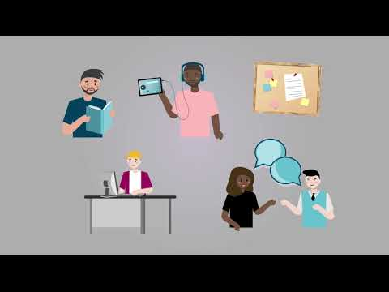

Knowledge Check: Representation
Answer the following question to self-check your knowledge (answers are at the end of the document).
- Which of the following are examples of providing multiple means of representation in a learning environment?
  - Using visual aids like charts and diagrams
  - Providing only text-based materials
  - Offering transcripts of videos and recordings
  - Using a single teaching method for all students
  - Creating interactive quizzes

Action and Expression: The How of Learning
Action and expression recognizes that students have diverse strengths and preferences when it comes to expressing what they have learned. By offering various options for action and expression, educators can accommodate diverse learners, ensuring that all students have the opportunity to succeed.
Promoting self-regulation and executive function skills helps students set goals, plan their work, and manage their time effectively. Teaching strategies for self-assessment and reflection can also empower students to take ownership of their learning and make informed decisions about how to best demonstrate their knowledge.

There are many ways to motivate students to take action and express themselves:

Strategy Development
Strategy development is crucial for fostering independent and effective learners. Effective strategies help students break down large projects into manageable steps, monitor their progress, and adjust their approaches as needed. This not only enhances their academic performance but also builds essential life skills such as problem-solving, critical thinking, and self-regulation.
Methods for promoting strategy development include:
- Goal Setting: Model how to set specific, achievable goals for learning and break tasks into manageable steps. This helps everyone focus and stay motivated.
- Graphic Organizers: Use tools like the syllabus, mind maps, flowcharts, and Venn diagrams to help students organize their thoughts and plan their work.
- Time Management: When presenting assignments and activities, address how to prioritize tasks, create schedules, and manage time effectively. This will help students balance their workload.
- Problem-Solving Frameworks: Provide structured approaches to problem-solving, such as the scientific method or design thinking, to guide students through complex tasks.
- Instructions: Providing clear and consistent instructions that present all the required elements of the project will help students plan their time and effort accordingly.
- Resource Guides: In the syllabus or a general course information module, include a list of institutional resources with descriptions of their purposes (e.g. tutoring services, disability-related offices, IT support). This informs students of what's available and leaves the choice to them on what assistance they need.

Assessment Methods
Using different assessment methods allow students to showcase their understanding and demonstrate mastery of learning objectives in ways that play to their strengths and interests. This approach not only makes assessments more inclusive but also helps students develop a broader range of skills.
Assessment methods to consider are:
- Oral Presentations: Students present their understanding of a topic verbally, which can help develop public speaking and communication skills.
- Projects: Long-term assignments that allow students to explore a topic in depth and present their findings through models or multimedia presentations.
- Practical Demonstrations: Hands-on activities where students show their skills in real-world scenarios, such as science experiments or technical tasks.
- Creative Projects: Artistic expressions like drawings, paintings, or performances that allow students to demonstrate their understanding in a creative way.
- Portfolios: Have students create portfolios that showcase their work over time. Reviewing their portfolios allows students to see their growth and reflect on their learning journey.

Reflection and Feedback
Providing opportunities for reflection and feedback promotes continuous improvement and personalized learning. Effective feedback helps students understand their strengths and areas for growth, guiding them towards achieving their learning goals. It fosters a growth mindset by encouraging students to view challenges as opportunities for development.
Methods of promoting self-reflection and feedback include:
- Reflective Journals: Encourage students to keep journals where they regularly reflect on their learning experiences, challenges, and achievements. This practice helps them identify their strengths and areas for improvement.
- Self-Assessment Tools: Provide rubrics, checklists, and self-assessment forms that allow students to evaluate their own work against set criteria. This helps them understand expectations and take ownership of their learning.
- Peer Feedback: Facilitate peer review sessions where students give and receive constructive feedback on each other's work. This not only helps them learn from their peers but also develops their ability to critique and improve their own work.
- Teacher Conferences: Schedule one-on-one conferences with students to discuss their progress, provide personalized feedback, and set future learning goals. This individualized attention helps students feel supported and understood.
- Corrective Assignments: Provide feedback on parts of a project and allow students to make corrections to demonstrate how they've critically interpreted and applied feedback.
In the 2-minute video below, the Southern Illinois Professional Development Center provides a tutorial on Action and Expression with examples to show how it can be applied practically.
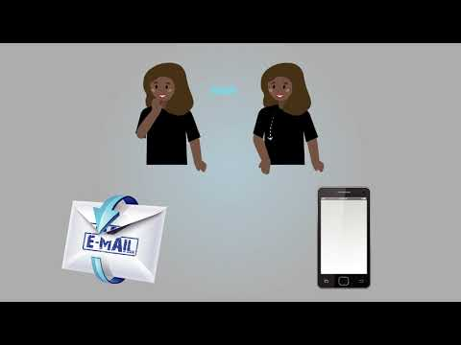

Knowledge Check: Action and Expression
Answer the following question to self-check your knowledge (answers are at the end of the document).
- Which of the following assessment methods helps accommodate diverse learners?
  - Oral Presentations
  - Standardized Tests
  - Projects
  - High-stakes Testing

Technology: Tools at Stony Brook University
The university provides a variety of tools that can support your students and your ability to create a more inclusive learning environment.

Brightspace
The university's Learning Management System (LMS) facilitates accessible content delivery through a range of built-in tools and features designed to support diverse learning needs. The platform includes an Accessibility Checker to help instructors create content that meets accessibility standards, ensuring that all students can engage with the material.
Brightspace is compatible with screen readers, and it allows for customizable display settings to accommodate various visual preferences. Additionally, the platform ensures keyboard accessibility for students with motor impairments and prompts the inclusion of alternative text for images.
Instructors: Winter '25 & Spring '25 Brightspace course shells are now available. Winter & Spring '25 course sites are available to Instructors only. It is up to the instructor make the course active so students can see it/access it. Details can be found on our checklist Students - as long as you see your courses in SOLAR, you are registered.
Learn more on the Division of Information Technology Service’s Brightspace Information page.

Ally
Ally is a built-in tool within Brightspace that generates alternative formats for digital content, ensuring that all students can access materials in ways that suit their needs. It provides detailed feedback to instructors on the accessibility of their course content, offering guidance on how to improve it. This proactive approach helps educators create more inclusive materials from the start.
Learn more on the Division of Information Technology Service’s Ally Information page.

Echo 360
Echo 360 is a lecture capture and video creation tool. It includes automatic speech recognition (ASR) and transcript-to-caption automation, making video content accessible to students who are deaf or hard of hearing. Echo360's lecture capture capabilities allow students to review recorded lectures at their own pace, accommodating different learning preferences and needs.
Learn more on the Division of Information Technology Service’s Echo 360 Information page.

VoiceThread
VoiceThread allows students and instructors to create and interact with multimedia presentations using text, audio, and video comments. It encourages active learning and collaboration by enabling students to create their own VoiceThreads and engage in asynchronous discussions.
Learn more on the Division of Information Technology Service’s Accessibility Information page.

Solstice
Solstice facilitates many-to-many collaboration by enabling users on any device to concurrently share, control, and annotate information on in-room screens. The room display can be connected to a Windows, Android, or Apple devices.
Learn more on the Division of Information Technology Service’s Solstice Information page.

Virtual Reality/Augmented Reality Studio
This space is designed for faculty to experiment with virtual and augmented reality technologies, providing hands-on experience with innovative software and hardware. Discover how to seamlessly integrate immersive experiences into your courses and enhance student engagement.
Learn more on CELT’s Virtual Reality (VR) Information page.

Conclusion
You have completed the Introduction to Universal Design for Learning course!
Please fill out the Feedback Survey form to record your completion of this course and to provide feedback for improvements.

Knowledge Check Answer Keys
Knowledge Check: Engagement – A and C
Knowledge Check: Representation – A, C, and E
Knowledge Check: Action and Expression – A and C

