Title II: The Rule Update and How to Prepare Course ContentBy: Lindsay Bryde
Table of Contents
Background 2
1990: The Americans with Disabilities Act Signed 2
1996: Digital Content is Protected Under ADA 2
November 2022: Stony Brook University's Digital Accessibility Policy 2
April 2024: Updated Rule to the ADA 2
April 2026: New Rule In Effect 2
What are the WCAG Guidelines? 2
What's Impacted? 3
Who is Responsible for a Course's Accessibility? 4
How Do I Get Started? 4
Review old digital content 4
Remediate 4
Recognize what makes a document accessible from the start 4
Recommendations for Accessible Content 5
PDFs 5
Videos 5
Images 5
Microsoft Accessibility Assistant 5
Brightspace 5
Additional Resources 5
CELT Self-Paced Resource Guides 5
Electronic Information Technology (EIT) Review 5
CELT Course Content Accessibility Consultations 6
Learn More About Document Accessibility 6

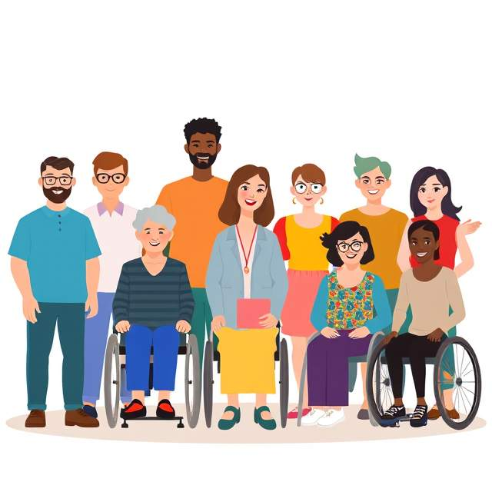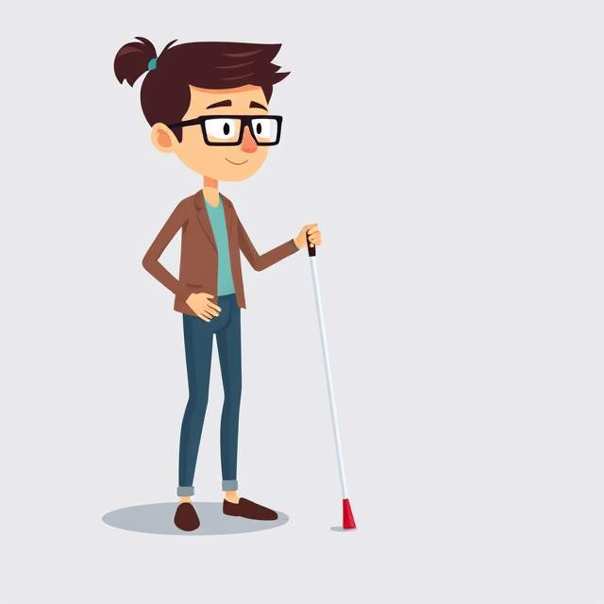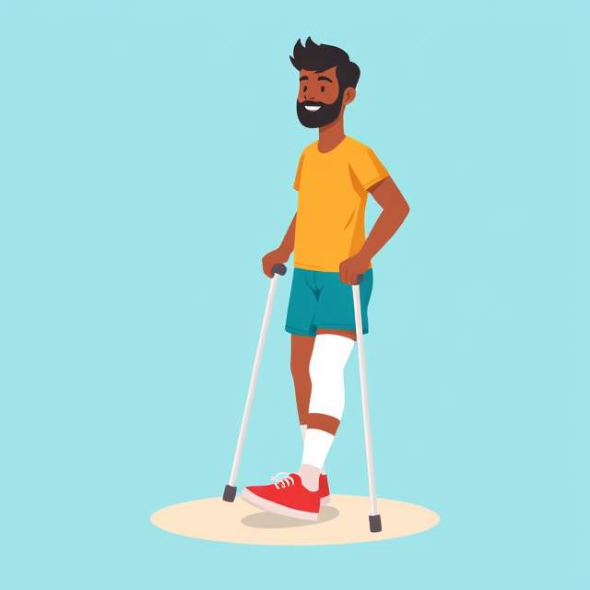

Background
The Americans with Disabilities Act (ADA) was landmark legislation, reflecting decades of advocacy by the disability rights movement. A new rule updating the ADA has been announced by the Department of Justice (DOJ). This change impacts all members of Stony Brook University's community and we need to prepare for this new approach to digital accessibility.

1990: The Americans with Disabilities Act Signed
Americans with Disabilities Act (ADA) signed into law. It prohibits discrimination on the basis of disability. The ADA ensures equal opportunities in public accommodations, employment, transportation, state and local government services, and telecommunications.

1996: Digital Content is Protected Under ADA
The Department of Justice (DOJ) said ADA applied to digital content, but gave no guidelines.

November 2022: Stony Brook University's Digital Accessibility Policy
Stony Brook University implemented a digital accessibility policy(opens in a new tab).

April 2024: Updated Rule to the ADA
The DOJ published a rule to establish technical standards for web and mobile app accessibility for public entities under Title II of the ADA.“The Web Content Accessibility Guidelines (WCAG) Version 2.1, Level AA is the technical standard for state and local governments’ web content and mobile apps” (Civil Rights Division(opens in a new tab), 2024).

April 2026: New Rule In Effect
Digital content must adhere to WCAG 2.1 AA for public entities with a population over 50,000.
Under the rule, digital content includes all types of web pages, PDFs, word processor documents, presentations, spreadsheets, and videos. All course content (such as instructional videos and readings on Brightspace) needs to adhere to these new guidelines too. This will take a lot of time, and we want to do as much as we can to support you in understanding the new rules and updating your course materials.

What are the WCAG Guidelines?
WCAG is an internationally-recognized set of standards established by the World Wide Web Consortium (W3C).
They are based around four principles:
- Perceivable
- Operable
- Understandable
- Robust
Each version of WCAG is made up of several Success Criteria that outline specific metrics used to determine whether a site satisfies the guidelines. There are three levels of success criteria:
Level A: Represents the minimal level of conformance. For Level A conformance, a web page must satisfy all Level A Success Criteria.
Level AA: For Level AA conformance, a web page must satisfy all Level A and Level AA Success Criteria. Note, this is the new technical standard.
Level AAA: For Level AAA conformance, a web page must satisfy all Level A, Level AA, and Level AAA Success Criteria.

What's Impacted?
All published digital content. This includes all course content, such as:
- Syllabi
- Web pages on Brightspace
- Lecture notes provided to students
- Files uploaded from a conventional Electronic Document (e.g., PDF, word processor file format, presentation file format, or spreadsheet).
- Images
- Social media posts
- Digital books, textbooks
- Live-audio or prerecorded content (e.g., embedded or linked out to videos).
- Websites that are being linked out to from the course
- Learning Tool Interoperability (LTIs) that integrate remote tools with the LMS
Are there any exceptions?
There are five exceptions to the rule. Note, these only apply to content published prior to the April 2024 rule.
- Sections of sites clearly identified as an "Archive" of old data (e.g., a news article or press release published in 2018).
- Documents that are no longer used by/required for users (e.g., a flyer from a 2019 event).
- Content posted by a third-party to an entity’s site (e.g., a local community member posts to social media and tags Stony Brook University). Note: Students are not considered a third-party under Title II and this exception does not apply to content they produce on university sites.
- Password-protected Word, presentation, PDF, or spreadsheet files (does not apply to other file types or code). For example, a water bill in PDF format meant for a specific customer would be an except, whereas a general notice about a change in service to all customers would not apply. Note: Password-protected course content does not fall under this exception.
- Pre-existing Social Media posts (e.g., a tweet from 2017 about a class cancellation).
Note, if any content that once fell under the exception is revised, edited, or updated after April 2024 then it must be made accessible to meet the technical standard. For example, if archive course content from a Fall 2023 course is copied into a Fall 2026 course, the content in the new section needs to be remediated.

Who is Responsible for a Course's Accessibility?
Everyone who is creating content, including:
- Instructors
- Teaching Assistants
- Graduate Assistants
- Students
- Staff

How Do I Get Started?

Review old digital content
Remove old or outdated digital documents, web pages, and/or media so you can focus on making the remaining digital content accessible.

Remediate
Start updating digital content that is not accessible or finding alternative content.
Choose a strategy that works for you: Start by going over the material for the classes you teach most frequently and have the most students enrolled in. As an alternative, you could begin by updating a single kind of content across all of your courses, like Word documents, slide decks, or videos.

Recognize what makes a document accessible from the start
Creating new content? Check out our tips on how you can make it accessible.

Recommendations for Accessible Content

PDFs
Most PDFs are not machine readable and would require extensive work, so when creating and sharing content, use Microsoft Office tools or initiate a file within a Brightspace page.
A resource guide on how to pick the best format for your content is available.

Videos
Use university-supported tools (Echo, Zoom) to transcribe videos, and review them for accuracy.
Resource guides on how to create accessible content using university-supported tools are available.

Images
Ensure that all images in Brightspace, PowerPoints, etc. have alt text or, if necessary, a longer description.
A resource guide is available on how to determine when a longer description is needed and how to develop it.

Microsoft Accessibility Assistant
Run the Accessibility Assistant for all Word, PPT, and Excel files. In the Navigation bar, or ribbon, at the top of Microsoft tools, go to the "Review" section, and click "Check Accessibility" to see the Assistant's report.
Resource guides on using Microsoft tools accessibly is available.

Brightspace
Check your Ally score for your Brightspace course content. Click the "All Issues" button to see a list of recommendations to improve your score.
A resource guide on Brightspace accessibility and how to use Ally is available.

Additional Resources

CELT Self-Paced Resource Guides
CELT has an accessibility page that includes self-paced resource guides on how to make course content more accessible.

Electronic Information Technology (EIT) Review
All procured software needs to get an EIT review to ensure the tool is accessible and complies with Title II. You will need to provide the HECVAT(opens in a new tab) and VPAT (opens in a new tab)from the vendor to the university's review group(s).

CELT Course Content Accessibility Consultations
Request assistance with achieving accessible digital content.

Learn More About Document Accessibility
For more information about document accessibility, please reach out to CELT by emailing celt@stonybrook.edu.
To view additional tutorials and resources, visit CELT's Accessibility page.

Figure 4 Stony Brook University's logo

