Navigating Rise Courses
By: Lindsay Bryde
Table of Contents
Navigating Rise Courses 1
CELT Course Types 1
Rise Course Navigation 1
The Home Screen 1
Navigation Within a Course 2
Microlearning Navigation 3
Special Notes for Rise Courses and Microlearnings 3
Additional Resources 4
Keyboard Shortcuts 4
Tab-Key Navigation for Mac Users 4
Supported Browsers 4
Accessibility Resources 4
Learn More About Document Accessibility 4

CELT Course Types
All Center for Excellence in Learning and Teaching (CELT) courses use a program called Articulate Rise. There are two course types users will encounter:
- A Rise Course addresses a broad ranging topic and contains multiple lessons that users can navigate between.
- A Microlearning provides an in-depth lesson on a specific topic.
Let's review some essential information you'll need to effectively and accessibly navigate courses using this player.

Rise Course Navigation

The Home Screen
When entering a Rise course, you'll find the Home screen. It provides you with important information you'll need before starting (e.g., course objectives, any special notes/attributions).
There are two ways to get started with a course from the Home screen.
- The Start Course button will take you to the very first section, also known as a module.
- Scroll to the bottom of the Home screen to find a list of all the modules in the course. You can select any one of these titles and begin reviewing content starting with that module.
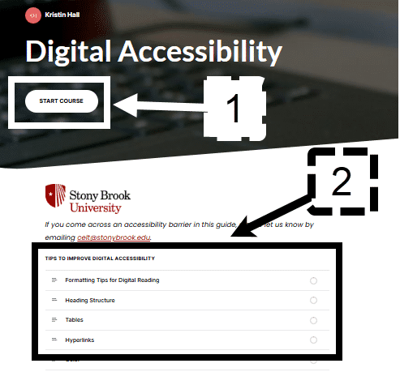
Figure 1 The Home screen of a rise course. An arrow and the number 1 shows the Start Course button at the top of the screen and an arrow with a number 2 shows where the course sections are located at the bottom.

Navigation Within a Course
Within each module are three key buttons for navigating your content:
- Sidebar: Track the percentage of the course you've completed and select module titles to jump ahead or go backward in the course.
- Continue: Some information within a module may be chunked out, the Continue button will appear when it's time to jump to the next piece of information.
- Next Module: At the end of each module, you'll see a bar that notes the number and name of the next module you can move toward.
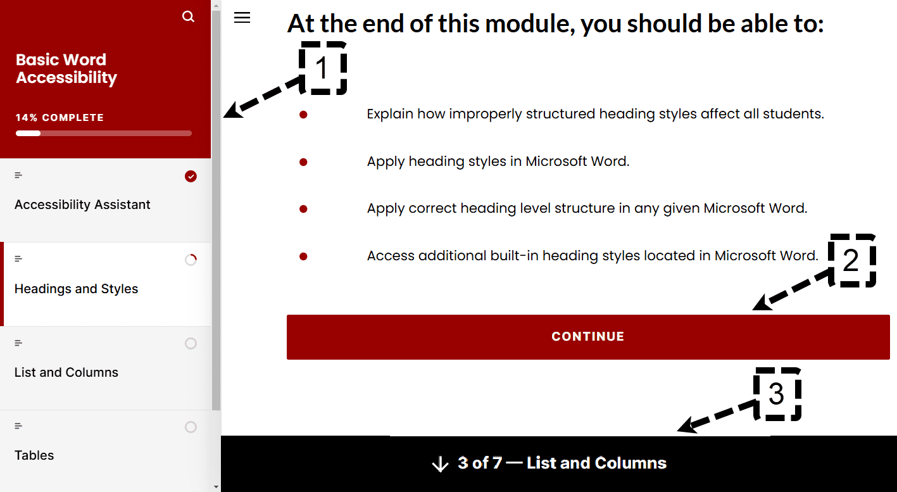
Figure 2 Inside a course section, the Sidebar is indicated along the left-hand side panel with a number 1, the continue button is noted with a number 2, and the next module button is noted at the bottom of the screen with the number 3.

Microlearning Navigation
When entering a microlearning, its title and author information will appear at the top.
An arrow pointing downward appears below it. This is the Start button for the microlearning.
Users either need to select the Start button or keep scrolling down on their mouse to open the content.
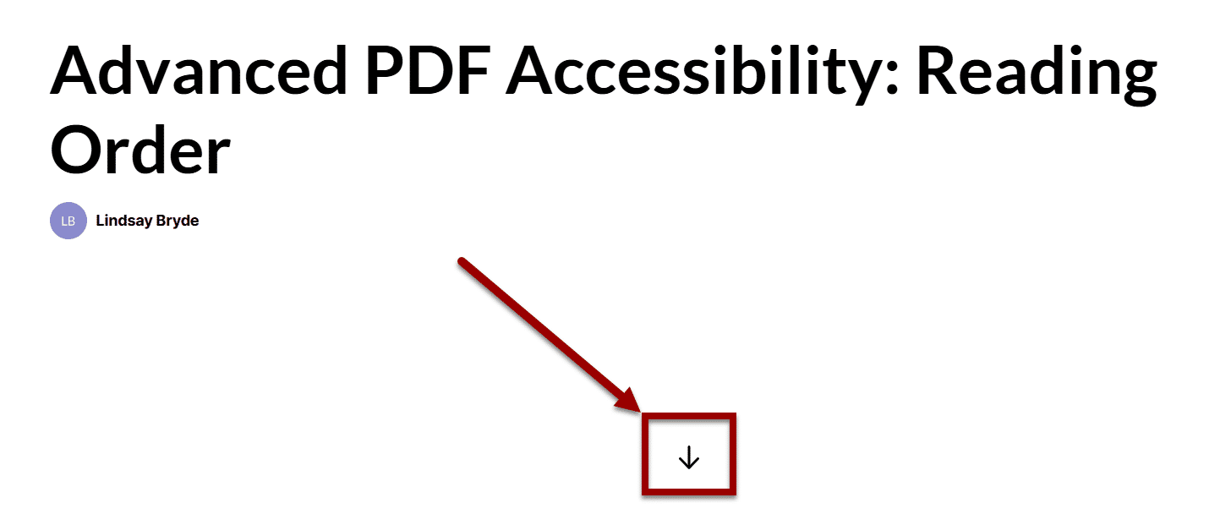
Figure 3 A screenshot of a microlearning's start menu. An arrow at an angle is pointing toward a box containing the "Start" button (the icon is an arrow facing straight down).

Special Notes for Rise Courses and Microlearnings
- Alternative Text: All courses and microlearnings provide alternative text through image descriptions either next to or below an image, and through the alt text tag for images in interactive content blocks.
- Images: Select images to view them in a larger frame.
- Links: All links open to a new tab.

Additional Resources

Keyboard Shortcuts
A review of keyboard shortcuts when navigating Articulate Rise courses.

Tab-Key Navigation for Mac Users
Tab-key navigation is setup by default for Windows users. It does need to be enabled for Mac users depending on the web browser being used.

Supported Browsers
A review of minimum technical requirements for Articulate Rise courses

Accessibility Resources
A review of all supported accessibility tools for Articulate Rise courses

Learn More About Document Accessibility
For more information about document accessibility, please reach out to CELT by emailing celt@stonybrook.edu.
To view additional tutorials and resources, visit CELT's Accessibility page.

Figure 4 Stony Brook University's logo

