Microsoft Tutorial: Use PowerPoint Show to Restrict Editing of Slides
By: Lindsay Bryde
Table of Contents
Microsoft Tutorial: Use PowerPoint Show to Restrict Editing of Slides 1
Why It's Best to Use a PowerPoint Show Compared to a PDF 1
How to Create a PowerPoint Show 1
How to Edit a .ppsx File Later 2
Learn More About Document Accessibility 2

Why It's Best to Use a PowerPoint Show Compared to a PDF
PowerPoint Show (.ppsx) is better for accessibility than a PDF because it preserves the slide deck’s native interactive structure and data that is often lost or corrupted during PDF conversion. When a presentation is exported to PDF, complex elements like animations, embedded video captions, and live transitions become static, and the "tagging" required for assistive technology to navigate the content often needs to be manually re-added, which is time-intense and requires software like Adobe Acrobat Pro.
PowerPoint Show maintains the original reading order and alt text "out of the box," while also allowing users to benefit from the Presenter View and built-in magnification tools.
Note: Any content in the "Notes" section will be available in the PowerPoint Show player. If you'd like to keep this content private/personal, it needs to be removed from the editable copy of the slide deck.
Important: Before you create your PowerPoint Show, run Word's built-in Accessibility Assistant (Review > Check Accessibility) to ensure that your slide's reading order, alt text for images, and table structures are accessible before "locking" the content to this read-only view.

How to Create a PowerPoint Show
- Open your presentation in PowerPoint.
- Go to the File tab in the top-left corner and select Save As (or Save a Copy).
- Click Browse to choose where you want to save the file.
- In the Save as type dropdown menu, scroll down and select PowerPoint Show (*.ppsx).
- Click Save.
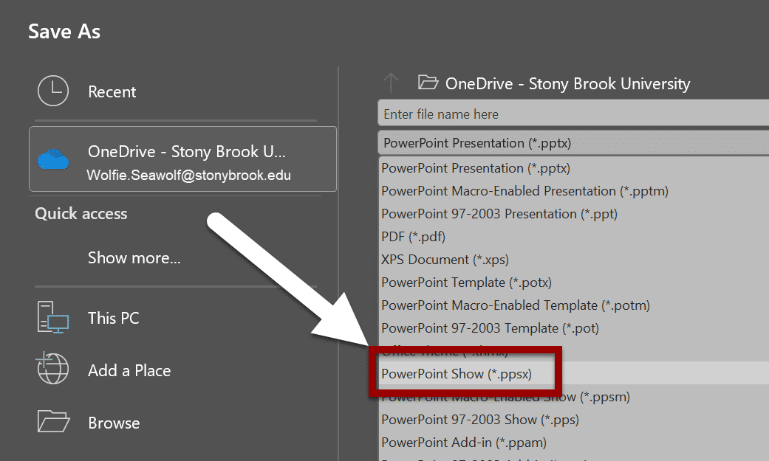
Figure 1 The File>Save As section of Microsoft PowerPoint, the PowerPoint Show option is noted with an arrow in the file options drop-down menu.
When you double-click this new file, it will launch immediately into full-screen presentation mode, bypassing the editing interface entirely. This is perfect for kiosk displays or sending to students/colleagues.

How to Edit a .ppsx File Later
If you realize you made a typo after saving, the file isn't permanently "locked":
- Option A: Open your original .pptx file, make the change, and save as a show again.
- Option B: Open PowerPoint first, then go to File > Open and select the .ppsx file. This will open it in the editor instead of launching the show.

Learn More About Document Accessibility
For more information about document accessibility, please reach out to CELT by emailing celt@stonybrook.edu (opens in a new tab).
To view additional tutorials and resources, visit CELT's Accessibility page (opens in a new tab).
Please fill out the Feedback Survey Form (opens in a new tab) to record your completion of this course and to provide feedback for improvements.

Figure 2 Stony Brook University's logo

