Microsoft Tutorial: Restrict Editing to a Document
By: Lindsay Bryde
Table of Contents
Microsoft Tutorial: Restrict Editing to a Document 1
Why It's Best to Use a Read-only Word Document Compared to a PDF 1
How to Set Up "Restrict Editing" 1
Password Protection 2
How to Open a Restricted Document for Editing 3
Learn More About Document Accessibility 4

Why It's Best to Use a Read-only Word Document Compared to a PDF
Choosing Restrict Editing in a Word document is better to exporting to a PDF because it maintains the document’s native accessibility features while granting users the flexibility to accommodate their specific needs. PDFs require a complex layer of "tagging" and manual remediation to meet all the WCAG 2.1 Level AA requirements, whereas Word documents are inherently more compatible with assistive technologies "out of the box."
When you restrict editing in Word, the underlying semantic structure (e.g., headings, alt text, and lists) remains intact and easy for assistive technology tools to navigate. By locking the content within Word rather than converting it, you provide a secure "final" version that is significantly more usable and adaptable for the widest range of people.
Before you lock your document, run Word's built-in Accessibility Assistant (Review > Check Accessibility) to ensure that your headings, alt text for images, and table structures are accessible before you enforce the "Read only" state.

How to Set Up "Restrict Editing"
- Go to the Review tab on the top ribbon. In the Protect group, click on Restrict Editing.
- In the pane that appears on the right, look under the 2. Editing restrictions section and:
  - Check the box: "Allow only this type of editing in the document."
  - Select No changes (Read only) option from the drop-down menu. This prevents any modifications to the text while keeping the document navigable.
  - Optional: Select "More Users" in the Exceptions (optional) section to add users who have your permission to edit/lift restrictions on the document without your sign-off (for more information, see the Password Protection section below)
- Go down to section 3. Start enforcement and click the button Yes, Start Enforcing Protection.
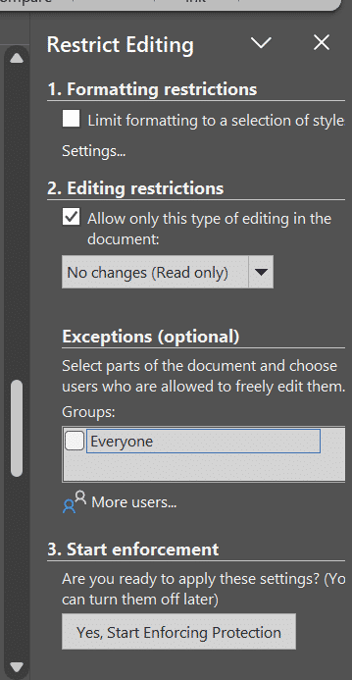
Figure 1 The Restrict Editing pane in a Word Document. The "Editing Restrictions" is set to "No Changes (Read only)."

Password Protection
A dialog box will pop up asking for a password. You have three options:
- Add a Password: Prevents others from easily turning off the protection.
- Go Without a Password: Simply click "OK" to lock the document. This is often enough to prevent accidental edits while still allowing a tech-savvy user to unlock it if they truly need to adjust formatting for their specific accessibility needs.
- Add User authentication: When you choose User Authentication over a simple password to restrict editing in Word, you are moving from a "shared secret" (like a house key anyone can pass around) to a "digital ID" (like a badge that only works for a specific person). With this method, any additional users you granted permissions to in the Exceptions (optional) section can unlock the document. If you did not select anyone in this section, you as the author will be the only person who can lift the restriction.
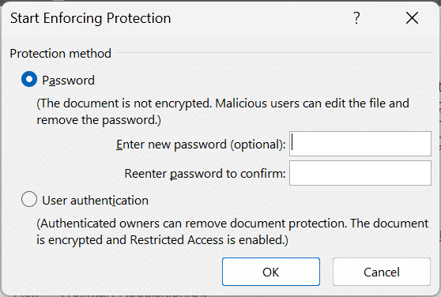
Figure 2 The Start Enforcing Protection dialog box, displaying options to add a password or user authentication.

How to Open a Restricted Document for Editing
- Go to the Review tab on the top ribbon.
- Click the Restrict Editing button in the Protect group.
- At the bottom of the right-hand pane that appears, click the Stop Protection button.
- Verify that you want to stop protection:
  - If password protected: A box will appear asking for the password. Enter it and click OK.
  - If no password was used: The document will unlock immediately.
  - If User Authentication was used: Word will verify your digital ID. If you are the owner or have "Full Control" permissions, the restrictions will lift.
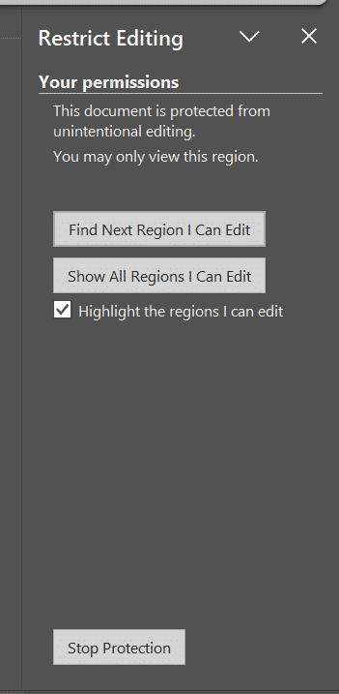
Figure 3 The Restrict Editing pane is open with a restriction being enforced. The Stop Enforcement button is available at the bottom of the pane options.

Learn More About Document Accessibility
For more information about document accessibility, please reach out to CELT by emailing celt@stonybrook.edu (opens in a new tab).
To view additional tutorials and resources, visit CELT's Accessibility page (opens in a new tab).
Please fill out the Feedback Survey Form (opens in a new tab) to record your completion of this course and to provide feedback for improvements.

Figure 4 Stony Brook University's logo

