STEM Accessibility: Microsoft Equation Editor
By: Lindsay Bryde
Table of Contents
STEM Accessibility: Microsoft Equation Editor 1
Making Equations Accessible 1
Getting Started with the Equation Editor 2
Insert an Equation 2
Use the Equation Tools 3
Keyboard Shortcuts 3
Ink Equations 3
Linear Format Equations Using UnicodeMath and LaTeX 4
Converting a Document with MathML to an HTML page 4
Step 1: Download WordtoEPUB 4
Step 2: Open WordToEPUB 5
Step 3: Select your file 5
Step 4: Provide the new HTML file's information 6
Step 5: Create HTML version 6
Step 6: Open the code 7
Step 7: Copy the Code 7
Step 8: Add the content to the HTML page 8
Learn More About Document Accessibility 8

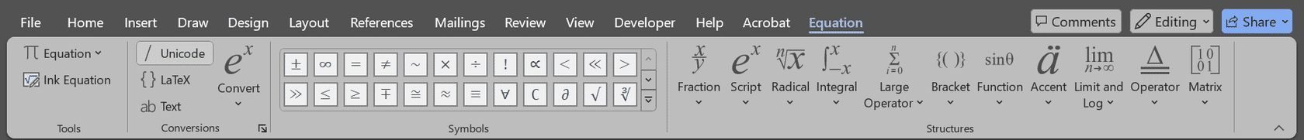
Figure 1 The Equation Editor of Microsoft Word.

Making Equations Accessible
Manually typed or hand-drawn math problems can be inaccessible to many users, particularly those who rely on screen readers or other assistive technologies. These formats often lack the necessary structure and semantic information that assistive tools need to interpret and convey the content accurately.
Mathematical Markup Language (MathML) addresses this issue by providing a standardized way to encode mathematical notation, making it machine-readable and accessible. By using MathML, educators and content creators can ensure that their materials are inclusive and accessible to a wider audience.
Microsoft Word's Math Equation Editor can be used to present accessible equations and convert content to MathML if it needs to be published on a webpage.
While Microsoft includes its Math Equation Editor in Excel, those equations are placed over cells, which can be difficult for screen reader users to navigate. If you are presenting equations, it's best to use Word's editor and functionality at this time.

Getting Started with the Equation Editor
It's best to create all the content that goes before and after any equations in your document first. It will reduce potential formatting/spacing issues that could occur.
As a reminder, make sure you're applying accessible headers, color contrast, and alt text for images in your document. When you're ready to add your equations, there are four ways to use the Math Equation Editor in Microsoft Office.

Insert an Equation
- Go to the Insert tab.
- Click on Equation in the Symbols group.
- Choose a built-in equation from the drop-down menu or click More equations from Office.com for an expanded list.
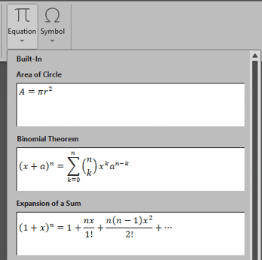
Figure 2 The insert an equation section of Microsoft Word with built-in equation options available in a drop-down menu.

Use the Equation Tools
- Go to the Insert tab.
- Select the Insert New Equation option.
- Once the equation editor is open, use the Design tab to access various symbols, structures, and templates.
- You can type your equation directly or use the provided tools to insert fractions, exponents, integrals, and more.
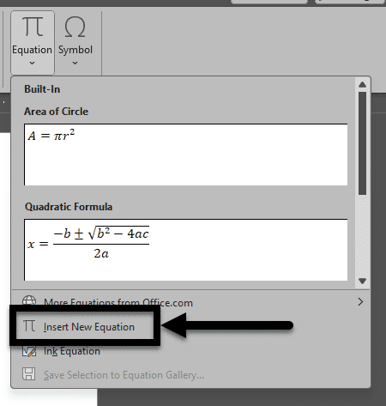
Figure 3 The Equation drop-down is open and the Insert New Equation option is noted with an arrow near the bottom of the list.

Keyboard Shortcuts
Use shortcuts like Alt + = to quickly open the equation editor.
Familiarize yourself with other shortcuts for common symbols and structures to speed up your workflow.

Ink Equations
If you have a touch-enabled device, you can use the Ink Equation feature to write equations by hand:
- Go to the Draw tab.
- Select the Ink to Math option from the ribbon.
- You can start to write the math in the "Write math here" grid.
- Click the "Insert" button when your equation is written and ready to go in the main document.
A preview of what the equation will look like in your document will appear above where you're writing.
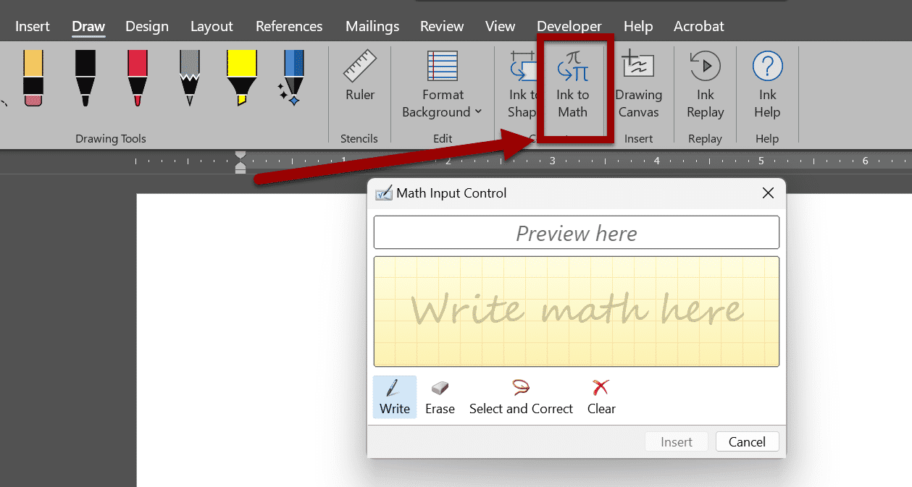
Figure 4 The "Draw" section of Word's ribbon is open, and the Ink to Math icon is noted with an arrow in the middle of the section. The Math Input Control of Microsoft Word is displayed below the ribbon. It allows a user to draw or write the equation and it gene

Linear Format Equations Using UnicodeMath and LaTeX
Microsoft provides instructions and tutorials for users who want to use the LaTeX syntax on their website.

Converting a Document with MathML to an HTML page
If your content in a document with MathML needs to be converted to publish on an HTML page, you need to first download the WordToEPUB tool(opens in a new tab), which is published by the DAISY Consortium for free use.

Step 1: Download WordtoEPUB
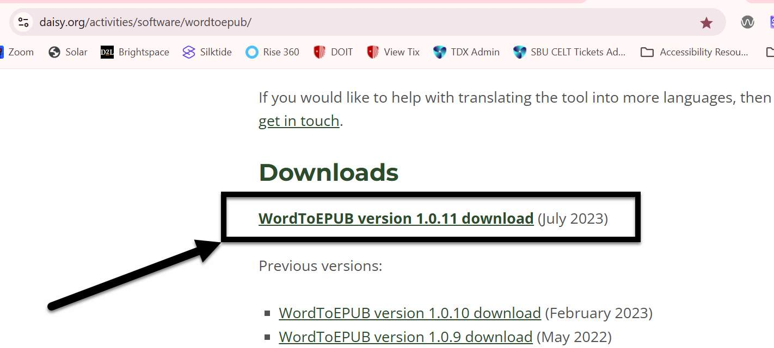
Figure 5 The Downloads section of the WordtoEPUB website. The most recent download is noted with an arrow immediately after the section header.
- If this is your first time converting a Word document to HTML, go to the WordToEPUB tool (opens in a new tab) download page.
- Scroll down to the Downloads section.
- Select the most recent version of the WordtoEPUB tool to begin the download (the versions are in reverse chronological order, so the most up-to-date version is at the top of the list).
- Go to your device's Downloads folder.
- Execute the SetupWordtoEPUB.exe file to begin the download to your device.
Note: Stony Brook University employs may get prompted to provide additional information about the purpose of this download if you're using a university-owned device.

Step 2: Open WordToEPUB

Figure 6 The WordToEPUB file icon on a computer desktop.
Open WordToEPUB where you previously downloaded the tool to on your device, a file picker will open.

Step 3: Select your file
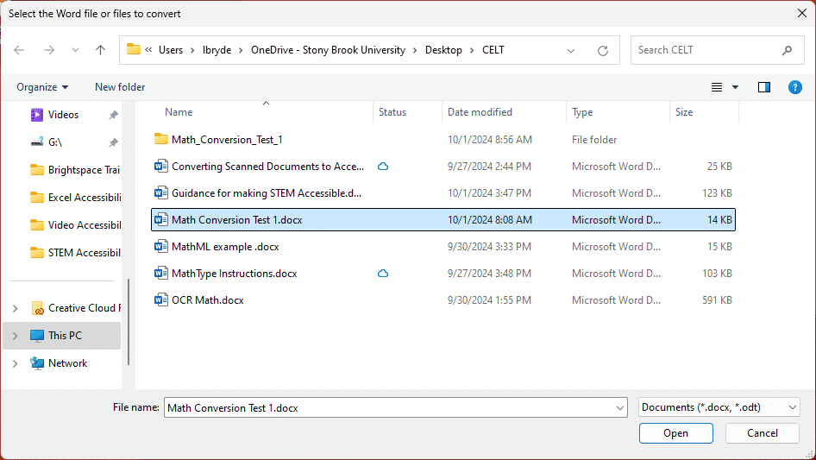
Figure 7 The WordToEPUB file picker.
Select the file you need to convert from the file picker and click the Open button.

Step 4: Provide the new HTML file's information
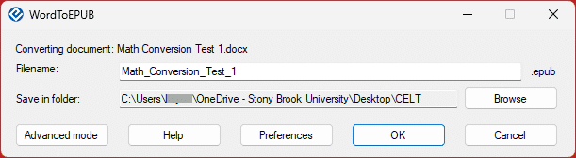
Figure 8 WordToEPUB's home screen to add file information and destination.
- Enter the new HTML file’s name in the Filename textbox
- Click the Browse button to select where you’d like the file to save.
- Click on the Advanced mode button.

Step 5: Create HTML version
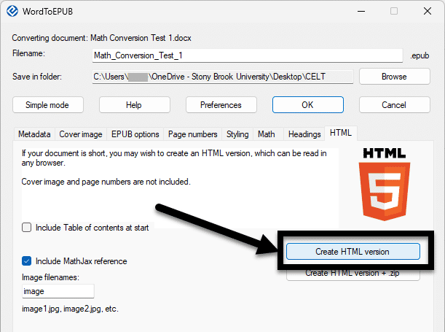
Figure 9 The Advanced Menu of Word to Epub, the Create HTML version button is noted with an arrow.
- Select the HTML sub-section.
- Click the Create HTML version button. Note: it's located below the Ok and Cancel buttons.
Warning: conversion can take approximately thirty seconds to a minute depending on the device, don't close or restart the program during processing. An error message will display if conversion could not be completed.

Step 6: Open the code
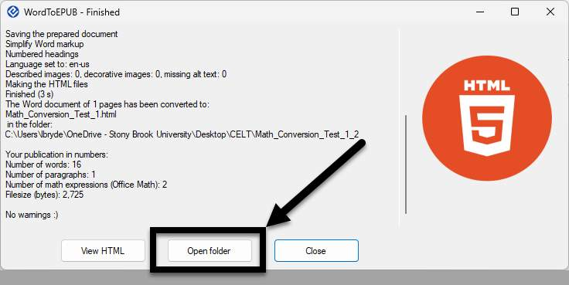
Figure 10 WordToEPUB after initial conversion is complete. An arrow is pointing to the Open folder button.
Select the Open folder button.
Right-click the HTML file in the folder and select Open with>Notepad from the drop-down menu.

Step 7: Copy the Code
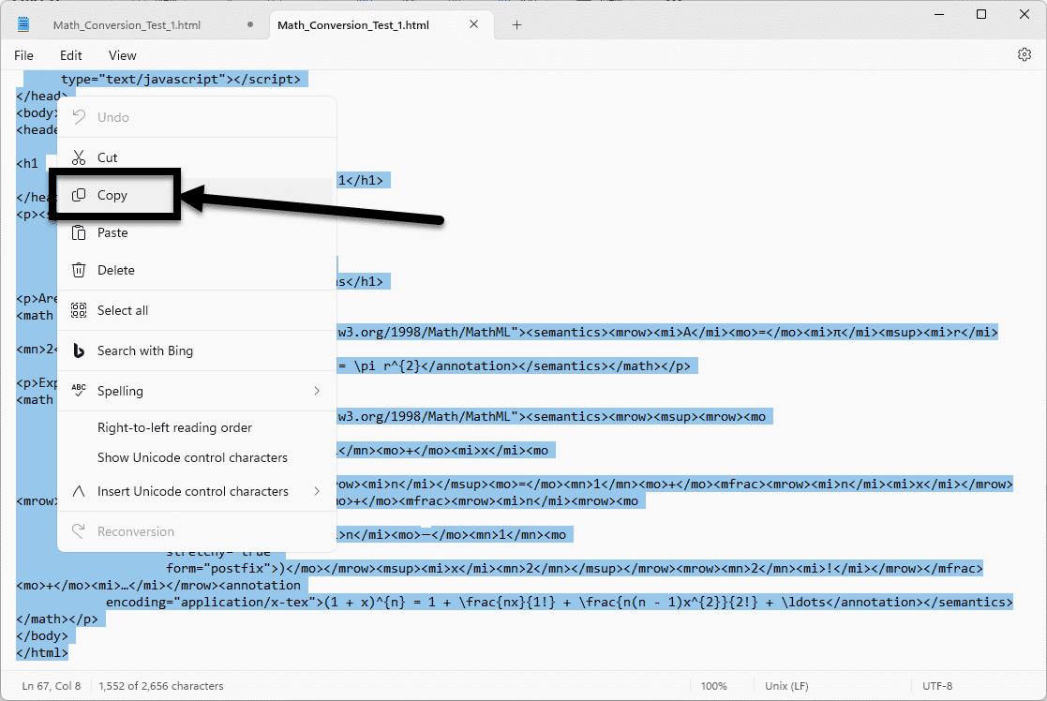
Figure 11 HTML code is open in Notepad, and the copy option is noted with an arrow.
- Select all of the HTML code from Notepad (keyboard shortcut (keyboard shortcut Ctrl/CMD+A)
- Copy the selected HTML code (keyboard shortcut Ctrl/CMD+C).

Step 8: Add the content to the HTML page
- Open or create the page where the code should go.
- Open the Source Code for the page.
- Place the cursor where the content should appear.
- Paste the HTML code (keyboard shortcut Ctrl+V).
- Save the content on the page.

Learn More About Document Accessibility
For more information about document accessibility, please reach out to CELT by emailing celt@stonybrook.edu (opens in a new tab).
To view additional tutorials and resources, visit CELT's Accessibility page (opens in a new tab).
Please fill out the Feedback Survey Form (opens in a new tab) to record your completion of this course and to provide feedback for improvements.

Figure 12 Stony Brook University's logo

