Microsoft Tutorial: Hyperlinks and Screentips
By: Lindsay Bryde
Table of Contents
Microsoft Tutorial: Hyperlinks and ScreentipsBy: Lindsay Bryde 1
Meaningful Link Text 1
Your Students' Perspective 2
Hyperlink Tutorial 2
Option 1: Insert a new link 2
Option 2: Create a link from existing text 2
Option 3: Paste a link and edit the displayed text 3
Screen Tip 4
Learn More About Document Accessibility 4

Meaningful Link Text
When providing hyperlinks during presentations, you want to ensure that the link text displayed to your audience is descriptive.
Microsoft products refer to the URL that you're sending your audience to as the "Address."
Link text should be unique and meaningful when read out of context, and should help users to know something about their destination if they click on it. Link text such as “Click here” and “More” would be too broad to be considered effective.
Consider the various ways users interact with links:

Screen reader users can generate a list of links and navigate them alphabetically. Redundant, repetitive, or ambiguous link text such as “More” is meaningless in this context.
Users of speech recognition technology can select a link with a voice command like “click” followed by the link text. Therefore it is also helpful to use unique link text that is short and easy to say.

Your Students' Perspective
Watch this 1-minute video on Links: Inaccessible VS Accessible to see how screen-readers read inaccessible and accessible links, it shows why it's so valuable to use descriptive link text.

Hyperlink Tutorial
While it may seem simple to copy and paste a link into a presentation and press the ENTER or the SPACEBAR to make an active hyperlink, that link is not very accessible because the text displaying does not have context or meaning for the reader.
There are multiple ways you can create an accessible hyperlink:

Option 1: Insert a new link
- Place the cursor where you want to add a link in a textbox.
- Under the Insert tab, click the Links command, the Edit Hyperlink dialog box will open.
- In the Text to display field, enter the descriptive text you want readers to see when they go to click the link.
- Paste the URL that you want to send users to in the Address field.
- Select Ok.
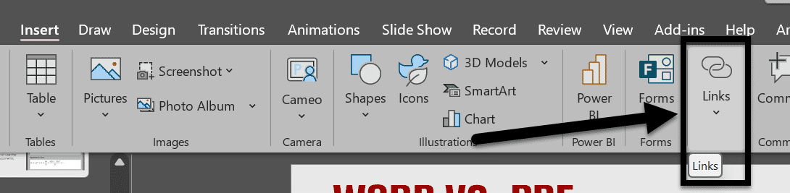
Figure 1 The Insert ribbon, the Links icon has an arrow pointing toward it.

Option 2: Create a link from existing text
- Highlight the text in the document that you want to add a hyperlink to, the Edit Hyperlink dialog box will open.
  - Best practice: do not include spaces before or after the text that will be part of your link.
- Right-click the text and select the Links option from the drop-down.
- Paste the URL that you want to send users to in the Address field.
- Select Ok.
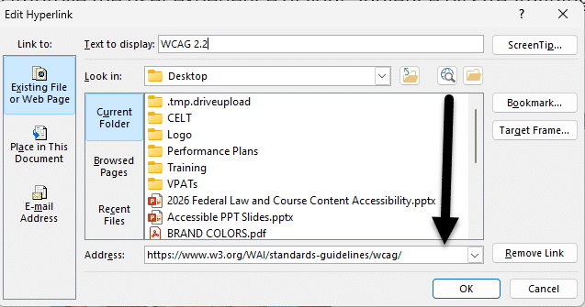
Figure 2 The Edit Hyperlink box is open, and there is an arrow pointing to the Address field near the bottom of the box.

Option 3: Paste a link and edit the displayed text
- Paste the URL that you want to send users to in the document where you want the link to be created.
- Click the ENTER or SPACEBAR key, the URL will become a hyperlink.
- Right-click the link and select the Links option from the drop-down.
- In the Text to display field, replace the URL with the descriptive text you want readers to see when they go to click the link.
- Select Ok.
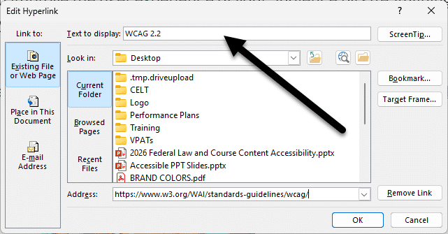
Figure 3 The Edit Hyperlink box is open, and there is an arrow pointing to the Text to display field near the top of the box.

Screen Tip
Screen tips are small pop-up boxes that appear when you hover your mouse over certain elements in a PowerPoint presentation. They provide additional information or context to your link and its purpose without cluttering the slide. This helps keep your slides clean and focused while still offering detailed explanations when needed.
When you're creating a link in the Edit Hyperlink box, click on the Screen Tip... button to add your tips.
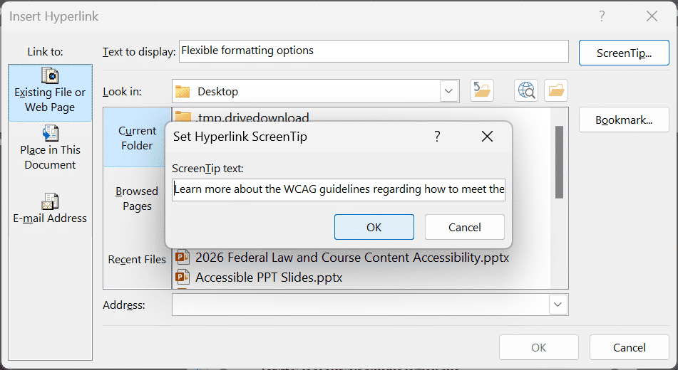
Figure 4 "The Set ScreenTip" box is open, displaying a textbox to enter additional guidance about a link.

Learn More About Document Accessibility
For more information about document accessibility, please reach out to CELT by emailing celt@stonybrook.edu (opens in a new tab).
To view additional tutorials and resources, visit CELT's Accessibility page (opens in a new tab).
Please fill out the Feedback Survey Form (opens in a new tab) to record your completion of this course and to provide feedback for improvements.

Figure 5 Stony Brook University's logo

