Microsoft Tutorial: Exporting Files
By: Lindsay Bryde
Table of Contents
Microsoft Tutorial: Exporting Files 1
Exporting a Microsoft File to PDF and Keep the Formatting 1
Retaining markup tags when exporting to Adobe PDF 1
Learn More About Document Accessibility 2

Exporting a Microsoft File to PDF and Keep the Formatting
Microsoft tools allow you to preserve the accessibility information as markup tags in the code of the document.
Important: make sure your file is accessible before exporting. It is significantly more difficult and requires Adobe Acrobat Pro to make a PDF accessible than it is to make a Microsoft document or presentation accessible.
If the following tutorial looks a bit different from the version of a tool that you have, visit Microsoft's Save or Convert PDF(opens in a new tab) to find specific version support.

Retaining markup tags when exporting to Adobe PDF
If you are exporting content from MS Word to an Adobe PDF. There are two ways to create a PDF. To retain your markup tags consistently, use the following option:
Click the Save as a Adobe PDF in the File tab.
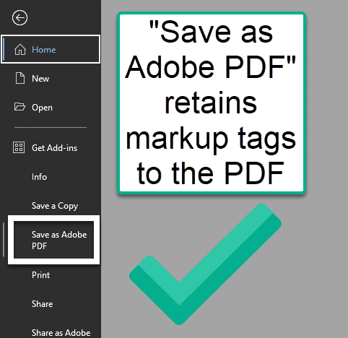
Figure 1 The File tab is open. The Save as Adobe PDF option is noted with a box. There's a callout box next to it, stating that this option retains markup tags in PDFs, and a checkmark.
Note: If you select the PDF file type in the "Save a Copy" area, the markup tags do not consistently export to the new file type.
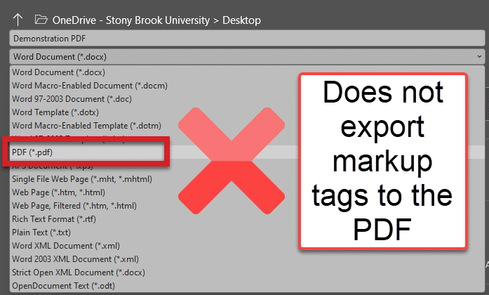
Figure 2 The Save a copy screen is open, the PDF option in the Destination drop-down is selected and noted with a box around it. There's a callout box next it, stating that this option does not retain markup tags in PDFs, and an X logo.

Learn More About Document Accessibility
For more information about document accessibility, please reach out to CELT by emailing celt@stonybrook.edu (opens in a new tab).
To view additional tutorials and resources, visit CELT's Accessibility page (opens in a new tab).
Please fill out the Feedback Survey Form (opens in a new tab) to record your completion of this course and to provide feedback for improvements.

Figure 3 Stony Brook University's logo

