Linking Library Content in a Brightspace
By: Lindsay Bryde
Table of Contents
Linking Library Content in a Brightspace 1
Why It's Better to Provide a Link to the Library Content in a Course 1
How to Find a Permalink 1
Add a Permalink to a Brightspace Module 2
Add a Permalink to a Brightspace Page 3
Learn More About Document Accessibility 3

Why It's Better to Provide a Link to the Library Content in a Course
Linking directly to library resources rather than uploading static PDFs is a best practice for both copyright compliance and accessibility. When you use a persistent link (or permalink), you ensure you're following the source's licensing agreement, as the library has already paid for the right for students to access that content through secure authentication.
Using permalinks provides a better experience for students; the links often point to the most recent editions, offer accessible formatting options, and provide accurate metadata for citations. This method also allows the library to track usage statistics, which helps ensure the most used resources are consistently available.

How to Find a Permalink
- Perform your search and click on the title of the source (e.g., article, book, video, etc.) to open the Detailed Record.
- Go to the Send to section of the source's record.
- Click the Permalink icon (it looks like a small chain link).
- A text box will appear containing the URL.
- Select the Copy the Permalink to Clipboard button.
- Add the permalink to the material(s) as needed.
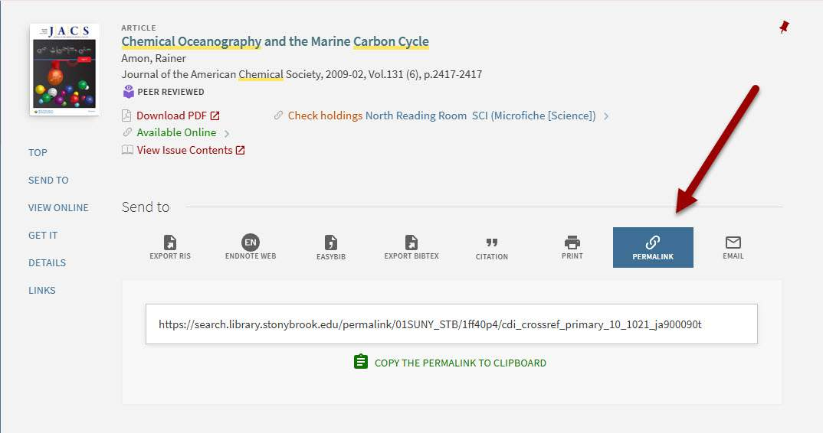
Figure 1 In the Send to section of each source's record is an option to generate a permalink.

Add a Permalink to a Brightspace Module
- Go to the module.
- Select the Upload/Create button.
- Select the Create a Link option from the drop-down.
- Enter the name of the library source as you want it to appear in the Title field, and paste the permalink to the URL field.
- Optional: Leave the Open as External Resource box unchecked for ease of use for students.
- Select the Create button to save your link to the module.
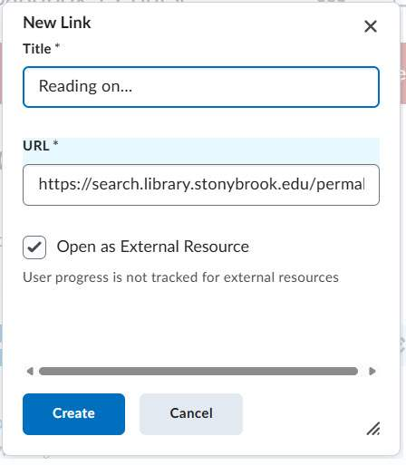
Figure 2 The New Link textbox in Brightspace.

Add a Permalink to a Brightspace Page
- Go to the page.
- Select the text that the link should be embedded behind, a drop-down menu will appear.
- Select the Add/Edit Link option (looks like two chains linked together) from the drop-down, a dialog box will display.
- Paste the permalink in the Link field, and optionally, make any edits to the displayed text in the Text field.
- Optional: Set the "Open in" setting to Current window for better accessibility. If you selecting the "New window" option, include some type of indication in the Text field (e.g., add (opens in new window) after your description).
- Select the Apply button to save your settings.
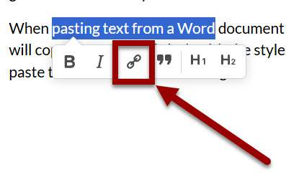
Figure 3 The Add/Edit Link displays when text is highlighted.
Note: If adding a permalink to a citation, the American Psychological Association has updated their guidance on how to present a link in APA format accessibly(opens in a new tab).

Learn More About Document Accessibility
For more information about document accessibility, please reach out to CELT by emailing celt@stonybrook.edu (opens in a new tab).
To view additional tutorials and resources, visit CELT's Accessibility page (opens in a new tab).
Please fill out the Feedback Survey Form (opens in a new tab) to record your completion of this course and to provide feedback for improvements.

Figure 4 Stony Brook University's logo

