Use Language Settings for Accessible Content
By: Lindsay Bryde
Table of Contents
Welcome 1
Learning Objectives 2
Language Settings and Microsoft 2
Default language settings in Microsoft Word, Excel, and PowerPoint 3
Setting language for multilingual content in Microsoft Word, Excel, and PowerPoint 3
Knowledge Check 1: Language Settings and Microsoft 4
Google Workspace 5
Preferred language settings in Google Workspace 5
Changing the language for an individual Google file on Docs, Slides, and Sheets 6
Knowledge Check 1: Google Workspace 6
Adobe Acrobat 7
Set Default Language in Adobe Acrobat PDFs 7
Set a second (or third) language in Adobe Acrobat PDFs 7
CELT PDF Remediation Pilot 9
Knowledge Check 3: Adobe Acrobat 9
Conclusion 9
Knowledge Check Answer Key 9
Knowledge Check 1 Answers: Language Settings and Microsoft 9
Knowledge Check 2 Answers: Google Workspace 9
Knowledge Check 3 Answers: Adobe Acrobat 9


Figure 1 Stony Brook University Logo

Welcome
This course addresses why language settings are important for accessibility and how to set them in a variety of documents.
The estimated time to complete this course is 10 minutes.

Learning Objectives
- By the end of this guide, you will be able to
  - Explain why document language settings need to be set accurately.
  - Edit default language settings in Microsoft, Google, and PDF files.
  - Set multilingual documents in Microsoft and PDF files.
For more information about document accessibility, please reach out to CELT by emailing celt@stonybrook.edu.
If you come across an accessibility barrier in this guide, please let us know by emailing celt@stonybrook.edu.
Note on links:
All links open to a new tab.

Language Settings and Microsoft
Why are language settings important for accessibility?
Assistive technologies like screen readers rely on the document's language setting to accurately read text aloud. This helps visually impaired users understand the content better. The language settings also allow Microsoft's spell check to work accurately (e.g., words won't be flagged as misspelled if it's in a different language than the default).
When language settings are not set accurately, the content will not be read with the proper pronunciation or accents. It'll sound like a bad tourist.
View a 1-minute video made by NC State IT Accessibility to show exactly why you want these settings to be accurate.


Default language settings in Microsoft Word, Excel, and PowerPoint
In Microsoft, it is best to check what your display language and authoring languages and proofing settings are to ensure they reflect the type of content you'll be producing. The display language is how the controls will appear/be read to you. The authoring language and proofing settings are what language your content will be presented in to a reader.
To review or change your settings,
- Go to File>Options.
- Select Language from the left sidebar.
- Under Office display language, choose your preferred language and click Set as Preferred.
- Under Office authoring languages and proofing, select your desired language and click Set as Default.
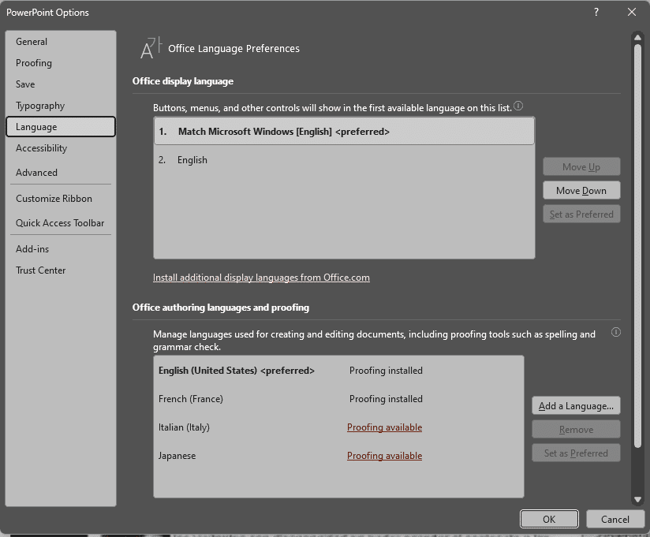
Figure 2. Microsoft PowerPoint Options, displaying the language section with English set as the default for display, authoring, and proofing language. Additional languages are added to the authoring and proofing options.

Setting language for multilingual content in Microsoft Word, Excel, and PowerPoint
When you have multilingual texts, all the content will read in your default authoring and proofing language unless you set the content in the second (or third) additional language. To set a second language:
- Highlight the text in the second language.
- Go to Review>Language.
- Select Set proofing language from the drop-down menu.
- Select the second language that you'd like to set the highlighted text to.
- Click the Ok button to save your new setting.
- Repeat steps 1-5 for all other content in a language other than the default.
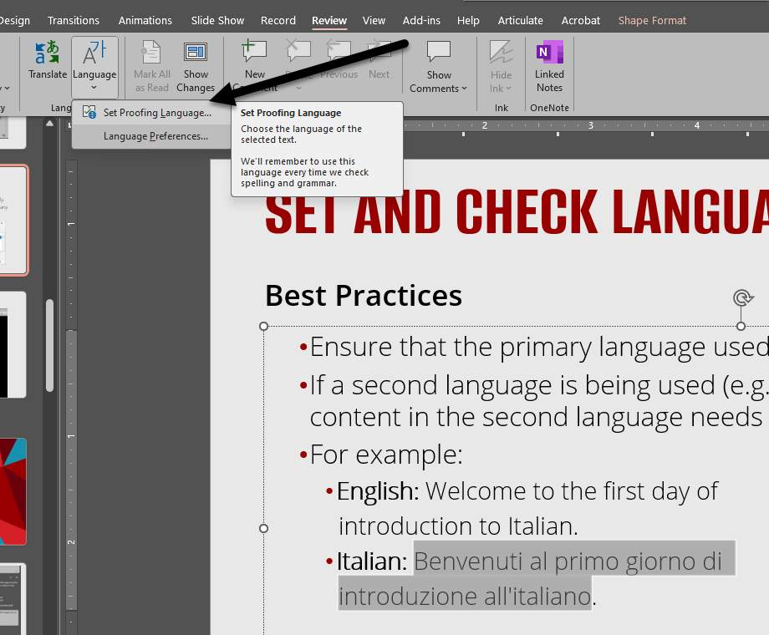
Figure 3. A slide in PowerPoint is displayed with two language. Content in the second language is highlighted. The "Review" section of the ribbon is open, and an arrow is pointing to the "Language" drop-down menu.
Figure 1.2. A slide in PowerPoint is displayed with two language. Content in the second language is highlighted. The "Review" section of the ribbon is open, and an arrow is pointing to the "Language" drop-down menu.

Knowledge Check 1: Language Settings and Microsoft
Answer the following question to self-check your knowledge (answers are at the end of the document).
Why is it important to set the correct language for content in Microsoft tools? (Check all that apply.)
- To automatically translate the content into multiple languages
- To ensure assistive technologies can accurately read the content aloud
- To improve the visual formatting of the document
- To enable spell check features in all languages set within the document

Google Workspace

Preferred language settings in Google Workspace
Google Workspace allows one preferred language to be set at a time on the web. The preferred language can be changed for individual mobile apps.
To check or change your global preferred language, you need to:
- Go to https://myaccount.google.com/(opens in a new tab)
- Select the Personal Info option on the left-side bar menu.
- Go to General Preferences for the web> Language.
- Select the Edit button (a pencil icon); it's the left of the current Preferred language that's listed.
- Select the option you'd like to be made the new preferred language.
- Click the Save button.
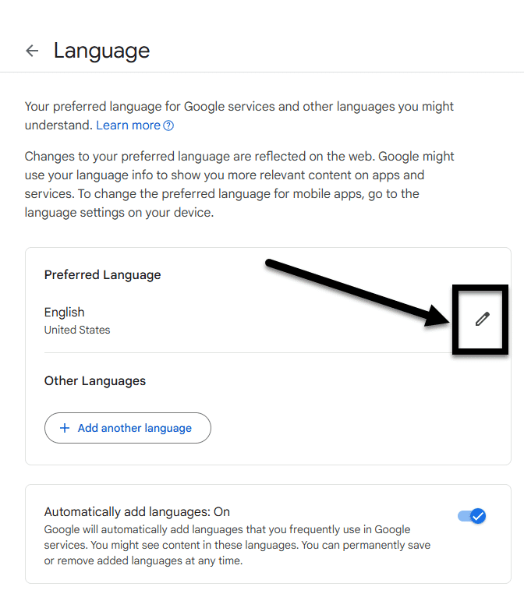
Figure 4. The Language page in Google's MyAccount. The "Edit" button is noted with an arrow next to the currently set preferred language.

Changing the language for an individual Google file on Docs, Slides, and Sheets
- Note: Google Workspace only allows users to have one language set in each file. Multilingual documents need to be exported to an equivalent Microsoft tool (e.g., Word, PowerPoint, or Excel) to have the second language set.
To check or change the language setting for an individual document, slide deck, or spreadsheet:
  - Go to File>Language.
  - Select the new language from the sub-drop down menu.
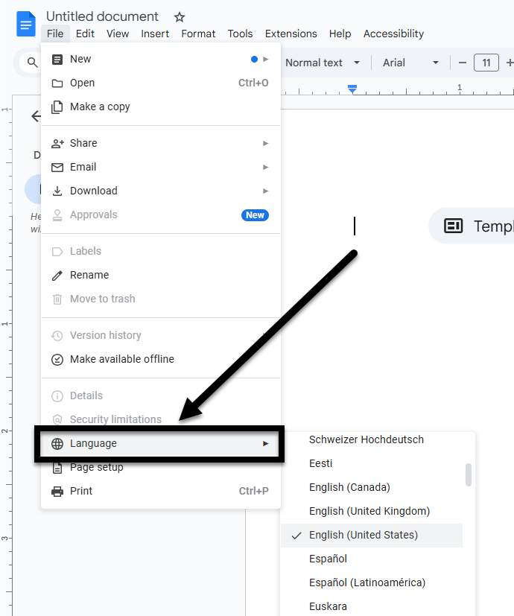
Figure 5. A blank Google Doc with the "File" drop-down open. An arrow is pointing to the "Language" option displayed near the bottom of the list.

Knowledge Check 1: Google Workspace
Answer the following question to self-check your knowledge (answers are at the end of the document).
Why can't you set multilingual documents in Google Workspace?
- Google Workspace only allows one language per file.
- Google Workspace does not support language settings.
- Multilingual documents require a premium Google Workspace subscription.
- Google Workspace automatically translates documents, so setting multiple languages is unnecessary.

Adobe Acrobat

Set Default Language in Adobe Acrobat PDFs
Adobe Acrobat Pro allows users to configure default language settings for an overall document. To get started:
- Go to the Top Menu.
- Select Document Properties from the drop-down menu, a dialog box will open.
- Navigate to the Advanced tab and scroll down to Reading Options>Language.
- Select the document's primary language from the Language drop-down menu.
- Click the Ok button to save your selection.
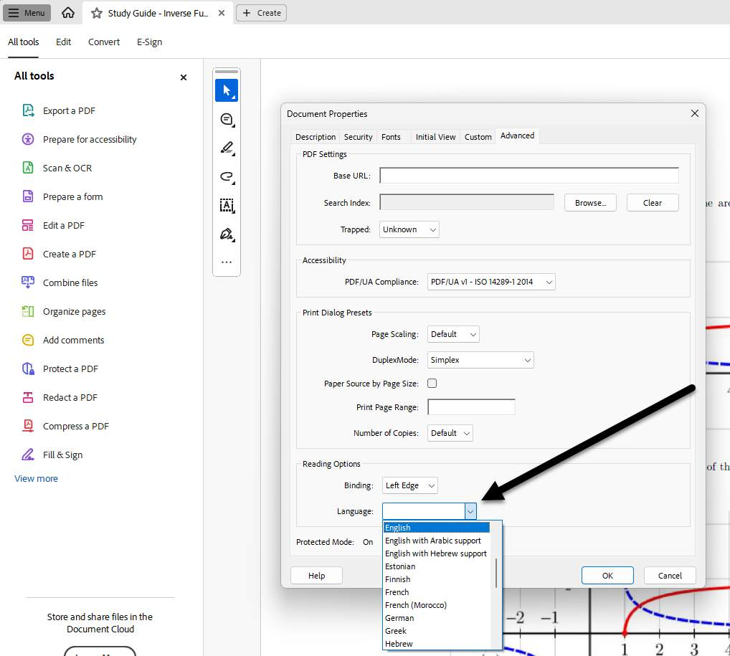
Figure 6. The Document Properties window of Adobe Acrobat Pro is open. An arrow is pointing toward the "Language" drop-down is open, displaying a variety of language options.

Set a second (or third) language in Adobe Acrobat PDFs
Note: Before attempting to set a second language in an Adobe Acrobat PDF, the document must be tagged. For information about PDF tagging and accessibility, see CELT's PDF Accessibility (opens in a new tab) page.
For multilingual texts, any text that is in a second language from what was set as the default needs to be tagged in the document to be read correctly:
- Open the Accessibility tags pane (it's either available on the left-navigation pane or by going to Top Menu>View>Show/Hide>Side Panels>Accessibility Tags).
- Select the tag that contains the content that needs the language set. The content on the screen should have a box go around it.
- Select Options (three dots in the upper-right corner of the screen).
- Select Properties from the drop-down menu, a dialog box will open.
- Go to Tags>Language.
- Select the highlighted text's language from the Language drop-down menu.
- Click the Ok button to save your selection.
- Repeat steps 1-7 for all content in a language other than the default.
- the default.
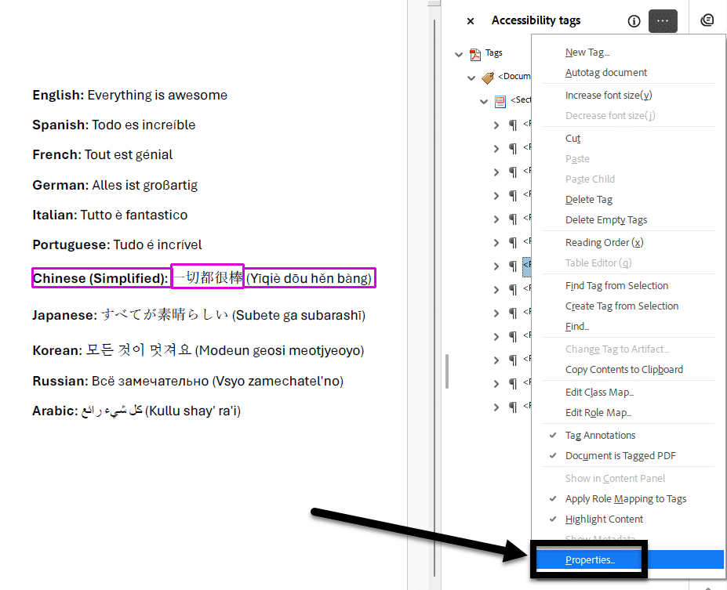
Figure 7. A PDF with the same phrase written in multiple languages and the Accessibility tags pane is open. And arrow is pointing to "Properties" under the "Options" drop-down.

CELT PDF Remediation Pilot
For users with PDFs that don't have a license to Adobe Acrobat Pro, CELT offers a PDF remediation pilot program for all Stony Brook University course content. Instructors can submit their PDFs to the pilot program and will receive an accessible copy of their document. Please note what language(s) the content is in using the Notes field.

Knowledge Check 3: Adobe Acrobat
Answer the following question to self-check your knowledge (answers are at the end of the document).
What is the first step to set a second language in an Adobe Acrobat PDF?
- Select the tag containing the content
- Tag the document
- Choose the language from the drop-down menu
- Open the Accessibility tags pane

Conclusion
You have completed the “Use Language Settings for Accessible Content” course!
Please fill out the Feedback Survey Form to record your completion of this course and to provide feedback for improvements.

Knowledge Check Answer Key

Knowledge Check 1 Answers: Language Settings and Microsoft
- B and D

Knowledge Check 2 Answers: Google Workspace
- A

Knowledge Check 3 Answers: Adobe Acrobat
- B

