Google Tutorial: Accessibility Features
By: Lindsay Bryde
Table of Contents
Google Tutorial: Accessibility Features 1
Meaningful Link Text 1
Adding Links 2
Option 1: Insert a link without existing text 2
Option 3: Paste a link and edit the displayed text 3
Additional Resource 4
Work with links and bookmarks in Google Workspace 4
Learn More About Document Accessibility 4

Meaningful Link Text
When providing hyperlinks during presentations, you want to ensure that the link text displayed to your audience is descriptive.
Link text should be unique and meaningful when read out of context, and should help users to know something about their destination if they click on it. Link text such as “Click here” and “More” would be too broad to be considered effective.
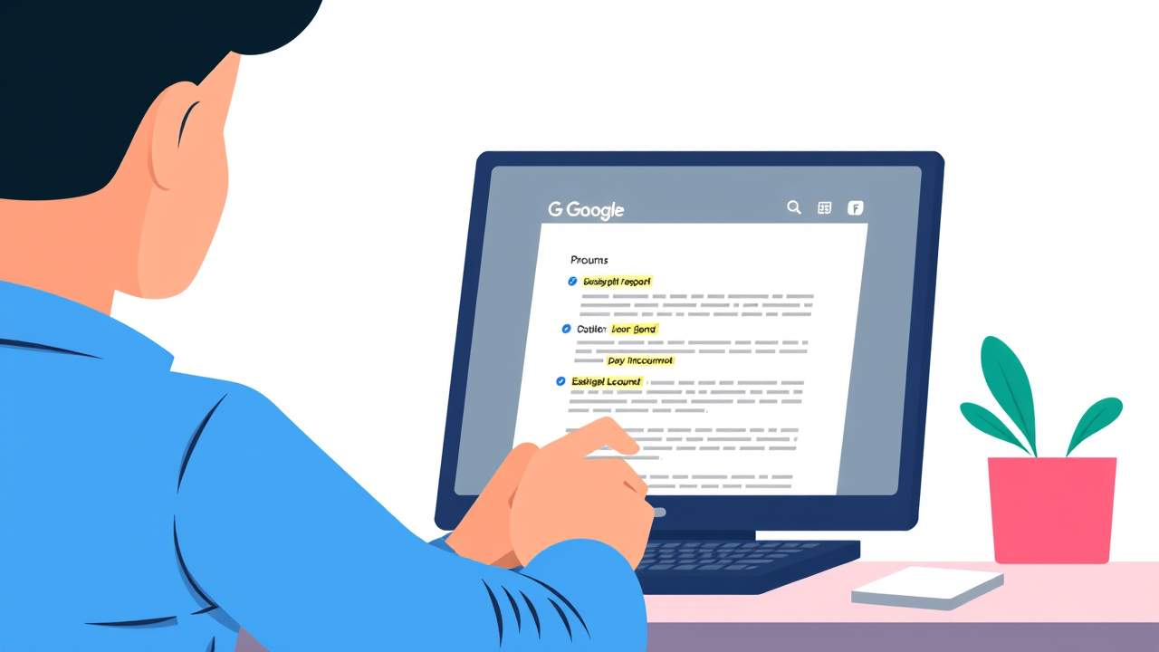
Consider the various ways users interact with links:

- Screen reader users can generate a list of links and navigate them alphabetically. Redundant, repetitive, or ambiguous link text such as “More” is meaningless in this context.
- Users of speech recognition technology can select a link with a voice command like “click” followed by the link text. Therefore, it is also helpful to use unique link text that is short and easy to say.

Adding Links
While it may seem simple to copy and paste a link into a file, and press the ENTER or the SPACEBAR to make an active hyperlink, that link is not very accessible because the text displaying does not have context or meaning for the reader.
There are multiple ways you can create an accessible hyperlink:

Option 1: Insert a link without existing text
- Place the cursor where you want to add a link in a textbox.
- Click Insert >Link, and a dialog box will open.
- In the Text field, enter the descriptive text you want readers to see when they go to click the link.
- Paste the URL that you want to send users to in the Search or past a link field.
- Select Apply.
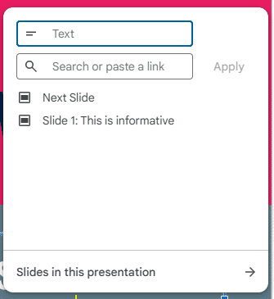
Figure 1 The link dialog box displaying the text and URL fields, as well as additional links based on recent search history.
Option 2: Create a link from existing text
- Highlight the text in the document that you want to add a hyperlink to.
  - Best practice: do not include spaces before or after the text that will be part of your link.
- Right-click the text and select the Link option from the drop-down.
- Paste the URL that you want to send users to in the Search or past a link field.
- Select Apply.
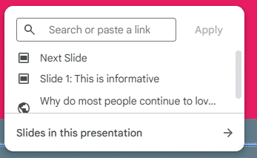
Figure 2 The link dialog box displaying the link search field, as well as additional links based on recent search history.

Option 3: Paste a link and edit the displayed text
- Paste the URL that you want to send users to in the document where you want the link to be created.
- Click the ENTER or SPACEBAR key, the URL will become a hyperlink.
- Right-click the link and select the Link option from the drop-down.
- In the Text field, replace the URL with the descriptive text you want readers to see when they go to click the link.
- Select Apply.
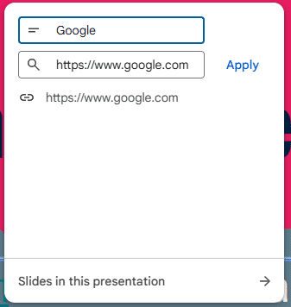
Figure 3 The link dialog box displaying the text and URL fields with text that can be edited.

Additional Resource

Work with links and bookmarks in Google Workspace
Learn more about adding and editing links using Google Workspace tools.

Learn More About Document Accessibility
For more information about document accessibility, please reach out to CELT by emailing celt@stonybrook.edu (opens in a new tab).
To view additional tutorials and resources, visit CELT's Accessibility page (opens in a new tab).
Please fill out the Feedback Survey Form (opens in a new tab) to record your completion of this course and to provide feedback for improvements.

Figure 4 Stony Brook University's logo

