Digital Accessibility Resource Guide
By: Kristin Hall
Table of Contents
Digital Accessibility Resource Guide 1
Welcome 2
Learning Objectives 2
Note on links 3
Formatting Tips for Digital Reading 3
Font 3
Left Align 3
Capital Letters 4
Chunking Information 4
Heading Structure 5
Headings and Subheadings 5
Using Heading in Microsoft Word and Google Docs 6
Additional Resources 6
Using Headings in Brightspace 7
Tables 11
Table Formatting 12
Formatting Tips for Tables 12
Header Rows in Tables 12
Additional Resources 12
Avoid Merged or Split Cells 13
Tab Order 13
Summary Tips on Tables 14
Hyperlinks 14
Summary Tips on Hyperlinks 15
Color 15
Color - Contrast 15
Color Contrast Checker - WebAim 16
Color Contrast Checker in Brightspace 18
Color- Conveying Information 18
Summary Tips on Use of Color 19
Images 19
Alt Text 20
Adding Alt Text to Images 22
Decorative Images 22
Long Descriptions 22
Summary Tips on Use of Images 23
Lists 23
Lists Provide Structure 23
When to Set Ordered or Unordered Lists 23
Additional Resources 24
Inaccessible Practices in a List 24
Videos 25
Closed Captioning and Transcripts 25
Editing Captions and Transcripts in Educational Technologies 26
Knowledge Check 27
Conclusion 27
Knowledge Check Answer Key 27


Figure 1 Stony Brook University logo

Welcome
In this guide, we provide tips and strategies to help make your syllabus and courses more accessible. These strategies are not exhaustive but hopefully are a starting point in providing more accessible digital resources.

Learning Objectives
By the end of this guide, you will be able to
- Describe ways to make digital content more accessible including headings, tables, hyperlinks, use of color, videos and images.
For more information about course planning, syllabus development or a syllabus review, please reach out to a CELT Instructional Designer by emailing celt@stonybrook.edu.
If you come across an accessibility barrier in this guide, please let us know by emailing celt@stonybrook.edu.

Note on links
All links open to a new tab.

Formatting Tips for Digital Reading
Based on design principles, the following tips help to create an easier to read digital content that minimizes cognitive load (the amount of information our working memory can process at any given time) and increases accessibility for all students. For guidance on formatting your syllabus, you can reference the CELT Syllabus Templates for examples.

Font
Use a sans serif font and use the same font throughout the document.

Sans Serif Font Examples:
Arial, Calibri, Futura, Helvetica, Lato (recommended font for Brightspace), Montserrat, Roboto, Open Sans.

Formatting tip:
Use Crtl⌃ A (PC) or Command ⌘ A (Mac) to select all the text in the document. Choose a font to change all to the same font style.

Underlining Text
Avoid underlining text for emphasis because this can be interpreted as a broken hyper link in a digital context.
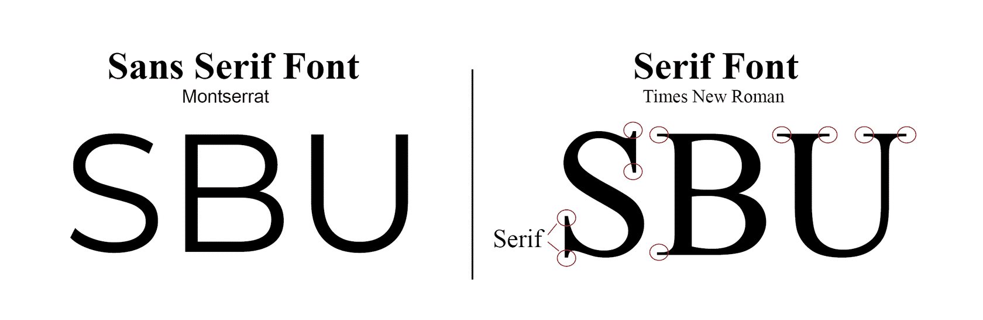
Figure 2 Example of a font with and without serifs. Montserrat is a sans serif font and Times New Roman is a serif font.

Left Align
Left align text as much as possible. Avoid right alignment and justified text and minimize centered text.
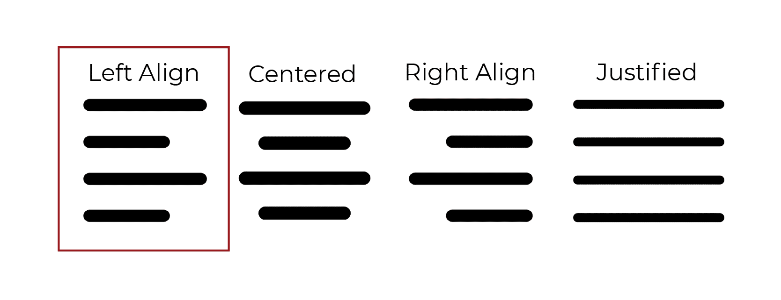
Figure 3 Examples of how text looks as left align, centered, right align and justified. A red box highlights that left align is most readable text.
Capital Letters
Avoid CAPITALIZING all text for emphasis within text as this is more difficult to read and appears as if someone is shouting or yelling. Capital Letters can be used for headings or titles.

Best Practice:
All assignments for this class are due on Saturdays at 11:59pm.

Avoid:
THE ASSIGNMENTS FOR THIS CLASS ARE DUE ON SATURDAYS AT 11:59pm.

Chunking Information
Avoid large blocks of text. Reduce the amount of text by eliminating unnecessary words and use bullet points to break things down.
The below examples state the same thing. In the Best Practice example, we removed unnecessary words and used bullet points to chunk and organize the content.

Best Practice:
Response Time and Feedback on Assignments
You can expect the following response times for feedback on assessments:
- Knowledge check grades will be published no more than 3 days after the due date.
- Discussions will be graded within 5 days after the due dates using the discussion rubric.
- Feedback on assignments will be provided within 2 weeks after the due date.
- Feedback on the final project will be provided within 2 weeks after the due date.

Avoid:
Response Time and Feedback on Assignments
I will provide feedback throughout the semester on all of your assignments. You will receive feedback within different time spans depending on the type of assignment. You can expect the following response times for feedback on assessments. The knowledge check grades given every week will be published no more than 3 days after the due date. The discussion board posts will be graded within 5 days after the due dates using the discussion rubric provided on the syllabus and in Brightspace. Feedback on all assignments will be provided within 2 weeks after the due date. Finally, feedback on the final project will be provided within 2 weeks after the due date.
Brightspace Tip: When working in any of the HTML editors in Brightspace including Announcements and Creating a File (Document templates) the recommended font is Lato and the recommended size is 19 or 20px

Heading Structure
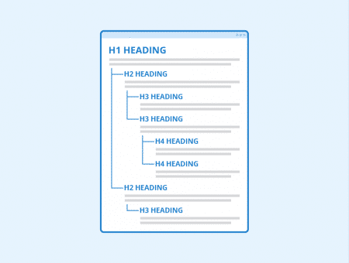
Figure 4 An example showing a heading structure with heading 1, heading 2 and heading 3 nested in a document.

Headings and Subheadings
Headings and subheadings are necessary for digital accessibility. Headings allow those who use screen readers to be able to navigate a document efficiently. They can jump from section to section without having to read the whole document from the beginning each time they access the document. The addition of a table of contents in word processing documents supports this ease of navigation.
Using a heading structure helps all learners by
- making it easier to scan a document
- providing a way to chunk content
- allowing you to generate a table of contents for ease of navigation
Headings need to be classified in the program you are using to create content such as Microsoft Word, Google Docs, PDFs, websites and even Brightspace. Simply bolding or making the font bigger is not sufficient. Headings need to be in the structure of the document using the built in settings.
The CELT Syllabus Templates use a heading structure and a table of contents. You can adapt these documents to suit your needs for your course.
For an overview of using headings in documents, view the US Department of Education Office of Civil Rights 3 minute video on Heading Structure below.
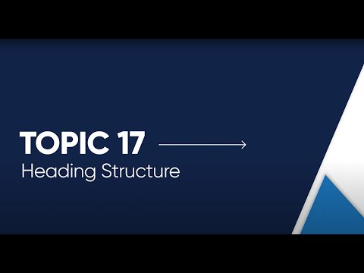

Using Heading in Microsoft Word and Google Docs
Microsoft Word and Google Docs have built in settings for Headings, but these settings can be customized to suit your needs while keeping the structure in place.
Microsoft Word
To access headings and subheadings in Microsoft Word, click on "Home" on the top of your screen. You will then see "Styles" in the middle of the top tool bar.
Google Docs
To access heading and subheadings in Google Docs, click on "Format" on the top toolbar and then click on "Paragraph Styles".

Additional Resources
Select Microsoft Word Heading Structure for more information about updating and customizing headings in Microsoft Word.
Select Google Docs Heading Structure for more information about updating and customizing headings in Google Docs.

Using Headings in Brightspace
Brightspace also has built in headings in their Document Templates feature. When building your course, you can use the Document Templates as an easy way to create content that is visually appealing, helps to chunk information and is accessible.
The following step by step tutorial guides you through how to access Document Templates in Brightspace. Select on the images to view them in a larger frame.

Step 1
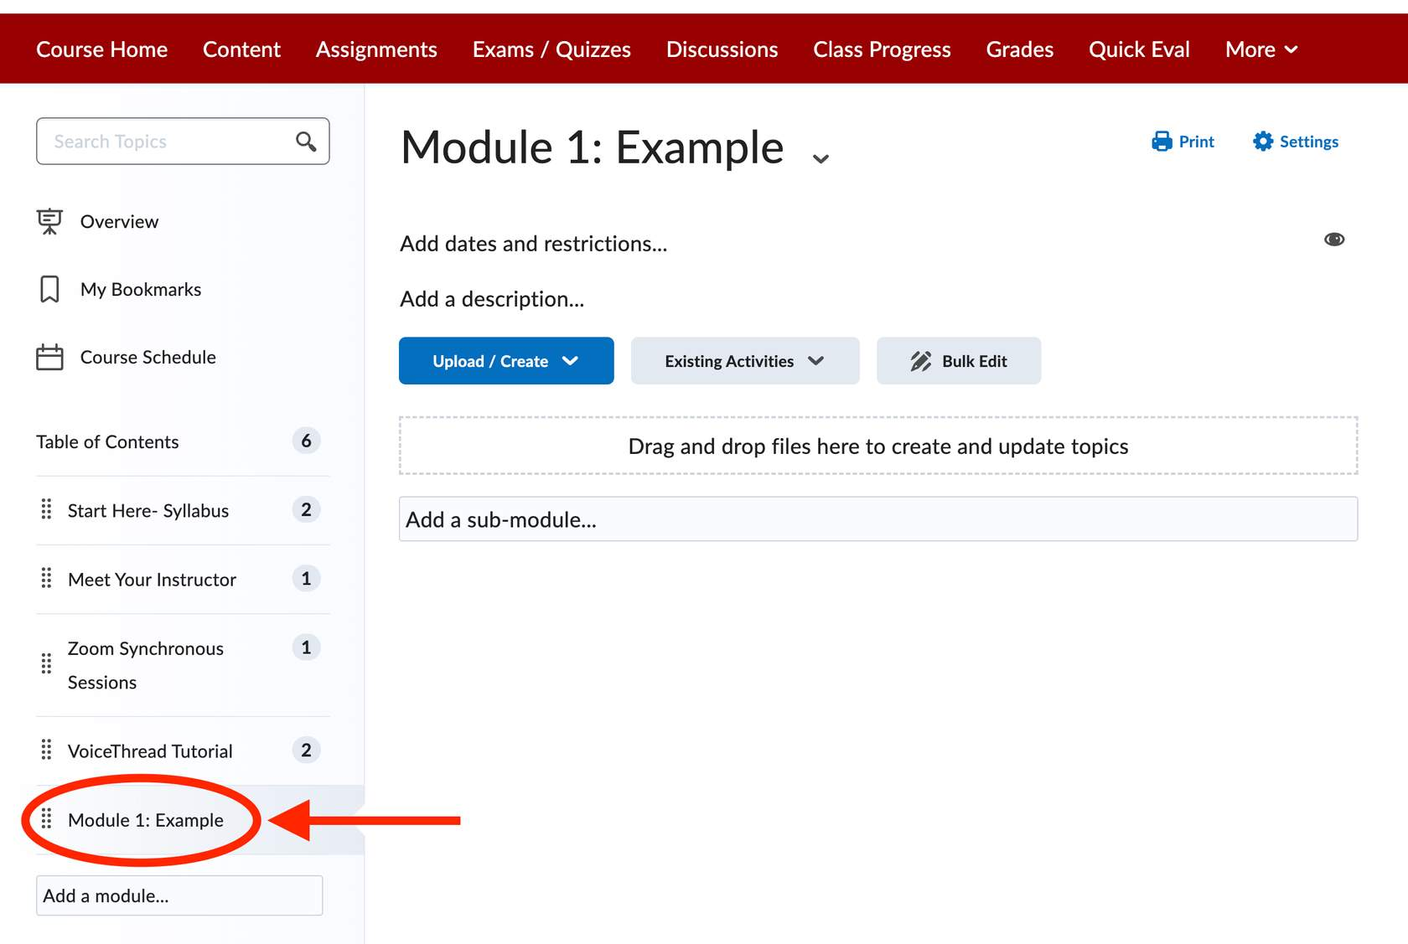
Figure 5 Screenshot of Brightspace screen pointing to clicking on Module 1 example.
Select the Module on the Left Navigation Panel that you want to add content to.

Step 2
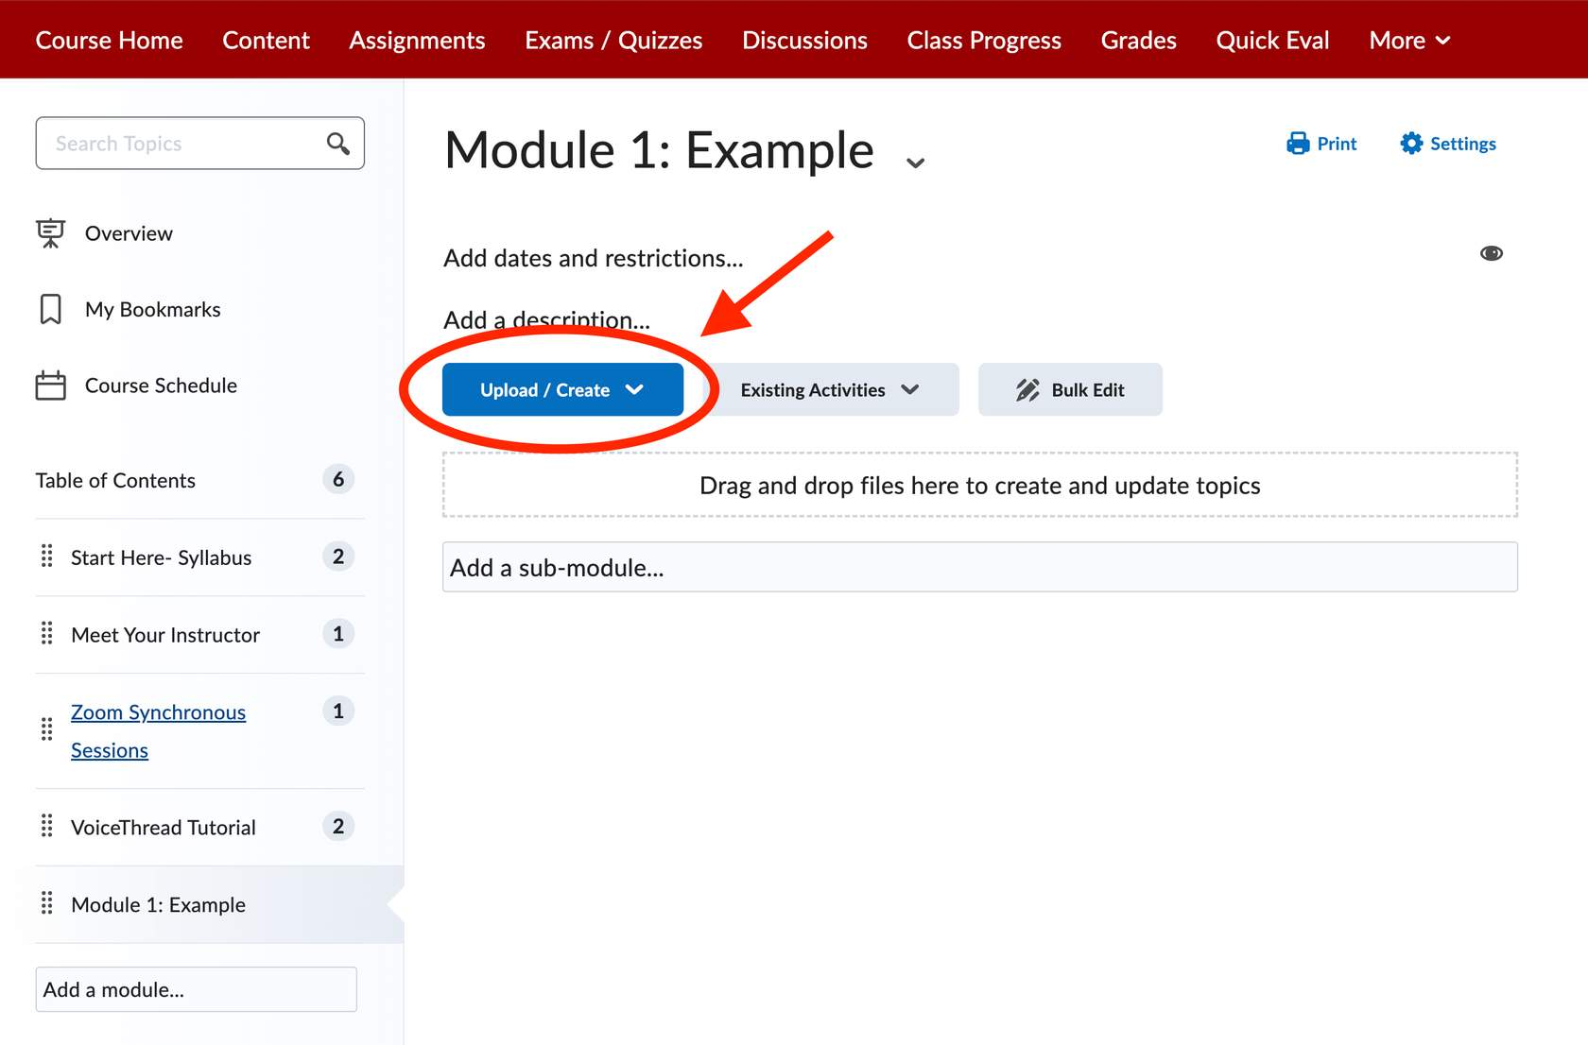
Figure 6 Screenshot of a Brightspace course pointing to the Upload/Create button within a module.
Select the Upload/Create blue button

Step 3
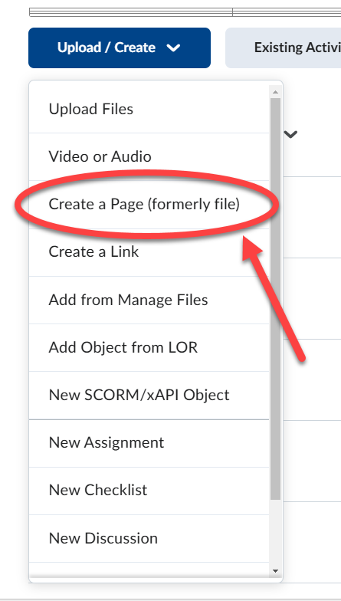
Figure 7 Screenshot of a Brightspace course pointing to "Create a Page (formerly file)" from the drop down menu when selecting the Upload/Create button.
Select "Create a Page (formerly file)"

Step 4
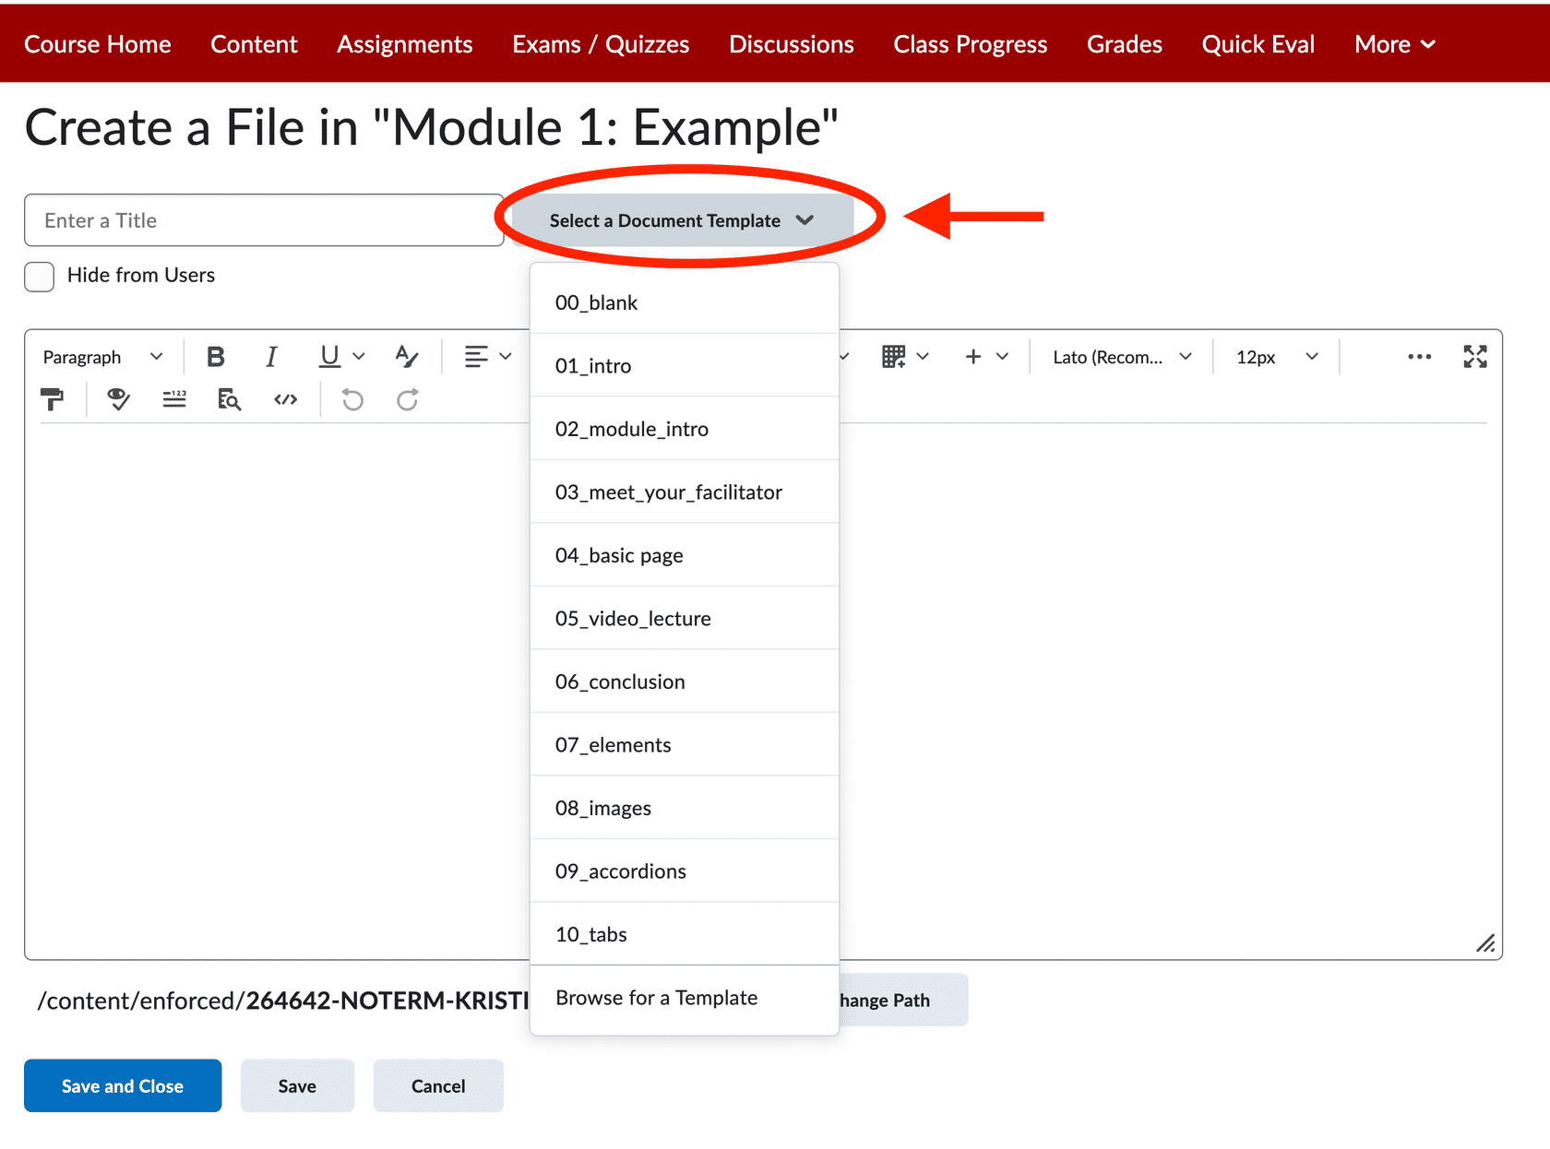
Figure 8 Screenshot of a Brightspace course pointing to selecting the "Select a Document Template" button to reveal a drop down of the templates.
You will come to an HTML editor page. Select the Document Templates button for a list of document templates to choose from.

Step 5
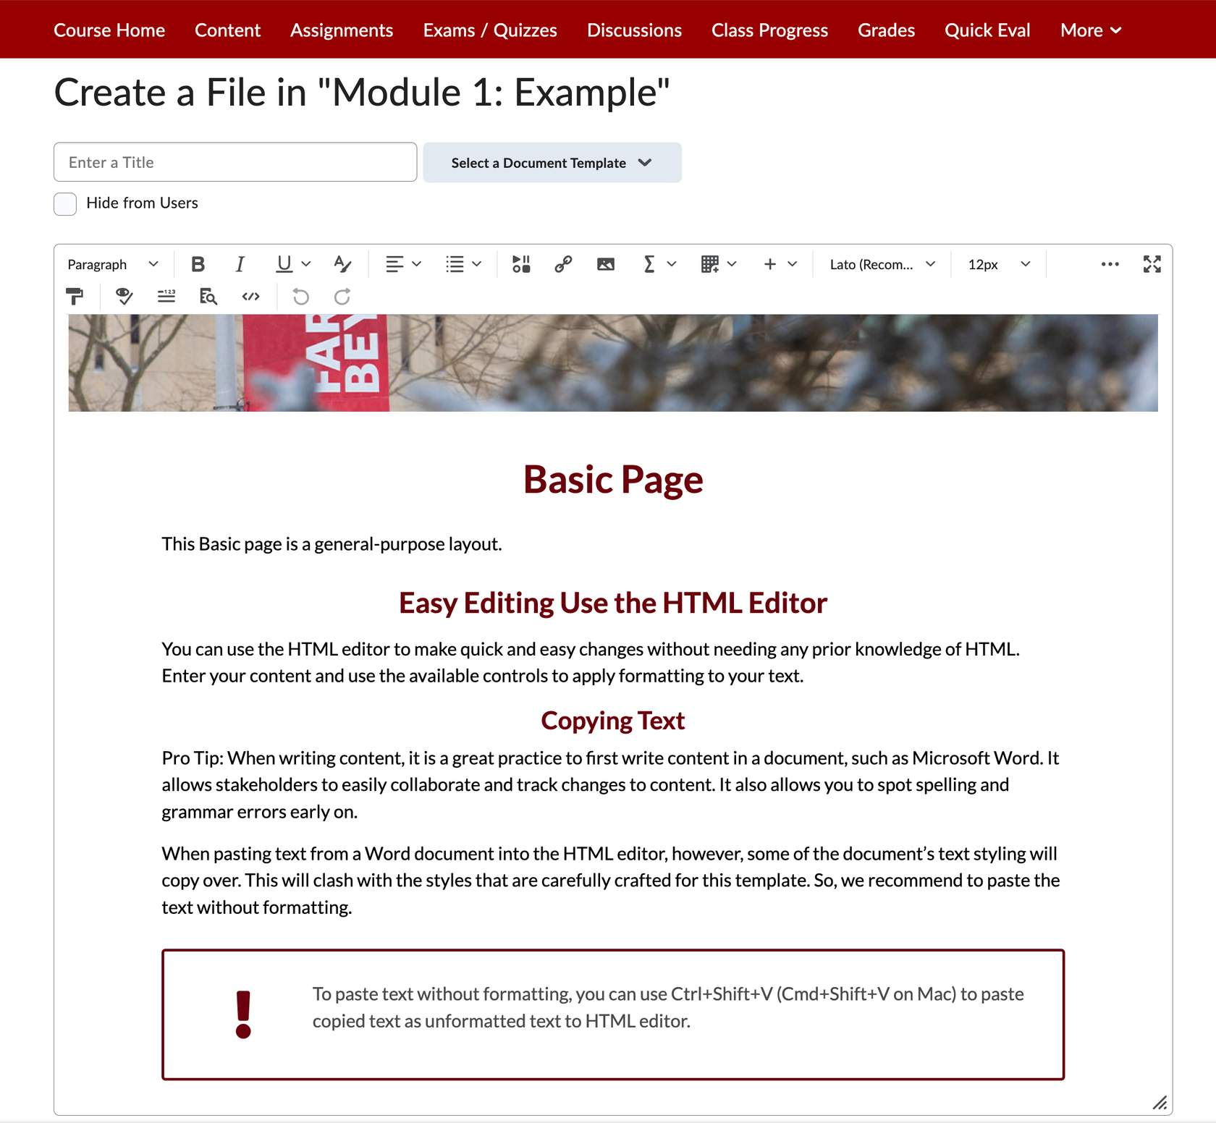
Figure 9 Screenshot of Brightspace course showing the layout of the Basic document template.
This is an example of the Basic Page document template. The Heading structure (Heading 1, Heading 2, Heading 3) is already built into this template and you can edit as needed. The document templates are all fully accessible.

Step 6
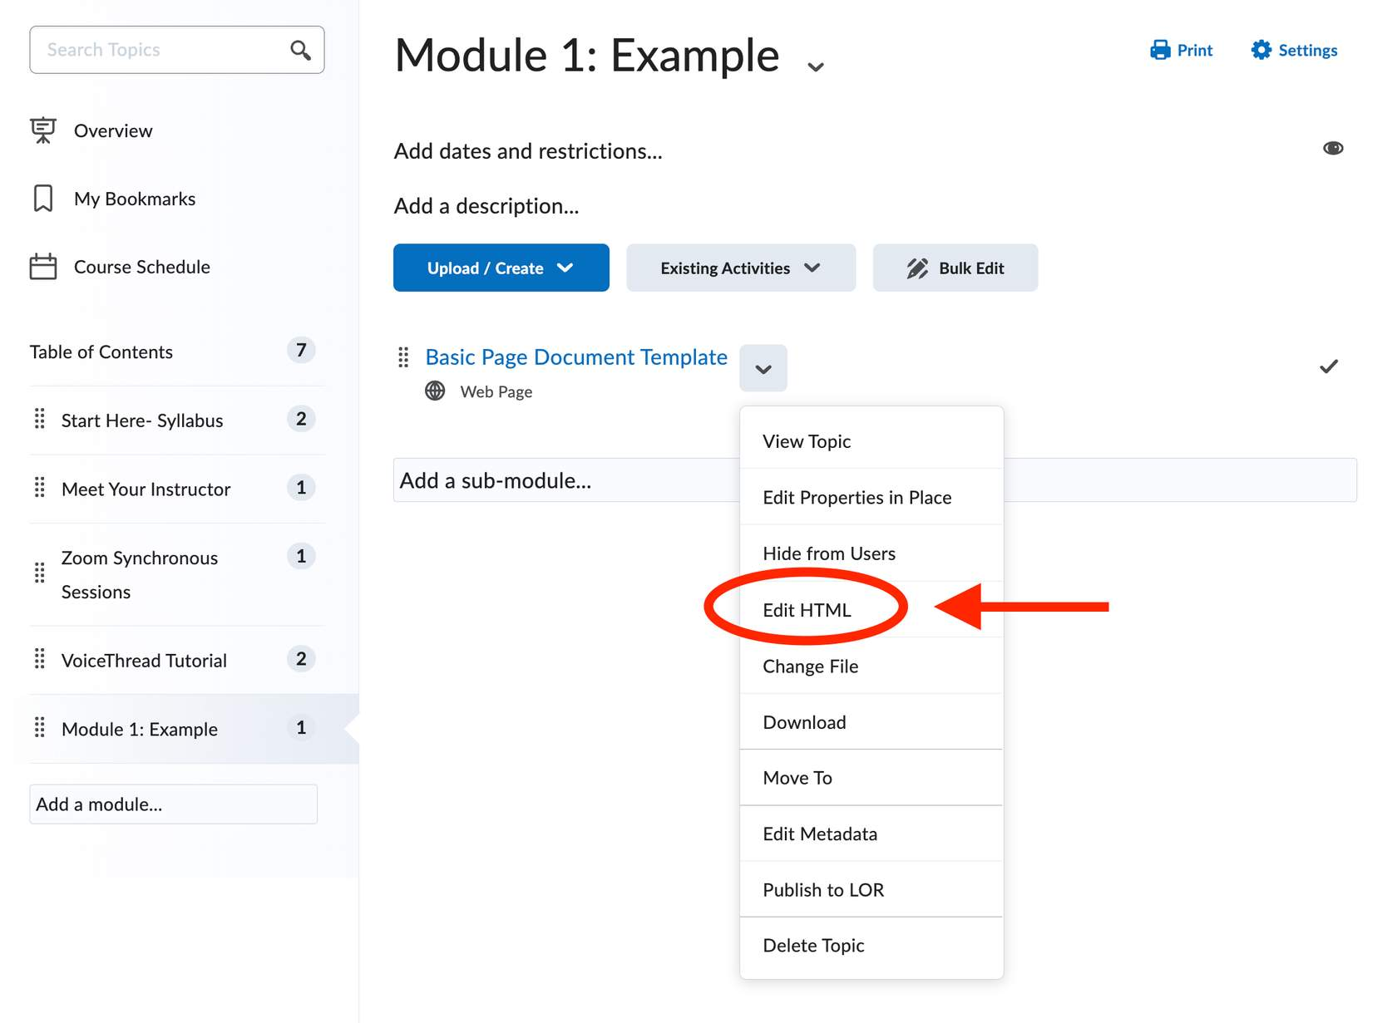
Figure 10 Screenshot of a Brightspace course indicating how to edit the HTML page.
To edit this page in the future, select on the Module where you created the page. Select the arrow next to the page and then select "Edit HTML.” This will bring you back to the HTML editor to make any updates or changes you need.
Summary Tips on Headings and Subheading
- Headings and a table of contents make it easier to scan a document and chunk information into more meaningful parts.
- Use the built-in heading structure in the content creating program (Word, Google Docs, Brightspace, etc.) Don't just use bold or bigger font to distinguish headings.
- Brightspace has built in headings and accessibility features in their Document Templates.

Tables
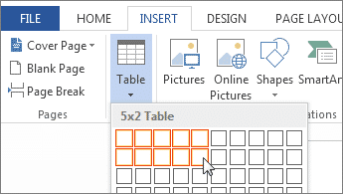
Figure 11 Screenshot of table tool in Microsoft Word.

Table Formatting
Tables help to chunk and organize information, but these can bring some challenges for accessibility.
View the US Department of Education video on Tables below for an example of how and why tables need to be formatted with headers.
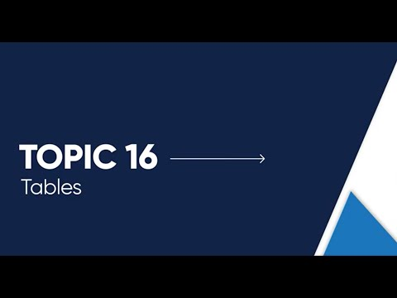

Formatting Tips for Tables
Below you will find tips and strategies for creating more accessible tables in your digital documents. As the video explains, first decide if the information makes sense presented in a table format or if there is another way to present this information.
As you format your tables, pay attention to headers, tab order, and avoid merged and split cells.

Header Rows in Tables
Here are some tips for using headers in tables. You will also find resources for formatting tables in Microsoft Word and Google Docs.
- Use a header row to explain content of each column.
- Repeat the header row on each page if the table extends beyond a page.
- Avoid letting rows break across pages.

Additional Resources
Select Formatting Tables Microsoft Word for information on how to format tables in Microsoft Word.
Select Formatting Tables Google Docs for information on how to format tables in Google Docs.

Avoid Merged or Split Cells
The Table below shows examples of merged, vertical split and horizontal spilt cells. Avoid splitting or merging any cells as these make it difficult for screen readers to navigate. As you can see from the video from the US Department of Education, merged and split cells make it difficult for screen readers to put the cell in context.
If you have any merged or split cells as shown below, consider revising your table or presenting the content in a different format.

Example of Merged and Split Cells to Avoid
Header Row | Content 1 | Content 2 |  | Content 3
Merged Cells |  | Vertical Split Cell | Vertical Split Cell | Horizontal  Split Cell
 |  | Vertical Split Cell | Vertical Split Cell | Horizontal  Split Cell

Example of Well Formatted Table
Header Row | Content 1 | Content 2 | Content 3
Row 1
Row 2

Tab Order
Lastly, you want to test the tab order to indicate the correct order of content. This is important for individuals that navigate documents without a mouse and for those who use screen readers.
To do this, click on the table and only use the tab key on your keyboard to navigate through the document. Does this order make sense in the context of the content?
View this 4-minute video from the US Department of Education on Logical Reading order for an example of when the tab order does not make sense.
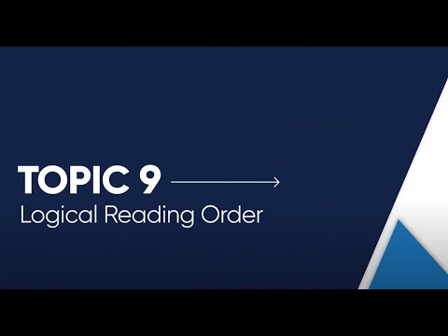

Summary Tips on Tables
- Use a header row in each table to explain what each column contains
- Repeat the header row on each page if the table goes beyond one page
- Avoid merged and split cells
- Test the tab order to make sure the context makes sense

Hyperlinks
When providing hyperlinks in your digital documents or on Brightspace, use descriptive language to communicate these hyperlinks. Descriptive language allows users to identify links easily. If using a screen reader, the user can toggle between links and clearly communicate what the link is in reference to. Avoid using terms like “Click Here” and then adding a hyperlink to the word “here."
See example below with a link to the US Department of Education videos.
Best Practice | Common Mistake
View the US Department of Education video on Hyperlinks. | Click here to view the US Department of Education video on Hyperlinks.
In addition, you want to make sure there is another non-color way of links standing out such as underlining. This is common in word processing documents and website when adding a link.
View the US Department of Education 4-minute video for tips and an explanation of using Hyperlinks in a digital context.
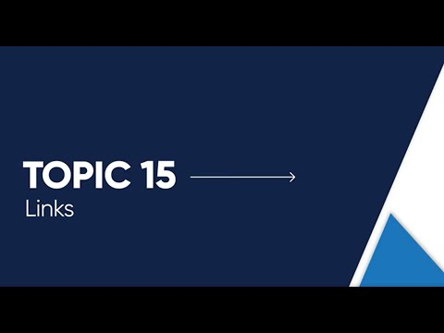

Summary Tips on Hyperlinks
- Avoid using terms such as "Click Here" or "Read More Here."
- Use descriptive language for each hyperlink.
- Avoid using the URL as the link text.
- Avoid repeating the same word or phrase for every link on the same page or in the same document, you need to make each of them unique.
- If a link opens in a new tab or window, inform users by including text like (opens in a new tab) in the link description.
- Provide another non-color way for links to stand out for those with low vision such as underlining.

Color

Color - Contrast
The most readable text is black font on a white background. Be careful with colored fonts in combination with colored backgrounds as some of these combinations may not be accessible.
Colored fonts that are too similar to the background may not have enough contrast so they may not be viewable to individuals with low vision.
View the following 4-minute video from the US Department of Education where they describe the use of color contrast in more detail.
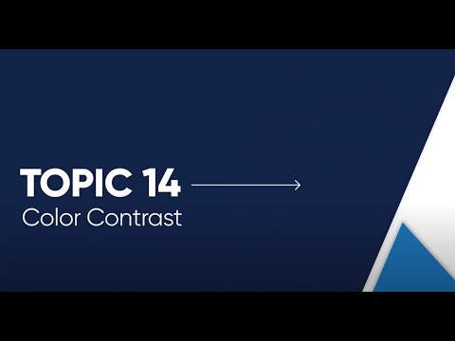

Color Contrast Checker - WebAim
As described in the video above, you can uses a Color Contrast checker to see if the color combination you would like to use is accessible. WebAim Color Contrast Checker is one tool available on the internet that offers an eyedropper tool.
This link to the WebAim Color Contrast Checker will bring you to the color contrast checker.
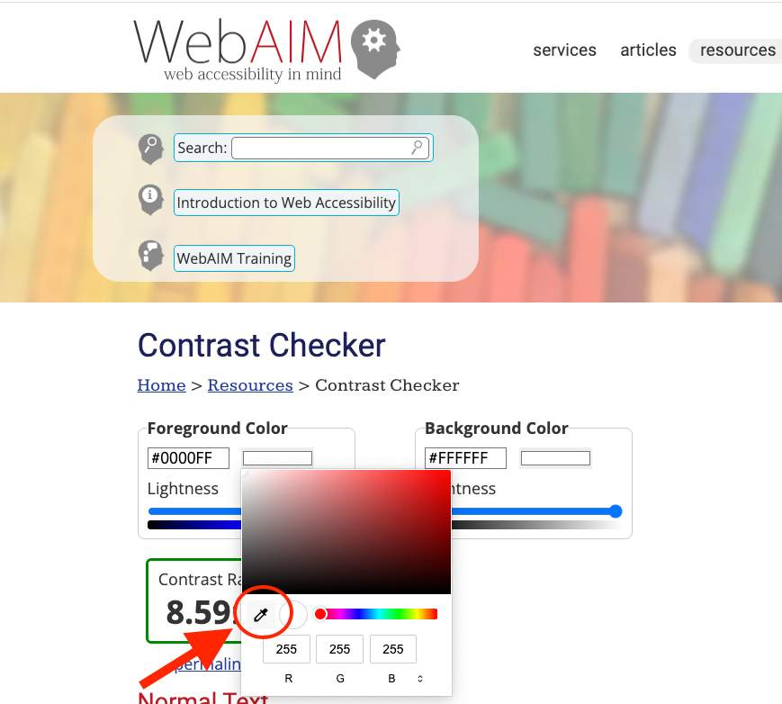
Figure 12 Screenshot of WebAim Color contrast checker demonstrating where to find the eyedropper tool.
Screenshot of WebAim color contrast checker eyedropper tool

Using the Eye Dropper Tool
WebAim Color Contrast Checker has an eyedropper tool to ensure you are getting the most accurate color.
- To access this tool, click on the color swatch next to the HEX code (#0000FF) for the foreground color.
- Click on the eyedropper tool on the left side of the color box that pops up.
- Hover over the font color you want to check and click on the color to capture the color code.
- Repeat for the background color.

Example of Failed Color Contrast
Red font with a yellow highlight is sometimes used to show emphasis and importance of information. As you can see from the screenshot of WebAim Contrast Checker, this combination fails most of the accessibility checks as the color contrast ratio is less than 4.5:1. In general, you want to avoid using this color combination.
Example:
The due date has changed.
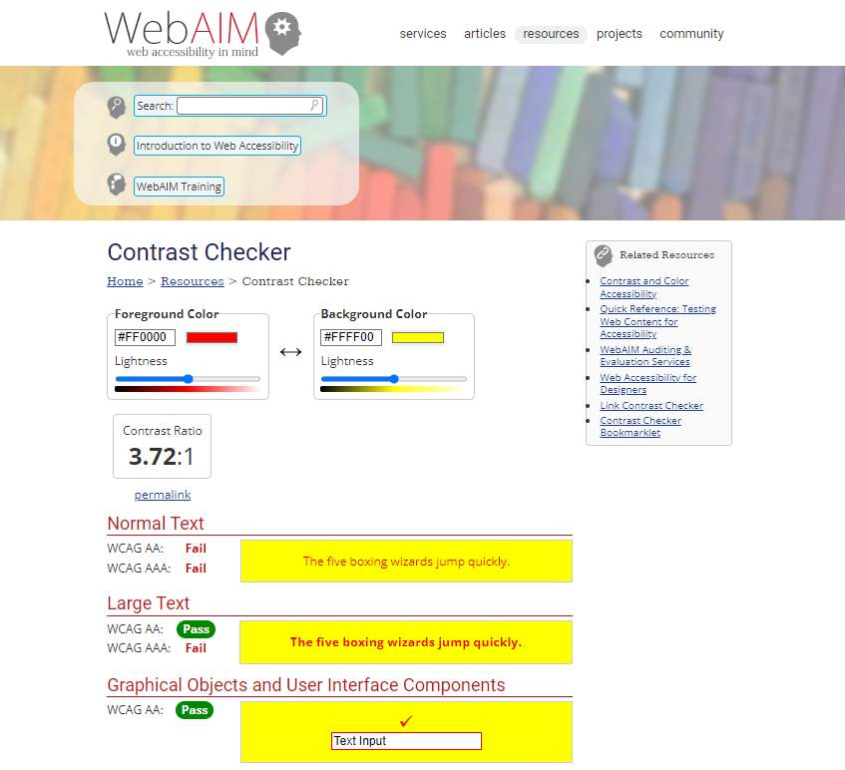
Figure 13 Screenshot of WebAim color contrast checker website. Red for foreground color and yellow for background color are tested for contrast. This color combination fails.
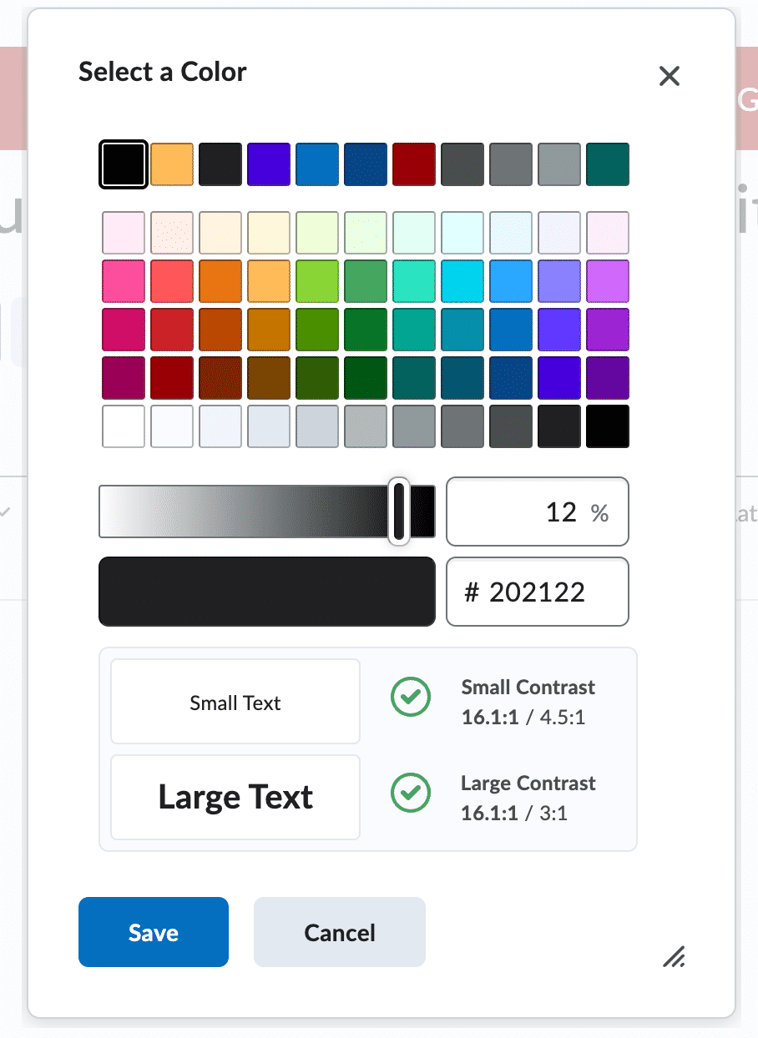
Figure 14 Screenshot of color contrast checker in Brightspace.

Color Contrast Checker in Brightspace
Brightspace also has a built-in color contrast checker in their HTML editors. When changing the font color you will see a dialog box pop up like the image on the left.
At the bottom you will see the contrast ratio for small text and Large text. The green check marks will indicate the color passes color contrast check.
If the color combination does not pass color contrast check, a red x will appear in place of the green check mark.

Color- Conveying Information
It is important to also avoid using color as the only way of communicating information. This includes highlighting text or using a different color font to emphasize information.
For example, if you make updates to your syllabus at all throughout the semester, you will want to include a phrase such as “Updated on September 18, 2023” before the new information. If you use a color only to indicate changes, students who are color blind may not be able to distinguish between the colors to know what is new or updated information.
Best Practice
Midterm Exam: November 15th - New Date (Updated on 9/15/23)
Common Mistake
All updates will be shown in red
Midterm Exam: November 15th
View this 5-minute video from the US Department of Education that explains the use of color alone to convey information. You will also find a continued explanation of color and formatting of hyperlinks.
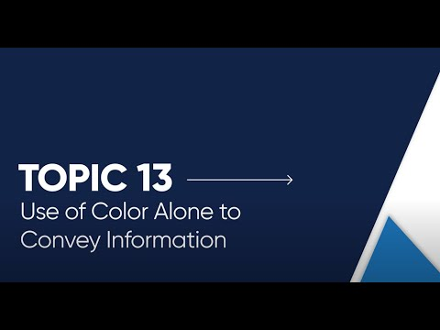

Summary Tips on Use of Color
- The most readable font color is black on a white background.
- Check the color contrast of colors used in your digital content to make sure they are at least a ratio of 4.5:1. Use tools such as WebAim Color Contrast checker.
- Avoid using color as the only way of communicating information.

Images

Figure 15 SBU Mascot Wolfie on campus.
Based on research in multimedia learning, you want to avoid using unnecessary decorative images or graphics in your document. This can be seen as extraneous information and potentially contribute to a cognitive overload and can interfere with comprehension.
As a best practice, only include images and graphics that are needed to explain content or are related to your content.
The image to the left while relevant to Stony Brook University, is not relevant to the topic of digital accessibility tips in the college classroom. This would be considered a decorative image.

Alt Text
For any images you do include, provide a description of the image or what is referred to as Alt Text. The alt text should describe the image in the context of the content.
The following 5-minute video from the US Department of Education explains alt text in more detail.
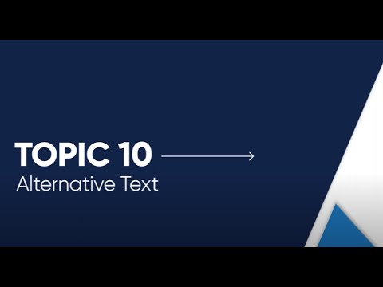

Alt Text Examples
Below are two examples of images and the alt text that corresponds with each image.

Figure 16 Man looking through a microscope

Alt Text Example #1: Microscope
This image depicts the use of a microscope. In a general sense, the alt text could be:
"Man looking through a microscope."
If in the context of lab safety, the alt text could be:
"Man wearing a hair cap while using a microscope."
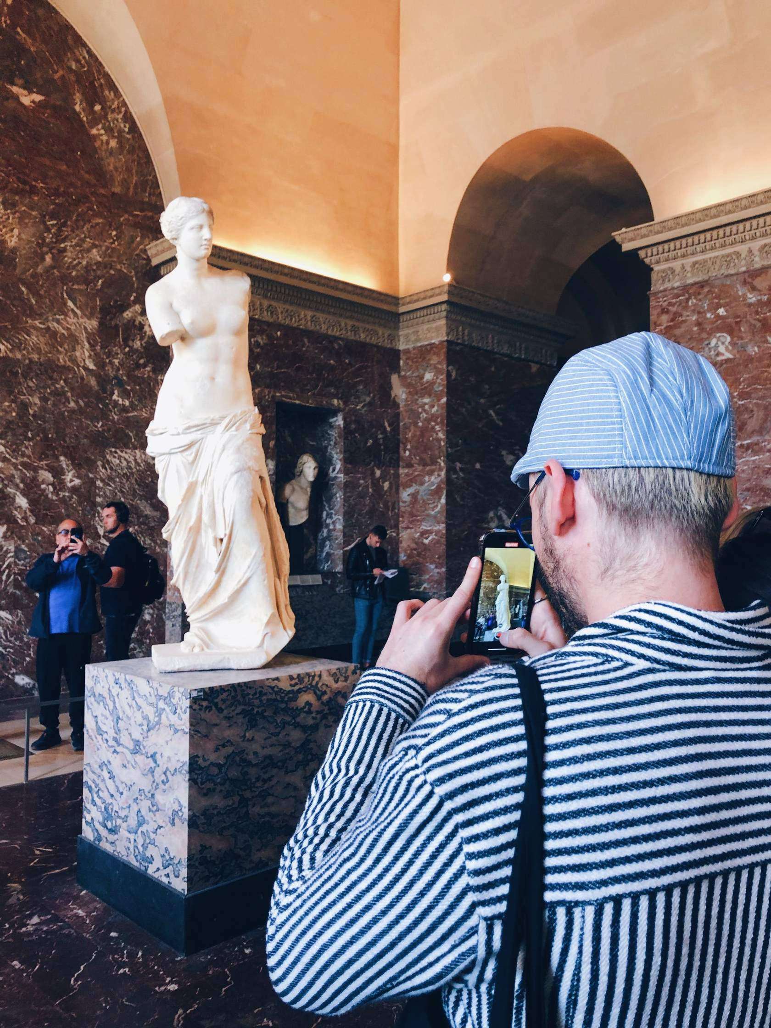
Figure 17 Tourist taking picture of Venus de Milo statue with a cell phone

Alt Text Example #2: Venus de Milo Statue
This image depicts the famous statue Venus de Milo that currently resides in the Louvre museum.
If this image is being used in the context of tourism in Paris the alt text could be:
"Tourist taking picture of Venus de Milo statue with a cell phone"
However, if this image is being used in the context of studying art history, the alt text could be:
"Man taking a picture with a cell phone of the Venus de Milo statue's contrapposto stance."

Adding Alt Text to Images
Different technologies and software programs give you the option to add Alt Text to your images. Select the links below for tutorials in adding Alt Text to the most commonly used including Microsoft Word, PowerPoint, Google Docs, VoiceThread and Brightspace.
- Microsoft Word - Alt Text
- Microsoft PowerPoint - Alt Text
- Google Docs - Alt Text
- Voice Thread - Alt Text
- Brightspace – Alt Text
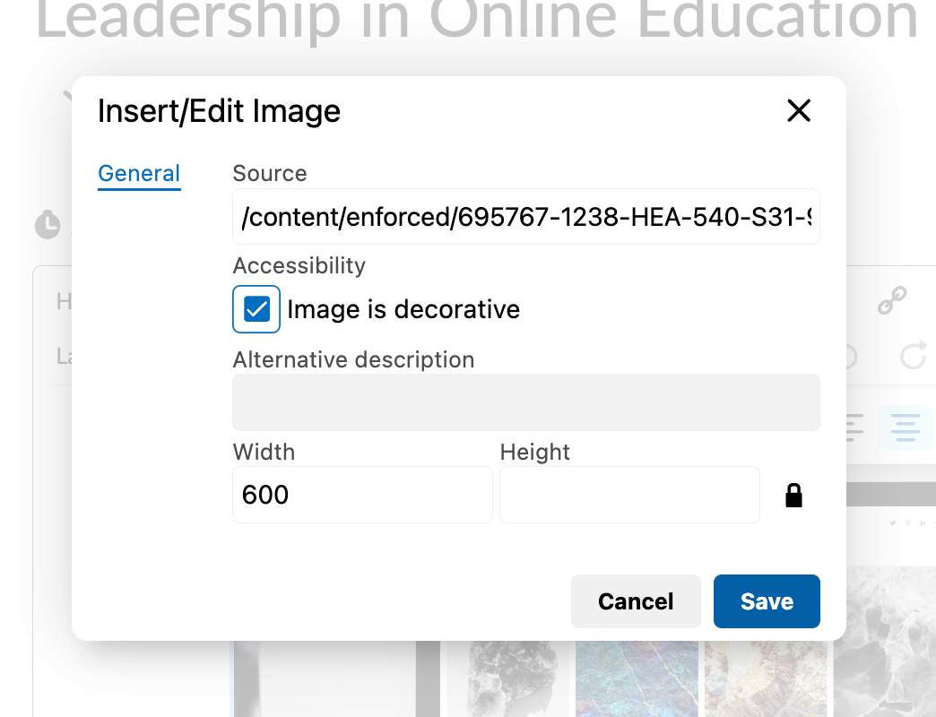
Figure 18 Screenshot of where to add alt text and mark an image as decorative in Brightspace.

Decorative Images
If an image is not needed to convey information to the user, you can mark the image as decorative when adding alt text. If someone is using a screen reader, the screen reader will skip over this image as it is not pertinent to understanding the content on the page.
The image to the left shows you how you can mark an image as decorative in Brightspace when adding alt text.

Long Descriptions
If an image is more complex, like a chart or diagram, then a detailed explanation that captures all the critical information may be needed. For example, you'll need a long description if an image contains complex elements, multiple objects, or important details that need to be understood clearly. This is very commonly needed for images related to STEM fields.
See the Long Descriptions Tutorial to access a tutorial on how to write a long description and where to place it with your content.

Summary Tips on Use of Images
- Avoid using decorative images as this can be seen as extraneous information and contribute to cognitive overload.
- Provide Alt Text for each image in the context of the content you are presenting.
- Alt Text should be short and concise. If a longer description is needed, consider providing a description with your content.
- If the image also includes text, include all relevant information in the Alt Text.

Lists

Lists Provide Structure
Lists add important hierarchical structure to a document. They are great from an accessibility standpoint because they provide order to content in a linear fashion.
Lists are recommended as potential replacements for simple tables, as tables can be more difficult to navigate and sometimes we provide info in tables that really would be better suited to lists.
It's important to use the built-in tools within the product that you're using to create a document.
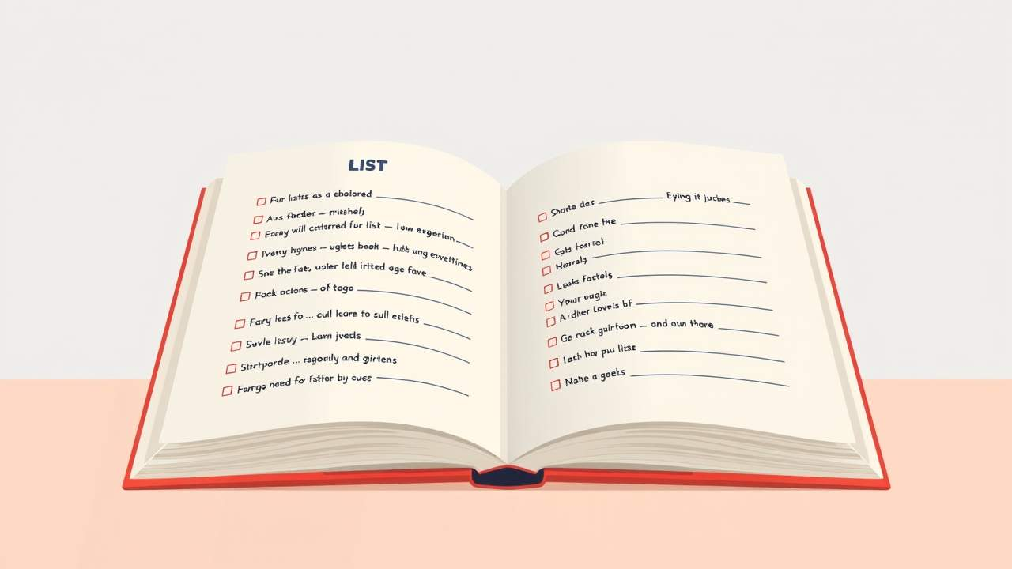
Figure 19 A book is open with a list.

When to Set Ordered or Unordered Lists
It's important to know what type of list you're creating because most authoring tools have a different setting/function for each type: ordered or unordered.

Ordered Lists
Ordered or numbered lists are used to present a group of items (words, phrases, sentences) that follow a sequence.
For example:
- Visit the school homepage.
- Download and fill-out "Submit Additional Information" PDF.
- Print your PDF.
- Submit to the Student Center on-campus.

Unordered Lists
Unordered or bullet lists are used for a group of items without a sequence.
For example:
- Pencil
- Pen
- Notebook
- Eraser
While the items can be related, they don't follow a specific order or importance or series of events.

Additional Resources
Select Formatting Lists in Microsoft Word for information on how to format tables in Microsoft Word.
Select Formatting Lists in Google Docs for information on how to format tables in Google Docs.

Inaccessible Practices in a List
Some methods of list creation and formatting can be visually appealing, but makes the list inaccessible for assistive technology users.

Line Spacing
Bad Practice: Manually adding space between items by hitting the "Enter" button. It's telling a screen reader that each bullet is its own separate mini-list.
Best Practice: Using the line spacing functions in the authoring tool you're using.

Dashes and Symbols
Bad Practice: Manually adding dashes or symbols to mark each item in the list.
Best Practice: Using the ordered or unordered list function.
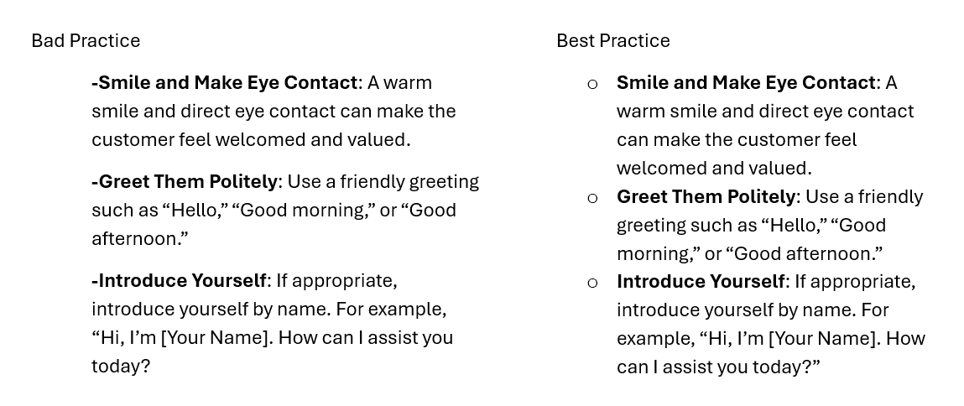
Figure 20 Two side by side lists. The first list shows the bad practice of manually adding dashes. The second list shows the best practice of adding a built-in list/bullets.

Videos
Videos are a great way to provide content to students in online and face-to-face modalities. Videos and lecture captures give students the ability to watch and re-watch content at their own speed.
If you use videos in your courses, it is important to provide closed captioning and transcripts to make the content accessible to all. This can be helpful for those that are deaf or hard of hearing, individuals where the language of instruction is not their first language, or those that are watching the video in a loud or distracting environment.
View the US Department of Education OCR 5-minute video below on Video Captioning for more information and examples of how auto-captioning sometimes fails.

Closed Captioning and Transcripts

Figure 21 Closed captioning icon.
There are many software programs that use auto-captioning software to create captions and/or transcripts for your videos, but these are not always accurate. It is important to view these and edit them to make sure they are accurate.
As discussed in the Video Captioning video above, the following are some instances where auto-captioning may not always be accurate.
- Speaker is speaking too quickly.
- Speaker's voice is muffled or they're mumbling.
- Speaker speaks with an accent that is less familiar to the auto-captioning software.
- There are multiple speakers.
- The video is highly technical or uses discipline specific language.
- Background noise.

Editing Captions and Transcripts in Educational Technologies

Zoom
If you record your Zoom session to the cloud, Zoom will auto generate a transcript. This transcript can be edited within Zoom and then downloaded as a file if needed. These transcription files can also be applied to the recorded video as closed captions.
- Auto generated Transcripts
- Editing transcripts within Zoom
- Apply transcripts to closed captioning
* Please note that all recorded videos to the cloud in Zoom will be automatically deleted in 180 days. For any videos you want to keep, please make sure to download these video files.

Echo 360
Echo360 is most known for lecture capture in specific lecture halls on campus. However, you can also upload videos to Echo just like you would to a video repository such as YouTube. Echo will auto-generate a transcript for videos that you can edit within Echo as well. You can also upload a transcript file and apply it to the video.
The following link provides resources on adding transcripts, editing transcripts and applying transcripts to closed captioning in Echo Videos.
EchoVideo- Transcripts

VoiceThread
VoiceThread also has an auto-captioning feature for videos recorded within VoiceThread. These captions usually appear within 5-10 minutes after the video is recorded. You can also edit these captions directly in VoiceThread
To apply these captions, the user will need to turn on the closed captioning by click on the CC icon in the upper right-hand corner next to their name.
The following link provides more information about auto captioning within VoiceThread and how to edit these.
Automatic VoiceThread Captioning
Summary Tips on Videos
- Provide closed captions and/or transcripts for all videos you provide to students.
- Many software programs such as Zoom, Echo 360 and VoiceThread provide auto generated captions and/or transcripts, but these are not always accurate.
- Edit transcripts for accuracy and to make sure the correct meaning is being conveyed.

Knowledge Check
Answer the following questions to self-check your knowledge (answers are at the end of the document). Then, fill out our Feedback Survey at the Conclusion on the next page.
- When formatting tables, which of the following practices is recommended to enhance readability and usability for all users?
  - Merge cells to create a seamless visual layout.
  - Utilize color coding as the means of conveying important information.
  - Use visual elements and designs to make the table more visually appealing.
  - Provide clear and concise headers for rows and columns.
- When considering color contrast and communicating information using color for accessibility, what is the best practice?
  - Ensure there is sufficient color contrast between text and its background.
  - Use color to enhance the visual aesthetic of your document.
  - Use color as the only means of conveying important information.
- When adding alt text to images for accessibility in digital content, what is the recommended practice?
  - Use a brief and generic description like "image" or "image123" for all images.
  - Provide as much detail as you can to describe the image.
  - Include the file name or image dimensions in the alt text.
  - Provide a concise, descriptive text that conveys the purpose or content of the image.
- When creating hyperlinks in digital documents, what is a best practice to improve accessibility and a positive user experience?
  - Include descriptive and meaningful text that provides context for the hyperlink's destination.
  - Use generic phrases like "click here" or "read more" as hyperlink text.
  - Make hyperlinks visually distinctive by using colors to stand out.
  - Place hyperlinks only at the beginning or end of a document to avoid disrupting the flow of content.
- Which statement is true for heading structures in documents?
  - Headings can be achieved by bolding font to stand out to the reader.
  - Headings help organize content, making it easier for all users to navigate and understand the document.
  - Headings are for aesthetic purposes and do not impact accessibility.

Conclusion
You have completed the Digital Accessibility Guide!
Please fill out the feedback survey form to record your completion of this guide and to provide feedback for improvements.

Knowledge Check Answer Key
- D
- A
- D
- A
- B

