Converting STEAM Content for Accessibility
By: Lindsay Bryde
Table of Contents
Converting STEAM Content for Accessibility 1
Welcome 2
Learning Objectives: 2
Note on links: 3
File Formats and Metadata: How They Impact Accessibility 3
How the Rules of Accessibility Are Changing 3
What is Metadata? 4
How Does Metadata Impact My File Format? 4
What Formats Are Best For Making Accessible STEAM Content? 4
Why PDFs Struggle with Metadata 4
Can PDFs Ever Be Made Accessible 5
Selecting the Best Format for Your Content 5
Key Takeaways 6
Converting PDFs and LaTeX with Mathpix 7
Request a Mathpix License 7
Converting a PDF with Mathpix 7
Key Takeaways 8
Remediating HTML Conversions 8
Exporting from MathPix 9
Exporting from LaTeX 9
Loading HTML Content to Brightspace 10
Formatting Content 10
Correcting Notations 12
Tables 13
Alt Text for Images 19
Final Accessibility Check 20
Key Takeaways 21
Remediating Microsoft Word Conversions 21
Set Up the Basic Document Formatting 21
Compare the Word Document to the Original PDF 24
Common Formatting Inconsistencies After Export 24
Check the Accuracy of the Math Conversion 27
Common Conversion Blindspots 28
Tables 28
Alt Text for Images 31
Final Accessibility Check 32
Key Takeaways 32
Conclusion 33


Figure 1 Stony Brook University Logo

Welcome
Welcome to "Converting STEAM Content for Accessibility," a self-paced guide to bridging the gap between complex technical documentation and inclusive digital design. In STEAM fields, critical information is frequently locked behind inaccessible PDFs that screen readers and other assistive technologies cannot parse.
This guide provides you with the practical, actionable skills needed to transform traditional STEAM materials into fully compliant, accessible formats using standard Microsoft tools and semantic HTML. There are many elements that go into making content accessible; this guide is not exhaustive.
It is highly recommended that you review the Digital Accessibility Resource Guide before beginning this course.
The estimated time to complete this course is 30-40 minutes.

Learning Objectives:
By the end of this guide, you will be able to
- Identify and explain the specific digital accessibility barriers inherent in traditional STEAM formats, such as standard PDFs, flattened image formulas, and unformatted data tables.
- Convert complex mathematical equations and technical notations into semantic HTML (using MathML) and structurally sound Microsoft Word documents that pass standard accessibility checkers.
- Deconstruct intricate technical visuals, including multi-variable graphs, circuit diagrams, and chemical structures, to determine the essential information required for context-rich alternative text.
For more information about document accessibility, please reach out to CELT by emailing celt@stonybrook.edu.
If you come across an accessibility barrier in this guide, please let us know by emailing celt@stonybrook.edu.

Note on links:
All links open to a new tab.
Accessibility is fundamentally about metadata, not file formats. Any file format can be accessible if it contains the right metadata, and that means we need to take a deeper look at our foundational content creation processes.
By integrating more robust metadata into our digital assets, we ensure our content is discoverable and accessible to everyone. This shift will not only bridge existing gaps in user experience but elevate the standard of everything we produce moving forward.

File Formats and Metadata: How They Impact Accessibility
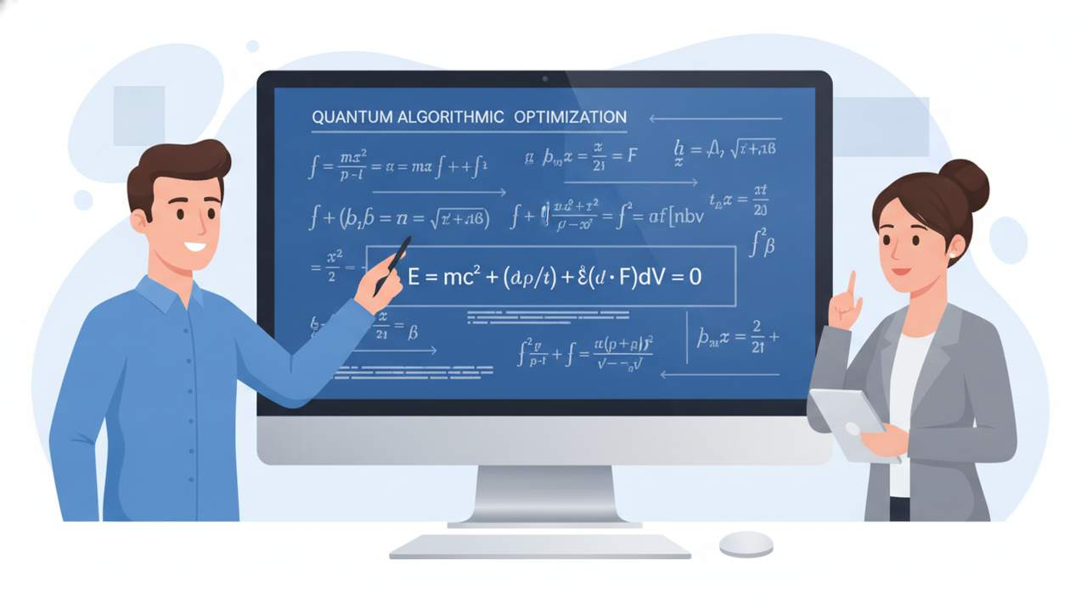

How the Rules of Accessibility Are Changing
When the American's with Disabilities Act was enacted in 1991, it allowed content creators to make alternate accessible versions of their materials upon request. However, this reactive model is no longer sufficient. It forces individuals with disabilities to wait for access that others get instantly, creating an unequal barrier that doesn't need to be created.
Starting April 24, 2027, the new standard is that all shared digital content must be accessible upon publication, with sufficient metadata built in from the start. This includes going back to any content that's still in active use today and "remediating" it for accessibility. Archival content (e.g., an old Facebook post from 2020 or meeting minutes from 2018) is exempt.
For an overview of what's changing, view CELT's 1-minute video on accessibility rules.

What is Metadata?
Metadata is essentially "data about data," internal information computers use to structure, interpret, and display digital content (e.g., headers, font size, alt text, author, date created).

How Does Metadata Impact My File Format?
File formats (DOCX, PPTX, HTML, PDF, JPEG, MP4) are simply conventions for storing digital content alongside its metadata.
When you open a file, programs like Microsoft Word use the metadata to render it, you only see a portion of the actual file.

What Formats Are Best For Making Accessible STEAM Content?
HTML and Microsoft tools (e.g., Word and PPT) allow for accessible and metadata rich content creation. Microsoft has developed several built-in tools (e.g., Styles for headings, an alt text editor) that embeds proper metadata.
In a web environment, the digital content is separated from the file structure. The associated file structure (metadata) provides the necessary instructions so that the information can be communicated clearly. It's why webpages render consistently across browsers.
Similarly, a Word document relies on its internal metadata to define the relationship between different pieces of information. The essential metadata element here is the file structure that organizes the content, ensuring the message is delivered as intended even if the document is converted or shared.
For an overview showing the difference between the design of a document and the accessibility of its code, view CELT's 4-minute video on code and metadata.

Why PDFs Struggle with Metadata
The Portable Document Format (PDF) serves as a primary case study for the "metadata over format" argument. Throughout its history, the PDF has demonstrated that simply having a universal file format is not enough to ensure that information is accessible to all users.
When Adobe created the Portable Document Format (PDF) in the 1990s, the goal was to ensure a document looked exactly the same on every computer and printer, regardless of the operating sySTEAM. To achieve this, a PDF treats content less like a live document and more like a digital photograph or a fixed map. For a PDF to be accessible, it must be more than that. It must contain a robust file structure (i.e., metadata), which requires the creation of what's known as "tags."
PDFs cannot natively read math equations or chemical notations dynamically. Math and chemistry in standard PDFs are usually flattened into vector images or broken down into separate font symbols (like a fraction bar being read as an underscore line). To fix it, you often have to manually embed hidden, complex text strings behind the math, describing the content (think an extended alternate text description of the content).

Can PDFs Ever Be Made Accessible
There has been progress in PDF 2.0 (originally announced in 2017), an updated standard that allows for incorporating metadata and restructuring files to better support accessibility. However, PDF 2.0 has not fully solved the accessibility problem because it requires heavily manual revision of the content to create tags.
Some software does a reasonable job of adding some of the necessary metadata when creating or exporting PDFs, but many tools do not. This means that simply having a PDF, even one created under newer standards, does not guarantee that the required accessibility metadata is present.
Compounding this is the difficulty of verifying and remediating PDF files, determining what metadata is missing from an arbitrary PDF can be laborious, and fixing those gaps can be prohibitively challenging or expensive.

Selecting the Best Format for Your Content
When presenting STEAM content, selecting the right format is all about balancing the technical complexity of your material with the specific needs of your audience. If your priority is cross-platform accessibility, high-quality assistive technology support, and web-standard responsiveness, MathML is typically the best choice. However, if your readers primarily consume content in static print or standalone documents, native Microsoft Word equations can be a more practical choice.
To help you determine the optimal setup for your content, the comparison table below outlines how the leading math formats stack up.
Consideration | LaTeX to HTML | MathPix | Microsoft Word (docx) | LuaLaTeX with PDF 2.0
Summary / Purpose | Export LaTeX to webpage format | Convert PDF files to MS Word documents | General typesetting | Render LaTeX in an accessible PDF
LaTeX? | Yes | Yes | Yes, with effort | Yes, with effort
Handwritten content? | No | Yes | No | No
Output | HTML webpages and images | MS Word documents; see next column | MS Word documents | PDFs
Faithfulness | Yes | May require verification | Yes, with effort | Yes
Maturity | Mature | Mature | Mature | New / Evolving
Recommended for: | Medium-to-large documents with substantial technical content | Handwritten documents or documents with considerable technical content | MathPix output or documents with little technical content | Not presently recommended; noted for future reference
Disadvantage(s) | Potentially lots of files; images may require alt text | Output requires human attention | Time consuming and an inconvenient interface | Immature and still developing

Key Takeaways
Accessibility in digital content relies heavily on the inclusion of appropriate metadata. Here are some key takeaways:
- Metadata is essential for accessibility, providing structure and context to digital content.
- HTML and Microsoft tools are effective for creating accessible content due to their built-in metadata features.
- PDFs pose challenges for accessibility, requiring meticulous tagging and metadata management.
By focusing on metadata, you can ensure your digital content is accessible to all users.

Converting PDFs and LaTeX with Mathpix
Mathpix is a powerful, AI-driven optical character recognition (OCR) and document conversion tool that has become a staple resource for digital accessibility remediation in STEAM disciplines. The platform allows creators to take a screenshot or upload a scanned image of any complex formula, handwritten note, chart, or text, and instantly convert it into editable, digitally structured formats.


Request a Mathpix License
Stony Brook University has procured Mathpix licenses. Please note that there are a limited number of licenses.
If you are a faculty, staff, and/or TAs that would like a Mathpix license to remediate digital documents that have mathematical formulas, please fill out the Mathpix License request form.

Converting a PDF with Mathpix
If content contains equations, mathematical expressions, chemical formulas, or other scientific notation, it is necessary to upload the PDF to Mathpix first, and export content into a Microsoft Word document.
- Select the Upload PDF button on Mathpix.
- Review and adjust the Upload PDF settings (e.g., File Name, Page Ranges, Section Numbering, Equation Numbering) as needed and select the Upload button to confirm your settings.
  - Note: Upon confirmation, the conversion can take a minute or two to complete..
- In the PDFs section, go to your newly converted file, and select the Export>DOCX option.
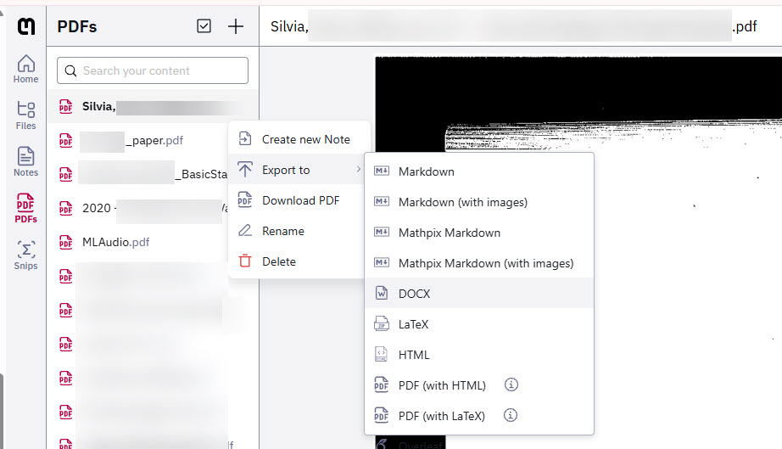
Figure 2 The Mathpix editor allows content creators to export content in a variety of formats.
For an overview of how to start a conversion, view CELT's 2-minute video on processing documents using Mathpix.
Find the exported file in your devices Downloads folder, and use the converted Word document as the starting file for the remaining accessibility edits in the next module.
After downloading the Word document, still review each equation and formula for accuracy, because conversion errors can still occur.

Key Takeaways
This module covered the effective use of MathPix for converting STEAM documents. Here are some key takeaways:
- Use MathPix to convert STEAM documents into editable formats. This tool simplifies handling complex scientific content.
- Adjust settings before uploading files. Proper configuration ensures accurate and tailored conversions.
- Review converted content for accuracy. Verifying results minimizes errors in the final document.
By applying these practices, you can efficiently manage and edit STEAM-related documents.

Remediating HTML Conversions
Converting LaTeX and PDF files to HTML transforms semantic content into a responsive, accessible format that automatically adapts to any screen size. Furthermore, HTML natively supports assistive technologies, so academic and technical work can actually be discovered, and allows for the seamless integration of interactive elements like animations, dynamic charts, and live code.
Brightspace allows content creators to publish HTML content using the "Create a Page (formerly a file)" option.


Exporting from MathPix
- Open your document in the Mathpix Snip app or web dashboard.
- Click the Export button.
- Select the HTML option.
- Save the file to your computer.
  - Note: By default, files can be found on the desktop's Downloads folder.

Exporting from LaTeX
A standard LaTeX installation (e.g., MacTeX for macOS) — Tex4ht MathML is included in most standard installs.
- Open your LaTeX project in your IDE (e.g., MacTeX, TeXworks).
- Instead of running PDF LaTeX, select Tex4ht MathML as the typesetting engine.
- Run the converter. It may take a moment to process.
- If your document has figure numbers or cross-references, run it a second time to ensure those are correct.
- In your project file tree, confirm that a new .html file has been generated alongside supporting files.
  - Note: By default, files can be found on the desktop's Downloads folder.

Loading HTML Content to Brightspace
Loading HTML content into a Content Management SySTEAM (CMS) or a Learning Management SySTEAM (LMS), like Brightspace, is a straightforward process that typically involves creating a new web page within the platform and pasting the raw HTML code directly into its native source code editor (</> tool). While both platforms handle web content efficiently, it is highly recommended that instructors utilize Brightspace as the primary hub for all course-related materials.
- Log into Brightspace and navigate to your specific course.
- Click on Content in the top navigation bar.
- Select the Module (or folder) where you want the file to live.
- Click the Upload/Create button and select Create a page (formerly file).
- Give your page a title.
- Look at the text editor toolbar and click the Source Code button (it looks like </>).
- Open your exported HTML file in a text editor (like Notepad or TextEdit), copy all the code, and paste it into the Brightspace source code window.
- Click Save. Brightspace will render your text and math. Any additional edits or remediations can be completed with the advanced editor.

Formatting Content
Formatting HTML content with clear hierarchical headings and consistent styling ensures a consistent layout that looks professional across all devices.

Font Size
Change all plain text font to Lato 19px and font color should be black.
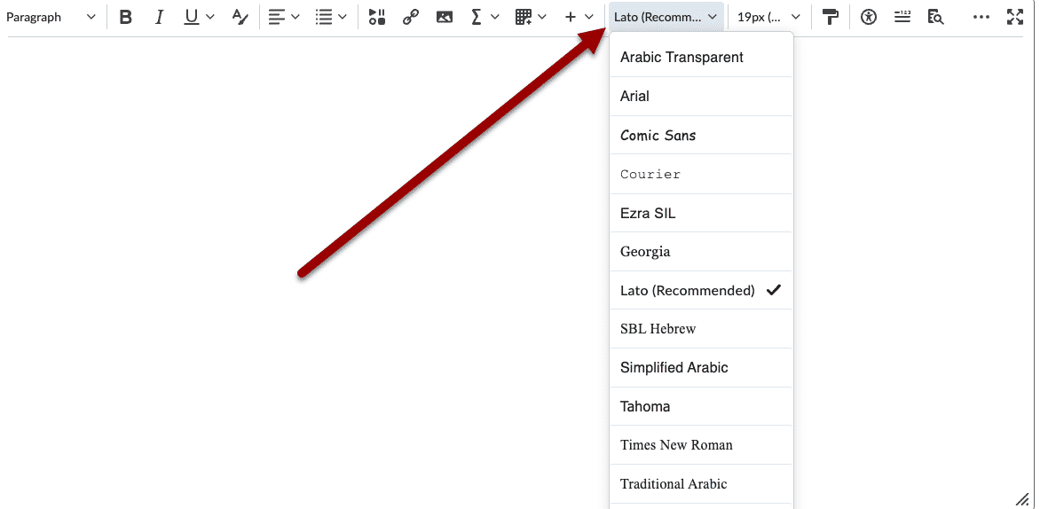

Headings
Headings are essential for accessibility, enabling screen reader users to navigate documents with greater ease. When processing the document, assign each heading an appropriate level (e.g., Heading 1, 2, 3, or 4) prioritizing logical hierarchy over the visual formatting of the PDF.
Suggested heading structure:
- Heading 1: Document title
- Heading 2: Major sections
- Heading 3: Subsections within major sections
- Heading 4: Smaller subsections if needed
Then the rest of content will be changed to Paragraph and aligned left.
For an overview of how to set heading levels, view CELT's 2-minute video on Headings in Brightspace below.

Dividers
Adding dividers can help readers know which subsection they are reading now.
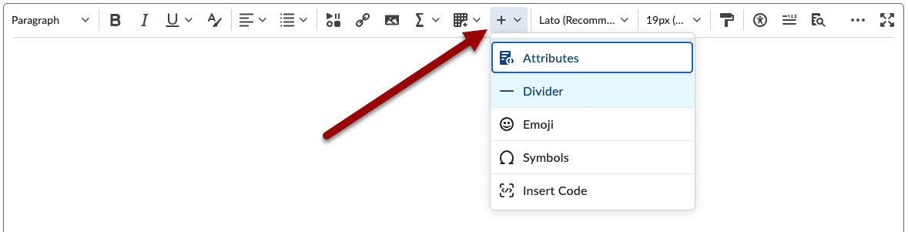

Lists
- If you have already typed your text, highlight the lines you want to turn into a list. If you are starting from scratch, place your cursor where you want the list to begin.
- Select one of the two list icons:
  - Bulleted List Icon: (Looks like three dots next to horizontal lines).Use this for items where the order doesn't matter.
  - Numbered List Icon: (Looks like 1 2 3 next to horizontal lines). Use this for sequential steps or ranked items.
- Type or edit your text.
  - Note: Pressing Enter/Return on your keyboard will automatically generate the next bullet point or number.
- When you are finished, press Enter/Return twice to break out of the list format and return to normal paragraph text.
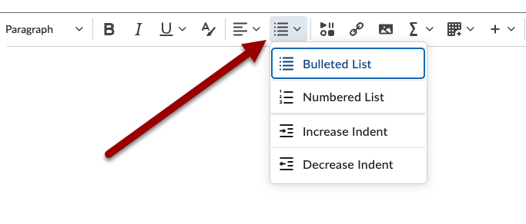

Correcting Notations
When Mathpix or LaTeX converts incorrectly into Brightspace, it usually happens because the equation delimiters (like $$, \[, or \() weren't recognized, or special LaTeX characters conflicted with Brightspace's HTML editor.
Because Brightspace has native MathJax support, you can fix these glitches quickly using either the built-in equation editor or by tweaking the underlying code.
Here is how to fix them:

Method 1: Use the Brightspace Equation Editor (Easiest)
If only a few equations are broken, you can fix them visually without looking at any code.
- Click Edit on your Brightspace page.
- Highlight or delete the broken equation text.
- On the editor toolbar, click the Graphical Equation icon (represented by a symbol).
  - Note: If you don't see it, click the ... (More Actions) button on the toolbar first.
- A drop-down will appear, so you can either
  - Select LaTeX Equation to paste your clean LaTeX code into the window. Brightspace will show you a live preview of the fixed math.
  - Select Graphical Equation to use Brightspace's built-in editor to recreate the content. Brightspace will show you a live preview of the fixed math.
- Click Insert.
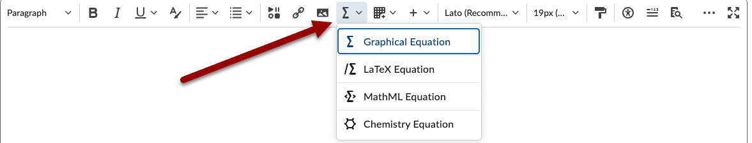
Method 2: Check the HTML Source Code (Fastest for Multiple Errors)
If your equations are completely missing or showing up as raw text (e.g., displaying code like \frac{a}{b} instead of a fraction), the HTML tags are likely broken.
- Open the Advanced Editor and click the Source Code button (</>) at the bottom or top toolbar.
- Look for your broken math. Brightspace natively recognizes LaTeX when it is wrapped in specific delimiters.
- Fix the delimiters manually:
  - For an inline equation (math inside a sentence), wrap the LaTeX in: \( ... \)
  - For a centered, block equation, wrap the LaTeX in: \[ ... \] or $$...$$
- Example of a fix:
  - Broken: $f(x) = x^2$ (Note: Brightspace sometimes ignores single dollar signs).
  - Fixed: \(f(x) = x^2\)
- Click Save to apply the fixes.

Tables
When transferring tables from Mathpix or LaTeX into Brightspace, they are notorious for breaking, shrinking, or losing their styling.
To ensure your tables are functional, visually consistent, and accessible, you should verify or add:

Table Headers
A table's rows or columns indicate the significance of the grid's data.
When a user can see the table, they can quickly form visual associations between the data and the row/column headers. When a user cannot see the table, they must use a screen reader to navigate through the cells one at a time, which means the table's column/row headers need to be properly marked to read the information accurately.
Below is a tutorial on how to set the table's headers and scope accurately.
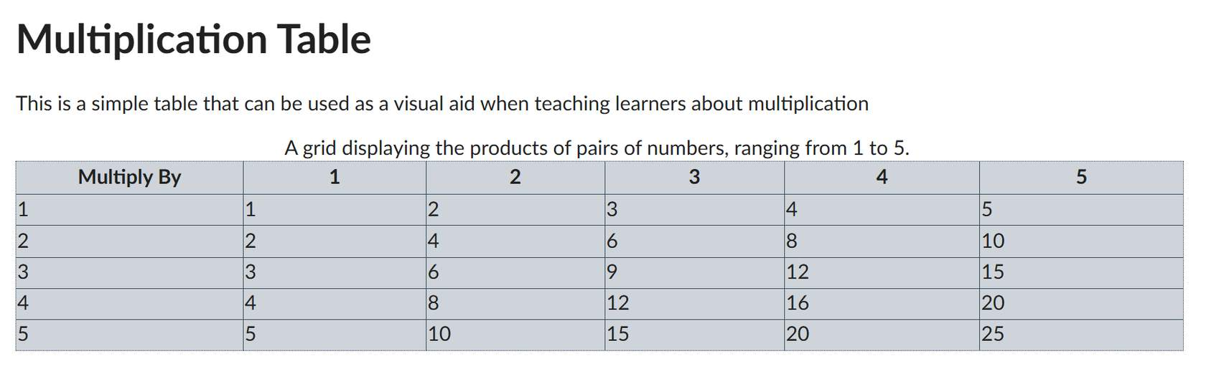

Step 1: Highlight the cell(s) of the header(s)
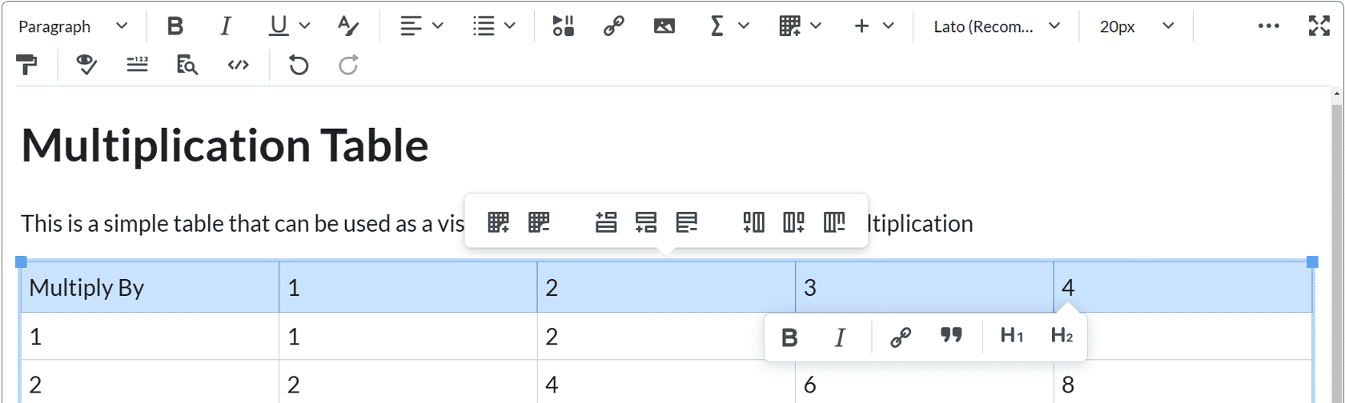
Put the cursor in the cell or highlight the cells you want to mark as a table header.

Step 2: Table icon
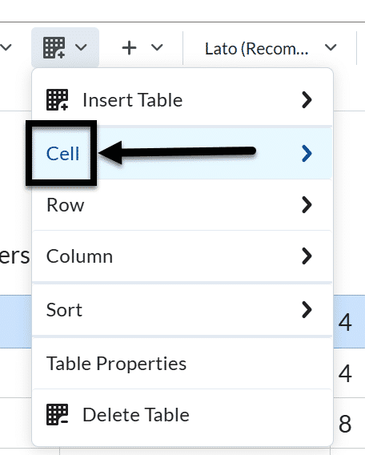
Click on the drop-down menu next to the Table icon in the Brightspace Editor, and select the Cell option from the drop-down.

Step 3: Cell properties
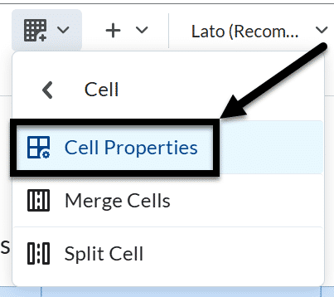
Select Cell Properties, the Cell properties window will pop-up.

Step 4: Cell Type
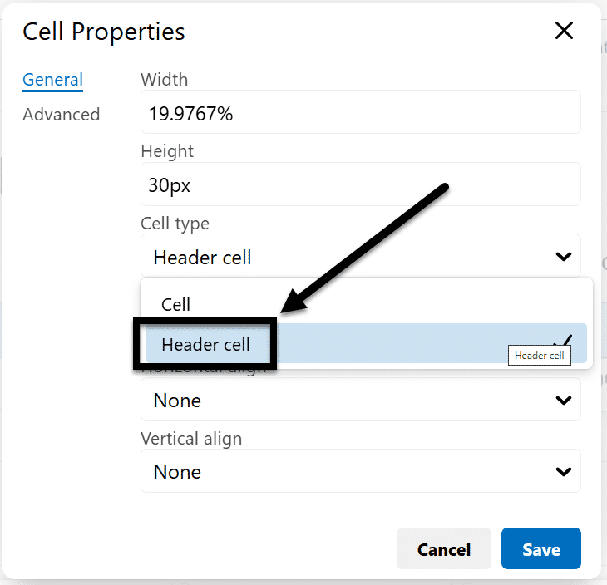
In the Cell type field, click on the drop-down list and select Header cell.

Step 5: Set the scope
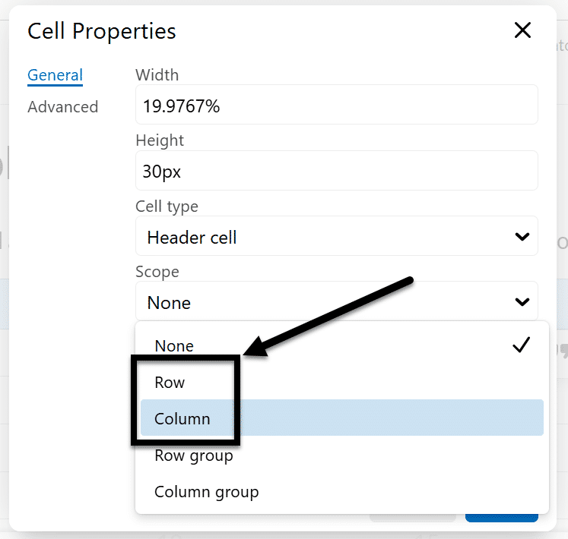
In the Scope field, click on the drop-down list, and select whether the header is for a Column or Row.

Step 6: Save and repeat as needed
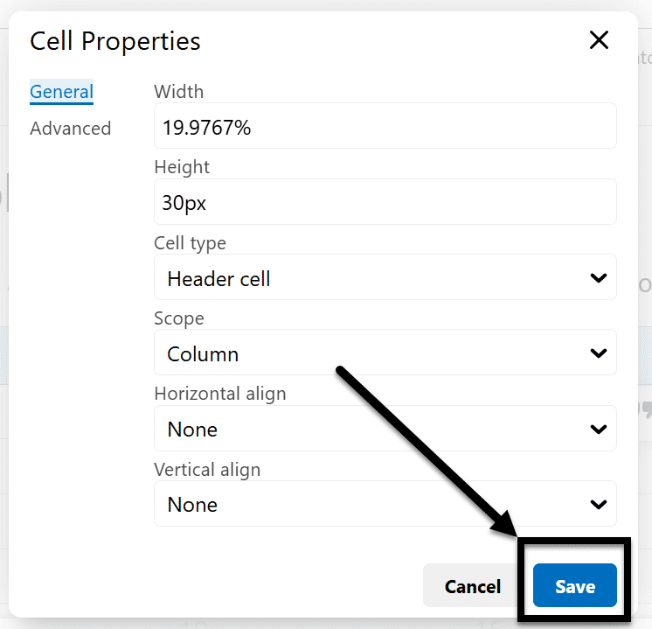
Click the Save button and repeat for each cell that is a column or row header.

Table captions
Table captions can be a good way of capturing the overall purpose of your table for all users.
Follow the tutorial below to add captions to your table using the Brightspace Editor.

Step 1: Select the table
Click on the table you want to add captions to.

Step 2: Table icon
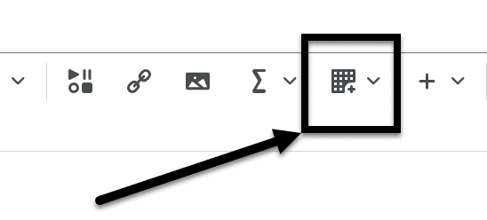
Click the Table icon in the Brightspace Editor.

Step 3: Table Properties
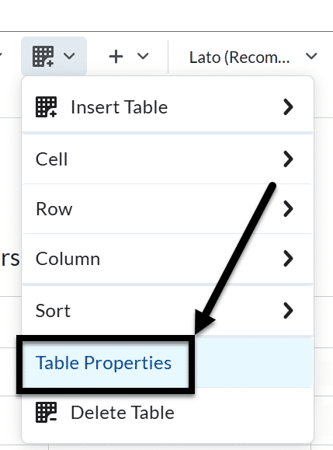
Select the Table Properties option, the Table properties window will pop-up.

Step 4: Show caption
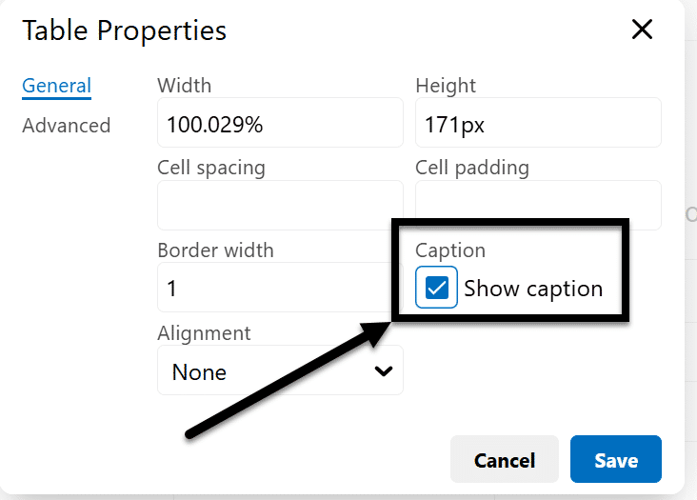
Check the Show caption box and click the Save button

Step 5: Add caption
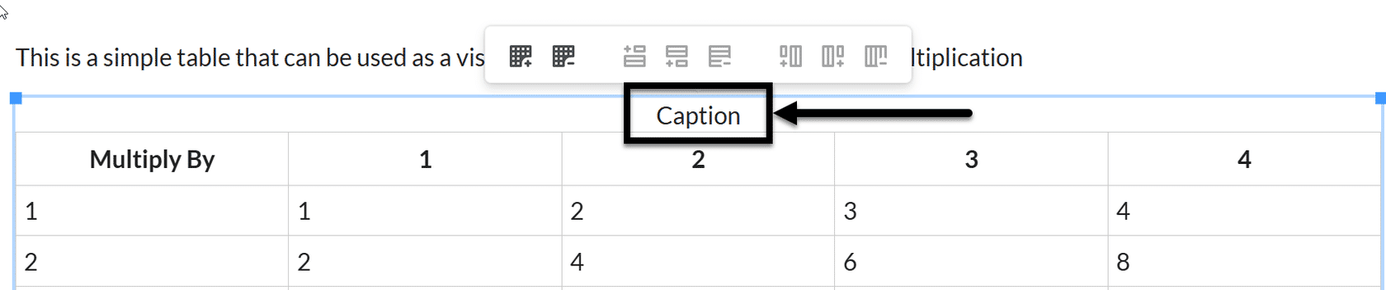
Enter your caption into the table; there’s now a placeholder in the last row for it.

Alt Text for Images
There are multiple reasons to use alt text to make your content accessible:
- Students and users who rely on screen readers depend on alt text to understand what an image represents.
- Web pages don't always load perfectly. If a student has a weak internet connection, or if there is a temporary server glitch, images may fail to load. When this happens, browsers will display the alt text in place of the missing image, ensuring that the user doesn't lose the context or the core message of the page.
If your content was originally in LaTeX and you added alt text to the images, you want to verify that the content converted to the HTML page. If the content was converted from Mathpix, alt text needs to be added for each image.
- Click Edit on your Brightspace page.
- Click directly on the image inside the text editor to select it.
- Click the Image Options button that pops up on the toolbar (it looks like a picture icon with a gear or pencil next to it).
- An options window will slide out or pop up. Look for the Alternative Text field.
- Update your description or mark it as decorative, then click Save.
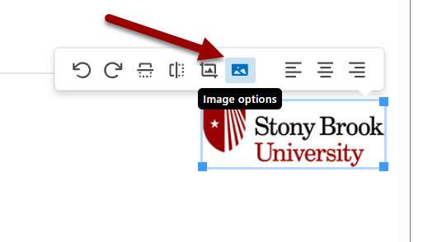
4.2. Image Options becomes available when you select any image in Brightspace.
A useful prompt when using AI is:
“Based on the PDF, can you make alt text for this image that is 125-150 characters?”
While AI tools can assist in generating accessible content, content creators are strongly encouraged to utilize university-licensed enterprise software to ensure data privacy and to verify the accuracy of output.

Final Accessibility Check
Before finalizing the document, do one last review for accessibility and readability.
Confirm the following:
- For math and chemistry-heavy content, MathML was used to render the content.
- The document title is formatted as Heading 1.
- Headings follow a logical order.
- Body text formatting is consistent (e.g., plain text is Lato 19px).
- Tables are cleanly formatted with header cells identified.
- Captions have been added to figures and tables.
- Superscripts, subscripts, equations, and special symbols are correct.
- Unnecessary blank lines have been removed.
- Alt text has been added for all meaningful images.
- The final document follows a clear reading order.
The goal is not only to make the document look like the original PDF or LaTeX content, but to make it easier to navigate, understand, and read with assistive technology.

Key Takeaways
This module explores the conversion of LaTeX and PDF documents into HTML format. Here are some key takeaways:
- Understand the conversion process. Transforming LaTeX and PDF files into HTML enhances accessibility and responsiveness.
- Utilize Brightspace tools. Employ the 'Create a Page' feature to upload and edit HTML content effectively.
- Ensure content accessibility. Adhere to formatting standards and perform checks to make content user-friendly.
By applying these principles, you can create accessible and responsive digital content.

Remediating Microsoft Word Conversions
Once Mathpix has successfully extracted your technical data, the next step is ensuring that content behaves within the exported file. While Mathpix handles the translation of visual math into digital text, Microsoft Word acts as the framework that structures that information for assistive technologies.
Exporting technical data is only half the battle; formatting it correctly ensures compliance.


Set Up the Basic Document Formatting
Before making detailed edits, start by applying consistent formatting across the document. Headings are important for accessibility because they allow assistive technology to navigate the document more easily.

Set Up the Basic Document Formatting
- Select all text in the Word document.
- Set the font to a sans serif font, 12 pt. or higher.
- Set the margins to 1 inch on all sides.
- Remove unnecessary spacing before paragraphs, if present. Use Layout> Breaks>Page (CTRL/CMD+ENTER) to create a break between pages.
- Place the cursor in the first body paragraph and adjust the paragraph indentation to the desired position.
- With the cursor still in the paragraph, go to Styles, right-click Normal, and select Update Normal to Match Selection.
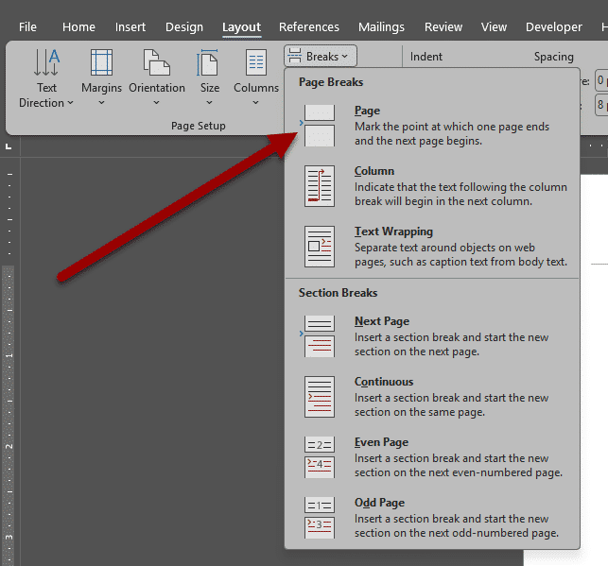

Format the Title and Author Information
Whether you're distributing course content or a professional publication, taking the time to fill out the Title and Author metadata in a Microsoft Word document adds to the readability and searchability of your document.
- Go to File>Info.
- Click into the Properties>Title field and type your document's official title.
- Go to Related People>Author field and edit the author name(s) as needed.
  - Note: Word usually defaults this to your account name. If you need to change it or add a co-author, click Add an author and type the name.
  - Tip: If you don't see the Title field immediately, click the Properties dropdown at the top of that right-hand column and select Advanced Properties to open a detailed dialog box.
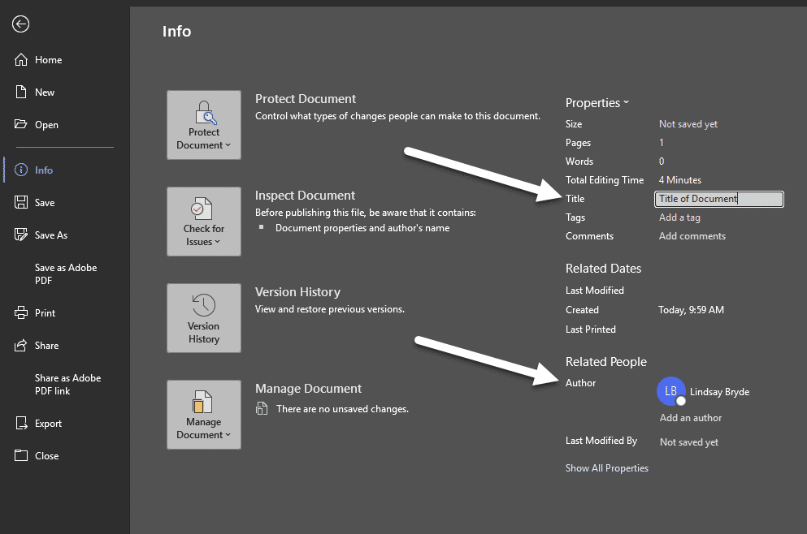

Apply Headings in a Logical Order
Headings are important for accessibility because they allow users to navigate the document more easily. They need to be programmatically set in the Home>Styles section of the ribbon (embiggening or bolding text is not sufficient for marking a heading).
The heading levels should follow a logical structure rather than only matching the visual appearance of the original document.
Suggested heading structure:
- Heading 1: Document title
- Heading 2: Major sections
- Heading 3: Subsections within major sections
- Heading 4: Smaller subsections, if needed
After formatting a heading to match the PDF, select it, go to Styles, right-click the appropriate heading level, and select Update Heading to Match Selection.
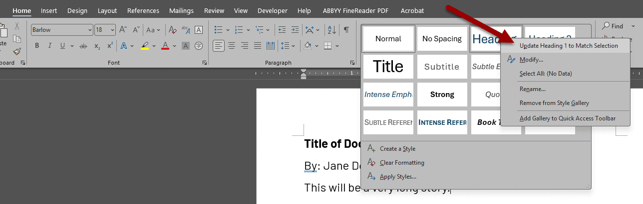

Compare the Word Document to the Original PDF
Once the main formatting and headings are set, compare the Word document carefully with the original PDF. Look for formatting issues that may have occurred during conversion.
Common issues include:
- Paragraphs that were split into two separate paragraphs because they continued across pages in the PDF.
- Extra blank lines or blank pages.
- Footnote numbers that appear as regular superscript text instead of actual Word footnotes.
- Dashes or special characters that copied incorrectly.
- Paragraphs that begin before a figure or table and continue after it.
When a paragraph is split by a table or figure, it is usually better for accessibility to reconnect the paragraph so that it reads continuously. This makes the reading order clearer for screen reader users.

Common Formatting Inconsistencies After Export
When we show up to the present moment with all of our senses, we invite the world to fill us with joy. The pains of the past are behind us. The future has yet to unfold. But the now is full of beauty simply waiting for our attention.

Fix Footnotes
PDF-to-Word conversions may not preserve footnotes correctly. Sometimes the superscript number appears in the body text, but the footnote itself is placed at the end of the document.
To fix this:
- Place the cursor where the footnote number should appear.
- Go to the References tab.
- Select Insert Footnote.
- Move the footnote text into the correct footnote location.
- Delete any duplicate or incorrectly placed footnote text.
This allows Word to recognize the footnote properly.
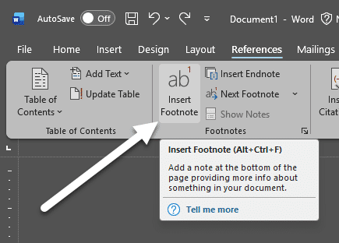

Clean Up Special Characters and Notation
Check the document for special characters that may have copied incorrectly from the PDF.
Examples include:
- En dashes, em dashes, or minus signs that appear as regular hyphens.
- Superscripts and subscripts that separate from the main word or number.
- Mathematical symbols that do not copy correctly.
- Scientific notation, chemical formulas, equations, table values, and figure labels.
These issues may need to be fixed manually. Make sure each subscript or superscript is attached to the correct word, symbol, or number rather than separated into its own empty notation.
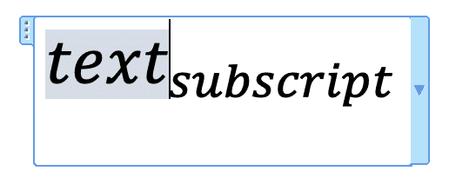

Use Dividers to Separate Figures and Tables
A divider can help visually separate figures and tables from the main body text.
To insert a simple divider:
- Place the cursor on a new line.
- Type three hyphens: ---
- Press Enter.
Word will automatically convert the three hyphens into a horizontal line. Use dividers only when they improve the organization of the document. Avoid adding too many, since excessive dividers can make the document feel cluttered.

Format the Reference Page
References often do not convert cleanly from the PDF. The spacing, numbering, italics, bolding, and line breaks may need to be corrected.
A helpful workflow is:
- Compare the references of the Word Document with the original PDF.
- Reformat the references so they match the PDF as closely as possible.
- If the references are numbered, use Word’s built-in numbered list formatting.
- Avoid recreating a two-column reference layout unless required.
When using ChatGPT for reference formatting, you can use a prompt such as:
Note: “Can you format these references in the Word document exactly as they are in the PDF and put them into the Word document? Do not put the references into two columns.”
After reviewing the output, you may need to ask for additional corrections, such as:
“Please add the bolding in the references where it appears in the PDF.”
“Please use Word’s numbered list formatting for the numbered references.”

Add Tab Stops to Format Equation Numbering
Manually typing numbers is a functional workaround in Word for equation numbers. Adding a tab stop allows you to format the number on the page consistently and accessibly. Before starting, check that the ruler is visible in Word. If it's not, go to the View tab in the ribbon and check the "Ruler" option.
- Place your cursor in the paragraph where you want to add the tab stop.
- Click on the ruler at the point where you want the tab stop to appear. A tab stop marker will show up.
- By default, clicking on the ruler sets a left tab stop. If you need a different tab type (such as right or center), click the tab selector at the left end of the ruler until you see the desired tab symbol, then click on the ruler.
- Place your cursor where you want to add the tab (i.e., where you want your equation number). Press the Tab key on your keyboard to align text to the tab stop.
- Adjust the tab stop position by dragging the tab marker left or right on the ruler until you're satisfied with the alignment.

Check the Accuracy of the Math Conversion
Converting math content from Mathpix to Microsoft Word is usually a lifesaver, but things can occasionally get lost in translation. Symbols can drop out, formatting can warp, and inline equations can suddenly turn into block equations.
To ensure your document is flawless, you need to check both the visual accuracy and the underlying structure. Here is a step-by-step checklist to verify your document:
- Look for placeholders or syntax leaks: Scan for raw LaTeX code that didn't render (e.g., matching tags like $$ or \[, or unrendered commands like \frac).
- Check alignment: Ensure equations that are supposed to be embedded within a sentence (inline math) haven't accidentally broken onto a new line (display math).
- Watch for font anomalies: Word uses Cambria Math by default for equations. If a symbol looks like a generic square ($\square$) or a completely different font, Word didn't recognize the character.
- Convert negative numbers into an Equation format: Highlight the negative number, press Insert, then Equation.
- Check for Native Math Zones: Word handles math in two distinct ways: Native Math Zones (editable OMML equations) and Images/Fields. You want native math zones for editing:
  - Select an equation.
  - Does the "Equation" tab appear in the top ribbon?
    - If yes, Word recognizes it as a native equation.
  - Does the "Picture" tab appear in the top ribbon?
    - If yes, Mathpix has exported the math as an image wrapped in an equation box. Go to Insert>Equation>Insert New Equation and re-type the equation using the equation editor.

Common Conversion Blindspots
Certain mathematical structures are notoriously prone to conversion hiccups. Pay extra attention to these elements:
Mathematical Element | What Usually Goes Wrong | How to Spot It
Matrices & Determinants | Brackets detach from the numbers, or columns misalign. | Look for clipping or numbers overlapping the brackets.
Limits & Integrals | Subscripts and superscripts () stack incorrectly or float too far away. | Check if the upper/lower bounds are correctly positioned.
Accents & Overbars | Vectors () or tildes shift to the right or left of the character. | Ensure the accent is perfectly centered over the base letter.
Multi-line Equations | Alignment points (e.g., ) break, causing the math to stagger awkwardly. | Verify that line breaks are clean and equals signs align.

Tables
Tables often convert poorly from PDFs. When reviewing your tables:
- Choose a clear table design. A simple grid table often works well.
- Check that all columns and rows are aligned correctly.
- Delete any extra columns or rows that were created during conversion.
- Avoid merged or split cells.
There are additional settings needed for making your table accessible based on its content.

Set the Table Properties.
If a table continues onto another page, the header row should repeat and not break across pages.
- Select the top row of the table.
- Go to Table Layout>Properties in the ribbon or Table Properties when right-clicking the table.
- Go to the Row tab and
  - Uncheck Allow row to break across pages.
  - Select the option to Repeat the header row across pages.
This makes the table easier to understand when it spans multiple pages and improves readability.
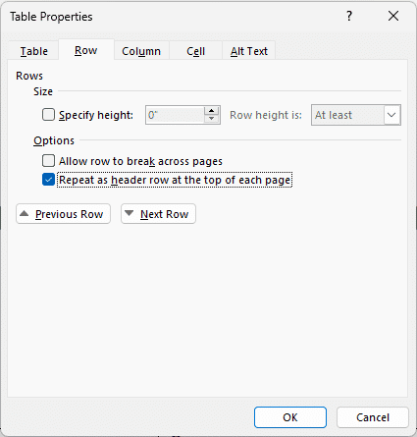

Use Landscape Orientation for Wide Tables
Some tables are too wide for portrait orientation. In those cases, use a landscape page for that table only.
To make one page landscape:
- Place the cursor before the wide table.
- Insert a section break, go to Layout>Breaks>Next Page to start a new section.
- Change the orientation of that section, go to Layout>Orientation>Landscape.
- After the table, insert another Next Page section break.
- Change the following section back to Portrait.
This allows only the table page to be landscape while the rest of the document remains portrait.
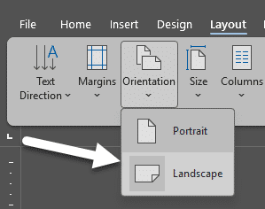

Keep Figure and Table Captions Together
Figure and table titles or captions may separate from the image or table when the document moves across pages. To keep them together:
- Select the figure or table title and caption.
- Right-click and select Paragraph.
- Go to Line and Page Breaks.
- Select Keep lines together.
You may also need to use Keep with next if you want the caption to stay with the table or figure that follows it.
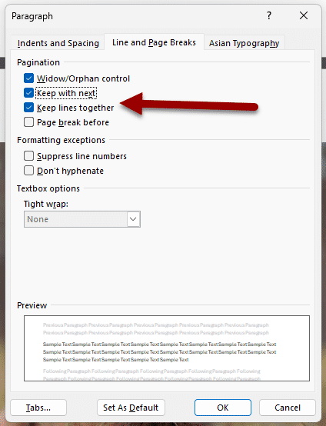

Alt Text for Images
Images, graphs, schemes, and figures should include alt text so that users with screen readers can understand the important information.
When writing alt text:
- Identify the main purpose of the image.
- Describe the important information clearly and briefly (125-150 characters max).
- Avoid unnecessary visual details unless they are important.
- Mention trends, labels, or comparisons if they are central to the figure.
- Do not begin with “Image of” or “Picture of” unless needed for clarity (e.g., what type of image or picture is being displayed).
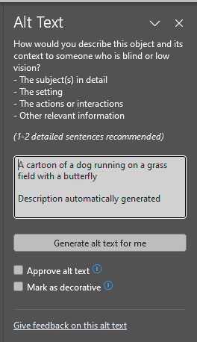
For complex figures, it may be helpful to separate the figure into individual panels and write alt text for each panel.
A useful AI prompt is:
“Based on the PDF, can you make alt text for this image that is 125-150 characters?”
While AI tools can assist in generating accessible content, content creators are strongly encouraged to utilize university-licensed enterprise software to ensure data privacy and to verify the accuracy of output.

Arizona State Image Accessibility Generator
Upload images through the Arizona State Image Accessibility Generator and it will provide alt text and longer descriptions that you can add and edit in your documents.
Note: The site notes that "This tool currently utilizes the GPT-4o model provided by OpenAI. We are using their API platform, which ensures the data sent is not retained or stored to improve their training or models."

Final Accessibility Check
Before finishing, review the document one more time for accessibility and readability.
- Equations have all been converted to MathML/equation formatting.
- The title is the only Heading 1.
- Headings are applied in a logical order.
- Body text is consistent.
- Tables are formatted cleanly.
- Table headers repeat across pages when needed.
- Rows do not split awkwardly across pages.
- Figures and captions stay together.
- Footnotes are properly inserted using Word’s footnote tool.
- Superscripts, subscripts, equations, and special symbols are correct.
- Blank pages and unnecessary blank lines are removed.
- Alt text has been added for all meaningful images.
- The final document follows a clear reading order.
The goal is not only to make the document look like the original PDF, but also to make it easier to navigate, understand, and read with assistive technology.

Key Takeaways
Here are some key takeaways:
- Ensure consistent formatting. Apply uniform styles throughout the document for improved accessibility.
- Utilize logical heading structures. Organize headings hierarchically to aid navigation for assistive technologies.
- Verify mathematical content and tables. Confirm their accuracy and proper formatting post-conversion.
By following these guidelines, you can create accessible and well-structured documents.

Conclusion
You have completed the Converting STEAM Content for Accessibility guide!
Please fill out the following Feedback Survey form to record your completion of this guide and to provide feedback for improvements.

