Closed Captioning and Transcription with YouTube
By: Lindsay Bryde
Table of Contents
How Videos Improve the Learning Experience 1
Why Transcripts and Closed Captions Matters 2
Adding Captions to YouTube Videos 3
Adding captions while uploading a new video 3
Editing generated and manually added captions 6
Best Practices for Editing Transcripts/Captions 8
“Pause while typing” 8
Listen carefully 8
Keep captions short 8
Avoid filler words 8
Use proper punctuation 8
Spell check in context of the dialogue 8
Track speakers 8
Add tone and visual cues 8
Additional Resources 9
Learn More About Document Accessibility 9

How Videos Improve the Learning Experience
Using videos in a course can significantly enhance engagement and comprehension. Videos provide a dynamic and visual way to present information, making complex concepts easier to understand through animations, demonstrations, and real-life examples.
Embedded videos can be paused and replayed, allowing learners to review material at their own pace. This flexibility helps reinforce learning and retention, making videos a powerful tool in educational settings.
Important: Do not share content that contains blinking or flashing. It can cause seizures in individuals with photo-sensitivity.

Why Transcripts and Closed Captions Matters
Transcripts and closed captions ensure content is accessible for individuals who are deaf or hard of hearing, allowing them to fully engage with what's being shown. They can also aid in comprehension for non-native speakers and those with learning disabilities.
Transcripts are a written document with the audio content of a video and descriptions of any visuals displayed on screen. They do not break down the timing of when certain actions take place or when certain words are spoken.
Closed captions are when the content of a transcript is chunked out based on the video's timing. They can enhance the viewing experience in noisy environments where audio might be difficult to hear (e.g., a big lecture hall).
Overall, transcripts and closed captioning promotes inclusivity and ensures that video content is accessible to a broader audience.
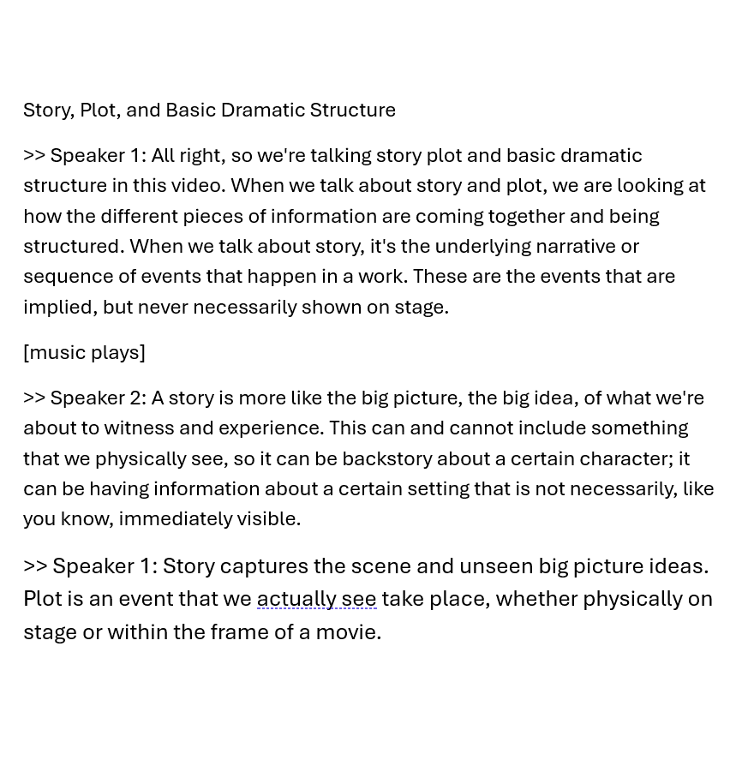
Figure 1 A sample transcript noting which speakers are saying what and when any non-verbal cues begin in brackets.
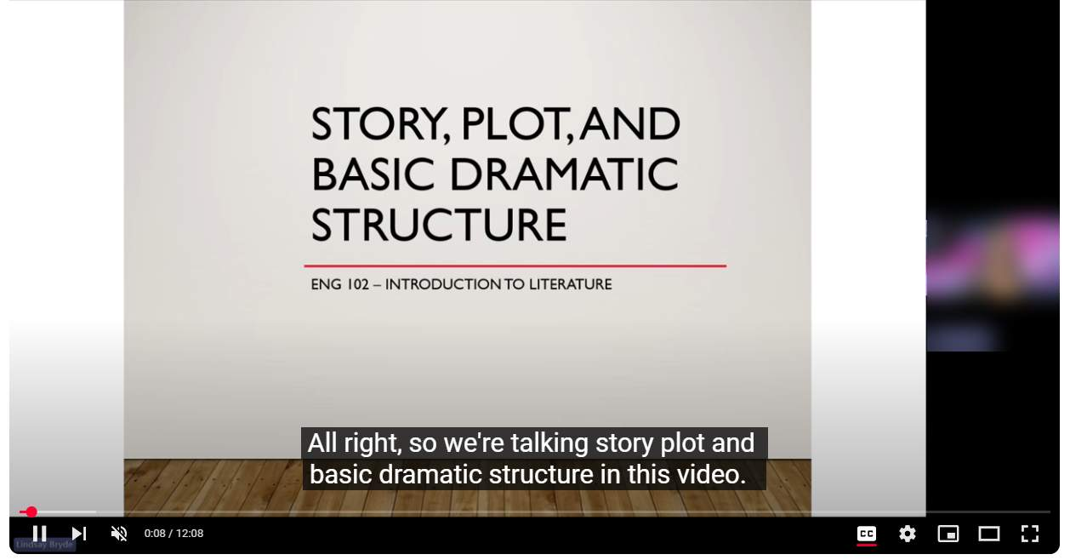
Figure 2 A YouTube video is playing, the Closed Captions are turned on, and white text of what's being said in a black box appears over the video content at the bottom of the screen.

Adding Captions to YouTube Videos
YouTube provides automatically generated captions using their speech recognition technology (SRT). This can be a good tool for getting an initial pass on your captions, but SRT is not fully accurate and does need to be manually reviewed/checked to ensure it's sufficiently accurate. Recordings need to be at least 98% accurate to be considered accessible.
Additional options are to manually create your own transcripts and subtitles/captions, or upload a file if you have one already created.

Adding captions while uploading a new video
Whether you're manually creating your own captions or uploading a file you've already created, it's a simple process to add them during the upload process.

Step 1: Upload the video
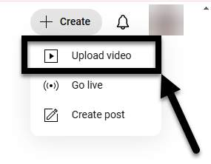
Figure 3 The Create drop-down is displayed and the Upload video option is noted with an arrow.
Click the Create button in the upper-right corner of YouTube, and select the Upload video option from the drop-down.

Step 2: Select the video
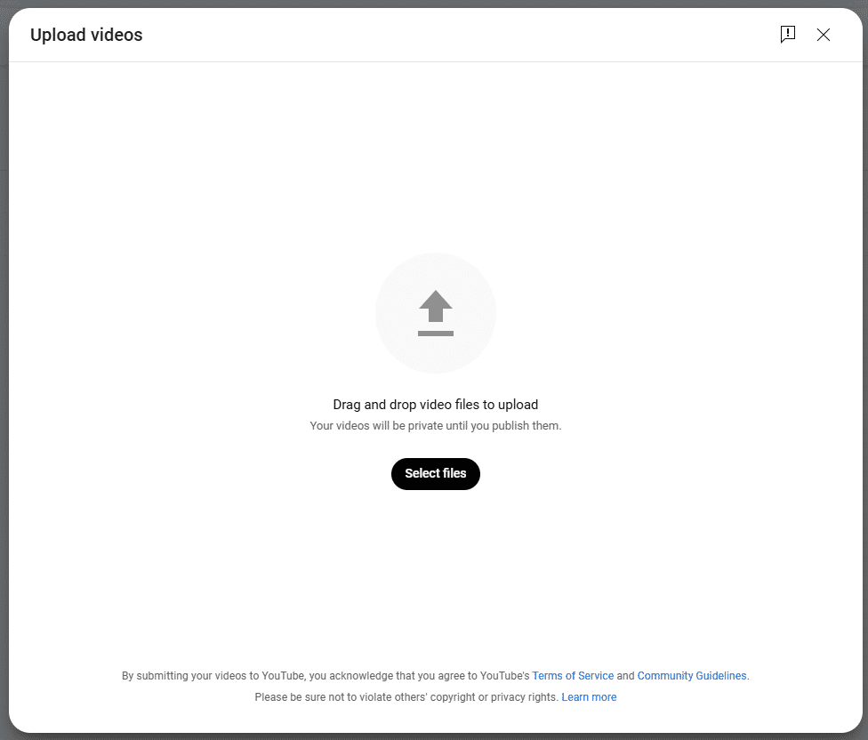
Figure 4 The file picker has options to drag and drop videos and to select files.
Use the file picker to select the video.

Step 3: Provide video information
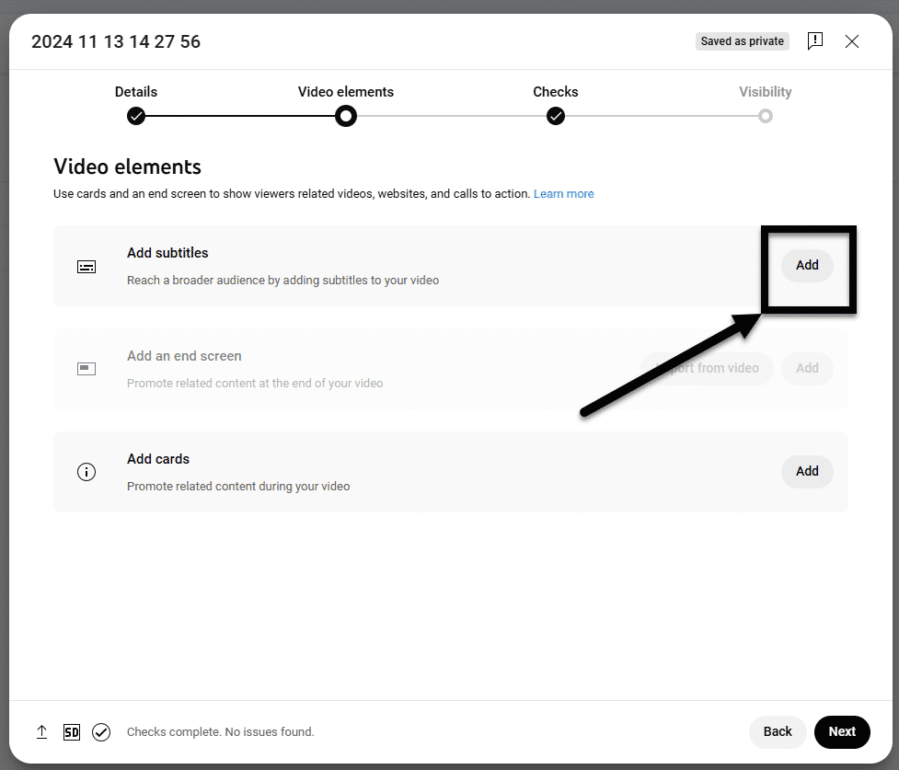
Figure 5 The Video Details section of the upload process, and the Add button is noted next to "Add substitles."
Under Details, provide the video's title, a brief description of the content, the audience. Under Show more, select the video's language (this is required to manually create or upload captions) and provide the caption certification information (i.e., whether your video has ever aired on U.S. television and if it falls under guidelines provided by the FCC).
Under Video Elements, click Add next to the Subtitles option. Next, choose from one of the options to add your subtitles and captions: type manually, auto-sync, or upload a file.

Step 4: Add the captions
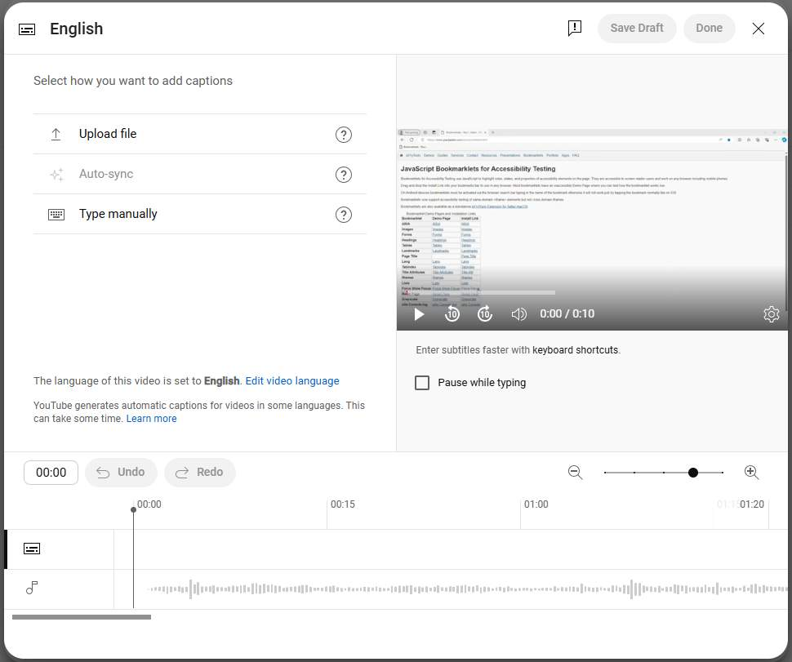
Figure 6 The caption editor in YouTube, showing you the options to add subtitles by video upload, type manually, or auto-sync.

For Type Manually:
Play the video and enter your captions. Note, you can pause while typing.
Select Publish.

For Auto-sync:
You can manually add your captions or upload a transcript, and then set the timing to sync with your video.
Enter the words in the video or upload a transcript file.
Select Edit, then click Save and Close.

For Upload a File:
Choose between "With timing" or "Without timing," then select Continue.
Choose a file to upload with the file picker.
Select Save.

Summary: How to Add Captions While Uploading & Editing Your Videos
Congratulations, you've successfully added your captions to the file. If you realize there's something you missed the first time, you can always go back to edit later.

Editing generated and manually added captions
There are simple steps to checking and editing existing or automatically generated captions.
A good way of estimating how long, automatically generated captions take to display for editing is at least two minutes for each minute of the video (e.g., it'll take 30 minutes for the captions to appear for a 15-minute video).

Step 1: Find your video
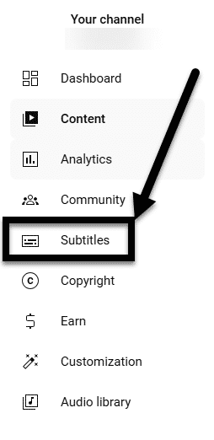
Figure 7 The Subtitles option under the YouTube studio is noted with an arrow on the left-hand side of the screen.
Sign in to YouTube Studio(opens in a new tab) and select Subtitles from the menu on the left-hand side of the screen. Next, click the video you’d like to edit.

Step 2: Find the language/set of captions that need editing
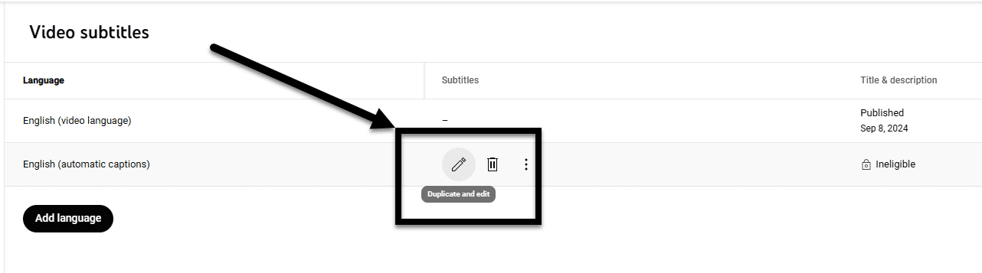
Figure 8 The Video Subtitles of a video are listed, the Duplicate and edit button is noted with an arrow for one set of automatic captions.
Find the language you'd like to edit, hover over the details under "Subtitles" select Duplicate and Edit.

Step 3: Edit the captions and timings
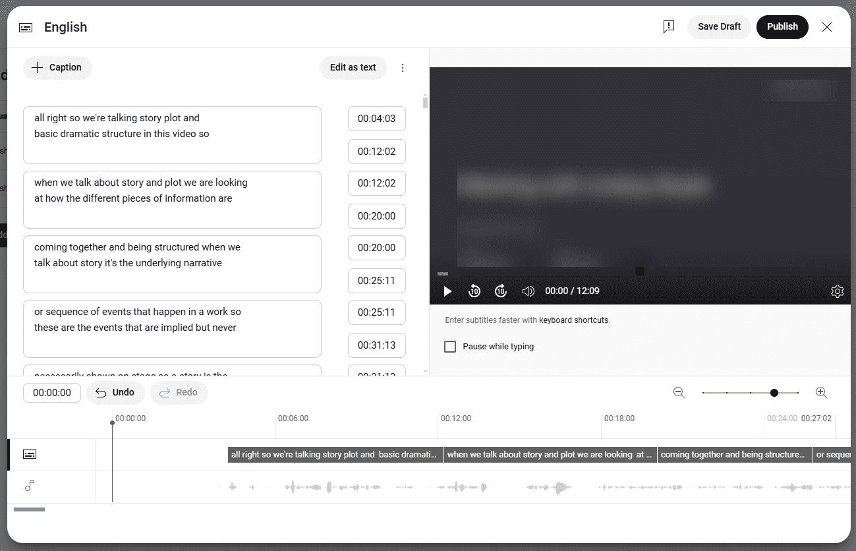
Figure 9 The Edit timings window is open. The captions are listed on the right-hand side of the screen, broken into short ten to fifteen second increments. The left-hand side contains a player to watch the video while editing. The bottom of the screen has a time
To edit the caption text, click inside any line in the caption track panel.
To edit the caption timings, select a specific line in the caption track panel and adjust the two timestamp boxes beside the caption track. The box at the top is the start time, and below it is the end time.

Save your work
Don't forget to click Publish to save your edits. Note, closing the window without clicking Publish will erase your work.
Warning: If you edit or remove automatically generated captions from a YouTube video, they cannot be reverted back, turned on, or retrieved.

Best Practices for Editing Transcripts/Captions

“Pause while typing”
Check the "Pause while typing" box to have the audio play when you're not typing. It will automatically pause when you start typing to edit your content and it resumes when you've stopped typing.

Listen carefully
Play the video while editing to ensure you capture the exact words spoken.

Keep captions short
Limit captions to 20–30 characters per second.

Avoid filler words
Eliminate unnecessary fillers like "um," "uh," and "you know" unless they add value to the content (i.e., you need to show how lost or awkward the conversation is).

Use proper punctuation
Ensure correct punctuation for better flow and comprehension.

Spell check in context of the dialogue
Check the context of words to ensure the accurate word is displaying (e.g., SUNY versus sunny).

Track speakers
When you have more than one speaker, you want to identify each of them.
You can do this by:
- Adding their names (if known), or
- Identifying them with numbers of letters (e.g., Speaker A or Speaker 1).
- You want to put two more than signs >> before the name of a speaker when there is a shift.

Add tone and visual cues
Notes about tone and visual cues in video transcripts provide a comprehensive understanding of the content.
Tone indicators, such as noting when someone is speaking sarcastically or emotionally, help convey the speaker's intent and nuances that might be lost in text alone. Visual cues, like describing significant gestures, facial expressions, or on-screen actions, ensure that viewers can fully grasp the context and subtleties of the video.
In the transcript, non-verbal cues should be placed in brackets.
Examples:
[angrily] How dare you.
[bird chirping] What was that?
[music starts] Want to dance?

Additional Resources
Learn more about the advanced transcription and closed captioning settings from YouTube.

Learn More About Document Accessibility
For more information about document accessibility, please reach out to CELT by emailing celt@stonybrook.edu.
To view additional tutorials and resources, visit CELT's Accessibility page.

Figure 10 Stony Brook University's logo

