Basic PDF Accessibility
By: Lindsay Bryde
Table of Contents
Welcome 2
Learning Objectives 2
Note on links 3
Note on course attribution 3
New to Accessibility? Let's Get Started 3
Key Terms: Adobe, Acrobat, and PDF 4
Knowledge Check 1: New to Accessibility? Let’s Get Started 4
Start with an Accessible Document 5
Knowledge Check 2: New to Accessibility? Let’s Get Started 5
Congratulations 5
PDF Accessibility Repair Workflow 6
Brief PDF Accessibility Overview 6
Key Tools to Get Started 7
Hierarchy of Tasks 7
Knowledge Check 2: PDF Accessibility Repair 13
Congratulations 13
Accessibility Checker Results & Remediations 14
Adobe's Accessibility Checker 14
Running Your First Accessibility Check 14
Knowledge Check 1: Accessibility Checker Results & Remediations 17
Accessibility Checker Results Key & Limitations 17
Knowledge Check 2: Accessibility Checker Results & Remediations 18
Needs Manual Check 18
Common Issues in the Results 20
Saving the Accessibility Report to the PDF 22
Congratulations 23
Conclusion 23
Knowledge Check Answer Key 24
Knowledge Check 1 Answers: New to Accessibility? Let’s Get Started 24
Knowledge Check 2 Answers: PDF Accessibility Repair Workflow 24
Knowledge Check 3 Answers: Accessibility Checker Results & Remediations 24


Figure 1 Stony Brook University Logo

Welcome
In this self-paced guide, we provide guidance and introductory instructions to help make PDFs and scanned images more accessible. There are many elements that go into making content accessible; this guide is not exhaustive. This is a good starting point for making basic documents accessible.
It is recommended that you review our training "Picking the Most Accessible Format for Your Content: PDF, Word, PowerPoint, or a Brightspace Page" to ensure that a PDF is the best format for your content.
The estimated time to complete this course is 20 minutes.

Learning Objectives
By the end of this guide, you will be able to
- Describe resources and tools related to accessible PDFs.
- Recognize when to remediate a PDF document and how to best develop and edit content the original document (if available).
- Prepare a PDF for an accessibility check.
- Execute an Optical Character Recognition (OCR) and edit the content of a scanned/image-based PDF.
- Interpret accessibility report and complete remediations based on recommendations.
- Conduct manual testing for logical reading order and color contrast.
Ready to Begin? There are two ways to navigate:
- If you are brand new to PDF Accessibility, please start with the module "New to Accessibility? Let's Get Started"
- If you have some PDF Accessibility experience, and there are specific sections you need to review, please select the specific module(s) you need from the list below.
For more information about document accessibility, please reach out to CELT by emailing celt@stonybrook.edu (opens in a new tab)(opens in a new tab).
If you come across an accessibility barrier in this guide, please let us know by emailing celt@stonybrook.edu (opens in a new tab)(opens in a new tab).

Note on links
All links in this course open to a new tab.

Note on course attribution
This course has been adopted from San Diego Mesa College's PDF Accessibility (Self-Paced) course(opens in a new tab), licensed under a Creative Commons Attribution 4.0 International License(opens in a new tab). San Diego Mesa College adopted their training from PDF Accessibility by CCC Accessibility Center(opens in a new tab), licensed under a Creative Commons Attribution 4.0 International License(opens in a new tab). Development of this course was funded by a grant from the California Community Colleges' Chancellor's Office. *Our version of this course has been condensed and it reflects Adobe Acrobat's current navigation and features (as of 2024), Stony Brook University's services, and Learning Management System.

New to Accessibility? Let's Get Started
Welcome!
Do you need an accessible PDF?
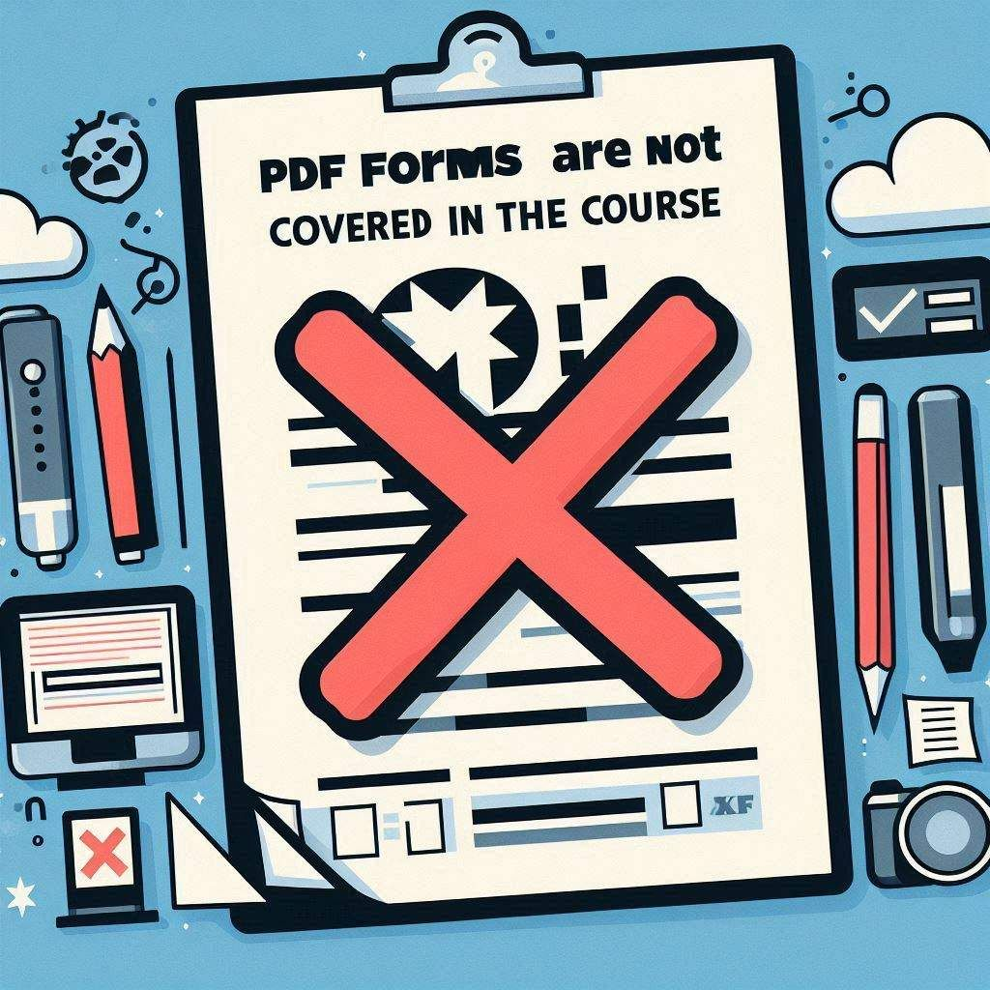
Figure 2 A warning sign stating "PDF Forms are not covered in the course."
You've come to the right place: this self-paced provides guidance on how to prepare and run an accessibility check of a basic PDF.
Due to the complex nature of PDF Forms and scanned images (e.g., a photocopy of a textbook), how to make accessible forms and scanned images will not be covered in this course.
Please check in with the Center for Excellence in Learning and Teaching for support and resources.
By the end of this module:
- Recognize the differences between key resources and tools for PDF accessibility.
- Select the best authoring tool for accessible content that will be distributed in a PDF format (e.g., MS Word, PowerPoint, InDesign).

Key Terms: Adobe, Acrobat, and PDF
Before we get started, it is essential we distinguish between three key terms: Adobe, Acrobat, and PDF. While you may have heard them used interchangeably in the past, they are quite different when we begin discussing PDF accessibility. The terms Adobe, Acrobat, and PDF are related in the same way as Microsoft, Word, and doc.
- Adobe: The company that created the software Acrobat.
- Portable Document Format (PDF): A type of document created by Adobe.
Adobe Acrobat Reader: A tool for viewing and printing PDF files.
- Adobe Acrobat Standard: A tool for viewing, adding content (like a signature), and printing PDF files.
- Adobe Acrobat Pro A tool for creating, editing, viewing, and printing PDF files; it contains tools to make PDFs accessible.
Source: WebAIM PDF Accessibility(opens in a new tab).
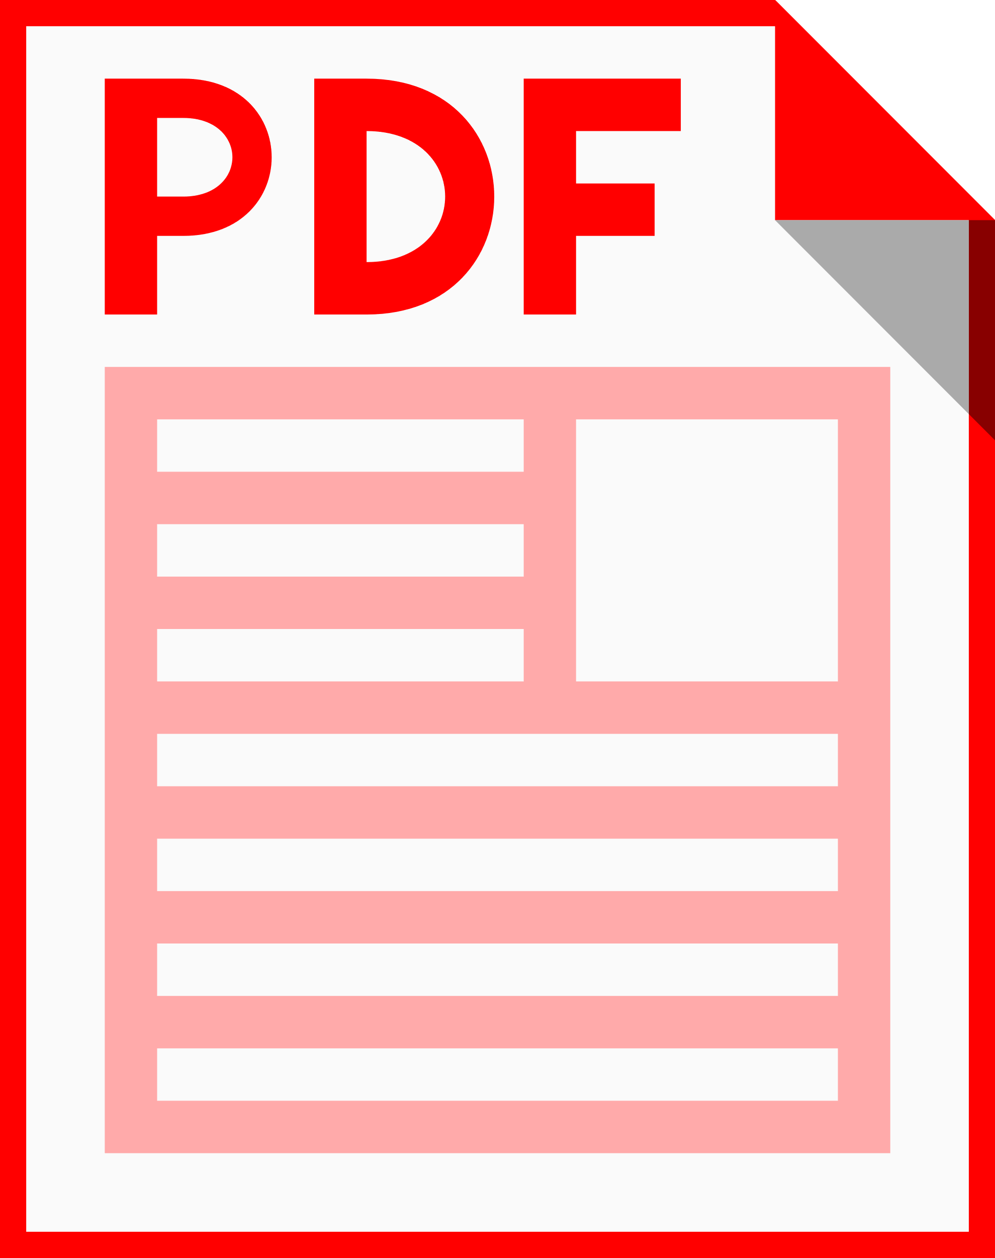
Figure 3 A red PDF file icon.

Knowledge Check 1: New to Accessibility? Let’s Get Started
Answer the following questions to self-check your knowledge (answers are at the end of the document).
- What is the relationship between Adobe, Acrobat, and PDF? (Select one of the following.)
  - Adobe is a type of document, Acrobat is a company, and PDF is a tool
  - Adobe is a company, Acrobat is a tool, and PDF is a type of document
  - Adobe is a tool, Acrobat is a type of document, and PDF is a company
  - Adobe is a document format, Acrobat is a company, and PDF is a tool

Start with an Accessible Document
Adapted from Adobe Acrobat Pro DC – Introduction to Accessible PDFs, Rob Haverty, Senior Product Manager, Document Cloud Accessibility

Creating an accessible source document
Choosing an accessible authoring program can simplify your PDF accessibility workflow.
If you originally developed your content in another document type (e.g., Microsoft Word, Google Docs, InDesign), it will be a lot easier to edit and tag the original document, and save you time when it comes to remediating the PDF version of the content. You want to use the following built-in resources these applications have:
- alternative text for images
- headings levels
- built-in lists (numbered and bulleted)
- descriptive and meaningful URLs
- creating accessible data tables
- setting a logical reading order for graphics and presentations
If the source document is unavailable, in most cases, the document can still be made fully accessible. However, it will take significantly longer and more manual work is required in Acrobat Adobe DC to ensure the PDF is accessible.
In many instances, it is easier to copy and paste content from an inaccessible PDF into a Microsoft Word doc, apply all accessibility principles, then export as a PDF into Adobe Acrobat DC.
If you absolutely need to remediate a scanned PDF, we'll review the steps in the PDF Accessibility Repair Workflow module.

Knowledge Check 2: New to Accessibility? Let’s Get Started
Answer the following question to self-check your knowledge (answers are at the end of the document).
- When is it best to develop accessible content in a different authoring tool before exporting to a PDF? (Select one of the following.)
  - When the content includes lots of images and alt text
  - When the content includes complex math equations
  - Every time

Congratulations
You completed the New to Accessibility? Let's Get Started module!
In this section, you learned about the background of PDF accessibility basics. Can you...
- Distinguish between the software available to create an accessible PDF?
- Select the best tool to develop your content accessibly?
Before you continue, make sure you answer the questions above! If you need additional support on any of the bullet points above, please review this module.

PDF Accessibility Repair Workflow

Brief PDF Accessibility Overview
This module describes the overall process of preparing accessible PDFs.
Various types of PDFs you will encounter include:
- scanned image-based PDFs (that do not have searchable text)
- text-based PDFs (that have searchable text but no tags)
Whenever possible, accessibility should be incorporated directly into a word-processing document. This lessens the repair workload required in Adobe Acrobat Pro.
It is significantly more work and time-consuming to remediate in Adobe Acrobat Pro than it takes in Microsoft Word. For example, if changes are only made in the PDF and not in Microsoft Word, a lot of accessibility work will need to be done each time in Adobe Acrobat Pro if the document is updated.
Use the following steps as a guide to help prepare a PDF for an accessibility check. This module is meant to lay down the foundation of what you need to know.
At the end of this module, you should be able to:
- Describe how to approach the different type of PDFs based on whether the PDF is image or text-based.
- List the steps to prepare a PDF for an accessibility check.
- Apply the steps to prepare a PDF for an accessibility check.

Key Tools to Get Started
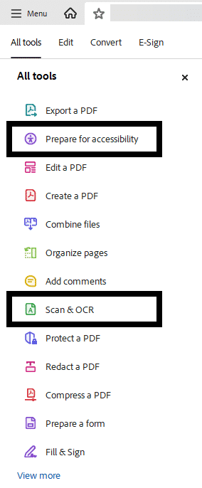
Figure 4 The All Tools pane is open and the "Prepare for accessibility tool" and the "Scan & OCR tool" are noted with a black box around them.
Before you can begin the repair workflow, you should move these two tools up in your All Tools pane.
These will help in preparing and remediating accessible PDFs:
- Prepare for accessibility
- Scan & OCR

Hierarchy of Tasks
The first thing authors need to understand is the hierarchy of tasks. You need to know what is contained in your document so you know how to convert it and in what order to proceed.
There are five steps to this process.

Step 1: Is the PDF Text-Based?

Figure 5 A woman reading a document on a computer that contains images and text.
A common method for making PDF documents is to place a paper copy of a document into a scanner and view the newly scanned document as a PDF with Adobe Acrobat.
A text-based PDF allows the use of copy-and-paste text selection and searching for keywords. Text PDF files are much smaller than scanned PDF files. To create a text-based PDF document, create the document normally in your word processor, and export as a PDF.
Unfortunately, scanners only create an image-based PDF or an image of text, not searchable and editable text; the content is not accessible to users who rely on assistive technology. Additional modifications must be made to make the document accessible.
How to determine if a PDF is a scanned document
There are many ways to determine if a PDF file originated from a scanned page.
Sometimes sheets are not properly fed into the scanner. The result is the page appears to be crooked or skewed on the screen. Lines of text will not be straight but will appear to slant up or down.
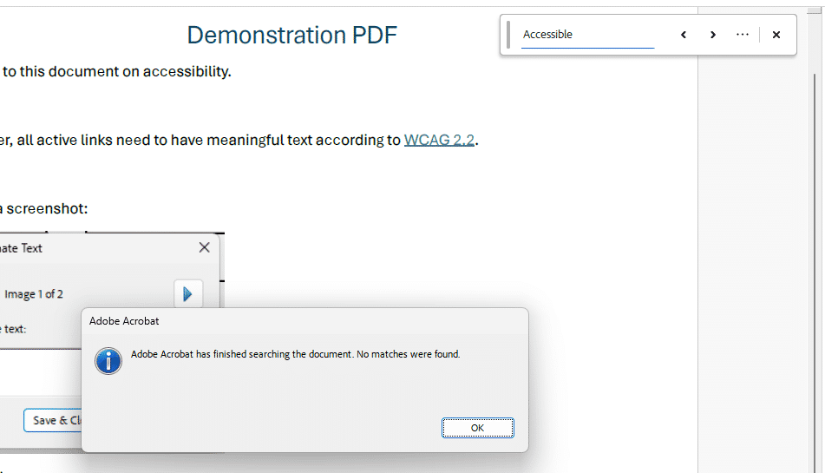
Figure 6 The search field in Adobe Acrobat Pro DC has a term entered and a dialog box is stating that there are no matches found in the document.
If lines of the text are straight, you'll need to search for characters that appear on the page.
Use the Find command in Acrobat to search for text that appears on the page.
Click the Find text or tools icon (a magnifying glass) in the upper-right corner of Adobe Acrobat, a search field will appear, and type in a word that appears on the page in the search field.
If the PDF is text-based, Acrobat will highlight all instances of the word/characters you searched for in the document. You'll be able to move onto Step 2 without any additional action.
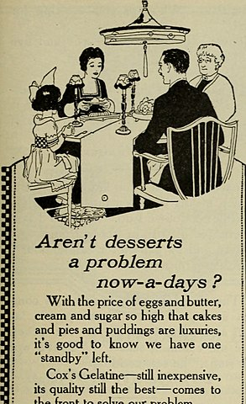
Figure 7 A scanned image of a family sitting to dinner from the Internet Archive Book Images, No restrictions, via Wikimedia Commons
If the PDF is image-based, Acrobat will not be able to complete a word search. If the word search fails, a message will appear: “Acrobat has finished searching the document. No matches were found.”
Before moving to Step 2, you will need use Adobe Acrobat DC's Scan & Optical Character Recognition (OCR) tool to remediate your PDF.
Please note that Adobe's Adobe Acrobat DC's Scan & OCR tool is limited, and not always effective. It is highly recommended to use a dedicated OCR tool, or if possible, find the original source document.

How to Use the Scan & OCR tool for image-based PDFs
Perform Optical Character Recognition (OCR) to convert the bitmap image of text to actual characters.

Step 1: Open the Scan & OCR tool
Go to the All Tools menu and select the Scan & OCR tool, the panel will open on the left-hand side.

Step 2: Set the language of the document
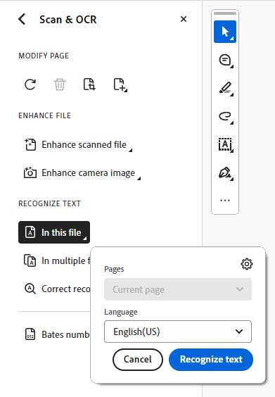
Click the In this file option to review your settings:
- Select if you want a specific page scanned. All pages is set by default.
- Select the language of the document. English is set by default.
Click the Recognize text button.

Step 3: Check that all the content scanned accurately
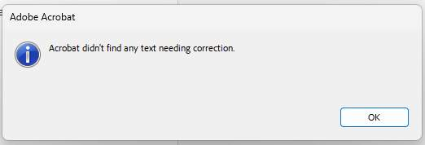
Select the Correct recognized text option. A dialog box will display to either:
- show you any text that the system needs you to verify is accurate, or
- notify you if there if there is no text that needs to be corrected.
Summary
You've successfully scanned your image-based PDF and checked that all text is now searchable. It's time to move on to Step 2 in the Hierarchy of Tasks.

Step 2: Does the PDF Contain Links?
Links allow users to quickly move to another part of a document, to related information in a different document, or to the desired website. For URLs to be accessible to users of screen readers, they must be converted to active links and be correctly tagged in the PDF file.
If the document was tagged during conversion from a word-processing application to Adobe PDF, the links in the document are most likely active and included in the tag tree.
The links should be verified and any additional links added to the document must follow this process to ensure access.
Creating links in Adobe Acrobat Pro
- By default, the selected text for each link becomes the link text.
- If the document is tagged, the proper link tags will be added in the appropriate place in the structure tree.
- If the document is not yet tagged, the appropriate link tags will be generated when the document is tagged.
Be Careful...
- Automatically detected URLs in PDF documents are not accessible.
- The General Preference option, “Basic tools: Create Links from URLs” does not allow users of the keyboard-only or screen readers to access a link. This option must not be relied upon for ensuring access to links.
- Creating links with Acrobat Standard does not generate any tags for the links; you need Acrobat Pro.

Step 3: Does the PDF have multimedia?
If there are videos or any multimedia (e.g., audio files), you need to host that content on an HTML page or on Brightspace (e.g. Create a File). This will allow anyone to view your content without requiring additional steps to access your PDF content.
Warning: If you're seeing a PDF that was created prior to 2020 and it contains Flash Player content, it is no longer supported by Adobe. For more information, see Flash Player end-of-life(opens in a new tab).
Help your audience focus on your content, rather than trying to access your content by using a different delivery method or a combination of different modalities to convey content.

Knowledge Check 1: PDF Accessibility Repair
Answer the following question to self-check your knowledge (answers are at the end of the document).
- What is the best way of making a PDF with multimedia content accessible? (Select one of the following.)
  - Host the content on an HTML webpage and provide a link to it in the PDF so anyone can access it
  - Add alternate text to the media with a transcript of the content
  - Run the Accessibility Full Checker
  - Tag it as a Figure

Step 4: Does the PDF have Tags?
There are two ways to accomplish this:

Option 1: Check Document Properties
This option is the most efficient way to check for tags. Document Properties can also indicate if the PDF is tagged. Anywhere on the PDF, right-click > Document Properties.
Alternatively, on the keyboard: CTRL (for Windows) or CMD (for Mac) + D
Under the Advanced options, you'll see a Tagged PDF section noting whether
- Yes (the PDF is tagged and you can move to step 5) or
- No (the PDF is not tagged and you need to take this step before moving to step 5).
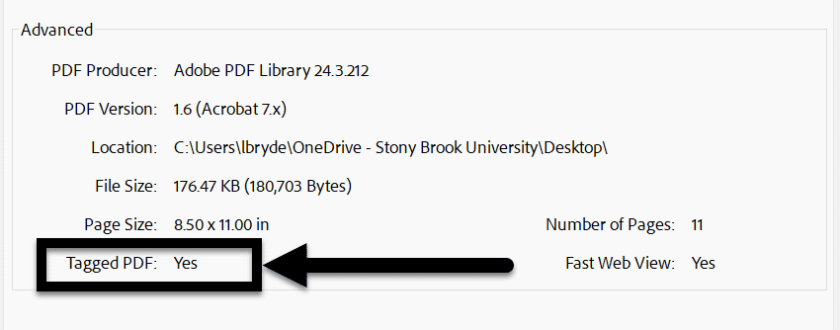

Option 2: Use Accessibility tags Panel to view tags
- To open the Tags panel, select View > Show/Hide > Side Panels > Accessibility Tags.
- Examine the Accessibility tags panel.
  - A tagged document will show tags and a structure tree descending from the root node. To fully expand the entire tree, Control + click on the root node labelled “Tags.” This means you're ready to move to Step 5.
  - An untagged document will display the words “No Tags Available” as its root and no structure tree will appear. This means, you need to tag your document before moving on to the next step.
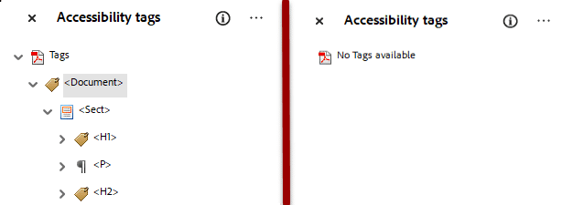
No tags? Add them from the Prepare for Accessibility tool
- Open the Prepare for accessibility tool.
- Select the Automatically tag PDF option to add tags to the document. If tags already exist, you will be asked to confirm that you want to delete the existing tags and re-tag the document.
- Verify the tags in the Accessibility tags panel, which will open on the right-hand side of the screen.

Knowledge Check 2: PDF Accessibility Repair
- What is the first step in the PDF accessibility repair workflow? (Select one of the following.)
  - Perform text recognition (OCR)
  - Determine if the PDF is text or image-based
  - Ensure the PDF is tagged
  - Add multimedia content

Congratulations
By now you should be familiar with the steps to creating an accessible PDF. PDF remediation is a time-consuming and laborious task. If possible, it is much easier to begin in the native program, create an accessible document, and then export to a PDF.
Can you...
- Describe how to approach the different type of PDFs based on whether the PDF is image or text-based?
- Apply the steps to prepare a PDF for an accessibility check?
Before you continue to the next module, make sure you answer the questions above! If you need additional support on any of the bullet points above, please review this module.

Accessibility Checker Results & Remediations

Adobe's Accessibility Checker

Figure 8 A student looking at content on a desktop computer and listening to audio via headphones.
At this point, you should have evaluated your PDF per the PDF Accessibility Repair Workflow, as shown in the last module.
It's time to run the Accessibility Checker!
At the end of this module, you should be able to:
- Locate the Prepare for accessibility tool and run an accessibility report.
- Interpret Accessibility Checker Results.
- Identify Accessibility Checker limitations.
- Execute manual checks for logical reading order and color contrast.
- Save the Accessibility report to the PDF.

Running Your First Accessibility Check
You're ready to check your PDF. Reminder, save a copy of your PDF before running the check so no previous work to this point is lost.

Step 1: Find the Prepare for accessibility Tool
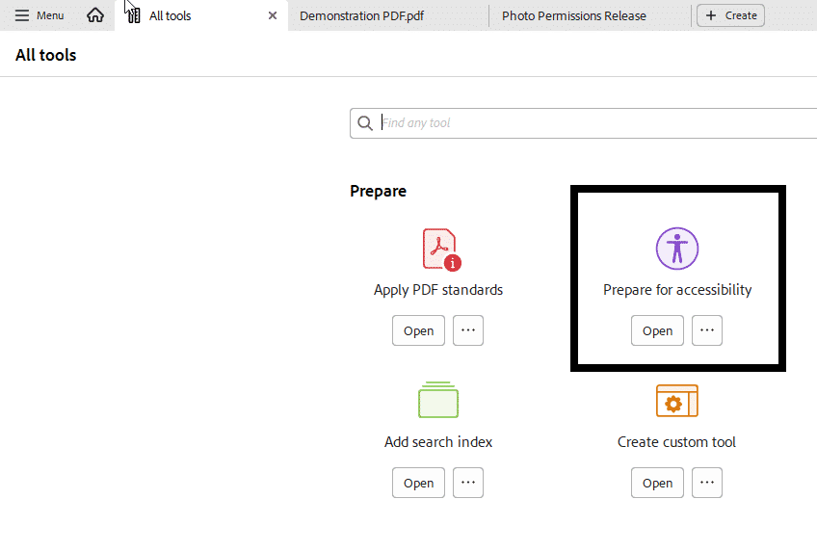
Figure 9 The All tools menu is open and the Prepare for Accessibility option is noted with a black box around it.
There are two ways to find the Prepare for accessibility tool:
- from the All tools menu on the left, select View more and then select Prepare for accessibility.
- from the Top Menu (a house icon), select See all tools. Scroll down to Prepare>Prepare for accessibility and select the Open button.
It will display the Prepare for accessibility tool page with a list of all available actions on the left panel of the app.

Step 2: Check for accessibility
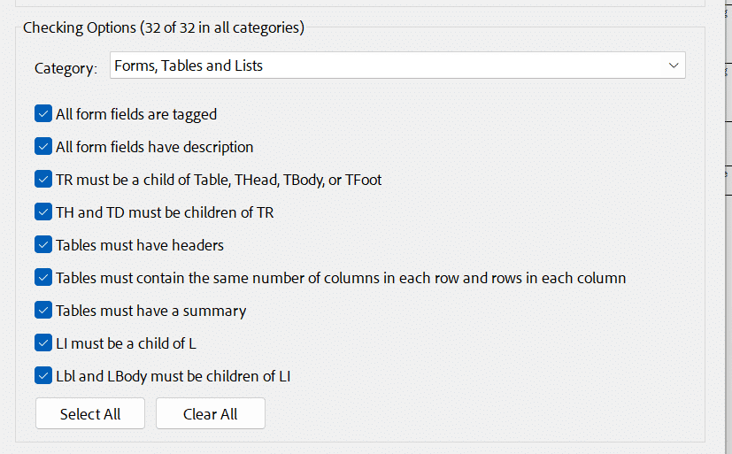
Figure 10 The Checking Options dialog box is open and all items are checked for the visible category.
Click the Check for accessibility action, a dialog box will open.
Review all the Checking Options selected and ensure that (32 of 32 in all categories) are selected; you want every box checked for all four categories.
Click the Start Checking button.

Step 3: Navigate the results
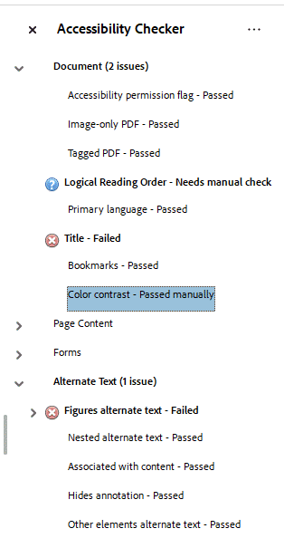
Figure 11 The Accessibility Checker pane is open and displaying the results of an accessibility check that includes items that are passed, failed, requires manual check, skipped, and manually passed.
Once the check is complete, a panel will display on the right-hand side of the app that lists all the categories checked.
You'll know there is something to review because each category with an issue will be bolded and have a parenthesis next to it noting how many issues can be found in that category. For example - Document (3 issues).
Next to each category, there's a drop-down to view the items checked and make any fixes needed.

Running Your First Check
Congratulations, you've run your first check. Keep in mind, every PDF is going to require some additional review, editing and remediation.
Next, we'll look at how to find and read the report, as well as some of the most common edits and manual checks needed.

Knowledge Check 1: Accessibility Checker Results & Remediations
- Can you skip any of the items when running the Accessibility Check? (Select one of the following.)
  - Yes, you can skip the table summary
  - Yes, you can skip the alternate text if there are no images
  - No, you should not skip any of the items to ensure everything is checked fully

Accessibility Checker Results Key & Limitations
The Accessibility Checker displays one of the following statuses for each item checked:
- Passed: The item is accessible.
- Skipped By User: Rule was not checked because it wasn't selected in the Accessibility Checker Options dialog box.
  - Note: Do not skip any items when checking content that will be used by Stony Brook students, employees, or guests.
- Needs Manual Check: The Full Check/Accessibility Check feature couldn't check the item automatically. You need to verify the item manually and determine if it passes.
- Failed: The item didn't pass the accessibility check.

Check Each Item that Failed
You need to be thorough and check each item that failed. When you right-click on an issue, a drop-down list appears with available options to troubleshoot or fix the issue directly:
- Fix: Displays if the issue can be fixed in a specific-dialog box.
- Explain: View guidance and suggestions from Adobe about what this item is checking for and how to fix issues.
- Show in Content Panel: See a hierarchical view of the objects that make up the PDF file. It can help with troubleshooting/fixing issues because you can:
  - See how text is placed in the PDF
  - Delete words without affecting the placement of other words
  - Replace words
- Show in Tags Panel: See all tags that have been created in the PDF File. It can help with troubleshooting fixing issues because you can:
  - View tags, Edit tags, and Create tags.
- Check again: Select if you've made a change and want to run the check again to see if you fixed it.
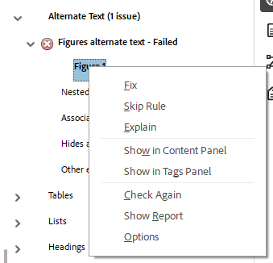
Figure 12 The Alternate Text category has one issue in the Accessibility Checker. The dialog box on Figure 1 is open, displaying user options to troubleshoot and fix the issue.

Limitations
Although the Accessibility Checker provides a thorough overview of document accessibility, there are still some elements that require human eyes to verify if:
- heading levels are in a logical order.
- document has a logical reading order.
- there is enough color contrast of text color and background color.
- the intended table rows or columns are designated headers .
- alternative text is described in a meaningful way.
- links are descriptive.
The Accessibility Checker is intended to provide a basic assessment of the PDF document, and is not reflective of a full and complete accessibility analysis. It is an automated tool and, as such, can only test a handful of the accessibility standards that can be automated.

Knowledge Check 2: Accessibility Checker Results & Remediations
- What is not a limitation of the Accessibility Check? (Select one of the following.)
  - Check that the document has a logical reading order
  - Check that there is sufficient color contrast of text color and background color
  - Check that links are descriptive
  - Check that the document was tagged

Needs Manual Check
No matter how accessible your document is, there are always two items that you need to manually check your PDF every time: logical reading order and sufficient color contrast.

Logical Reading Order
Heading tags provide organization for the PDF. On the right-hand side, there's a tag icon that you need to click to open the Accessibility tags panel to check the reading order.
You want to ensure that the tags are structured correctly beginning with <H1> as this designates the title of the document.
- <H1> = Heading 1. This is the title of your document. There should only be one <H1> for the entire document.
- <H2> = Heading 2. This is the highest level sub‐headings in a document.
- <H3> = Heading 3. This is a third level heading.
- <H4> = Heading 4. This is a fourth level heading.
Note: Like in an Outline, you should never skip heading levels.
For example an incorrect heading structure would be: Heading 1 > Heading 3 > Heading 2 > Heading 4.

Verifying the Check is Complete
If your PDF has a logical reading order, you need to manually pass the Logical Reading Order criterion in the Accessibility Checker by right-clicking the item and selecting the "Pass" option from the drop-down.
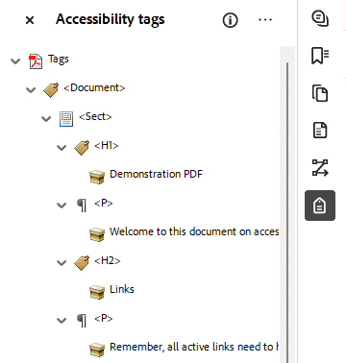
Figure 13 The Accessibility tags panel is open and displaying a logical reading order.

Sufficient Color Contrast
Color contrast is one of the accessibility issues that Acrobat Pro is unable to help with beyond reminding us to check it.
There are a variety of tools available to help with checking color contrast, and you are encouraged to find one that you like, and use it as part of your standard workflow.
WebAim(opens in a new tab) has provided a free color contrast checking tool on their website and it can be used to test the color contrast of anything you can see on the computer monitor.

Change the Text Font Color in Adobe Acrobat
- Go to the All Tools menu, and select the Edit PDF tool.
- Highlight the text you want to modify in the PDF.
- Click the Font Color icon (it's a box with the current font color selected in the Edit panel on the right-hand side of the screen).
- Select the new font color text from the pop-up menu options. Typically, a white background with black text will suffice for color contrast.
- Click the Save button in the upper left-hand corner to save your selection.

Change the Background Color in Adobe Acrobat
- Go to the All Tools menu, and select the Edit PDF tool.
- Click Add Content > Background icon.
- Select the Add option.
- Select the new background color text from the pop-up menu options.
- Click the Ok button to save your selection.

Verifying the Check is Complete
If your PDF has a logical reading order, you need to manually pass the Color contrast criterion in the Accessibility Checker by right-clicking the item and selecting the "Pass" option from the drop-down.

Common Issues in the Results
There are many criteria and potential issues that the Accessibility Checker can note. Here are the three most common issues with simple fixes.
Description (Title, Subject, Author, Keywords)
Several document properties must be set to ensure the document is accessible. Also, interactive features such as links and bookmarks can be added at this step. Properties to configure include:
- Document Title
- Document Subject
- Document Author
- Document Keywords
When the Document > Title item failed during the check, right-click the item and select the Fix option from the drop-down. A dialog box will open and you can view all the data that was previously added to the document.
Uncheck the Leave As Is box underneath each field to unlock it and make any edits you need.
Click the Ok button to save your edits.
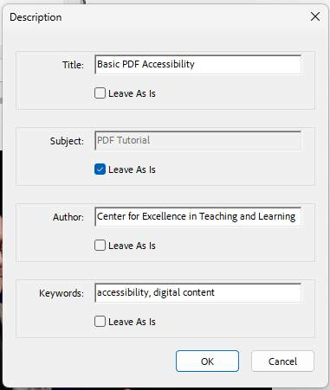
Figure 14 The Description dialog box displaying a mix of editable field and locked fields (due to the "Leave As Is" checkbox is selected).

Primary Language
Setting the document language in a PDF enables screen readers to switch to the appropriate language. This check determines whether the primary text language for the PDF is specified. If the check fails, set the language.
To set the language automatically, select Primary Language in the Accessibility Checker panel, and then choose Fix from the Options menu.
Choose a language in the Set Reading Language dialog box, and then click OK.
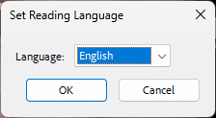
Figure 15 The Primary Language pop-up box is open.

Alternate Text
Alt Text is a textual description of an image. When creating a meaningful alt text, it is essential to describe the picture in a way that ties into the content.
The Figures alternate text item in the accessibility check will only fail if there is no alt text associated with an image in the PDF.
It's recommended to review all the alt text that's been associated with your document to ensure that all alt text is accurate and effectively describes the image to your readers.
To review all the alt text, go to the Prepare for accessibility tool and select the Add alternate text option. A dialog box will open where you can review the text associated with each image, and to see if any images have been set as a Decorative Figure.
Click the Save & Close button when your review is complete.
Note: only images that do not add value to the reader's understanding of the content should be marked as a Decorative Figure. All images that add meaning to the content need to include alt text.
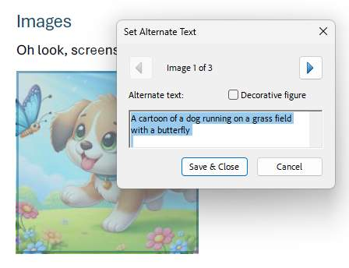
Figure 16 The alt text box is open. It includes navigation between images, a checkbox to mark an image as decorative, and a fillable textbox to enter a description of the image.

Saving the Accessibility Report to the PDF
When all problems identified in the PDF have been remediated/resolved, it is important to save your work and the report!
- Go to Prepare for Accessibility > Open accessibility report.
- Click the More options icon (three dots in the Accessibility Report pane).
- Select the Attach Accessibility Report to Document option from the drop-down.
- Click the Save button in the upper-right hand corner of Acrobat.
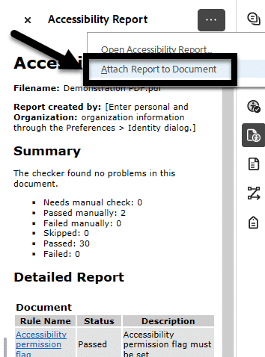
Figure 17 The Accessibility report is open. The "More options" drop-down is open and the "Attach Report to Document" option is selected and noted with a box and arrow.

Congratulations
You completed the Accessibility Checker Results and Remediation Module!
In this section, you learned about Accessibility Checker features, how to use it, and its limitations. Once the PDF is created, setting the metadata, language, checking the color contrast, and reviewing the reading order will need to be completed.
Can you
- Locate the Accessibility Checker and run an accessibility report?
- Interpret Accessibility Checker results?
- Identify Accessibility Checker's limitations?
- Complete manual reviews for logical reading order and color contrast?
- Save the accessibility report's results to the PDF?
Before you continue, make sure you answer the questions above! If you need additional support on any of the bullet points above, please review the module.

Conclusion
You have completed the Basic PDF Accessibility course!
Please fill out the Feedback Survey Form to record your completion of this course and to provide feedback for improvements.

Knowledge Check Answer Key

Knowledge Check 1 Answers: New to Accessibility? Let’s Get Started
- B
- C

Knowledge Check 2 Answers: PDF Accessibility Repair Workflow
- A
- B

Knowledge Check 3 Answers: Accessibility Checker Results & Remediations
- C
- D

