Basic Brightspace Accessibility
By: Lindsay Bryde
Table of Contents
Welcome 2
Learning Objectives 2
Ally and Brightspace Accessibility Checker 3
What is Ally? 3
What do the symbols mean? 4
Ally for Students 4
Reviewing Results 4
Brightspace Accessibility Checker 5
Knowledge Check 1: Ally and Brightspace Accessibility Checker 6
Document Templates and Formatting 7
Setting Default Fonts and Sizes 7
How to Set Default Font and Size in Brightspace 7
Document Templates 9
How to Set Up a Document Template 9
Best Practices for Headers and Formatting 14
Knowledge Check 2: Document Templates and Formatting 16
Hyperlinks 16
Quicklinks 16
What are Empty Links 17
Force Focus Bookmarklet 19
Fixing Empty Links 20
Knowledge Check 3: Hyperlinks 22
Lists 23
Why Lists Need to be Created and Formatted in Brightspace 23
Creating a List with Advanced Editor 23
How to Check If a List is Inaccessible 24
Knowledge Check 4: Lists 25
Tables 25
Best Practices 25
Table Headers 25
Table captions 29
Knowledge Check 5: Tables 31
Equation Editor 31
Why use the Brightspace Equation Editor? 31
Creating an Equation 31
Knowledge Check 6: Equation Editor 34
Knowledge Check Answer Key 34
Knowledge Check 1 Answers: Ally and Brightspace Accessibility Checker 34
Knowledge Check 2 Answers: Document Templates and Formatting 34
Knowledge Check 3 Answers: Hyperlinks 35
Knowledge Check 4 Answers: Lists 35
Knowledge Check 5 Answers: Tables 35
Knowledge Check 3 Answers: Equation Editor 35


Figure 1 Stony Brook University Logo

Welcome
In this course, we provide guidance and introductory instructions on creating accessible content in Brightspace. There are many elements that go into making content accessible; this guide is not exhaustive.
It is highly recommended that you review the Digital Accessibility Resource Guide before beginning this course.
The estimated time to complete this course is 15-20 minutes.

Learning Objectives
- By the end of this guide, you will be able to
- Locate and complete an accessibility check with Ally
- Describe the limitations of Ally.
- Identify and fix empty links.
- Explain the importance of using Quicklinks.
- Create lists, tables, and equations using built-in tools.
- Apply document templates, including accessible font sizing and spacing.
- Execute a check for sufficient color contrast.
For more information about document accessibility, please reach out to CELT by emailing celt@stonybrook.edu.
If you come across an accessibility barrier in this guide, please let us know by emailing celt@stonybrook.edu.
Note on links:
All links open to a new tab.

Ally and Brightspace Accessibility Checker

What is Ally?
Ally produces automated reports to identify webpages and files that need remediation within the Learning Management System (LMS).
Ally reports appear in each module of a course and at the top of every Brightspace file (e.g. uploaded PDFs, Word documents, PowerPoint presentations) and page (course content developed within Brightspace).
The symbol for Ally is a meter that changes based on the level of accessibility of the file you're looking at.
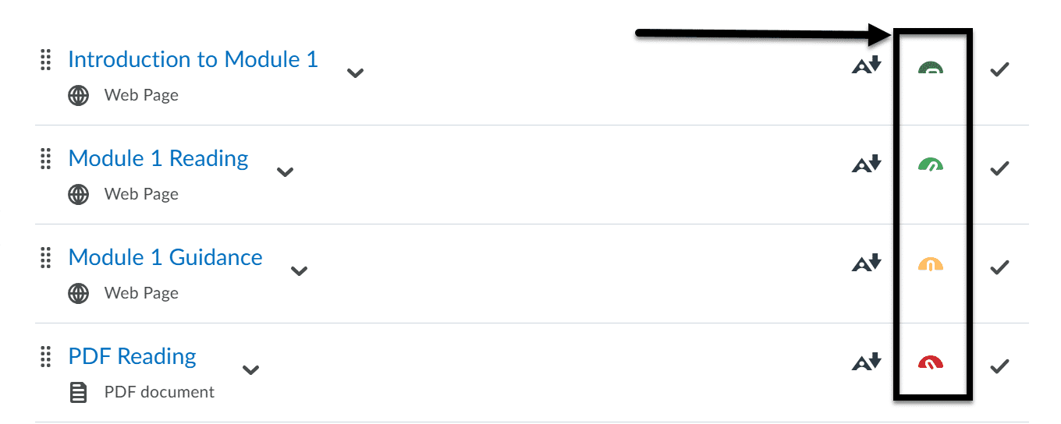
Figure 2 A Brightspace content section, displaying four pages.

What do the symbols mean?
- Perfect (100%) - dark green indicator with needle pointing to the right: the file is accessible, and no edits are needed.
- High (67-99%) - light green indicator with needle pointing at an angle to the right: the file needs minor edits to meet all accessibility requirements.
- Medium (34-66%) - orange indicator with needle pointing to the middle: the file needs moderate edits to meet all accessibility requirements.
- Low (0-33%) - red indicator with needle pointing at an angle to the left: needs immediate attention, meets little to no accessibility requirements.

Ally for Students
For information about Ally's tools for students, see the Division of Information Technology Service's Ally page.

Reviewing Results
Click on the colored indicator to open that page's Ally report. You'll only see the top issue when you first open the report.
Click on the All issues button to see all the remediations needed to make the file or document fully accessible.
You can click any item to see more information about what Ally found, and if there are any instructions or suggestions on how to fix the problem available.
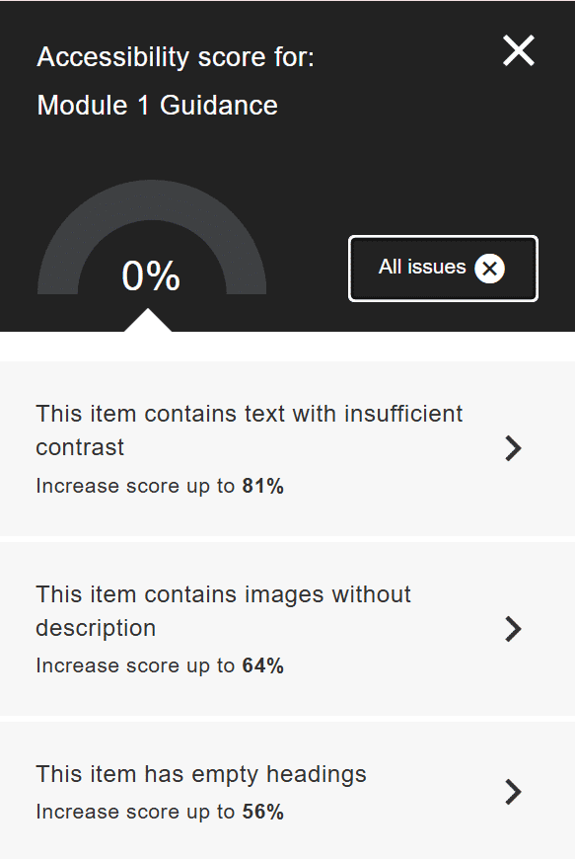
Figure 3 The accessibility report for a single page in Brightspace, including the overall score and a list of items to improve the score.
Ally's Limitations
Ally is an automated tool, meaning it can check for many accessibility issues, but it does have some limitations:
- Cannot check module overviews, assignments, discussions, or quizzes.
- Cannot check if the alternative text (or alt text) used for an image is descriptive enough. It can only see if alt text has been entered.
- Cannot interpret complex tables (e.g., if a value is missing or if an inaccurate header is marked).
- Cannot check for the presence or accuracy of captions in videos.
It's still key that you're manually checking your content and using Ally as a backup.

Brightspace Accessibility Checker
For content Ally cannot check (e.g. module overviews, assignments, discussions, and quizzes), users can run their own review using the Brightspace Accessibility Checker. In the Brightspace Editor, click the Accessibility Checker icon (an eye over a checkmark).
A pop-up window displays showing you any identified issues and recommendations on how to remediate the content.
Similar to Ally, the Brightspace Accessibility Checker has it's own limitations. It cannot check the quality or accuracy of headers, alt text, or captions.
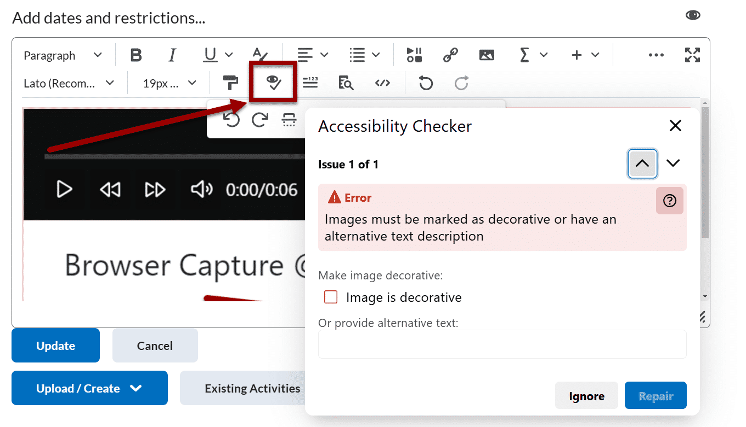
Figure 4 A Brightspace module open for editing with the Accessibility Checker report on display in a pop-up. The Accessibility Checker icon is noted with an arrow.
Note: The Brightspace Accessibility Checker is also available for anyone adding a new thread or writing a reply in a discussion forum.

Knowledge Check 1: Ally and Brightspace Accessibility Checker
Answer the following questions to self-check your knowledge (answers are at the end of the document).
- Where do Ally reports appear in Brightspace?
  - In the Gradebook section
  - In the Discussions section
  - In each course module and at the top of each Brightspace file and page
  - In the Calendar section
- What does the Brightspace Accessibility Checker see that Ally can't?
  - Assignments
  - Uploaded files (Word documents, presentations, and spreadsheets)
  - Quizzes
  - Brightspace pages
  - Module Overviews
  - Discussions

Document Templates and Formatting

Setting Default Fonts and Sizes
While many Word processor and presentation tools scale their fonts in points (pt), Brightspace sets their font sizes in pixels (px). Px are much smaller than points, so a 12 px is closer to a 9 pt font.
The best practice in Brightspace is to use the Lato font and set it to 19 or 20 px to make your text comfortable to read. There is a way to make this the default font settings every time you add new content to Brightspace.
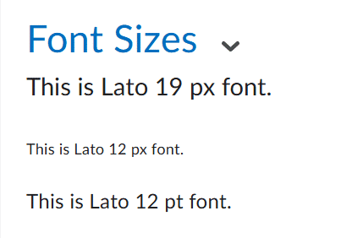
Figure 5 A Brightspace announcement with three very different sizes of text in the Lato font. The first is 19 px, the second is 12 px, and the third example is 12 pt.
Note, this setting only impacts any future content added to Brightspace. The setting does not go back to update any previously added content.

How to Set Default Font and Size in Brightspace
It's best practice to set these settings in Brightspace before creating content. This only needs to be set in your course(s) once.

Step 1: Content Tab
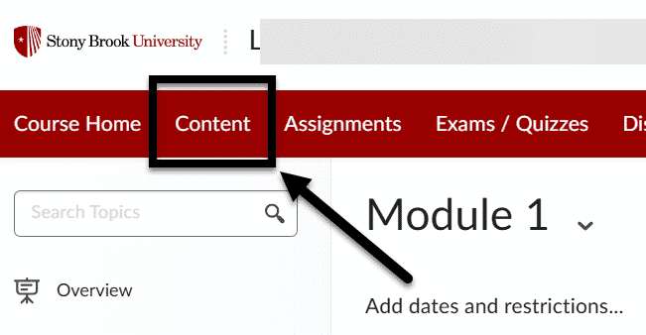
Figure 6 The Content tab in a course's NavBar is indicated with an arrow.
Click on the Content tab in your course.

Step 2: Settings
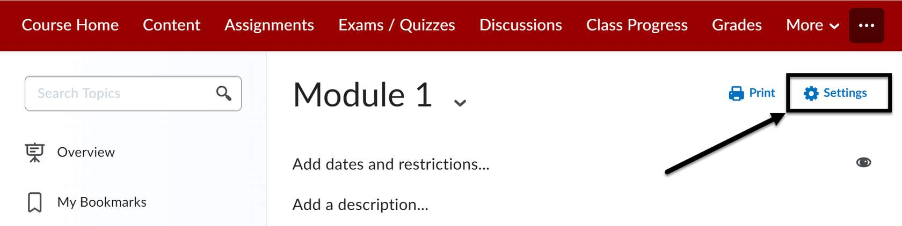
Figure 7 In a Brightspace module, the Settings option is indicated with an arrow.
Select the Settings option.

Step 3: Default Font Settings
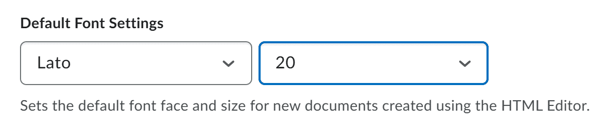
Figure 8 The Default settings area with Lato and 20px selected.
Adjust the Default Font Settings to Lato and 20 px.

Conclusion
Once your settings are adjusted, don't forget to click the Save button before leaving the page.

Document Templates
Brightspace has built in headings in their Document Templates feature. When building your course, you can use the Document Templates as an easy way to create content that is visually appealing (with Stony Brook University branded imagery), helps to chunk information, and is accessible.
Once your template is setup, you can use the Brightspace Editor to continue editing and formatting your content (e.g., adjusting colors, adding images, inserting tables).

How to Set Up a Document Template
Anytime you want to create a new page, it's best to select a document template that helps to organize and visualize your content. There are many templates to pick from.

Step 1: Find Your Module
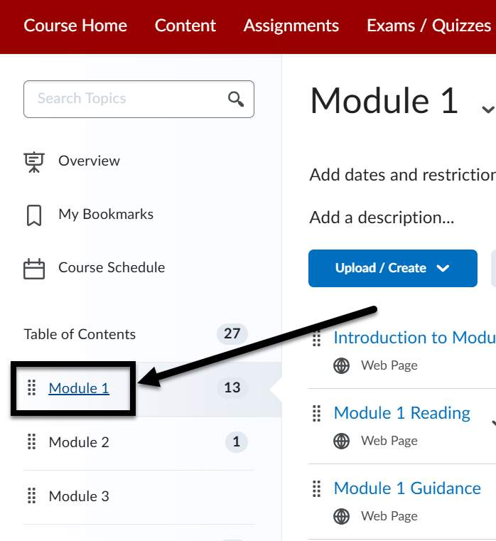
Figure 9 The Brightspace table of contents on the left-hand side of the screen, a module is indicated with an arrow.
Select the Module on the Left Navigation Panel that you want to add content to.

Step 2: Upload/Create
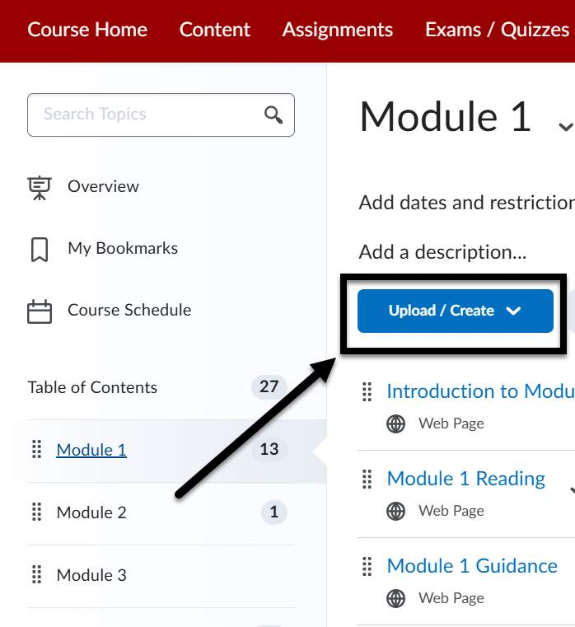
Figure 10 The upload/create button at the top of a module is indicated with an arrow.
Click the Upload/Create blue button.

Step 3: Create a File
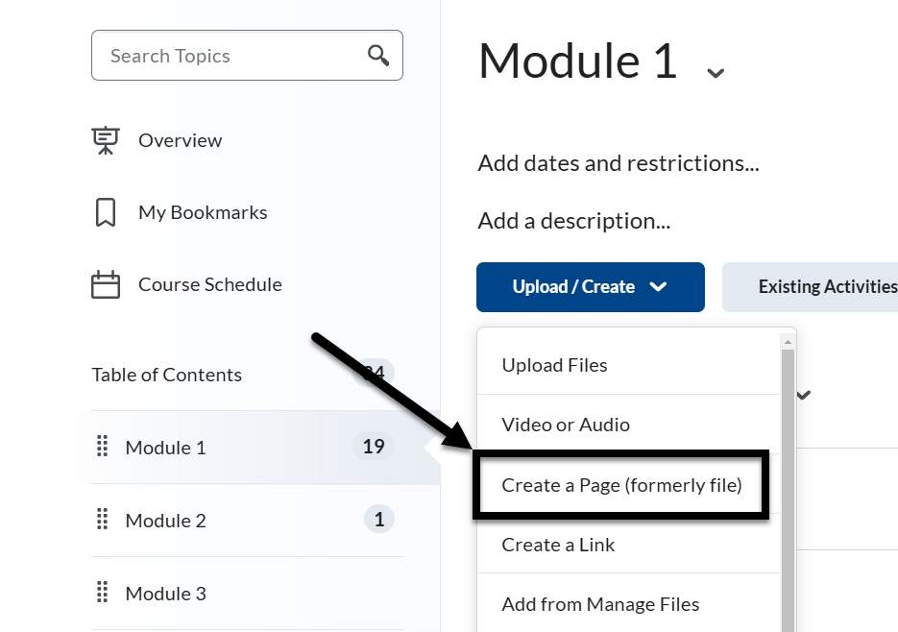
Figure 11 The upload/create drop-down is open and the Create a Page (formerly file) option is indicated with an arrow.
Select Create a Page (formerly file) from the drop-down.

Step 4: Select a Document Template
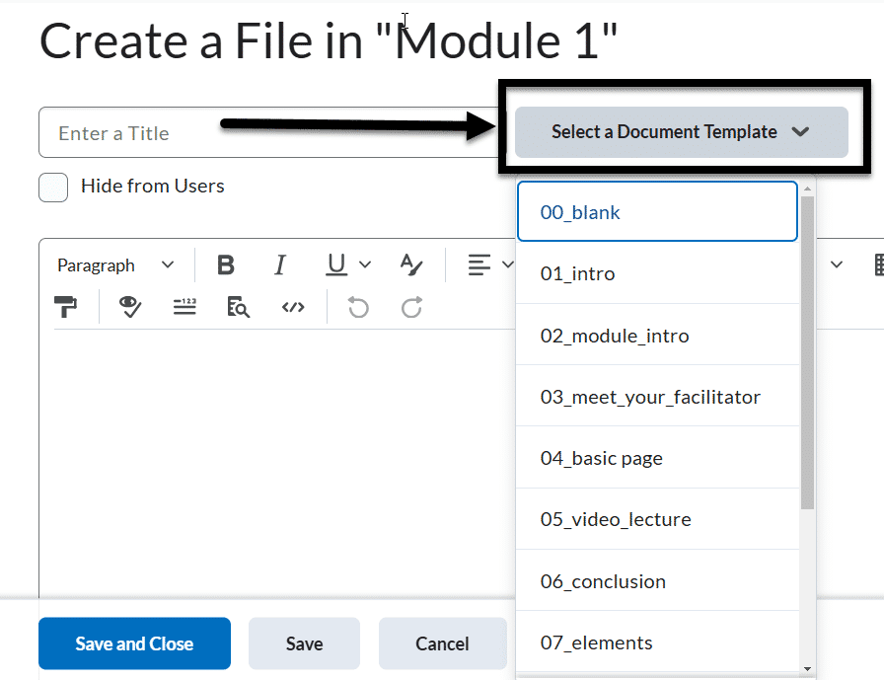
Figure 12 Inside a Brightspace page, the Select a Document Template button at the top of the screen is indicated with an arrow.
You will come to an HTML editor page. Select a Document Template button for a list of document templates to choose from.

Step 5: Follow the Template
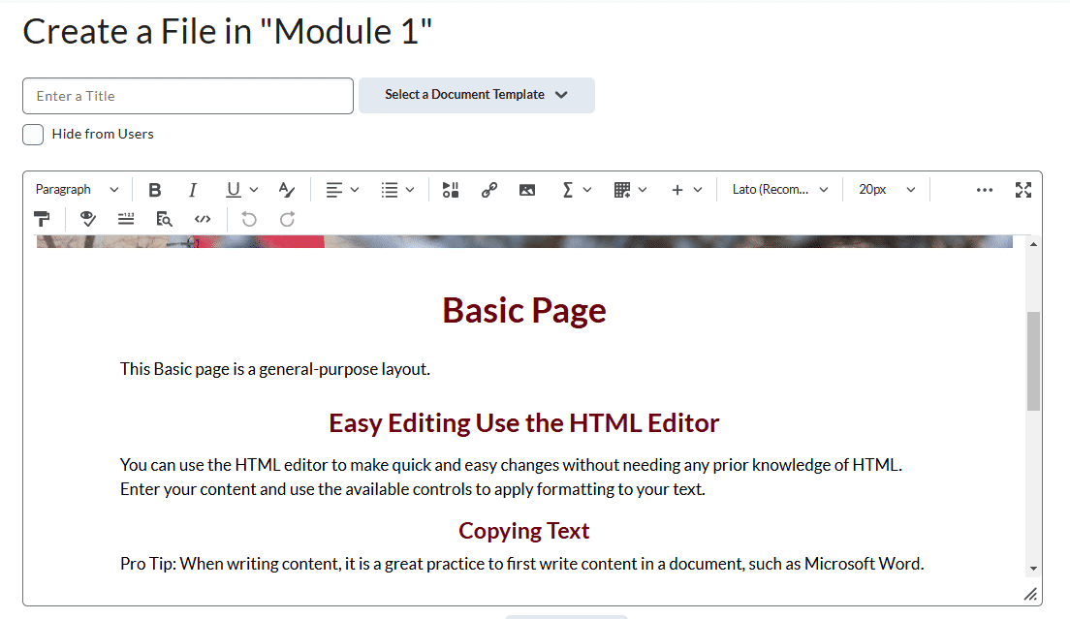
Figure 13 A Brightspace page with a basic page document template.
This is an example of the Basic Page document template. The Heading structure (Heading 1, Heading 2, Heading 3) is already built into this template and you can edit as needed. The document templates are all fully accessible.

Step 6: Edit Your Page in the Future
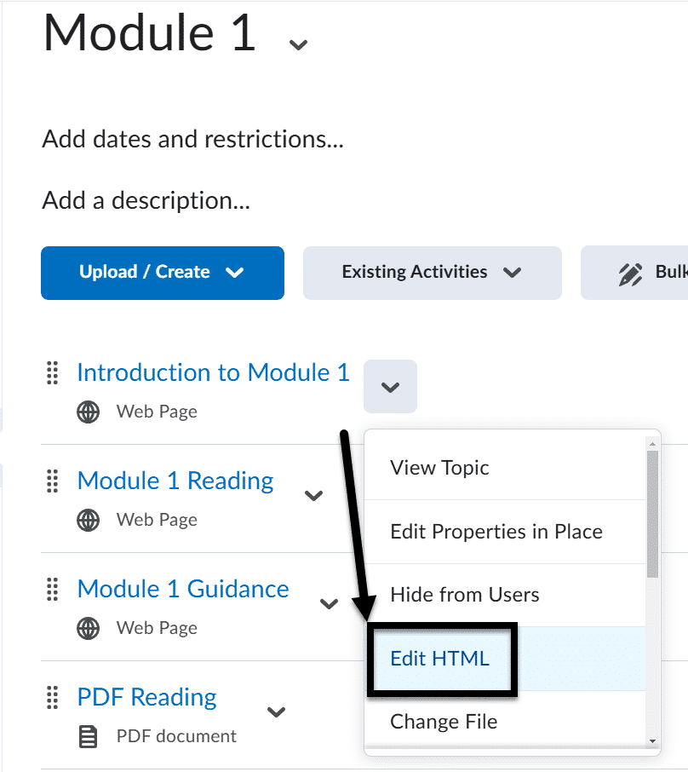
Figure 14 An existing Brightspace page with the chevon/drop-down next to it open. The Edit HTML option is indicated with an arrow.
To edit this page in the future, select on the Module where you created the page. Select the arrow next to the page and then select Edit HTML. This will bring you back to the HTML editor to make any updates or changes you need.

Best Practices for Headers and Formatting

Use unique and descriptive names
Make sure each module, activity (e.g., assignment, discussion, quiz), page, and file has a unique and descriptive name. These are read as headers by screen readers.
It can be confusing if you have two assignments with the same name, and you don't know why the phrase is repeating itself.

Set heading level 1 as text
There should only be one Header 1 <h1> level per page. Header 1 cannot be an image, it must include text.

Don't skip heading levels
It's best to avoid skipping heading levels. For example, don’t go from an <h1> to an <h3> without using an <h2> in between.

Use built-in formatting tools to create white space
Instead of adding multiple blank spaces or lines, use the built-in paragraph styles and formatting tools to create white space on the page.
For example:
- add a Divider if you want to visually add a space between sections (pictured below).
- Use the Paragraph Left to Right or Right to Left tools to create indents.
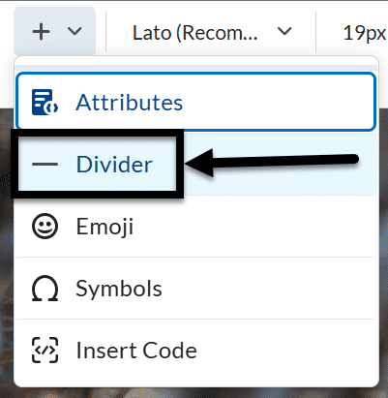
Figure 15 The More options drop down is open with the Divider tool indicated by an arrow.

Check the color contrast checker when making updates
Using the Brightspace color contrast checker is essential for ensuring that your course content is accessible to all students, including those with visual impairments. Located under the Select a Color tool, it helps you verify that the text and background colors in your content meet the Web Content Accessibility Guidelines (WCAG) standards for contrast.
Adequate color contrast improves readability and ensures that all users can perceive the information clearly, regardless of their visual abilities.
Be careful that your color select is passing both the Small and Large Contrast checks.
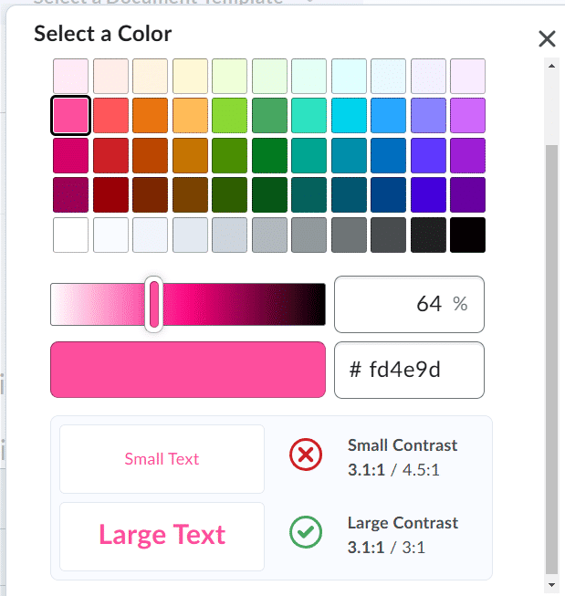
Figure 16 The color contrast checker displays underneath the color options in the Select Color pop-up.

Knowledge Check 2: Document Templates and Formatting
Answer the following question to self-check your knowledge (answers are at the end of the document).
- What is a best practice for using headers in Brightspace?
  - Use multiple Header 1 levels per page
  - Skip heading levels for simplicity
  - Use unique and descriptive names for each module and activity
  - Use images as Header 1

Hyperlinks

Quicklinks
If you want to create links between varying pages in your course (e.g., linking to a specific course reading in the instructions for an assignment), you need to insert what Brightspace calls Quicklinks.
Quicklinks are specially coded links to navigate within a course. If you decide to import your content to multiple sections or courses, the links will continue to direct students to the right page within the new section/course.
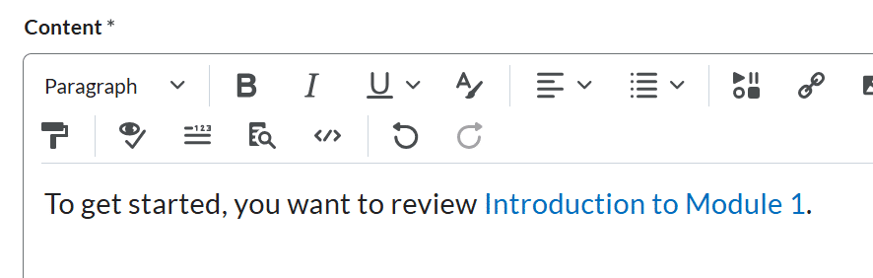
Figure 17 An Announcement draft with a Quicklink inserted into the text.

Add a Quicklink
- Click the Insert Quicklink icon (two links of a chain together) in the Advanced Editor.
- Select which page/activity you want to direct users to.
  - You will need to click down to the specific page if there’s more than one announcement, page, activity.
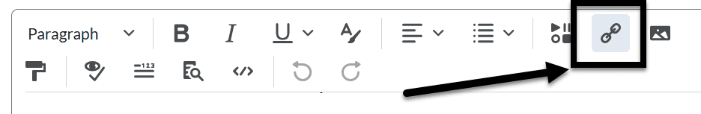
Figure 18 The Brightspace Editor is displayed with the link icon indicated by an arrow.

Bad Course Links
Do not enter the static URLs from the top of the web browser, those links only allow users to navigate to that specific page in that course. You could lock out students from information if/when you import the content to a new section in the future.
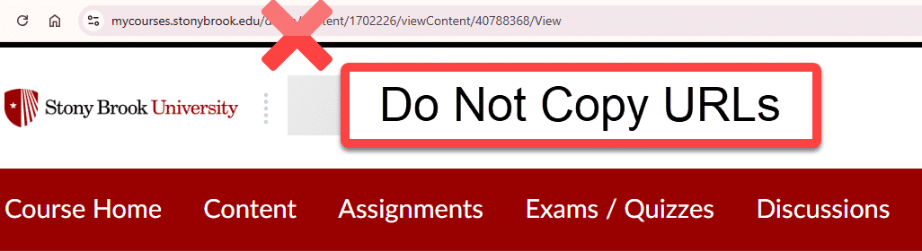
Figure 19 The static URL of a Brightspace page is visible with an x over it and a warning label noting "Do Not Copy URLs."

What are Empty Links
A common error identified in Ally reports is: "This item contains links with missing text." This means a link has been accidentally added to the HTML code of your page, but it's not associated with any of the text present on the page.
These "Empty Links" can be a problem for a few reasons:
- It’s hidden from sighted users since there's no text to display. They could accidentally click on it and be taken away from a page without warning.
- It’s confusing for screen reader and keyboard navigation users since there’s a link with no context. They don't know if something's broken or if they missed something.

An example of a good link
For example, a properly coded link in the HTML/Source code of your page would have:
To learn more, go to <a href ="www.stonybrook.edu"> Stony Brook University's website </a>.
It's a good link because after the link information (i.e. the URL that you're sending people to), there's a description of the link's purpose before the closing tag </a>. This means that sighted users will see the descriptive text and that it's a clickable link and screen reader users will have that information read aloud.
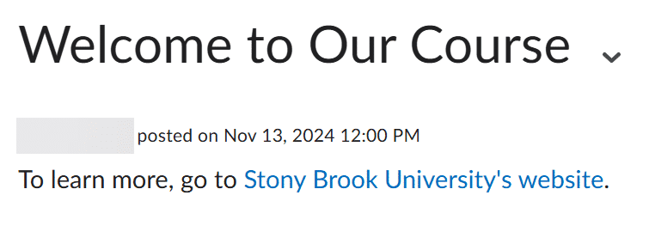
Figure 20 An example of a course announcement with an accessible clickable link.

An example of a bad link
An example of an empty link in the HTML/Source code of your page that we want to avoid would be:
To learn more, go to <a href ="www.stonybrook.edu"> </a> Stony Brook University's website.
It's a bad link because the description of the link is after the closing tag, meaning it's not associated with the link. This means that:
- Sighted users won't know that "Stony Brook University's Website" was meant to have a link (e.g., the color of the text looks the same as all the other regular plain text) and nothing will be clickable here (unless you accidentally click the mouse on exactly the right sport of white space where the empty link is hiding).
- Depending on how a screen reader user is navigating, they'll either hear "To learn more, go to link [insert really long pause] Stony Brook University's website" or "Link....[insert really long pause]."
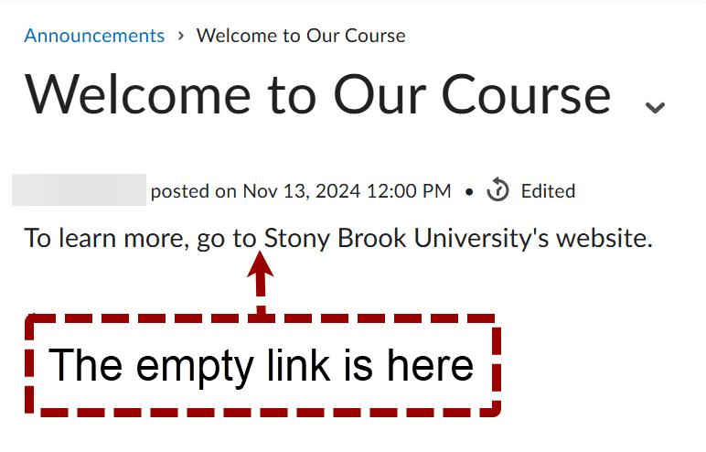
Figure 21 An example of an inaccessible empty link that isn't clickable. There's a callout box noting where the empty/invisible link should be.

Force Focus Bookmarklet
A free and valuable tool to help find empty links is Paul J. Adam's Bookmarklets(opens in a new tab) - specifically the Force Show Focus tool. Bookmarklets are a free accessibility tool that helps you check a page of content and find where accessibility errors are quickly.
Before you attempt to find and fix an empty link, go to the Bookmarklet's site. You want to drag the Force Focus link from the "Install Link" column, and drop it in your web browser's bookmarks.
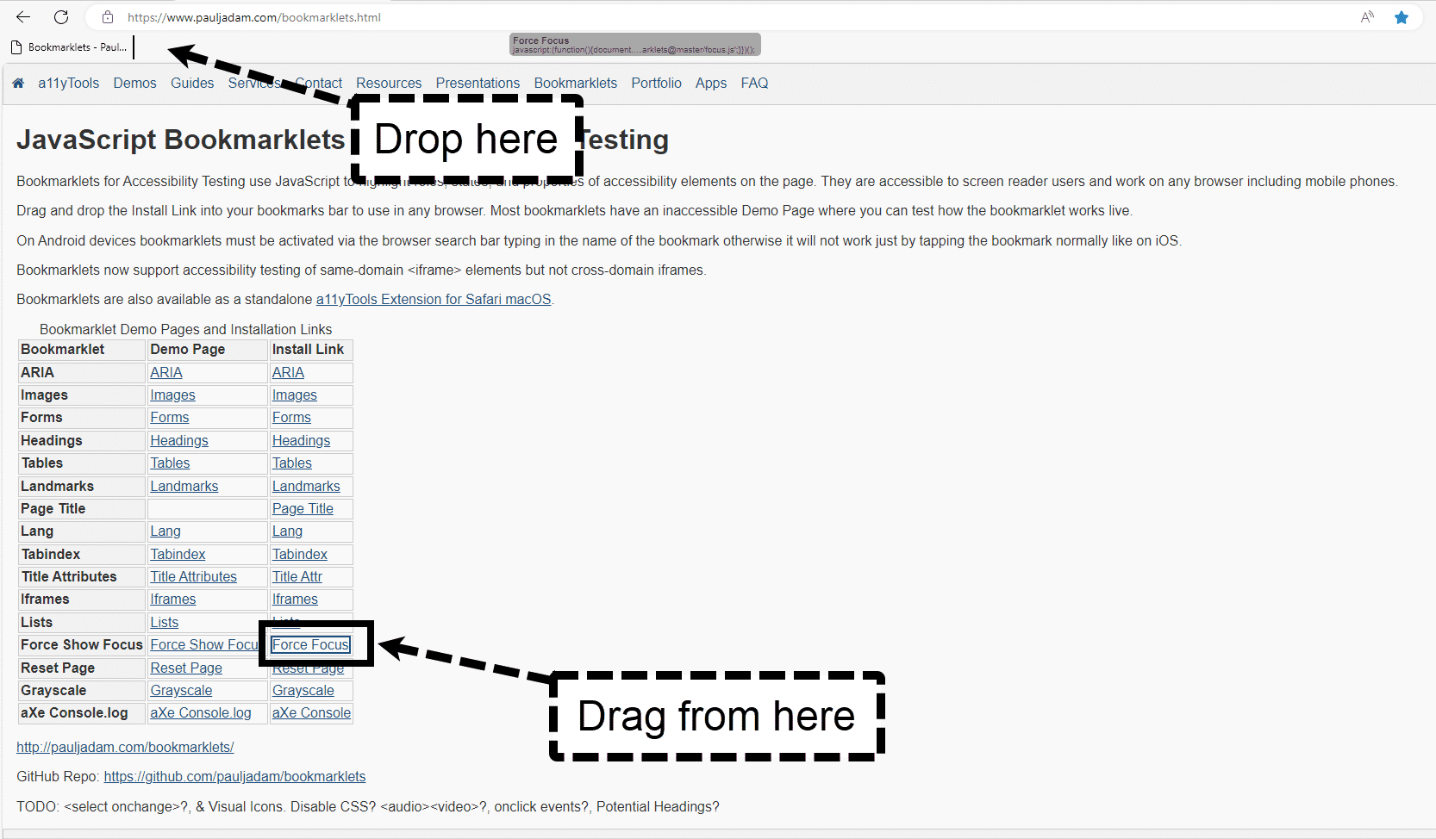
Figure 22 The Bookmarklets site. An arrow is pointing to the Force Focus link with an arrow and a callout stating "Drag from here" and a second callout pointing to the bookmarks bar at the top of the screen with a callout stating "Drop here."
Once the Bookmarklet is added, go to the page in Brightspace that needs to be checked and click the Force Focus Bookmarklet in your Bookmarks. Next, begin clicking the tab button, you'll see a brightly colored box show you where links are located on the page.
You want to continue selecting the tab button until you see a box that doesn't have any text or icons in it, that's where your empty link is located. This is where you'll want to focus your search when checking the source code during the following tutorial on how to fix the empty link.
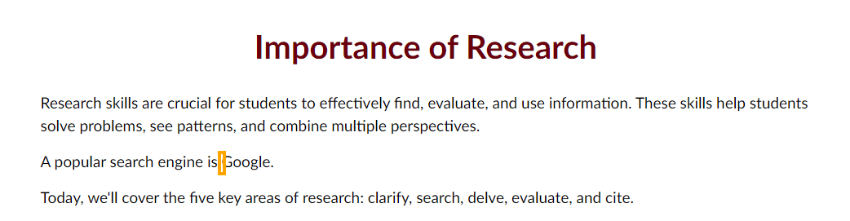
Figure 23 A Brightspace page that has Bookmarklet's brightly colored box indicating where an empty link is located.

Fixing Empty Links
Empty links need a manual review of the content to fix them.

Step 1: Open the HTML editor
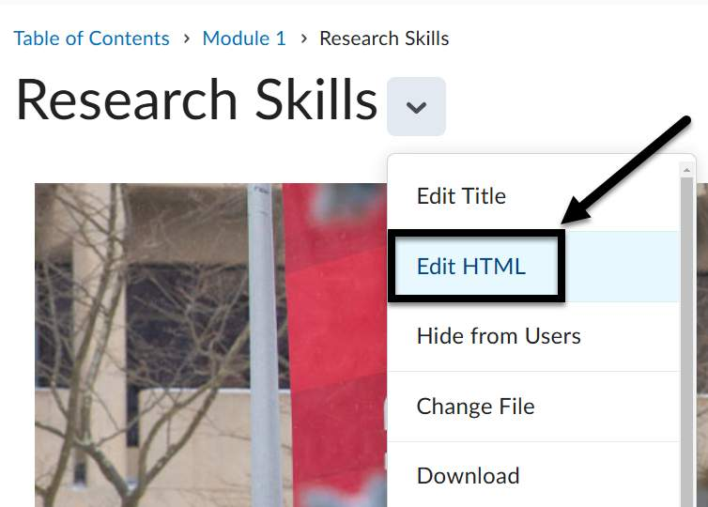
Figure 24 A Brightspace page with the drop-down open, and the "Edit HTML" option is noted with an arrow.
Click on the chevron next to the page's title, and select "Edit HTML" from the drop-down menu.

Step 2: Go to the page's source code
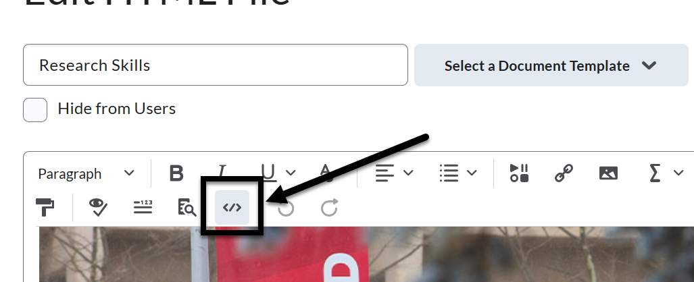
Figure 25 The Brightspace Editor is open and the "Source Code" icon is indicated with an arrow.
Open the page's Source Code (the icon has a less than and a more than sign <>), a dialog box will open.

Step 3: Find the code with the empty link
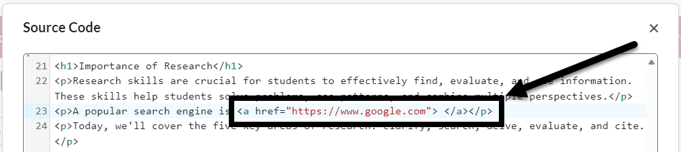
Figure 26 A sample of a coded link that is inaccessible due to an empty link.
Go to the section of the code where you saw the empty box using Bookmarklet. You should see an empty link in the code, there should be no additional text after the opening tag with the site's URL and the closing tag.
For example: <a href="https://www.stonybrook.edu/”> </a>.

Step 4: Decide the best method to fix the link
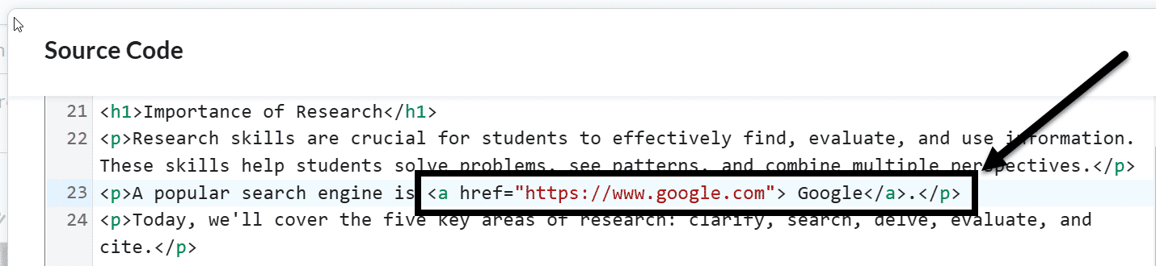
Figure 27 A screenshot of code with the descriptive text placed between the opening and closing tags.
Now that you found your link, you need to decide:
- If you want this link to be visible and accessible, add relevant link text just before the </a> tag to describe the link's purpose.
- If this link was added in error, delete the the entirety of the tag: <a href ="URL"></a>.

Step 5: Saving your work
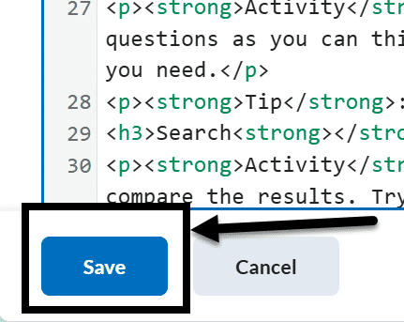
Figure 28 The Source Code dialog box with the Save button in the bottom left corner of the screen noted with an arrow.
Click the Save button in the dialog box and click the Save and close button in the Brightspace Editor (only clicking the first Save button will not save your work).

Knowledge Check 3: Hyperlinks
Answer the following question to self-check your knowledge (answers are at the end of the document).
- Why should you avoid using static URLs from the web browser in Brightspace?
  - They are too long
  - They only allow navigation to a specific page in that course
  - They are not secure
  - They are difficult to copy

Lists

Why Lists Need to be Created and Formatted in Brightspace
Lists can very easily be made inaccessible when content creators:
- type them out phonetically or
- copy and paste them from another source (e.g., a Word document or a PPT)
While these lists may look okay visually, the code underneath it (that's only visible to you) is unable to read the list accurately to screen reader users.

Creating a List with Advanced Editor

Create a New List
- Place the cursor where you want to create the list in the page.
- Click the List icon in the Advanced Editor.
- Select Bulleted List (for unordered lists) or Numbered List (for ordered lists).
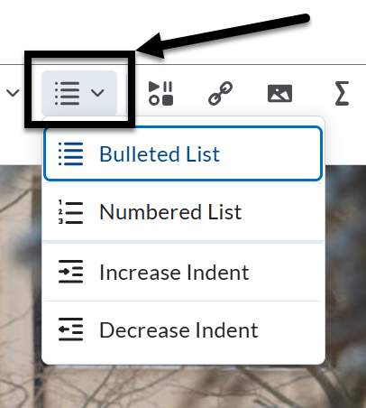
Figure 29 The List drop-down is open in the Brightspace editor displaying the numbered and bulleted list options.

Format an Existing List
Note: it's best practice to remove any manually added or copied bullets or numbers from the list before you start this process.
- Highlight the content you want to format as a list.
- Click the List icon in the Advanced Editor.
- Select Bulleted List (for unordered lists) or Numbered List (for ordered lists).

How to Check If a List is Inaccessible
If you have older content and you're not sure if the lists were set up properly, you can open the page's Source Code and scroll down to where the list is noted.

What you'll see if it's not accessible
- The <div> </div> tags.
  - The tags mean that each line is its own section/list – it's not all in one list.
- You can see the bullet/symbol or number in the code, after the tag.
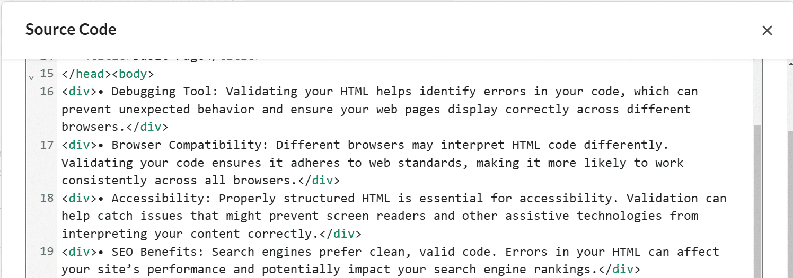
Figure 30 An example of inaccessible code for a list with the <div> tag.

What you'll see if it's accessible
- The <ul> and </ul> for unordered lists.
- The <ol> and </ol> tags ordered lists.
- The <li> and </li> tags for each item in the list.
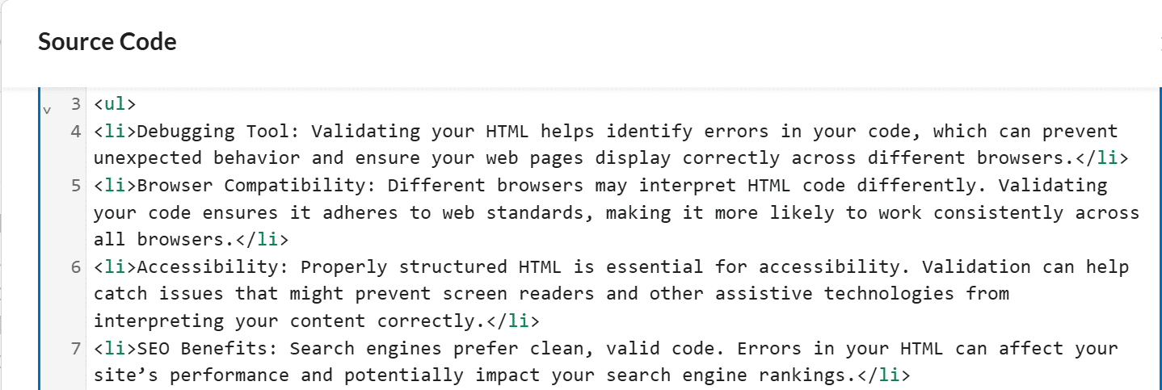
Figure 31 An example of accessible code for an unordered list with the <li> and <ul> tags.

Knowledge Check 4: Lists
Answer the following question to self-check your knowledge (answers are at the end of the document).
- Why can lists become inaccessible when content creators type them out phonetically or copy and paste them from another source?
  - They look visually unappealing
  - The underlying code is unable to read the list accurately to screen reader users
  - They take up too much space on the page
  - They are difficult to edit

Tables

Best Practices
- Create tables in Brightspace pages directly and use the Brightspace Editor to format them.
- Keep the data simple and avoid splitting or merging cells
- Avoid copying and pasting content from another source. Any accessibility settings in the old table will not copy over.
- Set which cells in the table are column or row headers.
- Include a summary of the data before or after the table to provide context to the information.
- If you change topics, start a new table.

Table Headers
A table's rows or columns indicate the significance of the grid's data.
When a user can see the table, they can quickly form visual associations between the data and the row/column headers. When a user cannot see the table, they must use a screen reader to navigate through the cells one at a time, which means the table's column/row headers need to be properly marked to read the information accurately.
Below is a tutorial on how to set the table's headers and scope accurately.
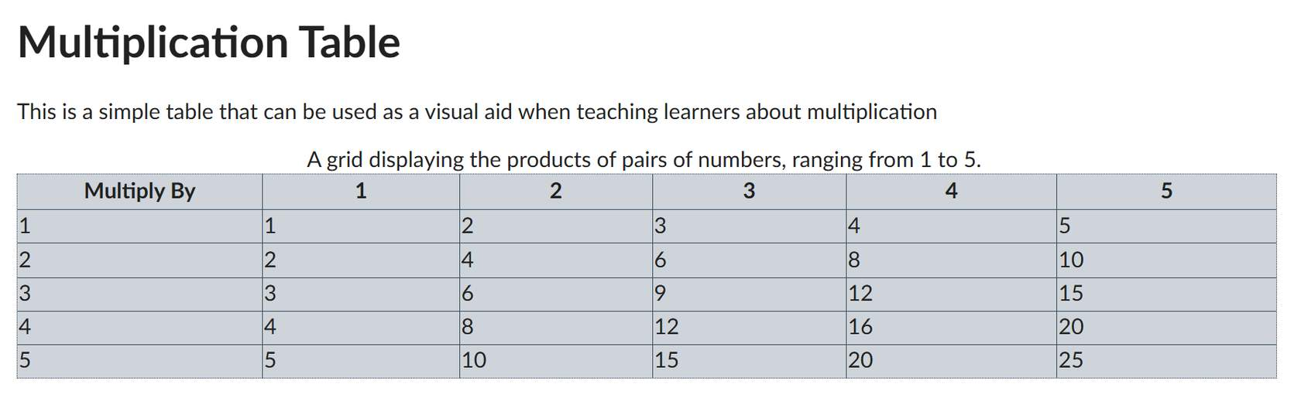
Figure 32 A simple table created in Brightspace about multiplication.

Step 1: Highlight the cell(s) of the header(s)
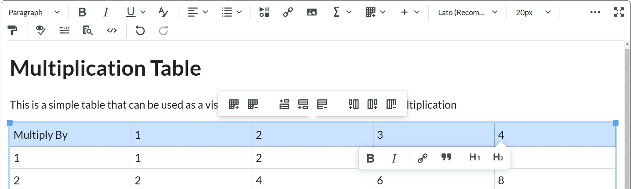
Figure 33 A Brightspace table with the cells of the entire top row highlighted.
Put the cursor in the cell or highlight the cells you want to mark as a table header.

Step 2: Table icon
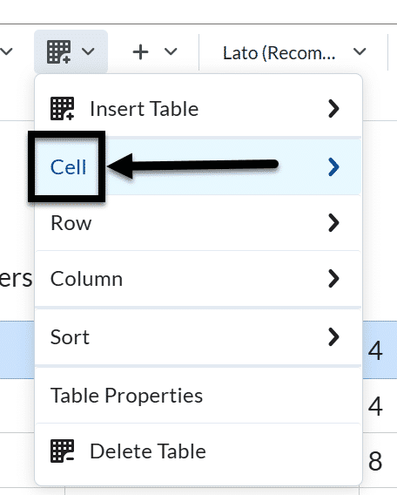
Figure 34 The Table icon has been selected and the Cell option is indicated with an arrow.
Click on the drop-down menu next to the Table icon in the Brightspace Editor, and select the Cell option from the drop-down.

Step 3: Cell properties
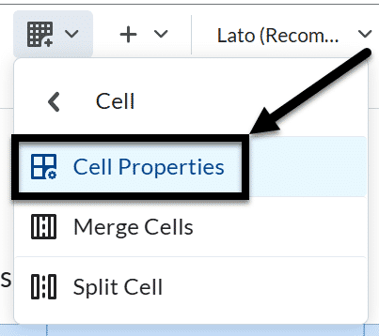
Figure 35 The Cell drop-down is open and the Cell properties option is indicated with an arrow.
Select Cell Properties, the Cell properties window will pop-up.

Step 4: Cell Type
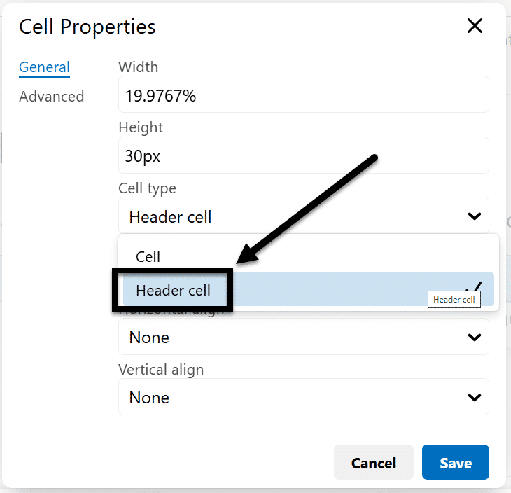
Figure 36 The Cell Properties pop is open and the Cell type drop-down is showing the header cell option.
In the Cell type field, click on the drop-down list and select Header cell.

Step 5: Set the scope
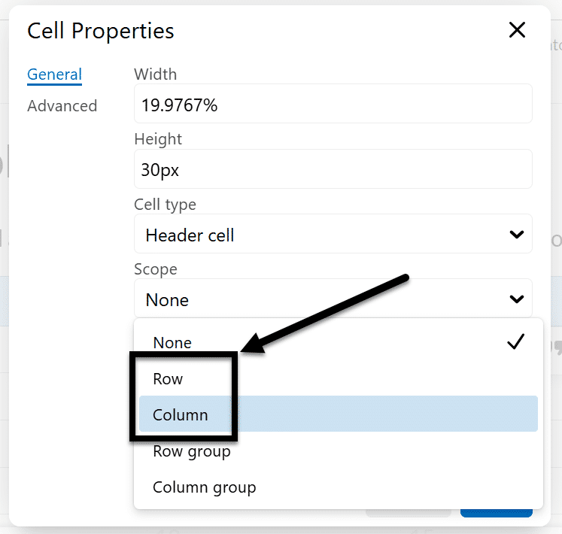
Figure 37 The Scope drop-down is open and showing the row and column options.
In the Scope field, click on the drop-down list, and select whether the header is for a Column or Row.

Step 6: Save and repeat as needed
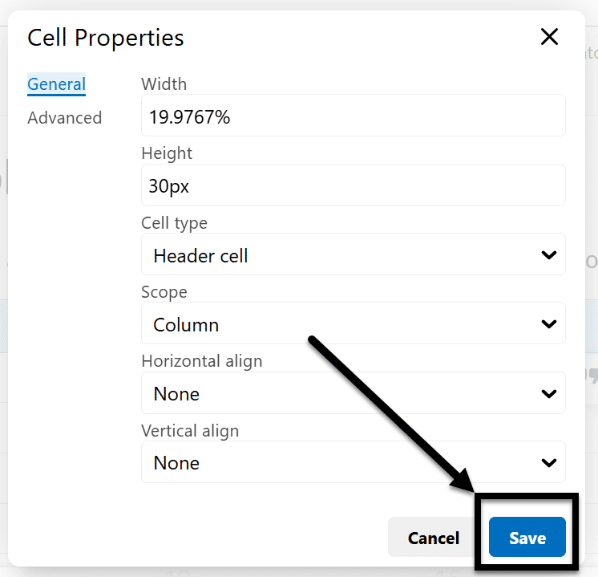
Figure 38 The Cell properties pop-up is open with the Save button being indicated by an arrow.
Click the Save button and repeat for each cell that is a column or row header.

Table captions
Table captions can be a good way of capturing the overall purpose of your table for all users.
Follow the tutorial below to add captions to your table using the Brightspace Editor.

Step 1: Select the table
Click on the table you want to add captions to.

Step 2: Table icon
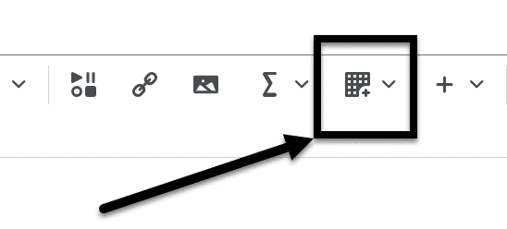
Figure 39 The Table icon is indicated in the Brightspace Editor with an arrow.
Click the Table icon in the Brightspace Editor.

Step 3: Table Properties
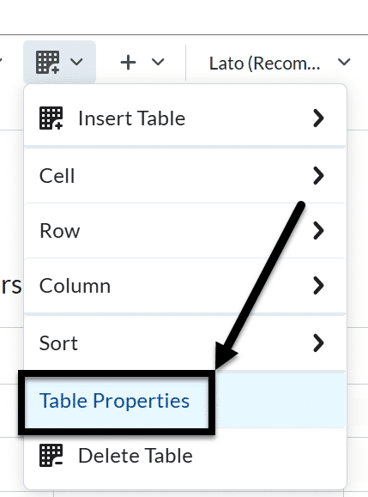
Figure 40 The Table drop-down is visible and the Table properties option is indicated with an arrow.
Select the Table Properties option, the Table properties window will pop-up.

Step 4: Show caption
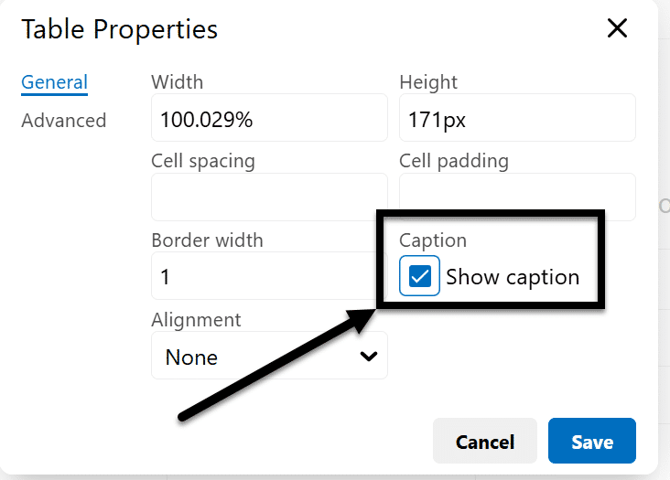
Figure 41 The Table Properties pop-up is open and the Show Caption checkbox is checked and indicated with an arrow.
Check the Show caption box and click the Save button

Step 5: Add caption
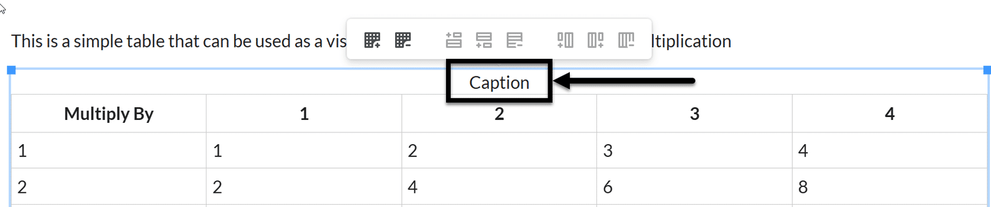
Figure 42 The Caption placeholder is indicated in a table with an arrow.
Enter your caption into the table; there’s now a placeholder in the last row for it.

Knowledge Check 5: Tables
Answer the following question to self-check your knowledge (answers are at the end of the document).
- What is the purpose of including a caption with a table?
  - To make the table look more professional
  - To provide context to the information for all users
  - To increase the size of the document
  - To add more content to the page

Equation Editor

Why use the Brightspace Equation Editor?
Using an Equation Editor ensures that mathematical expressions are clear and accurately formatted, which is critical for understanding complex equations.
The Brightspace Equation Editor presents information in MathML or LaTeX, which supports assistive technologies in ways that manually typing out an equation is not equipped to do.

Creating an Equation
The Equation Editor's seamless integration into various parts of Brightspace (e.g., quizzes, assignments, and content pages) ensures consistent and accurate display of equations.

Step 1: Which page or activity needs an equation?
Open the module overview, page, assignment, discussion, or quiz on Brightspace where you want to create an equation.

Step 2: Where does the equation need to go on the page?
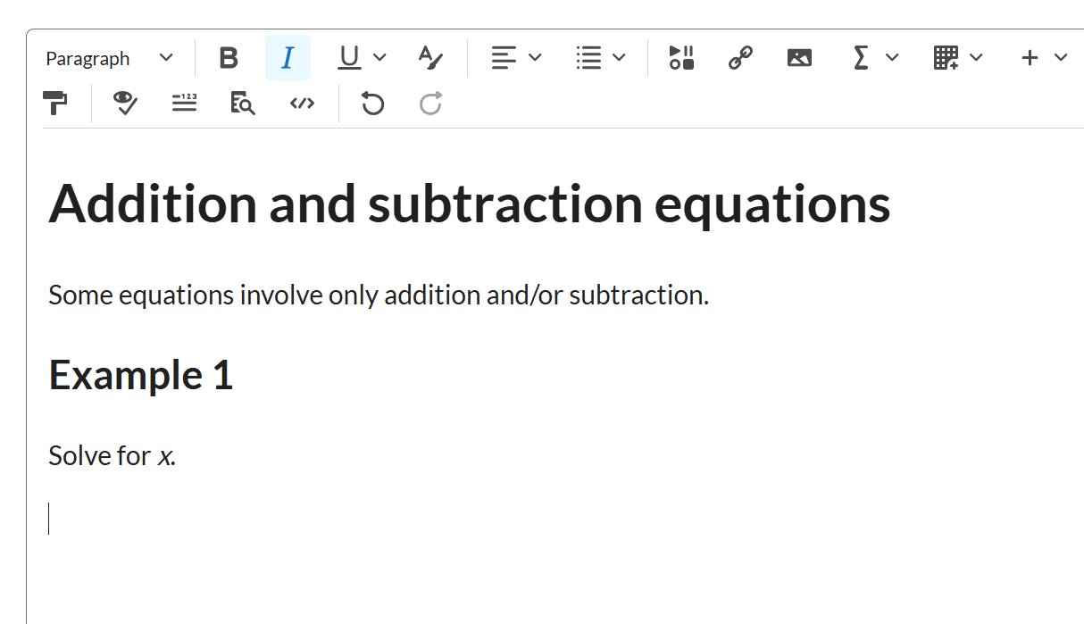
Figure 43 The cursor is in the middle of a Brightspace page.
Put the cursor where you want to add the equation.

Step 3: Which type of equation is needed?
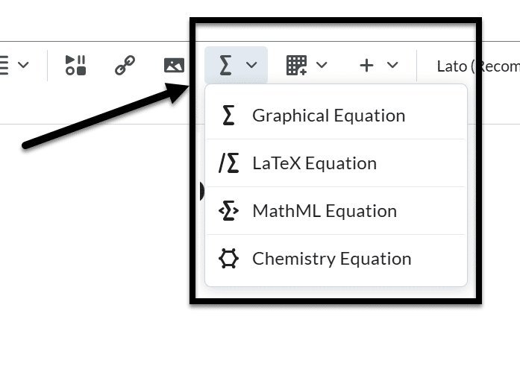
Figure 44 The Equation editor icon is indicated with an arrow and the drop-down is open, displaying the Graphical Equation, LaTeX Equation, MathML Equation, and Chemistry Equation options.
From the Graphical equation drop-down list, do one of the following:
- To insert a graphical equation, click Graphical equation.
- To insert a chemistry equation, click Chemistry equation.
- To insert a MathML equation, click MathML equation.
- To insert a LaTeX equation, click LaTeX equation.

Step 4: How do you want to format your equation?
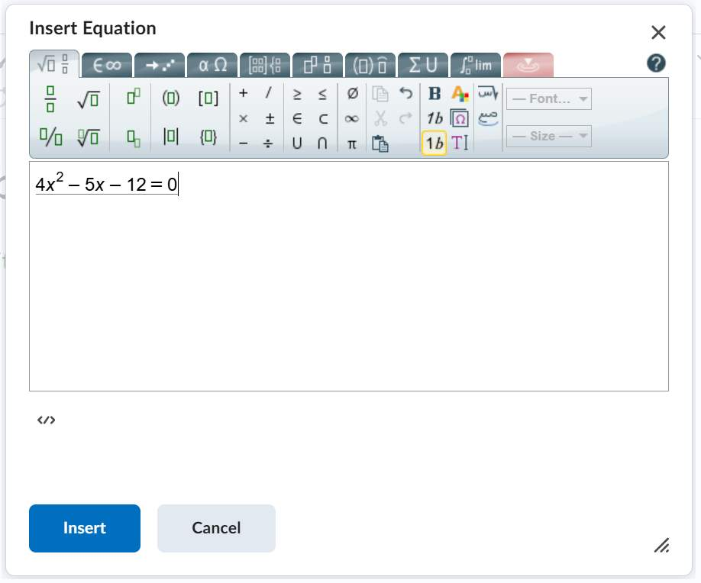
Figure 45 The Graphical Equation editor is open with an equation displaying.
In the Insert Equation window, enter your equation using keyboard characters and your cursor to select symbols from the tabs.
Note: Click the Source code button </> to preview what the code looks like.
Step 5: What happens when I'm done formatting the equation?
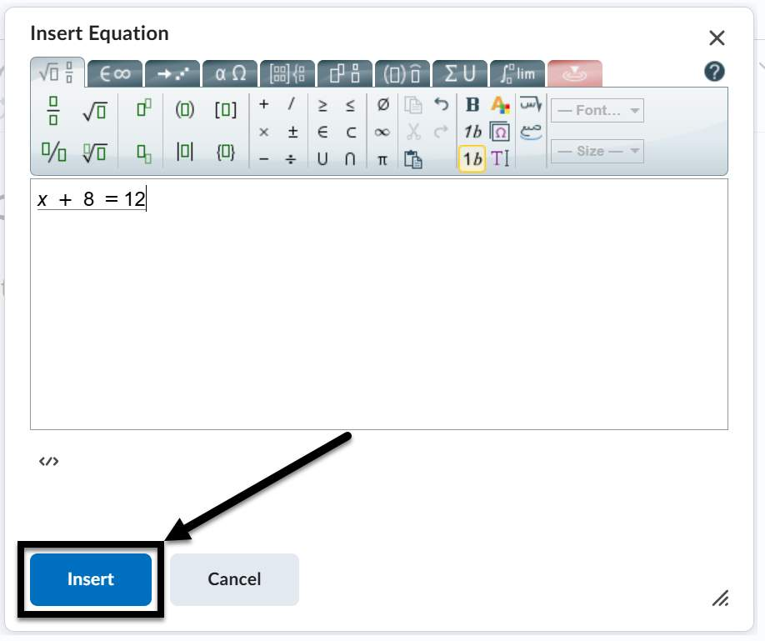
Figure 46 The Graphical Equation editor is open and an arrow is pointing toward the "Insert" button at the bottom of the screen.
Click Insert to add the content to the Brightspace editor and add any additional, non-equation content needed.
Click the Save and close button when you’re done editing the overall page.

Knowledge Check 6: Equation Editor
Answer the following question to self-check your knowledge (answers are at the end of the document).
- Why is it important to use the Brightspace Equation Editor for mathematical expressions?
  - It makes the equations look colorful
  - It allows for the use of emojis in equations
  - It automatically solves the equations
  - It ensures that mathematical expressions are clear and accurately formatted

Knowledge Check Answer Key

Knowledge Check 1 Answers: Ally and Brightspace Accessibility Checker
- C
- A, C, E, and F

Knowledge Check 2 Answers: Document Templates and Formatting
- C

Knowledge Check 3 Answers: Hyperlinks
- B

Knowledge Check 4 Answers: Lists
- B

Knowledge Check 5 Answers: Tables
- B

Knowledge Check 3 Answers: Equation Editor
- D

