Advanced PDF Accessibility: Tagged Annotations
By: Lindsay Bryde
Table of Contents
Why Do Annotations Need to be Tagged? 1
What Do I Need to Tag Annotations? 1
How Do I Add Tags to Annotations within a PDF? 1
Learn More About Document Accessibility 2

Why Do Annotations Need to be Tagged?
Tagging annotations ensures accessibility and usability in a PDF. Tags provide a structured, textual representation of the content. This allows screen readers to interpret and convey the information accurately.

What Do I Need to Tag Annotations?
Adobe Acrobat Pro is required to tag annotations within an existing PDF.
It is strongly recommended to develop new documents in Microsoft Word, which has several features that make creating an accessible document simpler, and then export the content to PDF.

How Do I Add Tags to Annotations within a PDF?
- Open the Accessibility tags pane.
- Click the More options drop-down menu and select the Find option.
- Select Unmarked Annotations from the Find drop-down menu and the Search Document radio button.
- Click the Find button, and you'll be taken to the first annotation, which will be marked with a pink box.
- Click the Tag Element button, and a dialog box will open.
- Enter the type of tag you need to create and the title of the tag.
- Click the OK button.
- Click the Find Next button and repeat steps 5 through 8 until all annotations have been tagged.
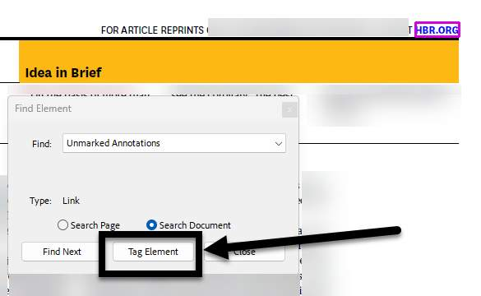
Figure 1 The Find Element box is open on a PDF and the Tag Element button is noted with an arrow.
Note: if the content being highlighted is in the footer/header of your document and repeated on most or all pages, it is best to tag the content as a Background/Artifact.

Learn More About Document Accessibility
For more information about document accessibility, please reach out to CELT by emailing celt@stonybrook.edu (opens in a new tab).
To view additional tutorials and resources, visit CELT's Accessibility page (opens in a new tab).
Please fill out the Feedback Survey Form (opens in a new tab) to record your completion of this course and to provide feedback for improvements.

Figure 2 Stony Brook University's logo

