Advanced PDF Accessibility: Security Settings
By: Lindsay Bryde
Table of Contents
Advanced PDF Accessibility: Fillable Forms 1
Accessibility Permission Flag 1
When Security is Not Required 1
When Security is Required 2
Set security that permits accessibility 2
Learn More About Document Accessibility 2

Accessibility Permission Flag
It is important to ensure the Acrobat DC security settings permit access to the document by assistive technology. Verify that the Acrobat DC or Acrobat Reader DC security settings do not prohibit access by assistive technology by checking the Security tab of the Document Properties dialog.

When Security is Not Required
By default, security is not set and is unlocked. This unsecured default setting will allow assistive technologies to access the document content.
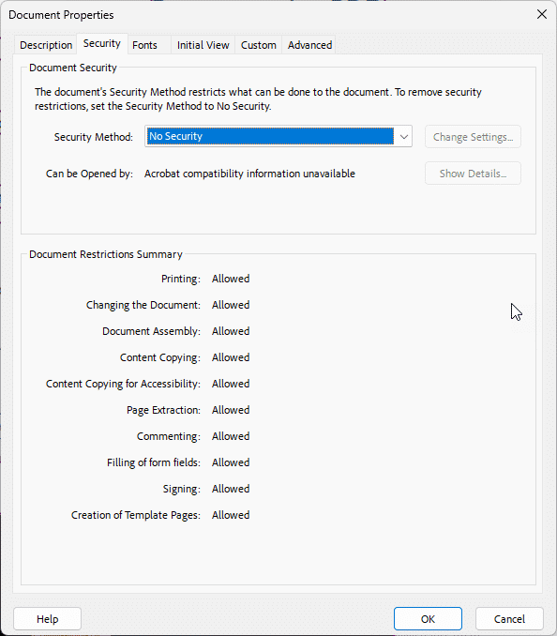

When Security is Required
- Select Password Security as the security method from the drop-down list.
- In the Permissions section of the Password Security Settings dialog, verify that the box labeled Enable text access for screen reader devices for the visually impaired is checked.
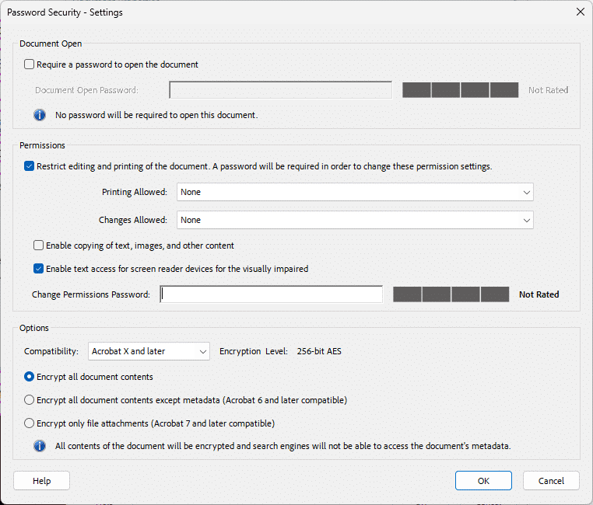

Set security that permits accessibility
- Open the All Tools menu.
- Select the Protect a PDF tool.
- Select the Set security properties option, a dialog box will open.
- Determine the security level needed. If security is not required, by default, security is not be set and is unlocked. This unsecured default setting will allow assistive technologies to access the document content.
- When security is required, select Password Security as the security method from the drop-down list. In the Permissions section of the Password Security Settings dialog, verify that the box labeled Enable text access for screen reader devices for the visually impaired is checked.

Learn More About Document Accessibility
For more information about document accessibility, please reach out to CELT by emailing celt@stonybrook.edu (opens in a new tab).
To view additional tutorials and resources, visit CELT's Accessibility page (opens in a new tab).
Please fill out the Feedback Survey Form (opens in a new tab) to record your completion of this course and to provide feedback for improvements.

Figure 1 Stony Brook University's logo

