Advanced PDF Accessibility: Fillable Forms
By: Lindsay Bryde
Table of Contents
Advanced PDF Accessibility: Fillable Forms 1
The Challenge Ahead 1
Designing a New Fillable Form in Word 1
Exporting a New Form from Microsoft Word to PDF 2
Creating and Editing Form Fields and Tags 3
Step 1: Prepare a form 3
Step 2: Add form fields (if needed) 3
Step 3: Edit form fields 3
Step 4: Create new tags in the reading order 4
Step 5: Create the tags for the form fields and nest with the tags 4
Checking Keyboard Navigation of a Form 5
Method 1. The "Tab Test" (Manual Check) 5
Method 2. Viewing and Setting the Tab Order 5
Troubleshooting Issues for Fillable Forms in the Accessibility Report 6
Learn More About Document Accessibility 6

The Challenge Ahead
Remediating fillable form PDFs for accessibility presents several challenges and can be a time-consuming process. Before deciding that you want to remediate an existing fillable PDF, you want to decide if it's better or easier to create a new form from scratch.
Despite these challenges, creating accessible forms is essential for inclusivity and compliance with legal requirements (e.g., the Americans with Disabilities Act), making the effort worthwhile.

Designing a New Fillable Form in Word
While it may be tempting to create a new fillable form in Adobe Acrobat Pro, it's actually simpler to create/do the initial formatting of your form using Microsoft Word and export it to PDF.
In your Word-version of the form, you want to include:
- Allow enough space in the form for the length of the answer you expect. For example, don't give someone two lines of space to answer a question that will require a lengthy explanation of a paragraph or more.
- Avoid using tables in the design layout, unless you are creating ratings questions. If you use a table, you need to set the table's headers and scope.
- Do not use symbols for form control stand-ins (e.g., using a bullet for a radio button). In the PDF document they may show up as Unicode errors or require remediation to make them Artifacts.
- Use heading styles to identify different sections (e.g., personal information, signatures).
- Note any special instructions that a user needs before posing the question.

Exporting a New Form from Microsoft Word to PDF
Once the initial bones of your form have been written in a Word document, it's time to export your form to PDF and add the finishing touches.
- In Microsoft Word, go to Files and click the Save to Adobe PDF option.
- Open the PDF in Adobe Acrobat Pro.
- It's best to run a general accessibility check of your form in case anything didn't carry over from Word to PDF:
  - Go to All Tools>Prepare for accessibility.
  - Select the Check for accessibility option.
  - Make any general remediations as needed, manually check the reading order and color contrast of the file's tags, and save your document.
- Next, you'll be ready to add the form's fields.
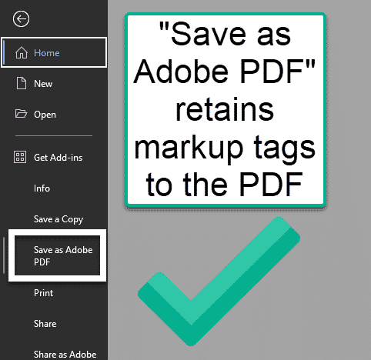
Figure 1 Always use the Save as Adobe PDF option when exporting from Microsoft Word.

Creating and Editing Form Fields and Tags
Whether you're using a form initially designed in Microsoft Word or remediating an existing form, you want to ensure your form's fields are properly configured in the document.

Step 1: Prepare a form
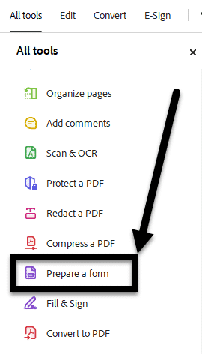
Go to All Tools>Prepare a form. A panel will will open on the left-hand side of the screen.

Step 2: Add form fields (if needed)
Drag and drop the form components that align with how you want respondents to answer (e.g., a text box, a date picker, a signature).
Tip: Add the fields in the order that they should be read. This will make setting them in your Logical Reading Order for keyboard navigation easier later.

Step 3: Edit form fields
For each form field, you need to set the field's properties:
- Right-click the field.
- Select the Properties option.
- Enter a unique name in the Name field.
- Add instruction on how to complete the field in the Tool tip field.
- Verify the Participant Role drop-down has the correct descriptor of who needs to complete this field.
  - The default is "Anyone."
- Optional: Check the Required checkbox if this field must be completed.
- Repeat until all fields have been completed.

Step 4: Create new tags in the reading order
- Go to the Accessibility tags pane.
- Select where you want the field to be added in the Logical Reading Order (e.g., before or after any plain text instructions associated with the form field).
- Click the More options button (three vertical dots).
- Select New tag from the drop-down menu.
- Select the Form tag type.

Step 5: Create the tags for the form fields and nest with the tags
- Open the Accessibility tags pane.
- Select the <Form> tag that the form field should be associated with.
- Click the More options drop-down menu and select the Find option.
- Select Unmarked Annotations from the Find drop-down menu and the Search Document radio button.
- Click the Find button, and you'll be taken to the first annotation, which will be marked with a pink box.
- Click the Tag Element button, and a dialog box will open.
- Enter the type of tag you need to create and the title of the tag.
- Click the OK button.
- If creating all the form fields together, click the Find Next button and repeat steps 6 through 9 until all annotations have been tagged. If creating each tag individually, go to step 12.
- Nest all form field tags to their corresponding <Field> tag. Move all <Field> tags with nested form fields to where it should appear in the Accessibility tags pane's logical reading order.
  - Note: Form fields containing corresponding/grouped checkboxes and radio buttons (e.g., checkboxes with options for a multi-select question or "Yes" and "No" buttons related to the same question) need to be nested together under one <Form> tag.
- Close the Find Element box, and repeat steps 2-8 for all form fields needed.
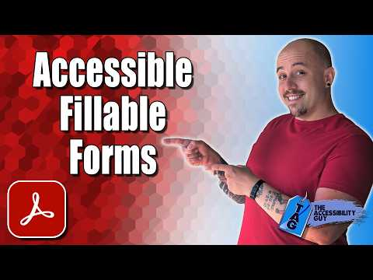

Checking Keyboard Navigation of a Form
Checking keyboard navigation in Adobe Acrobat Pro is essential for ensuring that users who don't use a mouse (including those with motor disabilities or visual impairments) can navigate your form in a logical order.
There are two methods of auditing and fixing your form's navigation.

Method 1. The "Tab Test" (Manual Check)
The quickest way to see what a user experiences is to perform a manual walk-through.
- Open your PDF in Adobe Acrobat Pro. Even if you've had the document open, close and re-open it to see what's present when opening.
- Press the Tab key starting from the top of the document.
- Observe the focus, does the cursor move from top-to-bottom, left-to-right (i.e., does it follow the logical reading order)?
- Ensure the focus doesn't get stuck in a specific field or skip important sections like "Submit" buttons or "Signature" fields.

Method 2. Viewing and Setting the Tab Order
If the "Tab Test" reveals that the focus is jumping around randomly, you need to reorder the fields manually.
- Open the Prepare Form tool from the Tools pane.
- On the right-hand side, you will see a list of all form fields. This list represents the Tab Order.
- In the Fields panel, click the Order icon (usually looks like a small list or a "1-2-3" icon) and ensure it is set to "Show Tab Order."
- To change the order, simply click and drag the fields up or down in the list. The field at the top of the list is the first one a user will hit when they press Tab.

Troubleshooting Issues for Fillable Forms in the Accessibility Report
The Accessibility Report can check for several technical errors in a fillable form. Below is a list of all the potential issues it can identify, questions to ask yourself as the person remediating, and tips on how to fix the issue.
Issue | Question(s) | How to Fix
Tagged forms | Do all form fields have tags? | All forms need two tags: the overall Form tag and the [Name of field]-OBJR.Any preceding or succeeding text should not be under in the Form tag.  It’ll look like this:  - Form  - [Name of field]-OBJR
Field descriptions | Do all form fields have Tooltips that are different from the field’s name? | Instructions on what needs to be entered into the field that’s not otherwise stated on the form.

Learn More About Document Accessibility
For more information about document accessibility, please reach out to CELT by emailing celt@stonybrook.edu (opens in a new tab).
To view additional tutorials and resources, visit CELT's Accessibility page (opens in a new tab).
Please fill out the Feedback Survey Form (opens in a new tab) to record your completion of this course and to provide feedback for improvements.

Figure 2 Stony Brook University's logo

