Advanced PDF Accessibility: Bookmarks Panel
By: Lindsay Bryde
Table of Contents
Why Are Bookmarks Important? 1
What Do I Need to Create Bookmarks? 1
How Do I Add Bookmarks to an Existing PDF? 1
Learn More About Document Accessibility 2

Why Are Bookmarks Important?
Bookmarking your PDFs offers several advantages that enhance your reading and navigation experience. By adding bookmarks, you can easily jump to specific sections or pages within a document, saving time and effort.
Bookmarks help organize your content when sharing with others, making it more accessible and easier to reference. Bookmarks are recommended for lengthy documents, such as e-books, research papers, or reports, where finding specific information quickly is crucial.

What Do I Need to Create Bookmarks?
Adobe Acrobat Pro is required to add Bookmarks to an existing PDF.
It is strongly recommended to first develop new documents in Microsoft Word, which has several features that make creating an accessible document simpler (including Bookmarks), and then export the content to PDF.

How Do I Add Bookmarks to an Existing PDF?
- Go to the Top Menu>View>Show/Hide>Side panels>Bookmarks.
- Select the header/title of the section you'd like to bookmark in the document.
- Click the Add a new bookmark button.
Bookmarks can be nested by dragging and dropping them under the appropriate top section.
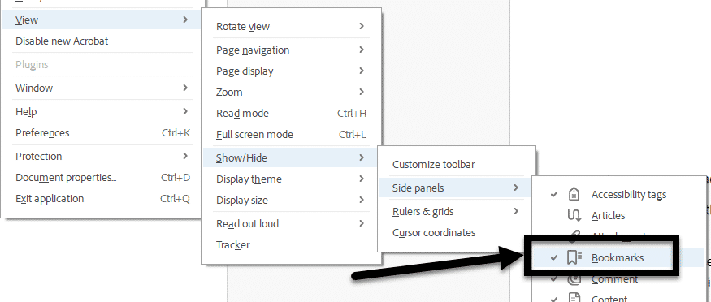
Figure 1 The click path from the Top Menu through the sub-menus to open the Bookmarks side panel.
Note: To minimize additional work, it's best to bookmark a document when it's completely written and go straight through since each new bookmark appears immediately after the last added in the list.

Learn More About Document Accessibility
For more information about document accessibility, please reach out to CELT by emailing celt@stonybrook.edu (opens in a new tab).
To view additional tutorials and resources, visit CELT's Accessibility page (opens in a new tab).
Please fill out the Feedback Survey Form (opens in a new tab) to record your completion of this course and to provide feedback for improvements.

Figure 2 Stony Brook University's logo

