Advanced PDF Accessibility: Accessibility Tags Panel
By: Lindsay Bryde
Table of Contents
Why Are Tags Important? 1
Where Do I See the Tags? 2
Tags are Bins of Information 2
Warning: Tagging an Untagged Document 2
Determine if the Document is Tagged 2
Option 1: Check Document Properties 3
Option 2: Use the Accessibility tags Panel 3
Add Tags to an Untagged Document 4
Add tags automatically from the Prepare for accessibility tool 4
Add tags automatically from the Accessibility Checker results 4
Add tags manually via the Accessibility tags panel 4
How to Change an Incorrect Tag Type on the Accessibility tags Panel 5
Specialty Tags 5
Images 5
Lists 6
Background/Artifact 7
Learn More About Document Accessibility 8
Note on Course Attribution 8

Why Are Tags Important?
Tagging is essential for PDF accessibility. Tags establish logical reading order, provide a means for indicating structure and type, and adding alternative text descriptions to non-text elements for elements in the PDF document.
The Tags Panel can reveal the accessibility of a PDF:
- if all the text and images can be interpreted by a screen-reader
- document reading order
The Tags Panel can also edit the accessibility of a PDF:
- correct table tags
- change tag type
- reorder tag sequence

Where Do I See the Tags?
Adobe Acrobat Pro allows for elements of a document to be tagged according to their purpose. These tags are not displayed in the document, but they are used by screen readers to understand the structure.
Tagging documents used in online courses allows people with disabilities to access materials as quickly as their classmates!

Tags are Bins of Information
The Accessibility tags panel is divided into tags that can be thought of as bins that contain specific information. A tag can be expanded via the carrot or the arrow next to the tag.
Each tag is unique and helps users who rely on screen readers to identify what an element on a page is. For example, a screen reader can interpret the difference between a table from a heading due to the type of tag.
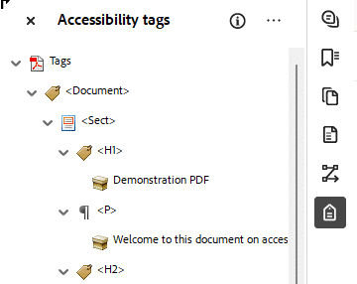
Figure 1 The Accessibility tags panel in an expanded view: headers, paragraphs, and links are visible.

Warning: Tagging an Untagged Document
Take a deep breath, and be prepared to add tags to untagged elements in a PDF. Although the tutorials may look easy -- (we hope they are easy to understand!) -- tagging a document yourself may take longer than you expected. It may take a lot of effort. This is because authoring for accessibility was an afterthought for Adobe Acrobat DC. Accessibility was not built into the authoring system.

Determine if the Document is Tagged
There are two ways to accomplish this:

Option 1: Check Document Properties
This option is the most efficient way to check for tags. Document Properties can also indicate if the PDF is tagged. Anywhere on the PDF, right-click > Document Properties.
Alternatively, on the keyboard: CTRL (for Windows) or CMD (for Mac) + D
Under the Advanced options, you'll see a Tagged PDF section. It will not if the PDF is tagged: yes or no.
You'll also be able to view the original program that the document was created in under Application. In this example, the application is Word. This provides helpful insight. This means we can easily convert the PDF document into a Word doc, and apply all the accessibility principles in that environment as it's much easier than in Adobe Acrobat Pro. Though this solution may not work for all documents.
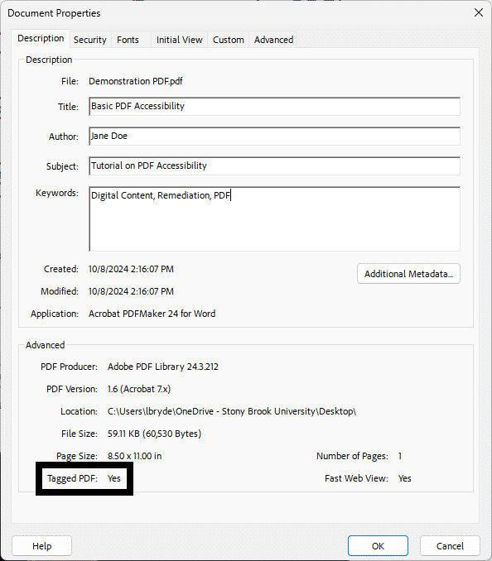
Figure 2 The Document Properties dialog box. Under Advanced options, Tagged PDF is set to "Yes" and noted with a black box.

Option 2: Use the Accessibility tags Panel
- To open the Tags panel, select View > Show/Hide > Side Panels > Accessibility Tags.
- Examine the Accessibility tags panel.
  - A tagged document will show tags and a structure tree descending from the root node. To fully expand the entire tree, Control + click on the root node labelled “Tags.”
  - An untagged document will display the words “No Tags Available” as its root and no structure tree will appear.
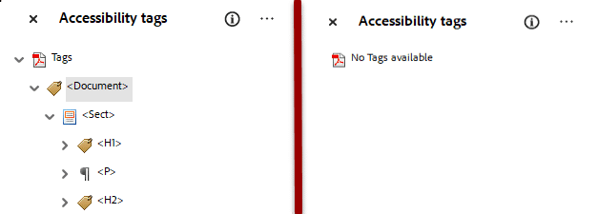
Figure 3 Side by side images of the Accessibility tags Panel. The left-side shows the panel with tags and the right-side shows an error message noting there are no tags.

Add Tags to an Untagged Document
Using Adobe Acrobat Pro DC, tags can be added to untagged documents. There are several ways to do this:

Add tags automatically from the Prepare for accessibility tool
- Open the Prepare for accessibility tool.
- Select the the Automatically tag PDF option to add tags to the document. If tags already exist, you will be asked to confirm that you want to delete the existing tags and re-tag the document.
- Verify the tags in the Accessibility tags panel.

Add tags automatically from the Accessibility Checker results
When the document is not tagged at all, “Tagged PDF” will be listed as “failed” under the Document tree item. To add tags to the document:
- Right-click or press the applications key (Windows) on the Tagged PDF—Failed tree item.
- Choose Fix.
- Verify tags have now been added to the document in the Accessibility tags panel. The “Tagged PDF” item will be listed as “passed” under the Document tree.

Add tags manually via the Accessibility tags panel
When the document was tagged, but specific content is still missing tags:
- Select New Tag from the Object tool in the Accessibility tags panel.
- Select the type of tag from the New Tag dialog and select OK.
- Move the new tag to the location in the Accessibility tag tree where the content is missing.
- Highlight the missing object in the document pane.
- Right-click on the new tag in the tree structure.
- Choose Create Tag from the selection.

How to Change an Incorrect Tag Type on the Accessibility tags Panel
- Right-click on the tag in the tag tree you want to modify and select Properties, a pop-up box will open.
- From the Tag tab, select the appropriate tag from the drop‐down box for Type.
- Click the Close button.
The old tag type changes to the new tag you just selected on the Tags Panel. You must do this for every tag in your document that is classified incorrectly.

Specialty Tags
Some types of tags need additional manual work or review to ensure they are accurate.

Images
The Prepare for accessibility tool has a step to provide automatic tagging; images will be automatically tagged and you'll then need to add alt text to the image.
If an image Is added after running the Prepare for accessibility tool, this means that the PDF already has tags (and presumable in proper reading order.) If this is the case, you'll need to manually add the tag(s).
- In the All Tools menu > Select the Prepare for accessibility tool
- Select Fix reading order, a Reading Order dialog box will appear.
- Apply the following settings in the Reading Order dialog box:
  - Select Structure types
  - This is optional: Check Show table cells
  - Uncheck Display like elements in a single block
  - Check Show tables and figures
Notice in the screenshot below that each element, whether it be text or an image (except for the blurry image of a cat that was added after the document was tagged) has a designated structure type. The image of the dog's alt text box has a "Fig" tag and displays a preview of the alt text. However, the blurry cat has none. If the Accessibility tags panel was revealed, the image would not have an associated tag.
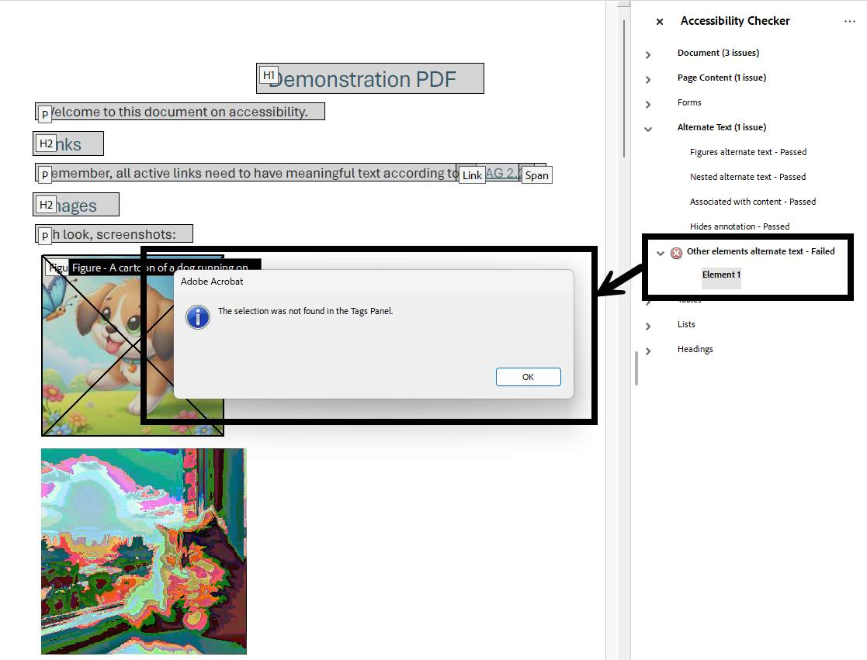
Figure 4 The Reading Order dialog box is open, and the PDF behind it is displaying the reading order with the headers, paragraphs, and a figure of a dog are tagged. The only exception is the final image at the bottom of the PDF, a blurry cat. The Accessibility C

Lists
To ensure a list is accurate, it must have:
- the List <L> tag
- List Item <LI> tags
They may also have the Label <Lbl> and List Body <Lbody> tags.
In the Accessibility tags panel image below, the first tagged item is <LI>, which contains the word, "Black," as it is listed as the first item on the document to the right of the Accessibility tags panel. Observe the two different tags listed in the Accessibility tags Panel in the image. The first tag is the List <L> tag. Under the List <L> tag are the List Item <LI> tags.
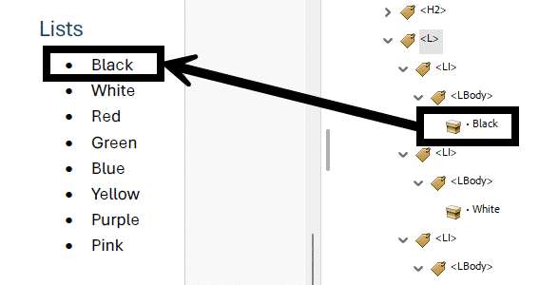
Figure 5 A list of colors with the color "black" on it. There's an arrow from it to where it appears in the Accessibility tag panel.

Background/Artifact
Adobe Acrobat’s Reading Order tool allows authors to manually zone page content and either add or remove this information to the document’s reading order. Content that does not belong as part of the document’s reading order can be marked as Background/Artifact. Be careful to use this option if the content is truly decorative or repetitive (e.g., the same logo that appears on every page), setting something as a Background/Artifact removes that information from the reading order and the content won't be communicated to the end-user.
Decorative images that have no relevance to the context of the document such as decorative image borders and dividers, page numbers, headers, and footers are often best tagged as Background/Artifact.
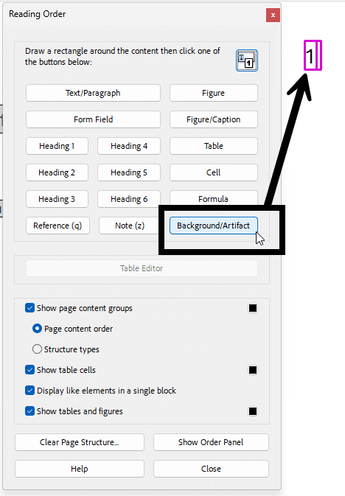
Figure 6 The Reader Order tool is open and the Background Artifact button is highlighted and marked with a box. An arrow is pointing from the box to the page number in the upper-right corner of the PDF, which has a dark pink box around it, indicating that it's t

Learn More About Document Accessibility
For more information about document accessibility, please reach out to CELT by emailing celt@stonybrook.edu (opens in a new tab).
To view additional tutorials and resources, visit CELT's Accessibility page (opens in a new tab).
Please fill out the Feedback Survey Form (opens in a new tab) to record your completion of this course and to provide feedback for improvements.

Figure 7 Stony Brook University's logo

Note on Course Attribution
This course has been adopted from San Diego Mesa College's PDF Accessibility (Self-Paced) course(opens in a new tab), licensed under a Creative Commons Attribution 4.0 International License(opens in a new tab). San Diego Mesa College adopted their training from PDF Accessibility by CCC Accessibility Center(opens in a new tab), licensed under a Creative Commons Attribution 4.0 International License(opens in a new tab). Development of this course was funded by a grant from the California Community Colleges' Chancellor's Office. *Our version is condensed to focus on the Module "Tag Panel" and contains additions to reflect Adobe Acrobat's current navigation and features.

