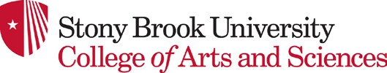
Fall 2025 Newsletter


Dear Alumni and Friends,
DEPARTMENT OF BIOCHEMISTRY AND CELL BIOLOGY
This has been another productive year for Biochemistry and Cell Biology, marked by concurrent faculty searches and successful hires. We are delighted to welcome
four new colleagues to our department: Dr. Vish Chandrasekaran, Dr. Julia Rogers, Dr. Jae-Ho Lee, and Dr. Noureddine Hammamouch. Dr. Chandrasekaran performed his postdoctoral research at the MRC Laboratory of Molecular Biology and Dr. Rogers at the Harvard Medical School Department of Biological Chemistry. We are also delighted to welcome Dr.
Jae-Ho Lee and Dr. Nour Hamamouch. Both Drs. Lee and Hamamouch started their positions in January 2025. Dr. Lee’s laboratory investigates the impact of ribosome speed on the biogenesis and homeostasis of nascent polypeptides (Co-translational Proteostasis). Dr. Hamamouch serves as the principal lecturer in Biochemistry and Cell Biology, overseeing BIO 202.
As we celebrate the arrival of our new colleagues, we bid farewell to our long-serving colleague, Dr. Susan Erster, who served as a senior lecturer in Biochemistry and Cell Biology for 20 years. We extend our heartfelt wishes to Susan in her well-deserved retirement.
A huge congratulations to Eric Girardi, a graduate student in the Hu lab, who was selected as the recipient of the Sanford R. Simon Endowed Fellowship in Biochemistry. We are grateful to Dr. Amy Liao, a former BCB graduate student in Sandy Simon’s lab, for her generous gift to establish the Fellowship. We extend our warmest congratulations to the Stony Brook iGEM team, mentored by our own BCB faculty members, Dr. Peter Gergen and Dr. Kathryn Gunn, who returned with a gold medal from an international competition.
Your support continues to be vital to our department’s success. We express our sincere gratitude to all our alumni and friends who have contributed to the BCB Endowment for Excellence in the past year, with special thanks to Sue and Bill Studier and Professor Erwin London for their generous gifts. We are grateful to
Amy Liao PhD ‘93 for establishing a $1,000,000 Yang Manzhen Endowed Fund. For details, please see the Philanthropy Corner below. The unwavering support of our alumni and friends is deeply appreciated

The upcoming academic year promises to be equally exciting, as we are currently in the midst of two new faculty searches at the assistant professor level.
We remain committed to enhancing Biochemistry and Cell Biology’s strengths and establishing the department as a supportive and nurturing environment for all our students and colleagues.
Sincerely,

Wali Karzai Professor and Chair
Department of Biochemistry and Cell Biology

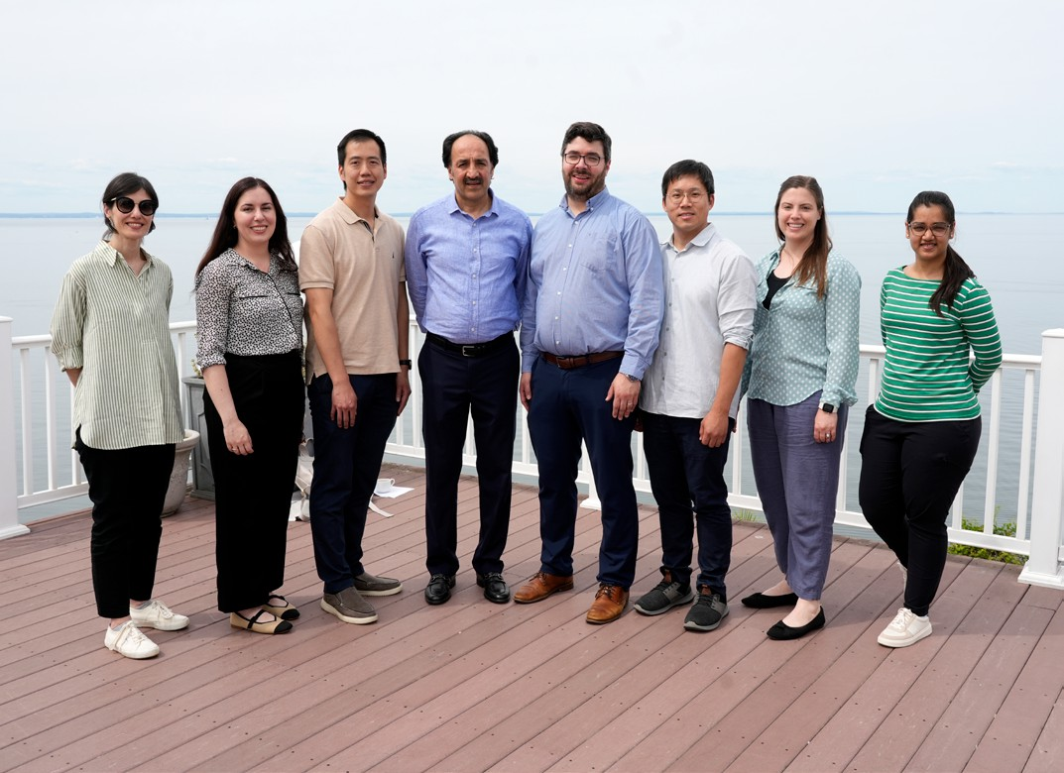
Left to right: Lina Carlini, Julia Rogers, Benjamin Lin, Wali Karzai, Professor and Chair, Jonathan Nelson, Jae Ho Lee, Kathryn Gunn, and Stuti Sharma at the beautiful Port Jefferson Country Club during our annual department retreat.

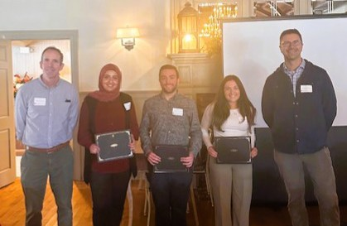
Our PhD programs in Molecular and Cellular Biology (MCB) and Biochemistry and Structural Biology (BSB) continue to be at the forefront of biological science education. These rigorous programs are designed to equip graduates with the skills and knowledge necessary for thriving careers in both academic research and the dynamic biotechnology industry.

A highlight of the academic year was the annual BSB/MCB Retreat, held in October at the picturesque Old Field Club. This valuable event brought together faculty for insightful presentations and showcased the
impressive research of our fourth year students in a lively poster session.

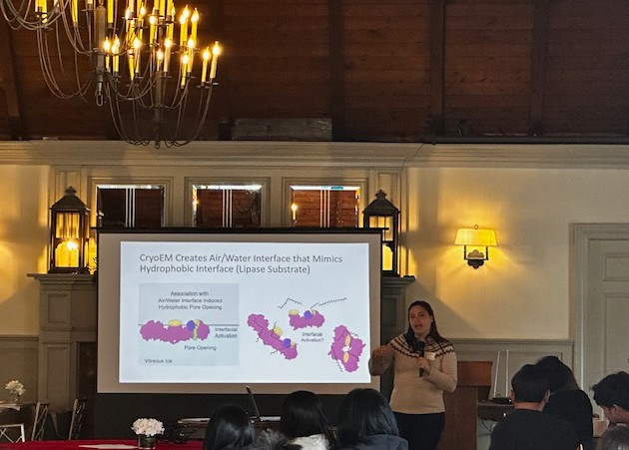
We’re thrilled to announce the winners of this year’s poster presentations:

- Jowana Obeid (MCB)
- Deanna Peperno (MCB)
- Antonio Torlentino (BSB)

Congratulations to Jowana, Deanna, and Antonio on their outstanding work! Their achievements underscore dedication and innovative spirit within our programs.

BSB Program Welcomes New Talent and Celebrates Graduates

The Biochemistry and Structural Biology (BSB) Program is thrilled to announce a successful admissions season, and we look forward to welcoming six new students in Fall 2025! We’re especially proud to share that one of our incoming students, Behrgen Smith, is a recipient of the prestigious Graduate Council Fellowship. You can discover more about all our incoming students on the program website.
A proud moment at the 2025 PhD Hooding Ceremony! (Pictured on right.) Congratulations to all the graduates, including our own Dr. Leonidas Pierrakeas. A huge accomplishment for all!

Celebrating Our Accomplished Graduates
We also want to recognize the remarkable achievements of several BSB students who graduated over the past year. Their dedication and groundbreaking research are truly inspiring:

- Yu-Ching Chen, PhD
Spring ‘24, Advisor: Nicole Sampson
Dissertation: “Uncovering the Roles of Mycobacterium tuberculosis melH in Redox and Bioenergetic Homeostasis: Implications for Antitubercular Therapy”
(Defended March 6, 2024)

- Abhik Tambe, PhD
Summer ‘24, Advisor: Ramana Davuluri
Dissertation: “Traversing the hierarchy: understanding multi-level (dys)regulation of somatic hypermutation using interpretable deep learning, multi-omics and structural modeling” (Defended July 22, 2024)

- Samruddhi Jewlikar, PhD Winter ‘25, Advisor: Peter Tonge
Dissertation: “Probing the signaling transduction mechanism of the light-activated adenylate cyclase OaPAC using unnatural amino acid mutagenesis”
(Defended January 17, 2025)

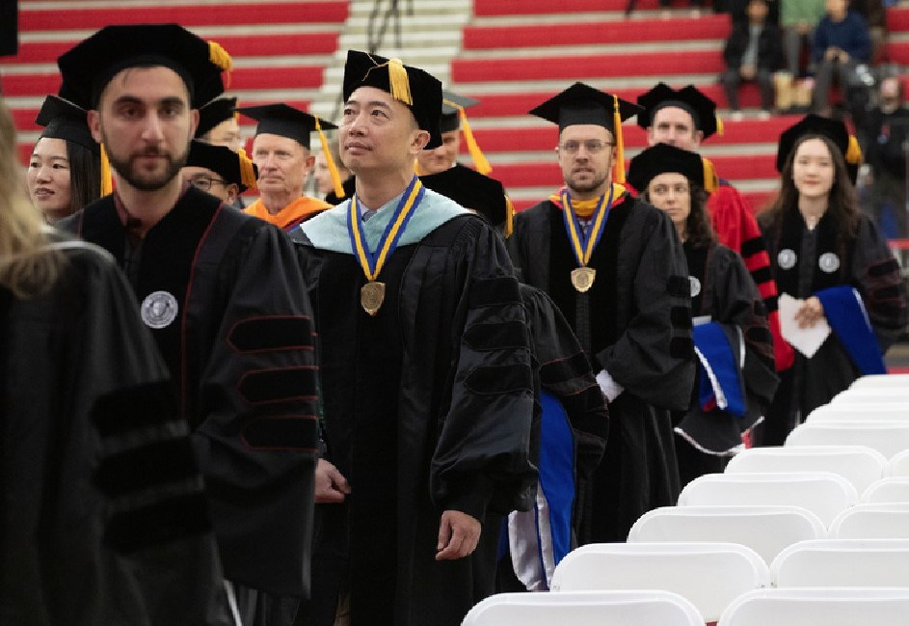
Dr. Leonidas Pierrakeas with Ed Luk, Steven Glynn, Taylor Rahn, Michael Airola, and Lingshuang Wu.

- Ian Outhwaite, PhD
Spring ‘25, Advisor: Markus Seeliger
Dissertation: “Overcoming On-Target Resistance in Human Cancers” (Defended February 12, 2025)

Ian is also the distinguished recipient of the 2025 President’s Award to distinguished doctoral students, awarded by the SBU Graduate Council.

Congratulations to all our graduates! We’re excited to see the impact they’ll continue to make in the scientific community.
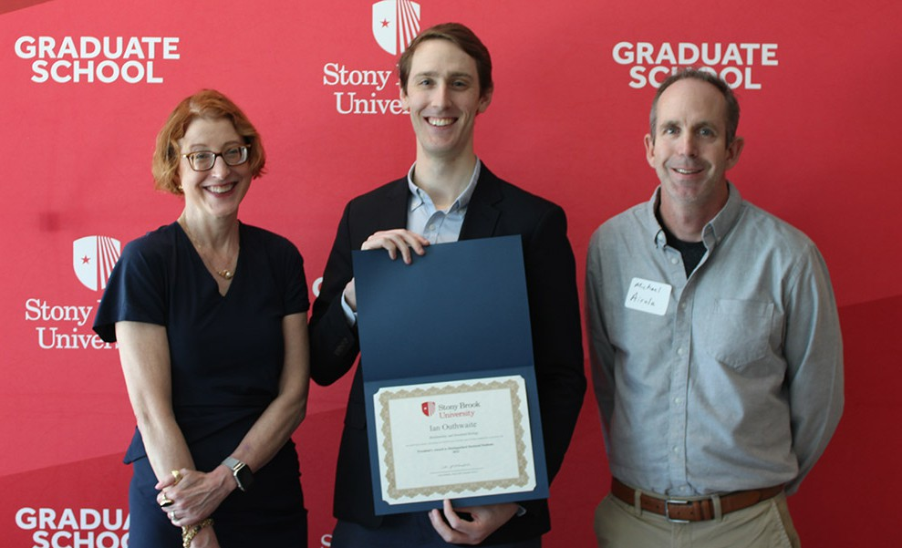
Ian Outhwaite celebrating his accomplishments alongside Dean Celia Marshik and Program Director Michael Airola.

MCB Program Welcomes Large Incoming Class

The Molecular and Cellular Biology (MCB) PhD program had an outstanding admissions season, welcoming fifteen new students for Fall 2025!
We’re excited to announce that Katelyn Grote is an incoming Graduate Council Fellowship recipient. Additionally, Emily de Onis, an SBU Biochemistry MS graduate, will be joining Dr. Ed Luk’s lab directly. You can learn more about all our talented incoming students on the website.

Celebrating Our Recent MCB Graduates

We are incredibly proud to recognize the dedication and significant achievements of the students who graduated from the MCB program over the past year:

Summer 2024
  - Cynthia Converso, PhD Advisor: Ed Luk
Dissertation: “Nucleosomal DNA sequence stimulates the remodeling activity of the SWR complex and influences histone H2A.Z targeting” (Defended August 2, 2024)

  - Robert Morabito, PhD Advisor: Benjamin Martin
Dissertation: “Exploring the Role of Sox2 and Cell Cycle Dynamics in Zebrafish Tailbud Midline Progenitor Cells” (Defended July 15, 2024)

  - Manojit Mosur Swamynathan, PhD Advisor: Lloyd Trotman
Dissertation: “Nutrient Therapy of Prostate Cancer” (Defended June 25, 2024)

Fall 2024
  - Danielle Guercio, PhD Advisor: Elizabeth Boon
Dissertation: “Characterizing the role of the histidine kinase NahK in Pseudomonas aeruginosa” (Defended September 3, 2024)

Spring 2025
  - Mojtaba Sadeghi, PhD Advisor: Yusuf Hannun
Dissertation: “Investigating the Biological Roles of Protein Kinase Ca in Non-small Cell Lung Cancer”
(Defended March 11, 2025)
- Samantha Hayashi, PhD Advisor: Yusuf Hannun
Dissertation: “EGFR kinase domain: signaling specificity
and Mig6 regulation” (Defended March 13, 2025)

- Maheen Rashid, PhD Advisor: David Thanassi
Dissertation: “Investigating the regulated production of outer membrane vesicles and tubes in Francisella novicida” (Defended March 18, 2025)

- Grace Himmler, PhD Advisor: Erich Mackow
Dissertation: “Mechanisms of Powassan Virus Attenuation” (Defended March 20, 2025)

- Leonidas Pierrakeas, PhD Advisor: Ed Luk
Dissertation: “Investigating the function and targeting of variant chromatin structures” (Defended April 7, 2025)

- Mohammad Fauzan, PhD Advisor: Martin Kaczocha
Dissertation: “Astrocytic FABP5 Modulates Retrograde Endocannabinoid Transport at Central Synapses of the Brain” (Defended April 28, 2025)

- Faniya Doswell, PhD Advisor: Martin Kaczocha
Dissertation: “Investigation of Myeloid-FABP5 in
Inflammation and Pain Signaling”
(Defended April 30, 2025)

- Heng Liang, PhD Advisor: Alea Mills
Dissertation: “PRMT5/WDR77 Enhances the proliferation of Squamous Cell Carcinoma via the “ΔNp63a-p21 axis” (Defended May 9, 2025)

Second Year Symposium Highlights Emergining Research

In May, the program hosted its second annual Symposium, where our second-year students eloquently presented their ongoing research. Congratulations to all the student presenters for their excellent work:
  - Francesco Castelli
  - Jiyao Chai
  - Lirong Chan
  - Eric Girardi
  - Sophia Long
  - Colin McLaughlin
  - Auntara Nandi
  - Daniel Toobian
  - Wenyi Yang

Their presentations showcased the exciting and diverse research happening within the MCB program!

More information on our PhD Programs can be found on our website.
Molecular and Cell Biology: Biochemistry and Structural Biology:

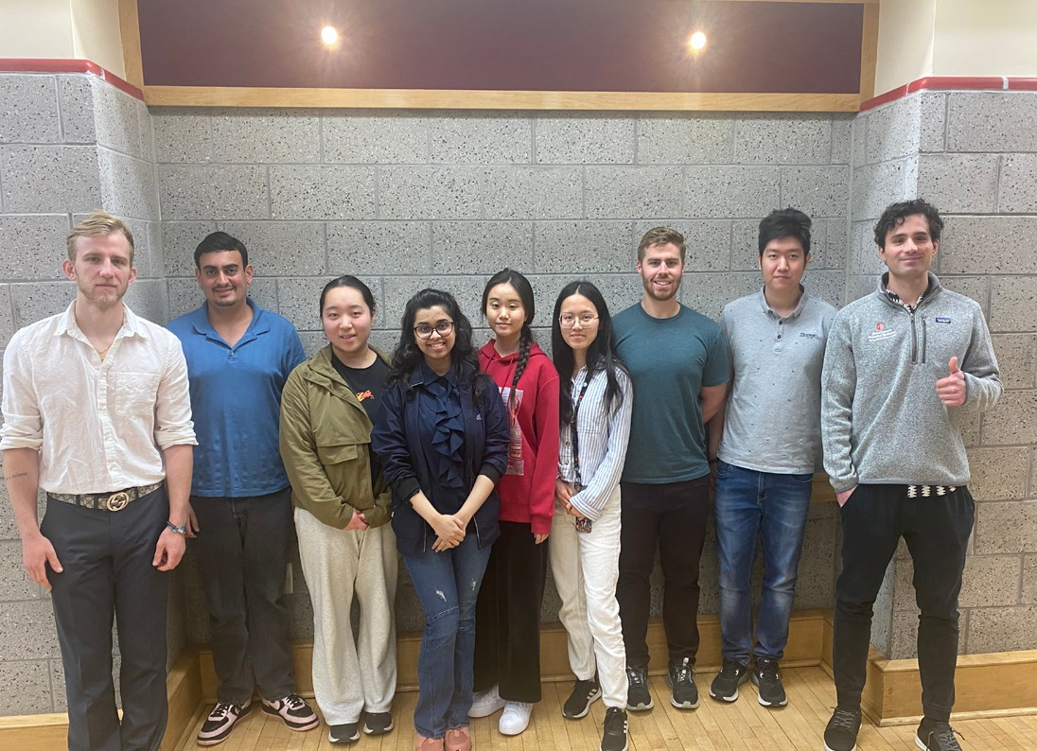
Pictured left to right: Francesco Castelli, Daniel Toobian, Lirong Chan, Auntara Nandi, Sophia Long, Wenyi Yang, Colin McLaughlin, Jiyao Chai, and Eric Girardi. We’re so proud of their hard work and excellent presentations!

Celebrating 15 Years of Excellence:
The Biochemistry and Cell Biology MS Program

The Biochemistry and Cell Biology MS graduate program is about to enter its fifteenth year and by all metrics, continues to be a success! This program aims to prepare our graduate students for careers in the life sciences by providing a strong foundation in both theoretical and practical biochemistry and cell biology. As measured by our student career outcomes, we are meeting our goals.
Program Success by the Numbers (as of last year):
Outstanding Graduation Rate: 94% of our admitted students have graduated, typically within three semesters.
Academic Excellence: Our students are academically competitive with their graduate cohorts, including 1 st year Ph.D. students, with 93% of BCB MS students
earning a B or better in graduate biochemistry, genetics, and cell biology courses.
Advanced Degree Pathways: Approximately 40% of our BCB MS graduates have been admitted to prestigious PhD, MD, or DDS programs. These alumni have pursued their doctoral studies at excellent institutions such as Stony Brook University, Johns Hopkins, Cornell, Einstein, Mt. Sinai, and Imperial College (London), to name a few.
Impressive Employment Opportunities: Equally impressive, about 42% of our graduating students have secured research positions at leading pharmaceutical companies, including Regeneron, Pfizer, and Aldatu Biosciences, or at esteemed academic institutions
like Rockefeller University, Yale, Stanford, Stony Brook University, Sloan Kettering, and Cold Spring Harbor Laboratory.
We are immensely proud of our dedicated students and the faculty who provide invaluable mentorship throughout their journeys.

BCB MS Alumni News
We love to celebrate the achievements of our alumni!
  - Louie Pierrakeas ‘20, BCB MS:
Congratulations to Louie, who successfully defended his PhD thesis based on his work in Ed Luk’s laboratory.
  - Emily DeOnis ‘23, BCB MS
We are delighted that Emily will be returning to SBU to pursue her PhD in the MCB program.
  - Cynthia Converso ‘18, who defended her thesis in Summer 2024 based on work she performed in Ed Luk’s laboratory.
  - Robert Morabito ‘16, who defended his thesis in Summer 2024 based on work he performed in Ben Martin’s laboratory.
- Jiyao Chai ‘22, now in his second year of PhD studies in the Airola lab
- Lirong Chan ‘22, now in her second year of PhD studies in the Luk lab.
Class of 2023 Career Highlights:
- Brandon Thrope: Congratulations to Brandon, who is now a Quality Control Analyst II at Werfen Technology Center in Orangeburg, NY.
- Declan Wallace: Declan is employed as a Scientific
Associate IV at Brookhaven National Laboratory.
- Ryan Swick: Ryan is working as a lab technician in the Kurosaki lab, Department of Biotechnical and Clinical Laboratory Sciences, at the University of Buffalo.
We look forward to many more years of continued success for the Biochemistry and Cell Biology MS program and its graduates!

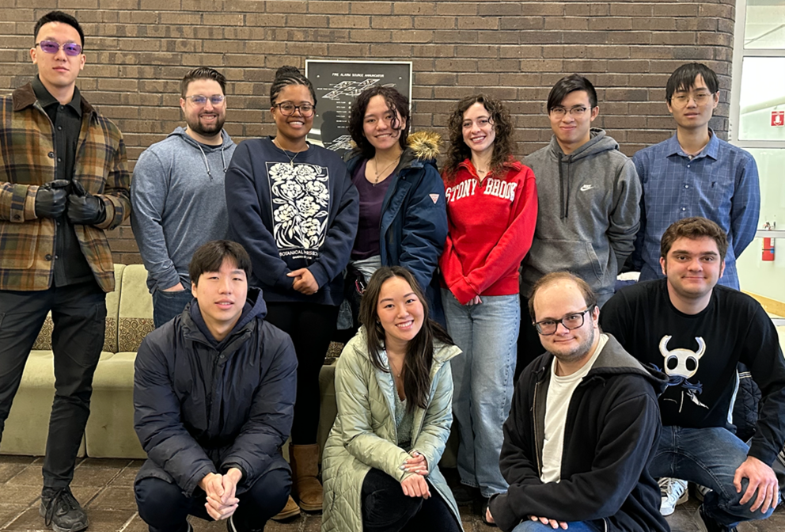

Left to right; Kai Bou, Jake Masters, Joninne Douglas, Hana Colagrosso, Kendra Byrne, Victor Lam, TianHan Wang, Hasung Jung, Samantha Sita, Evan Zuppani, Joseph Epstein

Sincerely, Neta Dean, Program Director

Details about the BCB MS program
Details about our new accelerated BCB BS/MS program

2025 Undergraduate Biochemistry BS Graduate
Achievements

2025 Biochemistry Major Ward Melville Valedictorian
(GPA 4.0)
  - Gan Shi
2025 Goldwater Scholar
Sean Krivitsky
2025 Phi Beta included five graduating Biochemistry
majors
- Benjamin An • Limin Li Hsin Hua Lin
- Kai Bou • Tashu Patel
- Jane Chen • Michael Pulle
- Peter Gillespie • Kesavan Sahaana
- Rachel Zhao

2025 Biochemistry Major Graduates Completing Honors Thesis:
- Ama Fernando (Mentor: Dr. Shipra Agrawal): “Role of Selective Modulation of PPARg in Water Retention Through the Collecting Duct”
- Nigina Kirgizbaeva (Mentor: Dr. Bettina Fries): “The Role of Sirtuins in Aging of Cryptococcus neoformans”
- Kathryn Ravano (Mentor: Dr. Roger Sher): “Characterizing the Effects of Colchicine-Induced Polyploidy on Endoreplication and Cycle Dysregulation”
- Colman Shaver Honors College (Mentor: Dr. Benjamin Martin):
“Developmental Signaling in Regenerative Models: Consequences of id3 Induction on Regenerating Muscle”
- Amanda Strohm (Mentor: Dr. Peter Tonge):
“Time-Dependent Inhibition of E. coli Leucyl-tRNA Synthetase”
- Rachel Zhao (Mentor: Dr. Dada Pisconti): “Maintains the Balance Between Quiescence and Differentiation in Muscle Stem Cells”
- Nikhil Pasumarthi Honors College (Mentor: Benjamin Lin):
“The Role of Septin Proteins in Primordial Germ Cell Migration in Drosophila”
2025 Other Majors completing honors thesis mentored by BCB Department faculty:
Isabella Janowicz - WISE Biology
(Mentor: Dr. Bernadette Holdener):
“POGLUT2/3’s relationship with Fibrillin Network Organization and Signaling in Digit Separation”
Wendy Zeng – Biology (Mentor: Dr. Ed Luk): “Developing a Chromatographic Methodology to Isolate Chromatin Particles Based on DNA Sequences”
2025 Summer Undergrad Research Awards to Biochemistry majors or other majors mentored by BCB Department faculty:
Biology Alumni Research Award
Randhula Wickramasinghe, Biochemistry Mentor: Dr. Simmerling, Chemistry
Ann Zhang, Biochemistry – Mentor: Dr. Peter Gergen (Biochemistry and Cell Biology)
Denise Loring Undergraduate Research Award
Aman Mistry, Biochemistry – Mentor: Dr. Benjamin Martin (Biochemistry and Cell Biology)
Explorations in Stem
Sierra Fiano, Biochemistry – Mentor: Dr. Stuti Sharma (Biochemistry and Cell Biology)

Francisco-Anderson Family Undergrad Research Award

Benjamin Costa, Biochemistry
Mentor: Dr. Peter Gergen (Biochemistry and Cell Biology)

Manahil Kashif , Biochemistry – Mentor: Dr. May Shelly (Neurobiology and Behavior)

Mitchell Wortzman Undergraduate Research Award

Trinity Hausch, Biochemistry
Mentor: Dr. Siu Chiu Chan (Medicine)

Steven K. Galson Undergraduate Research Award

Shalom Obimba, Biochemistry
Mentor: Dr. Peter Gergen (Biochemistry and Cell Biology)

SUNY SOAR Program
Samiah Cann, Biochemistry
(Dr. Eric Josephs, Biomedical Engineering)
Fatemeh Dehpanah, Biochemistry
(Dr. David Montrose, Medicine)
Jialin Li, Biochemistry
(Dr. Jeffrey Lipshultz, Chemistry)
Justin Lim, Biochemistry
(Dr. Hyungjin Kim, Pharmacological Sciences)
Jun Lin, Biology
(Dr. Lina Carlini, Biochemistry and Cell Biology)
Raisa Suha, Biology
(Dr. Kathryn Gunn, Biochemistry and Cell Biology)

URECA
Kevin Byun, Biochemistry
(Dr. Leonard Cheung , Physiology and Biophysics)
Damian Davila, Biochemistry
(Dr. Michael Airola, Biochemistry and Cell Biology)
Natalie Eng, Biology
(Dr. Steven Glynn, Biochemistry and Cell Biology)
Mariam Hassan, Biochemistry
(Dr. Martin Kaczocha, Anesthesiology)
Mahir Hossain, Biochemistry
(Dr. Jeffrey Lipshultz, Chemistry)
Dan Jian, Biochemistry
(Dr. Gabor Balázsi, Biomedical Engineering)
Soo Ah Kwak, Biochemistry
(Dr. Sian Piret, Medicine)
Tetiana Nika, Biology
(Dr. Chi-Kuo Hu, Biochemistry and Cell Biology)
Hector Romero, Biochemistry
(Dr. Christopher Clarke, Medicine)
John Sengstock, Biochemistry
(Dr. Nurit Ballas, Neurobiology and Behavior)
Aberam Sriganesh, Biochemistry
(Dr. Gabor Balazsi, Biomedical Engineering)
AaronTu, Biochemistry
(Dr. Benjamin Lin, Biochemistry and Cell Biology)
Sophie Xiao, Biochemistry
(Dr. Jun Chung, Pathology)
Xingyu Xiao, Biochemistry
(Dr. Elizabeth Boon, Chemistry)
Amo Zheng, Biochemistry
(Dr. Dale Drueckhammer, Chemistry)
Becky Zhu, Biochemistry
(Dr. Chander Sadasivan, Neurological Surgery)

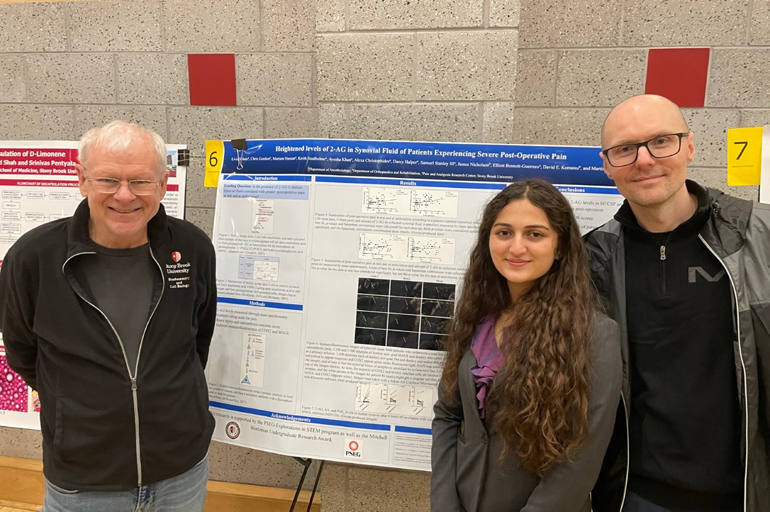

L-R: Peter Gergen, Mariam Hassan and Martin Kaczocha at the 2025 URECA Celebration. Mariam is a BCH major in the WISE Honors Program and received the Mitchell Wortzman Undergraduate Research Award from the Biology Program to support her research in Dr. Kaczocha’s lab in the summer of ‘24.

URECA Biology Alumni Research Award
Meha Dhyani (Computer Science) – Mentor: Dr. Peter Gergen (Biochemistry and Cell Biology)

URECA/iGEM (Mentor Dr. Peter Gergen, Biochemistry and Cell Biology)

- Parker Fording, Applied Mathematics and Statistics
- Coco Gao, Computer Science
- Doorva Garg, Biomedical Engineering
- Bevis Jiang, Biochemistry
- Samuel Li, Biology and Psychology
- Leslie Liu, Biology
- Rachel Liu, Biology
- Hamza Raja, Biology and Psychology
- Duaa Zeeshan, Biology

Velay Fellowship for Women in Science

Alexandria Lewkowski , Biochemistry
Mentor: Dr. Lina Carlini (Biochemistry and Cell Biology)

Elaine Mei, Biochemistry
Mentor: Dr. Galadriel Hovel-Miner (Microbiology and Immunology)

Faculty Updates

Michael Airola, Associate Professor
Mike continued as the Program Director of the Biochemistry and Structural Biology PhD Graduate Program and maintained his involvement with the American Society of Biochemistry and Molecular Biology (ASBMB), serving as the Co-Director of the ASBMB Lipid Research Division, and on the Editorial Boards of the Journal of Biological Chemistry and the Journal of Lipid Research. He presented talks at the 65th International Symposium Advances in Biological Regulation held
in Bologna, Italy, and the École normale supérieure in Paris. In Paris, he spent two weeks in the lab of Dr. Rachid Thiam to continue their collaborative research on lipid droplet biology, and also made time to attend several PSG football matches.
The lab continues to grow, but we will be sad to say goodbye to two members: Taisha Elizaire, who graduated with her degree in Psychology, and Taylor Rahn, who is expected to graduate with her PhD this August. Taylor will continue in research as a postdoc at Yale. The lab welcomed four new students: Kevin Shionarain and Rishav Mitra who both joined from the Biochemistry and Structural Biology PhD program, and Yiru Lu and Damian Davila, as new undergraduate researchers.
Significant research breakthroughs include helping develop a new biosensor for our favorite lipid phosphatidic acid, characterizing the human lipase as a triglyceride transacylase, and identifying a structural
mechanism for phosphatidic acid recognition by the lipin family of enzymes.

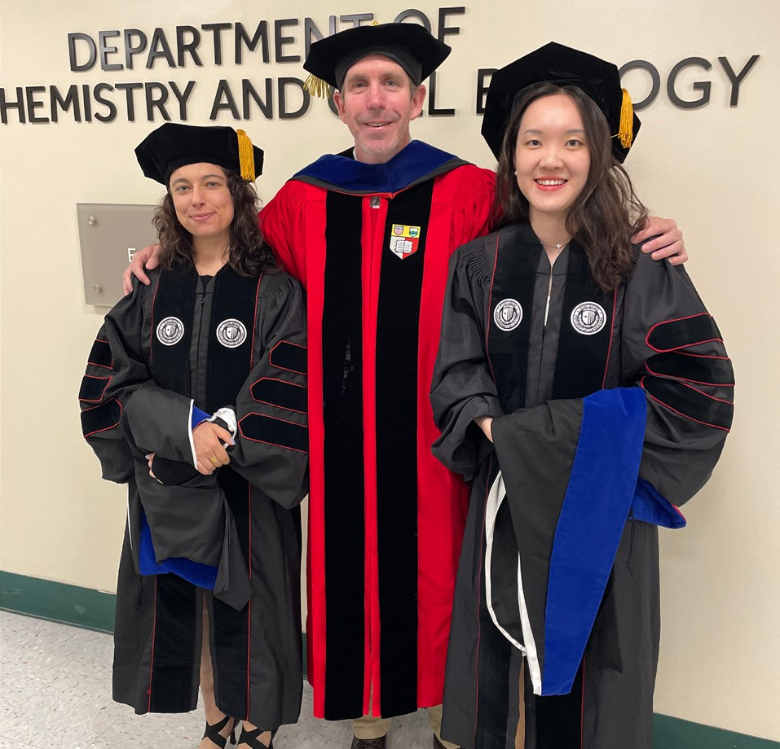
Left to right: Taylor Rahn, Michael Airola, Lingshuang Wu

In other news, Franceine Welcome co-organized the Gordon Research Seminar on the Molecular and Cellular Biology of Lipids in New Hampshire, and Rideeta
Raquib co-organized a Career Exploration for Scientists symposium. Lingshuang Wu was selected to give a talk in the main session at the annual ASBMB conference in Chicago. Jiyao Chai, an MCB 2nd year, won a best poster award at the Department Retreat. Damian was awarded a URECA fellowship for summer research.
Current members of the lab include Dr. Shujuan Gao, Taylor Rahn, Lingshuang Wu, Franceine Welcome, Doug Marr, Khalayi Aywa, Rideeta Raquib, Kevin Shionarain, Rishav Mitra, Yiru Lu, and Damian Davila.
The lab remains funded by a R35 MIRA grant from NIGMS, the Alfred P. Sloan Foundation, and is happy to report funding from a new multi-PI grant (co-PIs:
Del Poeta, Airola, Ojima, Rizzo) from NIAID entitled “Developing new antifungals against sterolglycosidases”.

Ivet Bahar, Professor & Director, Laufer Center for Physical and Quantitative Biology

Two new R01s have been awarded, one starting on 9/15/2024, and the other on 5/1/2025, both for five years. The respective titles are “The Role of HIV Proteins in Psychostimulant Abuse” and “Regulating Dopamine Transport Through Allosteric Modulation- Functional and Behavioral Studies”. The former is a collaborative project with the University of Alabama (MPI: Bahar, Galli and Carter), and the 2nd is a collaborative project with Drexel U (PI: Mortensen). Apart from the significant progress has been made in the R01 “Structure….” (MPI: Bahar and Vilardaga), which lead to an important publication (Zhang et al., 2025). Two other major milestones are the development of the pathogenicity predictor Rhapsody 2.0 (Banerjee, Bogetti, Bahar, PNAS 2025) and the demonstration of the significance of hinge sites as targets for binding drugs (Zhang, Gur & Bahar, PNAS 2025). Apart from these studies, our collaboration with Emory U (funded by 2 R01s) on breast cancer immunotherapy is in progress (Chi et al., Nature 2025).

2025 Lab Graduate- Haotian “Frank” Zhang

Other Bahar lab news:
Anthony Bogetti- Awarded best Postdoc talk, “The Next Frontier in Protein Structure Prediction: Pathways and Kinetics” at the 2025 Laufer Center Spring Retreat.
Hoang Nguyen- Awarded best poster presentation, “Switching States: VPS13 Conformations and Dynamics Governed by Hinge Sites” at the 2025 Laufer Center Spring Retreat.
Matthew Licht has been selected as a NIH T32 Fellow in the prestigious Chemical Biology Training Program (CBTP) at Stony Brook University. This significant achievement is a testament to Matthew’s dedication,
hard work, and exceptional talent in the field of chemical biology. The T32 Fellowship is a highly competitive and esteemed award that supports the training of promising young scientists.
Carlos Ventura, PhD student in the Chemistry Program Laufer Center Physical and Quantitative Biology track, has been invited to participate in the Innovation Programs’ Leadership Development Academy of the Annual Biomedical Research Conference for Minoritized Scientists (ABRCMS)

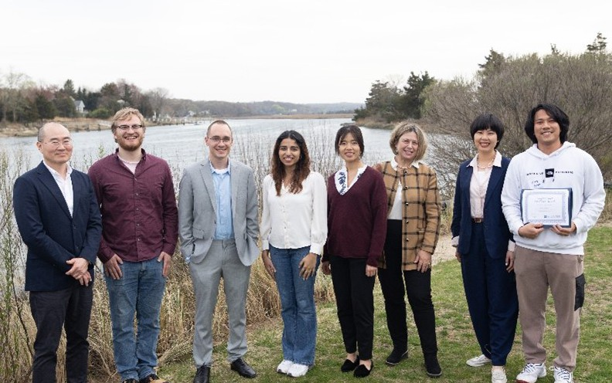
Bahar lab Spring Retreat

Paul M. Bingham, Associate Professor, with Zuzana Zachar & Shawn D. Stuart

The most important scientific project we are finishing is the last set of experiments necessary to support patent applications for second generation drugs of the
CPI-613 family. These novel agents are expected to robustly improve clinical performance, perhaps representing powerful, pan-cancer agents. After
retirement, Paul and Zuzana will continue to consult on a voluntary basis with Stony Brook’s Intellectual Property Partners (IPP) to support licensing of these new agents for clinical development.
Paul is working with Shawn Stuart to refine a system to allow Shawn to continue to teach our longstanding course on human evolution and its implications for the human condition (BIO358). BIO358 has been exceptionally well received by the 14,000 students
Joanne Souza, Shawn and Paul have taught over the last 27 years. We are confident that this tradition of teaching success can be continued. After retirement, Paul will act as a volunteer consultant to Shawn to ensure a smooth transition to deployment of this teaching system under Shawn’s direction.
Zuzana is stepping down as Director of the MAT Biology Program, part of the Institute of STEM education. Zuzana has been running the program since its inception in 1999. During her tenure, the program graduated 372 certified Biology teachers, who are teaching in every one of the
124 school districts on Long Island; others are teaching in NYC schools, including the Bronx High School of Science.
Finally, our last graduate student, Cynthia Vanessa Liliane Ouedraogo, submitted her thesis to the graduate school, thus completing her BCB MS.
As we approach the close of our time here, we want to emphasize our enthusiastic thanks to the diverse group of outstanding colleagues who have made our 43 years at Stony Brook immensely productive and rewarding.

Lina Carlini, Assistant Professor

Two undergraduate researchers in the Carlini Lab were recognized with competitive summer fellowships.
Alexandria Lewkowski (pictured below) was awarded
a Frances Velay Fellowship and was also named
Undergraduate students:
- Ka Ho Cao • Andrea Murati
- Laith Hana • Ryan Seecharan
- Jody Huie • Chao Feng Zhang

Researcher of the Month by Stony Brook’s URECA program. Jun Lin received a URECA Summer Fellowship to support independent research in cell and molecular biology. We are proud to support their continued development as young scientists!
- Shirley Jiang
- John Kaba
- Eva Lai
- Karen Lin
- Nicole Zhao
- Amy Zheng
- Michelle Zhu

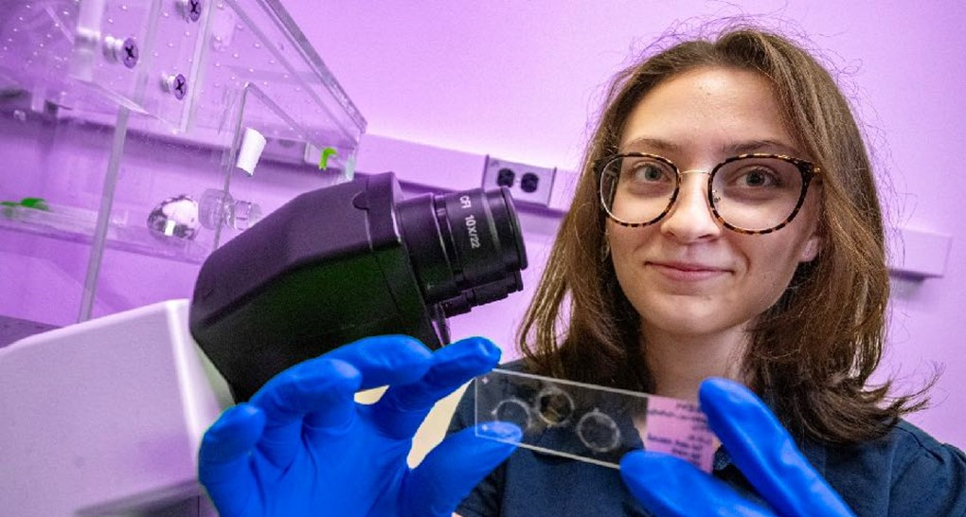

Vitaly Citovsky, Distinguished Professor

Vitaly continues to be funded by NIH, NSF, and BARD. Vitaly continues to serve on Editorial Boards of PLOS ONE, Scientific Reports (Nature Publishing Group), Biochemical and Biophysical Research Communications (BBRC), F1000 Research, Frontiers in Plant-Microbe Interactions, Frontiers in Plant Physiology, Plant Signaling & Behavior, and Communicative and Integrative Biology. Vitaly served on the MIRA ZRG1 CBD-N (55) NIH study section. Vitaly serves on the Departmental Awards Committee and on the University Senate Academic Standing and Appeals and Faculty Rights and Responsibilities Policies Committees. Vitaly also taught undergraduate and high school students at the Garcia Center for Polymers at Engineered Interfaces about plant genetic engineering.

Lab Members:
Two new lab members joined our lab this spring. Dr. Alexander Nedo and Ms. Nicole Bergamini.
Graduate students:
Melissa Passik (joint with the Geology Department)

Postdocs:
- Yumin Kan
- Benoit Lacroix
- Alexander Nedo
- Carrie Wright (joint with the Geology Department)

Affiliates:
Sondra Lazarowitz (Emeritus, Cornell University)

Peter Gergen, Distinguished Service Professor

Peter Gergen continues to be PI/PD of the Stony Brook IMSD-MERGE T32 training grant. The current fifth year of this project was an interesting ride to say the least. After submission of what was a very strong application for a competitive renewal in January 2025, the Notice of Award for the fifth year failed to arrive in February and then the institution was informed in late March that the project had been cancelled as it no longer aligned with the NIH mission under the leadership of the new Secretary of Health and Human Services. After much scrambling, institutional support from many sources, including in several cases faculty PIs, was found for all ten current IMSD trainees. The roller coaster ride took another turn in July when a lawsuit initiated by Attorneys General from 23 states led to this governmental action being declared illegal with a judicial order that all the affected grants must be restored. The return of this support is greatly appreciated but did involve a lot of extra administrative work from many offices on campus as well as by NIH staff. Perplexing times! Gergen also is a co-PI on an NSF IUSE Level 2 grant proposal from Binghamton, Geneseo and SBU that aims to disseminate high impact practices, such as undergraduate research and CUREs (Course-based Undergraduate Research) throughout the SUNY system. SBU is the lead institution for Long Island and downstate with proposed activities involving Purchase College. SUNY Old Westbury, Farmingdale State College and Suffolk County Community College in addition to Stony Brook. Gergen is also attending the first National Meeting of the National Institute on Scientific Teaching at Denver University in August 2025.

Peter Gergen is finishing his 15th and final year as the Director of the Undergraduate Biology Program. During this last year the University conducted an open search to identify candidates for this position. He is pleased
to report that Dr. Jordanna Sprayberry, previously from Muhlenberg College in Pennsylvania, has agreed to come to Stony Brook as a faculty member in the Department
of Ecology and Evolution and will assume duties as the Biology Program Director starting on September 1, 2025.

The Biology Program was in the second cohort of academic departments to complete a Self-Study and participate in an external review during the spring of 2025. This review coincided with the upcoming change in leadership. This review reinforced the need for additional resources to support the shared mission of the Biology Program and the three Life Science departments, including additional faculty and staff. Changes to address these needs were already underway with the recruitment to fill one of two vacant Lecturer positions, a vacant Academic Advisor position and a new Assistant Staff position for the Biology Program occurring during the spring semester.
The Division of Undergraduate Education also provided support to relocate the instructor workspace for the Introductory Biology Laboratory courses to a room previously used for storage and equip the vacated instructor workspace to serve as an additional instructional laboratory room for these courses. This will increase the capacity to 48 lab sections each semester, from 1,920 to 2,304 seats per academic year. This increased capacity should allow for a reduction in the backlogged demand for seats in these courses and set the stage for an eventual expansion with projected plans for increased enrollments.

The support for undergraduate research that the Biology Program can provide has continued to grow with significant contributions from alumni. During the 2024/2025 fiscal year the Program received donations
and income from endowed accounts of over $60,000 for the support of undergraduate research. Contributions
to endowed accounts for undergraduate research had a banner year with major donations from Paul Anderson (BCH ’78) and his wife Loise Francisco increasing the balance of the Francisco-Anderson Family Fund for Undergraduate Research to over $800,000. We were extremely pleased that Dr. Anderson was able to return to Stony Brook to serve as the Alumni Speaker at the 2025 Biochemistry and Biology Convocation Ceremony in May. While here, Dr. Anderson and his wife Loise
had the opportunity to meet with one of the two inaugural recipients of the Anderson-Francisco Family Undergraduate Research Award. Maria Pasquale (BCH 86‘) also made contributions to establish an endowed account to support as a permanent offering the Ellen Geis Undergraduate Research Award. With the addition of these generous contributions the Biology Program now has five endowed accounts dedicated to the support of undergraduate research in the biological science with an aggregate balance of nearly $1.2 million.
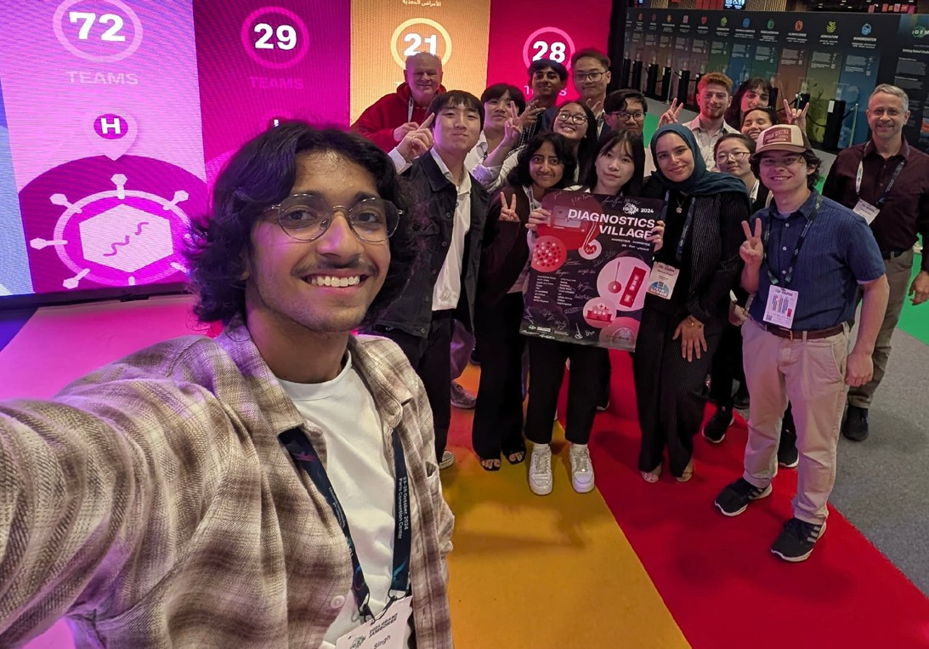
The gold-medal winning iGEM team in Paris with all 15 of the student team members, Peter Gergen and Gabor Balazsi, Biomedical Engineering in front of the iGEM logo

Continued

In the summer of 2025, a total of seventy-one Stony Brook undergraduates received support for immersive research experiences in the biological sciences, eighteen with partial or full stipend support from Undergraduate Biology. Contributions to the Biology Program from Steven Galson (BCH ’78) also supported Stony Brook’s registration for the 2025 iGEM (International Genetically Engineered Machines) competition and the participation of all 15 iGEM team members and two advisors in the iGEM Giant Jamboree in Paris in October 2025. This is the 12th year Stony Brook is participating in the iGEM competition.
The 2024 team brought home Stony Brook’s third gold medal last November with a project aimed at developing a less invasive, more cost effective way to
diagnose B-cell lymphoma. As has been the case for all SBU iGEM teams, the 2025 team is diverse and inter-disciplinary, comprising eight rising sophomores, four rising juniors and three rising seniors with majors
in applied mathematics and statistics, biochemistry, biology, biomedical engineering, computer science, environmental science, and psychology. Their project focuses on the development of a therapeutic strategy to target HIV using a modified CRISPR nuclease. Current HIV therapies are lifelong or limited by resistance and targeting. The 2025 iGEM team aims to develop a Cas13a-based fusion protein as a safer and more adaptable treatment for HIV. The fusion protein will consist of a ligand designed to bind specifically to CD4+ T-helper cells, a toxin to mediate cellular uptake, and Cas13a. Once inside the target cells, guide RNAs (gRNAs) will direct Cas13a to the HIV mRNA, enabling the enzyme to cleave the viral RNA and inhibit replication. They have been hard at work all summer, are looking forward to the Giant Jamboree, and hopefully to returning with another gold medal.

Kathryn Gunn, Assistant Professor

This January, the Gunn Lab proudly celebrated our
- year lab anniversary—complete with cake and plenty of excitement for what’s ahead! Over the past year, we’ve expanded our team and made some exciting strides in research.
We were thrilled to welcome several rotation students and undergraduates, along with three new core members:
  - Tom Whitbread, Lab Technician
  - Dr. Dana Diaz-Jimenez, Postdoctoral Fellow
  - Azi Mahdavinia, BSB Graduate Student

Our research milestones this year included:
  - Purifying our first protein on our new AKTA
  - Collecting our first cryo-EM dataset at Stony Brook
University (SBU)
  - Capturing our first fluorescent microscopy images at
CMIC
We’re incredibly proud of these accomplishments and can’t wait to see what discoveries next year brings!
Outside the lab, we stayed active in the scientific
community:
  - Kathryn attended the ASCB Annual Meeting in San Diego
  - Kathryn and Tom represented the lab at the NY Area CryoEM Symposium at NYU, where Kathryn gave a talk and Tom presented a poster
  - Isabella Berger, a graduating undergraduate, presented her work at the SBU Undergraduate Research Symposium
  - Raisa Suha, another undergraduate researcher, was awarded a SUNY SOAR Summer Research Fellowship—congratulations, Raisa!
  - And to top it all off, Kathryn published her first
research manuscript at SBU in Science Advances

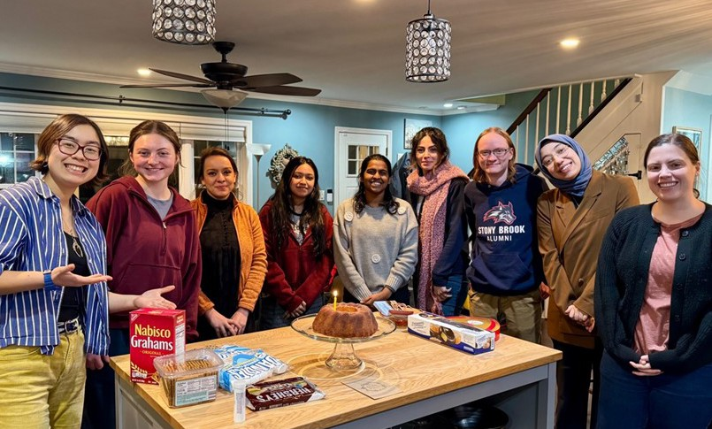

Gunn Lab celebrating 1-year anniversary. From Left: Isabella Berger, Alyvia Herman, Dana Diaz-Jimenez, Raisa Suha, Aparna Dileep, Azi Mahdavnia, Tom Whitbread, Hatice Baysal, and Kathryn Gunn

Bernadette Holdener, Professor

Bernadette Holdener, in collaboration with Dr. Robert Haltiwanger at University of Georgia, is investigating the role of protein glycosylation in embryonic development. The Holdener lab uses mouse mutations to determine why sugar modifications on groups of proteins with Thrombospondin type I repeats (O-linked glucose-fucose disaccharide) or Epidermal Growth Factor motifs (O-glucose) are important for embryo development.
Mutations that block these modifications alter the physical properties of the extracellular environment and impact morphogenesis, cell migration, and differentiation.
Understanding the molecular basis for the developmental defects in the mouse mutants will provide a better understanding of what causes common human birth defects including skeletal, lung and cardiovascular abnormalities. Bernadette and Dr. Thomsen continue to co-teach the core Developmental Biology course for the Biology Major Developmental Genetics track. She serves as the Director of Undergraduate Biochemistry Majors, is a member of the Biochemistry and Cell Biology Executive committee and Chairs the Stony Brook University Stem Cell Research Oversight committee.
2025-2026 will be Dr. Holdener’s final year at Stony Brook. She thanks her colleagues and former students for an exciting and fulfilling 30 years!
2025 Holdener Lab Alumni Updates: Former high school student Dr. Michael Feldman, MD, PhD joined Kymera Therapeutics in MA as the Executive Medical Director, Immunology and Inflammation Clinical Development.
Richard Grady, long time lab manager, retired in July. He and his wife and menagerie are relocating to Pennsylvania. Dr. Lance Lee (former MCB PhD student) was promoted to Professor in the Department of Pediatrics at the University of South Dakota Sanford School of Medicine. Dr. Christina Leonhard (former Genetics PhD student) is currently President and CEO National Cord Blood Network, Inc and Co-Founder and
Scientific Director Cord Blood Transplant Support Group, and Principal Consultant Wenatchi Group, Inc. Andrew Sillato (former Undergraduate) finished his first year
of his PhD program at Columbia and is a brand-new member of Ruben Gonzalez’s lab in the Department of Chemistry. He will be working on smFRET studies of
divalent anion sodium symporters (DASS) for his thesis.

Nancy Hollingsworth, Distinguished Teaching Professor

The Hollingsworth lab continues to study meiosis in budding yeast with the help of an NIH MIRA grant. Nancy was an invited speaker at the SFB Meiosis Symposium in Vienna, Austria in February. She was a Faculty Marshall for the 2025 Biochemistry/Biology undergraduate commencement ceremony and hosted Bill Sullivan, Sean Burgess and Amy MacQueen for the departmental seminar series. Last July, Nancy became a grandmother to Emma’s son, Jasper.
Alumni news: Former High School students: Cody Cheng placed second in the Microbiology category of the
Long Island Science and Engineering Fair based on his research in the lab and is going to start his undergraduate studies at Brown University in the Fall. Evan Cheng graduated from NYU and will be starting medical school at Hofstra University in the fall. Former Master’s students:
Dimitri Joseph is nearly finished with the PhD part of his DO/PhD program at Michigan State University and became a father in February. Bob Gaglione, currently a technician in the lab, is getting married this year. Izza Ilya graduated with her Master’s degree in December
2024. Former PhD students: Andrew Zeisel is also getting married this year and starting a new job as a Research Assistant Professor at Binghamton University. Current members of the Hollingsworth lab: Lihong Wan (Senior Research Scientist), Bob Gaglione (technician), Raunak Dutta (BSB Graduate student), and undergraduates Tyler Nagosky, Craig Chen, and Jaenai Tercius.

Chi-Kuo Hu, Assistant Professor

Our lab has had an exciting year. We have expanded our team with the addition of an BCB master’s student, Vincent Lam, and a Genetics PhD student, Hamidreza Khodajou Masouleh. We also recruited many talented undergrad researchers: Fritz Ebner, Alex Holmes, and
Lucy Tomasic. It is also a fruitful year for the lab members to receive various recognitions. Tanya Nika received
the URECA grant to support her summer research in the lab. Nate is admitted into the prestigious MBL
embryology course in Woods Hole, MA, and received the King Miller award to support his attendance at the
course. Eric Girardi has become a PhD candidate and also received Sanford Simon graduate fellowship to support his research in using the African killifish to explore the aging factors of Parkinson’s disease. Chi-Kuo Hu has organized an international killifish conference at MDIBL in Bar Harbor, Maine, with the help of Nate Sweet and Eric Girardi on the conference logistics. Nate also presents his work during the conference.
On the research front, we completed our single-
cell transcriptomic database of killifish embryonic development and the dormant state of diapause and were part of the team awarded an AI Innovation Institute Seed Grant for single-cell biology. Excitingly, we have also converted our undergrad-oriented research on color pattern formation in vertebrates into a team in the Vertically Integrated Projects Program at Stony Brook, which will help to recruit undergrads from different disciplines on campus.

Wali Karzai, Professor

The Karzai lab welcomes Hannah Bochniak, a talented PhD student from the MCB program. We continue to study Quality Control Mechanisms in protein synthesis and directed proteolysis by AAA+ enzymes. We have focused our recent efforts on understanding the mechanistic details and biological functions of two highly conserved AAA+ enzymes, Lon and ClpXP. Our efforts on the biochemical and structural analysis of the
ATP-fueled Lon nanomachine, spearheaded by Melanie Cragan, yielded unprecedented insight into how this key protease recognizes its diverse set of substrates and
harnesses the energy of the ATP binding and hydrolysis to unfold and degrade its protein substrates. Melanie’s paper on “Substrate Recognition and Cleavage-Site Preferences of Lon Protease” was published in April 2025. Our studies of the mechanism by which the AAA+ ClpXP protease is targeted to tmRNA rescued ribosomes, spearheaded by Dr Thiago Rodrigues, have yielded unique insights into how adaptor proteins guide AAA+ enzyme to specific subcellular locations.
The results of this fascinating study (Adaptor-Guided Recruitment of the AAA+ Protease ClpXP to tmRNA-Rescued Ribosomes), with broader implications for the targeting of other AAA+ enzymes, have been submitted for publication and are currently under review. Hannah will explore the mechanistic and structural details of how RNase R is recruited to tmRNA rescued ribosomes.

Current members of the Karzai Lab:
  - Dr. Thiago Rodrigues
  - Melanie Cragan
  - Hannah Bochniak
  - Tianhan Wang
  - Javon Lo
  - Anastasia Akapnitis
  - Elya Meylikhov.

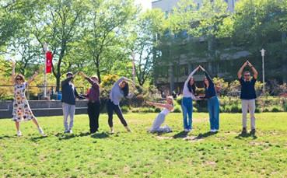
Recognize these letters? Members of the KARZAI lab having some fun!

Jae Ho Lee, Assistant Professor

The grand opening of Lee lab took place in January 2025 and the lab is fully up and running now! We are investigating how translation elongation speed of ribosome impacts protein biogenesis and homeostasis.
Current lab members include Modinat Akinboade (Chemistry PhD Student), Eimaan Bilal (Undergraduate), and Lucia Vilchez (Research Technician). We are looking forward to working with the new incoming PhD students and hope to continue to grow in size!
Dr. Lee contributed to a review paper about protein biogenesis, which was published at Journal of Molecular Biology in February 2025. Moreover, one of Dr. Lee’s major postdoctoral works was finally published in Science which highlights altered translation elongation kinetics as a major contributor to aging phenotypes.
Please stay tuned for future interesting and impactful papers from the lab!

Benjamin Lin, Assistant Professor
The Lin Cell Dynamics Lab investigates the molecular mechanisms underlying 3D cell migration, with a focus on unconventional migration modes employed during development and cancer. Our lab utilizes Drosophila genetics and live-cell imaging to investigate how cells behave in their native environment. In the past year, Ben received an NIH MIRA award to advance the lab’s research. Current members include Justin Palermo (Postdoctoral fellow), Francesco Castelli (MCB PhD Student), Richmond Asare-Bediako (Research technician), and undergraduates Maelle Aubry, Katherine Yo, Andrew Chen, Zoe Jiang, and Aaron Tu. Aaron received a URECA summer fellowship to continue his independent research project over the summer.
The Lin Lab said goodbye to our first lab member, Nikhil Pasumarthi, who graduated from the Honors College. We look forward to an exciting year of new research findings.
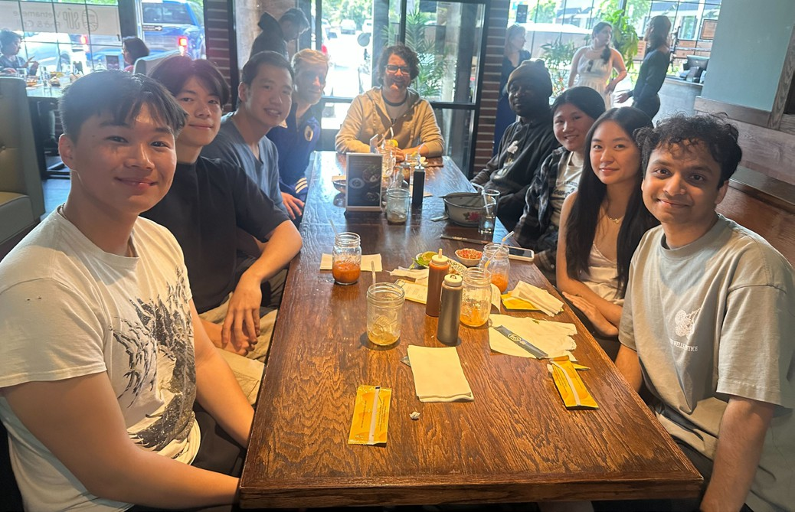
Happy end-of-year lunch for the Lin lab! We’re celebrating a great year and wishing our very best to Nikhil as he starts his next chapter. We’ll miss you!

Erwin London, Distinguished Professor

Erwin’s NIH MIRA award “Transformative Lipid Exchange Approaches to Study Membrane Organization” ended its third of five years. He continued to serve as a member
of the Postdoctoral Fellowship Award Committee for the Life Sciences Research Foundation and the editorial
board of The Journal of Membrane Biology. He continues as a member of the Biochemistry and Cell Biology Department Executive Committee, and is course
co-director of MCB 520, Graduate Biochemistry and course director of BSB 512, Structural Biology and Spectroscopy. Lab members in mid-2025 included research assistant professor Guangtao Li, postdoctoral research associate Shinako Kakuda, and PhD students Betty Du and Bingying Xia.
Erwin is also a co-advisor (with Todd Miller) for Antonio Torlentino and Sanjna Rana. Erwin presented talks
on the lab research at the Rutgers Center for Lipid Research, New Brunswick, NJ, Nov. 2024, at the Faraday Discussion on “Structural and functional asymmetry of plasma membranes”, London UK, April 2025, and at the Biophysical Society Thematic Discussion, “Beyond simple models: Consequences of membrane complexity in living systems. A celebration of the life and science of Luis Bagatolli.” Copenhagen, Denmark, July 2025. Betty Du presented a talk about her research on lipid rafts in yeast at a virtual session of the American Chemical Society annual meeting. She was also awarded a King/Miller travel award from the department.

Ed Luk, Associate Professor

Ed Luk and his lab continue their research on the regulation of chromatin structure and gene expression. The team includes Leonidas Pierrakeas, Cynthia Converso, Lirong Chan, Wendy Zeng, Kimberly Quach, and Kimberly Hane.
Leonidas (Louie) Pierrakeas, a PhD student in the Molecular and Cellular Biology (MCB) program, successfully defended his thesis on April 7, 2025. His dissertation focused on variant chromatin particles in cells, uncovering mechanisms of their targeting and functional roles. A major discovery from Louie’s work is the identification of R-octasomes, which are
non-nucleosomal chromatin particles composed entirely of histones H3 and H4, lacking H2A and H2B.
Louie is now a postdoctoral fellow in the lab, continuing his investigation of alternative chromatin particles found at promoters and telomeres.
Cindy Converso also completed her PhD in the MCB program, successfully defended in August 2024.
She co-authored a publication with Louie in PLOS Biology (May 2025), which revealed how the yeast genome encodes instructions that direct chromatin remodeling enzymes to specific genomic sites—key to establishing promoter architecture for transcription. The paper received significant attention in the field and was highlighted in an accompanying commentary article
in the same issue. Cindy is now pursuing her passion in teaching as a biology instructor at St. Anthony’s High School in South Huntington.
Lirong Chan, a second-year PhD student co-mentored by Dr. Ben Martin is investigating a zebrafish transcription factor and a signaling transducer. She is using a combination of approaches to probe the interactions between these factors Kimberly Hane a Genetics program student from Bruce Stillman’s lab at Cold Spring Harbor Laboratory, is conducting collaborative research in Ed’s lab on chromatin organization around DNA replication origins.
Wendy Zeng recently graduated with a BS degree in May and completed an Honors thesis project in Ed’s lab. Kimberly Quach, a rising junior, is also part of the
team. Both Wendy and Kim are fully engaged in summer research and have demonstrated impressive productivity in the lab, showing strong potential as
future biochemists!
Finally, Ed was recently awarded a Maximizing Investigator’s Research Award (MIRA) along with an equipment supplement grant from the National
Institutes of Health. The equipment grant supported the acquisition of a new high-performance liquid chromatography (HPLC) system. Ed has been busy exploring its capabilities in the lab this summer!

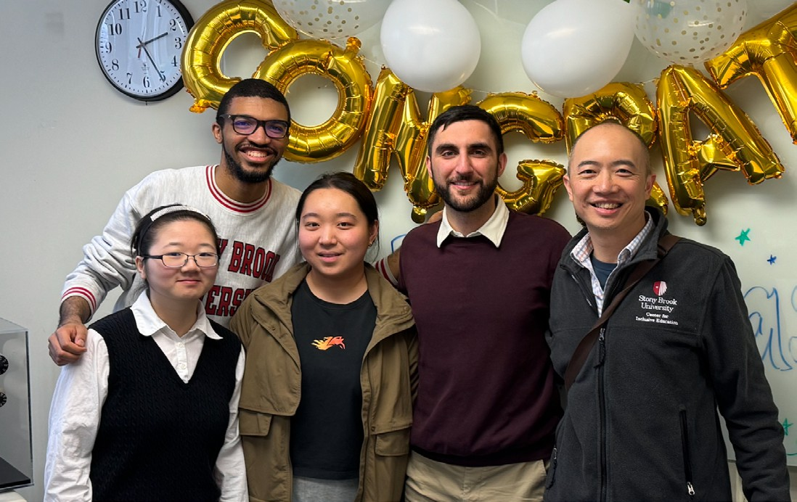
Cheers to Dr. Pierrakeas! The Luk Lab celebrates a successful defense and a job well done. Congratulations, Louie!

Benjamin Martin, Professor
The Martin Lab performs research to address questions related to cancer metastasis and stem cell biology
using zebrafish as a model system and currently receives funding from the NIH. The lab consists of technicians Wan Zhang and Calvin Yu, Ph.D. students Sam Stettnisch, Courtney Tello, Sabrina Hafeez, Rob Morabito, and Lirong Chan, Master’s student Joseph Epstein, and undergraduates Aman Mistry, Darren Wang, and Colman Shaver. Ph.D. student Rob Morabito graduated from the Molecular and Cellular Biology program and is now doing a postdoctoral fellowship in Chris Hammell’s group at Cold Spring Harbor Laboratory. Colman Shaver graduat-ed from the Honors College and with honors in Biochemistry. He will soon be embarking on a research trip to Madagascar. Sam Stettnisch and Courtney Tello are both NIH F31 predoctoral fellows, and Aman Mistry has a URECA fellowship from Stony Brook that will fund him for his summer research in the lab. Courtney also re-ceived a poster prize at the annual Biochemistry and Cell Biology retreat. Darren Wang is spending the summer at the University of Toronto in Andrew Woolley’s group developing tools for light inducible gene activation that we hope to implement in zebrafish.

Aaron Neiman, Professor

The Neiman Lab continues to use sporulation in yeast as a model to understand how cells can reorganize themselves during differentiation. The current lab
consists of Jae-Sook Park (Research Assistant Professor), Daniel Sanya (postdoc), Kai Zhang (Ph.D. Student), Hasung Jung (Masters student), Victoria Coman (technician), Nilufer Dilmen (technician) and Brandon Kim (undergraduate). Also, Professor Emeritus Rolf Sternglanz continues to come to the lab when he is in town. In alumni news from the far east, Hideki Nakanishi has moved his lab from Jiangnan University near Shanghai to Kanto Gakuin University in Yokohama.
Also, Yasuyuki Suda was promoted to associate professor at the University of Tsukuba outside of Tokyo.
In November, Aaron spoke at the annual meeting of the Lipid Research Center at Rutgers University describing Jae-Sook’s recent work on lipid transfer by the Vps13 protein. In February, he gave a seminar at Hofstra on the same topic. In June, Kai attended the Cold Spring
Harbor Yeast Meeting in Shanghai to present his work on asymmetric inheritance of the meiotic Spindle Pole Body.

Jonathan Nelson, Assistant Professor

The Nelson Lab entered its second year in 2024 and reached many new milestones. The lab received
its first grant – The American Federation for Aging Research Grant for Junior Faculty, funded by the Hearst Foundations. We also published our first two papers, a research article in Nature Communications revealing the role of insulin signaling in germline ribosomal DNA maintenance (PMID: 39755735) and a methods
article describing techniques to visualize locus-specific
ribosomal DNA transcription (PMID: 40227984). The lab shared its research at several conferences this year, including the Cold Spring Harbor Laboratory Germ Cell Meeting, the Cold Spring Harbor Laboratory Transposable Elements Meeting, and the Northeast Society for Developmental Biology Regional Meeting. Four undergraduate researchers from the lab – Abijot
Bains, Angel Karbanda, Hunter Sherman, and Zarah Ali – presented their research at the Stony Brook University URECA research symposium. This spring the first two graduate students joined the lab, Caroline Casella and Daisy Rubio, both PhD students from the MCB program. We are very excited about all the growth and progress the lab has made this year and are looking forward to achieving many more milestones in the coming year!

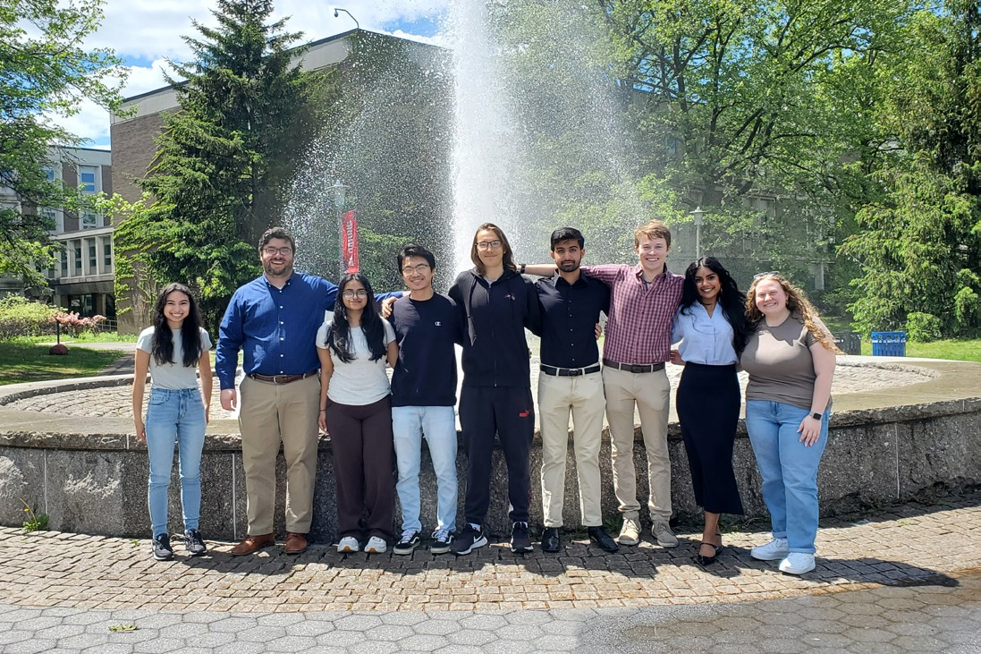

Spring has sprung and so has our research! The Nelson Lab crew, all smiles in front of the academic mall fountain. It’s a great group for a great year ahead!

Dada Pisconti, Associate Professor

This year we have said some goodbyes and welcomed new lab members. Rachel Zhao, Kseniya Rozanova, Nikita Rozsokha and John Khoury graduated this year, all with Honors! Moreover, Rachel and Kseniya even got awards! Now Rachel and Kseniya are off to medical school while John and Nikita are in the process of applying to Med School. We will miss them all so much!
In July we welcomed a new lab member, Richard Xu, our new Research Specialist. Richard received his bachelor’s degree from Stony Brook, and Master’s from Tufts. He will provide much needed help with all the ongoing projects and with keeping our mice healthy and happy.
Overall, it’s been a good year, we have published some papers, Dada has submitted two new grant proposals (fingers crossed) and we got loads of new cool data that we hope to publish soon.

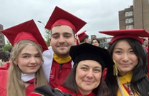
Huge congratulations to Kseniya, John, and Rachel, pictured here with Professor Pisconti, at the Biochemistry graduation ceremony in May 2025.

Stuti Sharma, Assistant Professor

This has been an exciting year for the Sharma lab as we received our first NIH grant! The award will support various projects in the lab, with an overall goal to understand how a ubiquitous and essential eukaryotic proton pump called the V-ATPase can be repurposed to conduct cellular signaling roles. Currently our lab
consists of two graduate students from the Biochemistry and Structural Biology (BSB) program – Caitlin Bricault and Andrew Hillowe, who are both supported by the NIH T32 Chemical Biology Training Program (CBTP). Over the summer, our lab is hosting an undergraduate student
– Sierra Fiano, who is supported by the “Explorations in STEM” program at SBU. We are also looking forward to welcoming a postdoc fellow Samuel Winkley, who will begin on July 15th 2025. Last year the lab said goodbye to Mayur Talele, an undergraduate researcher who left for the Chung Lab in the Department of Pathology to gain experience in translational research.

Gerald Thomsen, Professor

Jerry Thomsen’s lab is primarily focused on understanding mechanisms that regulate animal development and regeneration, with a major emphasis on regeneration, using the starlet sea anemone (Nematostella vectensis) and African clawed frog (Xenopus laevis) as model animals. Nematostella can regenerate its entire body from a small piece of tissue, and Xenopus tadpoles can regenerate their tail and other tissues and organs, so these animals provide diverse evolutionary standpoints from which to explore regeneration. Understanding regeneration in highly regenerative animals is not only fundamentally cool but has the potential to inform regenerative medicine to benefit human health and longevity.
Toward this lofty goal, the lab uses “chemical genetics” to identify molecular targets required for sea anemone polyp and tadpole tail regeneration. The approach is to amputate tissues from these animals and expose the amputees to small organic molecules that either block or activate known molecular targets (typically proteins). Nearly all these small molecules are pharmaceuticals or experimental reagents with well understood
target specificities and mechanisms of action. Thus, if a compound has an effect on regeneration, this immediately suggests a candidate gene or pathway is acting in regeneration and gives a target for future
validation with more traditional genetic and molecular biological methods (e.g. CRISPR knockout, in situ expression). Nearly 2,000 compounds have been screened thus far under an R03 grant from the NIH. This project has been driven mostly by graduate students
in the SBU Master of Arts in Teaching (MAT) program, based in iSTEM, and supported by summertime Robert Noyce Research (NRE) fellowships from a National Science Foundation grant to iSTEM. The NRE program provides future high school science teachers with authentic research experience that they can learn from and incorporate in their teaching careers. NRE students over the last three summers have included Stephanie DeNicola and Alanna Schwartz in 2023, Holly McNair and Elizabeth Von Brook in 2024, and Christine Maguad and Megan Zedalis in 2025. These students worked full time during their summer appointments, and some continued to do research part-time as they progressed toward their MAT degrees. Jerry also actively participates in the project as the chief “pharmacologist”. The project has yielded tantalizing results (not yet published) and Jerry aims
to expand the depth of the investigations under future grants (private support for this project would be greatly appreciated)
In the teaching and service realms, Jerry continues to co-instruct Animal Development (BIO 325)
with Bernadette Holdener in Fall semester, and Developmental Genetics Lab (BIO 327) with Peter Gergen in the Spring semester.
Personnel in the lab over the past year have included long time Research Scientist Dr. Pat Bossert), former NRE Fellow Holly McNair (part time research support), and summer NRE Fellows Christine Maguad and Megan Zedalis. Jerry is on the executive board of Undergraduate Biology, the admissions committees for BSB and MCB, and various PhD thesis committees.

Lonnie Wollmuth, Professor

NMDA receptors are ligand-gated ion channels that play prominent roles in brain development and function. They also participate in the development of the peripheral nervous system and other tissues located outside the central nervous system including the gut, the autonomic nervous system and sensory systems. Notably, children with missense mutations in the genes that encode NMDA receptors can display neurological and psychiatric diseases, such as autism, seizures, intellectual disability, and schizophrenia among many others. Research in
the Wollmuth group addresses biophysical, structural and physiological mechanisms mediating cell-to-cell signaling in the central and peripheral nervous system, focusing primarily on how disease-associated variants in NMDA receptors lead to clinical phenotypes. We also collaborate with Dr. Helen Hsieh, a pediatric surgeon
at SBU Medicine. Details of our research program and activities can be found at our webpage.
Our group had a successful year. We published 3 primary research papers. I also gave talks at various GRIN functions including general talks in Chicago, Illinois
and Denver Colorado. GRIN families have children who have missense mutations in the genes encoding NMDA receptors. It is very positive to meet the families and the children – makes you want to work harder to help find solutions for the children. One major phenotype in GRIN children is seizures, and one major focus of our group is to understand the basis for these seizures and potential routes for treatments. To do so, we take advantage of zebrafish, a model organism where we can more rapidly address issues of mechanisms and drug screens.
Presently, we have two post-docs in the lab: Amalia Napoli, who is working on how NMDA receptors affect the development of tissue outside the brain, and Bohdan Kysilov, who is studying how missense mutations in NMDA receptors lead to altered receptor function. Erica Nebet is an MD/PhD graduate student who is studying seizures. Another student, Christie Aprea, is studying how NMDA receptors affect development of the
gut – gastrointestinal issues are a major concern for families with GRIN children. Miaomiao He, a graduate student from the Biochemistry and Structural Biology program, graduated during this past year.

2025 Promotions

Michael Ariola, Assistant to Associate Professor

2025 Awards

Benjamin Martin, Professor was awarded the Godfrey Excellence in Teaching Award and John S. Toll Endowed Award for Teaching Excellence at this year’s 2025 Difference You Make ceremony.

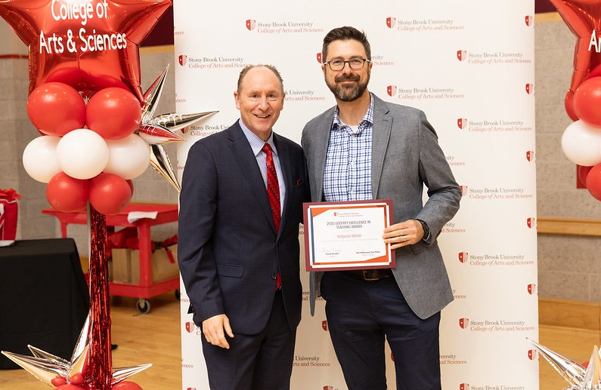
Dean David Wrobel, and Benjamin Martin, Associate Professor

In Memoriam

Martin Freundlich, Professor Emeritus

A founding member of the Biochemistry faculty, Marty passed away this past March at the age of 94. Marty was a valued colleague and a mentor to many generations of students and junior faculty. Read more about Marty on our webpage.

Harvard Lyman, Professor Emeritus

Harvey Lyman passed away in July at the age of 93. Harvey is fondly remembered as an avuncular colleague and for his dedication to students. Read more about Harvey on our webpage.

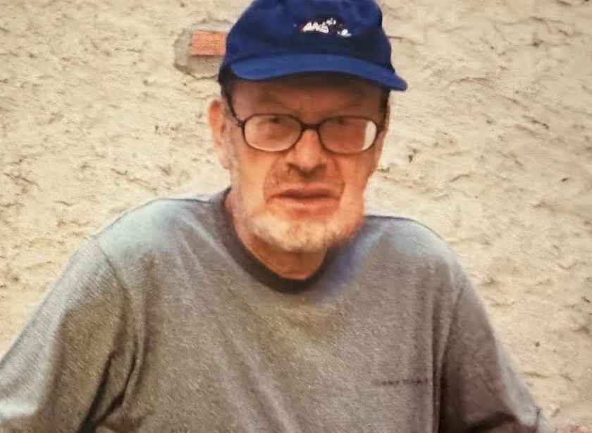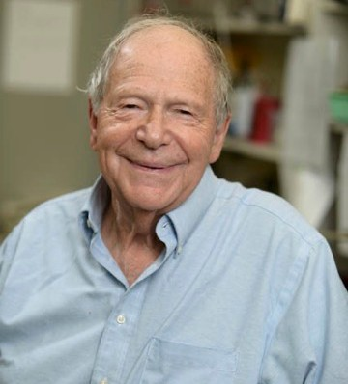

Alumni Corner

1970s

Bob Cafferata ‘70, PhD
Advisor: Marty Freundlich
Bob Cafferata visited Seppo Yla-Herttuala, a gene therapy pioneer, at the National Virus Vector Laboratory, Kuopio, Finland while his wife Gail Erickson Cafferata BS’66, MS’70 Sociology revisited her ancestral roots. Bob’s career as a translator between the twin silos of academia and business never ends.

Cheryl Dunayer Lapidus ‘77 BS Biochemistry
I retired from 42 years in pharmaceutical QA and moved to Florida in 2020 right before COVID hit. I am now working remotely part time in the industry doing QA support. Life is pretty good!

Mark Lehrman ‘77, BS Biochemistry 1977
After 42 years at UT Southwestern in Dallas, I retired Sept. 2024. Starting my “encore” as a docent at the Dallas Holocaust and Human Rights Museum. Looking forward to more traveling and new interests!

Larry Zwiebel ‘79 BS Biochemistry
My Stony Brook undergraduate research with Marty Freundlich and Masayori Inouye was instrumental in setting me up for a wonderful life in science that
has taken me all over the world. My research group at Vanderbilt University is focused on insect olfaction and in particular olfactory driven behaviors of malaria vector mosquitoes and eusocial ants. check us out: https://lab. vanderbilt.edu/zwiebel-lab/

1980s

Kaushik Das ‘83, BS Biochemistry
Joined White Plains Hospital as the Director of Neurosurgery

Paul Mazzeo, ‘84 BS Biochemistry
I am a board-certified neurologist with subspecialty certification in behavioral neurology, neuropsychiatry and headache medicine. I founded Coastal Neurology 30 years ago as the first neurology practice in Beaufort, SC and founded the Beaufort Memorial Memory Center where we participate in clinical research for various dementias. I am a co-author of an upcoming article in Nature of an anti-synuclein compound studied to slow the progression of Parkinson’s Disease.

Joseph Mormino, ‘85 BS
Dentist in Staten Island, New York

Brian Stevenson, ‘89 PhD 1989
Advisor: Marty Freundlich
I earned my Ph.D. with Marty Freundlich, focusing on bacterial gene regulation and DNA-binding proteins. I then did postdocs at Yale and Rocky Mountain Labs
NIH, working on pathogenic mechanisms of the Lyme disease agent, Borrelia burgdorferi. In 1998, I joined the faculty of the Dept. of Microbiology & Immunology at the University of Kentucky College of Medicine. During the past 27 years, we have discovered numerous novel nucleic acid-binding proteins, defined regulatory mechanisms that control expression of
virulence-associated proteins, and determined functions of B. burgdorferi surface proteins that are produced during human infection. Some details are presented on my university web site, https://medicine.uky.edu/users/ bstev0. On the personal side, my wife, Debbie, and I love living in Lexington, Kentucky, and enjoy gardening and working around the house. We have five wonderful & successful daughters, a film maker, three in healthcare/ public health, and a school teacher. We have 8 grandkids.

1990s

Donald Beckles ‘91, BS Biochemistry
I am the NEW Director of Cardiothoracic Surgery at Christus Ochsner Health in Southwest Louisiana.

David Mangiameli ‘93 BS Biochemistry
I graduated with my BCH/BS from SB under Dr Sarma in ‘93. I went on to med school general surgery/trauma residency, surgical oncology, and immunotherapy fellowships at NIH the. Finally, on to Columbia Presbyterian for breast cancer surgery and oncoplastic surgery. I am an attending for 14 years and am director of breast cancer services for NY Cancer and Blood specialists. I operate at St Charles, Mather, Peconic Bbay and NYU Suffolk. I have three breast cancer centers, in Westhampton beach, Riverhead and Patchogue. I also take a team internationally, annually to mitigate third world breast cancer and women’s health disparities.
We go to west Africa, South America and the Caribbean (likely Kenya in January). My son also just graduated from SBU as a health science major. He is in the Air Force and will deploy this year and follow next year with applications to medical school.

Sunita Kramer PhD ‘98, MCB Advisor: Peter Gergen
I will be returning to my alma mater- Franklin & Marshall College on July 1, 2025 to be the next Provost and Dean of the Faculty. Link to story here: https://www.fandm.edu/ stories/kramer-returns-as-provost.html

Ellen Hoffman ‘99, B.S. Biochemistry
2025 is the 10-year anniversary of starting my lab at Yale studying the genetics of autism spectrum disorder.

2000s

Anna Chan ‘01 BS Biochemistry
I went on for my medical degree and have my own private
office for 11 years this September.

2010s

Natalie E. Stenzoski PhD ‘18, BSB
Advisor: Dan Raleigh

I started a new role last summer as Senior Analytical Manager at Transpire Bio Inc, a pharmaceutical company developing novel therapeutics for inhalation drug delivery platforms.

2020s

Christopher Little ‘20 BS Biochemistry
Just graduated from the MD program at University of Buffalo Jacobs School of Medicine and Biosciences, as Dr. Christopher Little.

Cameron Chino ‘20, BS Biochemistry
I am currently preparing for Medical School. I feel that the education I got at Stony Brook University really helped prepare me well for the MCAT exam.

Lexin Chen ‘21, BS Biochemistry
I defended my PhD dissertation in April and will be graduating with PhD in Chemistry from the University of Florida in August 2025! My research focuses on developing cutting-edge software solutions for machine learning, clustering, sampling rare events, molecular dynamics, and DNA Encoded Libraries. With a strong foundation in computational chemistry and software development, I specialize in creating open-source
tools that streamline drug discovery through scalable algorithms.

Nick Siegel ‘22, BS Biochemistry
Shortly after graduating from SBU, I began pursuing my MS in Nutrition and working toward my Registered Dietitian (RD) credential at Boston University, where I
apply my biochemistry background to nutrition research. I was honored to receive the Sargent Student Research Grant, which supported my research and allowed me
to present at Nutrition 2025, the American Society for Nutrition’s (ASN) annual research conference. My poster, titled “The Role of Gut Microbial Diversity in the Protective Association Between Plant-Based Diets and Metabolic Syndrome Risk,” explored how the gut microbiome may help explain the link between diet
quality and chronic disease risk. I’m incredibly grateful for this experience and excited to continue learning and growing with the support of my mentors and peers. I’m especially interested in metabolomics and precision nutrition—and look forward to future opportunities in research or doctoral study that align with these interests.

Jonathan Caradonna ‘24, BS Biochemistry
I am currently doing my PhD in bioinformatics at North Carolina State University. I am in Dr. Xinxia Peng’s lab where I am working in the fields of computational immunology and transcriptomics analyses. I am currently working on two projects: One where I am setting up an atlas of T and B cell scRNA-seq data from our rhesus macaque projects for use in the future; the other being a project on evaluating the effect of PFAS levels across individuals inside and outside a community exposed to PFAS-contaminated drinking waters.

Philanthropy Corner

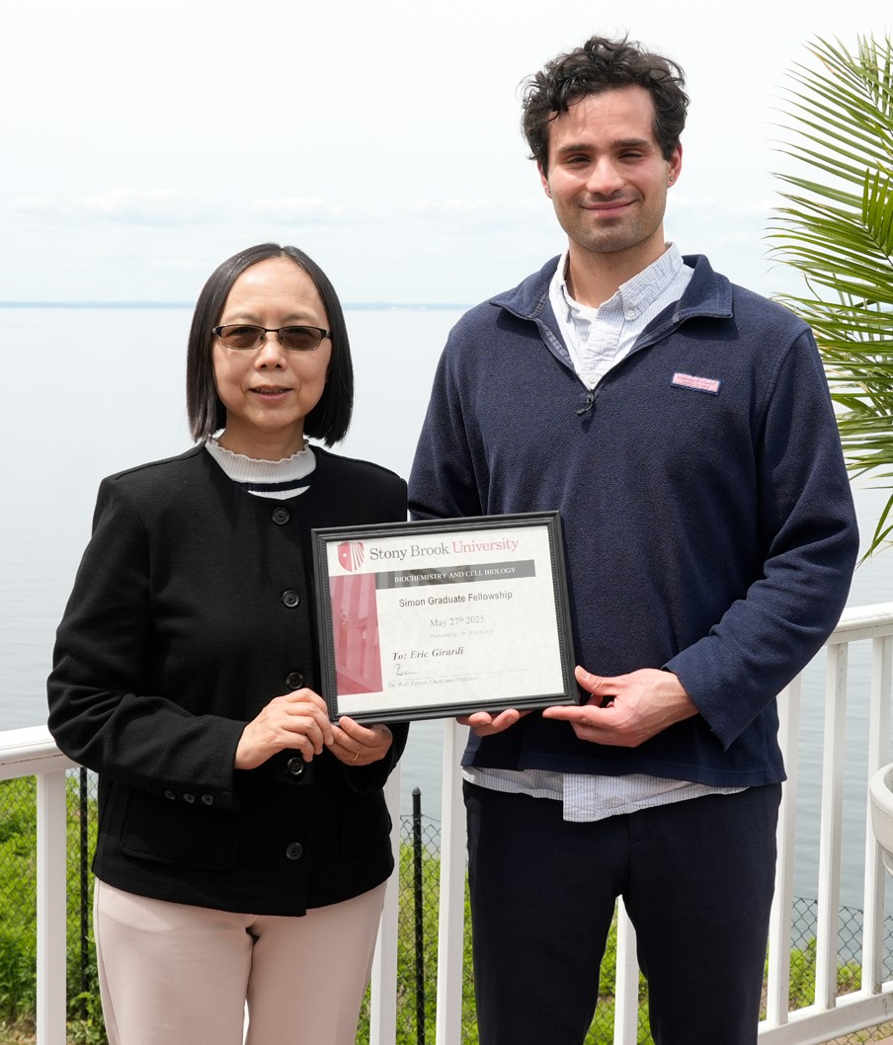
We continue to work to build endowment funds that will ensure a strong and stable future for the research and teaching missions of the Department.

Endowment Gifts from Bill and Sue Studier and Professor Erwin London
New York State is currently providing a 50% match to qualifying endowment gifts. We were fortunate to receive two such donations this year. Bill Studier, emeritus faculty at Brookhaven labs and longtime adjunct member of BCB and his wife Sue provided
one such gift. Professor Erwin London made a second qualifying donation. We are grateful to Bill, Sue, and Erwin for their generosity and for the impact it will have on the Department. Together these donations and the associated State matches will nearly double the size of the BCB endowment.

Amy Liao PhD ‘93 creates the Yang Manzhen Endowed Fund
This new endowed fund will exist in parallel to the departmental endowment to provide support for research and training in BCB. Named in honor of Dr. Liao’s grandmother, the endowment is established with a gift of $1,000,000 to be donated over the next five years and, when complete, New York State will provide an additional 50% match. This transformational gift will have lasting benefits for the students and faculty of BCB.

The third Simon Fellowship and four King/Miller Travel awardees:
At our Departmental retreat in May, Eric Girardi of
Chi-Kuo Hu’s lab was announced as the recipient of the third Sanford Simon Graduate Fellowship. Endowed
by Amy Liao PhD ’93, in honor of her thesis advisor, the Fellowship provides one year of stipend support for a 3rd or 4th year Ph.D. student doing their thesis research in a BCB faculty member’s lab.
Also announced were four King/Miller Travel Awards which were created several years ago in honor of Kevin King and John Miller, two PhD students tragically killed in a car accident. The four recipients were Lingshuang Wu (Airola lab); Betty Du (London lab); Kai Zhang (Neiman Lab); and Ryan Sweet (Hu lab) all will receive $1000 towards the cost of travel to a scientific meeting.

Celebrating excellence in research! Congratulations to Eric Girardi, the recipient of the Sanford Simon Graduate Fellowship. A special thanks to Amy Liao PhD ’93, for her generous support in honor of her advisor, Sanford Simon.

Giving Day

The Giving Day drive is our annual event to raise funds for the endowment. This year our efforts were buoyed by a $25,000 matching gift from Stuart and Gloria Hollingsworth that helped inspire gifts from nearly 100 different friends and alums. All told, the day raised over $43,000. We are seeking alumni volunteers to act as advocates to
help spread the word for next year’s Giving Day. If you are interested in participating, please contact Aaron Neiman: aaron.neiman@stonybrook.edu
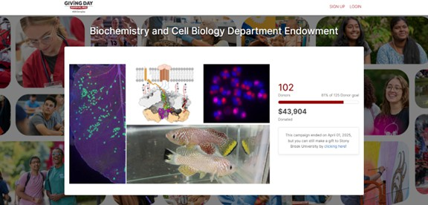

Thank you for your support!

Contributions can be made to the Biochemistry and Cell Biology Fund for Excellence, which provides funds for immediate use or to the Endowment for Excellence in Biochemistry and Cell Biology, which supports the long term health of the Department.
Visit our website

Visit the Department of Biochemistry and Cell Biology!
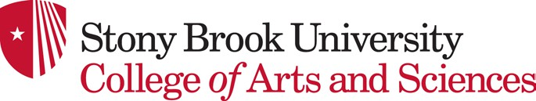
Stay up to date with our semester events and research activity.

