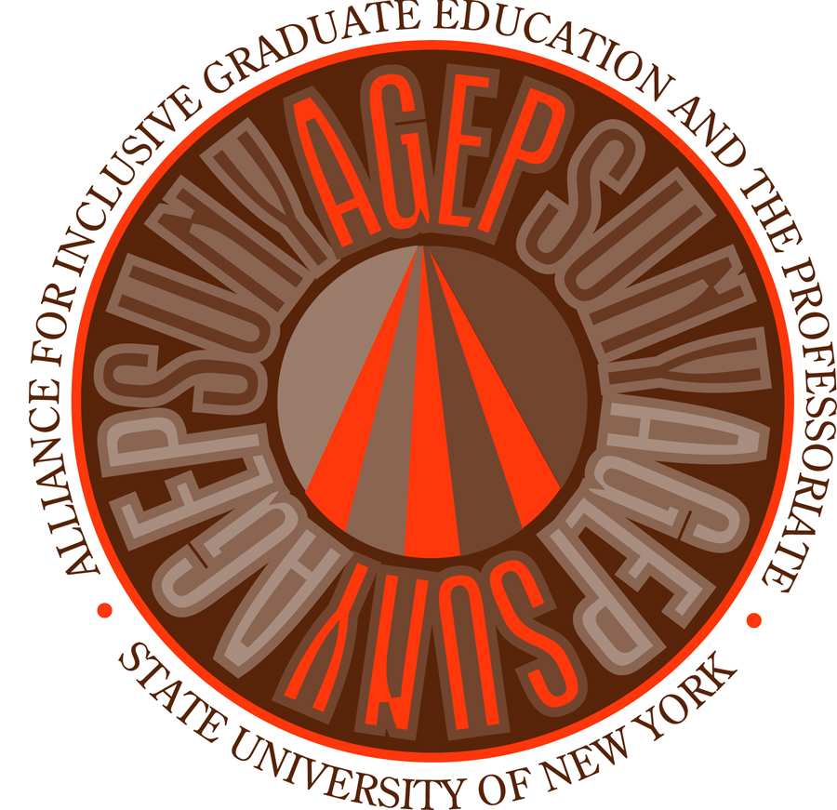
NSF SUNY AGEP
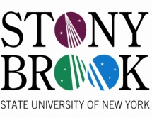
The Turner Fellowship Program

The Center for Inclusive Education’s
Celebrating Diversity and Academic Excellence (CDAE) in Graduate Education (May 2nd, 2011)
CALL FOR POSTER/ORAL SESSION PRESENTATIONS AND REGISTRATION
Deadline April 4th for presenter application and April 20th for registration
When and Where | The Center for Inclusive Education is pleased to announce CDAE which will be held on Monday, May 2nd, 2011 in the Student Activities Center Rooms A&B. Students, staff, and faculty can register online at www.stonybrook.edu/cie. Graduate students can apply to present a poster or oral presentation at www.stonybrook.edu/cie.
About the Conference | We are very proud to present this very special event that is being funded by a Stony brook University Presidential Mini Grant awarded to the Center for Inclusive Education. Co-sponsors include several Stony Brook University departments and campus centers such as the Center for Developmental Genetics and the Department of Sociology. The main purpose of this symposium is to recognize and celebrate Stony Brook University underrepresented minority graduate student research excellence. There is no fee for registration.
Why Participate? | We are very excited to announce our two prestigious keynote speakers who will present during the day: Tyrone Hayes and Kerry Ann Rockquemore. Tyrone Hayes is a Professor in the Department of Integrative Biology at UC Berkeley and will be talking about his fascinating research on the effects of hormones on amphibian development. Kerry Ann Rockquemore is a Professor in the Sociology Department at the University of Illinois and is the Executive Director of the National Center for Faculty Development and Diversity. The title of Kerry Ann’s talk is: Pursuing a Faculty Career and How to Win Tenure Without Losing Your Soul.
Deadlines | Please apply to present an oral presentation or poster by April 4th. We expect to have as many as 40-60 posters set up so please apply early to avoid all space being filled. The deadline for symposium registration is April 20th for undergraduates, graduate students, faculty and staff. Registered attendants will be provided a free catered lunch and refreshments will be available throughout the day. Students will be notified of acceptance of either presenting an oral presentation or a poster by April 18th.
Questions | If you have any questions or concerns please contact the Center for Inclusive Education office at: 631-632-1387 or email CIE_GraduateSchool@notes.cc.sunysb.edu. We are located in E-1340 Frank Melville Jr. Memorial Library.
Poster FAQ’s | Poster presenters will need to check in with our representative at 9:00AM, May 2nd, to set up their poster. The poster session will be from 1:30pm-3:00pm. We will provide the clips and easels for your poster. Your poster must remain up until the end of the day. Posters must fit into a space 36’’ x 42’’.  Oral presenters should prepare for an informal presentation lasting no longer than 12 minutes to be followed by a 3 minute Q&A.

The tentative agenda is as follows:
MONDAY MAY 2, 2011

TIME | ACTIVITY | LOCATION
9:00-10:00 | Poster check-in and set-up, refreshments | SAC Y Lobby, SAC A
10:00-10:15 | Provost Kaler Welcome and Introduction of Keynote Speaker | SAC B
10:15-11:30 | Dr. Kerry Ann Rockquemore (co-hosted by the Dept of Sociology) | SAC B
11:30-11:45 | Break
11:45-1:00 | Dr. Tyrone Hayes (co-hosted by the Center for Developmental Genetics) | SAC B
1:00 | Buffet Lunch Lines Open | SAC A
1:30-3:00 | Poster Session/Oral Presentations | SAC A/SAC B
3:00-3:30 | Awards Ceremony | SAC A

